SSUP: Winter Institute - PD Leader Guide Day 1
Grade Level | 4 | Day | 1 | STeLLA Strategies Focus | STL 1, 2, 3, 4 | Subject Matter Focus | Earth’s Changing Surface
Teacher Learning Goals | - The goals of the STeLLA PL program are to deepen knowledge of teaching and learning, increase ability to analyze and reflect on teaching and learning, increase ability to use content knowledge and knowledge of teaching and learning to transform classroom practice, deepen teacher content knowledge, and increase student learning in science.  - Earth’s Changing Surface Lessons 1-5  - (L1) Maps can help locate the different land and water features areas of Earth. While the Earth’s surface appears stable, it is changing over time.  - (L2) Erosion and deposition are processes that change the surface of Earth by carrying and depositing earth materials from one place to another.  - (L3) The amount of water, vegetation, and slope of the land can speed up or slow down erosion and deposition.  - (L4) Erosion and deposition are ongoing processes that continue to shape and reshape the land. People can also change where the rock and soil flow. This has positive and negative effects.  - (L5) As rock and soil interact with water (rain, waves, ice), wind, or plants, they break apart. This process is called weathering and it changes the Earth’s surface by causing rock to fragment, crack, and crumble into smaller pieces over time. Weathering and erosion are ongoing processes.  - Based on Communicating in Scientific Ways, teachers can distinguish observation and inference; data and evidence; claim, evidence, and reasoning; reasoning with data/evidence, ideas, and models; and eventually, explanation and argumentation.
Focus Questions | - How does watching classroom video help you become more reflective practitioner?  - Has the Earth’s surface always looked this way? Why or why not?  - Why is it important to intentionally plan to use STeLLA strategies throughout a lesson?
Ideal Teacher Response | - How does watching classroom video help you become a more reflective practitioner?  Watching video slows down what’s happening in the classroom so teachers can reflect on their use of STeLLA strategies to reveal, support, and challenge student thinking.  - Has the Earth’s surface always looked this way? Why or why not? (Lesson 1 Focus Question)  The Earth’s surface has changed overtime. The Mississippi River Delta got bigger and moved around over thousands of years. Water from all over the United States runs off the land and eventually into the Mississippi River. Where the river meets the ocean, there is a delta. Maps from different time periods show that while water and land in a system can appear stable, it can actually change over time. The Mississippi River Delta has grown larger over thousands of years. The river has changed course several times, and at the end of the river, new land forms and other land disappears.  - What causes deltas to form? (Lesson 2 Focus Question)  Moving water in rivers and streams shapes and reshapes Earth’s surface by moving rocks and soil from higher elevations and depositing them at lower elevations. Erosion is the process by which weathered earth materials, such as rock fragments, sand, and soil, are removed from one place on Earth’s surface and transported to another where they are deposited. Erosion helps make the tall places lower, while deposition helps build up the lower places. Deltas form at the end of rivers when this new land builds up over time.  - What can change how fast deltas grow? (Lesson 3 Focus Question)  Rainfall, the amount of water flowing, vegetation, and the type and slope of the land can affect the rate of erosion and deposition, changing where soil and rock flow and deposit. The Mississippi River freely deposited soil and rock that flowed from other places, which created the delta originally.  - What can cause a delta to shrink? (Lesson 4 Focus Question)  Increased flooding and rainfall caused humans to build walls to manage the flow of the river. This caused a steadier flow for communities and transportation along the river but limited how soil and rock could be deposited in the delta. Over time, the land seems to “disappear” but really the rocks are being swept away by the flow of water and wave currents. Human activity can have both positive and negative effects on natural processes.  - Where does the soil and rock in a delta come from and where does it go? Does the rock and soil ever change? (Lesson 5 Focus Question)  Smaller rocks were once part of bigger rocks. Rock breaks down all over the land because of rain, ice, vegetations, and wind. Weathering is a set of processes that cause rock to break into smaller and smaller pieces. Rocks that are carried away due to erosion previously came from bigger rocks. Rock and other weathered materials are transported between different land and water features. As rocks continue to be carried away (erosion) by gravity, water and/or wind, the rocks continue to break down into smaller pieces (weathering). These smaller pieces can be deposited in different places building up the surface of the Earth.  - Why is it important to intentionally plan to use specific STeLLA strategies throughout a lesson?  Identifying key stella strategies on which to focus in a lesson helps teachers be intentional in where and how they reveal, support, and challenge student thinking and/or help students construct a coherent science content storyline.

Preparation | Materials | Videos and Transcripts
Planning/Preparation Tasks:  - Study PDLG, PPTs, video clips, and handouts. Make changes to PPTs, if needed.  - Link clips  - Content Deepening Prep  - Prepare Stream Table Setups for Lessons 2-4  - Lesson 2 = 1 whole-group stream table  - Lesson 3 = 5 stream tables for the 5 conditions  - Lesson 4 = 1 whole-group stream table with dam  - Set up Lesson 5 weathering stations for reference  Daily Set Up Tasks:  - Check that video clips are correctly linked to PPT  - Set up PowerPoint and speakers  - Check video & sound  - Arrange furniture, food (include social distancing protocols in set up)  - Arrange posters/charts  Day 1 Set Up Task:  Arrange teacher materials on tables:  - Tabletop name cards  - Table boxes (small red, green, yellow dots; black permanent fine-tipped markers)  Daily Follow-up Tasks:  - Archive final PPT  - Collect and turn in daily feedback  - Disinfect common materials, tables, and common areas per protocol | Posters/Charts:  - STeLLA Conceptual Framework poster  - Communicating in Scientific Ways poster  - Program Goals chart  - Day 1 Agenda chart  - Norms poster  - Day 1 Focus Questions chart  - Parking Lot chart  Handouts in PD binder front pocket or in Pre-Tab:  - Earth’s Changing Surface Lesson Placemats  Handouts in SSUP PD binder, WI Day 1:  - [HO 1.1 CSW (in PD Binder from Unit 1 ET)]  - HO 1.2 The Mississippi River Delta  - HO 1.3 How does land change to form a delta?  - Ideas About Earth’s Changing Surface Mash Up  - HO2.1  - HO3.1  - HO4.1  - HO4.2  - HO5.2  - Evidence Cards Handout Sheets  Supplies:  - Chart paper and markers  - Sticky notes  - Red, green, and yellow dots for the Mash Up  Resources:  - STeLLA Strategies booklet  - BSCS Journal (norms pasted into the journal)  - Content Deepening Notebook | - Videos & Transcripts:  - L5_Potter_C1-3  - L5_Potter_C4-6  - Internet Connection to stream The Changing Delta Video clip: http://www.watchthedeltagrow.com/mississippi-river-paths

DAY 1 SESSION OUTLINE: Thursday 8:00 p.m. - 4:30 p.m.
Time | Purpose | Content | Activities
8:00 | Coffee and fruit available
8:00 – 8:20  20 min  Small Groups | Purpose: Continue to build community and set the stage for learning throughout the Winter Institute and academic year. | Content: Focus Questions  - Has the Earth’s surface always looked this way? Why or why not?  - How does watching classroom video help teachers become more reflective practitioners?  - Why is it important to intentionally plan to use specific STeLLA strategies throughout a lesson? | Opening  - Welcome & Introductions  - Goals, Agenda, and Norms  - Focus Questions
8:20 – 8:50  30 min  Whole Group | Purpose: Provide an opportunity for teachers to reflect on the fall unit as they prepare to teach the spring unit through the lens of the STeLLA Program Goals designed to increase ability to 1) analyze and reflect on teaching and learning and 2) use content knowledge and knowledge of teaching and learning to transform classroom practice. | Content: Teachers reflect on how participating in the STeLLA program so far has contributed to their professional growth and student learning/understanding. | Fall Video Reflection  - Teacher Led Discussion  - Revise Effective Science Teaching Chart
8:50 – 10:40  100 min  + 10 min break  Study Group Teams | Purpose: Model effective STeLLA-based science teaching and learning through a common experience that is grounded in a 3D, phenomena/problem driven unit and designed for adult learners. The Teacher Set-up and Follow-up are reflective of STeLLA Strategy F (Activity Set-up, Activity, and Activity Follow-up) with an eye toward teachers as science learners. PDLs use the teacher follow-up to uncover teacher ideas about their experience and then leverage those ideas throughout analysis of practice. | Content: STeLLA model lessons/units attend to the characteristics of effective science teaching and learning (e.g., 3D phenomenon/problem-driven, student-centered, make student thinking visible and support sense making, coherent, and access/engage prior knowledge and develop metacognitive abilities).  Science Content:  (L1) The Earth’s surface has changed over time. The Mississippi River Delta got bigger and moved around over thousands of years. Water from all over the United States runs off the land and eventually into the Mississippi River. Where the river meets the ocean, there is a delta. Maps from different time periods show that while a system can appear stable, it can actually change over time. The Mississippi River Delta has grown larger over thousands of years. The river has changed course several times, and at the end of the river, new land forms, and other land disappears. | Content Deepening: Anchor Lesson 1  - Teacher Set-up (15 min)  - Anchor Experience for Adult Science Learners (60 min)  - Teacher Follow-up (25 min)
10:40 – 11:40  60 min  Study Group Teams | Purpose: The purpose of this session is to model effective STeLLA-based science teaching and learning through a common experience that is grounded in a 3D, phenomena/problem driven unit and designed for adult learners. | Content: STeLLA model lessons/units attend to the characteristics of effective science teaching and learning (e.g., 3D, phenomenon/problem-driven, student-centered, make student thinking visible and support sense-making, coherent, and access/engage prior knowledge and develop metacognitive abilities).  The content deepening experience will include explicit modeling and use of elicit, probe, and challenge questions as well as focal STeLLA strategies for each lesson:  - L2: STL 6/ SCSL D  Science content:  (L2) Moving water in rivers and streams shapes and reshapes Earth’s surface by moving rocks and soil from higher elevations and depositing them at lower elevations. Erosion is the process by which weathered earth materials, such as rock fragments, sand, and soil, are removed from one place on Earth’s surface and transported to another where they are deposited. Erosion helps make the tall places lower, while deposition helps build up the lower places. Deltas form at the end of rivers when this new land builds up over time. | Content Deepening: Lesson 2  - Teacher Set-up (10 min)  - Science Content Deepening experience for adult science learners (50 min)
11:40 – 12:00  20 min  Study Group Teams | Purpose: The purpose of this session is to model effective STeLLA-based science teaching and learning through a common experience that is grounded in a 3D, phenomena/problem driven unit and designed for adult learners. | Content: STeLLA model lessons/units attend to the characteristics of effective science teaching and learning (e.g., 3D, phenomenon/problem-driven, student-centered, make student thinking visible and support sense-making, coherent, and access/engage prior knowledge and develop metacognitive abilities).  The content deepening experience will include explicit modeling and use of elicit, probe, and challenge questions as well as focal STeLLA strategies for each lesson:  - L3: STL 5  Science content:  (L3) Rainfall, the amount of water flowing, vegetation, and the type and slope of the land can affect the rate of erosion and deposition, changing where soil and rock flow and deposit. The Mississippi River freely deposited soil and rock that flowed from other places, which created the delta originally. | Content Deepening: Lesson 3  - Science Content Deepening experience for adult science learners (20 min)
12:00 – 12:30  30 min | Lunch
12:30 – 1:10  40 min  Study Group Teams | Purpose: The purpose of this session is to model effective STeLLA-based science teaching and learning through a common experience that is grounded in a 3D, phenomena/problem driven unit and designed for adult learners. | Content: STeLLA model lessons/units attend to the characteristics of effective science teaching and learning (e.g., 3D, phenomenon/problem-driven, student-centered, make student thinking visible and support sense-making, coherent, and access/engage prior knowledge and develop metacognitive abilities).  The content deepening experience will include explicit modeling and use of elicit, probe, and challenge questions as well as focal STeLLA strategies for each lesson:  - L3: STL 5  Science content:  (L3) Rainfall, the amount of water flowing, vegetation, and the type and slope of the land can affect the rate of erosion and deposition, changing where soil and rock flow and deposit. The Mississippi River freely deposited soil and rock that flowed from other places, which created the delta originally. | Content Deepening: Lesson 3  - Science Content Deepening experience for adult science learners (20 min)
1:10 – 3:10  110 min  +10 min break  Study Group Teams | Purpose: The purpose of this session is to model effective STeLLA-based science teaching and learning through a common experience that is grounded in a 3D, phenomena/problem driven unit and designed for adult learners. | Content: STeLLA model lessons/units attend to the characteristics of effective science teaching and learning (e.g., 3D, phenomenon/problem-driven, student-centered, make student thinking visible and support sense-making, coherent, and access/engage prior knowledge and develop metacognitive abilities).  The content deepening experience will include explicit modeling and use of elicit, probe, and challenge questions as well as focal STeLLA strategies for each lesson:  - L4: I/9  Science content:  (L4) Increased flooding and rainfall caused humans to build walls to manage the flow of the river. This caused a steadier flow for communities and transportation along the river but limited how soil and rock could be deposited in the delta. Over time, the land seems to “disappear” but really the rocks are being swept away by the flow of water and wave currents. Human activity can have both positive and negative effects on natural processes. | Content Deepening: Lesson 4  - Science Content Deepening experience for adult science learners (20 min)
3:10 – 4:15  70 min  Study Group Teams | Purpose: The purpose of this session is to develop a shared understanding of STeLLA Strategy F: Make explicit links between science ideas and activities and how its use creates a coherent science content storyline. | Content: Lessons with a strong science content storyline include a connected thread of content-related talk and activities leading from the focus question through a flow of events and science ideas to the summary of the lesson. For students to construct a coherent science content storyline, activities should have a purposeful set up, be designed to require links between the activity and science ideas, and a follow-up that focuses attention on how the activity contributed to the storyline.  The LAP supports a deep dive into a teacher’s practice and student understanding through intentional inquiry into evidence provided in analysis of classroom video. | Analysis of Practice (Teacher Set up for Content Deepening)  - Clip of L5 Weathering Stations  - Video Analysis (SCSL F)
4:15 – 4:30  15 min  Study Group Teams | Purpose: The purpose of this session is to reflect on the day’s experiences and learning and prepare for Friday. | Content: Focus Questions  - Has the Earth’s surface always looked this way? Why or why not?  - How does watching classroom video help teachers become more reflective practitioners?  - Why is it important to intentionally plan to use specific STeLLA strategies throughout a lesson? | Closing  - Revisit Focus Questions  - Day 1 Reflections  - Homework:  - Teacher Content Background Doc

DAY 1
Time and Focus | Purpose and Content &  What Participants Do | Slides | Process
8:00 – 8:15  15 min  Slides 1-6 | Opening  Purpose: The purpose of the opening is to continue to build community and set the stage for today’s learning  Content: Teachers reflect on how participating in the STeLLA program so far has contributed to their professional growth and student learning/understanding.  Resources  - Name Tags  - Journals  - Norms Poster  - PD Binder  - STeLLA Strategies Booklet  - STeLLA Conceptual Framework poster  - Charts | 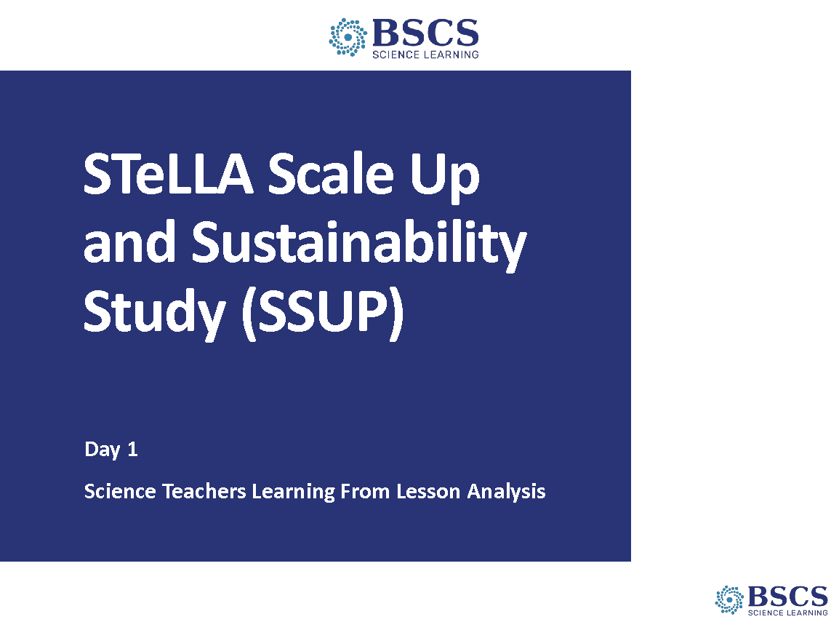 | - SSUP Title Slide (0 min)  - Greet participants as they enter the room. Help them pick up their materials and find their seats.
 |  | 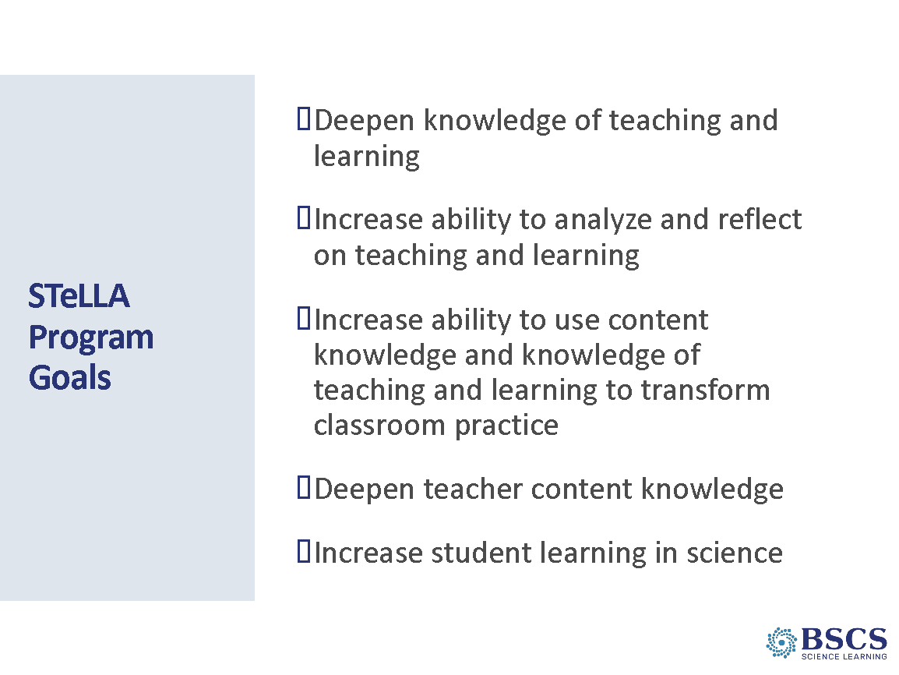 | - STeLLA Program Goals (5 min)  - Briefly share the Program Goals (p X)  - Forecast that we will continue to work toward these goals together throughout the winter institute and the remainder of the academic year.  - Ask participants to consider how these goals resonate with their expectations for the institute. Invite participants to record some ideas in their notebook.  PDL NOTE: Be sure to link what we will do during the winter institute to work toward these goals.
 |  | 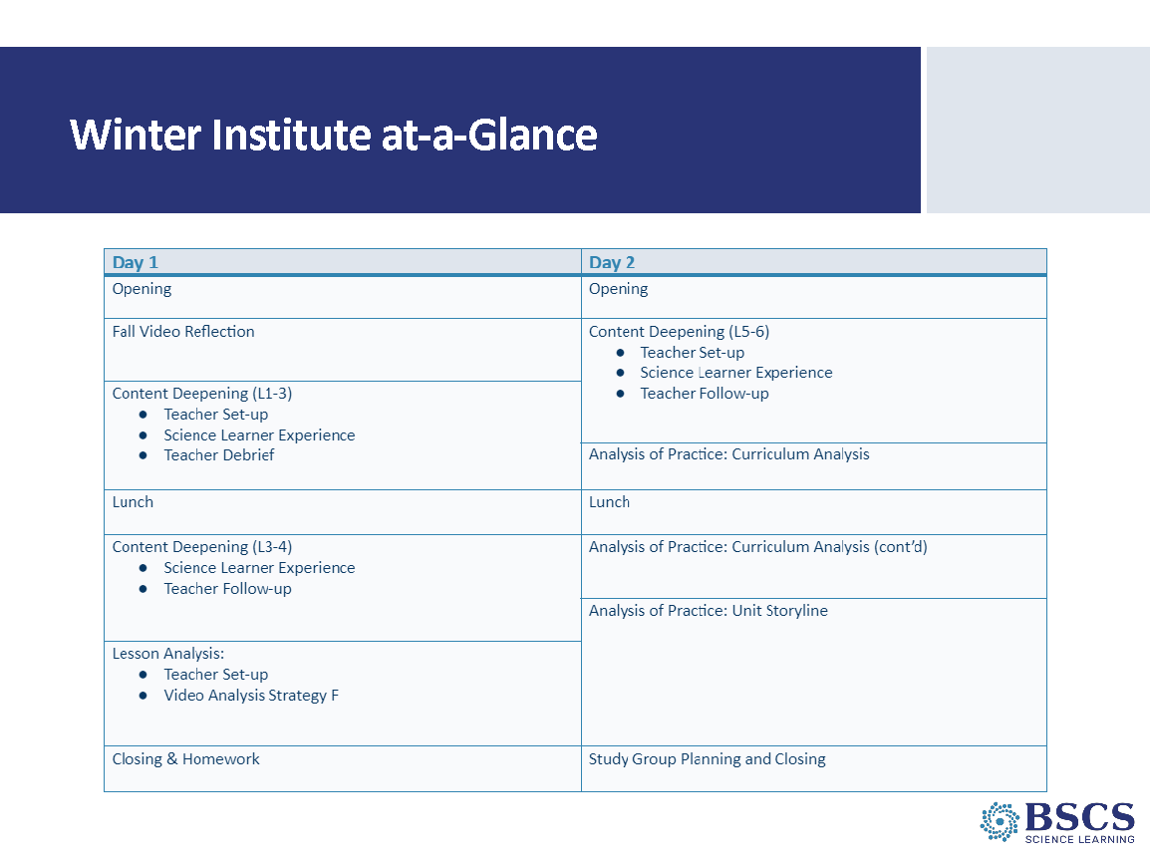 | - Winter Institute-at-a Glance (5 min)  - Provide an overview of the institute.  - Point to the Day 1 agenda chart.  - Remind participants how we will work.  - Parking lot  - Breaks/take care of your own needs  - COVID safety protocols
 |  | 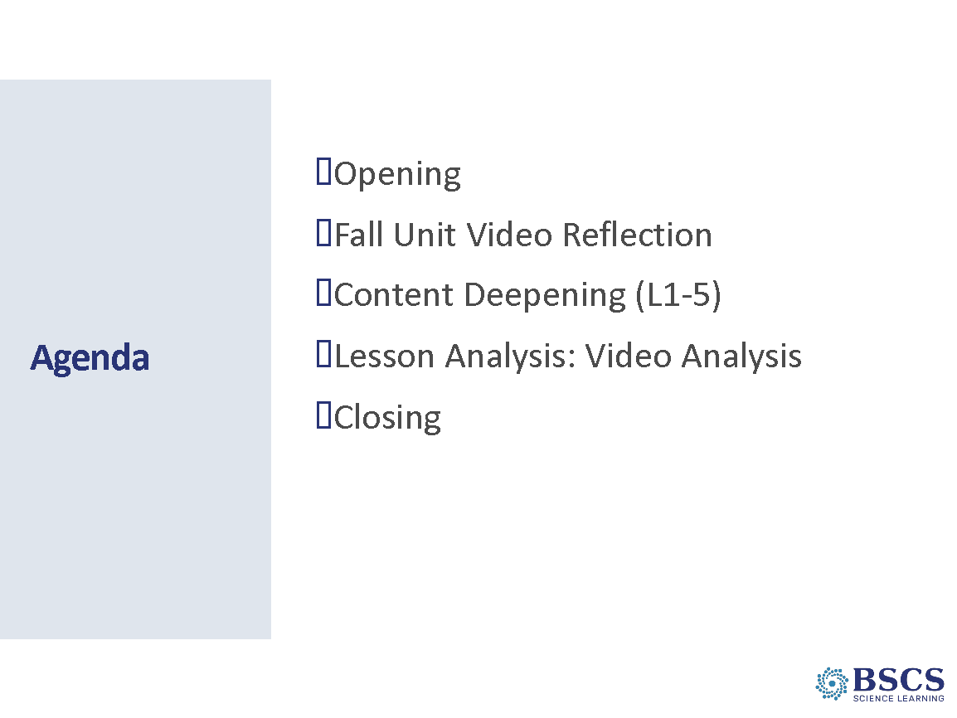 | - Agenda (0 min)  - Point to the Thursday agenda chart and link the agenda to the program goals.
 |  | 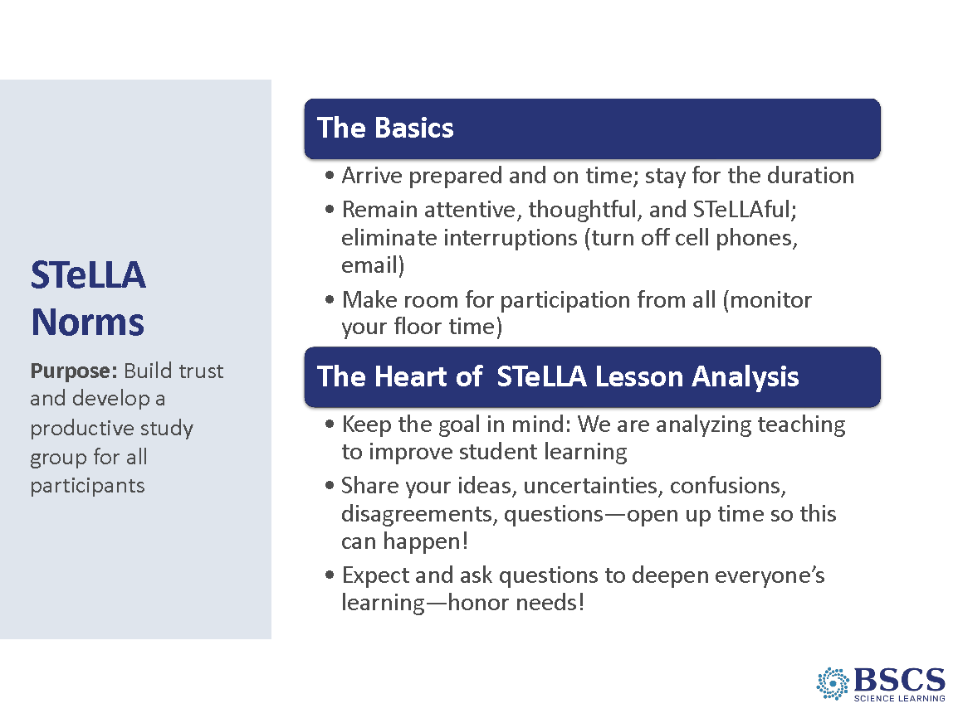 | - Norms (5 min)  - Remind participants of the importance of community and how the STeLLA norms support our work together. Note that we’ll continue to attend to the spirit of the norms in our work today.  - Prompt participants to select a norm that helped to push their thinking during the content deepening opportunities and study groups last semester. Have a few participants share out which norm they selected and why.
 |  | 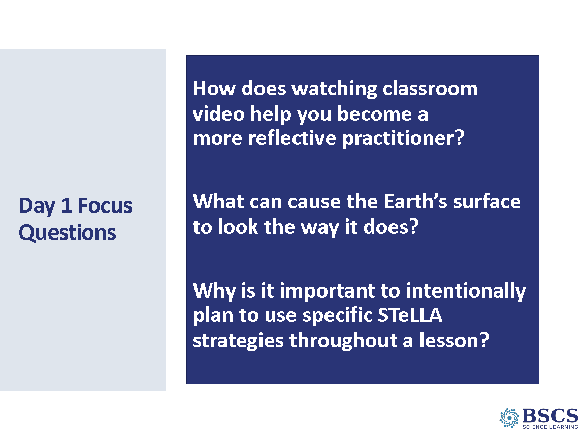 | - Focus Questions (5 min)  - Share the focus questions for the day.  - Note that the content focus question is the unit central question. We’ll dig into the Lessons 1-5 focus questions during our Content Deepening sessions.
8:15 – 8:50  35 min  Slides 7 - 8 | Purpose: Provide an opportunity for teachers to reflect on the fall unit as they prepare to teach the spring unit through the lens of the STeLLA Program Goals designed to increase ability to 1) analyze and reflect on teaching and learning and 2) use content knowledge and knowledge of teaching and learning to transform classroom practice.  Content: Teachers reflect on how participating in the STeLLA program so far has contributed to their professional growth and student learning/understanding.  What Participants Do: Have a discussion about how the STeLLA Program has contributed to their professional growth so far. Local PD Leaders will ask elicit and probe questions during the conversation to help make teacher’s thinking visible.  Resources  - Journal  - Fall Unit Video Reflections | 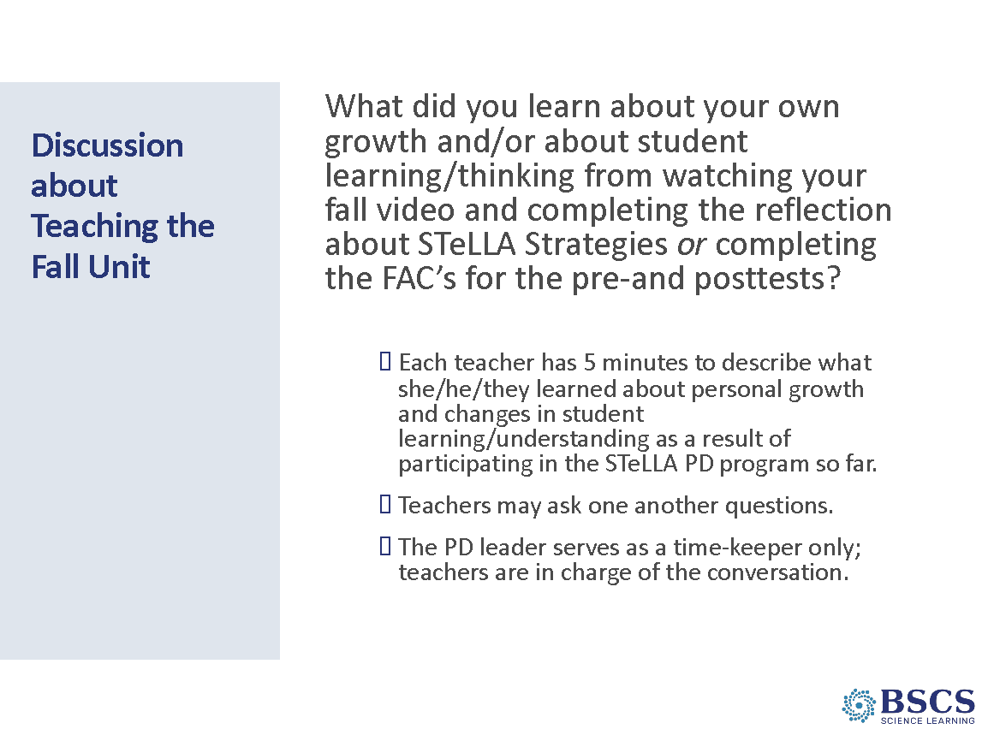 | - Fall Unit Video Reflection (25 min)  - Open the conversation with the prompt from the reflection sheet. What did you learn about your own growth and/or student learning/thinking from watching your fall video and completing the reflection about STeLLA Strategies or completing the FACs for the pre and posttests?  - Give a minute for teachers to organize their thoughts, as each teacher will only have a few minutes to share out.  - Each teacher has a few minutes to describe what they learned about personal growth and changes in student learning/understanding as a result of participating in the STeLLA PD Program so far. The conversation does not have to move around in a circle, teachers can listen and share to build if they have a connection.  PDL NOTE: If the group is small, have participants share in the whole group. If the group is large, divide participants into two groups (mix study group participants) to share. Based on the number of participants, adjust the time for each teacher to share out.  - Teachers may ask one another questions as the discussion moves along.  - PD Leader serves as the timekeeper only; teachers are in charge of this conversation.  Transition: We’ve learned a lot from analyzing and reflecting on our practice during our first unit, now let’s consider how our ideas about effective science teaching and learning have changed!
8:50 – 11:40  100 min  + 10 min break  Slides 9 - 26 | Purpose: Model effective STeLLA-based science teaching and learning through a common experience that is grounded in a 3D, phenomena/problem driven unit and designed for adult learners. The Teacher Set-up and Follow-up are reflective of STeLLA Strategy F (Activity Set-up, Activity, and Activity Follow-up) with an eye toward teachers as science learners. PDLs use the teacher follow-up to uncover teacher ideas about their experience and then leverage those ideas throughout analysis of practice.  Content: STeLLA model lessons/units attend to the characteristics of effective science teaching and learning (e.g., 3D phenomenon/problem-driven, student-centered, make student thinking visible and support sense making, coherent, and access/engage prior knowledge and develop metacognitive abilities).  The Earth’s surface has changed overtime. The Mississippi River Delta got bigger and moved around over thousands of years. Water from all over the United States runs off the land and eventually into the Mississippi River. Where the river meets the ocean, there is a delta. Maps from different time periods show that while a system can appear stable, it can actually change over time. The Mississippi River Delta has grown larger over thousands of years. The river has changed course several times, and at the end of the river, new land forms and other land disappears.  What participants do: Engage in the content deepening common experience as learners.  Resources  - Journal  - Science Notebook  - STeLLA Conceptual Framework Poster  - Content Deepening Resources  - STeLLA Strategies Booklet  - PD Binder  - Handouts  - Charts | 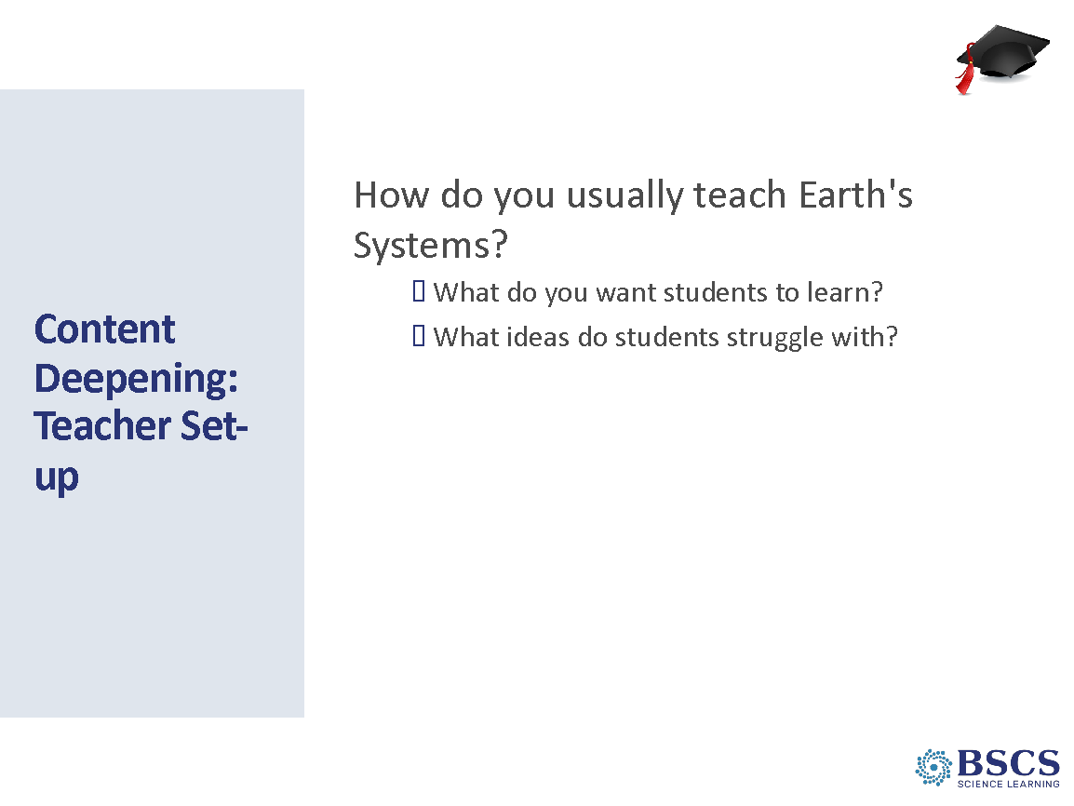 | - Content Deepening: Teacher Set Up (10 min)  PDL NOTE: The purpose of the Teacher Set-up is to set the stage for teacher learning through the content deepening experience. This part of the session should engage teachers as learners and elicit their prior knowledge and experience.  - Note the “teacher hat” in the upper right-hand corner of the slide and that we’ll begin with some time to think and write about how you usually teach Earth systems including “what” they teach and how they sequence the learning.  - Provide time for individual journaling based on the prompts.  - Whip around and gather ideas.  Transition: One of the things you shared was the science that you intend students to learn. Let’s consider our own understanding of the science.
 |  | 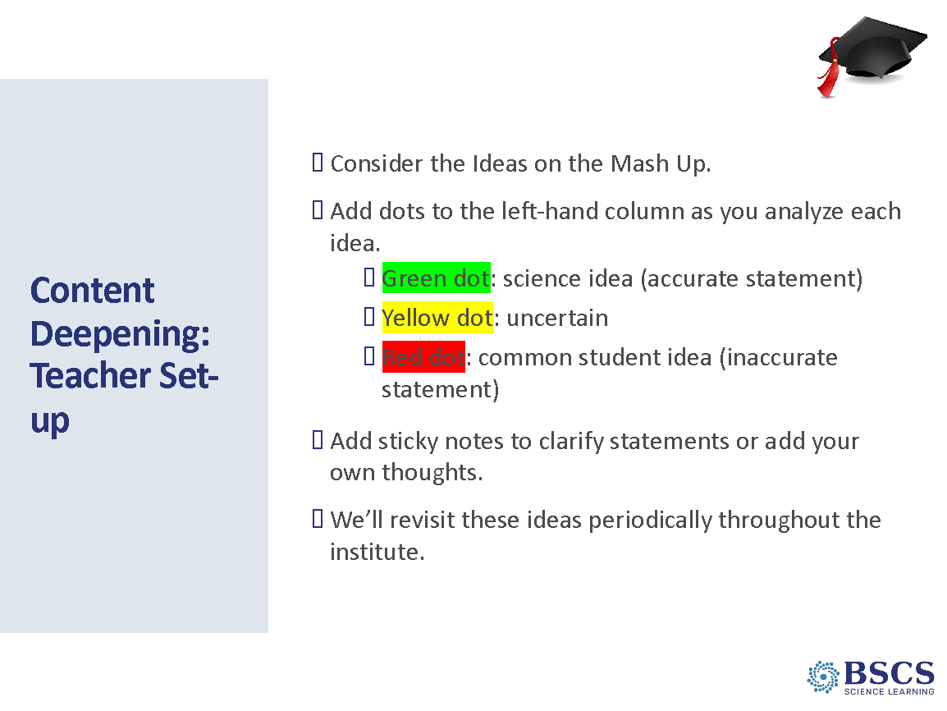 | - Content Deepening: Teacher Set Up (5 min)  - Invite teachers to turn to binder p. X and consider the ideas and science practices on the page. Note any ideas that are similar to those they shared in their previous conversation.  - Provide instructions and time for the task.  - Note that they’ll have periodic opportunities to revisit and discuss these ideas throughout the week.  Transition: Over the next hour or so, we’ll experience lesson 1 of a unit focused on the Earth’s surface. While this experience is grounded in lesson 1, we’ve designed the experience for you as adult learners—as science learners. You’ll see a ball cap in the upper right-hand corner of the slide to signify the new “science learner hat”.  To make the most of this time, set aside your teacher hat and thoughts/questions about how you’ll do this in your classroom with your students. Give yourself and our whole team the gift of immersing yourself in the experience as a science learner. When the inevitable wonderings about teaching come up, capture them on a sticky note or in your BSCS journal so you can re-focus as a learner on our shared experience.  Don’t worry, just as we are in the teacher set-up right now, there will be a teacher follow-up immediately after this science learner experience where we will address any teacher thoughts. Give yourself a moment to get organized. As you are doing that, consider what you’ll do to stay in the learner experience.  PDL NOTE: Be sure to refer to the common experience as learner hat and not student hat. We want participants to engage in the activities as adult science learners, not as one of their students.
 |  | 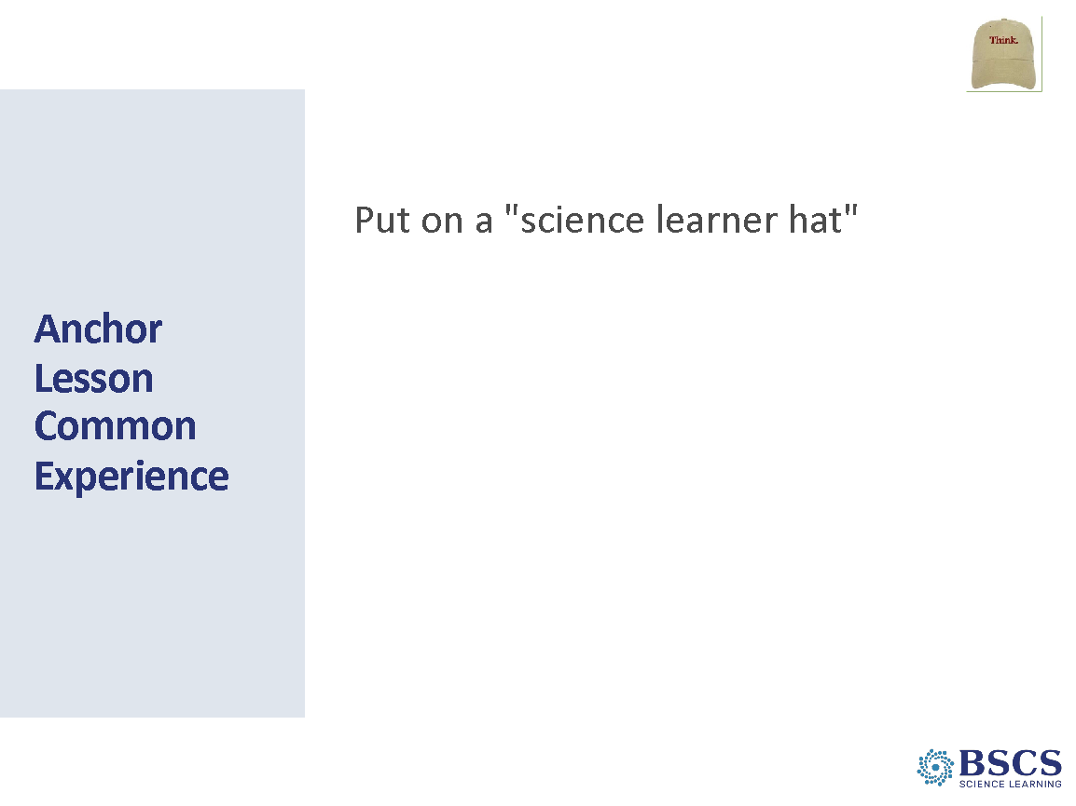 | - Anchor Lesson Common Experience (5 min)  PDL NOTE: Point teachers to their science learner journals. This part of the session should attend to teacher learning goals.  PDL NOTE: Engaging in the lesson as a learner may be a new experience for some participants. They may find it difficult to remain in learner hat. If you notice participants talking in teacher hat, gently encourage them to capture their teacher idea on a sticky note or in their BSCS journal to return to after the common learner experience. If a participant asks the whole group a teacher-focused question, you have a couple of options:  1) you can acknowledge that we will return to their great teacher question in the debrief and invite them to remain in learner hat for now, or  2) you can turn it into a learner hat question, or  Example:  Teacher question: How do I help kids ask questions for the DQB?  PDL follow-up: So, are you asking how we could work together to develop better questions for the DQB? Or Great question. Let’s think together about how we could ask better questions for the DQB.  3) you can acknowledge that it’s a conversation you would also have with students.  Example:  Teacher statement: Kids will really struggle with this.  PDL follow-up: We can all struggle with this. Let’s pause and talk about OUR struggles...just like we’d do with our kids in class. Let’s talk about it as learners.  Example:  Teacher statement: These content representations are really important. I think we need to pause and talk about the purpose of each in kids’ learning.  PDL follow-up: Exactly and this is something I’d want to do with kids in the classroom, so let’s us do this as learners, too. What role did content representation 1 play in your learning? In our learning?  The anchor experience will include explicit modeling and use of CSW and of elicit, probe, and challenge questions. Example of challenge questions include:  - How does your idea connect to X’s idea?  - What did you observe during the Anchor Lesson (NOT activity) that helped you ask that question?  - How does ____________ relate to your past experiences?  - What are you observing that prompts you to make that claim?
 |  | 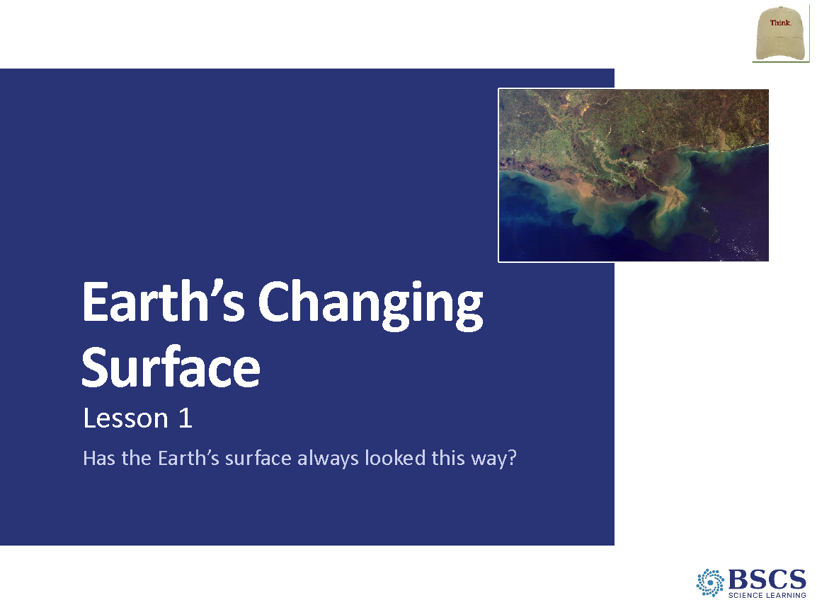 | - Earth’s Changing Surface (0 min)  - Share that today we are starting a new unit about Earth’s surface.
 |  | 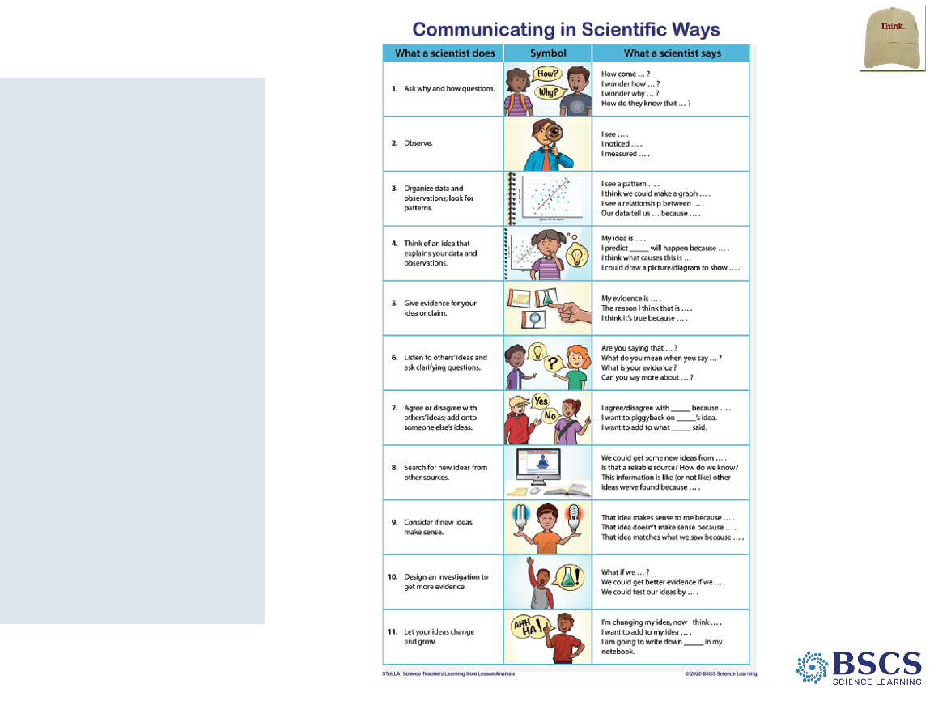 | - Communicating in Scientific Ways (0 min)  - Note that we will use the Communicating in Scientific Ways (CSW) poster as we communicate with one another throughout this unit.
 |  | 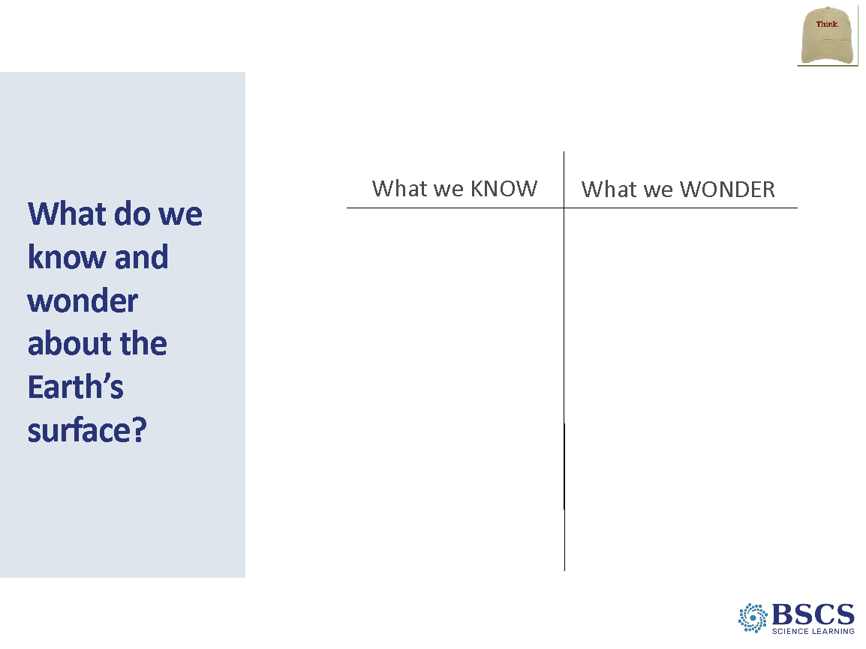 | - What do we know and wonder about the Earth’s Surface? (5 min)  - Share that we’ll begin by thinking about what we know and wonder about Earth’s surface. Pose the question, “What are your ideas about the Earth’s surface?”  - Provide a few minutes of individual think time, then invite several participants to share their ideas with the group.  - Chart ideas on the Know and Wonder chart.  PDL NOTE: The purpose of this chart is to make prior knowledge visible. It will not be used in subsequent lessons.
 |  | 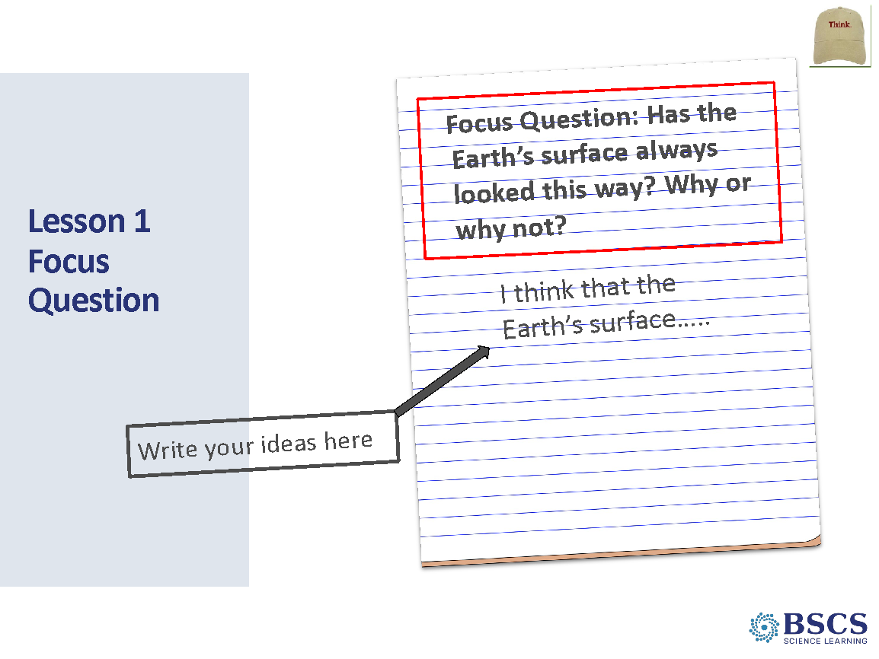 | - Focus Questions (5 min)  - Share that we have lots of great ideas and wonderings about the Earth’s surface. Share that we’ll begin investigating these ideas and wonderings by starting with the focus question, “Has the Earth’s surface always looked this way? Why or why not?  - Have participants leave a space approximately ¼ page at the top of the first page in their science notebook. Share that we will use this space later in the lesson.  PDL NOTE: This space in the notebook will be used to write the Unit Central Question after the creation of the Driving Question Board at the end of the Anchor lesson.  - Invite participants to write the focus question in their science notebooks and draw a box around it. Below the box, they should write the sentence starter: “I think that the Earth’s surface…”  - Have participants write their best ideas about the focus question and leave plenty of room after to add to and revise their thinking throughout the lesson.  - Invite several participants to share their ideas with the whole group. Record some of the participant ideas underneath the Lesson Focus Question on the Lesson 1 Focus Question chart.  PDL NOTE: for each Lesson Focus Question Chart in this unit, use the same color for initial ideas at the beginning of the lesson and the same color for revised ideas at the end of the lesson. For example, “blue” initial ideas and “green” revised ideas on each Lesson Focus Question chart.  PDL NOTE: Highlight the lesson focus question throughout the content deepening session.
 |  | 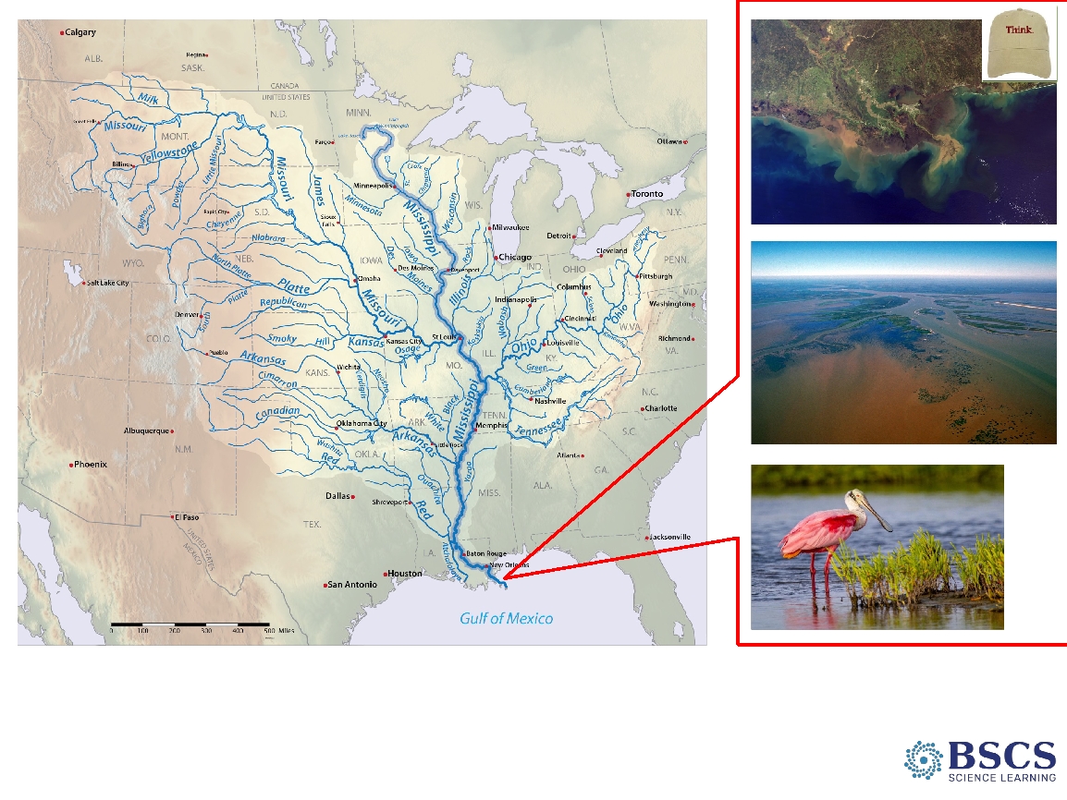 | - Mississippi Delta Map (8 min slides 16 -17)  PDL NOTE : Display the map in the PPT slides (same image as map in HO 1.2). Distribute HO 1.2, Mississippi River Delta to each participant.  - Share that as we think about our focus question: Has the Earth’s surface always looked this way? Why or why not? we will take a look at a specific area of the Earth’s surface. On the screen and in their handouts is a map of a unique place in North America. Ask, “What do you notice and wonder about the land and water features on this map? What do you notice and wonder about the images?” Prompt them to use the sentence stems in rows 1 and 2 of our CSW chart to make observations and ask questions about the Earth’s surface in this area.”  PDL NOTE: Mark rows 1 and 2 on the CSW chart with a sticky note (arrow).  PDL NOTE: Ask probe questions as learners share their noticings and wonderings. Highlight comments about elevation for L3.
 |  | 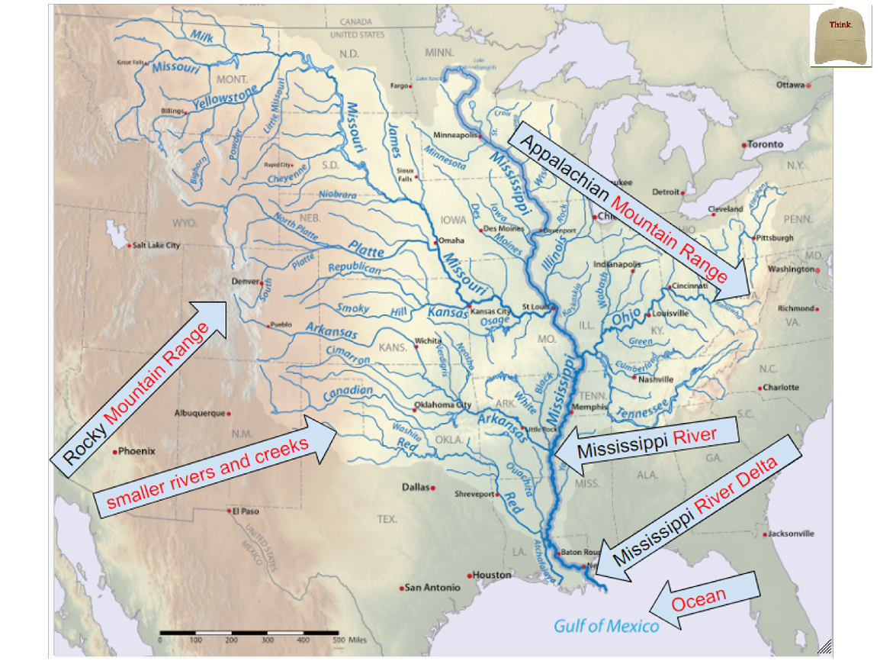 | - Mississippi Delta Map with Labels (0 min)  - Explain that “To help us communicate what we observe on the Earth’s surface, here are some land and water features that we can refer to as we explore the Earth’s surface in this area.”  - Once learners have had time to look at the map and images, turn their attention to the text to learn more. You might say, “Now we are going to read about the Mississippi River Delta to learn more about the Earth’s surface in this area. Prompt them that as they read, they will underline or circle any words they think are important or they want to know more about. Remind them to also think about our focus question and these land and water features on the map: Has the Earth’s surface always looked this way? Why or Why not?”  - Once the reading is done, ask learners to share a few ideas or words they highlighted. Ask, “What are some things you noticed from the reading?”  PDL NOTE: Ask probe questions such as why did you highlight that part of the reading? Why did you think that was important? Also, model CSW by asking others to add ideas as learners share.  - Explain that we know more about the land and water in the Mississippi River Delta, so we will return to our focus question. When looking at this map and images, what do you think? Has the Earth’s surface always looked this way? Why or why not?”  Transition: You all had some great noticing’s from the reading. I was curious about the Mississippi River Delta and why it looks this way too. So, we are going to look into that a little more closely and remember our focus question for today is, Has the Earth’s surface always looked this way? Why or why not?
 |  | 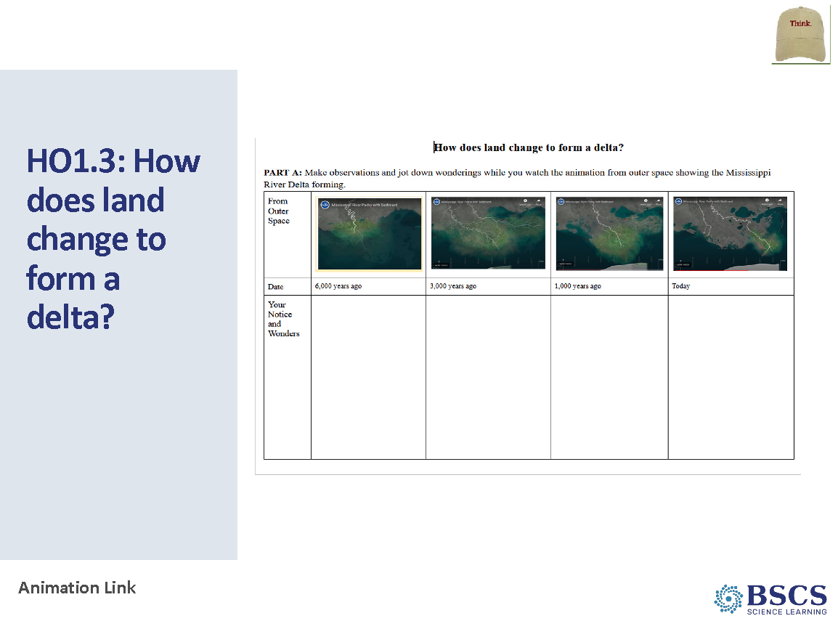 | - HO1.3: How does land change to form a delta? Part A (15 min slides 18 -19)  PDL NOTE: Prepare to play the animation at: http://www.watchthedeltagrow.com/mississippi-river-paths. Make sure all learners can see it. Before playing the animation, give learners an overview of what they are looking at. Remind learners that a bird’s or satellite’s perspective is the view looking back down at the land below. Importantly, a timeline will appear at the bottom of the animation. Orient the learners to the time scale by using phrases like “a really, really long time ago”.  Stay close to the computer so that you can stop the animation at 00:33 seconds (learners will watch the end of the animation during Lesson 4). Also, during the second viewing, pause the animation a few times for learners to jot down their noticings, again NOT showing the learners the animation past 00:33 seconds.  - Play the animation one time through for learners. They don’t need to write any observations the first time - learners should just watch. Pause after this and ask learners the following:  “What are we looking at?”  “What is the dark white line on the animation?”  PDL NOTE: Pass out HO1.3 to each learner. They will only complete PART A now. They should wait to complete PART B after watching the animation a couple of times.  - Orient learners to the handout. Tell learners that PART A is where they will record things they notice or have questions about as they watch the animation. Tell learners you will pause the animation to give them time to write, and also that you will play it a couple of times.  PDL NOTE: Probe learners about what the white line on the animation is called and what the other white lines in the animation are? You could also probe about what the timeline is showing at the bottom, what they see in the animation and where and what changes they noticed over time.  - Play the animation a second time through. This time pause the animation at about 5,000 years ago (around 00:06 seconds), 3,000 years ago (around 00:15 seconds), 1,000 years ago (around 00:22 seconds), and near present day (stopping at 00:33 seconds). Each time you pause it, give learners about 1 minutes to jot down what they notice or wonder.  - Once they complete the animation the second time through, ask learners to share a few of their initial observations. Have the animation available in case learners need to point to something.
 |  | 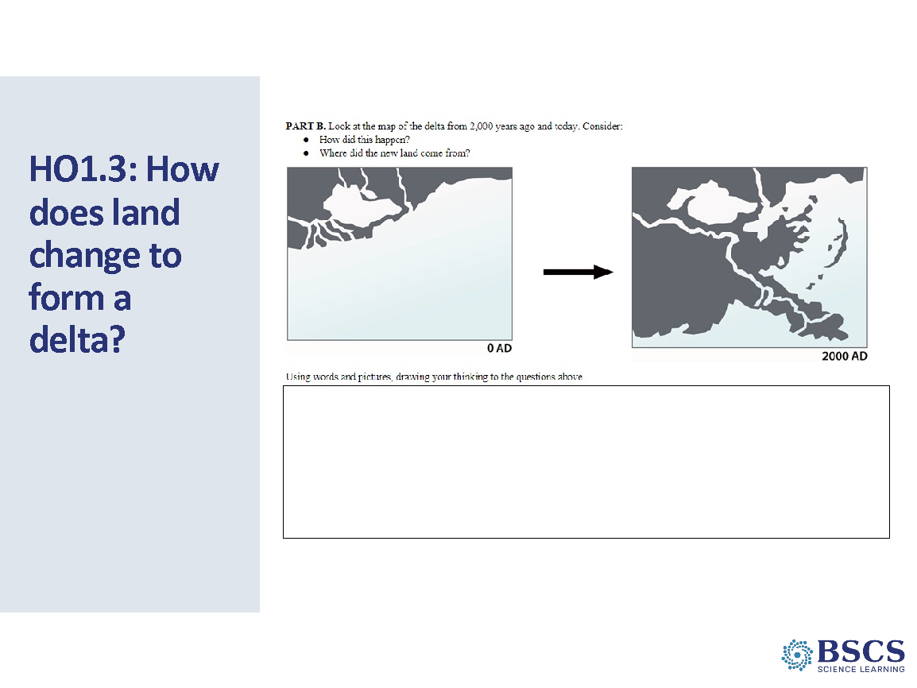 | - HO1.3: How does land change to form a delta? Part B (5 min)  - Share that we will now I look at PART B on the handout. It shows a map of what the coastline looked like about 2,000 years ago and what it looks like today. Prompt learners to consider the two questions: How did this happen? Where did the land come from?”  - Tell learners to draw or write words in the empty box to describe their thinking to those two questions. They can also draw on the maps too. Encourage learners to include questions they have as well.
 |  | 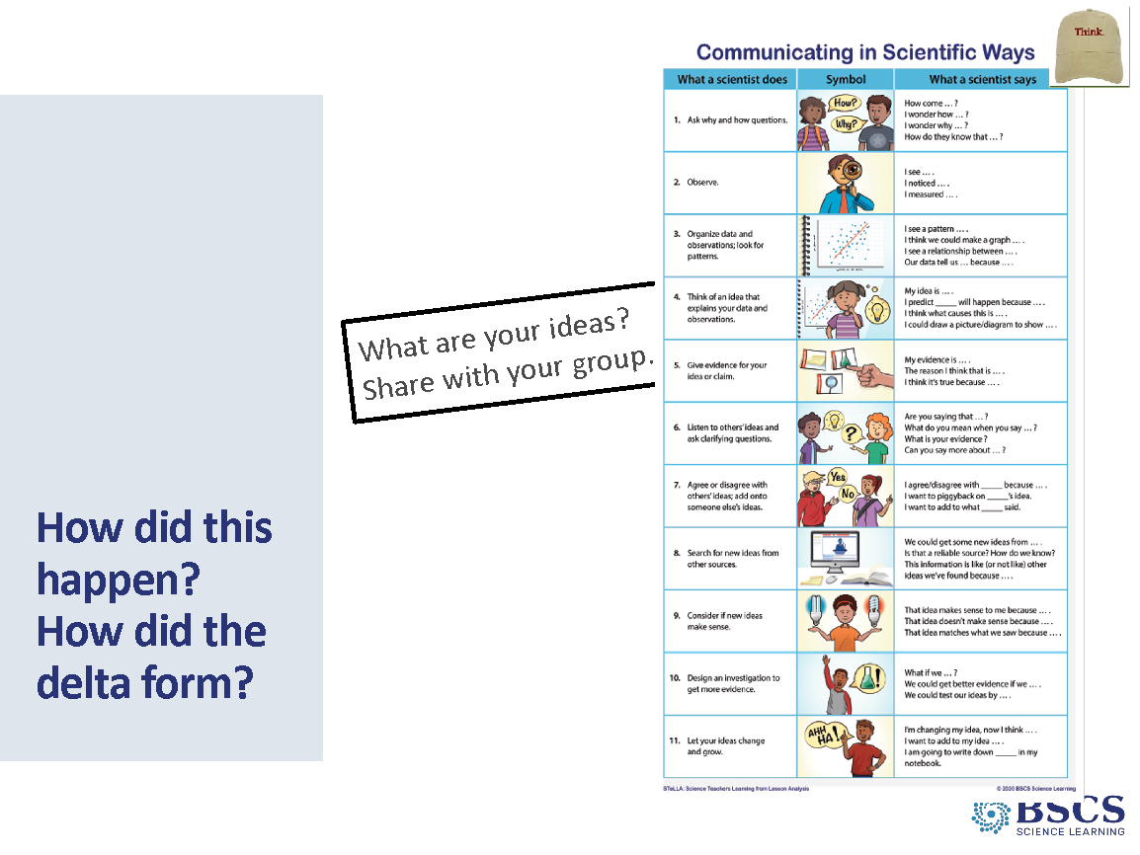 | - How did this happen? How did the delta form? (15 min slides 20 - 21)  - Group learners in teams of 3 or 4 for the next task.  - Say, “So we watched an animation of what happened to the Mississippi River Delta over that time and found out that the Earth’s surface has NOT always looked this way. But now we are wondering, how did this happen? What are your ideas about how it formed? Where did the land come from? Work with your team to come up with a few different ideas to share with the whole group.”  PDL NOTE: Give groups about 3 minutes to talk. Then ask them to share 1 idea from their groups. Try to get a variety of responses that contradict each other or that are different ideas for why. Chart these ideas as they are shared with the class. Also look for opportunities to draw out questions that they have. If they have questions, ask them to record each one on a separate sticky note. Try to keep the controversy going so learners don’t just accept any one idea. It is good scientific practice to be skeptical—to look for evidence for claims made even by scientists.  PDL NOTE: Probe learners thinking and ask them to think about the type of evidence they would need to support their ideas about how the land formed.  - Once several ideas have been shared, ask the groups to talk again and record some questions on sticky notes that they are wondering about. Give learners fine tipped markers to record each question on a separate sticky note. Tell them to write big enough so everyone can read their questions. Encourage learners to collaborate on their questions by saying something like, “Discuss the questions and make sure the team agrees on the wording. Use the Communicating in Scientific Ways poster to help you with this. Write each question on a separate sticky note and make sure everyone’s questions are on a sticky note. Make sure you have enough questions so that each person on your team has at least one question to ask.”
 |  | 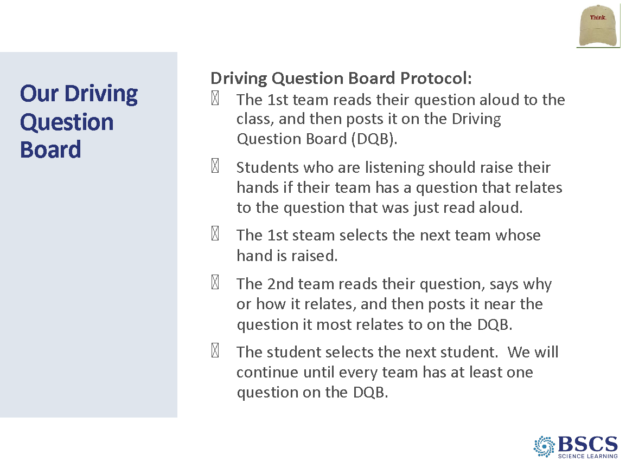 | - Our Driving Question Board (0 min)  PDL NOTE: To build the Driving Question Board (DQB) gather learners in a circle around the place you will post questions. The DQB should remain up during all of the lessons. The process will involve: Ask for a volunteer to come to the board, face the class, and read their question aloud to the class. Then have them post the question on the board. Ask if anyone has a similar question and have them come to the front and do the same, posting their question near the first one (or on top of the first one if it is identical). Once similar questions have been shared, move to an unrelated question. Continue until all learners have shared a question and all questions are posted.  - “Let’s build a Driving Question Board. These questions will drive our learning for several lessons. We may not answer all of them, but we will answer some. Gather your sticky notes and look at the questions you have written. Each team will share a question. If one is similar to your team’s question, put your sticky note next to the similar one.  - Can someone share with the class one question we have?”  PDL NOTE: Sample questions that learners may ask are given below. The questions shown on the right are similar to the focus questions for the remaining lessons. It would be great if these questions came from learners as you conclude this lesson. Take the opportunity to guide them toward these questions but do not negate other questions that they may ask. If a question does not come from learners, you can steer them this way: “It seems we have a lot of questions about how the land changes or forms over time. Someone said that water might have something to do with carrying dirt (soil, rock). Can someone put that question on a sticky note? And someone was curious about how a delta forms at the end of a river. Let’s get that up there as well.”  Sample Questions:  Where does the new land come from?  What causes a delta to form at the end of a river?  How long does it take a delta to form?  How long do deltas last?  Is it rock and dirt from the river?  How much rock and dirt does it take to make a delta?  - Probe learner ideas to know what they are thinking when they give examples or use words that are unfamiliar. If there is a question from the class about whether a student idea is “true” or not, ask the student to pose it as a question and write it on a sticky note.  - It will be very helpful for you to have a good idea of the focus questions for the next several lessons. You can lead a discussion that helps learners articulate some of their wonderings into questions similar to the next focus questions. Do not expect all focus questions to be on the DQB but it would be helpful if the focus question for the next lesson appears. Learners will return to the DQB several times during the lesson set and have the opportunity to add additional questions when they learn more.  - Share that these are great questions about the Earth’s surface and how it can change. Invite learners to label our driving question board with our Unit Central Question, What can cause the Earth’s surface to look the way it does?”  - Add this question as the title of the Driving Question Board and have participants add it to the top of their notebook page.
 |  | 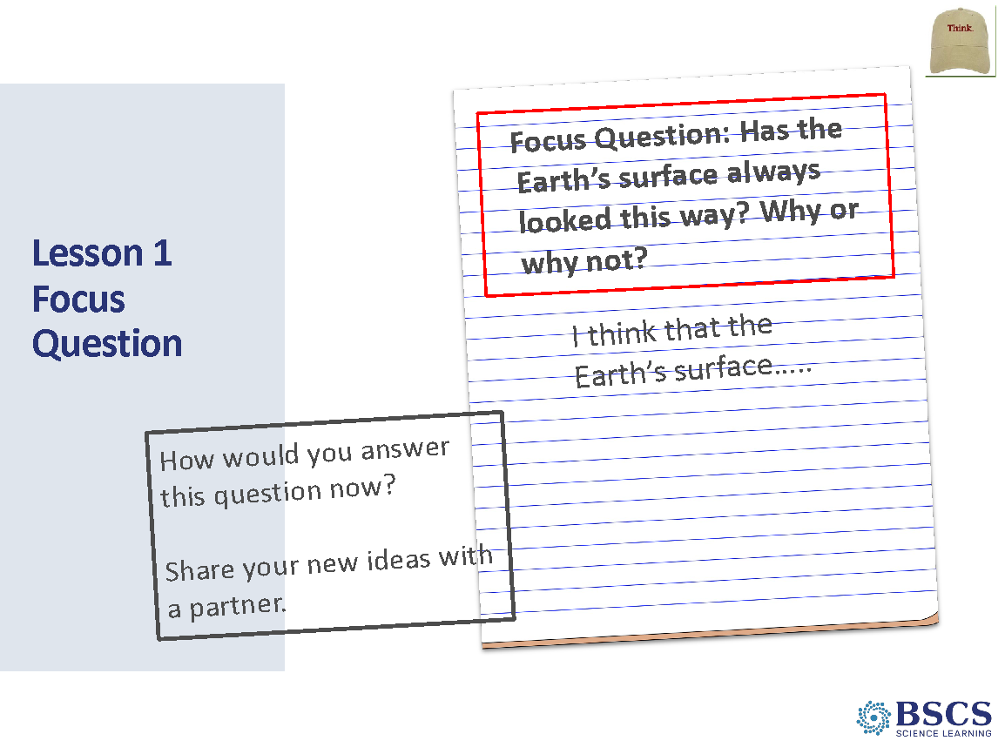 | - Focus Questions (6 min slides 22 - 23)  - Prompt learners by saying something like, “Alright, today’s lesson focused on the question: Has the Earth’s surface always looked this way? Why or why not? How would you answer this question now? Before I ask a few of you to share out, turn to a shoulder partner and share your answer using evidence from today’s lesson.”  - After learners have a chance to share with their partner, ask a few learners to share what they said or what they heard.  PDL NOTE: Invite learners to use CSW by asking them to paraphrase what they heard their partner say.  - As participants share, return to the Lesson 1 Focus Question chart and add revisions in a different color.  PDL NOTE: for each Lesson Focus Question chart in this unit, use the same color for initial ideas at the beginning of the lesson and the same color for their revised ideas at the end of the lesson. For example, “blue” initial ideas and “green” revised ideas on each Lesson Focus Question chart.  - Summarize what learners shared by saying something like, “Today we learned that maps from different time periods can show changes in land and water features. We saw that the Mississippi river has changed course several times, and when that happens, new land forms and other land disappears. We have some initial ideas about how land forms and changes and have lots of questions on our DQB.
 |  | 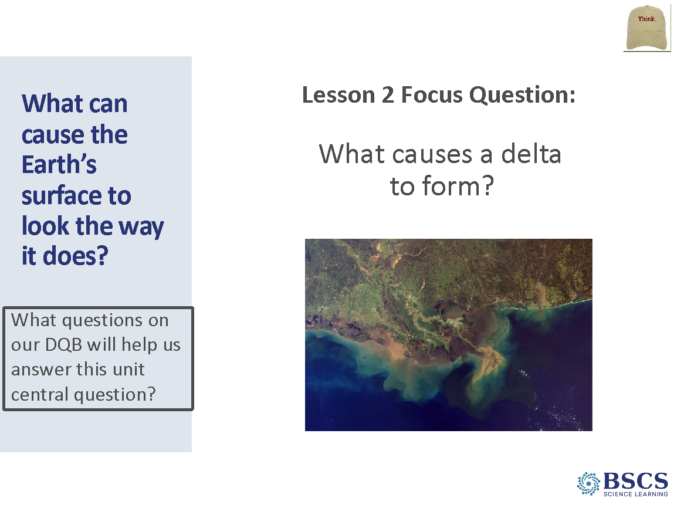 | - What can cause the Earth’s surface to look the way it does? (0 min)  PDL NOTE: Engage the learners in a discussion of any trends they see in the group of questions. Perhaps your class board has several questions related to the time it takes to change the land or where the land comes from. Communicate with learners that they will try to answer most of their questions in the next several lessons. Tell them that we will revisit the DQB several times, but they are free to add questions at any time. Also, encourage them to watch for questions they may have answered through the activities that they do. When they answer a question, we can place a big check mark by the question.  - “We have a lot of questions about our unit question, What can cause the Earth’s surface to look the way it does? Our questions seem like they are mostly about where the soil came from, how it makes land, and how long it takes.”  PDL NOTE: Customize this summary statement to capture the themes from the class DQB.  PDL NOTE: While the idea that “wind and water can change the shape of the land” is a K-2 disciplinary core idea (ESS2.A), this unit layers on the 3-5 crosscutting concept of “some systems appear stable, but over long periods of time will eventually change” (Stability and Change) and intersects with the 3-5 disciplinary core idea (ESS2.B) “maps can help locate different land and water features of Earth.”
 |  | 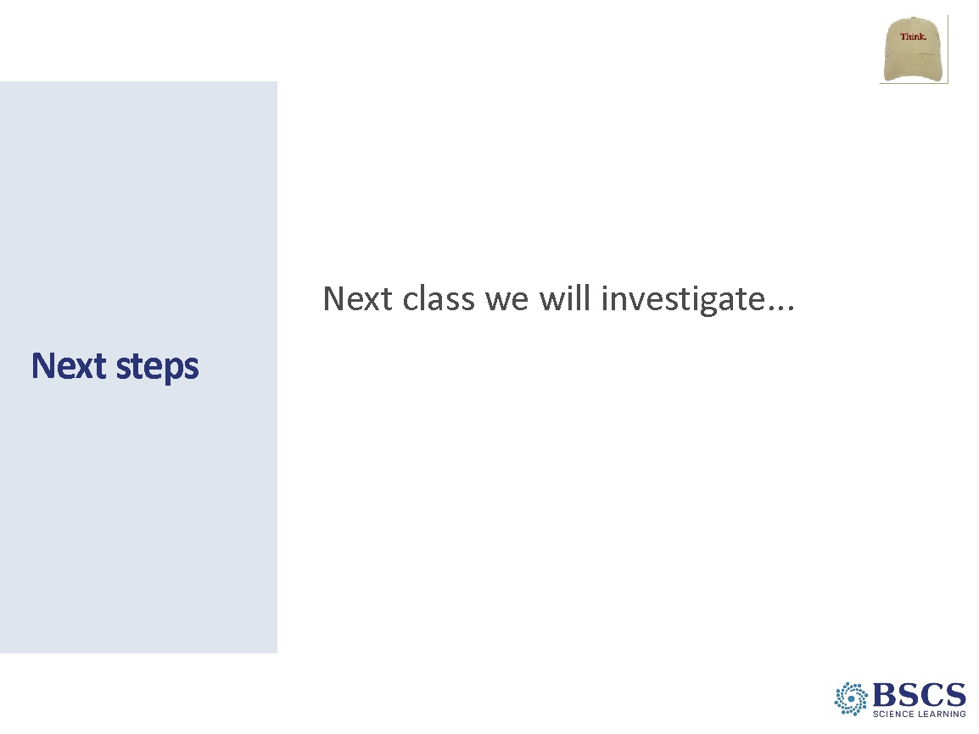 | - Next Steps (1 min)  - Share that to help us explore our unit question, What can cause the Earth’s surface to look the way it does? tomorrow we will investigate one of the questions on the board, What causes a delta to form at the end of a river?  PDL NOTE: The focus question for the next lesson is: What causes a delta to form? Look at the DQB and call attention to this question if it is on the board. Tell learners that in the next lesson, this question of theirs will be our focus question. If it does not appear, there is a suggestion below that will help you navigate to the next focus question.  - If the next lesson’s focus question does not appear on the DQB, say something like, “You mentioned that you are wondering where this land came from at the end of the river. This is what we will try to figure out in the next lesson.”  Transition: This concludes our work with Lesson 1 as learners. Let’s debrief our experience together as educators.
 |  | 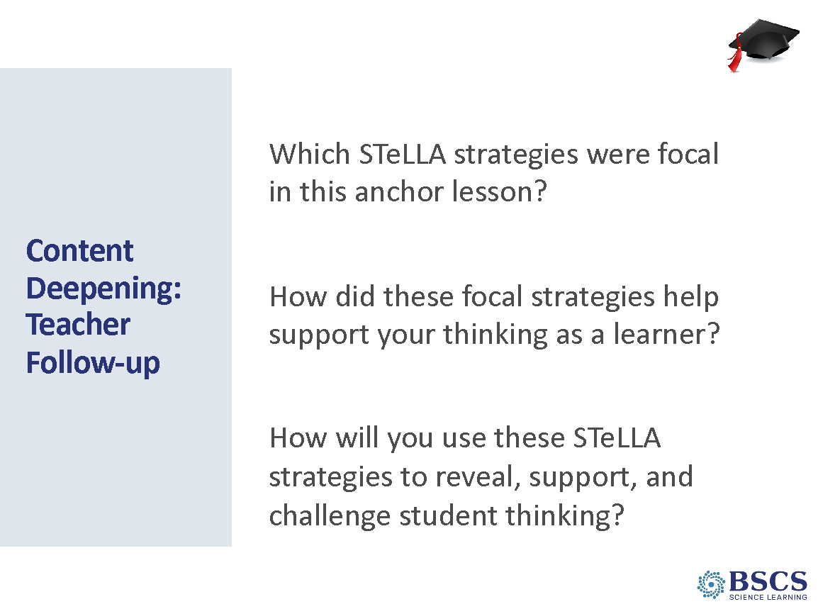 | - Teacher Follow-up (20 min)  PDL NOTE: This slide is animated. Only question 1 should be revealed initially, then advance the slide to show the other questions as prompted below. Use the discussion around the initial prompt as an opportunity to highlight what we mean by focal strategies as opposed to supporting strategies.  - Provide a few moments of individual think time. Distribute the Lesson 1 placemat and explain that participants will identify the focal strategies on the placemat with notes to justify their thinking. Explain that they should refer to the STeLLA Strategy Booklets as necessary.  - Invite participants to discuss their identified strategies with an elbow partner.  - Invite elbow partner teams to share their identified strategies with the whole group.  - Reveal question 2 and invite participants to share their thoughts with the whole group.  - Advance the slide to share question 3 and invite the whole group to share their ideas.
 |  | 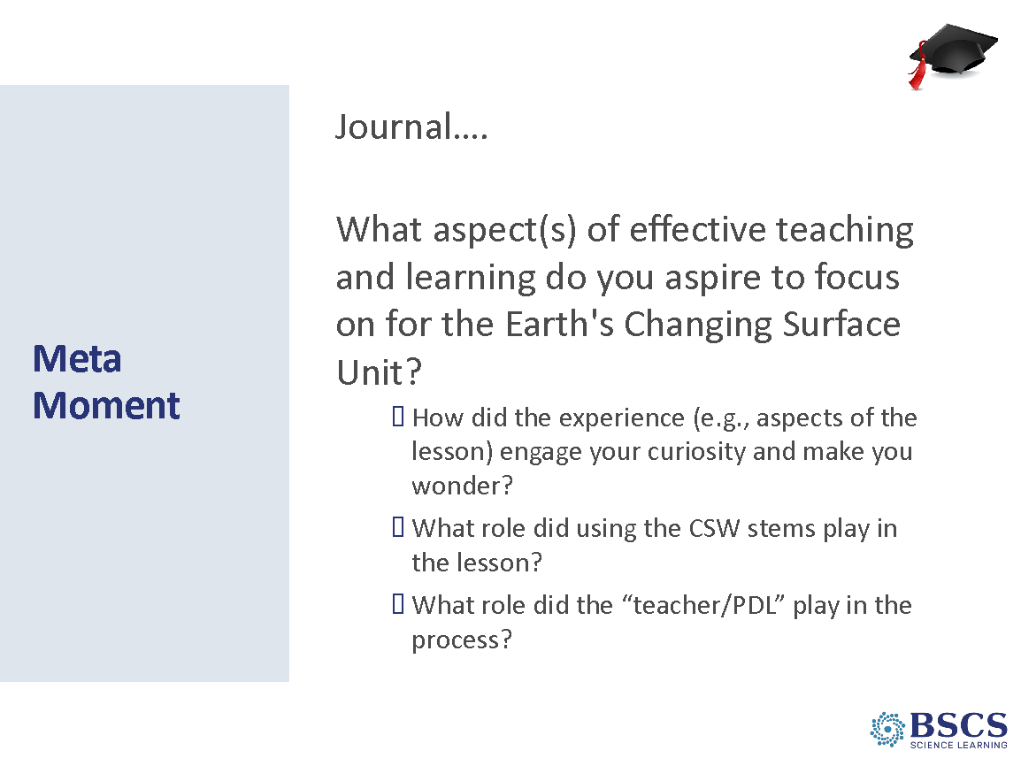 | - Meta Moment (5 min)  - Invite participants to respond to the prompts in their journals.  Transition: As we engage as science learners in Lessons 2-4, keep your aspirations in mind; we’ll reflect on them again as educators at the close of our Lesson 4 common experience.
10:40 – 11:40  60 min  Slides 27 - 35 | Purpose: The purpose of this session is to model effective STeLLA-based science teaching and learning through a common experience that is grounded in a 3D, phenomena/problem driven unit and designed for adult learners.  Content: STeLLA model lessons/units attend to the characteristics of effective science teaching and learning (e.g., 3D, phenomenon/problem-driven, student-centered, make student thinking visible and support sense-making, coherent, and access/engage prior knowledge and develop metacognitive abilities).  The content deepening experience will include explicit modeling and use of elicit, probe, and challenge questions as well as focal STeLLA strategies for each lesson:  - L2: STL 6/ SCSL D  Science content:  (L2) Moving water in rivers and streams shapes and reshapes Earth’s surface by moving rocks and soil from higher elevations and depositing them at lower elevations. Erosion is the process by which weathered earth materials, such as rock fragments, sand, and soil, are removed from one place on Earth’s surface and transported to another where they are deposited. Erosion helps make the tall places lower, while deposition helps build up the lower places. Deltas form at the end of rivers when this new land builds up over time.  Materials | 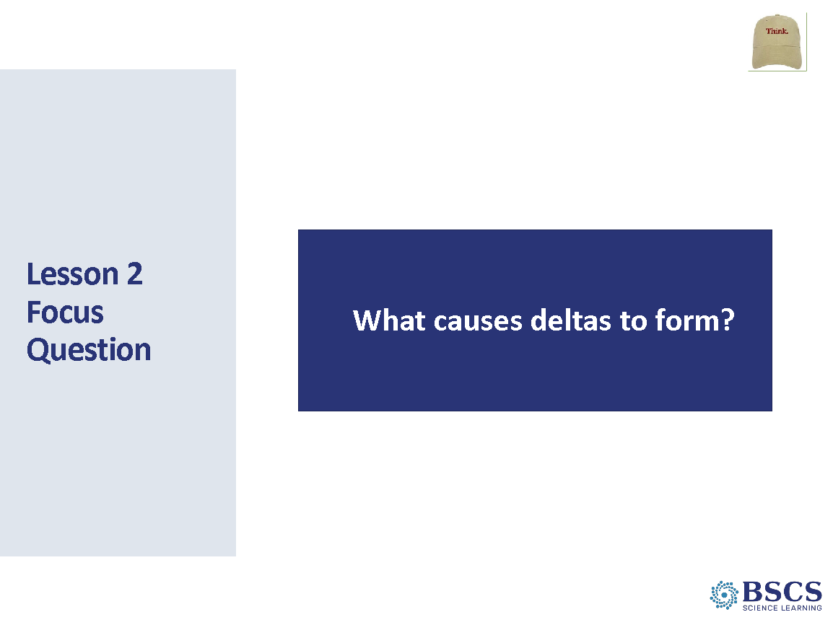 | - Earth’s Changing Surface – Lesson 2 (0 min)  - Mark that this is the beginning of lesson 2 and that we will work together in learner hat to engage in lessons 2-4.
 |  | 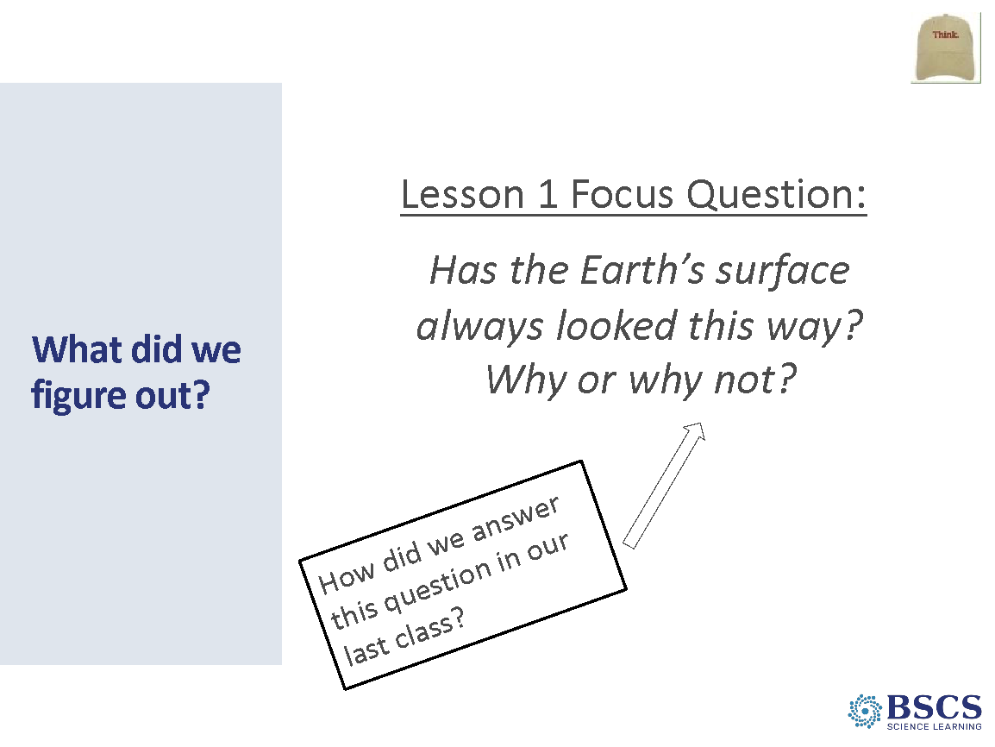 | - What did we figure out? (5 min)  - Link to Lesson 1 focus question. Ask:  - What did we figure out?  - How did we figure it out?  - What evidence did we use to answer this question?  PDL NOTE: Do not spend too much time on this slide as most of the ideas should have emerged during the teacher set up. Prioritize time for the second (how) and the third question (evidence).
 |  | 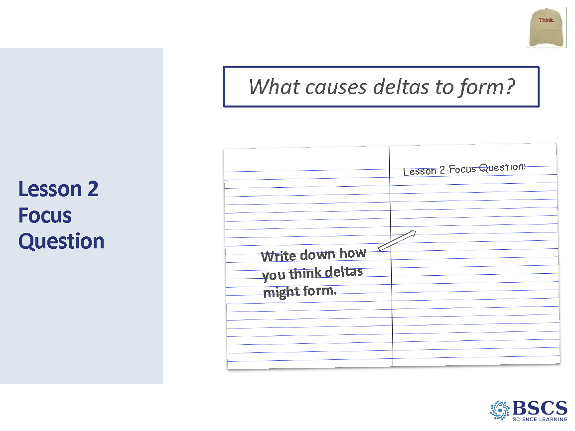 | - Lesson 2 Focus Question (5 min)  - Introduce Lesson 2 Focus Question  - Have participants write the question in their science notebooks and record their current thinking.  - Invite a couple of participants to share out. Record initial ideas underneath the Focus Question box on the Lesson 2 Focus Question chart. Use the same color for initial ideas that was used on the Lesson 1 Focus Question chart.  PDL NOTE: It might also be useful to summarize the big categories of initial ideas and summarize some of the wonderings that emerged from probe questions.
 |  | 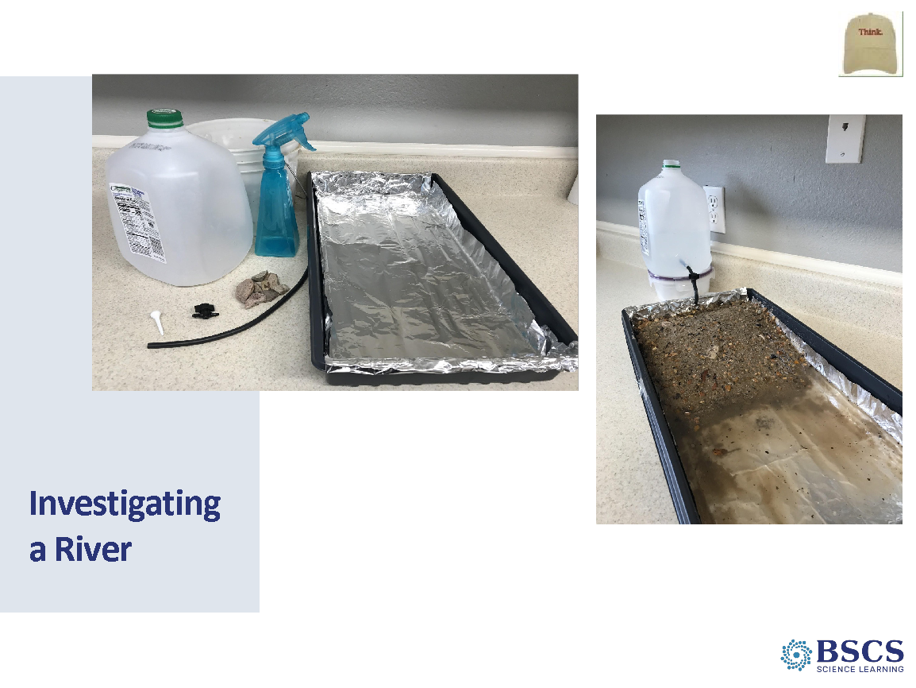 | - Investigating a River (5 min)  PDL NOTE: Lesson 2 in the classroom curriculum has a stream table set up for each group. For PD purposes, use one stream table set up as a demonstration for Lesson 2. (The other materials in the PD kit should be used to set up five stream tables for lesson 3 and one demo stream table for lesson 4.)  - Introduce the stream model and engage participants in using content representations and models by discussing what each feature represents in the real world.  - Possible features to discuss:  - Rocks and soil = land  - Water coming out of the hole in the jug = river  - Water at the end of stream table = lake; ocean  - Ask how the stream table is different from the real world. (it is smaller; the real world can have grass, trees, buildings, etc...)  PDL NOTE: Make connections to the reading from Lesson 1 (e.g., it takes 3 months for a drop of water to travel down the Mississippi River.)
 |  | 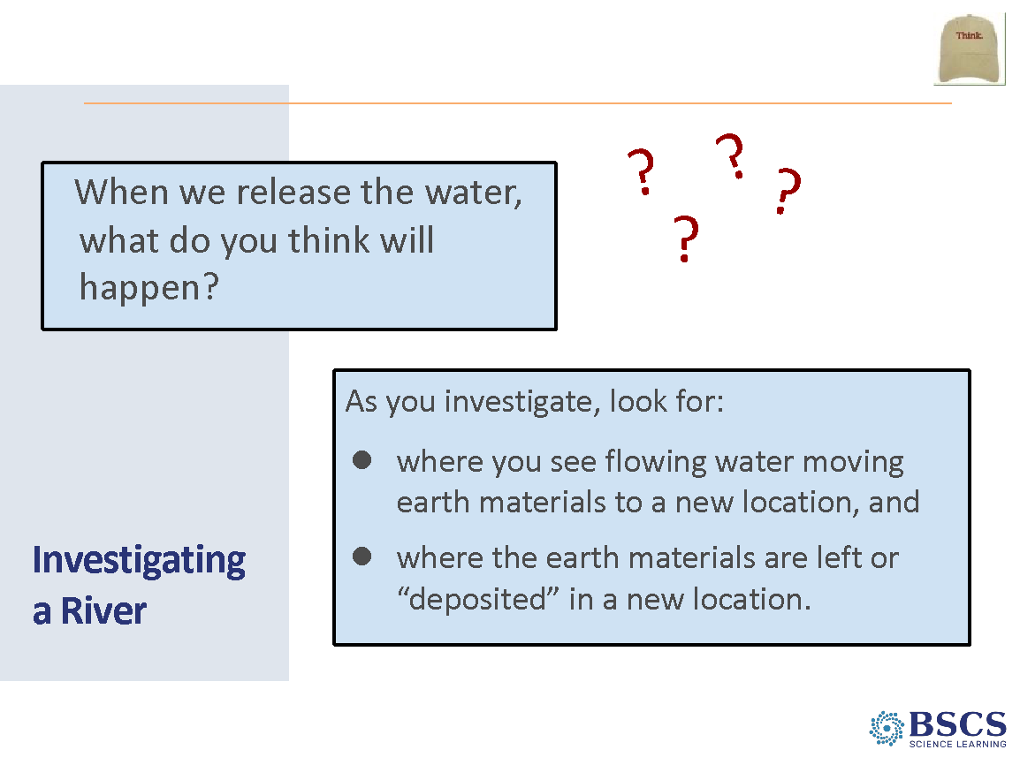 | - Investigating a River (5 min)  - Invite participants to make predictions about what might happen when water is released at the top of the table.  - Chart initial ideas on poster paper to refer back to during the activity follow up.  - PDL NOTE: Cut charting initial ideas for time if needed. Participants will write their predictions during the next slide.
 |  | 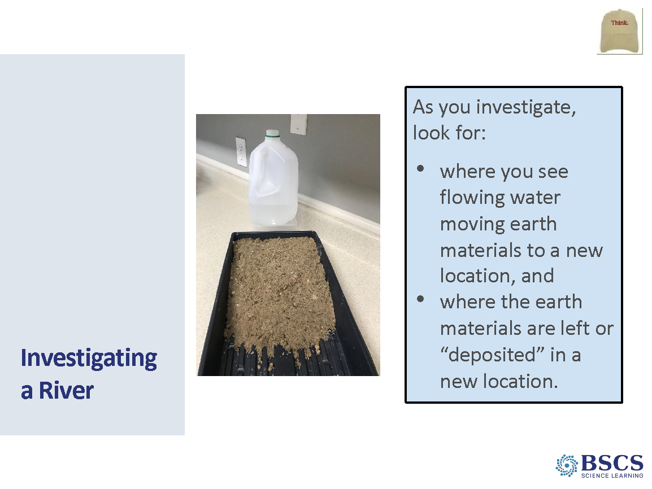 | - Investigating a River (10 min)  PDL NOTE: You may need to model how to release the top on the jug to control the flow of water.  - Highlight that there are two ways they will focus their observations. Review slide and keep slide up during activity for participants to refer to.  - Review Part 1 (initial observations and predict) and Part 2 (run water and make observations) of the Stream Model Observations HO2.1. Emphasize that they should focus on a small area at the top of the slope and watch what happens to the earth materials in that spot as well as the area where the land meets the water.  PDL NOTE: Sprinkling a pinch of colored sand at the top of the stream table will help with these observations.  - They should pay attention to when and where earth materials (sand, rocks, pebbles) are moving from one place to another and when and where they stop moving.  - Run one stream table at the front of the room. Give participants time to record their observations. As participants share their observations, ask elicit, probe and challenge questions and encourage them to use the CSW stems.  PDL NOTE: Make connections to the Energy Transfer Unit  - The water transferred some of its position energy to the sediment and rocks through collisions, when there was enough force, it was able to move things.  - Why did things stop moving? Reduction in energy. Why did some stop before reaching the bottom? The mass of the object that is being moved.  - The water slows down because the position energy was transformed to motion energy and the water/particles slow down due to collisions with the substrate (soil) and water molecules pooling at the base/lower position (ocean).  PDL NOTE: If learners need additional support around the energy concepts you may want to invite them to reread the ET content background document specifically to think more about the relationship between mass and energy.  PDL NOTE: Make a video of one of the stream tables. You will use this recording in the next lesson. (You can also make a recording prior to this session to use during lesson 3.)
 |  | 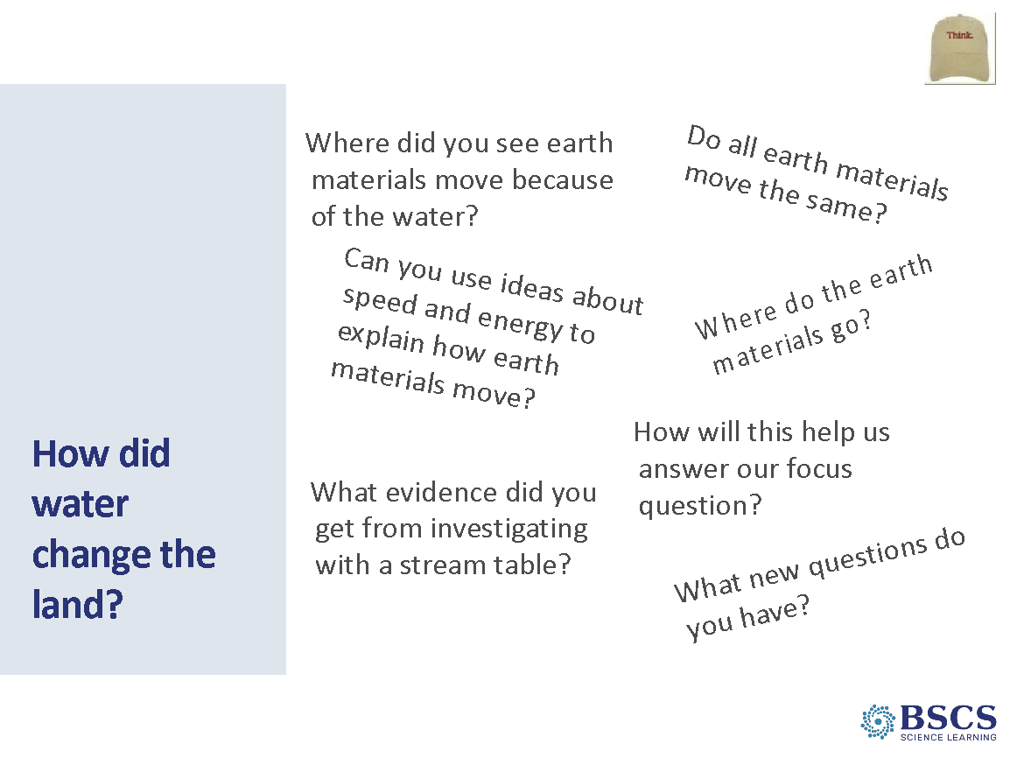 | - How did water change the land? (10 min)  - Invite participants to set their stream tables to the side and give time for participants to complete Part 3 of HO2.1  - Invite participants to share some of their ideas and drawings about how water changed the land in the stream table.  - Where are earth materials being taken away?  - Where are earth materials being built up?  - How is the stream table model like the Mississippi River and its delta? How is it different?  PDL NOTE: Use the questions on the slide and in the Lesson 2 teacher guide to deepen their understanding of relationships between parts of the stream table model and explain how deltas form. Use probe and challenge questions as needed.
 |  | 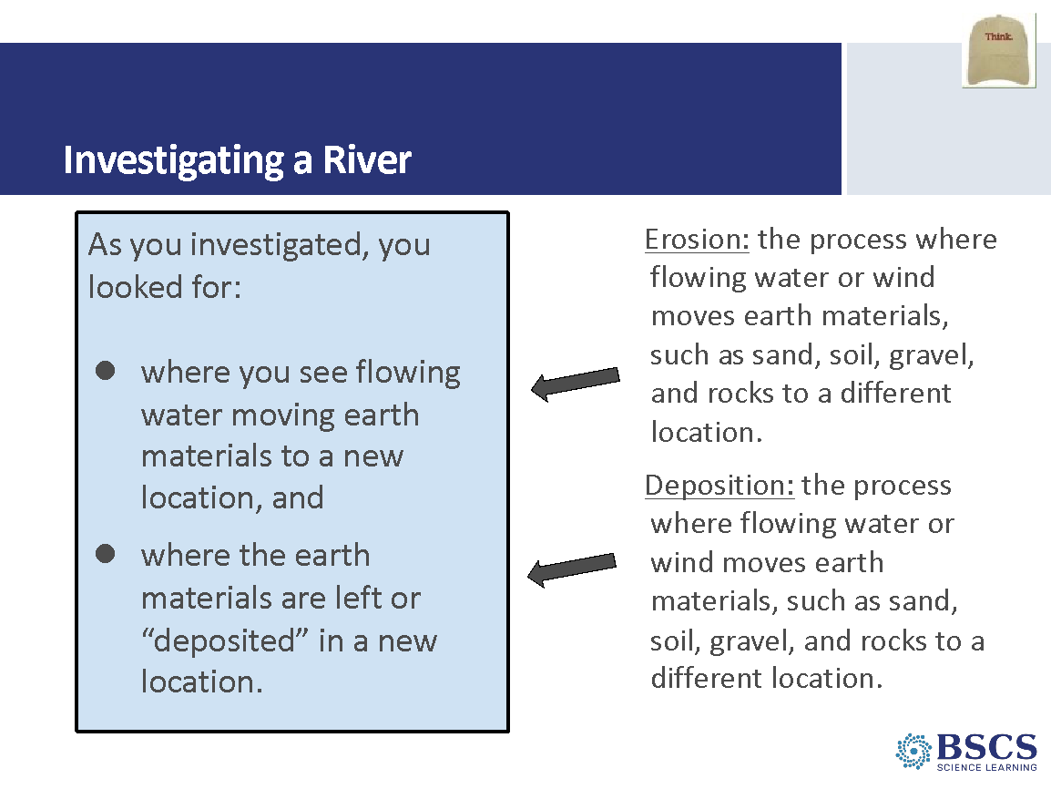 | - Investigating a River (5 min)  - Label the processes they have observed as erosion and deposition and invite participants to write the new terms and definitions in their notebooks.
 |  | 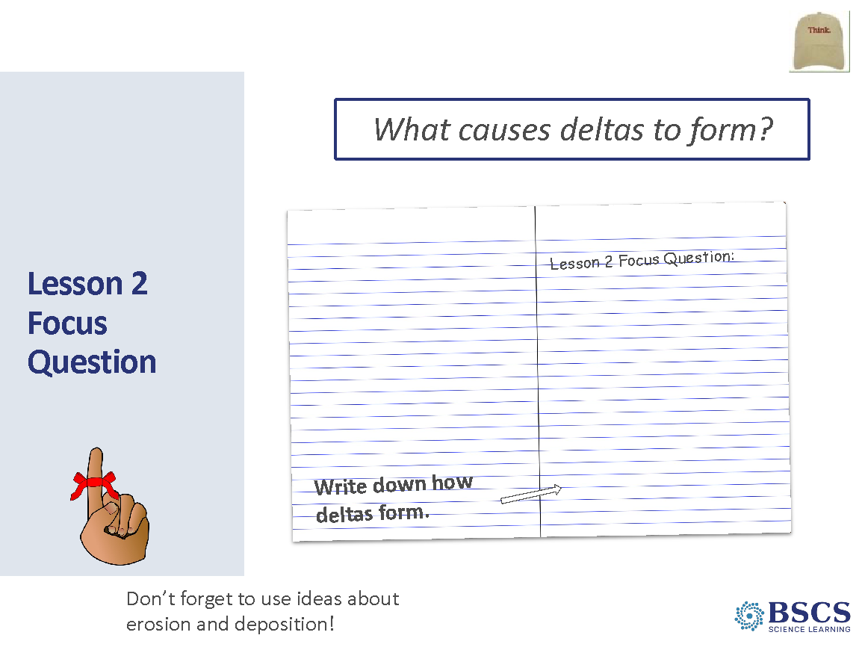 | - Lesson 2 Focus Question (5 min)  - Ask, how do our observations today help us understand our focus question, What causes deltas to form? What evidence do we how have? How did we collect that evidence?  - Return Lesson 2 focus questions in their science notebooks and invite participants to revise their answers. Record participant revised ideas on the Lesson 2 Focus Question chart, using the same color for revised ideas that was used on the Lesson 1 Focus Question chart.  - As participants share ideas, ask elicit, probe and challenge questions to highlight the science ideas they figured out, how they figured out those ideas, and the evidence that supports their answer to the focus question.  - Link to next lesson by saying something like: We saw in yesterday’s lesson that it took thousands of years for the Mississippi Delta to form. Do you think that means that erosion and deposition are always slow? In our next lesson, we will test some ideas for how we can speed up or slow down this process.
11:40 – 12:00  20 min  Slides 36 - 40 | Purpose: The purpose of this session is to model effective STeLLA-based science teaching and learning through a common experience that is grounded in a 3D, phenomena/problem driven unit and designed for adult learners.  Content: STeLLA model lessons/units attend to the characteristics of effective science teaching and learning (e.g., 3D, phenomenon/problem-driven, student-centered, make student thinking visible and support sense-making, coherent, and access/engage prior knowledge and develop metacognitive abilities).  The content deepening experience will include explicit modeling and use of elicit, probe, and challenge questions as well as focal STeLLA strategies for each lesson:  - L3: STL 5  Science content:  (L3) Rainfall, the amount of water flowing, vegetation, and the type and slope of the land can affect the rate of erosion and deposition, changing where soil and rock flow and deposit. The Mississippi River freely deposited soil and rock that flowed from other places, which created the delta originally.  Materials | 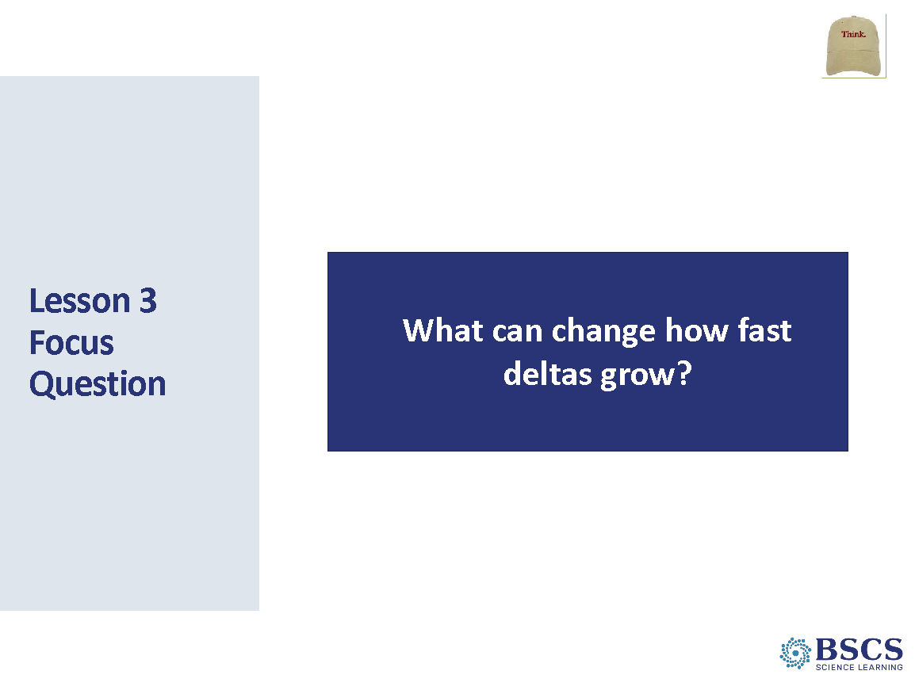 | - Earth’s Changing Surface – Lesson 3 (0 min)  - Keeping our learner hats on, let’s dive into lesson 3. Turn to a fresh page in your science notebook and write lesson 3 at the top.
 |  | 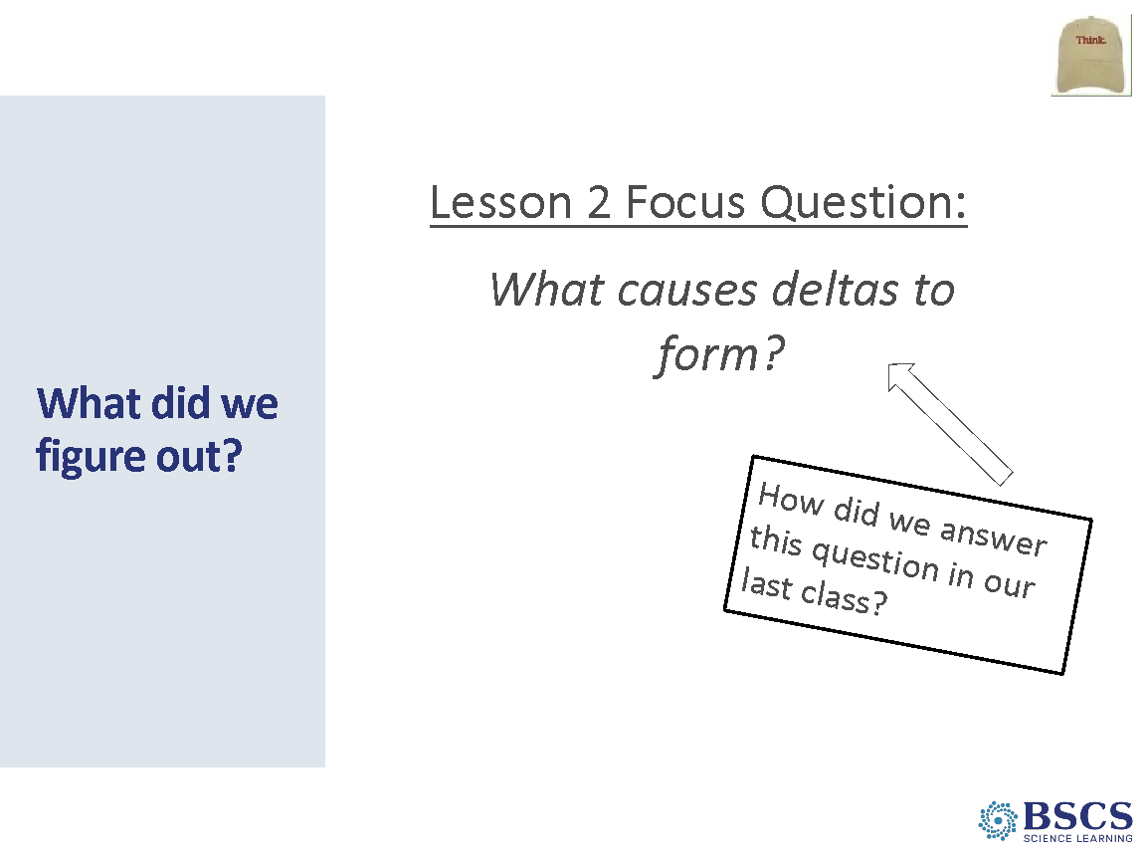 | - What did we figure out? (0 min)  - Draw participants’ attention to the Lesson 2 focus question chart. Note that these are the ideas we figured out in the last lesson, how we figured out those ideas, and the evidence we have that supports our answer, our claim, to the focus question.  PDL NOTE: Keep participants in Learner Hat. Do not reference what they might do with students.
 |  | 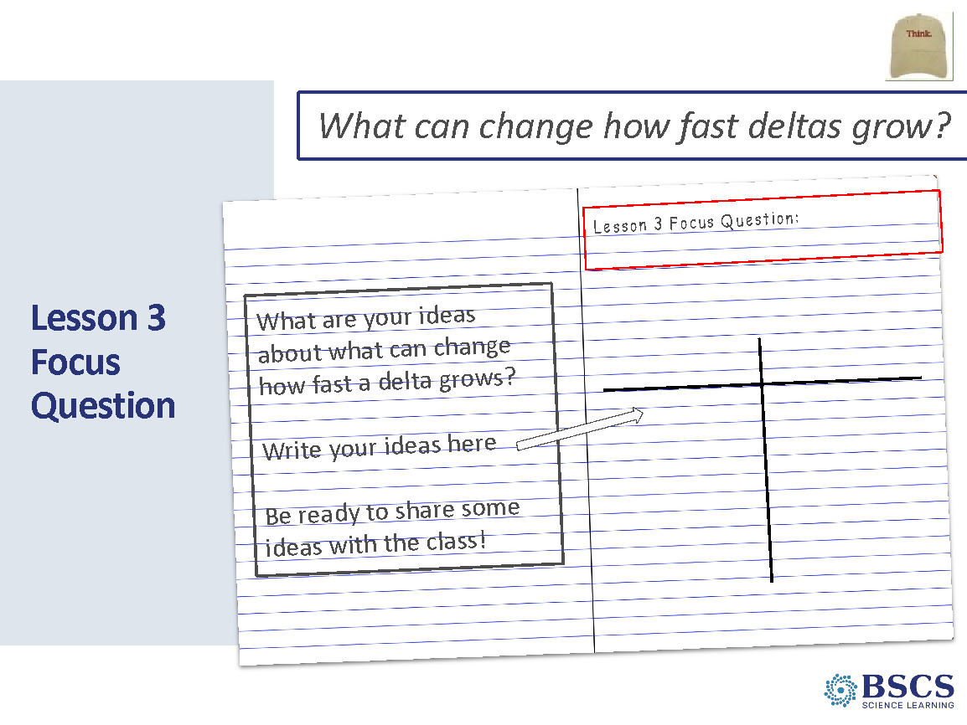 | - Lesson 3 Focus Question (5 min)  - Introduce the Lesson 3 focus question and invite participants to write the question in their science notebooks.  - Instruct participants to create a two-column chart below the focus question. Title the columns, “Things that speed it up” and “Things that slow it down”. Invite participants to add one or more idea in each column.  - Invite a few participants to share out and record ideas using the color of marker used for initial ideas on the first two Lesson Focus Question charts.  PDL NOTE: Refer to Lesson 3 Teacher Guide for ideas to listen for. Be sure to highlight erosion from ocean wave action as an idea for “things that slow down delta formation. Mark any questions on the Driving Question Board that refer to ocean waves as a source of delta erosion.
 |  | 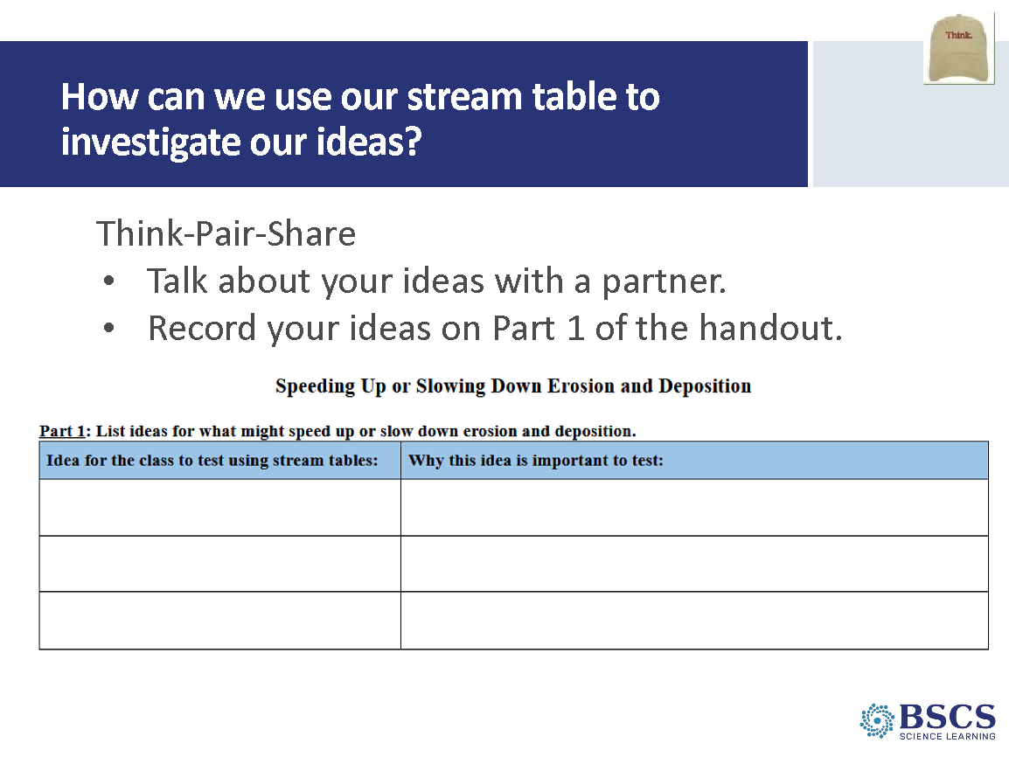 | - How can we use our stream table to investigate our ideas? (Slides 39-40 = 5 min)  - Distribute HO3.1: Speeding Up and Slowing Down Erosion and Deposition.  PDL NOTE: This handout is a scaffold for learners to engage in developing an explanation. The data they record and the questions they respond to will support them in the final Part 4 of the handout when they develop their explanation.  - With a partner, have participants discuss how we can use the stream tables to test some of our initial ideas.  - Invite pairs to share out and use probe and challenge questions for learners to provide a rationale for why they want to investigate a particular condition.
 |  | 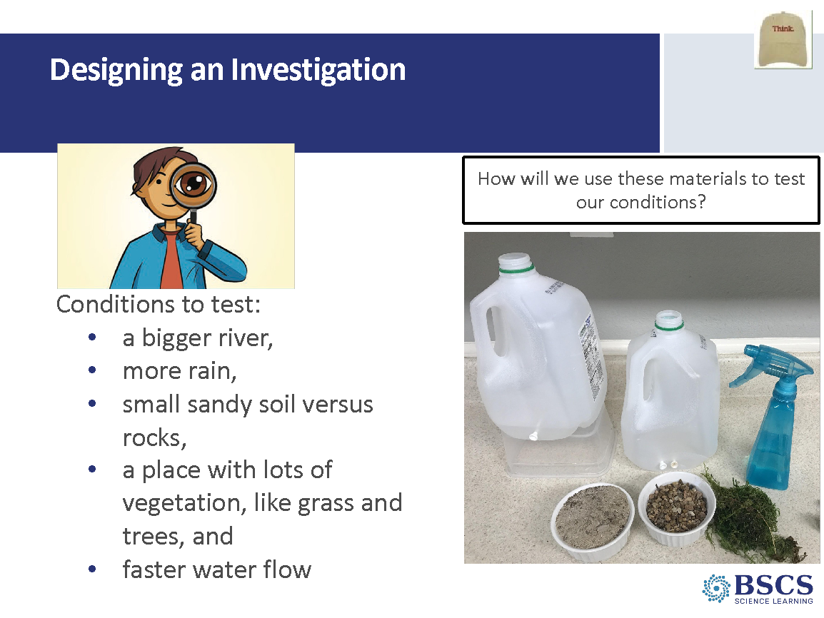 | - Designing an investigation  - Review the five conditions we can test today listed on the slide. Explain that each group will only test one condition and then share out their results with the whole group.  PDL NOTE: Make connections to ideas from lessons 1-2 and the focus question for L3 (the initial ideas shared during the discussion about what can speed up and slow down delta formation.) Make connections of the investigations to learner responses such as more water flowing (snow melt, more rain fall), size of the sediment (small sandy soil vs rocks), and obstacles to the flow of the river (vegetation).
12:00 – 12:30  30 min | Lunch
12:30 – 1:10  40 min  Slides 41-45 | Purpose: The purpose of this session is to model effective STeLLA-based science teaching and learning through a common experience that is grounded in a 3D, phenomena/problem driven unit and designed for adult learners.  Content: STeLLA model lessons/units attend to the characteristics of effective science teaching and learning (e.g., 3D, phenomenon/problem-driven, student-centered, make student thinking visible and support sense-making, coherent, and access/engage prior knowledge and develop metacognitive abilities).  The content deepening experience will include explicit modeling and use of elicit, probe, and challenge questions as well as focal STeLLA strategies for each lesson:  - L3: STL 5  Science content:  (L3) Rainfall, the amount of water flowing, vegetation, and the type and slope of the land can affect the rate of erosion and deposition, changing where soil and rock flow and deposit. The Mississippi River freely deposited soil and rock that flowed from other places, which created the delta originally. | 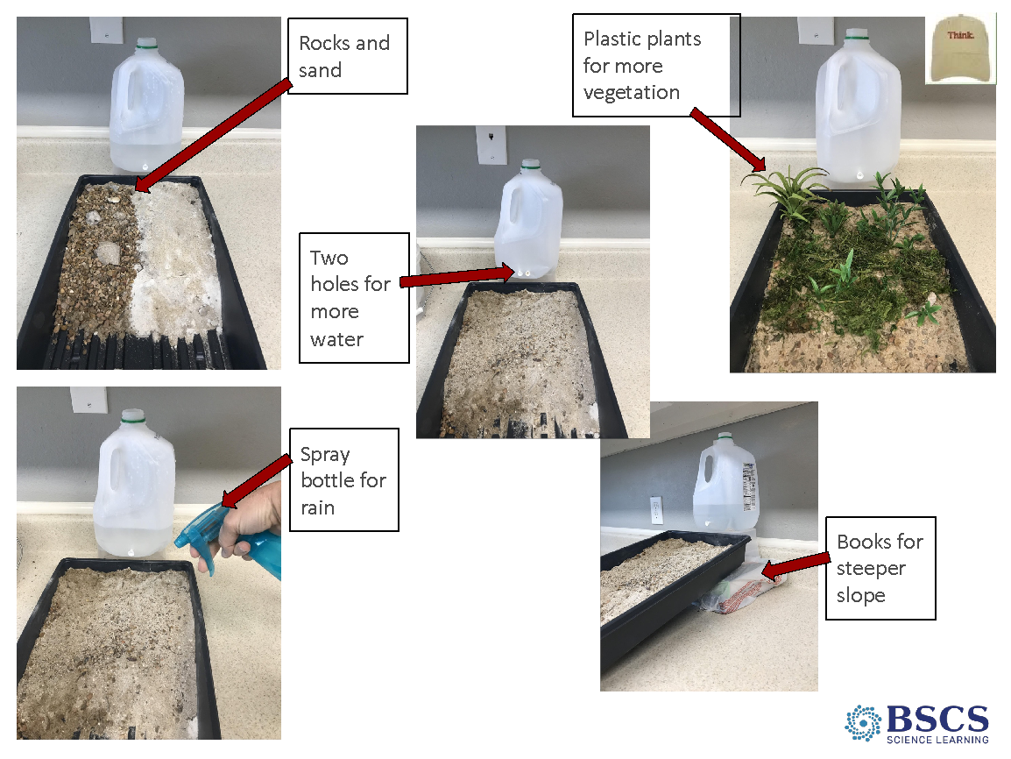 | - Five Conditions (Slides 41-42 = 10 min)  - Divide participants into five groups and assign the conditions, one per group.  - Have participants write down the condition they are testing and fill out the first column of Part 2.  - Explain that while each group is using a different condition, there are things that need to remain constant in order to make a fair comparison. While each group is testing a different condition, each group will use the same amount of water and stop the water once it gets down to the first mark (1/3 of the jug). Share that you will also project the video of the stream table from Lesson 2 so that they can compare.  PDL NOTE: As you engage participants in analyzing and interpreting data and observations, consider Student Thinking Lens Strategy 5.  - Give groups time to test their condition and record their observations in Part 2 of the handout. Circulate around the room using elicit, probe, and challenge questions as appropriate.
 |  | 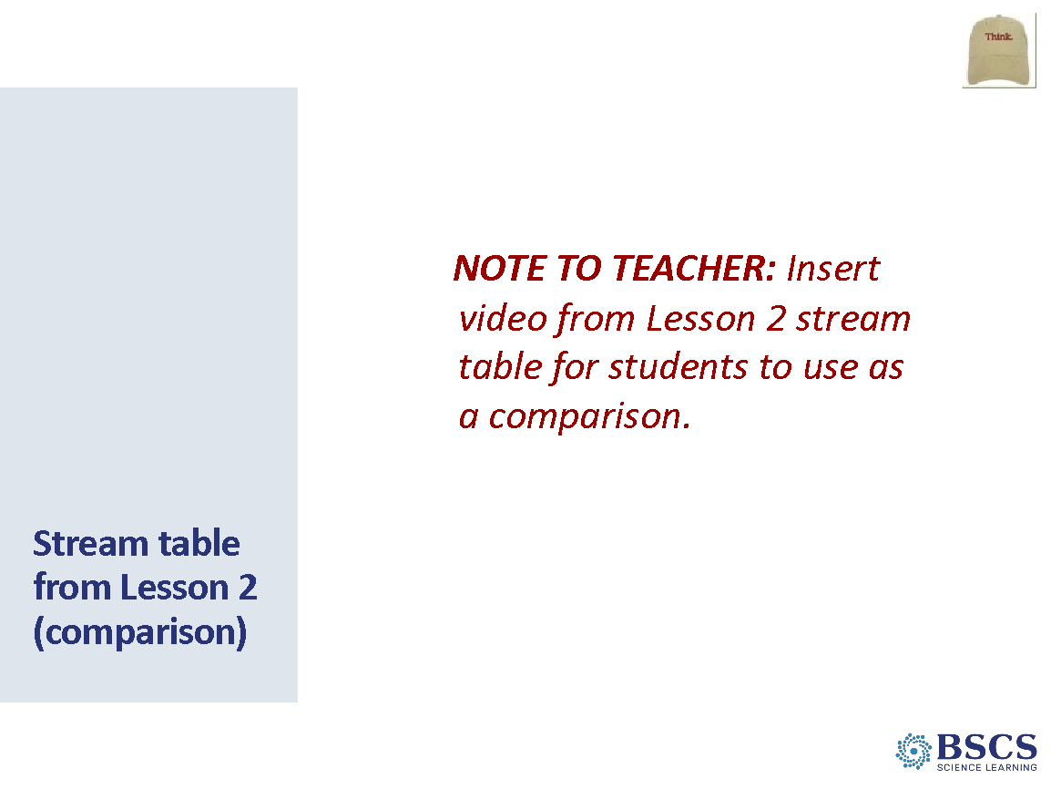 | - Stream table from Lesson 2 (comparison)  - As groups test their condition, play the Lesson 2 stream table video to allow for comparisons.
 |  | 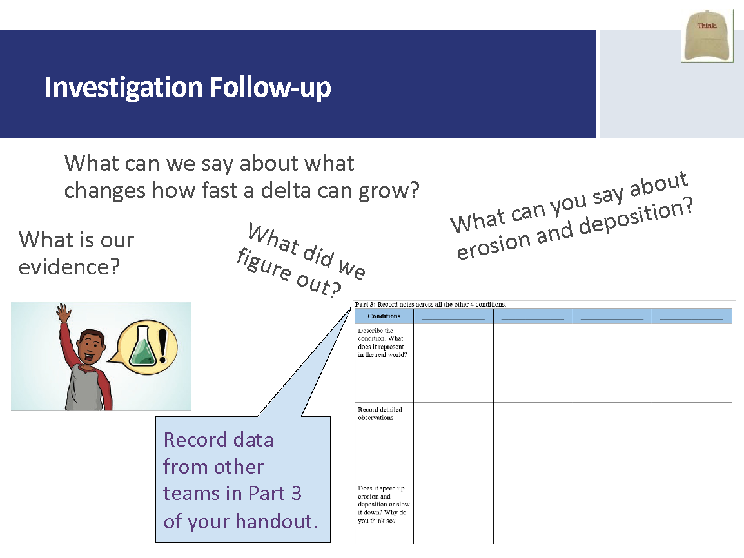 | - Investigation Follow-up (15 min)  - Invite groups to share out their observations for their condition (1 min to share out and 1 min for participants to ask clarifying questions from each group). Record on a public chart so that everyone can look across all five conditions. Participants should record what they learn about each condition in Part 3 of the handout.  - Once all five conditions have been shared, continue to engage learners in analyzing and interpreting data and observations by asking what can we now say about what speeds up or slows down erosion and deposition?  Conditions Big River Two soils Sandy vs Rocks Vegetation Rain Height/ Elevation  Describe the condition. What does it represent in the real world? Larger river like the Mississippi or flood condition River flowing through land Sand sediment (small) Rocky (large) sediment Wooded area More trees, shrubs with a break like a riverbed Mix of rock and sand sentiment Riverbed with less vegetation Spray bottle to represent rain (add water) Tray set up was higher than initial set up.  Record detailed observations Water quicky flowed downhill Larger debris at the bottom Deeper and wider path of water Small Water absorbed initially with pooling Water flowed down 2 paths then 1 Good amount of sediment deposited downstream Large Water pooled in the middle Took 1 path Larger sediment mostly stayed in place. Less small sediment moved down First pooling then tried to get over the vegetation 2nd water went under vegetation; sand absorbed 3rd water went around vegetation but limited flow and deposition  Does it speed up erosion or does it slow it down? Why do you think so? Small Speed up erosion More sediment deposited downstream Large Held small sediment in place Vegetation slows down erosion and deposition Speeds
 |  | 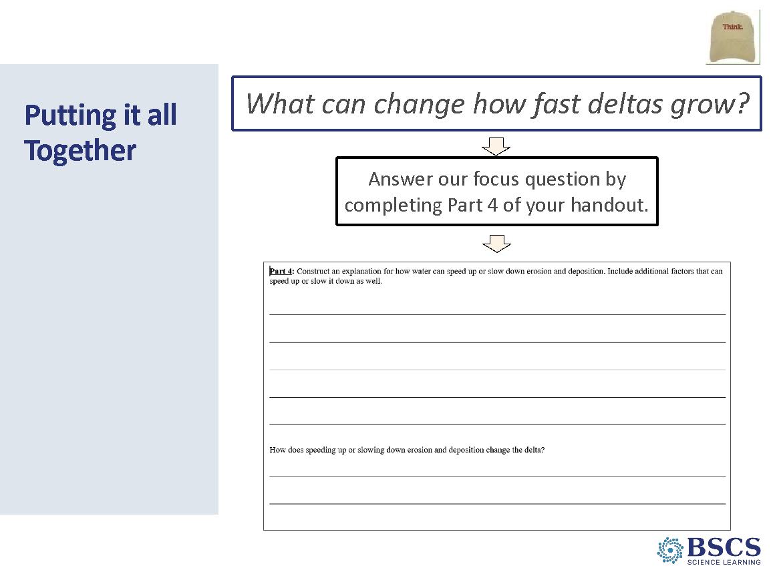 | - Putting it all together (Slides 44-45 = 10 min)  - Remind participants of the focus question and explain that they will use Part 4 of the handout to create an explanation that uses evidence and answers this question.  - After time to write, invite a few participants to share their thinking. Record participant ideas on the Lesson 3 Focus Question chart, using the same color used for revised ideas on the other Lesson Focus Question charts.
 |  | 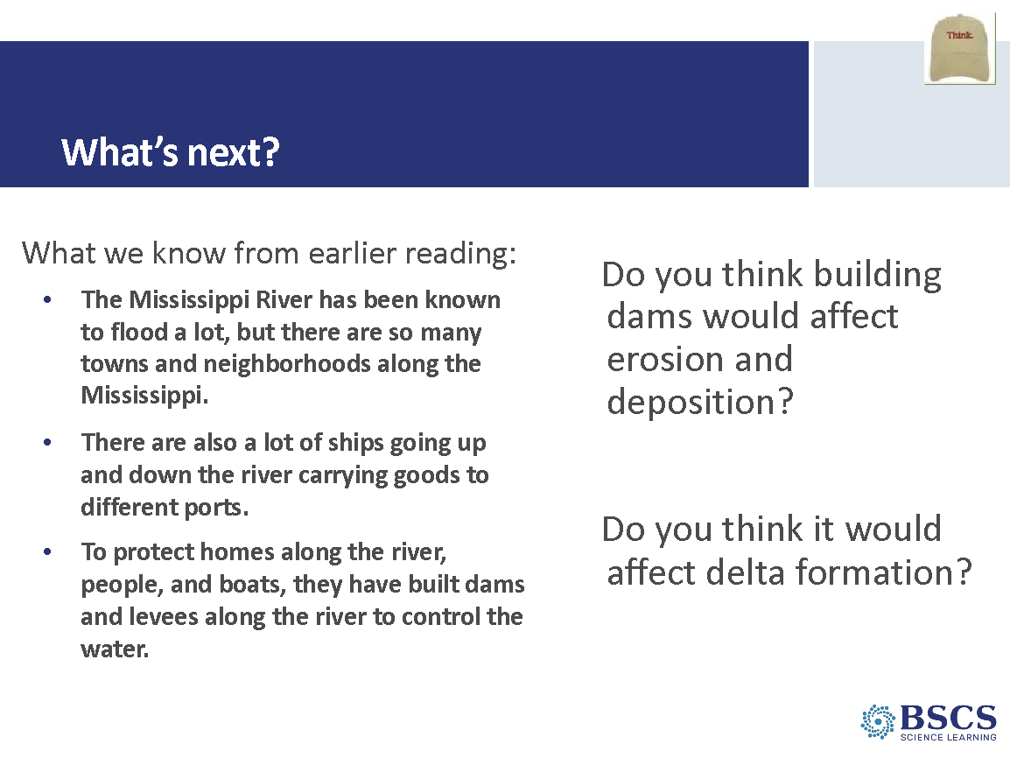 | - What’s next?  - Highlight that we noticed that more rain or water can cause erosion and deposition to happen faster. Ask what else can happen when there is a lot of rain or water? (Possible answer: Flooding!)  - Use the slide to remind participants ideas obtained from the reading in lesson 1. Ask, how might building a dam or levee on the river change erosion and deposition? Share that this what we will investigate in the next lesson.
1:10 – 3:10  110 min  +10 min break  Slides 46 - 57 | Purpose: The purpose of this session is to model effective STeLLA-based science teaching and learning through a common experience that is grounded in a 3D, phenomena/problem driven unit and designed for adult learners.  Content: STeLLA model lessons/units attend to the characteristics of effective science teaching and learning (e.g., 3D, phenomenon/problem-driven, student-centered, make student thinking visible and support sense-making, coherent, and access/engage prior knowledge and develop metacognitive abilities).  The content deepening experience will include explicit modeling and use of elicit, probe, and challenge questions as well as focal STeLLA strategies for each lesson:  - L4: I/9  Science content:  (L4) Increased flooding and rainfall caused humans to build walls to manage the flow of the river. This caused a steadier flow for communities and transportation along the river but limited how soil and rock could be deposited in the delta. Over time, the land seems to “disappear” but really the rocks are being swept away by the flow of water and wave currents. Human activity can have both positive and negative effects on natural processes.  Materials | 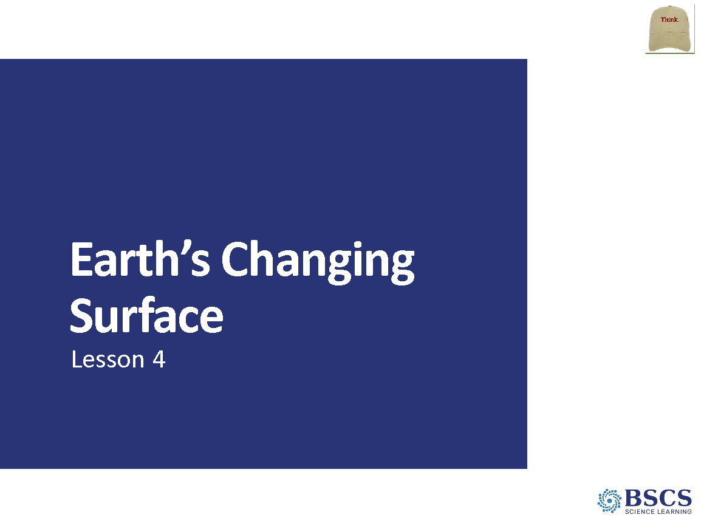 | - Earth’s Changing Surface – Lesson 4 (0 min)  - Mark that we are starting Lesson 4 of the Earth’s Changing Surface Unit. Have participants turn to a fresh page in their science notebook and write Lesson 4 at the top.
 |  | 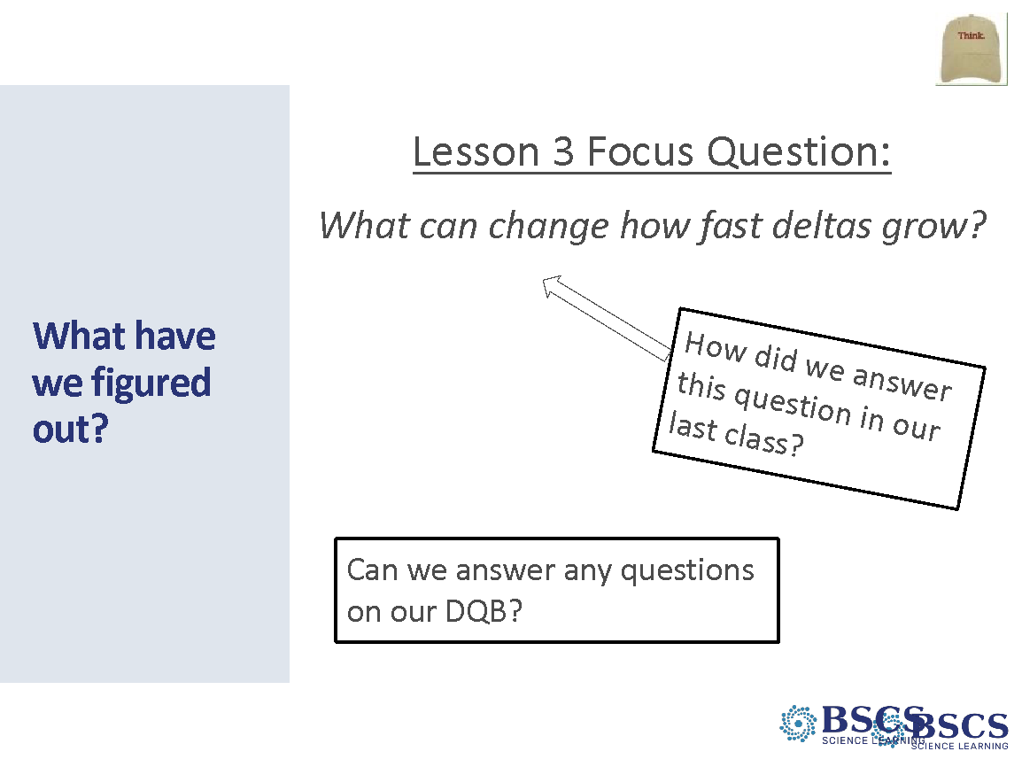 | - What have we figured out? (5 min)  - Invite participants to look back at the Driving Question Board (DQB) and ask if we now have some new ideas that will help us answer any of these questions.  - Transition to the Lesson 4 focus question either by highlighting a question on the DQB or saying something like, If we can form a delta and make it bigger or grow it faster, could we also find out if a delta can go away? We saw the Mississippi Delta getting bigger and changing. What do you think it is doing today? In today’s lesson, we are going to figure out what can cause a delta to change.
 |  | 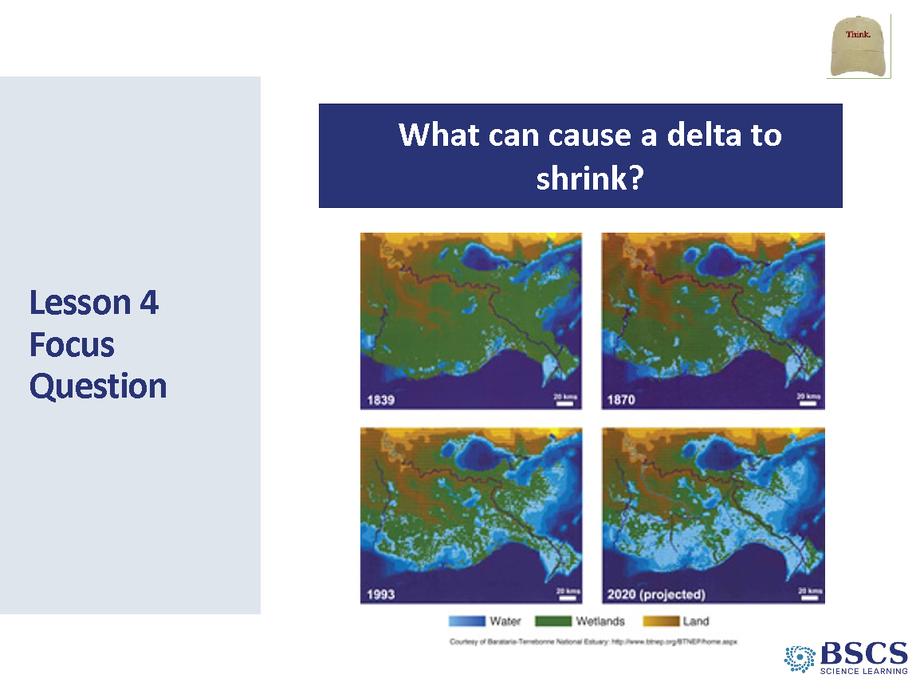 | - Lesson 4 Focus Question (Slides 48-49 = 10 min)  - Continue by letting participants know that they have only watch part of the Changing Delta animation and that today they will watch the last part. Link to animation:  http://www.watchthedeltagrow.com/mississippi-river-paths  - Play the video from the beginning. Stop at 00:33 seconds and let participants know that is where they stopped before showing the animation until the end.  - Ask participants for their observations and then introduce the lesson focus question: What can cause a delta to shrink?  - Invite participants to write the focus question in their science notebooks and record their initial ideas.  - After some time to write, invite a few participants to share out their ideas and record on the Lesson 4 Focus Question chart using the initial ideas marker color.  Transition: We are going to take a moment to read a bit more about the Mississippi delta because we know something changed recently.
 |  | 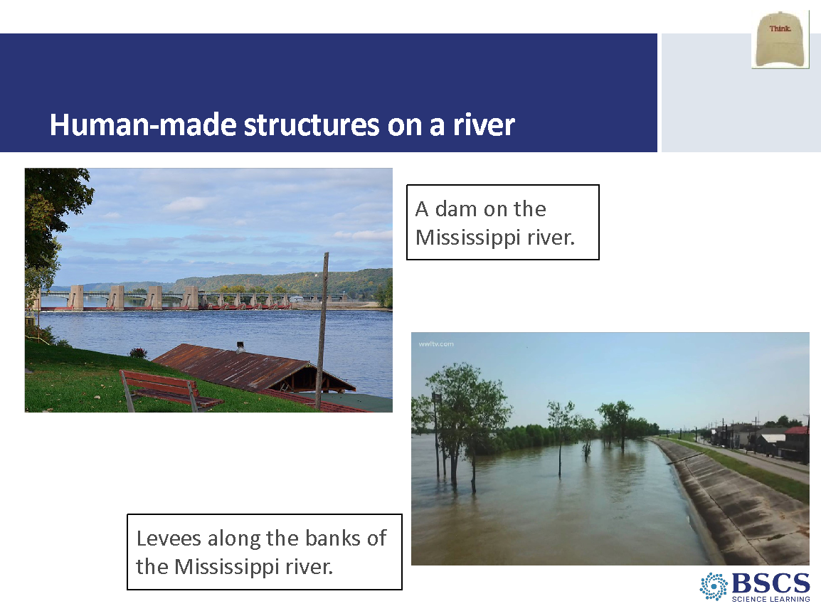 | - Human-made structures on a river  - Pass out HO4.1, The Changing Delta. Have participants read silently and complete the Stop and Jot questions.  - Invite participants to share their ideas in response to the reading.  PDL NOTE: Use the questions and sample dialogue in the Lesson 4 guide to support.  Transition: We have some ideas for how the river and delta might be changing. We know that people added dams and levees to the river to help protect towns from flooding, and to make power. But we think that maybe the dams also are doing something to change erosion and deposition in the river and delta. So, we are going to test this idea with our stream table.
 |  | 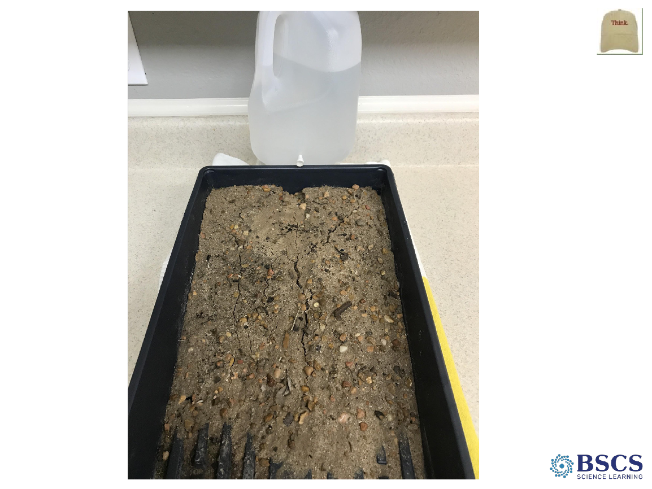 | - Investigate (10 min)  PDL NOTE: Even though this activity can be done in small groups with multiple stream tables, for PD purposes, use only one stream table as a whole-group activity. Make sure that this stream table already has a river channel carved into it. For the ‘dam’ you can use a wooden block as pictured or fold a piece of foil into a thick 1”x4” rectangle.  - Point to the river channel and ask what it represents.  - Distribute HO4.2 Dams and Rivers. Give participants a couple minutes to answer Question 1, using the stream table to help draw a picture of what they think might happen.  - Remind learners about what they were watching for previously in the stream table. (Where they see flowing water moving earth materials to a new location and where the earth materials are left or deposited in a new location.) Let the water flow freely at first and then place the ‘dam’ onto the river. Encourage participants to record their observations in words and pictures in Question 2 on their handout. Ask participants what they are noticing. Probe their responses to find out more about what they are thinking. Ask participants to connect what they are seeing to erosion and deposition.  PDL NOTE: Highlight the idea of erosion of the delta by ocean waves. Otherwise, the delta should just stop growing with less deposition but not shrink. Erosion by ocean waves is needed to counter the idea that sea level rise is the cause of the delta shrinking.  Transition: We figured out how dams might change erosion and deposition. Let’s put these ideas together and explain why the deltas might be shrinking.
 |  | 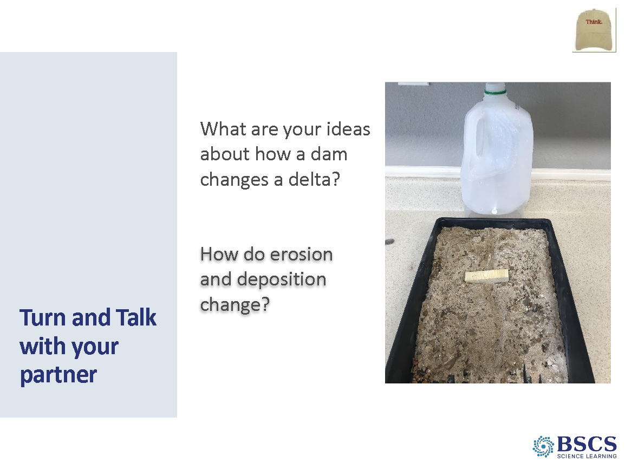 | - Turn and Talk with your partner (5 min)  - Give 2 min to talk with a partner about the questions on the slide and then invite a few pairs to share out.  - After discussion, give time for participants to answer Question 3 on HO4.2.  - Invite a few participants to share out.
 |  | 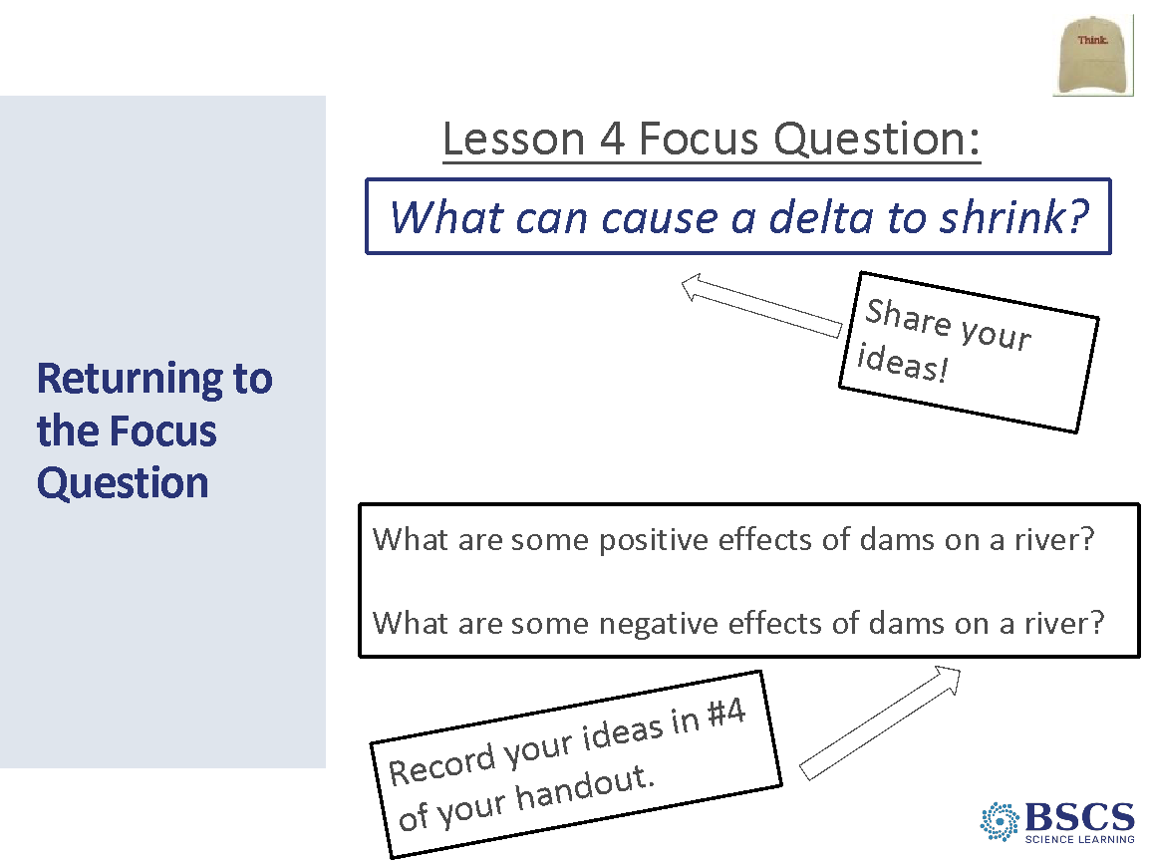 | - Returning to the Focus Question (5 min)  - Have participants to return to their initial ideas in their science notebook and revise their thinking, as well as complete Question 4 on HO4.2.  - Invite a few participants to share out their revised thinking and record their ideas on the Lesson 4 Focus Question chart using the chart color for revised ideas.
 |  | 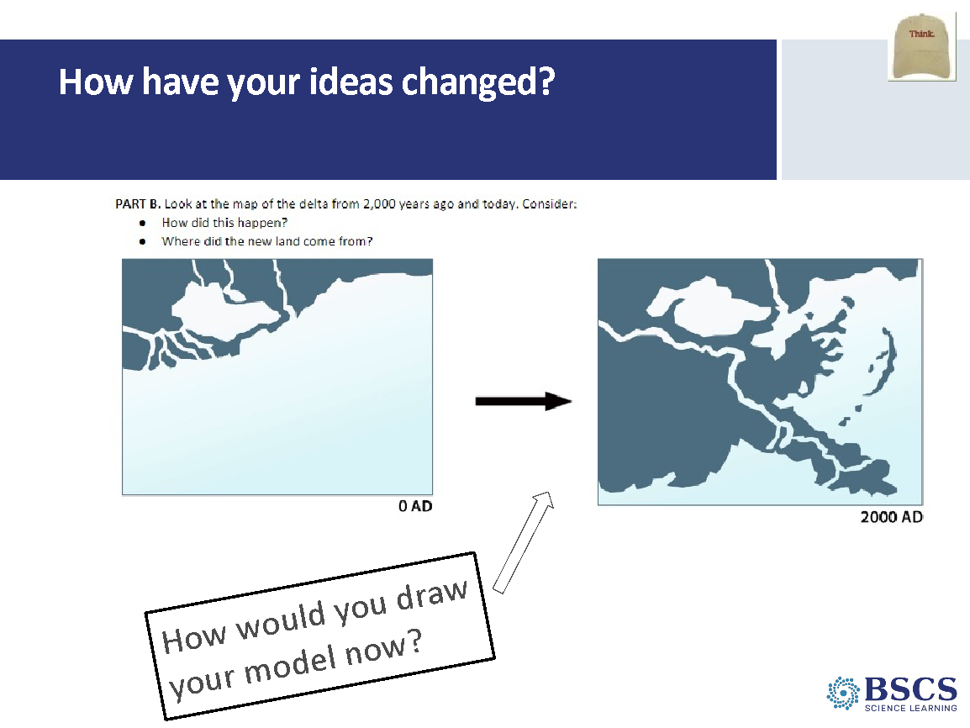 | - How have your ideas changed? (10 min)  - Invite participants to look back at their initial models from Lesson 1, Part B of HO1.3 How does land change to form a delta? Once they have reviewed their initial ideas, share that we will synthesize and summarize key ideas they have learned so far and discuss how their initial ideas have changed.  - Record big ideas on chart paper. You might say, we have great ideas about how new land forms at the end of the river. We know from our investigations that:  - sand and dirt (soil) are carried down a river by water (erosion) and deposited at the end of the river  - steeper land resulting in faster water flows, heavier rains, or a bigger river cause this to happen faster.  - flat land or slow water flow, not much rain, smaller rivers, or more vegetation can slow it down.  - If we block a river with a structure like a dam, we can also stop the flow of soil and sand to the end of the river.
 |  | 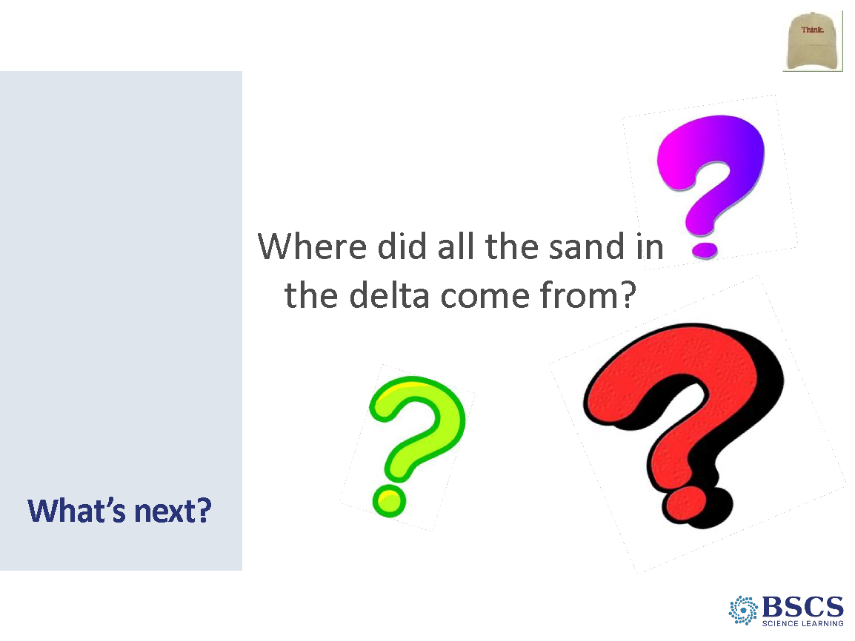 | - What’s next? (0 min)  - Transition to next lesson by either highlighting a question on the DQB or you might say, I have a wondering myself. Where did all this soil and sand come from in the first place? What ideas do you have? In our next lesson, we will try to figure out where all this sand came from that forms the delta.
 |  | 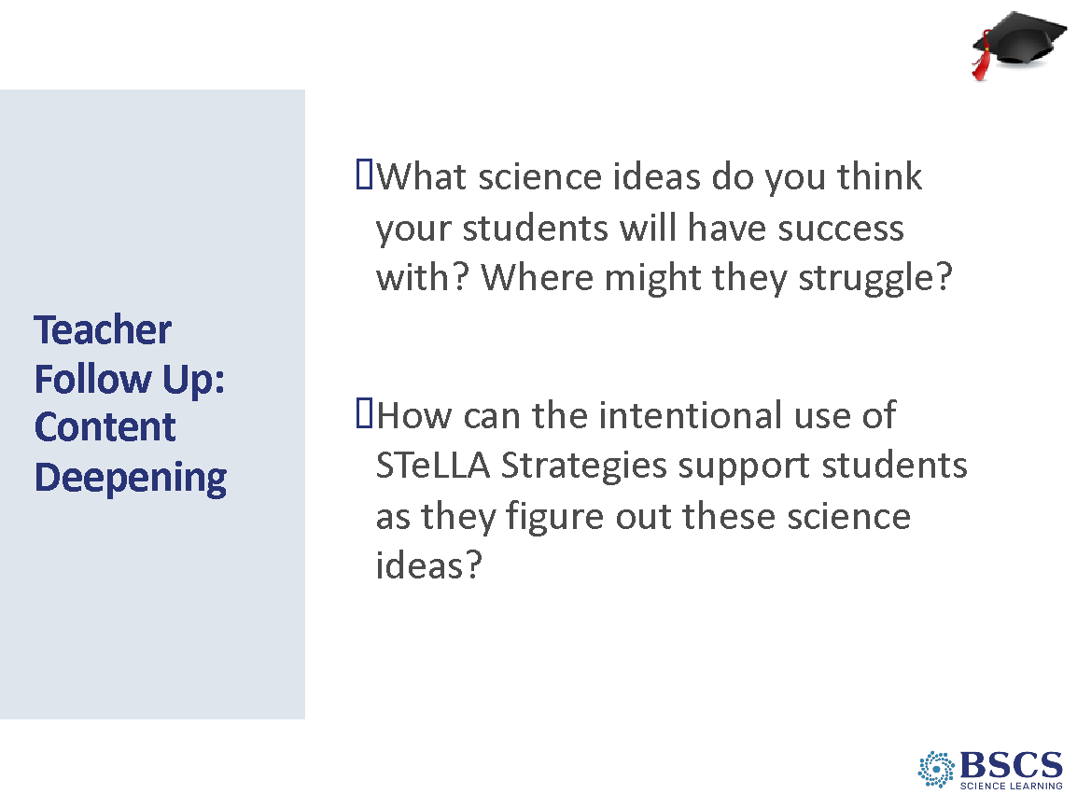 | - Teacher Follow-up: Content Deepening (5 min)  - Transition participants to Teacher Hat.  - Invite participants to silently consider the prompts on the slide:  - If time permits, invite several participants to share out.  Transition: Like yesterday, we’ll use lesson placemats to think about the key STeLLA Strategies leveraged in lessons 2-4. We’ll use a jigsaw to complete the placements for these lessons 2-4 to consider how the strategies to reveal student thinking and help them figure out key science ideas.
 |  | 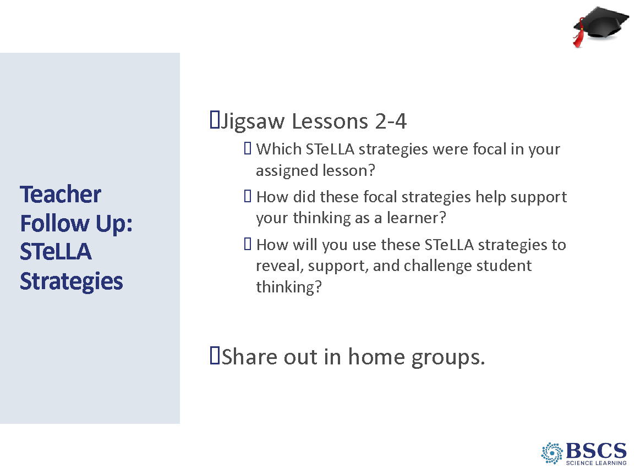 | - Teacher Follow-up: STeLLA Strategies (20 min)  PDL NOTE: This slide is animated  - Divide participants into three expert groups to identify strategies and record notes for their assigned lesson (8 min):  - What is/are the focal strategy/strategies that you will leverage in each part of the lesson? Record notes about how these strategies helped your thinking as a learner and ideas for how you will use these strategies to make student thinking visible and develop a coherent science content storyline.  - If groups have time, they should take a second pass and add supporting strategies within your lesson.  - As participants are completing their strategy identification, have them number off 1 through the number of people in their group. Have them regroup with their like-numbered partners to form home groups of three (one person from each lesson). Assign participants without full groups of 3 to different home groups.  PDL NOTE: Each person will have 4 minutes to share the focal strategies for their lesson with their home group while others in the group add notes to their placemats and ask probe and challenge questions (12 min.) Foreground that, after sharing in home groups, we will look for patterns in the STeLLA strategies used within and across lessons.
 |  | 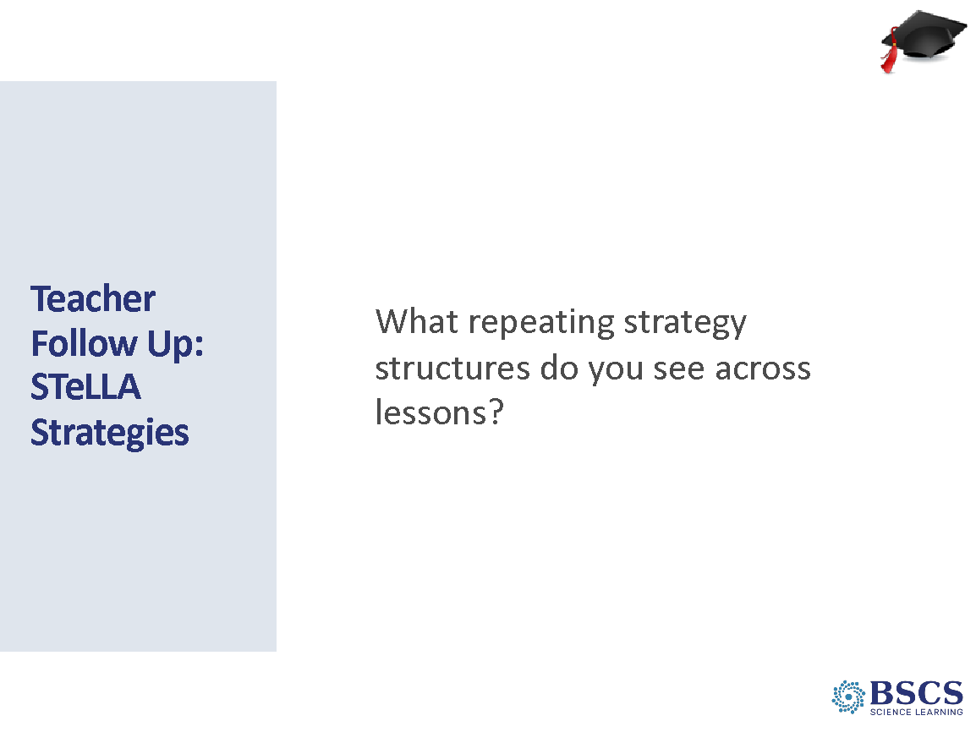 | - Teacher Follow-up: STeLLA Strategies (10 min)  - Draw participants together into the whole group. Invite participants to identify patterns of STeLLA strategies used within and across lessons and how the patterns of strategies both reveal, support, and move student thinking forward as well as help students construct a coherent science content storyline.  Some patterns to highlight include:  - Lessons begin with linking to science ideas of previous lessons (G)  - Lesson intention is set with a FQ at the beginning of the lesson – and the FQ is revisited at the end of the lesson (B, H. I)  - Activities are preceded with a set-up and followed with a follow-up (F)  - Lessons end with a synthesize/summarize (either by students or the teacher (I/9)  - EPC and CSW are used throughout the lesson (1, 2, 3, and 4)  - The activity may use strategies 5-8 to help students figure out key science ideas. (Participants may link strategies 4-7 to NGSS SEPs).
3:10 – 4:15  70 min  Slides 58 - 71 | Purpose: The purpose of this session is to develop a shared understanding of STeLLA Strategy F: Make explicit links between science ideas and activities and how its use creates a coherent science content storyline.  Content: Lessons with a strong science content storyline include a connected thread of content-related talk and activities leading from the focus question through a flow of events and science ideas to the summary of the lesson. For students to construct a coherent science content storyline, activities should have a purposeful set up, be designed to require links between the activity and science ideas, and a follow-up that focuses attention on how the activity contributed to the storyline.  The LAP supports a deep dive into a teacher’s practice and student understanding through intentional inquiry into evidence provided in analysis of classroom video.  Materials | 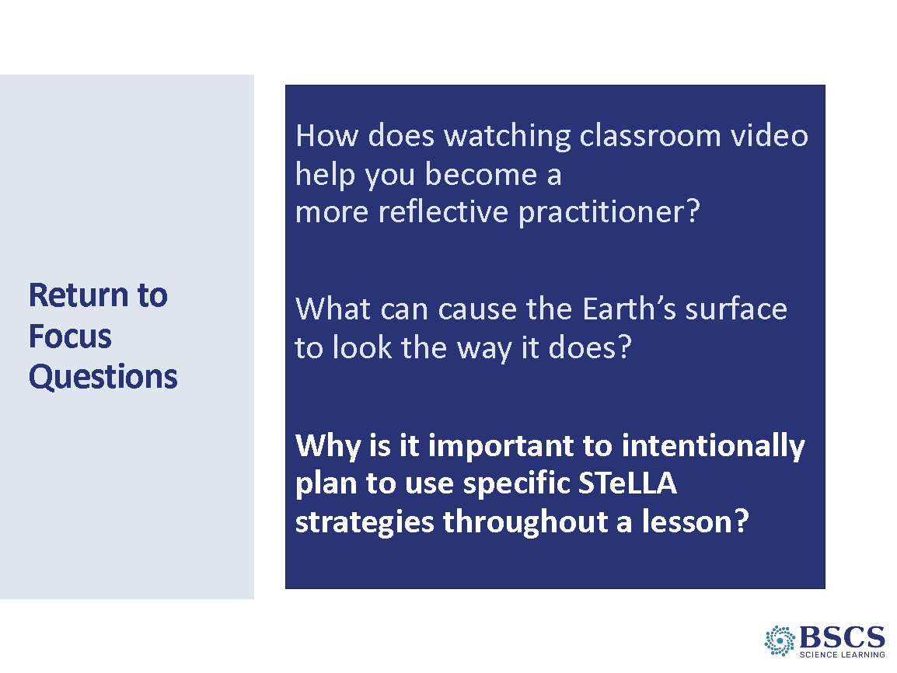 | - Return to Focus Questions (0 min)  - Take a moment and jot down some new or reinforced ideas under the last focus question in your BSCS Journal.
 |  | 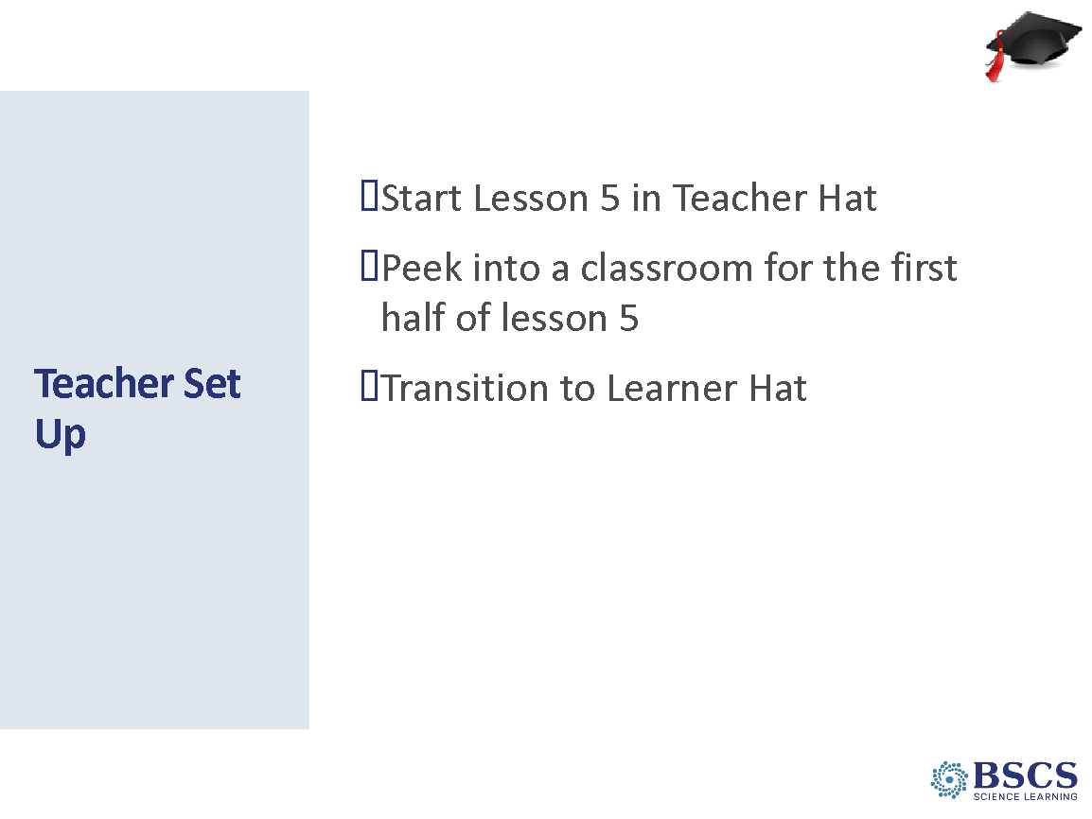 | - Teacher Set up (0 min)  - Share that we will zoom through the first half of this lesson in Teacher Lens. We will then take a break and come back to finish the lesson in Learner Lens.
 |  | 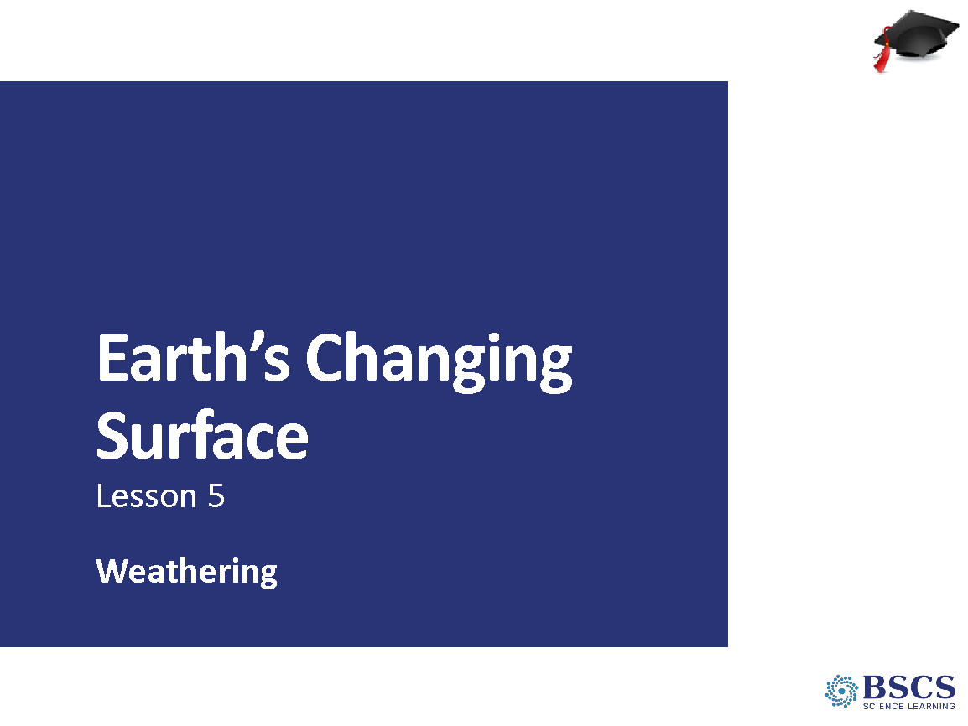 | - Earth’s Changing Surface – Lesson 5 (0 min)  - Mark that we are now starting Lesson 5 of the Earth’s Changing Surface Unit. Have participants turn to a new page in the Science notebook and write Lesson 5 at the top.
 |  | 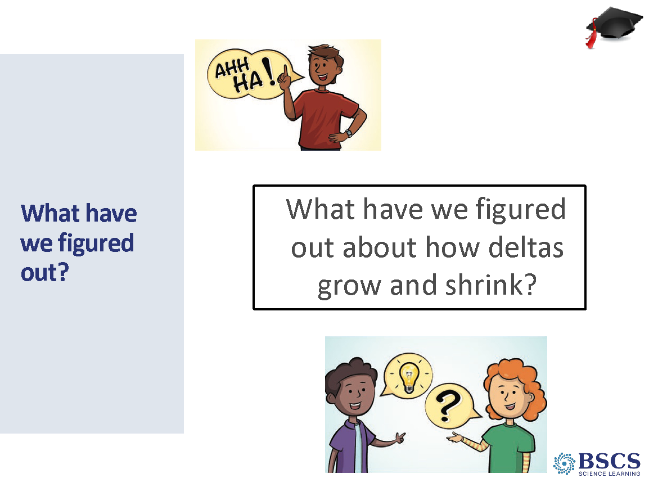 | - What have we figured out? (5 min)  - What are the key things your students would have figured out so far? Chart these ideas and label the chart, “Science ideas we have figured out”.  Transition: Ok we’ve talked about what can happen to all this earth as it is eroded and deposited. But where does this land, these earth materials, come from anyway?
 |  | 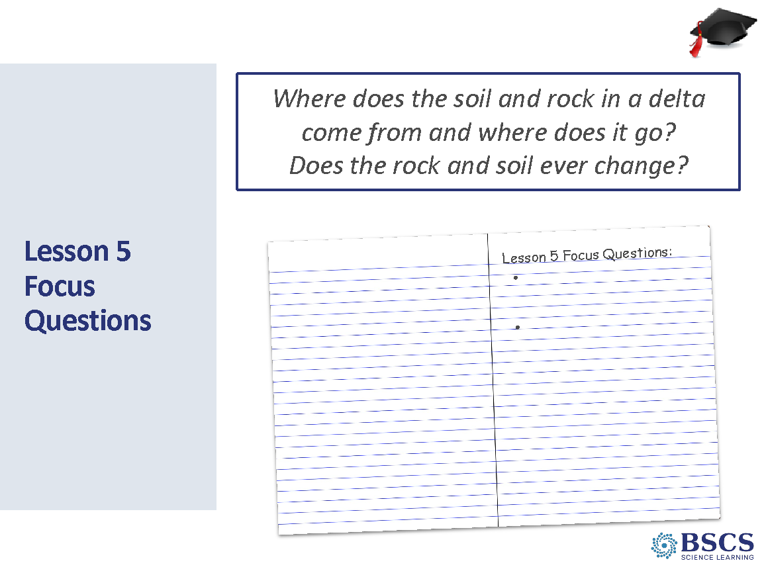 | - Lesson 5 Focus Question (5 min)  - Share that is in fact, this is the Focus Question for Lesson 5. Ask, How do you think your students will respond to that?  Transition: Now we will a look at how students figure out the Focus Question by examining the three investigation stations in Lesson 5.
 |  | 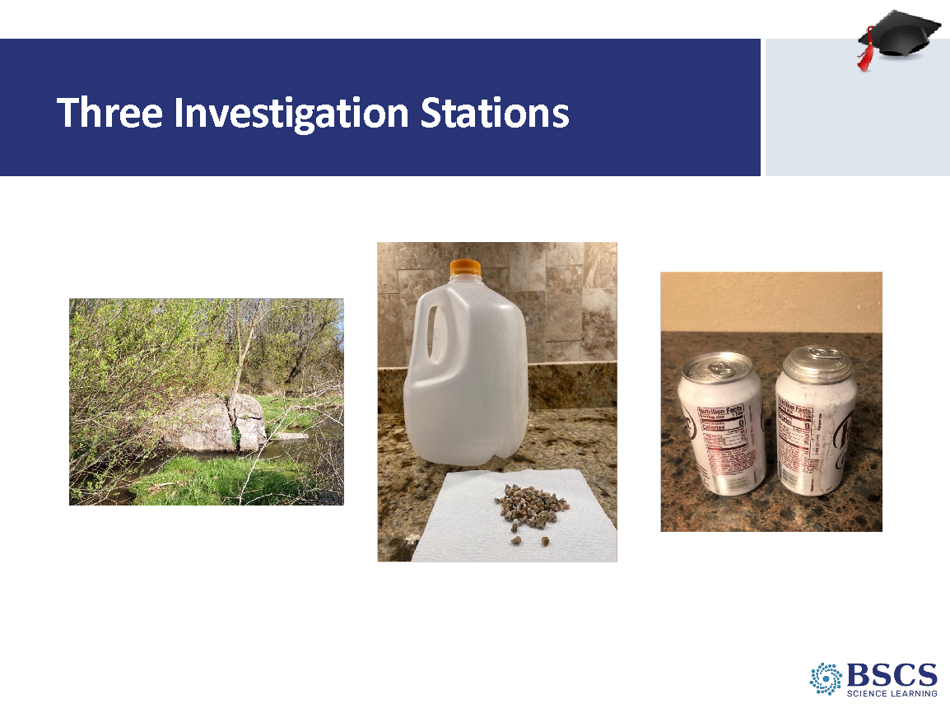 | - Three Investigation Stations Slides 63-64 = 5 min)  - Briefly describe the three stations. Use the physical set ups using kit materials in the room to reference.
 |  | 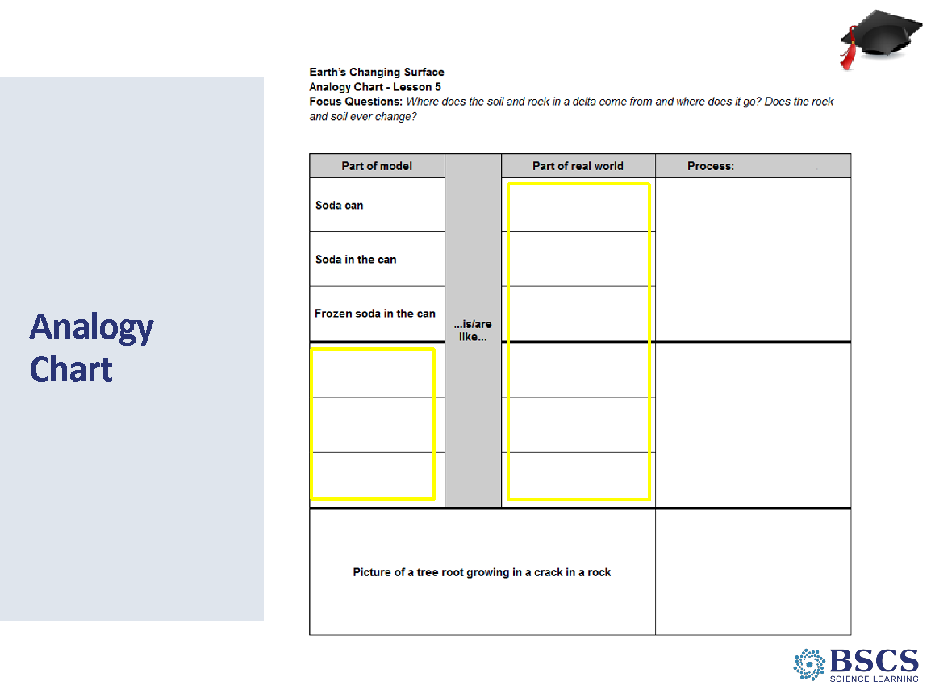 | - Analogy Map  - Share that, as we engage students in using content representations and models, we will consider how each model is like or unlike the thing they are studying in the real world. Pause and ask why they (as teachers) think this is important.  - Pass out HO5.2. Invite participants to fill in what we hope to see students write in columns 1 and 2.  PDL NOTE: If they transition into adult learner lens while filling out the analogy chart, that’s ok (don’t try to keep them in teacher lens.)
 |  | 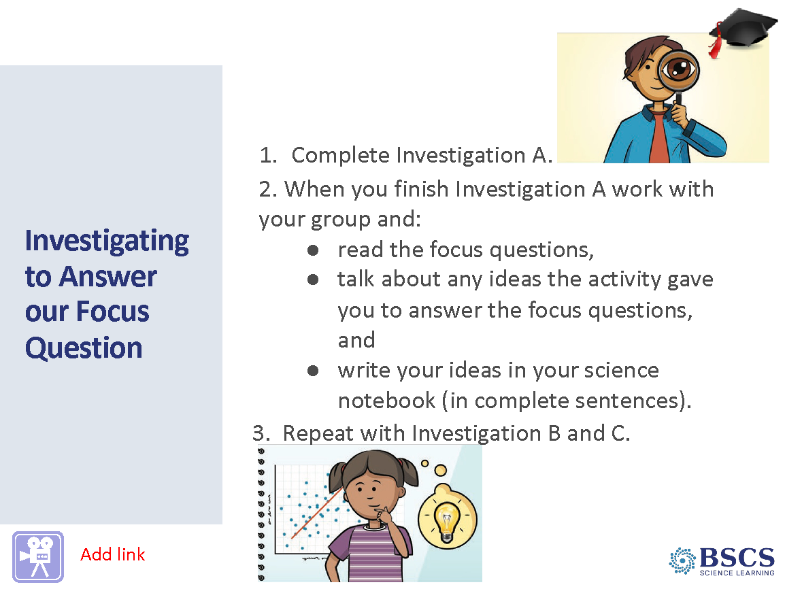 | - Investigating to answer of focus question (10 min)  - Share that instead of doing the stations ourselves, we will now watch a clip of students engaging with the models at each station. Pass out transcript L5_Potter_C1-3 and explain that we are not doing a LAP with this clip, but rather getting an idea of what these stations look and sound like when fourth graders are engaged with these models.  - Watch clip (3:15)  - We’ve just experienced this activity vicariously. What do you think the teacher will do next? Why is that important? (Possible response: Linking science ideas to activities; making sense of the activity)  Transition: Let’s now jump back into the classroom and see what happens. For this next clip, we will be doing a full lesson analysis, so let’s return to The Basics.
 |  | 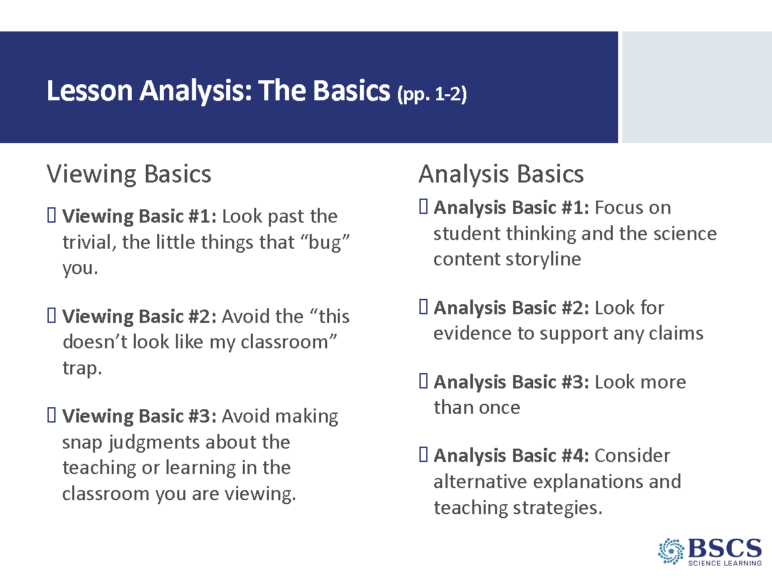 | - Lesson Analysis: The Basics (Slides 66-68 = 5 min)  - Revisit the Viewing and Analysis Basics  - Remind participants that both the Viewing and Analysis Basics will help us dig deeper and learn more from our analyses while keeping us focused on the ultimate goal – improved student learning.
 |  | 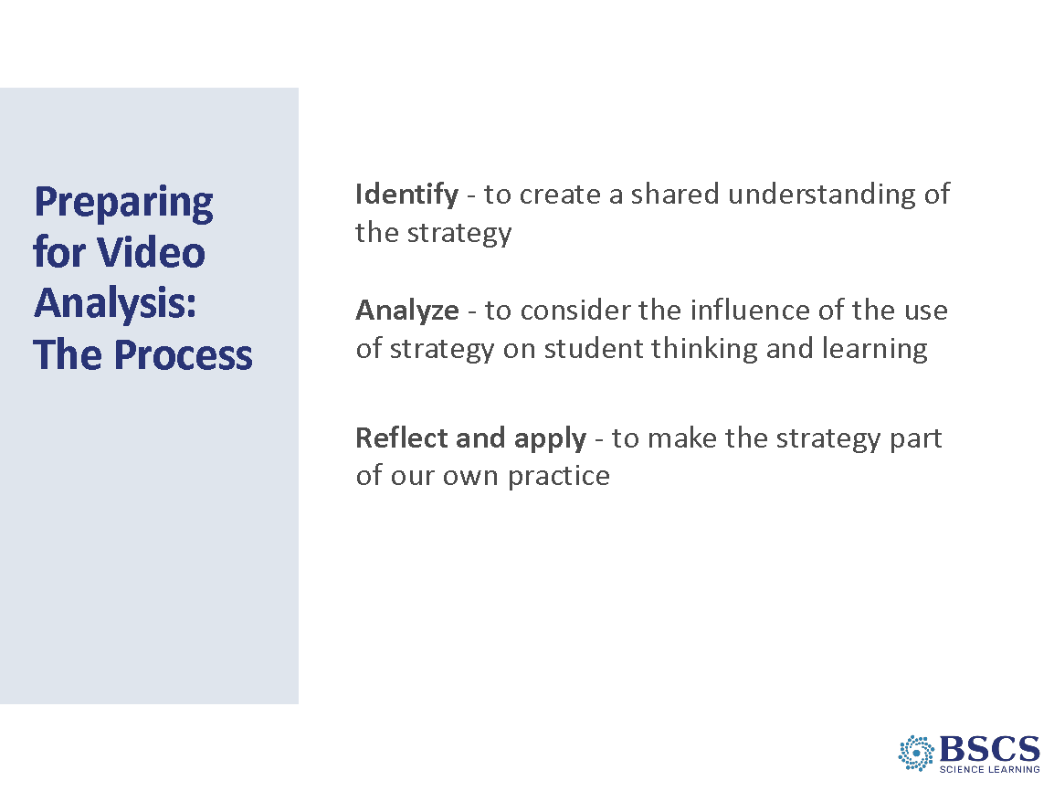 | - Preparing for Video Analysis: The Process  - Share that, again, we’ll be explicit about our video analysis structure. Framing our analysis in this way (i.e., identify, analyze, reflect, and apply) will help us to focus more holistically on BOTH the teaching and the impact of particular STeLLA strategies on student thinking and learning, and the storyline the students are constructing (i.e., the two lenses).
 |  | 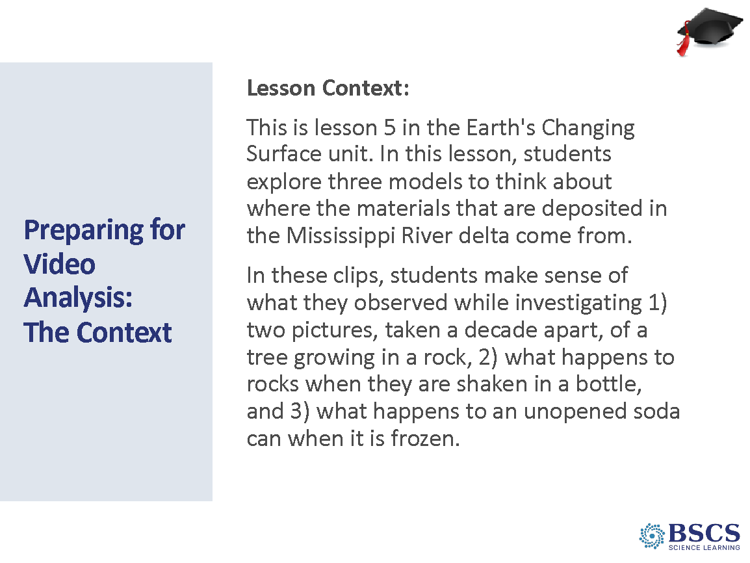 | - Preparing for Video Analysis: The Context  - Pass out transcript L5_Potter_C4-6.  - Share the context of the video
 |  | 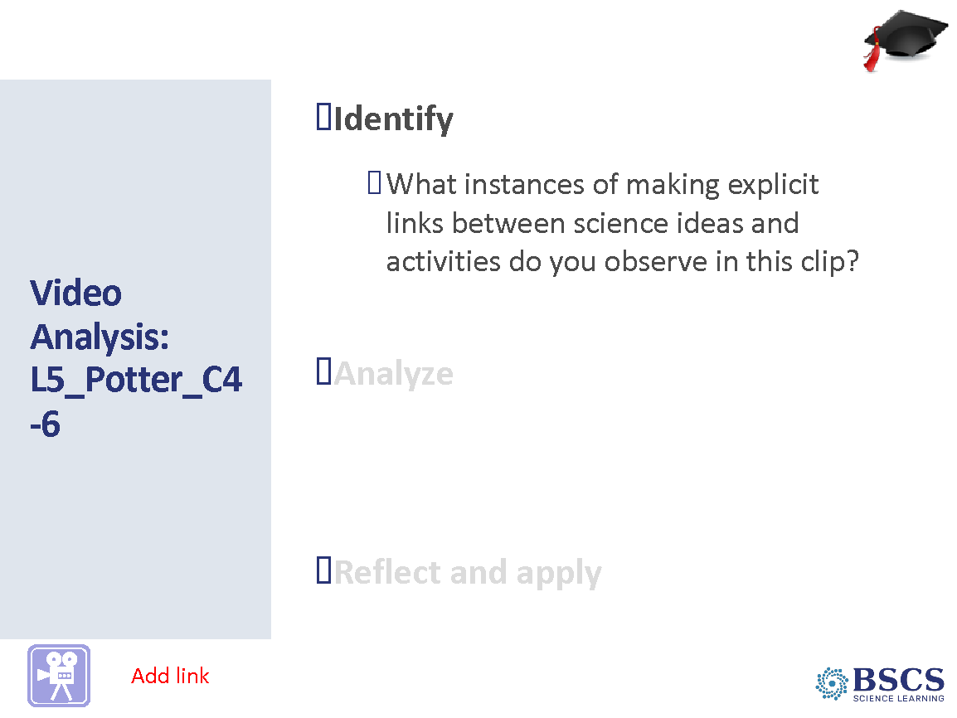 | - Video Analysis: L5_Potter_C4-6 (10 min)  - Watch video clip (4:56)  - Provide time to mark up the transcript for Strategy F  - Invite participants to share out clear examples.
 |  | 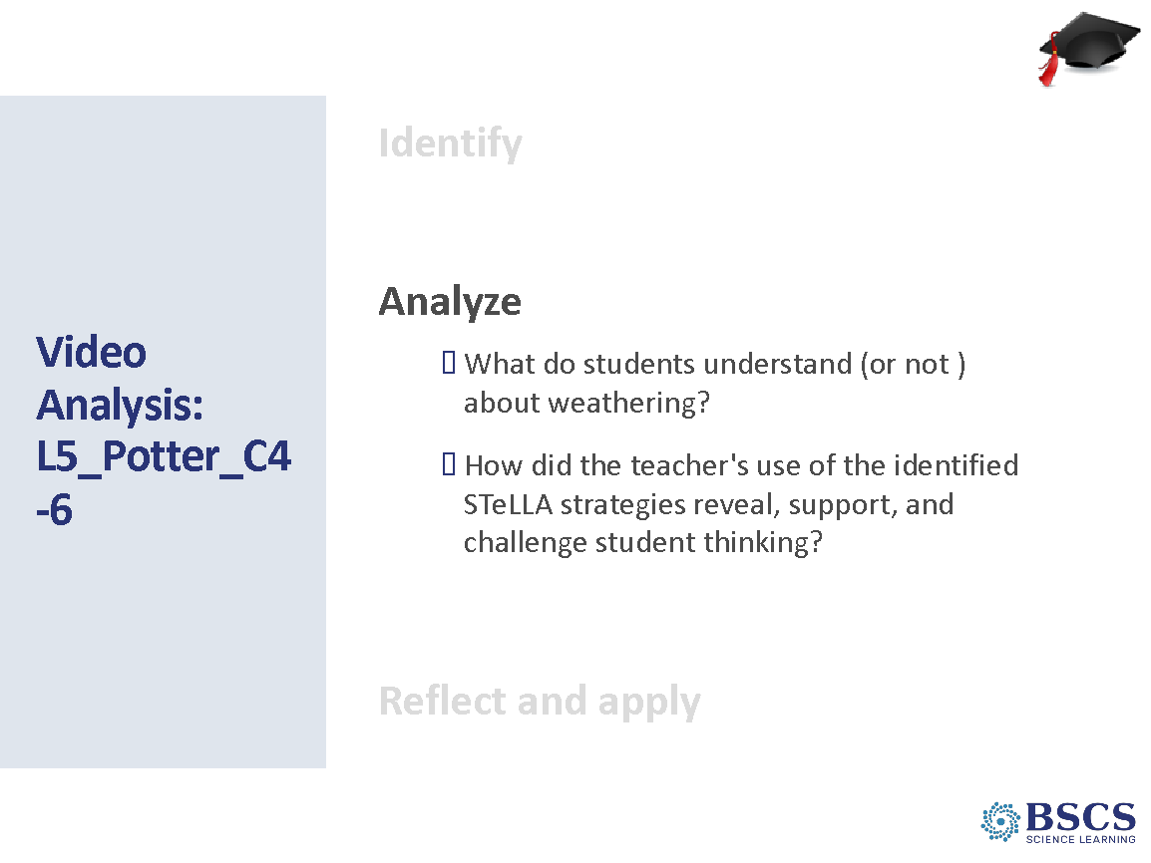 | - Video Analysis: L5_Potter_C4-6 (20 min)  - Pass out LAP for L5_Potter_C4-6  - Provide ~6 min for participants to complete their LAP.  - Invite participants to share their analysis and encourage discussion and deeper thinking between participants.  PDL NOTE: Examples of what students understand (or not) about weathering:  00:01:00 – 00:01:41 Students explain that when water freezes in a rock, it will cause the rock to burst or crack and split open. However, they do not explain that this is due to expansion of water as it freezes.  00:02:02 – 00:02:58 Students explain that when rocks hit the ground or other rocks they can break into smaller pieces (or even sand). Students connect rocks breaking into smaller pieces with mountains getting smaller (lowering).  00:03:31 The student connects freezing water with breaking up rocks and this causes mountains to lower.  00:04:16 – 00:4:43 The student agrees and disagrees with the previous student and names that freezing water causes rocks to break apart and create more rocks. The student agrees with the teacher that freezing creates more rocks. The student does not name that the new rocks would be smaller. This might be a missed opportunity to probe and/or challenge the student’s ideas about the creation of more rocks and their size.  PDL NOTE: Examples of making explicit links between science ideas and activities (SCSL F) to reveal, support, and challenge student thinking:  00:00:03 – 00:00:54 The teacher’s elicit question (00:00:03) invites students to make a connection between the frozen soda can (activity) and freezing water breaking apart rocks (science idea). At 00:00:54, the teacher challenges the student to connect their ideas about the expansion of the pop can with water freezing in rocks.  00:01:19 – 00:01:41 The teacher asks the student, “So can you link that idea to a rock? When the student says, “No.” the teacher follows with, “How might that frozen stuff in there affect a rock if we’re talking about water inside a rock?” The student then explains the freezing rock will cause the rock to split open.  However, there is a missed opportunity to connect the expansion of the soda can when it freezes to the expansion of water freezing in a rock causing the rock to break apart.  00:02:02 – 00:02:58 The teacher’s elicit question (00:02:02) invites students to make connections between shaking rocks in a bottle to rocks rolling down a mountain slope. At 00:02:28 the student describes rocks breaking as they roll down a mountain. The teacher challenges the student to provide evidence from the activity to support their ideas at 00:02:46: “Okay, do you have evidence for that around from around here?” The teacher elicits ideas from other students and a second student links shaking the rocks in the bottle to rocks breaking and mountains lowering.  00:04:11 – 00:04:56 The teacher probes the student’s ideas about more rocks being made when a big rock breaks apart (00:04:43). At 00:04:54, the teacher challenges the student to link their science ideas to the activity, “So where would you get the evidence from to support that?” The student names the evidence would come from the frozen soda can (00:04:56).
 |  | 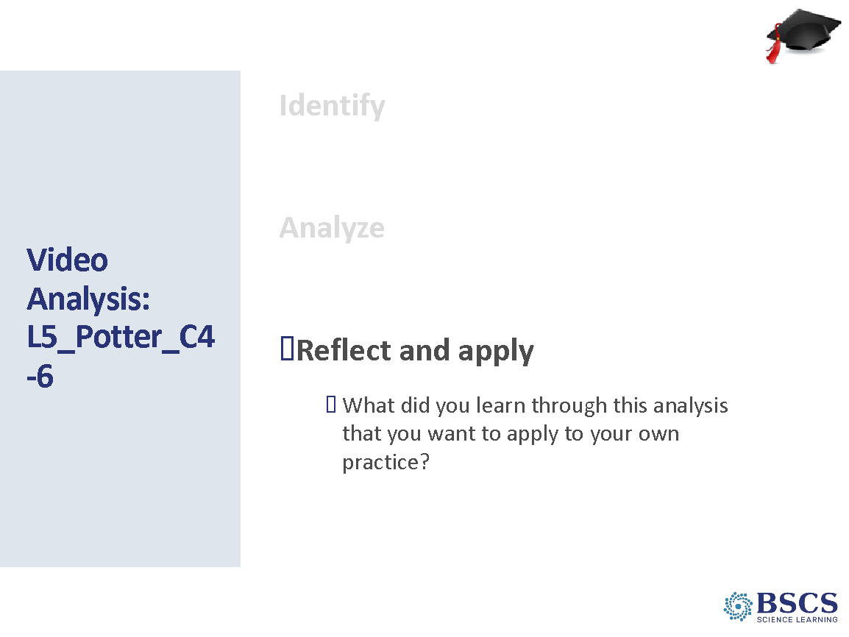 | - Video Analysis: L5_Potter_C4-6 (10 min)  - Provide participants time to reflect at the bottom of their LAP  - Invite participants to share their reflections aloud with the group.
4:15 – 4:30  15 min  Slides 72 - 75 | Purpose: The purpose of this session is to reflect on the day’s experiences and learning and prepare for Friday.  Content: Focus Questions  - Has the Earth’s surface always looked this way? Why or why not?  - How does watching classroom video help teachers become more reflective practitioners?  - Why is it important to intentionally plan to use specific STeLLA strategies throughout a lesson?  Materials  - Chart paper  - Sticky notes  - pens |  | - Day 1 Focus Questions (5 min)  - Close with a reflection on today’s learning by returning to the Friday Strategy Focus Questions.  - Invite participants to add/revise their response to these two questions in their BSCS Journal.  - Invite a few participants to share out.
 |  | 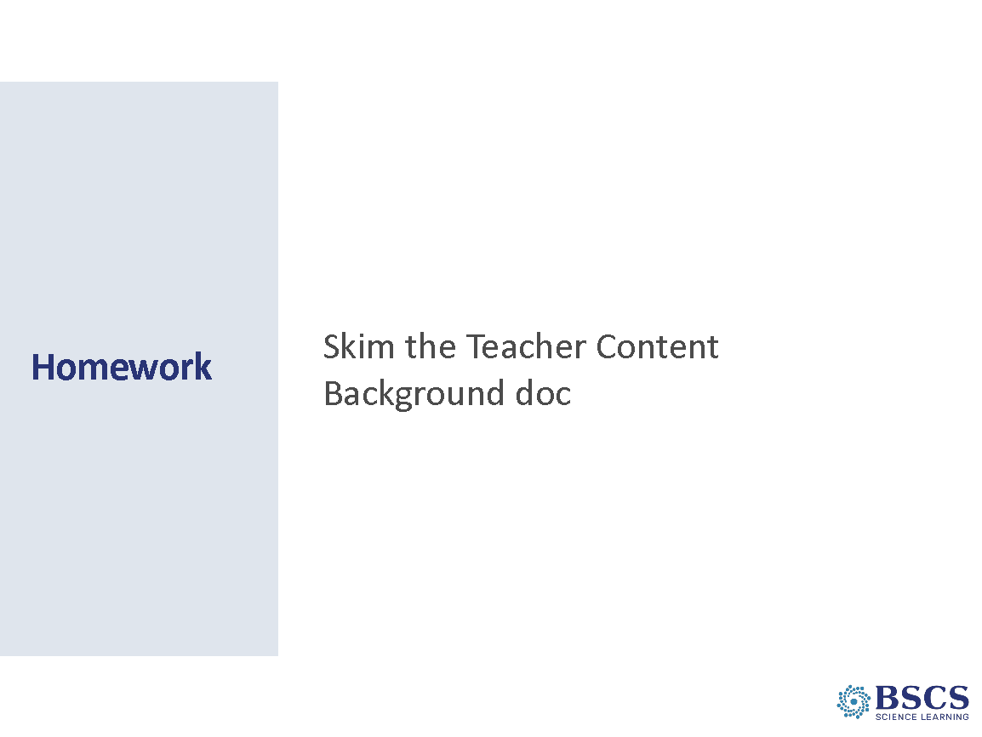 | - Homework (0 min)  - Encourage participants to skim the Teacher Content Background document as it will help as we engage as learners tomorrow in the final lesson of the unit.
 |  | 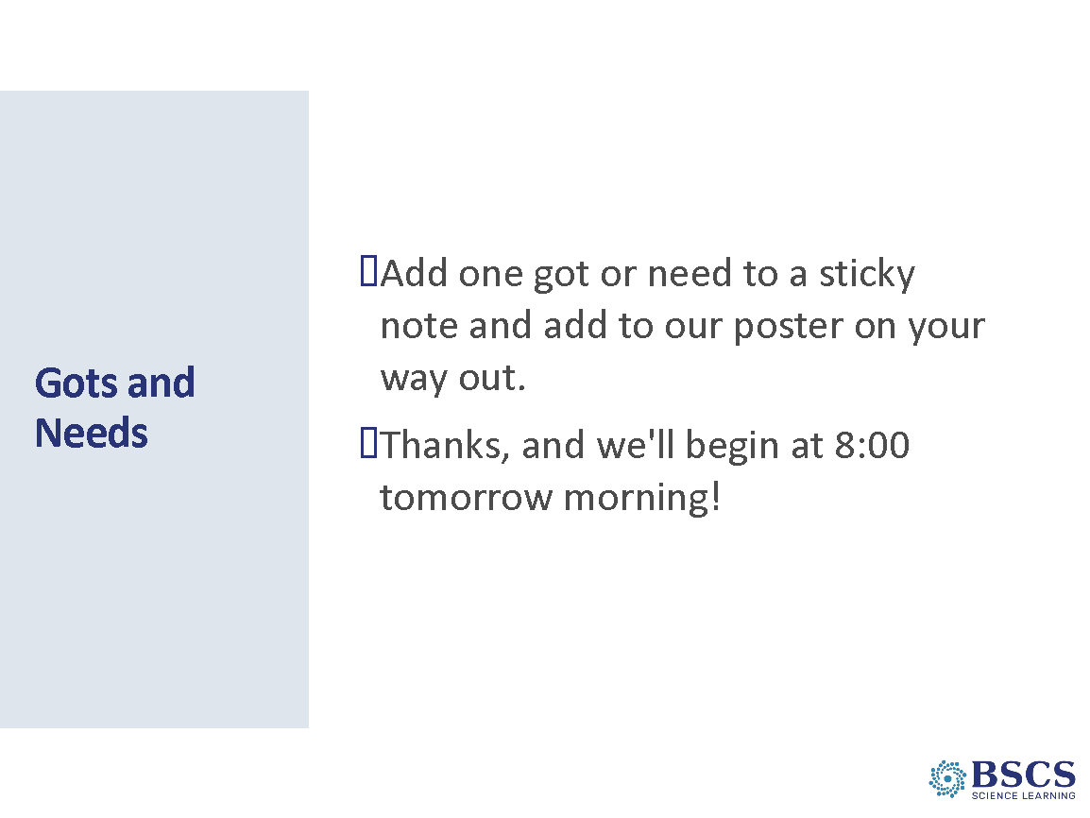 | - Gots and Needs (5 min)  - Provide directions for the task.
 |  |  | - Closing Slide (0 min)  - Thank participants for a great day!

