SSUP: Summer Institute - PD Leader Guide Day 1
Grade Level | 4 | Day | 1 | STeLLA Strategies Focus | STL 4 | Subject Matter Focus | Energy, Every Day, Everywhere
Teacher Learning Goals | - The goals of the STeLLA PL program are to deepen knowledge of teaching and learning, increase ability to analyze and reflect on teaching and learning, increase ability to use content knowledge and knowledge of teaching and learning to transform classroom practice, deepen teacher content knowledge, and increase student learning in science.  - The understanding and application of research on teacher and student learning has shown that the STeLLA Student Thinking and Science Content Storyline Lenses are important to improve science teaching and students’ learning.  - We can detect energy when an object is moving. We can detect changes in energy when the motion of an object changes.  - Based on Communicating in Scientific Ways, teachers can distinguish observation and inference; data and evidence; claim, evidence, and reasoning; reasoning with data/evidence, ideas, and models; and eventually, explanation and argumentation.
Focus Questions | - How do we know if something has energy?  - How can students be empowered to reveal their thinking and to listen to and interact with each other during classroom conversations?
Ideal Teacher Response | How do we know if something has energy?  An object has energy when it is moving. The faster an object is moving, the more energy it has. When the launcher bar of a toy car launcher is released, it has energy when it is moving forward. When the launcher bar hits the car, it gives the car energy, and the car starts moving. The farther the rubber band is pulled back, the faster and farther the car will go.  How can students be empowered to reveal their thinking and to listen to and interact with each other during classroom conversations?  Strategy 4 of the Student Thinking Lens, engage students in communicating in scientific ways, provides sentence stems that help students engage in scientific discourse and make their thinking visible to each other and the teacher. This classroom practice promotes a classroom culture that values student thinking.

Preparation | Materials | Videos and Transcripts
Planning/Preparation Tasks:  - Study PDLG, PPTs, video clips, and handouts. Make changes to PPTs, if needed.  - Link clips  - Content Deepening Prep (none)  Daily Set Up Tasks:  - Check that video clips are correctly linked to PPT  - Set up PowerPoint and speakers  - Check video & sound  - Arrange furniture, food (include social distancing protocols in set up)  - Arrange posters/charts  Day 1 Set Up Task:  Arrange teacher materials on tables:  - Tabletop name cards  - Table boxes (small red, green, yellow dots; black permanent fine-tipped markers)  Daily Follow-up Tasks:  - Archive final PPT  - Collect and turn in daily feedback  - Disinfect common materials, tables, and common areas per protocol | Posters/Charts:  - STeLLA Conceptual Framework poster.  - Communicating in Scientific Ways poster  - Program Goals chart  - Day 1 Agenda chart  - Norms poster  - Day 1 Focus Questions chart  - Effective Science Teaching chart (sections cut up for initial charting)  - Parking Lot chart  - Know/Wonder chart  - Notice/Wonder chart  - DQB Title (Unit Central Question)  Handouts in PD binder front pocket or in Pre-Tab:  - Z-fold chart: Student Thinking Lens Strategies  - Program Goals  - Week-at-a-Glance  Handouts in SSUP PD binder, Tab 1:  - Norms  - CSW Transcript: SSUP_ET_TN GR4_SG1_Willett_C1  - Day 1 Reflection  - Cut sheet: Science Content Handouts  - HO 1.1: Ideas about Energy  - HO 1.2: Communicating in Scientific Ways  Supplies:  - Car Launcher System (1/group of 3)  - Chart paper and markers  - Blue tape  Resources:  - STeLLA Strategies booklet  - BSCS Journal (norms pasted into the journal)  - Content Deepening Notebook | - CSW Clip: SSUP_ET_TN GR4_SG1_Willett_C1
DAY 1 SESSION OUTLINE: 10:00 a.m. - 4:30 p.m.
Time | Purpose | Content | Activities
10:00 – 10:40  40 min  Slides 1-7  Whole Group | Purpose: Continue to build community and set the stage for learning throughout the week and into the academic year. | Content: Share focus questions for the day:  - How do we know if something has energy?  - What are the STeLLA Lenses and Strategies, and why do we think they will make a difference in your science teaching and students’ learning?  - How can students be empowered to reveal their thinking and to listen to and interact with each other during classroom conversations? | Opening  - Welcome & introductions  - Goals, Agenda, and Norms  - Focus Questions  - Revisit Effective Science Teaching Chart
10:40 – 10:50  10 min | Transition to Study Groups
10:50 – 11:50  55 min  + 5 min break  Slides 8-16  Study Group Teams | Purpose: Model effective STeLLA-based science teaching and learning through a common experience that is grounded in a 3D, phenomena/problem driven unit and designed for adult learners. The Teacher Set-up and Follow-up are reflective of STeLLA Strategy F (Activity Set-up, Activity, and Activity Follow-up) with an eye toward teachers as science learners. PDLs use the teacher follow-up to uncover teacher ideas about their experience and then leverage those ideas throughout analysis of practice. | Content: STeLLA model lessons/units attend to the characteristics of effective science teaching and learning (e.g., 3D, phenomenon/problem-driven, student-centered, make student thinking visible and support sense-making, coherent, and access/engage prior knowledge and develop metacognitive abilities).  We can detect energy when an object is moving. We can detect changes in energy when the motion of an object changes. | Content Deepening: Anchor Lesson 1  - Teacher Set-up  - Anchor Experience for Adult Science Learners  - Teacher Follow-up
11:50 – 12:35  45 min | Lunch (served between 11:45 a.m. and 12:45 p.m. for maximum flexibility)
12:35 – 2:15  110 min  Slides 16-26  Study Group Teams | Purpose: Model effective STeLLA-based science teaching and learning through a common experience that is grounded in a 3D, phenomena/problem driven unit and designed for adult learners. The Teacher Set-up and Follow-up are reflective of STeLLA Strategy F (Activity Set-up, Activity, and Activity Follow-up) with an eye toward teachers as science learners. PDLs use the teacher follow-up to uncover teacher ideas about their experience and then leverage those ideas throughout analysis of practice. | Content: STeLLA model lessons/units attend to the characteristics of effective science teaching and learning (e.g., 3D, phenomenon/problem-driven, student-centered, make student thinking visible and support sense-making, coherent, and access/engage prior knowledge and develop metacognitive abilities).  We can detect energy when an object is moving. We can detect changes in energy when the motion of an object changes. | Content Deepening: Anchor Lesson 1  - Teacher Set-up  - Anchor Experience for Adult Science Learners  - Teacher Follow-up
2:15 - 2:30  15 min | Break
2:30 - 4:20  110 min  Slides 27-40  Study Group Teams | Purpose: Develop a shared understanding of STeLLA Strategy 4: Communicating in Scientific Ways and how it plays out in the classroom from the introduction of CSW to improving students’ use of the sentence stems. | Content: Engaging students in CSW helps students reveal their thinking and supports listening and responding to one another’s ideas. CSW helps establish a classroom culture of revising ideas and moves away from a culture of right answers. Teachers have an important role to play in supporting student discourse (student-to-student talk). | Lesson Analysis: STL Strategy 4  - Set up: Charting  - Video Analysis x2  - Follow-up
4:20 - 4:30  10 min  Slides 41-44  Study Group Teams | Purpose: Reflect on the day’s experiences and learning and prepare for Day 2. | Content: Focus Questions:  - How do we know if something has energy?  - What are the STeLLA Lenses and Strategies, and why do we think they will make a difference in your science teaching and students’ learning?  - How can students be empowered to reveal their thinking and to listen to and interact with each other during classroom conversations? | Closing  - Revisit Focus Questions  - Day 1 Reflections  - Homework:  - Read STL overview and Z-fold STL 1, 2, and 3

DAY 1
Time and Focus | Purpose and Content &  What Participants Do | Slides | Process
8:00 – 8:30 | Coffee & Conversation  Resources  - Name Tags |  | Need several hands-on deck to help participants complete registration, paperwork, and logistics.
8:30 - 9:20  50 min  Slides 1-7  Study Group Teams | Opening  Purpose: The purpose of the opening session is to continue to build community and set the stage for learning throughout the week and into the academic year.  Content: The STeLLA program is designed with the following goals in mind:  - Deepen knowledge of teaching and learning  - Increase ability to analyze and reflect on teaching and learning  - Increase ability to use content knowledge of teaching and learning to transform classroom practice  - Deepen teacher content knowledge  - Increase student learning in science  To achieve these goals, it is important to develop a strong community of learners to create a safe and respectful environment to make teacher thinking and practice visible.  What Participants Do:  Participants introduce one another and orient to the day’s activities and focus questions. They review the goals of the program and revisit their Effective Teaching and Learning charts.  Resources  - Journal  - PD Binder  - Week-at-a-Glance  - Norms  - STeLLA Strategies Booklet  - STeLLA Conceptual Framework poster  - Charts  - Program Goals  - Day 1 Agenda  - Day 1 Focus Questions  - Norms  - Parking Lot  - Effective Science T&L | 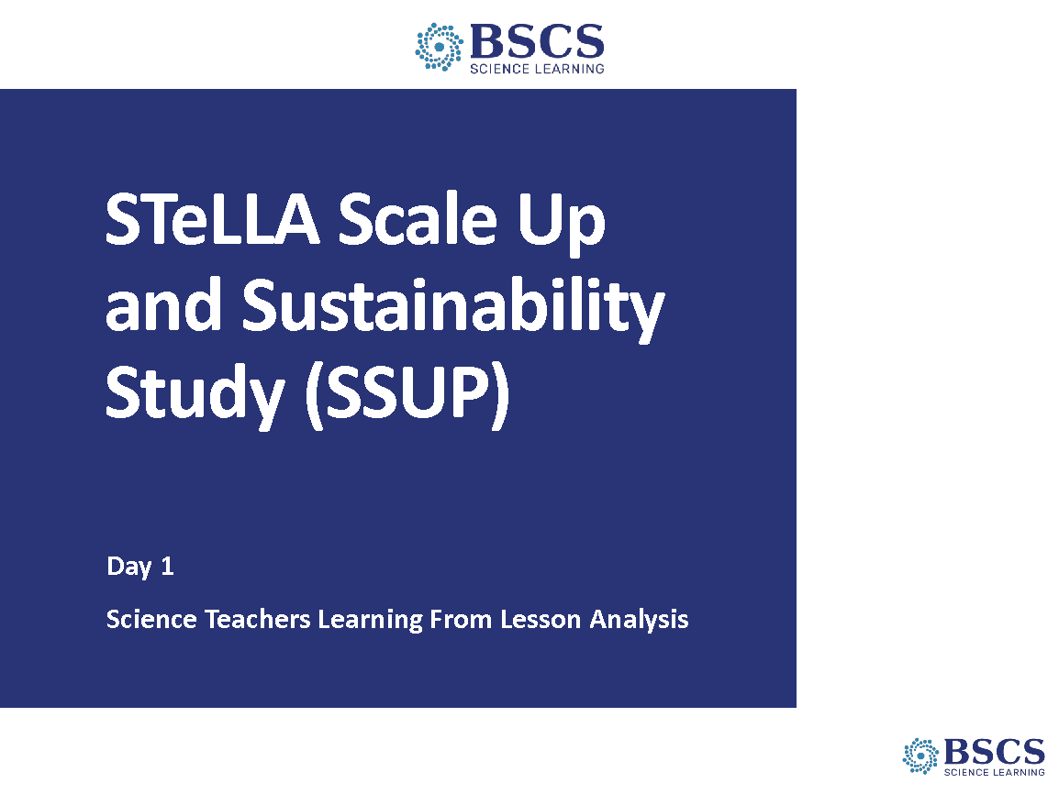 | - SSUP Program Day 1 (0 min)  - Greet participants as they enter the room. Help them pick up their materials and find their small group.
 |  | 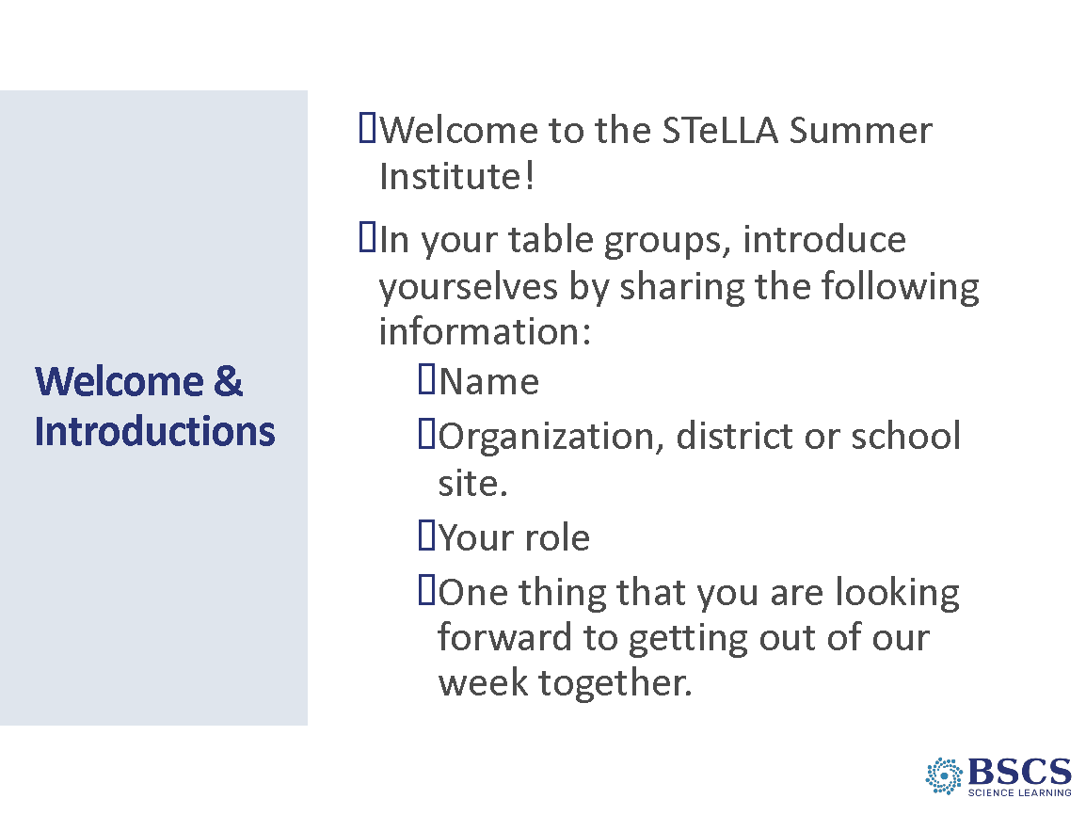 | - Welcome and Introduction (10 min)  - Welcome the team to the summer institute.  - Frame much of this opening session as part of continuing to get to know one another and building community. Provide instructions for the introductions task.  - Provide instructions for introductions to be done in their table groups as directed on the slide. Give table groups about 6 min to complete introductions. Remind them to listen for patterns/similarities.  - Ask tables to share a few examples of things people are looking forward to for the week.
 |  | 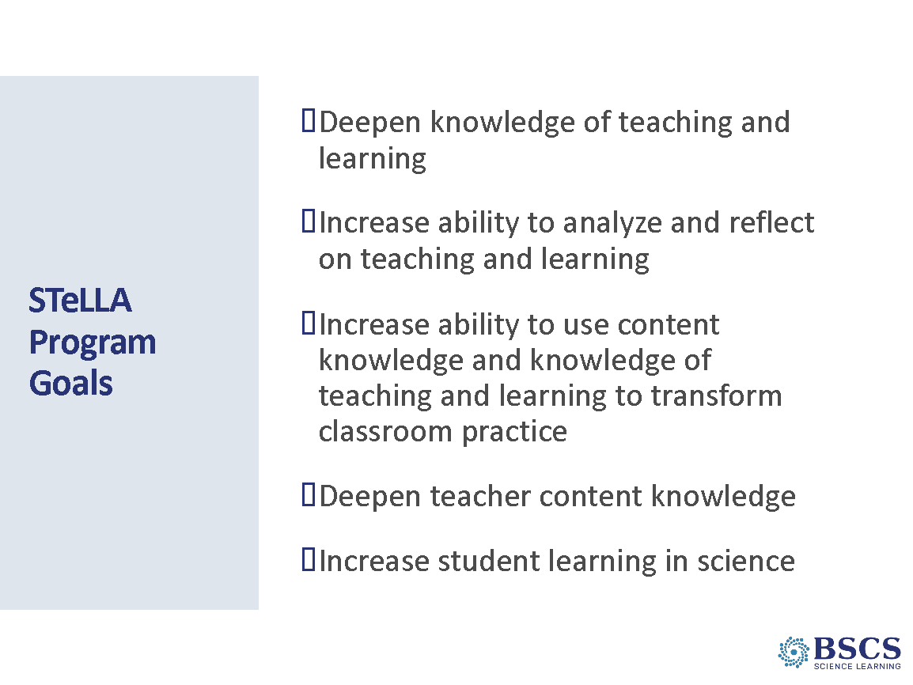 | - Program Goals (5 min)  - Briefly share the program goals (p. __).  - Forecast that we will work toward these goals together throughout the week and academic year. Note that one of the sessions later today will help us think together about why we think this program will “work”.  - Ask participants to consider how these goals resonate with their expectations for the week. Invite participants to record some ideas in their notebook.  PDL Note: Be sure to link what we will do during the summer institute to work toward these goals.
 |  | 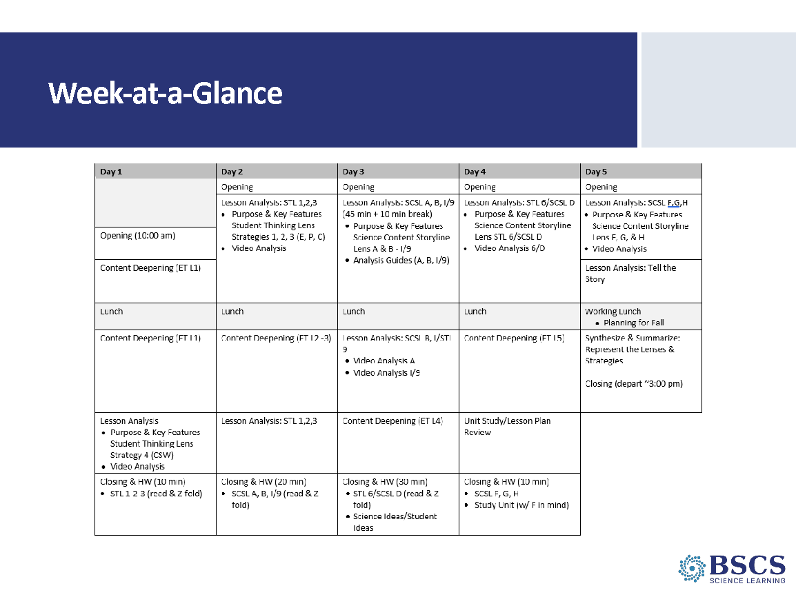 | - Week-at-a-Glance (5 min)  - Refer participants to p. __ in the PD binder.  - Provide an overview of the week.  - Point to the Day 1 agenda chart. Forecast there will be homework all week.  - Remind participants how we will work.  - Parking lot  - Breaks/take care of your own needs  - Safety protocols
 |  | 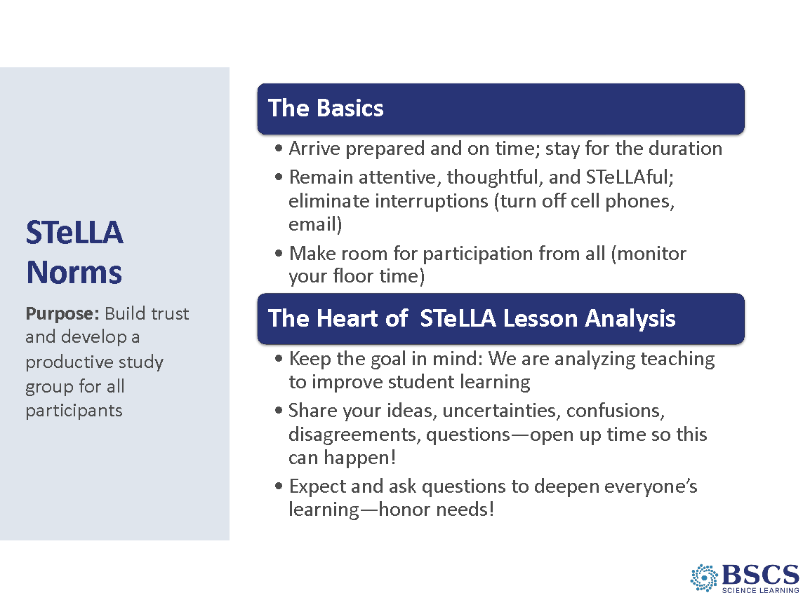 | - Norms (5 min)  - Refer participants to p. __ in the PD binder and in their BSCS journal.  - Begin by asking participants what kinds of norms they have used in the past. Whip around and gather some ideas. Follow-up responses with a question about why that norm or the use of norms in general was important.  - Highlight the purpose of norms in collaboration (i.e., learning together) and link to their ideas as possible. Note that we’ve found these particular norms to be especially helpful in the work of a STeLLA Study group.  - Ask for any clarifying questions and then to note which norms they think are really important to promote collaboration.  - Share that we’ll revisit the norms periodically and take some time tomorrow morning to customize them for our work together.
 |  | 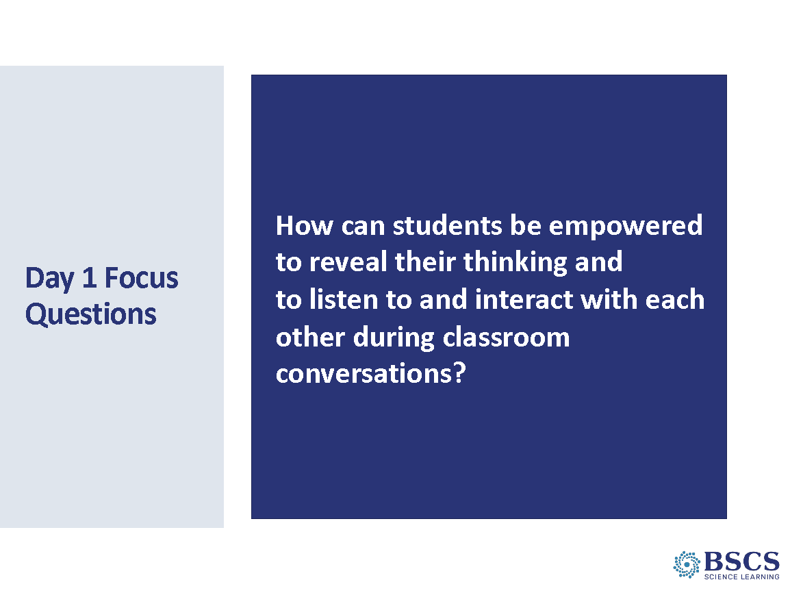 | - Focus Questions (5 min)  - Note that focus questions are a hallmark of this program.  - Share the focus questions for Day 1. Link back to the program goals.  Transition: This program is all about improving our science teaching so we can improve students’ learning. To get us started, we’ll revisit our ideas of effective science teaching.
 |  | 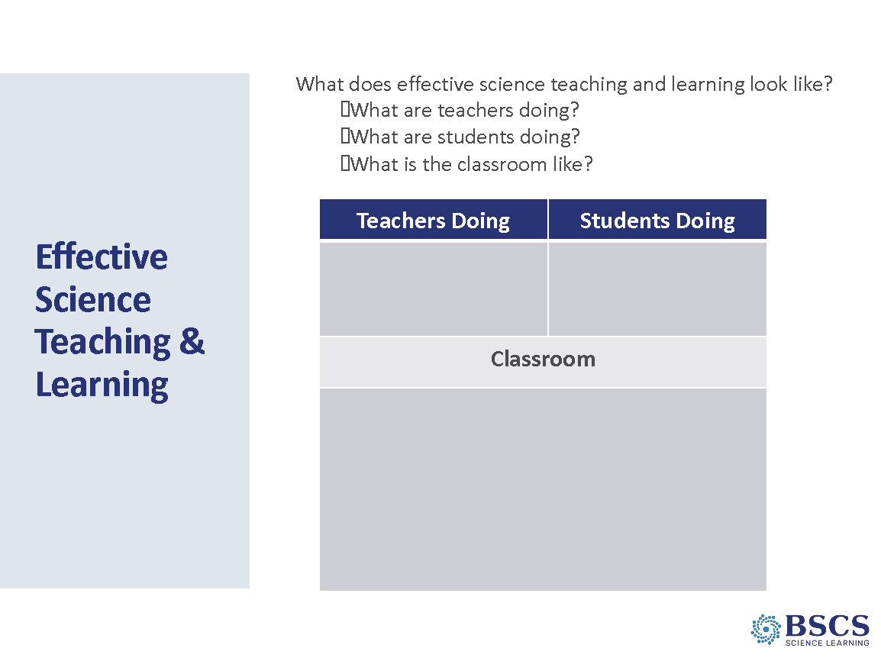 | - Effective Science Teaching & Learning (10 min)  - Share the questions on the slide and remind teachers of their work during the Virtual Kickoff sessions. Link to the program goals of improving our science teaching so we can improve our students’ learning.  - Briefly provide an overview of the task/process. Divide rooms into study groups and have each group discuss ideas on their Google document from the Zoom kickoff and translate the ideas onto chart paper.  Transition: We’ll revisit these ideas later as we learn more about the STeLLA Lenses and Strategies (point to focus questions) and the research about science teaching and learning that serves as the foundation for the Conceptual Framework (point to the Conceptual Framework cover page/poster).
10:40 – 10:50  10 min | Transition to Study Groups
10:50 – 10:55  5 min | Break  PDL Note: As participants arrive at their Study Group space, invite them to find a place for their materials and take a quick break before we begin the next session.
10:55 -11:50 60 min  Slides 8–16  Study Group Teams | Content Deepening: Lesson 1  Purpose: The purpose of this session is to model effective STeLLA-based science teaching and learning through a common experience that is grounded in a 3D, phenomena/problem driven unit and designed for adult learners. The Teacher Set-up and Follow-up are reflective of STeLLA Strategy F (Activity Set-up, Activity, and Activity Follow-up) with an eye toward teachers as science learners. PDLs use the teacher follow-up to uncover T ideas about their experience and then leverage those ideas throughout analysis of practice.  Content:  STeLLA model lessons/units attend to the characteristics of effective science teaching and learning (e.g., 3D, phenomenon/problem-driven, student-centered, make student thinking visible and support sense-making, coherent, and access/engage PK and develop metacognitive abilities).  Observable changes in a rubber band car launcher system provide evidence of energy changes in the system. Motion indicates an object has energy. When the pulled-back rubber band is released, the launcher bar moves forward. As the moving launcher bar collides with the stationary car, the car begins moving and the launcher bar stops. The farther the rubber band is stretched, the faster the launcher bar moves, and the faster and farther the car moves after the collision.  Identifying patterns in nature or the designed world help us ask questions about phenomena [or define problems]. Describing systems in terms of their components and interactions helps us ask questions and make generalizable statements that represent patterns.  Asking questions that can be investigated about what would happen if a variable was changed can help us identify patterns of change in a system.  What Participants Do  Participants identify the components of a toy car launcher system and identify where energy is present (or not) in the system. As they investigate the launcher system, they get clear about the phenomenon (energy changes in the system) they will explore. Participants ask questions that can be investigated about what would happen if a variable was changed and identify patterns of change within the system.  This experience involves the first of five lessons from a unit on Energy, Every Day, Everywhere. As such it represents learning at the intersection of the DCIs, CCCs, and SEPs. It also surfaces and challenges common misconceptions.  Resources  - Journals  - Science Notebook  - STeLLA Conceptual Framework Poster  - CSW poster  - PD Binder  - Science Ideas/Common Student Ideas (Mash up)  - Charts  - Parking Lot chart  - Day 1 Focus Questions chart  - Know/Wonder chart  - Notice/Wonder chart  Handouts  - Communicating in Scientific Ways  Materials  - Toy car launcher (1/group of 3)  - Chart paper and markers | 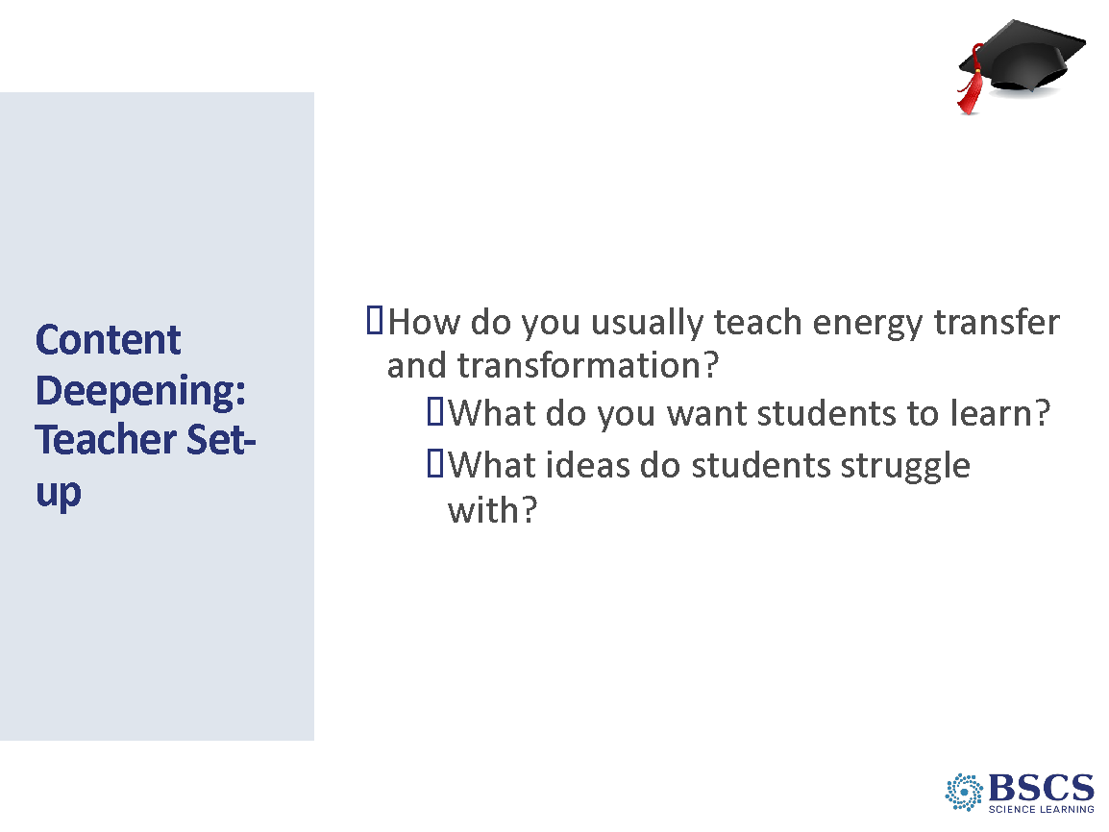 | - Content Deepening: Teacher Set-up (10 min)  PDL Note: The purpose of the Teacher Set-up is to set the stage for teacher learning through the content deepening experience. This part of the session should engage teachers as learners and elicit their prior knowledge and experience.  Transition: As you know, one opportunity offered by this program is to deepen our content knowledge—to learn some science together. We’ll do that through experiences grounded in a common unit of instruction that you’ll use with your students next fall. For our team, that unit will focus on energy transfer and transformation.  - Note the “teacher hat” in the upper right-hand corner of the slide and that we’ll begin with some time to think and write about how you usually teach energy transfer and transformation including “what” they teach and how they sequence the learning.  - Provide time for individual journaling based on the prompts.  - Whip around and gather ideas.  PDL Note: Be cautious about how much time you spend here.  Transition: One of the things you shared was the science that you intend students to learn. Let’s consider our own understanding of the science.
 |  | 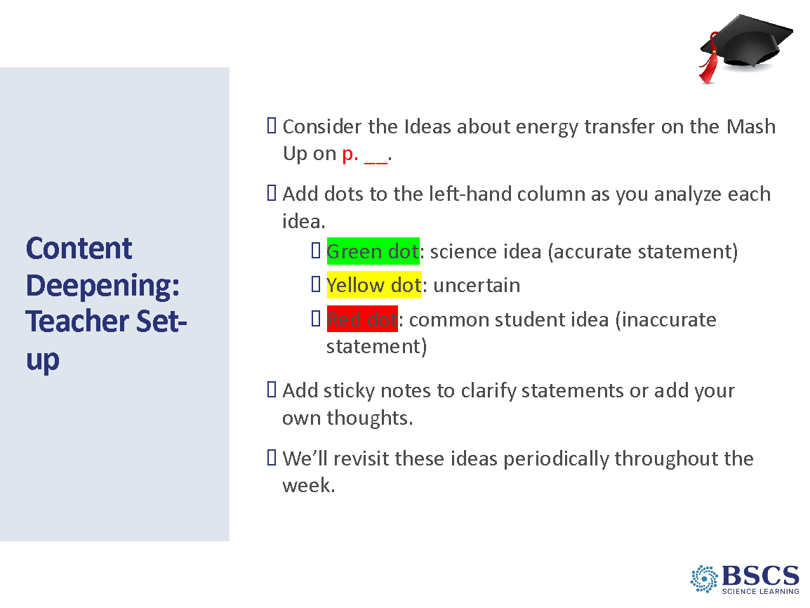 | - Content Deepening: Teacher Set-up (10 min)  - Invite teachers to turn to binder p. __ and consider the ideas and science practices on the page. Note any ideas that are similar to those they shared in their previous conversation.  - Provide instructions and time for the task.  - Note that they’ll have periodic opportunities to revisit and discuss these ideas throughout the week.  Transition: Over the next hour or so, we’ll experience lesson 1 of a unit focused on energy changes. While this experience is grounded in lesson 1, we’ve designed the experience for you as adult learners—as science learners. You’ll see a ball cap in the upper right-hand corner of the slide to signify the new “science learner hat”.  To make the most of this time, set aside your teacher hat and thoughts/questions about how you’ll do this in your classroom with your students. Give yourself and our whole team the gift of immersing yourself in the experience as a science learner. When the inevitable wonderings about teaching come up, capture them on a sticky note or in your BSCS journal so you can re-focus as a learner on our shared experience.  Don’t worry, just as we are in the teacher set-up right now, there will be a teacher follow-up immediately after this science learner experience where we will address any teacher thoughts. Give yourself a moment to get organized. As you are doing that, consider what you’ll do to stay in the learner experience.  PDL Note: Be sure to refer to the common experience as learner hat and not student hat. We want participants to engage in the activities as adult science learners not as one of their students.
 |  | 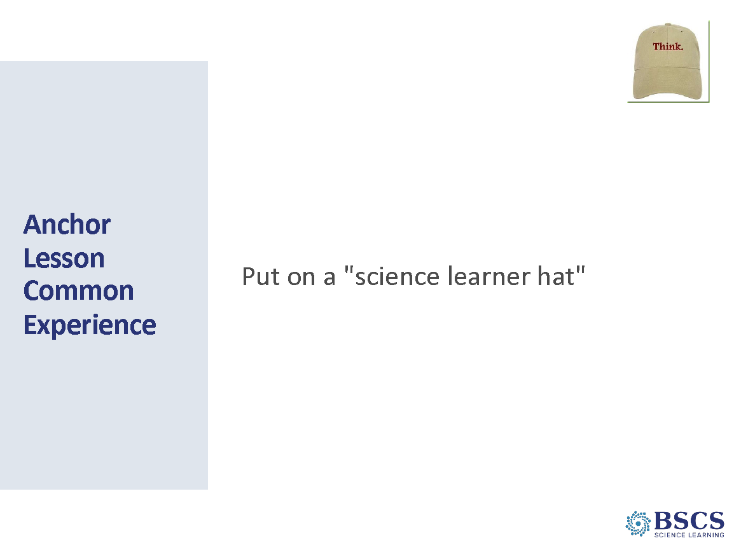 | - Anchor Lesson Common Experience (5 min)  PDL Note: Point teachers to their science learner journals.  PDL Note: Engaging in the lesson as a learner may be a new experience for some participants. They may find it difficult to remain in learner hat. If you notice participants talking in teacher hat, gently encourage them to capture their teacher idea on a sticky note or in their BSCS journal to return to after the common learner experience. If a participant asks the whole group a teacher-focused question, you have a couple of options:  1) you can acknowledge that we will return to their great teacher question in the debrief and invite them to remain in learner hat for now, or  2) you can turn it into a learner hat question, or  Example:  Teacher question: How do I help kids ask questions for the DQB?  PDL follow-up:  So, are you asking how we could work together to develop better questions for the DQB? Or  Great question. Let’s think together about how we could ask better questions for the DQB.  3) you can acknowledge that it’s a conversation you would also have with students.  Example:  Teacher statement:  Kids will really struggle with this.  PDL follow-up:  We can all struggle with this. Let’s pause and talk about OUR struggles...just like we’d do with our kids in class. Let’s talk about it as learners.  Example:  Teacher statement:  These content representations are really important. I think we need to pause and talk about the purpose of each in kids’ learning.  PDL follow-up:  Exactly and this is something I’d want to do with kids in the classroom, so let’s us do this as learners, too. What role did content representation 1 play in your learning? In our learning?
 |  | 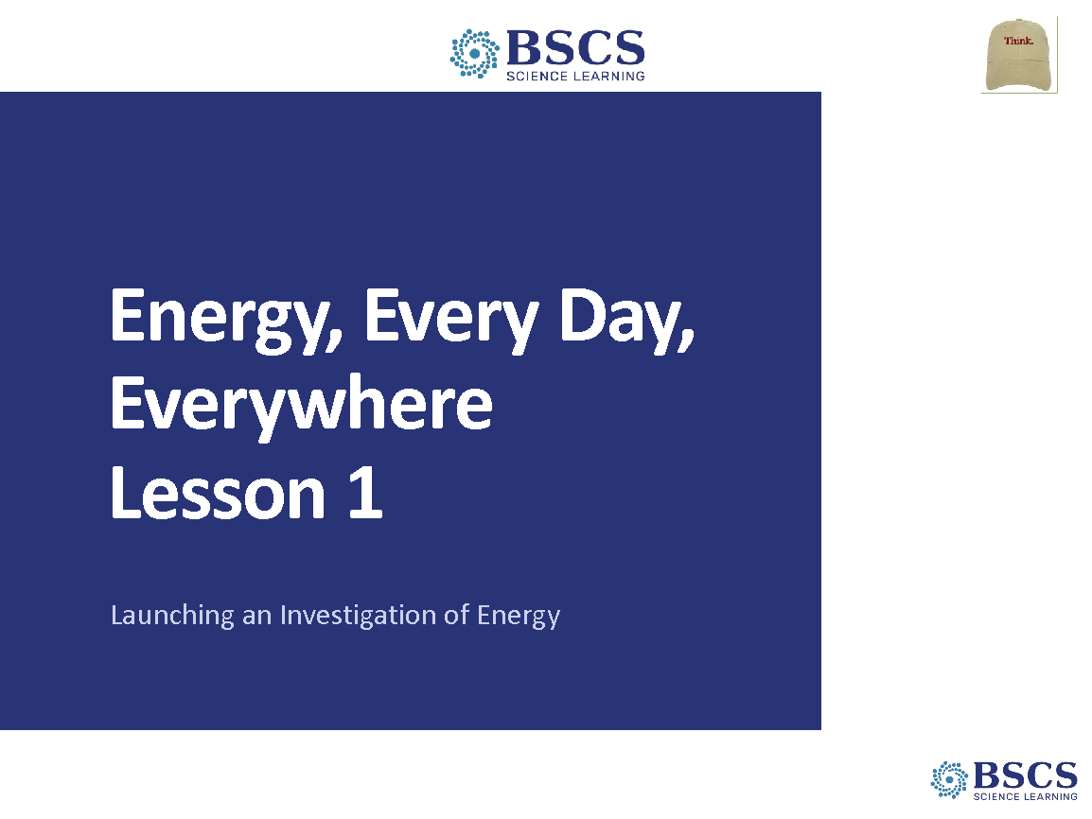 | - Energy Every Day, Everywhere Title Slide (0 min)  - Share that today we are starting a new unit about energy.
 |  | 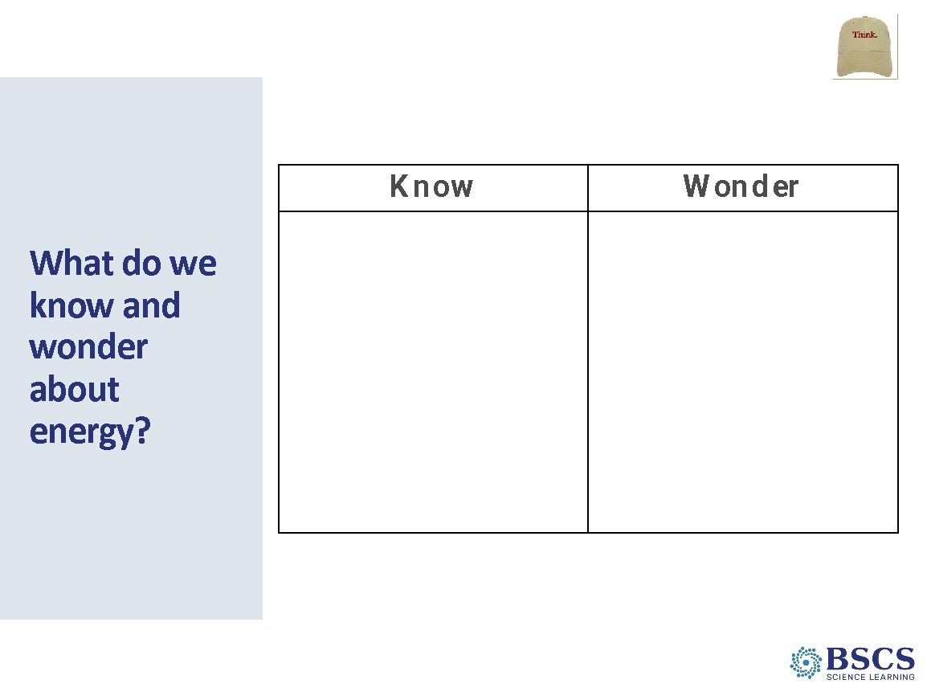 | - What do we know and wonder… (10 min)  - Share that we’ll begin by thinking about what we know and wonder about energy. Pose the question, “What are your ideas about energy?”  - Provide a few minutes of individual think time, then invite several participants to share their ideas with the class.  - Chart ideas on the Know and Wonder chart.  PDL Note: The purpose of this chart is to make prior knowledge visible. It will not be used in subsequent lessons.
 |  | 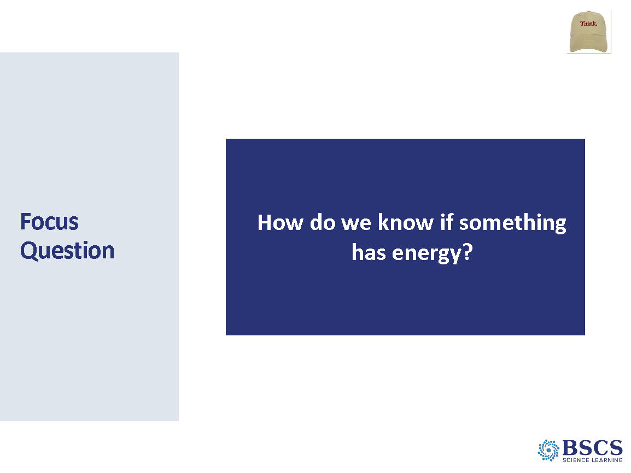 | - Focus Question (10 min)  - Share that we have lots of great ideas and wonderings about energy. Share that we’ll begin investigating these ideas and wonderings by starting with the focus question, “How do we know if something has energy?”  - Have participants leave a space approximately ¼ page at the top of the first page in their science notebook. Share that we will use this space later in the lesson.  PDL Note: This space will be used to write the Unit Central Question after the creation of the Driving Question Board at the end of the Anchor lesson.  - Invite participants to write the focus question in their science notebooks and draw a box around it. Below the box, they should write the sentence starter: “I know something has energy because…”  - Have participants write their best ideas about the focus question and leave plenty of room after to add to and revise their thinking throughout the lesson.  - Invite several participants to share their ideas with the whole group.  PDL Note: Highlight the lesson focus question throughout the content deepening session.
 |  | 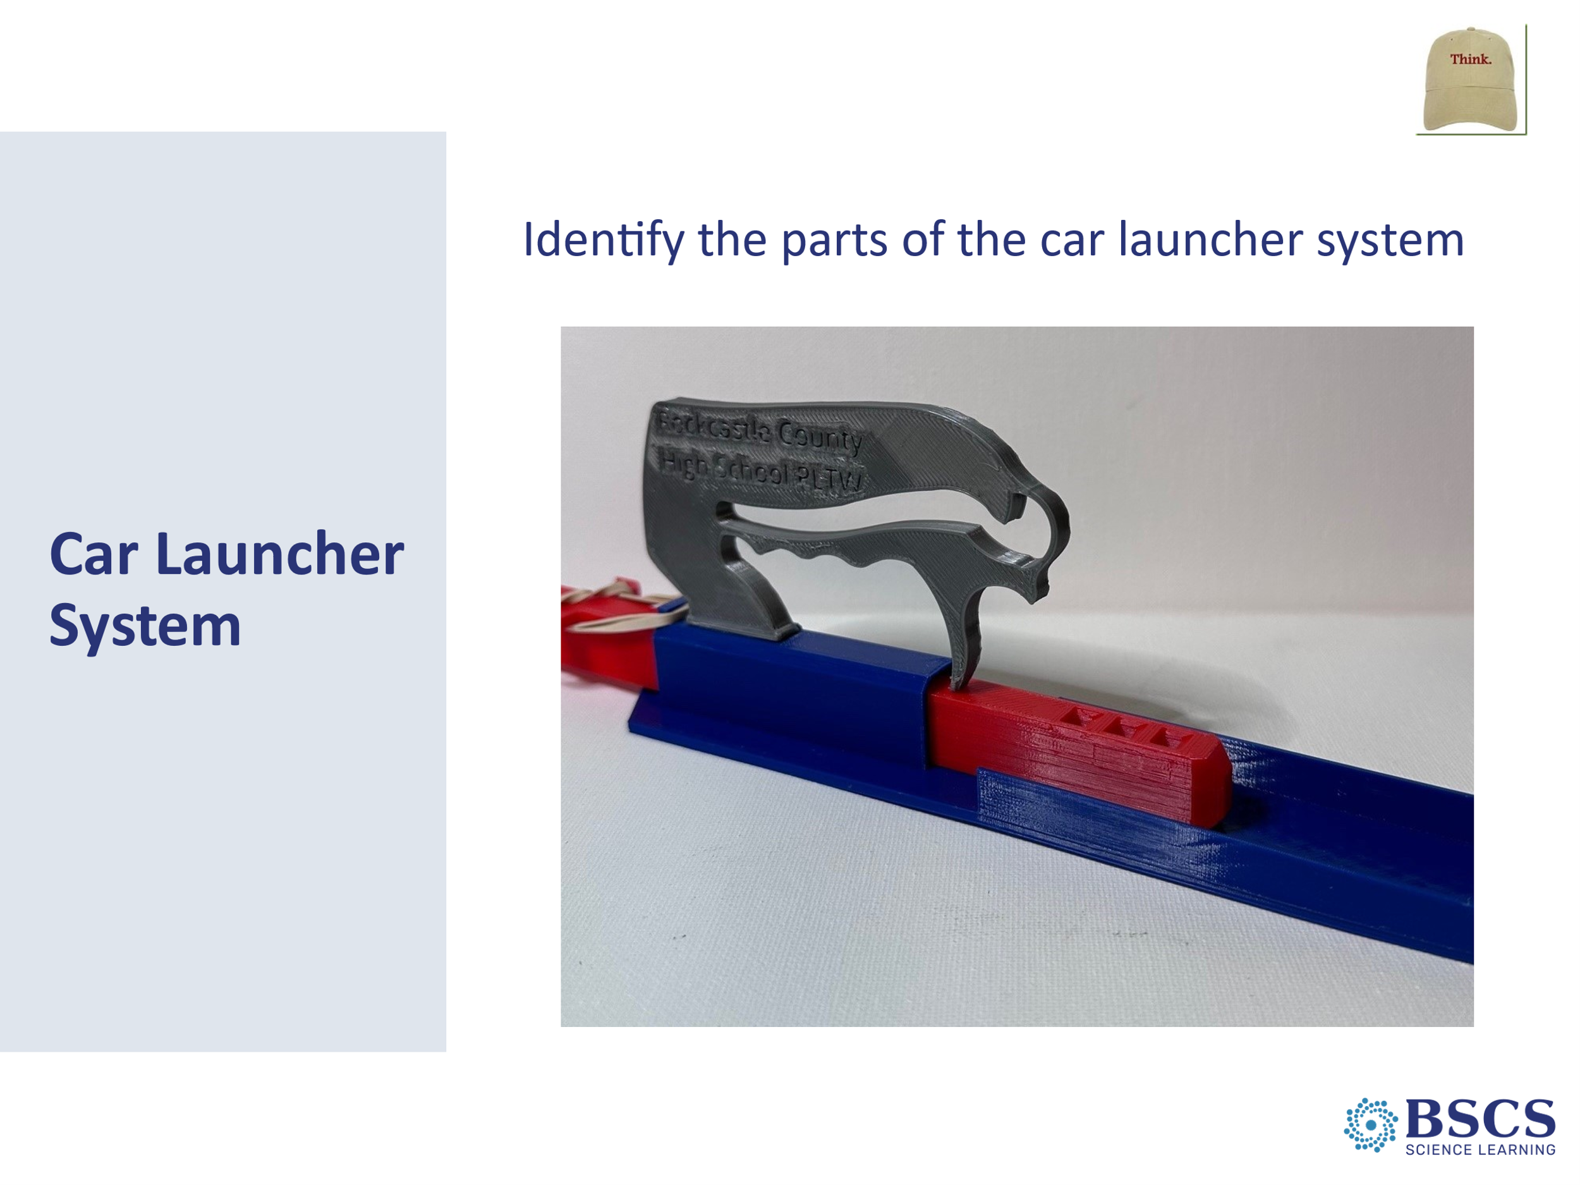 | - Car Launcher System (5 min)  - Share that we will use a toy car launcher system to think more about energy. Highlight that the car launcher is a system; a system has boundaries and is made of parts, or components that interact.  - Identify and come to consensus about names of the parts of the system:  - base  - launcher bar  - track  - car
 |  | 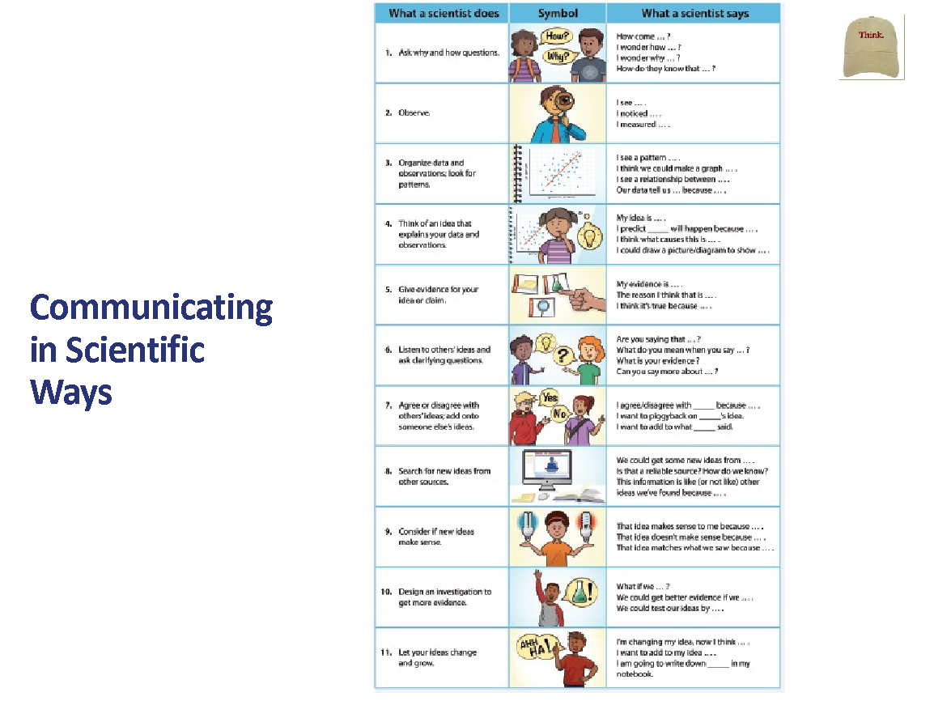 | - Communicating in Scientific Ways (5 min)  - Share that throughout this unit, we will talk about our ideas and questions in the same way that scientists do.  - Pass out the CSW handout and share that we will use the sentence stems to help us communicate like scientists. Orient participants to the Communicating in Scientific Ways (CSW) poster and highlight the categories of CSW and the sentence stems.  - Ask participants if they have used any of these sentence starters in the past and why/how they could be important/helpful AS LEARNERS!  - Share that we will use these sentence starters throughout our learning today, beginning with rows 2 and 7. Add a sticky note to mark these rows on the CSW poster.
 |  | 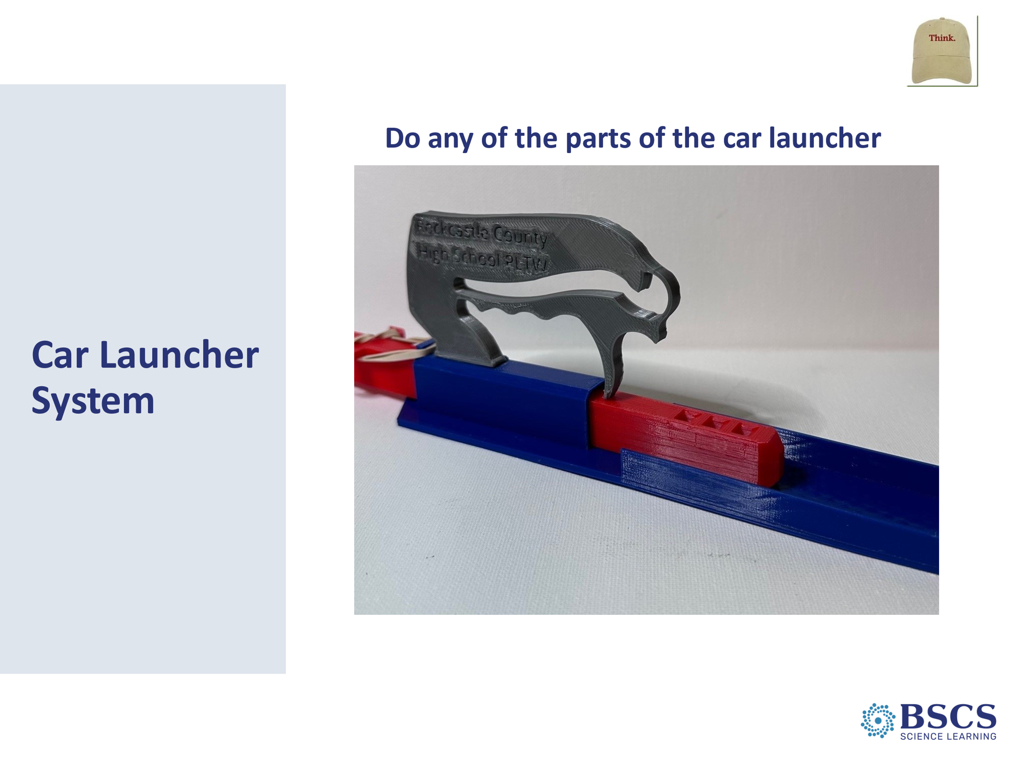 | - Car Launcher System (5 min)  - Invite participants to observe the stationary car launcher system. Pose the elicit question, “Do any parts of the car launcher system have energy?”  - Have participants consider the question individually, then invite participants to share their idea using sentence stems from rows 2 and 7 of the CSW poster.  - Ask elicit and probe questions as participants share. Highlight that you are using sentence stems from row 6 of the CSW chart to make sure you and the class understand each other’s thinking.  PDL Note: Provide timing and directions, including any safety precautions, for lunch.
10:50-12:35  45 min | Lunch
12:35 – 2:15  110 min  Slides 16-26  Study Group Teams | Content Deepening: Lesson 1  Purpose: The purpose of this session is to model effective STeLLA-based science teaching and learning through a common experience that is grounded in a 3D, phenomena/problem driven unit and designed for adult learners. The Teacher Set-up and Follow-up are reflective of STeLLA Strategy F (Activity Set-up, Activity, and Activity Follow-up) with an eye toward teachers as science learners. PDLs use the teacher follow-up to uncover T ideas about their experience and then leverage those ideas throughout analysis of practice.  Content:  STeLLA model lessons/units attend to the characteristics of effective science teaching and learning (e.g., 3D, phenomenon/problem-driven, student-centered, make student thinking visible and support sense-making, coherent, and access/engage PK and develop metacognitive abilities).  Observable changes in a rubber band car launcher system provide evidence of energy changes in the system. Motion indicates an object has energy. When the pulled-back rubber band is released, the launcher bar moves forward. As the moving launcher bar collides with the stationary car, the car begins moving and the launcher bar stops. The farther the rubber band is stretched, the faster the launcher bar moves, and the faster and farther the car moves after the collision.  Identifying patterns in nature or the designed world help us ask questions about phenomena [or define problems]. Describing systems in terms of their components and interactions helps us ask questions and make generalizable statements that represent patterns.  Asking questions that can be investigated about what would happen if a variable was changed can help us identify patterns of change in a system.  What Participants Do  Participants identify the components of a toy car launcher system and identify where energy is present (or not) in the system. As they investigate the launcher system, they get clear about the phenomenon (energy changes in the system) they will explore. Participants ask questions that can be investigated about what would happen if a variable was changed and identify patterns of change within the system.  This experience involves the first of five lessons from a unit on Energy, Every Day, Everywhere. As such it represents learning at the intersection of the DCIs, CCCs, and SEPs. It also surfaces and challenges common misconceptions.  Resources  - Journals  - Science Notebook  - STeLLA Conceptual Framework Poster  - CSW poster  - PD Binder  - Science Ideas/Common Student Ideas (Mash up)  - Charts  - Parking Lot chart  - Day 1 Focus Questions chart  - Know/Wonder chart  - Notice/Wonder chart  Handouts  - Communicating in Scientific Ways  Materials  - Toy car launcher (1/group of 3)  - Chart paper and markers | 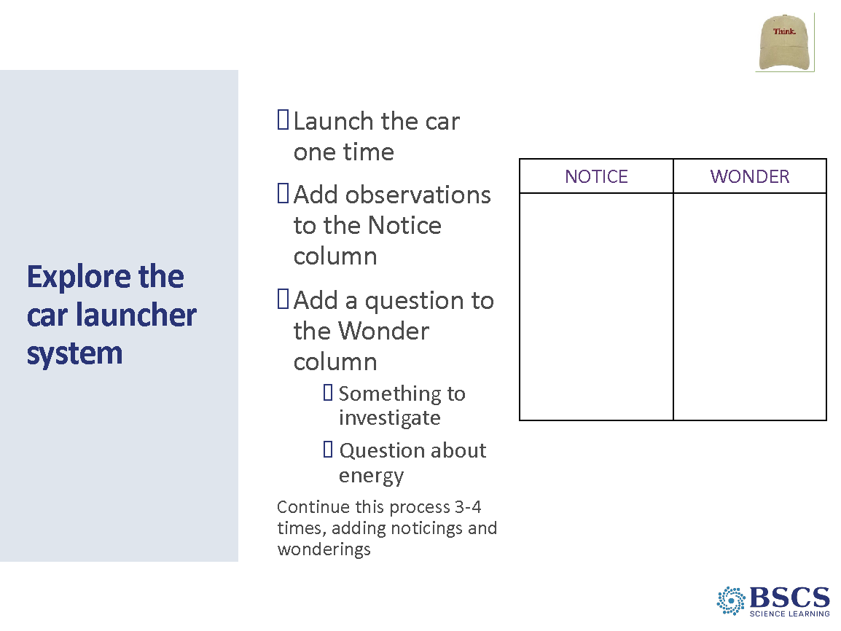 | - Explore the car launcher system (15 min)  - Remind participants of the lesson focus question. Share that we can use car launcher system to think more about the lesson focus question.  - Invite participants to draw a Notice and Wonder chart in their science notebooks.  - Provide directions for the investigation:  - Each team will launch the car 3-4 times.  - After each launch, work together to add your observations to the Notice column of your chart.  - Identify one question your group wants to investigate and/or a question about energy. Record the question in the Wondering column of your chart.  - Repeat the process of noticing and wondering for each launch.  - Move the sticky note arrows to rows 1 and 2 of the CSW chart. Invite participants to use CSW sentence stems from row 2 to identify noticings and row 1 to identify wonderings and questions.  PDL Note: As participants work in their groups, encourage participants to ask questions about what is happening to energy in the launcher system. Energy questions you might ask groups include:  - What observable changes are taking place in the launcher system?  - Where do you see evidence of energy (or not)?  - Where does the energy come from?  - Where does the energy go?  Encourage participants to use CSW sentence stems as they work.
 |  | 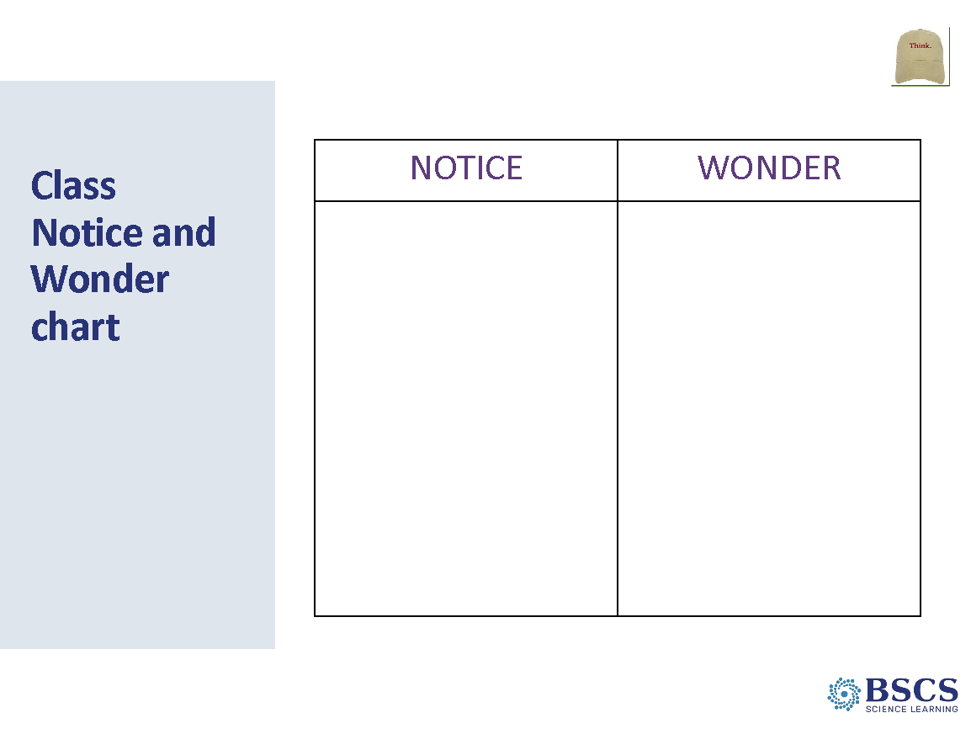 | - Class Notice and Wonder chart (10 min)  - Invite participants to gather around the Notice and Wonder chart with their science notebooks.  - Invite participants to first share their noticings using CSW sentence stems from row 2. As participants share their noticings, ask, “What do you notice about the launcher system and the parts that have energy? How do you know the part(s) have energy?”  PDL Note: If participants use force to explain the observable changes in the system, encourage them to begin to connect their ideas about force with their emerging ideas about energy. Share with participants that forces provide one explanation for the observable changes. Energy, like force can also provide an explanation for observable changes in the system. Refer to the Teacher talk and questions in Lesson 1 of the ET Classroom Curriculum for probe and challenge questions to use in this discussion.  - Invite participants to share their wonderings using sentence stems from row 1 of the CSW chart. As they share, record them on the Notice and Wonder chart.
 |  | 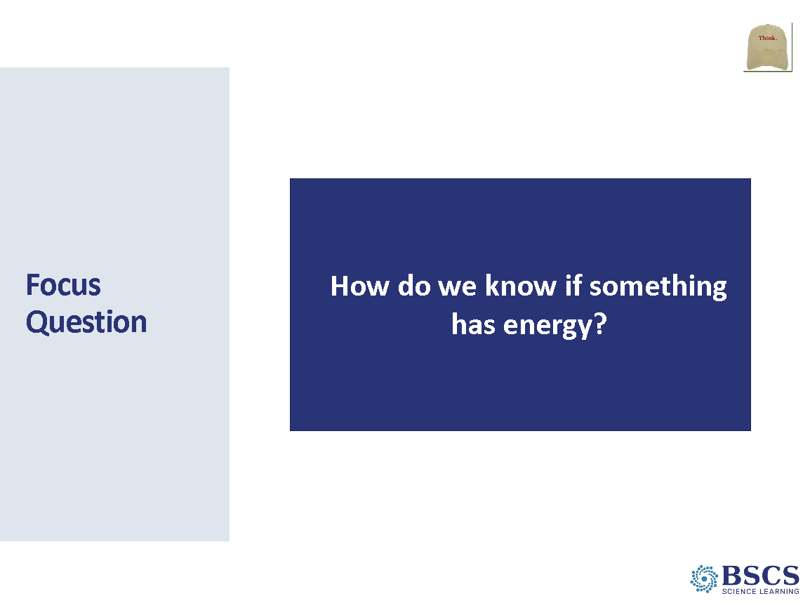 | - Focus Question (10 min)  - Highlight the diversity of ideas on the Notice and Wonder chart. Invite participants to return to their initial response to the lesson Focus Question to add to and/or revise their thinking. They should draw a single line through ideas that have changed and add new ideas in a different color.  - Move a sticky note arrow to row 11 of the CSW poster. Invite participants to share how their thinking has changed using sentence stems from that row. Emphasize that we are getting all ideas out on the table – we are not evaluating whether the ideas are right or wrong.  Transition: We’ve thought about our lesson focus question by exploring the car launcher system, but we still have lots of questions about energy that we need to figure out. Let’s take stock of the questions we have about energy.
 |  | 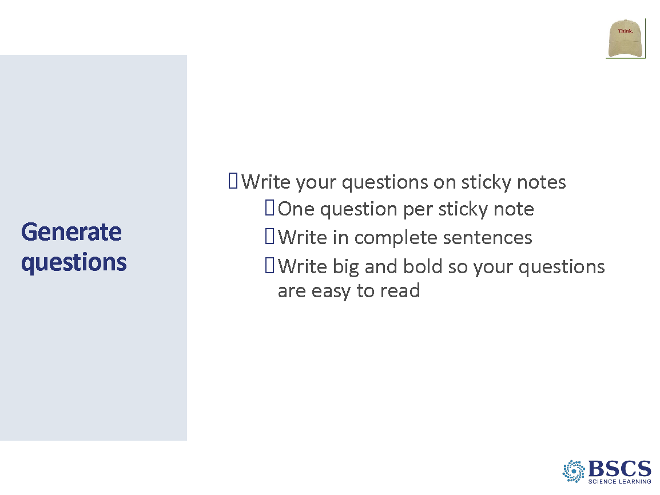 | - Generate questions (5 min)  - Invite participants to review the Know and Wonder chart and their Notice and Wonder chart. These charts are a good place to begin to document our questions about energy.  - Have participants record their questions on sticky notes with a fine point sharpie marker. They should record one question per sticky note in complete sentences. Encourage participants to write their questions big and bold so everyone can read the question easily.  Transition: We’ve generated a lot of questions on our sticky notes. It will be useful to organize them so that we can begin to investigate them.
 |  | 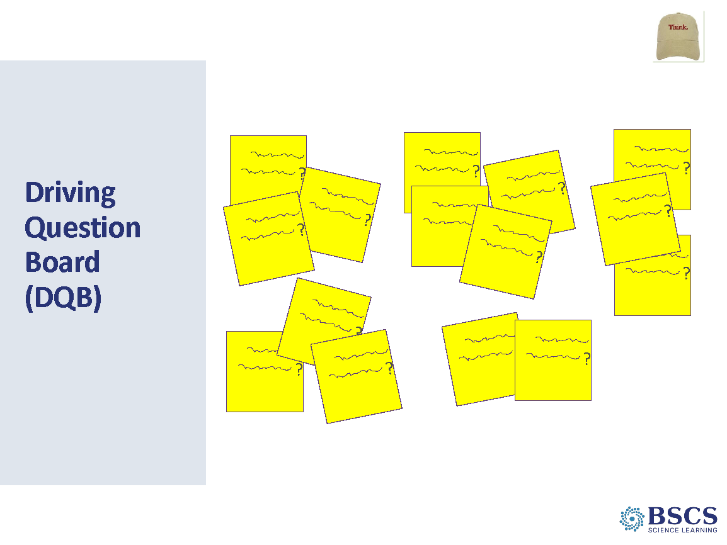 | - Driving Question Board (15 min)  - Invite participants to bring their sticky notes and gather around the Driving Question Board (DQB) chart. Invite participants to take turns reading one of their questions aloud and then sticking it on the chart. After each question is read and placed on the chart, have others with similar or related questions to read them and place them near that sticky note to begin spatially organizing clusters of questions.  PDL Note: Invite participants with fewer sticky notes to share first to ensure the greatest number of participants have the opportunity to read their question aloud.  - As questions are organized into clusters, help the group identify category names for each cluster. Add category names to the top of each cluster. Invite participants to return to their tables and open their science notebooks.  Transition: We have generated a lot of really good questions today. Throughout this unit we will have opportunities to reflect back on these questions to take stock of what we have figured out as well as add new questions.
 |  | 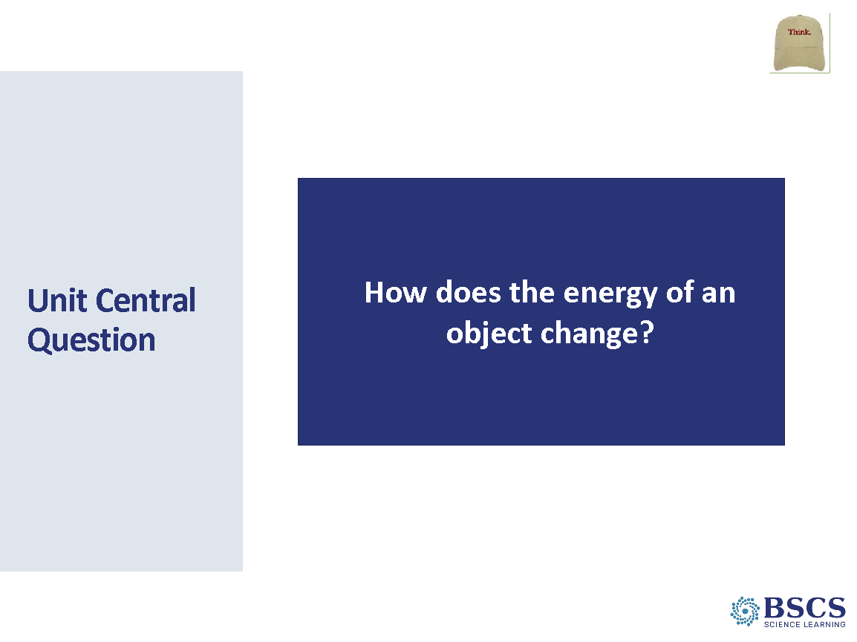 | - Unit Central Question (5 min)  - Review the questions on the Driving Question Board and identify a “group” of questions related to the Unit Central Question. Use their questions to introduce the Unit Central Question as the title for the Driving Question Board.  - Post the Unit Central Question at the top of the Driving Question Board and invite participants to add the Unit Central Question to the top of the page in their science notebook.  Transition: Our Driving Question Board captures what we have been thinking about. Now let’s pause and think about how we have been thinking.
 |  | 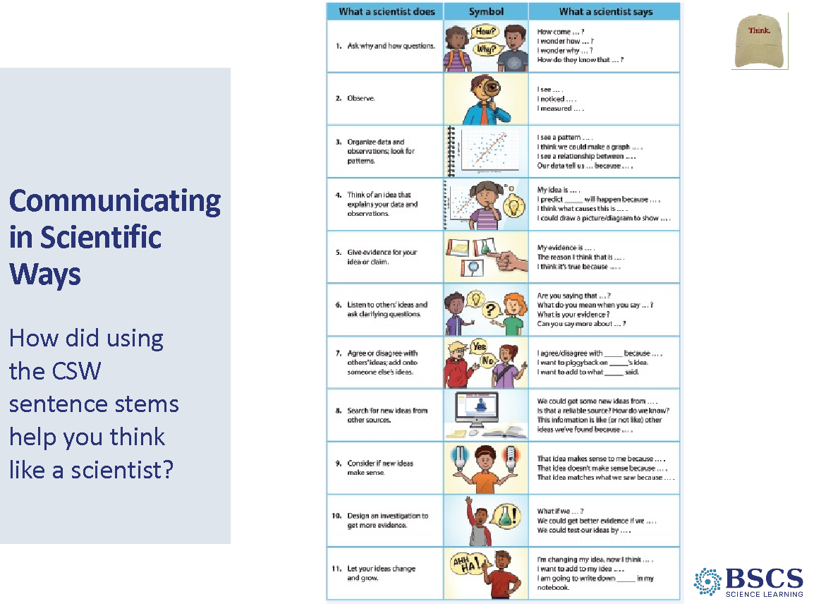 | - Communicating in Scientific Ways (5 min)  - Direct participants’ attention to the CSW poster and highlight the categories of CSW and the sentence stems.  - Ask how their use of these types of sentence starters helped them think like scientists. Follow up with questions about why/how they were/are important/helpful AS LEARNERS (or not).  PDL Note: Ensure teachers can answer this metacognitive question by including explicit use of the CSW sentence stems throughout the Anchor lesson.
 |  | 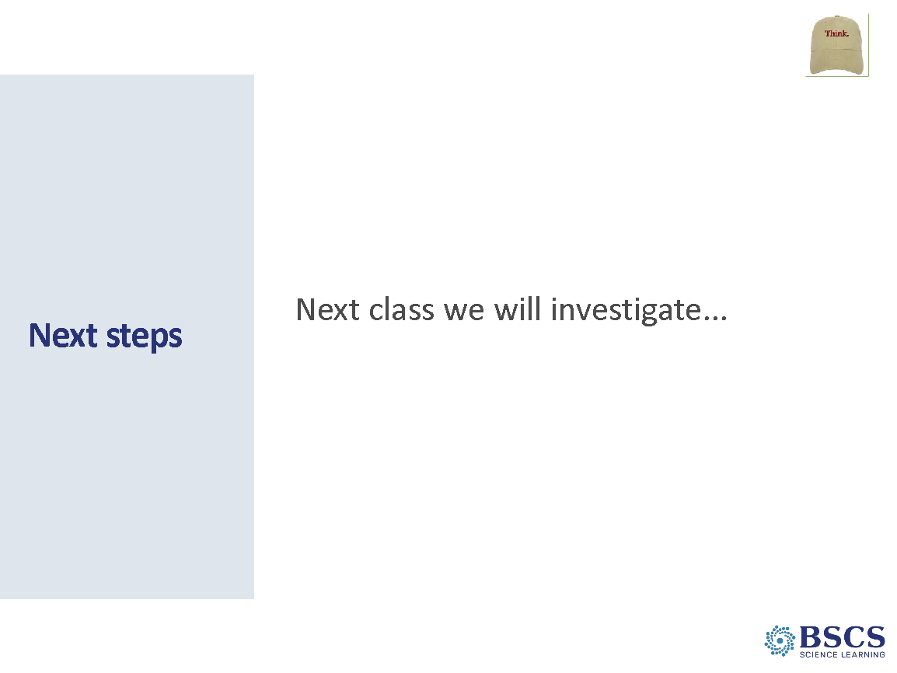 | - Next Steps (5 min)  - Highlight questions about motion and collisions. Share that this will be a good place to begin our investigations into energy in our next lesson.  Transition: Thank you for engaging in the lesson as a learner. We will now return to our teacher hats to debrief our experiences. Set your science notebook aside and open your BSCS journal.
 |  | 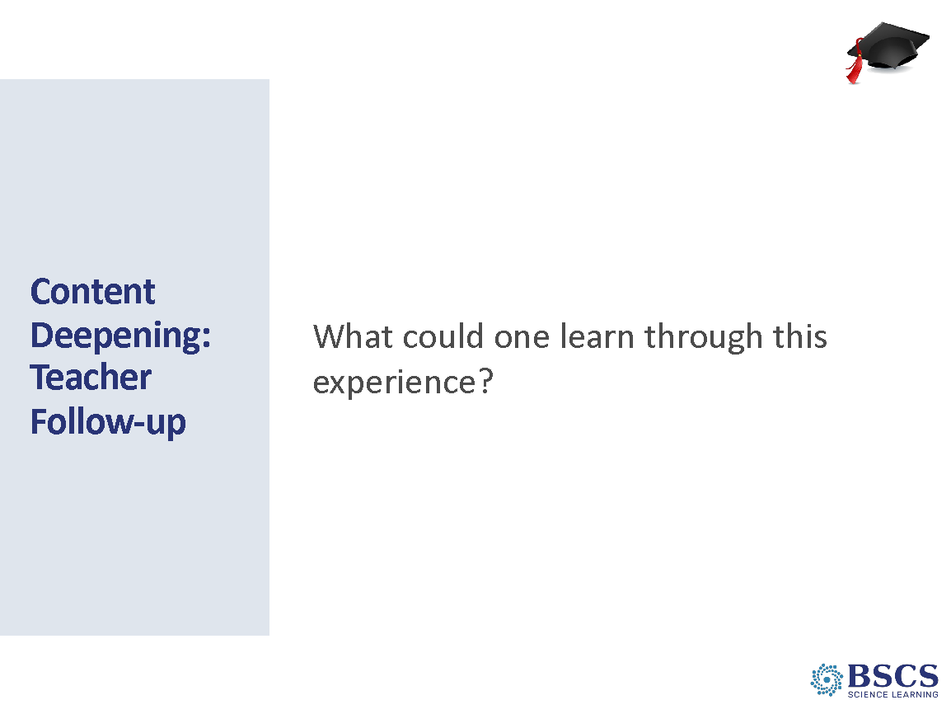 | - Content Deepening: Teacher Follow-up (30 min)  PDL NOTE: Keep in mind that everything up to the next Content Deepening experience is part of the teacher debrief. It is all part of the storyline and should be closely linked.  The purpose of the Teacher Follow-up is to continue teacher learning from the content deepening experience. This part of the session should engage teachers as learners and support them in explaining and reflecting on their experience.  - Provide time for teachers to consider this question and capture ideas in their BSCS Journal. While participants are writing in their journals post 4 chart papers side by side on a large wall.  PDL Note: These four charts will ultimately be titled: DCIs, SEPs, CCCs, and Misc. (I.e., teaching strategies, pedagogy, classroom culture). To begin, the charts will be blank. Sort and chart ideas onto the appropriate chart as participants share. After the charts are populated with participants’ ideas, you will ask for the titles for each chart.  - Begin a “Wall Debrief.” Invite participants to share their ideas with the whole group. As participants share ideas, record them on the appropriate untitled chart. If the idea isn’t easy to sort, probe for clarity:  - How did that contribute to your learning?  - How do you think it could impact students’ learning?  - Why is that important?  It is important to chart participants’ ideas and NOT what you are thinking about where it goes.  - Provide time to address any teacher-focused questions that participants recorded while they were in learner hat.  PDL Note: The idea below is attended to in Day 3. This note is an FYI. Questions will likely arise about the relationship between the questions on the Driving Question Board and the focus question. A lesson focus question is bigger than a particular phenomenon or problem and attends to the main learning goal of the lesson. Phenomena or problem-specific questions make terrific elicit questions. The main learning goal is a big idea in science, NOT a phenomenon or problem. Just as a phenomenon or problem is NOT a concept, but rather an observable event (among other things).  Driving questions AND focus questions are not the same thing. They may fulfill a similar purpose. Therefore, sometimes a driving question can be a focus question, but driving questions are not always focus questions.
 |  | 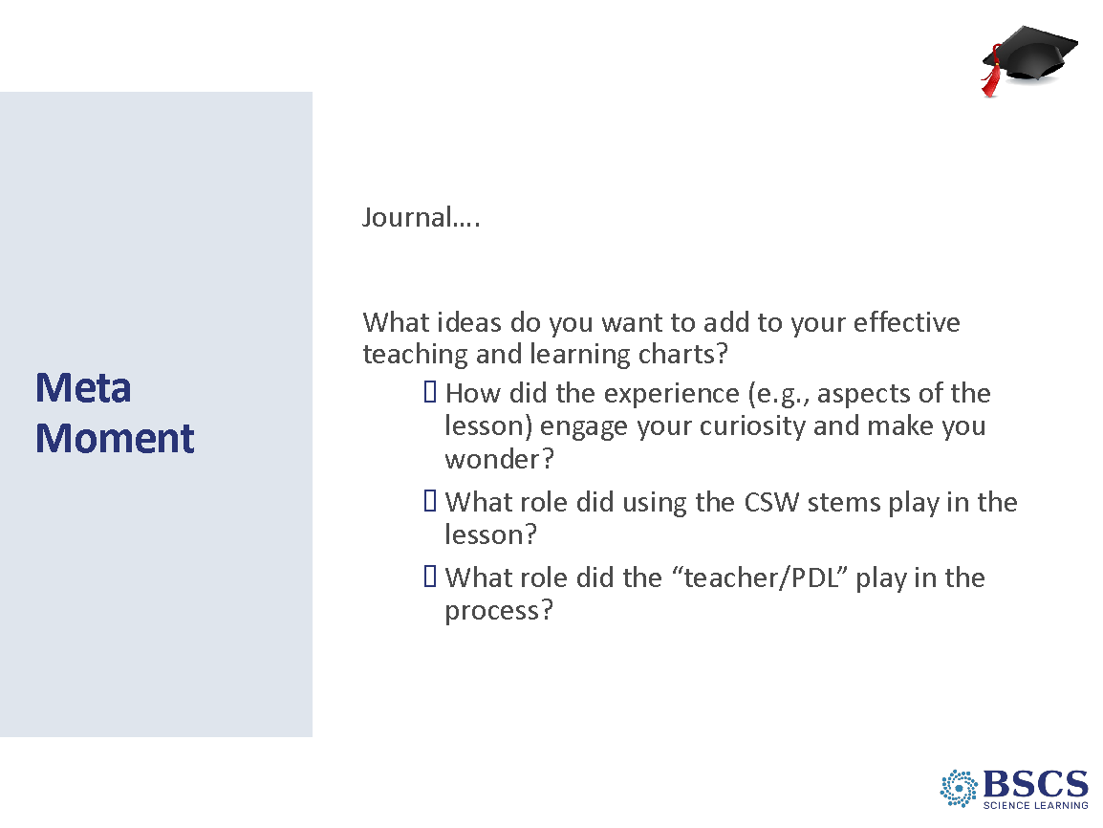 | - Meta Moment (10 min)  - Invite participants to respond individually to the prompts on the slide in their journals. Mark that we will revise our charts later today.  Transition: This morning we’ve had an opportunity to experience a STeLLA anchor lesson as a learner and as an educator. We’ve reflected on our experiences in light of our ideas of effective teaching and learning. When we come back from lunch, we’ll consider the research that is the basis for the STeLLA conceptual framework.  PDL Note: Keep in mind that every session up to the next Content Deepening session is part of the Teacher Debrief. These sessions are part of the Teacher debrief storyline and should be closely linked.
2:15 – 2:30  15 min | Break
2:30 - 4:20  110 min  Slides  Study Group Teams | Lesson Analysis: STL Strategy 4  Purpose: The purpose of this session is to develop a shared understanding of STeLLA Strategy 4: Communicating in Scientific Ways and how it plays out in the classroom from the introduction of CSW to improving students’ use of the sentence stems.  Content: Engaging students in CSW helps students reveal their thinking and supports listening and responding to one another’s ideas. CSW helps establish a classroom culture of revising ideas and moves away from a culture of right answers. Teachers have an important role to play in supporting student discourse (student-to-student talk).  What participants do  Participants read the summary document for STL 4: Communicating in Scientific Ways, complete their Z-fold, and chart the purpose and key features. After an introduction to the STeLLA process for analyzing video, they apply what they learn about CSW to the analysis of classroom video.  Resources  - Journals  - STeLLA Strategies Booklet  - PD Binder  - STL Z-fold  - CSW Transcript Duin Clip 1  - CSW Transcript Duin Clip 2  - CSW & Anchor Lesson  - Video  - CSW Duin Clip 1  - CSW Duin Clip 2  - Charts  - CSW Purpose/Key Features Chart |  | - Norms (5 min)  - Remind participants of the STeLLA norms from this morning and emphasize that we will be working together throughout the summer institute and academic year.  - Invite participants to consider their use of the Norms so far. Let them know that they’ll revisit these norms in the morning with a chance to revise them. Encourage them to add notes in their journal or add sticky notes near where the norms are inserted about  - norms they’ve done well with,  - norms that could be improved, and  - thoughts about revisions.  - Note that this afternoon we will start our analysis of other teachers’ classroom videos. In the fall, we will be analyzing classroom videos from each other’s classrooms. For this work to be meaningful, we need to push and challenge each other, but we need to do this with a common understanding of our goals.
 |  | 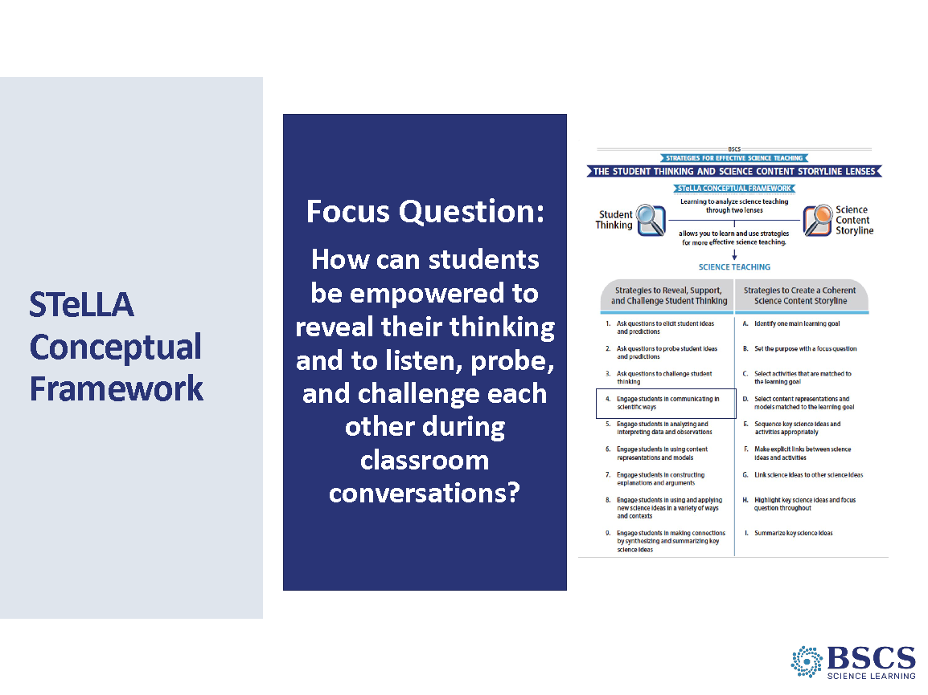 | - STeLLA Conceptual Framework (0 min)  PDL Note: This is an animated slide.  Direct attention to the focus question on the slide.  Point to the strategies highlighted on the slide – we will begin a deep dive into the Student Thinking Lens Strategy: Communicating in Scientific Ways (ADVANCE SLIDE to highlight the strategy) that we experienced in our content deepening session.  Invite participants to pull out their Z-fold and Strategies Booklet
 |  | 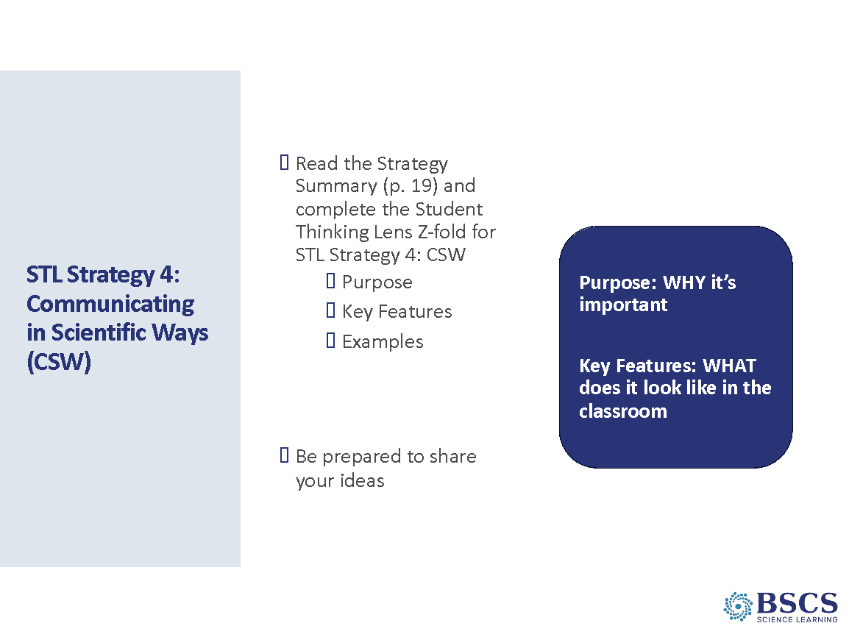 | - STL Strategy 4 (15 min)  Orient participants to the STeLLA Strategy booklet. Forecast that we will come back to the Strategies booklet time and time again to ensure that we consistently use ideas, meaning, and language that matches the STeLLA framework.  Invite participants to individually read the CSW strategy (Strategy Booklet p. 19) and complete the purpose and key features section of the Z-fold for this strategy. Note that, in the future, we will do this kind of reading and writing as homework.  Have participants share ideas from their Z-fold with an elbow partner. Encourage participants to provide evidence from the readings to support their ideas and ask each other questions consistent with our norms such as, “Where did your find that?” or “I interpreted that differently.”
 |  | 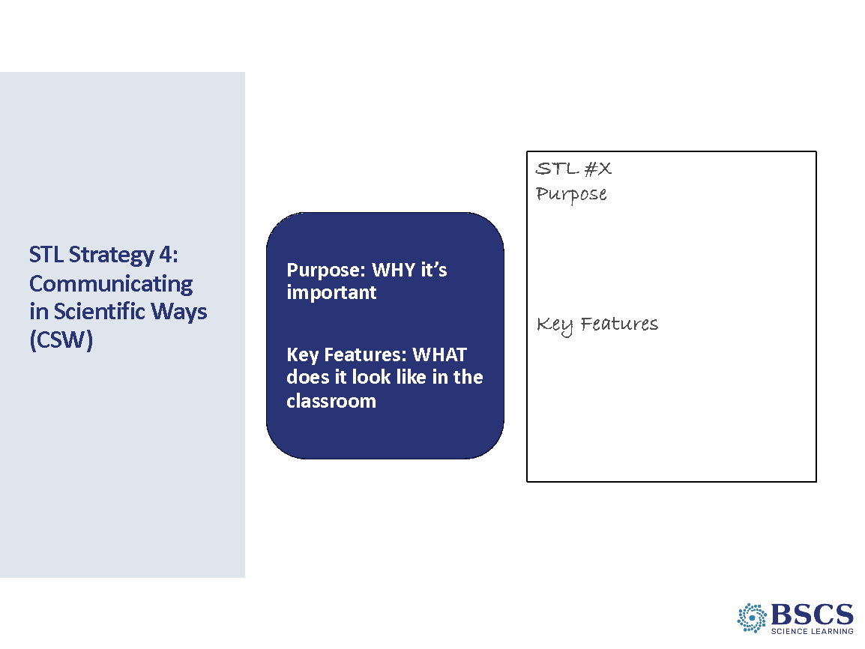 | - STL Strategy 4 (10 min)  - As a whole group, discuss the purpose and key features of the CSW Strategy, writing their ideas on chart paper. Hang the chart where it can be referenced later.  - Invite the group to share the main ideas they recorded for purpose and key features.  PDL Note: Key ideas about CSW include:  - CSW reveals students thinking more clearly as they communicate using scientific norms of discourse.  - Students use scientific discourse to propose new ideas or explanations, to support ideas with evidence, and to agree/disagree with classmates’ ideas.  - CSW must be explicitly taught.  - As students learn to communicate using CSW, the role of the teacher shifts from intermediary in student conversations to listening, noting progress, diagnosing problems in student understanding, and planning for instruction.  - CSW and sentence starters help students engage productively in the NGSS SEPs.
 |  | 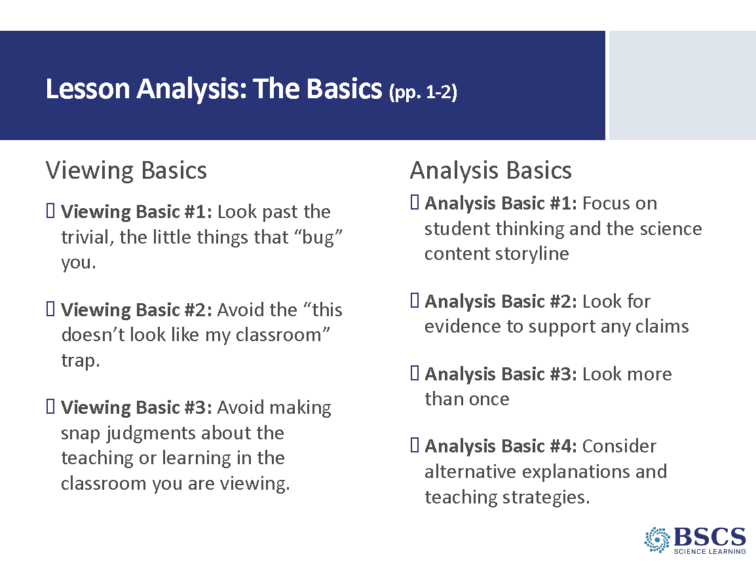 | - Lesson Analysis (5 min)  - Direct participant attention to the Viewing Basics (Strategy Booklet p. 1). Ask: Why is each Viewing Basic important? Which will be hardest for you?  - Direct attention to the Analysis Basics (Strategy Booklet p. 2). Share that both the Viewing and Analysis Basics will help us dig deeper and learn more from our analyses while keeping us focused on the ultimate goal – improved student learning. Mark that this process is NOT about critiquing teachers but improving student learning.  - Highlight that the videos we will analyze are not necessarily exemplars. You might say, The videos we’ll be viewing throughout the program are not necessarily exemplars, but rather they show teachers working to implement the STeLLA Strategies. “Real world” examples deepen our thinking because we can see the sometimes-unintended results of a teacher’s decisions and consider missed opportunities.  - Honor the videocase teachers. You might say: All of these teachers are courageous teachers who are not only working hard to improve their practice but are willing to make their practice public so that others can learn from it. None of them would claim to be exemplary science teachers.  - Tell participants they can find additional information about both the Viewing and Analysis Basics in their Strategy booklet.
 |  | 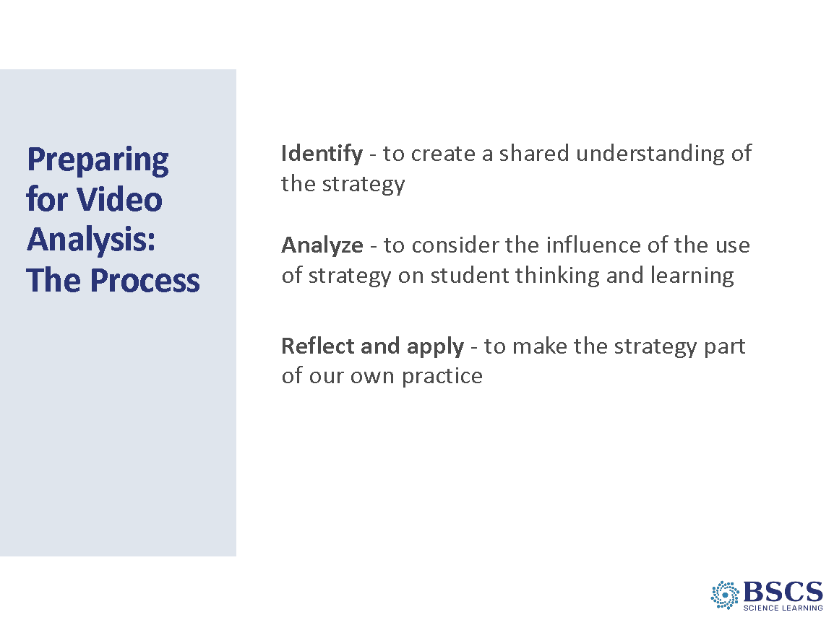 | - Preparing for Video Analysis: The Process (5 min)  - Note that we want to be explicit about our video analysis structure. As we move into the fall we will rely heavily on this structure.  - Share that framing our analysis in this way will help us focus more holistically on BOTH teaching strategies and the impact of those strategies on student thinking and learning, and the storyline that students are constructing (e.g., the two lenses).
 |  | 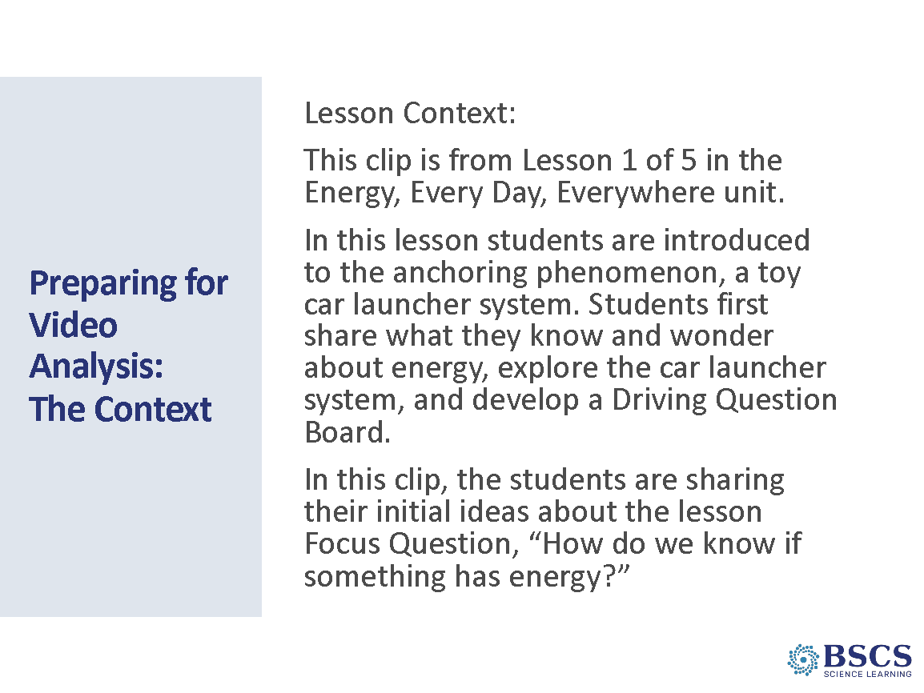 | - The Context (5 min)  - Provide instructions for watching the video clip and using the transcript to identify places where students are using CSW sentence stems.  - Invite participants to read the context for this clip at the top of the transcript.
 |  | 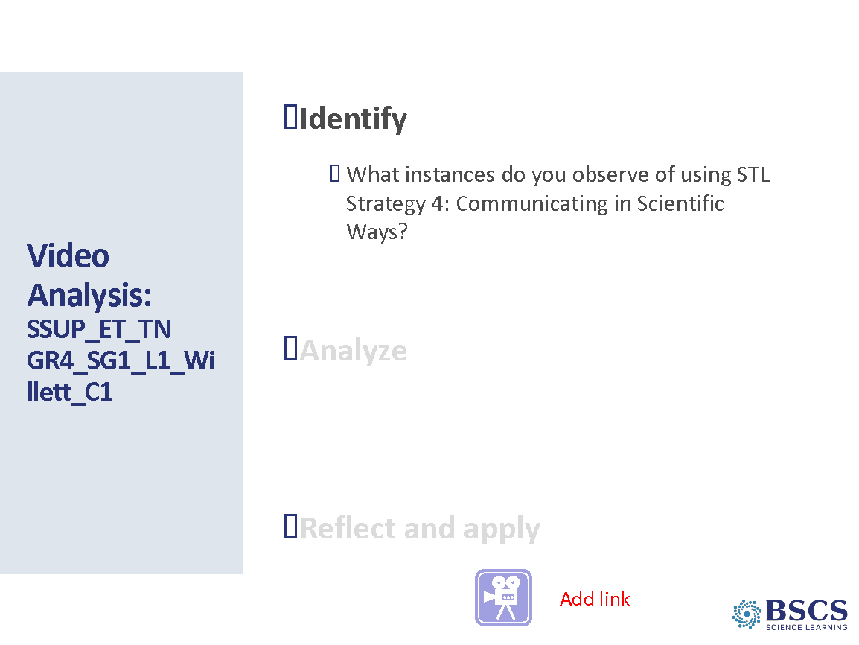 | - Video Analysis: Identify (15 min)  Note: Emphasize that the purpose of this first analysis is to see the whole process and that in future analyses, we’ll take much more time to go deeply into each step of the process.  - Show the video clip.  - Individually: Give time for teachers to review the transcript and mark any time students used a CSW sentence stems (or close to the sentence stem) or “way” of communicating like scientists.  - Whole group: Discuss what they observed in the video. Encourage teachers to use point to the timestamp from the transcript and justify their identification using their poster, Z-Fold, or the STeLLA strategy booklet. Begin by asking for a clear example of students using a CSW stem. After discussing clear examples, take some time to work through a more challenging example or two. Make sure to keep in mind that it’s about the justification…not the “right” answer.  PDL Note: Clear examples of teacher/students using CSW stems include:  - 01:29 “Y’all- anybody agree? Disagree? Want to add?” [CSW 7]  - 01:40 “I agree” [CSW 7]  - 01:43 “I agree because when…” [CSW 7]  - 01:51 “Agree, disagree, want to add, piggyback? Antoine, you want to add? What do you want to add?” [CSW 7]  - 03:42 “I disagree.” [CSW 7]  - 03:45 “I disagree because when…” [CSW 7]  Other examples of students communicating in scientific ways may include:  - Give evidence for your idea or claim [CSW 5]  - 00:51 “’Cause when we run…”  - 04:08 “’Cause it still have enough gas to run.”  - 04:59 “I know something has energy because…”
 |  | 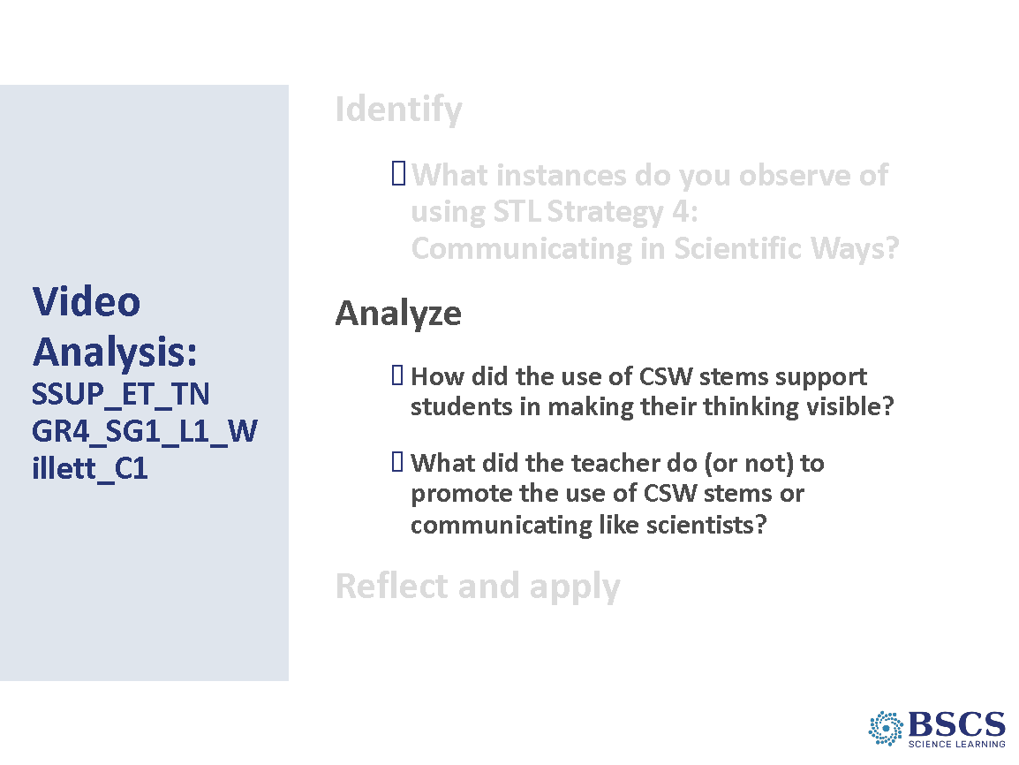 | - Video Analysis: Analyze (15 min)  - Have participants consider the analysis questions individually.  - Invite participants to share their ideas with the whole group.  - If time permits, ask if there were any sentence stems that students used more frequently, or sentence stems that students didn’t use. What does the pattern indicate about where students might need more support or encouragement in their communication?
 |  | 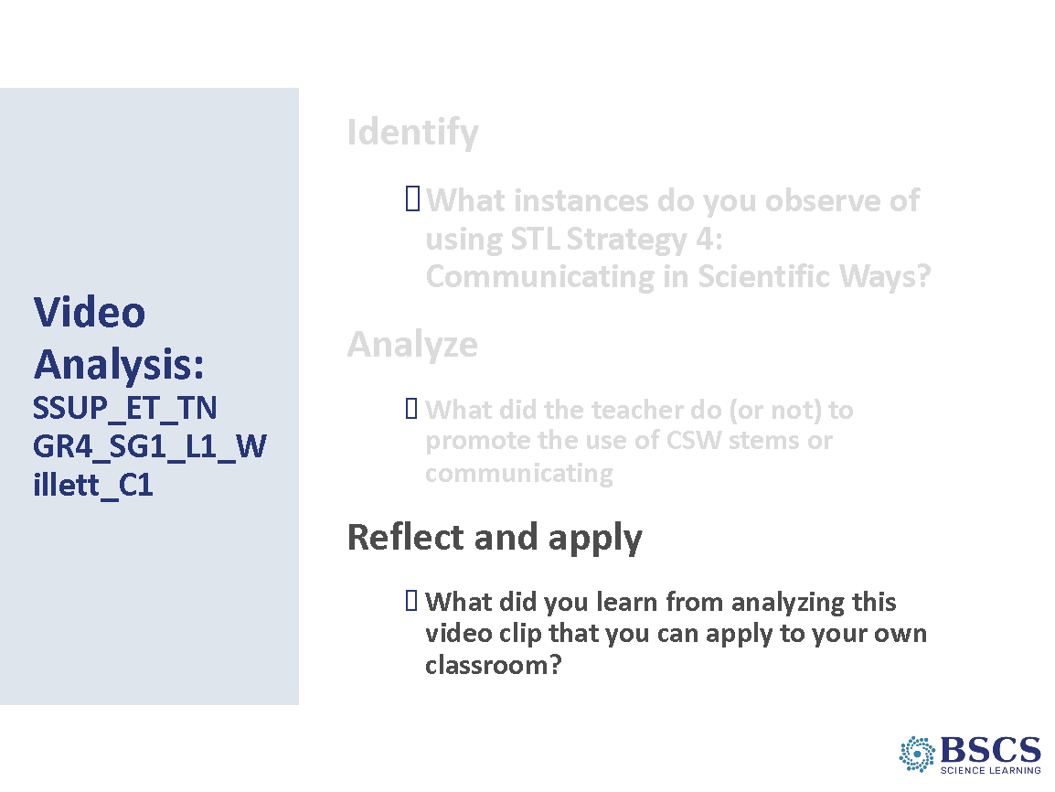 | - Video Analysis: Reflect and Apply (10 min)  - Invite participants to respond to the prompt in their journals.  - Have several participants share their ideas with the whole group.
 |  | 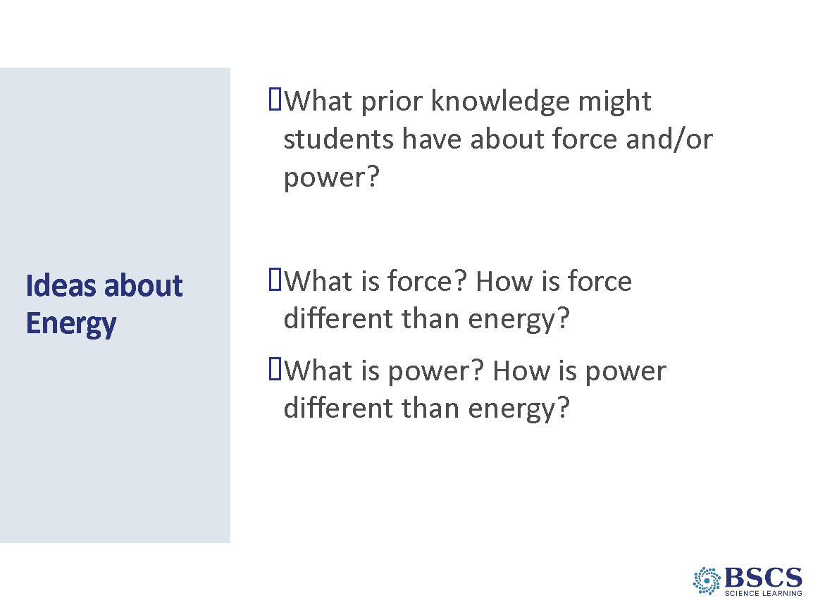 | - Ideas about Energy (10 min)  PDL Note: This slide is animated.  - Direct participants to timestamps 04:22 – 04:35 in their transcript. Note that the discussion is about power and energy. Invite participants to respond to the first prompt.  PDL Note: In the NGSS, force is a concept that is included in grade 3.  - Advance the slide and invite participants to first think individually about the second prompt and then share their ideas with an elbow partner.  - invite several participants to share key ideas and wonderings from their conversation with the whole group. Use elicit and probe questions to make participant reveal and support participant thinking.  - Share that, just as students in the clip were sharing their initial ideas and will learn more about energy in future lessons, we will continue to deepen our own understanding of energy – and the differences between energy, force, and power – throughout the content deepening sessions this week.  Transition: We’ve spent time as science learners experiencing the Anchor lesson for the Energy, Every Day, Everywhere unit. We debriefed our science learner experience as educators and analyzed a clip from the Anchor lesson. Let’s dig a little more deeply into the purpose of an Anchor lesson.
 |  | 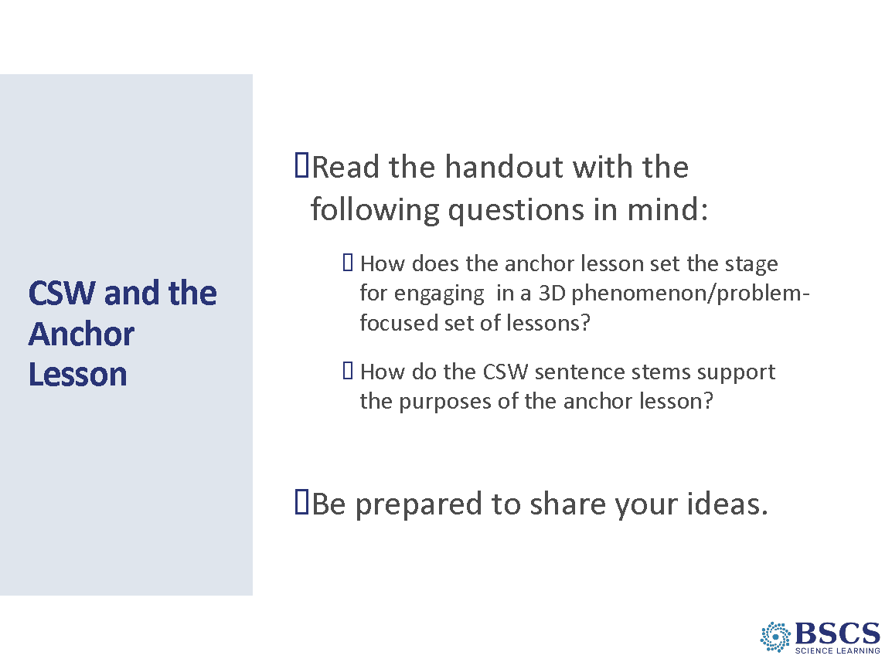 | - CSW and the Anchor Lesson (15 min)  - Direct participants to the reading of their PD binder (p. __). Invite participants to silently read with the questions on the slide in mind.  - As participants finish reading, they should make eye contact with others at their table and discuss the questions on the slide.  - If time permits, invite several groups to share highlights from their discussion with the whole group.
4:20 - 4:30  10 min  Slides  Study Group Teams | Closing: Reflection & Homework  Purpose: Reflect on the day’s experiences and learning and prepare for Day 2.  Content:  Focus Questions:  - What patterns in temperature can you find on Earth at different times of the year?  - What are the STeLLA Lenses and Strategies, and why do we think they will make a difference in your science teaching and students’ learning?  - How can students be empowered to reveal their thinking and to listen, probe, and challenge each other during classroom conversations?  What participants do  Participants reflect on their learning experiences through the day.  Resources  - STeLLA Strategies Booklet  - PD Binder  - STL Z-fold  - Day 1 Reflection Sheet | 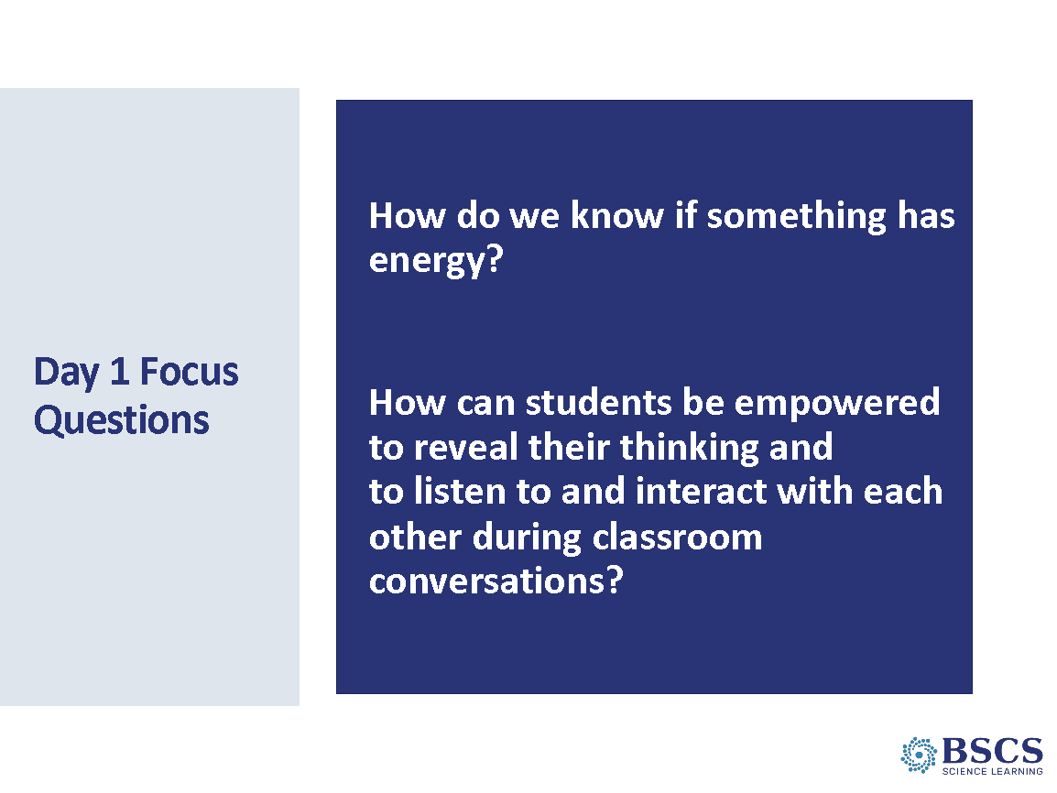 | - Focus Questions (0 min)  - Remind participants of our focus questions for today. Invite participants to consider how, in the spirit of CSW, their ideas about these questions have grown and changed throughout the day.
 |  | 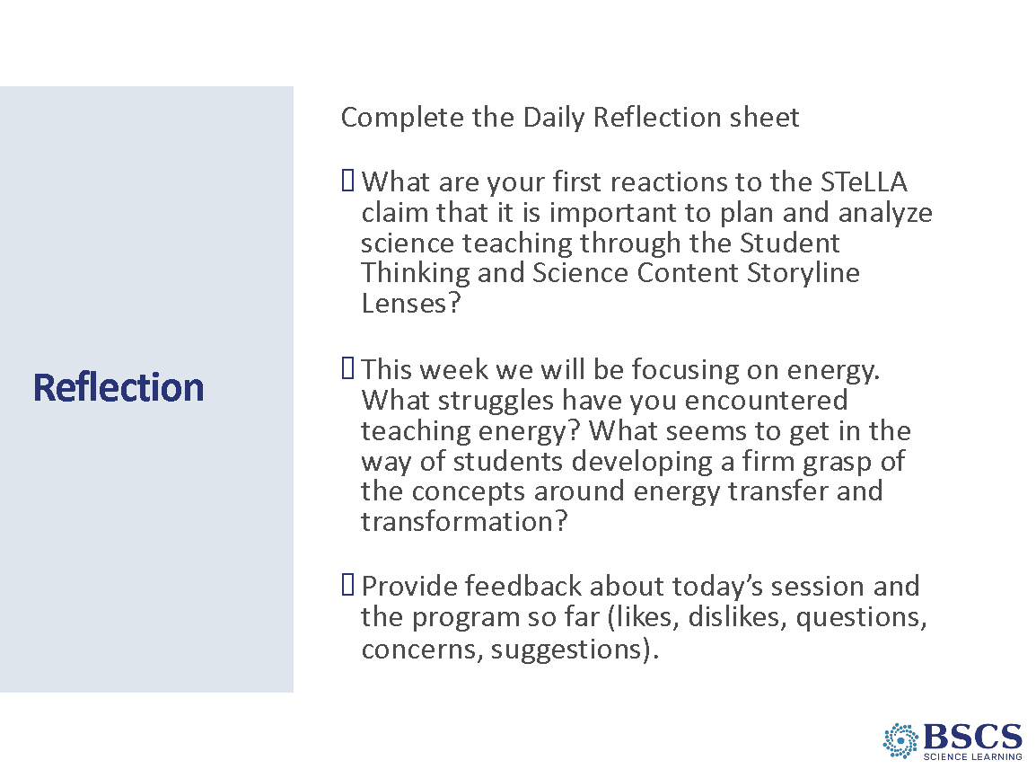 | - Reflection (5 min)  - Direct participants to the daily reflections sheet (PD Binder p.__). Completed sheets can be left in the center of each table.  - Remind participants that the parking lot is available for any concerns or questions.
 |  | 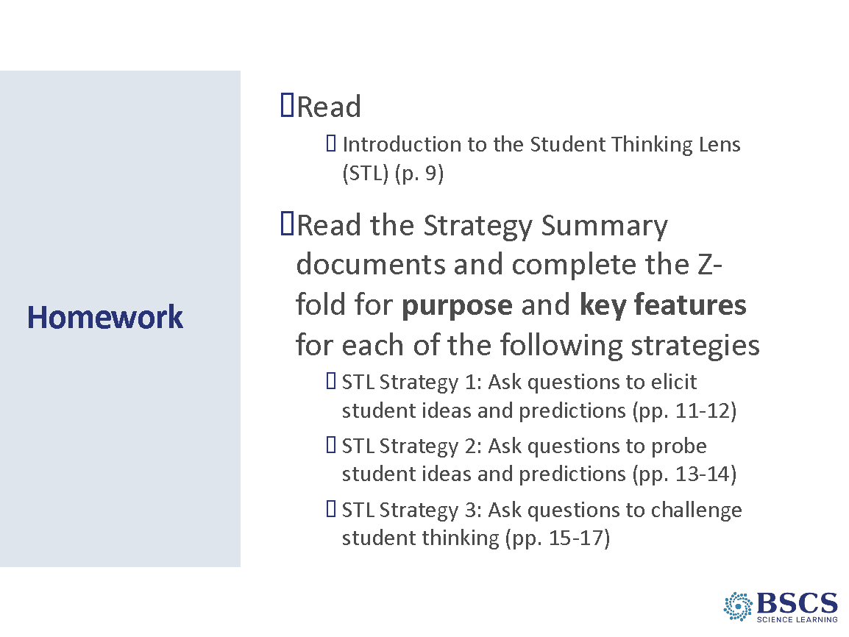 | - Homework (5 min)  - Provide instructions for the homework and ask for any clarifying questions about the homework.  - Remind participants that our goal is to develop a shared understanding of these important strategies so that we can enact them in our classrooms to improve student learning.  - Remind participants to bring their personal and school calendars on Friday so we can do some scheduling for our study group meetings and lesson videotaping in the fall.
 |  | 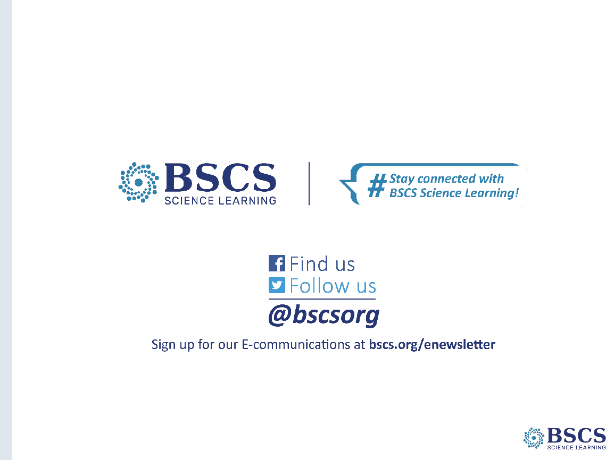 | - BSCS (0 min)  - Thank participants for a great first day!

