SSUP: Summer Institute - PD Leader Guide Day 3
Grade Level | 4 | Day | 3 | STeLLA Strategies Focus | SCSL A, B, I; STL 9 | Subject Matter Focus | Energy, Every Day, Everywhere
Teacher Learning Goals | - The production of heat, light, sound, or motion are evidence that the energy of an object or system has changed. Energy can be changed from one form to another in a variety of ways.  - For a strong and focused science content storyline, it is important to have just one main learning goal. The main learning goal and focus question set the lesson purpose and organize the entire lesson.  - Identifying one main learning goal, setting the lesson purpose with a focus question, and relating the summary activity to the learning goal creates greater lesson coherence.  - Analysis of the main learning goal should assess its importance as a big idea in science, its appropriateness for challenging student thinking, its scientific accuracy, and whether it addresses common student misconceptions.
Focus Questions | - Why is one main learning goal (SCSL Strategy A) essential for coherence of the Science Content Storyline?  - How does the use of a focus question (SCSL Strategy B) contribute to the coherence of the Science Content Storyline?  - How does synthesizing and summarizing key science ideas (SCSL I/STL 9) contribute to the coherence of the science content storyline?  - How can we begin and end a lesson using STeLLA Strategies?  - How do we detect and represent energy changes in a system?
Ideal Teacher Response | Why is one main learning goal (SCSL Strategy A) essential for coherence of the Science Content Storyline?  One main learning goal provides the focus for all the other STeLLA strategies and decreases the likelihood of distracting ideas. It is intended for use by the teacher in planning, enacting, and reflecting on lessons. The main learning goal is a big idea in science and is foundational to coherence.  How does the use of a focus question (SCSL Strategy B) contribute to the coherence of the Science Content Storyline?  The purpose served by the main learning goal for teachers, is similarly served by the focus question (matched to the main learning goal) for students. The sequence of the focus questions across a unit of instruction should be just as strong as the sequence of main learning goals.  How does synthesizing and summarizing key science ideas (SCSL I/STL 9) contribute to the coherence of the science content storyline?  Synthesizing and summarizing key science ideas by either or both the students and teacher closes the lesson with a focus on a few key science ideas.  How can we begin and end a lesson to help students develop a coherent science content storyline?  The use of a focus questions and a synthesize/summarize task or statement moves teachers and learners away from “activity-mania” and toward attention to the goal and intent of the lesson. Together, these strategies help teachers “begin with the end in mind”.  How do we detect and represent energy changes in a system?  Energy changes can be detected using our senses; we can feel heat, see light, hear sound, and see movement. This is evidence that energy is present and changing. Energy changes in a system can be represented with a system diagram that shows the components of the system, observable changes, where energy changes are occurring, where the energy comes from, and where the energy goes.

Preparation | Materials | Videos and Transcripts
Planning/Preparation Tasks:  - Study PDLG, PPTs, video clips, and handouts. Make changes to PPTs, if needed.  - Link clips  - Prep Lesson 3-4 materials  Daily Set Up Tasks:  - Check that video clips are correctly linked to PPT  - Set up PowerPoint and speakers  - Check video & sound  - Arrange furniture, food (include social distancing protocols in set up)  - Arrange posters/charts  Day 1 Set Up Task:  Arrange teacher materials on tables:  - Tabletop name cards  - STeLLA strategies booklet  - SSUP PD binder  Daily Follow-up Tasks:  - Archive final PPT  - Collect and turn in daily feedback  - Disinfect common materials, tables, and common areas per protocol | Posters/Charts:  - STeLLA Conceptual Framework  - Day 3 Agenda chart  - Program Goals chart  - Norms poster  - Focus Questions chart  - Effective Science T&L charts  - Parking Lot  - Purpose/Key Features (A, B, I/9) prepped for whole group  - Communicating in Scientific Ways poster  - System Diagram Components chart  Handouts in SSUP PD binder front pocket:  - Z-fold chart: Student Thinking Lens Strategies  - Z-fold chart: Science Content Storyline Strategies  Handouts in SSUP PD binder, Tab 3  - Walk-about-Review  - Candidate Main Learning Goals  - SCSL Strategy A: Analysis Guide  - Candidate Focus Questions  - SCSL Strategy B: Analysis Guide  - Grade 4 Classroom: SSUP_ET_KY GR4_SG3_L3_Norris_C1 Transcript  - Grade 4 Classroom: Parco (B, I/9) SSUP_ET_L2_Parco_C2 Transcript  - Grade 4 Classroom: Parco (B, I/9) SSUP_ET_L2_Parco_C3 Transcript  - Day 3 Daily Reflection sheet  - HO 4.1: System Diagram: Wind-Up Toy  - HO 4.2: System Diagram: Hand Crank Flashlight  - HO 4.3: System Diagram: Noisemaker  - HO 4.4: System Diagram: Rubber Ball  Supplies:  - MLG/FQ card sets  - 1 set/team: plastic bag containing a wind-up toy, hand crank flashlight, noisemaker, and rubber ball  - Chart paper: 1 sheet/group  - Markers  - Transparent tape: 1 roll/group  Resources:  - STeLLA Strategies booklet  - BSCS Journal  - Science Notebook  - MLG/FQ Card Set | - Grade 4 Classroom Clip (A)  SSUP_ET_KY GR4_SG3_L3_Norris_C1: This is lesson 3 of the unit. The teacher is eliciting student ideas about changes in the energy of a marble at different points along a ruler ramp.  - Grade 4 Classroom Clip (B, I/9)  SSUP_T_L2_Parco_C2.mp4: The teacher is eliciting students’ initial ideas about the lesson focus question.  - Grade 4 Classroom Clip (B, I/9) SSUP_T_L2_Parco_C3.mp4: The teacher is eliciting students’ ideas about how their thinking about the lesson focus question has changed.

DAY 3 SESSION OUTLINE: 8:00 a.m. – 4:30 p.m.
Time | Purpose | Content | Activities
8:30 – 9:05  35 min  Slides 1-7  Whole Group | Purpose: The purpose of the opening is to continue to build community and set the stage for today’s learning, in part by customizing the norms. | Content: Focus Questions  - Why is one main learning goal (SCSL Strategy A) essential for coherence of the Science Content Storyline?  - How does the use of a focus question (SCSL Strategy B) contribute to the coherence of the Science Content Storyline?  - How does synthesizing and summarizing key science ideas (SCSL I/STL 9) contribute to the coherence of the science content storyline?  - How can we begin and end a lesson using STeLLA Strategies?  - How do we detect and represent energy changes in a system? | Opening  - Day 2 Reflections  - Goals/Agenda  - Norms  - FQs  - Reconnection
9:05 – 9:50  45 min  Slides 8-9  Whole Group | Purpose: The purpose of this session is to develop a shared understanding of STeLLA Strategies A, B, I/9: one main learning goal, focus questions, and synthesize/summarize and summarizing key ideas. | Content: One main learning goal provides the focus for all the other STeLLA strategies and decreases the likelihood of distracting ideas. It is intended for use by the teacher in planning, enacting, and reflecting on lessons. The main learning goal is foundational to coherence.  The purpose served by the main learning goal for teachers, is similarly served by the focus question (matched to the main learning goal) for students. The sequence of the focus questions across a unit of instruction should be just as strong as the sequence of main learning goals. | Lesson Analysis: Strategies A, B, I/9  - Charting
9:50 – 10:00 | Break /Transition: Take charts to SG room
10:00 – 11:45  105 min  Slides 10-17  Study Group Teams | Purpose: The purpose of this session is to develop a shared understanding of STeLLA Strategies A, B, I/9: one main learning goal, focus questions, and synthesize/summarize and summarizing key ideas. | Content: One main learning goal provides the focus for all the other STeLLA strategies and decreases the likelihood of distracting ideas. It is intended for use by the teacher in planning, enacting, and reflecting on lessons. The main learning goal is foundational to coherence.  The purpose served by the main learning goal for teachers, is similarly served by the focus question (matched to the main learning goal) for students. The sequence of the focus questions across a unit of instruction should be just as strong as the sequence of main learning goals.  The use of a focus question and synthesize/summarize task or statement moves teachers and learners away from “activity-mania” and toward attention to the goal and intent of the lesson. Together, these strategies help teachers “begin with the end in mind”. | Lesson Analysis: SCSL Strategies A, B, I/9  - Lesson Analysis/Analysis Guides  - Card sort
11:45 – 12:15 | Lunch
12:15 – 1:40  85 min  Slides 18-27  Study Group Teams | Purpose: The purpose of this session is to develop a shared understanding of STeLLA Strategies A, B, I/9: one main learning goal, focus questions, and synthesize/summarize and summarizing key ideas. | Content: The use of a focus question and synthesize/summarize task or statement moves teachers and learners away from “activity-mania” and toward attention to the goal and intent of the lesson. Together, these strategies help teachers “begin with the end in mind”. | Lesson Analysis: SCSL Strategies B, I/9  - Grade 4 Classroom Clip (A)  SSUP_ET_KY GR4_SG3_L3_Norris_C1.mp4  - Grade 4 Classroom Clip (B, I/9)  SSUP_T_L2_Parco_C2.mp4  - Grade 4 Classroom Clip (B, I/9) SSUP_T_L2_Parco_C3.mp4  - Meta moment
1:40 – 1:50 | Break
1:50 – 4:00  140 min  Slides 28-45  Study Group Teams | Purpose: The purpose of this session is to model effective STeLLA-based science teaching and learning through a common experience that is grounded in a 3D, phenomena/program driven unit and designed for adult learners. | Content: STeLLA model lessons/units attend to the characteristics of effective science teaching and learning (e.g., 3D, phenomenon/problem-driven, student-centered, make student thinking visible and support sense-making, coherent, and access/engage prior knowledge and develop metacognitive abilities).  The content deepening experience will include explicit modeling and use of elicit, probe, and challenge questions.  The production of heat, light, sound, or motion are evidence that the energy of an object or system has changed. Energy can be changed from one form to another in a variety of ways. | Content Deepening:  Lesson 4  - Teacher Set-up  - Common Experience  - Teacher Follow-up
4:00 - 4:30  30 min  Slides 46-51  Study Group Teams | Purpose: The purpose of the closing is to continue to build community, reflect on the day, and set the stage for tomorrow’s learning. | Content: Focus Questions  - Why is one main learning goal (SCSL Strategy A) essential for coherence of the Science Content Storyline?  - How does the use of a focus question (SCSL Strategy B) contribute to the coherence of the Science Content Storyline?  - How does synthesizing and summarizing key science ideas (SCSL I/STL 9) contribute to the coherence of the science content storyline?  - How can we begin and end a lesson using STeLLA Strategies?  - How do we detect and represent energy changes in a system? | Closing  - Revisit Focus Questions  - Day 3 Reflection Sheet  - Homework
DAY 3
Time and Focus | Purpose and Content & What Participants Do | Slides | Process
8:00 – 8:30 | Coffee & Conversation |  | Need several hands on deck to help participants complete paperwork, registration and logistics. Remind participants that we’ll begin in the whole group for Day 3. They will need their Z-folds, STeLLA Strategies Booklet, the Walk-about-Review HO (p. __) from their PD binder, a writing utensil, and a few 3X3 sticky notes.
8:30 - 9:05  35 min  Slides 1-7  Whole Group | Opening  Purpose: The purpose of the opening is to continue to build community and set the stage for today’s learning  Content  Focus Questions:  - Why is one main learning goal (SCSL Strategy A) essential for coherence of the Science Content Storyline?  - How does the use of a focus question (SCSL Strategy B) contribute to the coherence of the Science Content Storyline?  - How does synthesizing and summarizing key science ideas (SCSL I/STL 9) contribute to the coherence of the science content storyline?  - How can we begin and end a lesson using STeLLA Strategies?  - How do we detect and represent energy changes in a system?  What participants do  Participants reflect on learning from both days 1, 2 and 3 using the Walk-about-Review. Participants chart and revise their thinking about STeLLA Strategies A, B, and I/9.  - SCSL Strategy A: Identify one main learning goal  - SCSL Strategy B: Set the purpose with a focus question  - SCSL Strategy I: Summarize key science ideas  - STL Strategy 9: Engage students in making connections by synthesizing and summarizing key science ideas.  Resources  - Name Tags  - Journals  - STeLLA Conceptual Framework Poster  - Norms poster  - PD Binder or Walk-about-Review HO p. __  - Charts  - Day 3 Agenda  - Focus Questions  - Parking Lot  - Effective Science T&L  - SCSL A, B, I/9 Purpose/Key Features  - Program Goals chart | 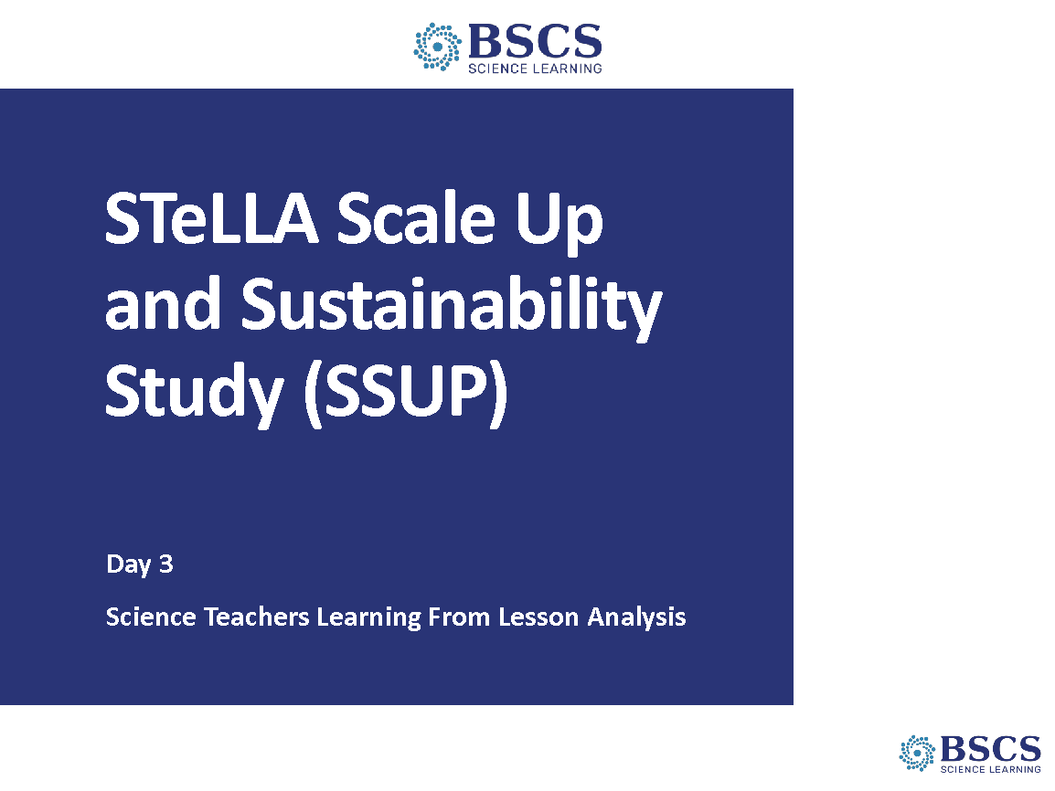 | - SSUP Program Day 3 (0 min)  - Greet participants as they enter the room. Help them pick up their materials and find their spots.
 |  | 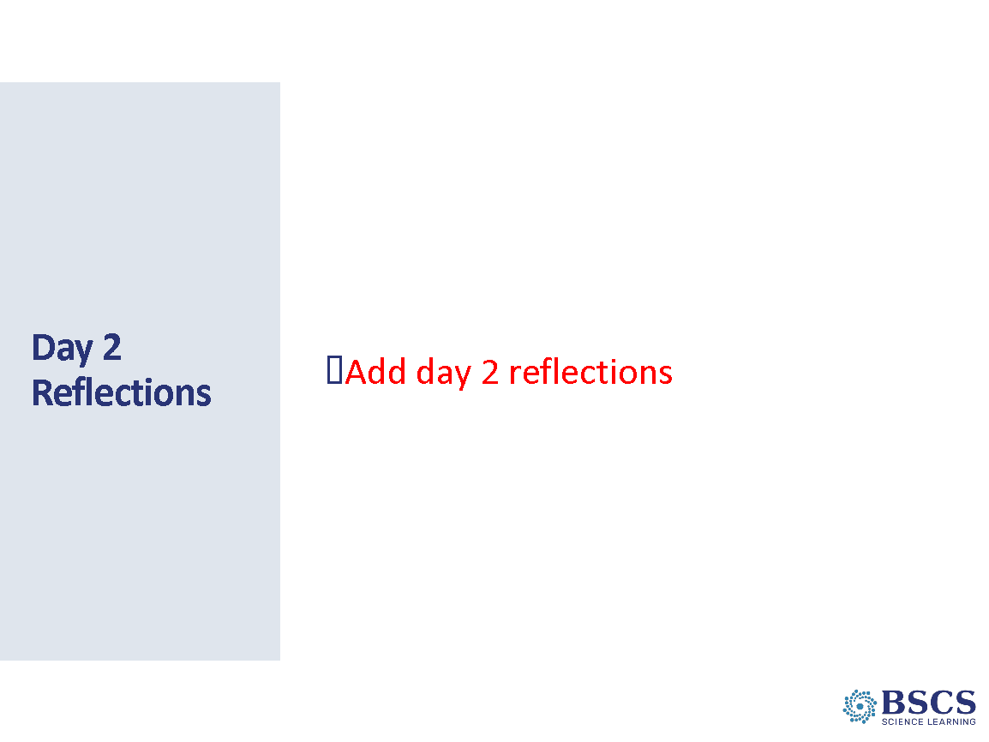 | - Day 2 Reflections (5 min)  - Share patterns in the Day 2 reflections. Link to goals and agenda for today where possible.  - Link back to the role of content in questioning in light of a good night’s sleep and their homework: What role does content knowledge and SCSL A, B, I/9 play in a teachers’ ability to ask good elicit, probe and challenge questions? Invite participants to share with a partner who is NOT in their study group. Then have each pair share with another pair.  - Check parking lot for questions and respond as appropriate.  - Direct participants to the daily reflections sheet (PD Binder p.__). Explain that we will be collecting these reflections again at the end of the day. Invite participants to add thoughts and ideas to their reflection sheet throughout the day.
 |  | 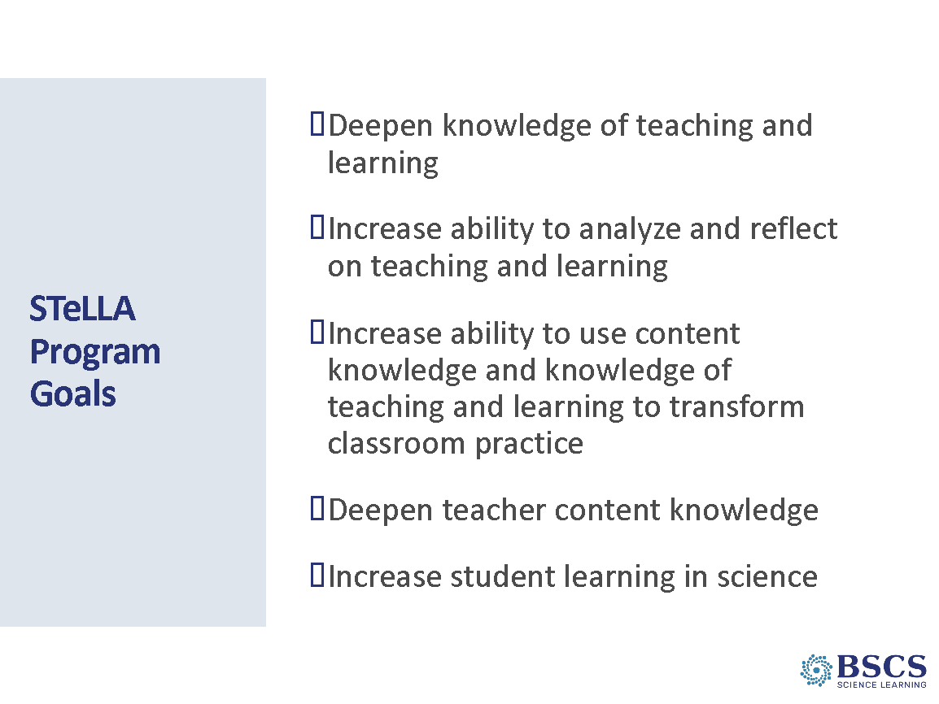 | - STeLLA Program Goals (5 min)  - Share program goals. Link as appropriate to reflections.  - Ask participants to review their notes on the program goals from yesterday and reflect on their progress. What program goals do they feel they have made progress? What goals need more attention?  - Invite participants to add a few more ideas in their notebook.
 |  | 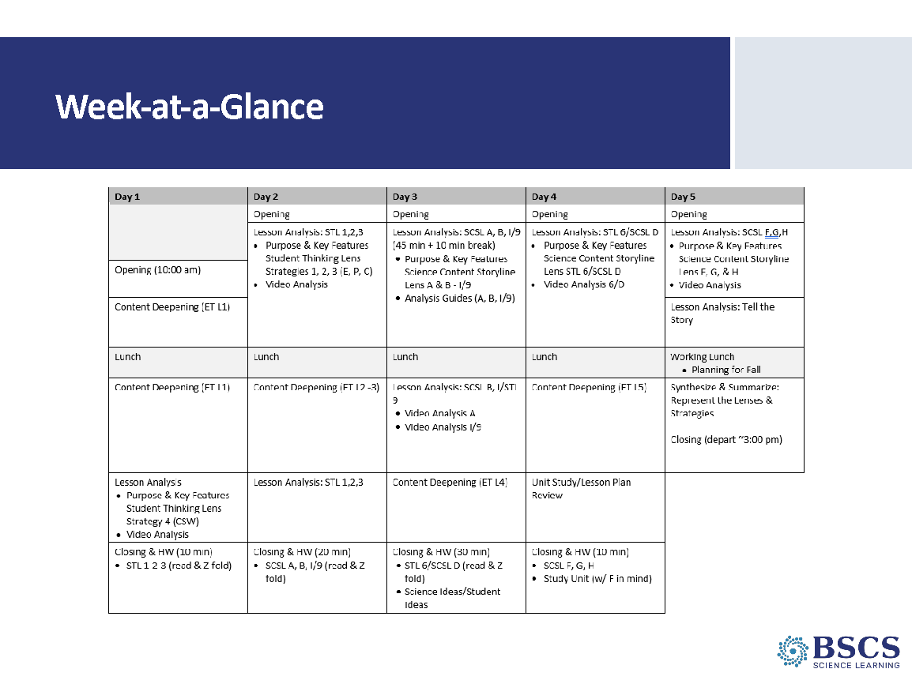 | - Week at a Glance (0 min)  - Point to the Day 3 agenda chart and link the agenda to the program goals.
 |  | 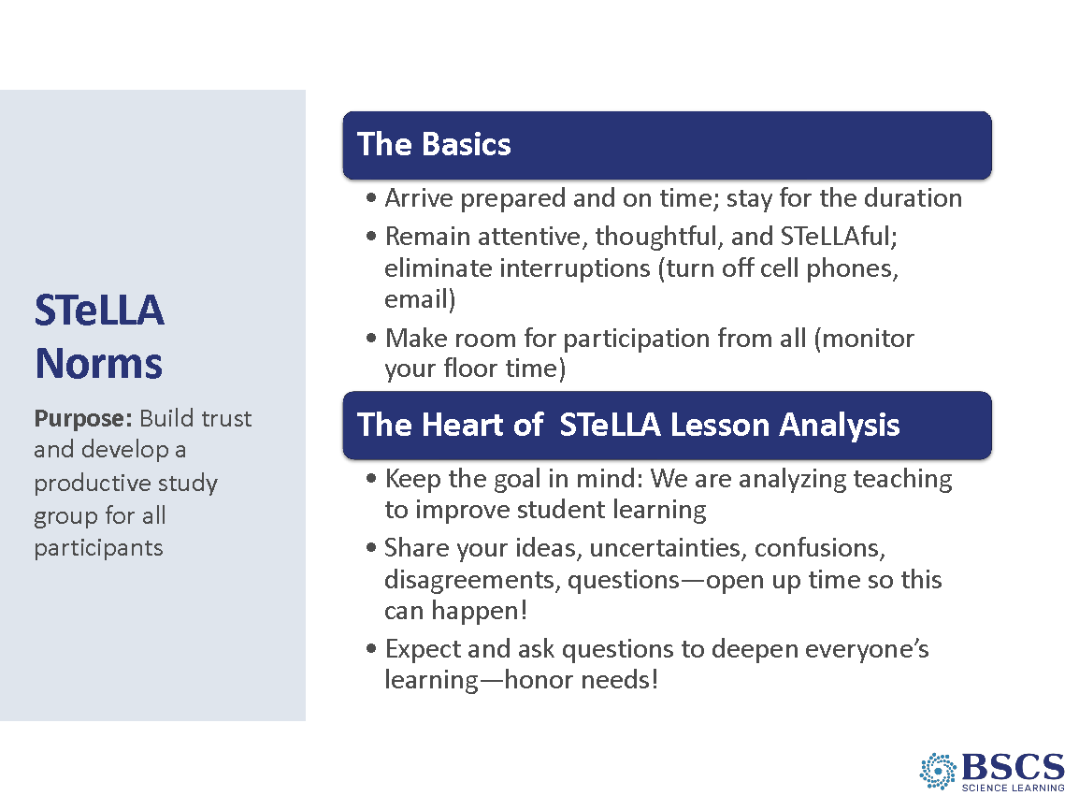 | - STeLLA Norms (5 min)  - Remind participants of the importance of community and how the STeLLA norms support our work together. Note that we’ll continue to attend to the spirit of the norms in the whole group. Note that each team revised their norms to better support their collaboration.  Transition: We’ve not had an opportunity to spend time in our whole cohort since we took a look at the research base of the STeLLA Conceptual Framework—the Student Thinking Lens and the Science Content Storyline Lens—as we considered the TIMSS Video Study and the findings from How People Learn II and How Students Learn Science in the Classroom.
 |  | 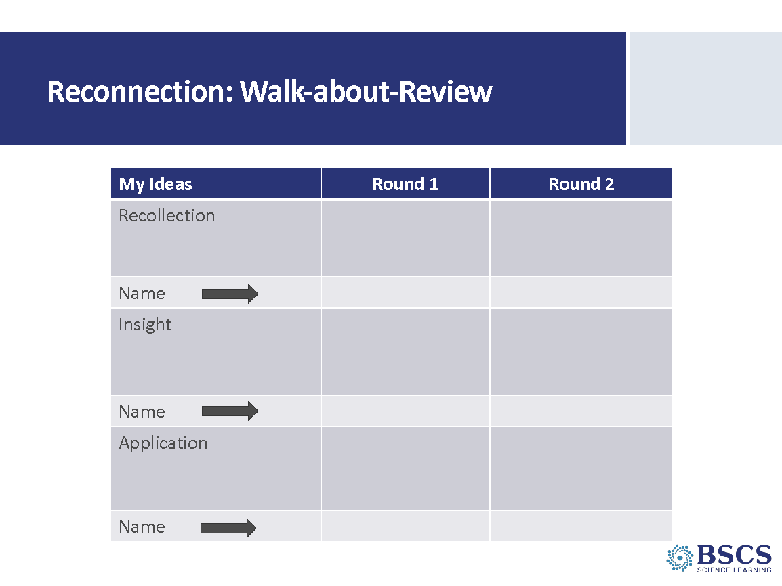 | - Walk-about Review (15 min)  - Provide instructions for the task. Remind participants that the reflections can be drawn from any of the learning experiences over the past two days.  - Offer up to 2 min. for individuals to record their recollections, insights, and applications in column 1. Let them know they should be prepared to share their ideas.  - For the next 5 min, they will “walk about” to share ONE of their recollections, insights, OR applications and record ONE recollection, insight, OR application from another person. in columns 2 and 3 along with the name of the person who shared the idea.  - At the conclusion of the time, whip around and gather a few key ideas from the group. Highlight and/or probe key ideas about making student thinking visible.
 |  | 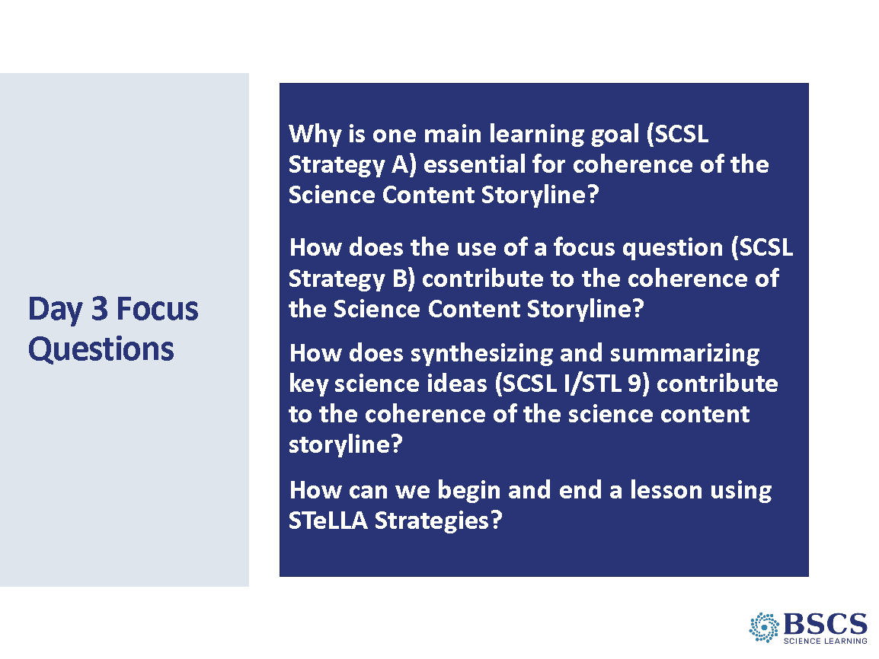 | - Day 3 Focus Questions (5 min)  - Share the Day 3 focus questions (strategy-focused only).  Transition: To begin to answer these questions, we’ll dig into the homework from yesterday as we transition to the Science Content Storyline Lens [ADVANCE SLIDE] and Strategies A, B, I/9.
9:05 - 9:50  45 min  Slides 8-9  Whole Group | Lesson Analysis  Purpose: The purpose of this session is to consider effective strategies to begin and end a lesson by developing a shared understanding of STeLLA Strategies A, B, & I/9.  Content: The Science Content Storyline Lens focuses teacher and students on the sequence of science ideas that build a coherent story about the big idea of the unit. Each lesson should have one main learning goal (SCSL A): a big idea that students are expected to learn showing the relationship among science ideas and used to explain phenomena.  While the main learning goal for a lesson is for teachers, students’ attention to the purpose for the lesson is established and maintained by the lesson focus question (SCSL B). Students return to the focus question throughout the lesson to revise their thinking and maintain focus on the lesson’s purpose.  SCSL I/STL 9 conclude a lesson with either a task (STL 9) or teacher summer (SCSL I) to ensure a focus on key science ideas and consistent with the main learning goal (SCSL A) and focus questions (SCSL B).  What participants do  Participants work together in their teams and across teams to begin to develop shared understanding of the identified STeLLA strategies.  Resources  - Name Tags  - STeLLA Conceptual Framework poster  - STeLLA Strategies Booklet & Z-folds  - A few sticky notes/person  - Charts  - SCSL A, B, I/STL 9 Purpose/Key Features charts & markers for each team |  | - Conceptual Framework (5 min)  - Highlight the SCSL/STL strategies from the homework assignment.
 |  | 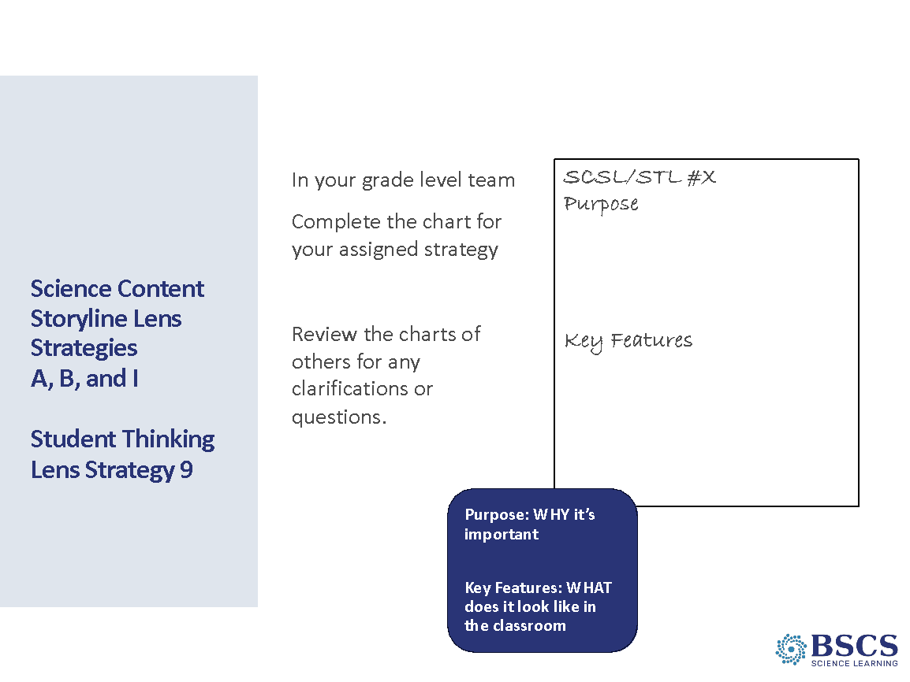 | - SCSL Strategies A, B, I/9 (40 min)  PDL Note: The slide provides an example of the charts that study group members will create.  Divide each study group into 4 groups and assign one strategy (A, B, I, and 9) to each group (different groups than E, P, C). Remind participants:  Purpose: why the strategy is important  Key features: characteristics that distinguish the strategy from others  Focus on the text; if the idea is not in the strategy document, it doesn’t go on the chart.  - Remind participants that our goal is shared understanding, so…if it is not in the summary doc, it doesn’t go on the chart.  - After charts are completed, invite participants to review the chart for their assigned strategy developed by at least one other team. They should use sticky notes to ask clarifying questions and pose wonderings about ideas that might be missing or where ideas came from in the strategy doc. If there’s time, they can review the chart for their assigned strategy developed by other teams.  - When groups return to their own charts, they should use the information gathered and feedback to clarifications to revise charts as needed.  - Whip around and gather a few examples of changes that teams made to their charts.  - If participants don’t ask, then be sure to raise the question of the relationship between a focus question and an elicit question. Refer back to Strategy Booklet.  - A Focus Question is at the lesson level. An elicit question may be of that grain size.  - Focus Questions are revisited throughout a lesson and perhaps across lessons to help students develop the intended science content storyline.  - Elicit questions may be asked at any time and serve to uncover students’ current thinking about a particular science idea, focus question, or experience.  PDL Note: As teams are working, move around to each group and ask questions such as:  - What do you mean by…?  - Where did you see that in the text?  Pay attention to ideas on the charts that need to be probed and challenged during the whole group conversation. Some of these ideas will be made visible to everyone by the prompts on the next two slides.  Ideas to watch for:  - SCSL A is for teachers, while SCSL B is for students.  - SCSL I/STL 9 needs to happen at the end of the lesson – whether students or the teacher says it.  Note the relationship between science ideas and student ideas as appropriate. If not appropriate here, the content of the HW reading will come up later in the session on Slide 14.
9:50 – 10:00 | Break: Transition/take charts
10:00 -11:45  105 min  Slides 10-17  Study Group Teams | Purpose: The purposes of this session are to 1) develop a shared understanding of STeLLA Strategies A and B: Identify one main learning goal and set the purpose with a focus question, and 2) deepen abilities to analyze a lesson are deepened through use of analysis guides.  Content: Analysis guides provide criteria used to evaluate the strengths of main learning goals and focus questions. While the main learning goal is for teachers and the focus question for students, they must be closely matched to support student construction of a coherent science content storyline. The focus question serves as a guide for student learning without giving away the “punchline” of the lesson.  What participants do  In content-specific study groups, participants consider candidate main learning goals and focus questions in light of the analysis guides, then match main learning goals to focus questions.  Resources  - Posters  - STeLLA Conceptual Framework  - Charts  - Purpose/Key Features for A, B, I/9  - PD Binder  - MLG AG (p. __)  - Candidate MLGs (p. __)  - FQ AG (p. __)  - Candidate FQs (p. __)  - SCSL I/STL 9 AG (p. __)  - STeLLA Strategies Booklet | 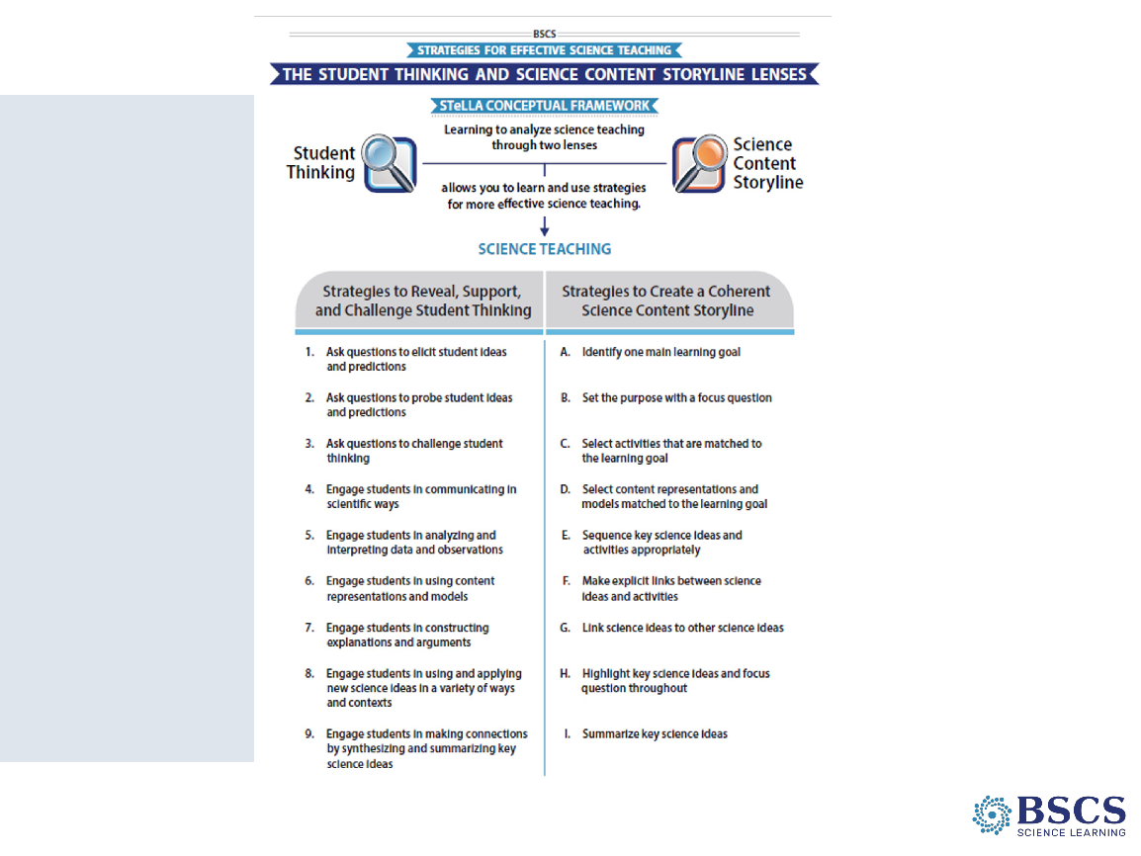 | - STeLLA Conceptual Framework (0 min)  - Orient participants to the Conceptual Framework and note that we’ll continue our study of the science content storyline lens with a focus on Strategies A and B during this session.  Transition: Note that one difference between Student Thinking Lens Strategies and strategies in the Science Content Storyline is the use of analysis guides to help us think through quality.
 |  | 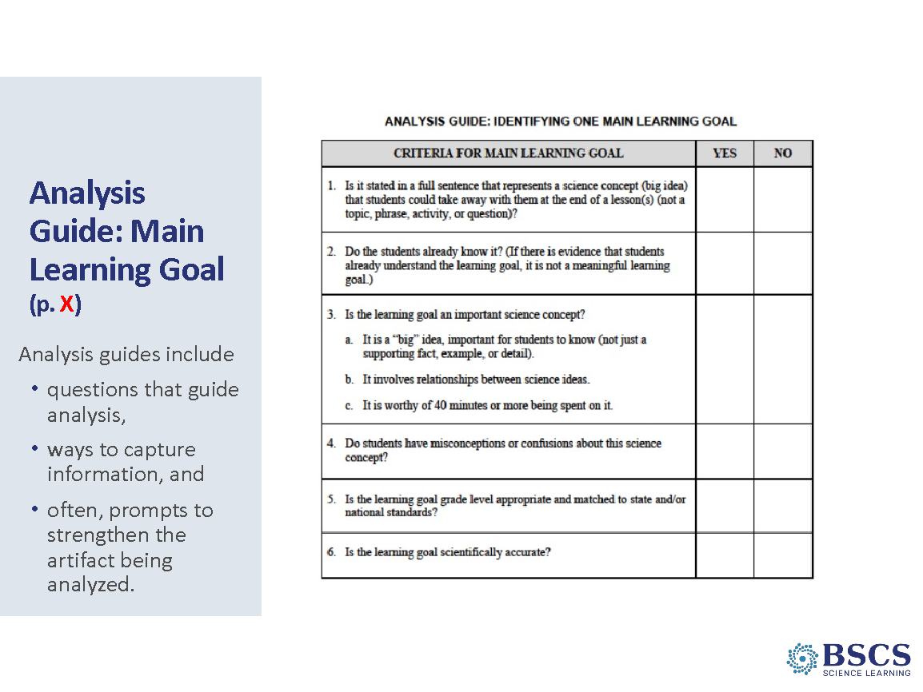 | - Analysis Guides: MLG (15 min)  PDL Note: The slide is animated. The first section provides general features of analysis guides.  - General characteristics of analysis guides include questions, a graphic organizer or space to capture information, and often prompts to strengthen the artifact being analyzed.  - Refer participants to the MLG Analysis Guide (PD Binder p. __). Provide a few minutes to study the questions. Ask them to consider how they would answer these questions if the candidate MLG was a GOOD example. Invite them to turn to a partner and discuss and be ready to ask clarifying questions.  - Highlight that MKGs include multiple science ideas and we need to be able to parse those out. Invite participants to turn in their Strategy Booklet to pp. 7-8 and read about Student Ideas and Science Ideas. As they read, they should consider the connections among this text, the text in the Main Learning Goal summary document (pp. ___), and in the MLG Analysis Guide.  - Whip around and gather ideas from the group. Listen for the following ideas to highlight.  - MLGs are bigger ideas than science ideas.  - The MLG is supported by multiple science ideas.  - Students link multiple science ideas to understand the main learning goal.  - Science ideas range in grain size—some are big ideas (more concept-like) and some are smaller ideas (more fact-like)  - Science ideas are accurate, student ideas may not be. Student ideas are their ideas which may be incomplete, naïve, or inaccurate.  PDL Note: Using the Analysis Guides will help participants develop a common understanding of A, B, I/9. Encourage teachers to add to their Z-folds!  Transition: Let’s take a look at some candidate main learning goals. You’ll use our conversation about examples and non-examples along with this new STeLLA tool to help you make decisions and justify your ideas.
 |  | 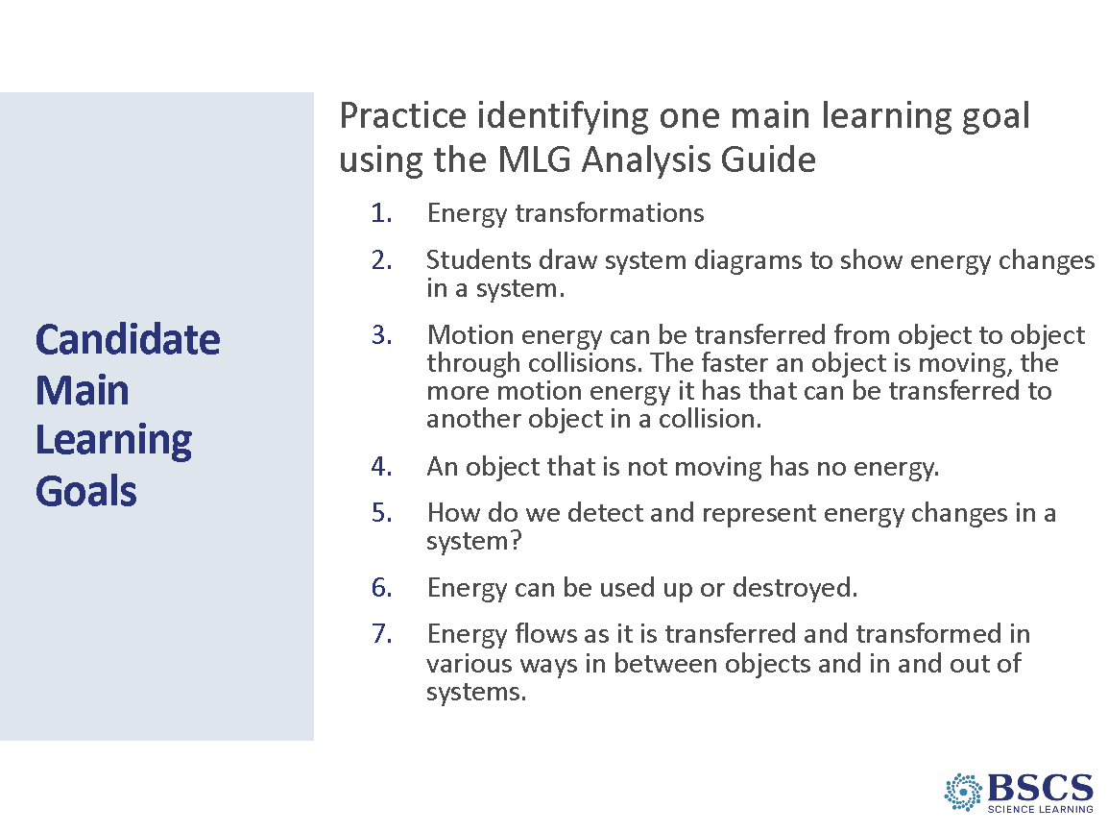 | - Candidate Main Learning Goals (40 min)  PDL Note: This slide is animated. The animation helps study group members hone in on good examples by eliminating low hanging fruit first. Review the animation to see if you want to use this process. If so,  - Which are easy to eliminate and why?  - Topic (#1)  - Question (#5)  - What do you think about #2? (activity)  - Are there any candidates on the list that are inaccurate?  - What does that leave us? What do you think?  - Provide a few minutes for participants to consider the candidate MLGs individually.  - Ask the sequenced questions above using the slide animation as participants respond. Be sure to ask what others think before revealing the “answer.”  ANSWER KEY  - No. Topic  - No. Activity  - Yes.  - No. Inaccurate  - No. Question  - No. Inaccurate  - Yes.  - Now that we’ve identified candidate statements 3 and 7 as MLGs, let’s choose one (#7) to unpack and identify supporting science ideas.  - Provide a few minutes for participants to generate science ideas for MLD candidate #7.  - Invite them to share a few of their ideas with a partner. Ideas you might expect to hear include:  - Energy can be transferred from one object to another through collisions.  - Energy can be transformed from position energy to motion energy or from motion energy to light/sound energy.  - Energy can be added to a system and/or can leave a system (e.g., as light or sound).  - Notice that candidate MLG #3 COULD be a MLG and it also includes science ideas needed for #7. Remember...grain size!  - Follow up with a question about why it’s important that we identify science ideas that are part of MLGs?  Transition: Now that we’ve used an analysis guide to consider SCSL Strategy A: Identify one main learning goal, we’ll continue to use analysis guides to think about SCSL Strategy B: Set the purpose with a focus question to think more about the role of focus questions in developing lessons that allow students to construct a coherent science content storyline.
 |  | 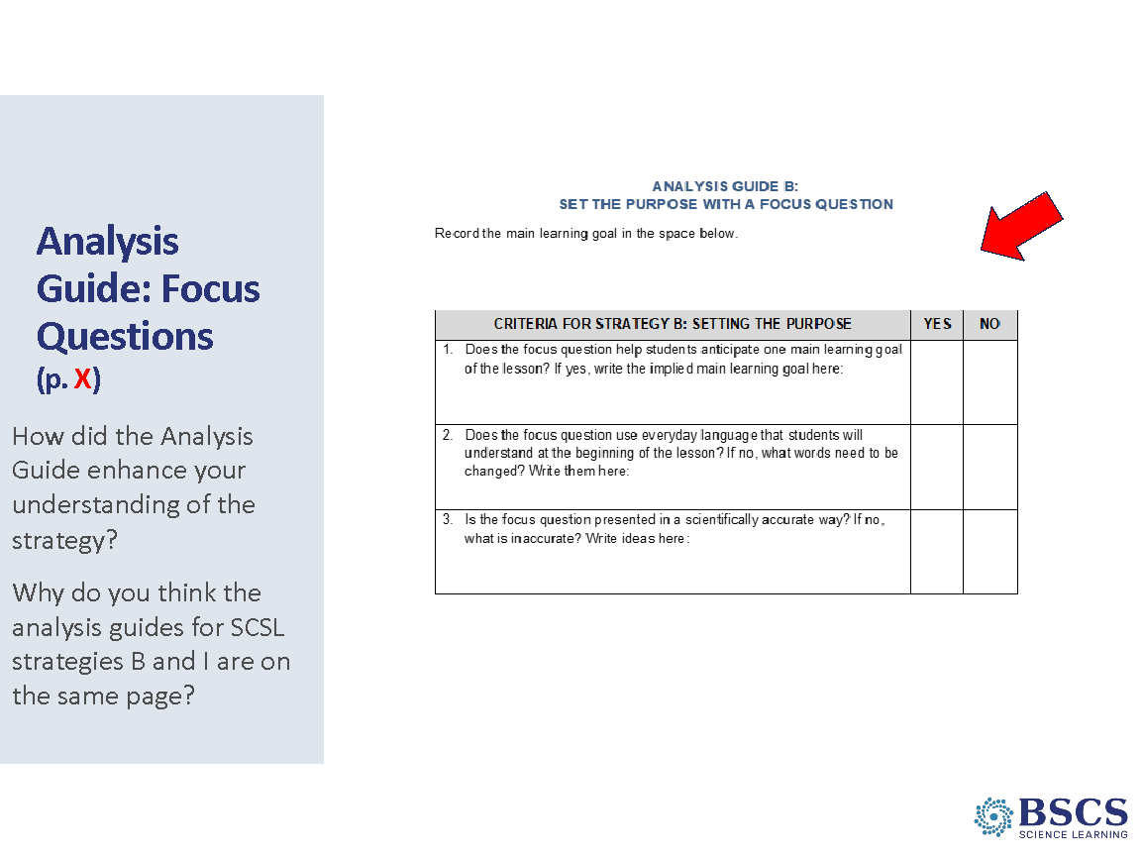 | - Analysis Guide: FQ (5 min)  PDL Note: The slide is animated. The first section provides general features of AGs.  - Refer participants to the FQ Analysis Guide (PD Binder p. __). Provide a few minutes to study the questions. Ask them to consider how they would answer these questions if the candidate FQ was a GOOD example. Invite them to turn to a partner and discuss and be ready to ask clarifying questions.  - Advance the slide to emphasize the importance of knowing the MLG in determining the quality of the FQ.  - Share the second question that links SCSL Strategies B and I/9.  PDL Note: Using the Analysis Guides will help participants develop a common understanding of A, B, I/9. Encourage teachers to add to their Z-folds!  Transition: Let’s apply the analysis guide to some candidate focus questions.
 |  | 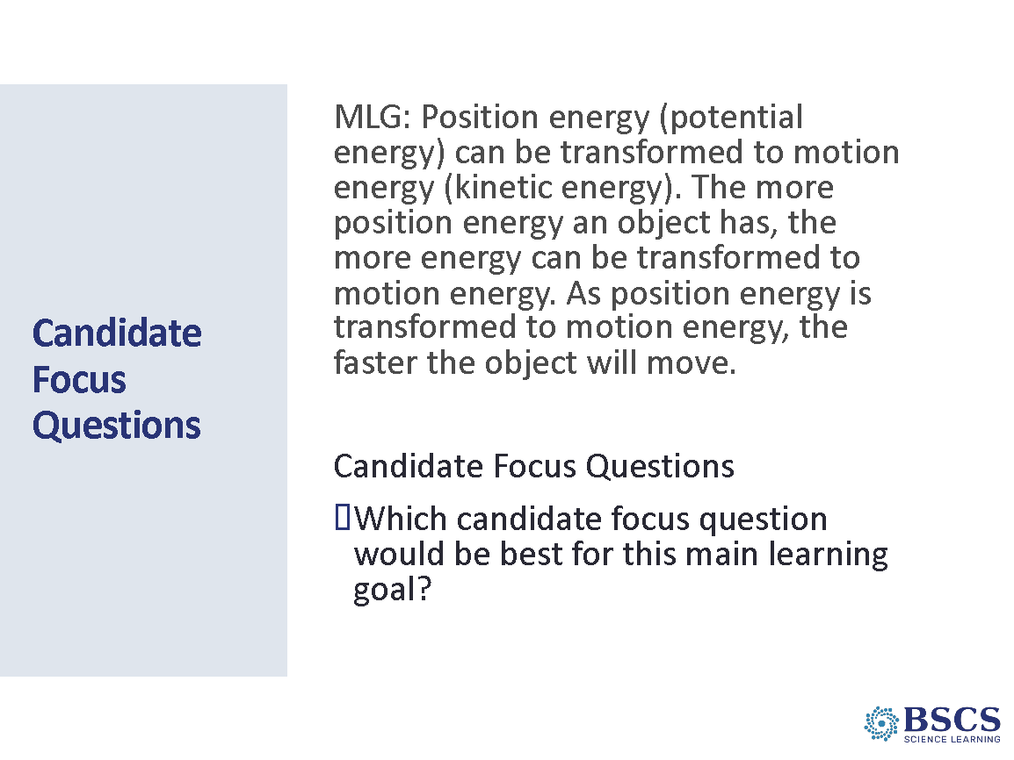 | - Candidate Focus Questions (20 min)  PDL Note: This process will be similar to the one we used with candidate MLGs.  - Refer participants the candidate focus question handout in their PD Binder (p. __).  - Share instructions for the task.  ANSWER KEY: Candidate FQ 5 is best for this MLG.  Transition: Build on the ideas shared by the group about why the MLG has to be recorded at the top of the FQ Analysis Guide. You’ve considered candidate MLGs and FQs. Now, we’ll take a look at the match between these two strategies.
 |  | 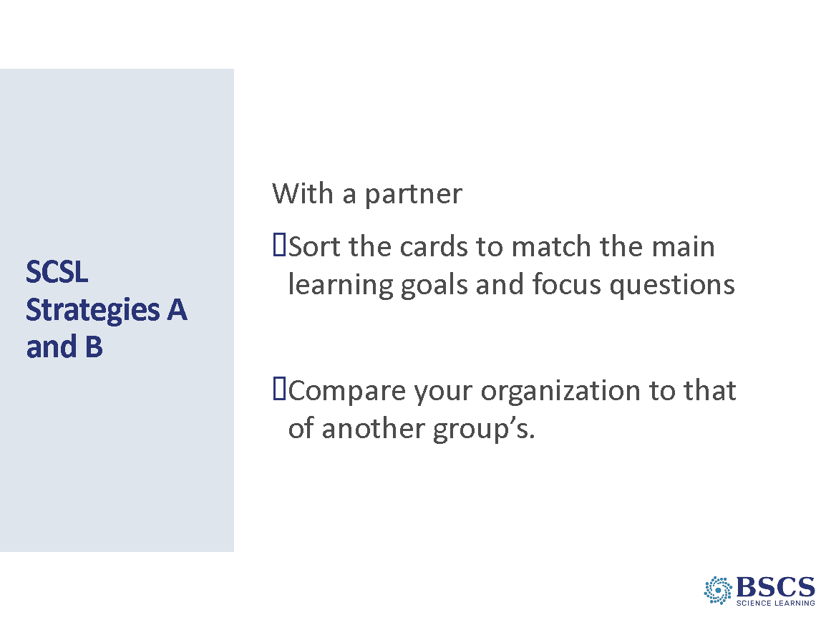 | - SCSL Strategies A and B (15 min)  - Provide instructions for the task.  Lesson # MLG FQ  1 We can detect energy (and energy changes) when an object is moving (and the motion of the object changes). How do we know if something has energy?  2 Motion energy can be transferred from object to object through collisions. The faster an object is moving, the more motion energy it has that can be transferred to another object in a collision. What happens to motion energy when objects collide?  3 Position energy (potential energy) can be transformed to motion energy (kinetic energy). The more position energy an object has, the more energy can be converted to motion energy. As position energy is transformed to motion energy, the faster the object will move How can we change the amount of motion energy of an object?  4 The production of heat, light, sound, or motion are evidence that the energy of an object or system has changed. Energy can be changed from one form to another in a variety of ways. How do we detect and represent energy changes in a system?  5 Energy flows as it is transferred and transformed in various ways in between objects and in and out of systems. Where does the energy come from and where does it go when changes happen in a system?
 |  | 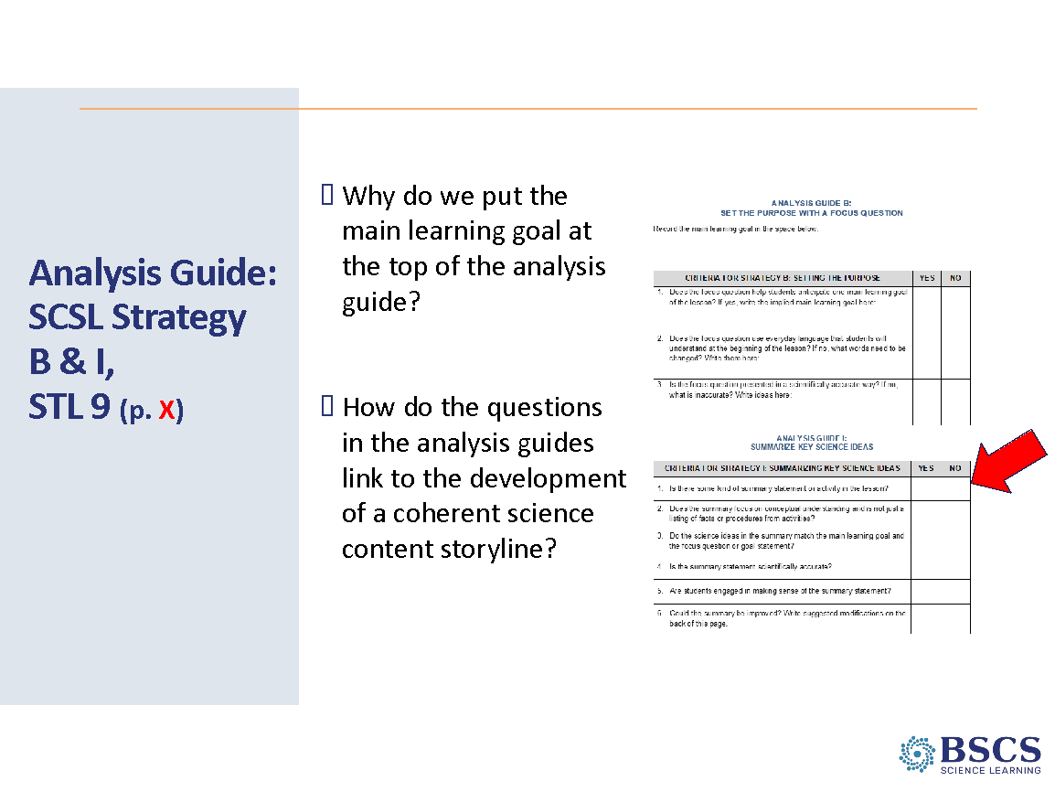 | - Analysis Guide SCSL B & I/9 (5 min)  - Introduce the I/9 Analysis Guide.  - Provide instructions for the task.  - Note that we’ll use this analysis guide later in the session.  PDL Note: Using the Analysis Guides will help participants develop a common understanding of A, B, I/9. Encourage teachers to add to their Z-folds!
 |  | 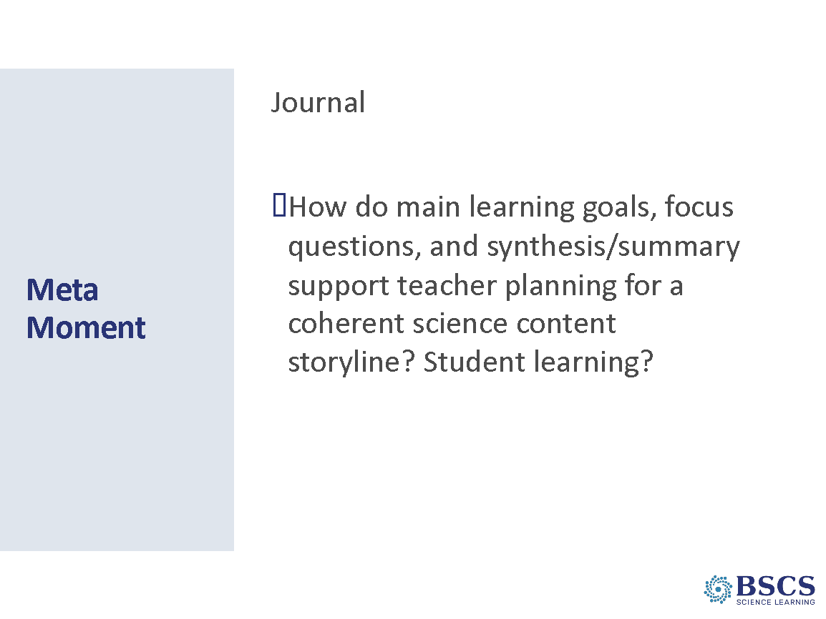 | - Meta Moment (5 min)  - Provide instructions for the task.  - Be sure the probe the relationship (similarities and differences) between SCSL Strategies A and B.  Transition: We’ll continue to refine our understanding of SCSL strategies A (MLG) and B (FQ) I/9 (Synthesize/Summarize) by analyzing classroom video after lunch.
11:45 - 12:15 | Lunch
12:15 – 1:40  85 min  LA C1 (40 min)  LA C2 (45 min)  Slides 18-27  Study Group Teams | Purpose: The purposes of this session are to 1) develop a shared understanding of STeLLA Strategies A and B: Identify one main learning goal and set the purpose with a focus question, and 2) deepen abilities to analyze a lesson are deepened through use of analysis guides.  Content: Analysis guides provide criteria used to evaluate the strengths of main learning goals and focus questions. While the main learning goal is for teachers and the focus question for students, they must be closely matched to support student construction of a coherent science content storyline. The focus question serves as a guide for student learning without giving away the “punchline” of the lesson.  What participants do  Participants consider candidate main learning goals and focus questions in light of the analysis guides, then match main learning goals to focus questions.  Resources  - MLG AG (p. __)  - Candidate MLGs (p. __)  - FQ AG (p. __)  - Candidate FQs (p. __)  - SCSL I/STL 9 AG (p. __)  - Lesson Analysis: The Basics (p. __)  - Video clips & transcripts (p. __)  - Grade 4 Classroom Clip (A)  SSUP_ET_L2_Parco_C1.mp4: This is lesson 2 of the unit. The teacher is eliciting student ideas about changes in motion of the blue and red marbles.  - Grade 4 Classroom Clip (B, I/9)  SSUP_T_L2_Parco_C2.mp4: The teacher is eliciting students’ initial ideas about the lesson focus question.  - Grade 4 Classroom Clip (B, I/9) SSUP_T_L2_Parco_C3.mp4: The teacher is eliciting students’ ideas about how their thinking about the lesson focus question has changed. | 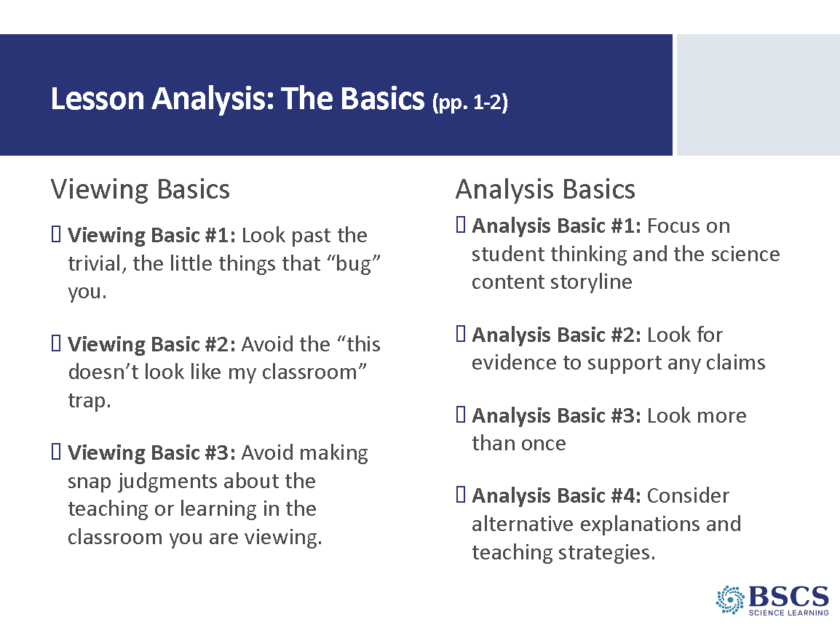 | - Lesson Analysis: The Basics (0 min)  - Welcome participants back from lunch and remind them that we’ll continue to refine our understanding of SCSL strategies A (MLG) and B (FQ) I/9 (Synthesize/Summarize) by analyzing classroom video.  - Share the lesson analysis basics.
 |  | 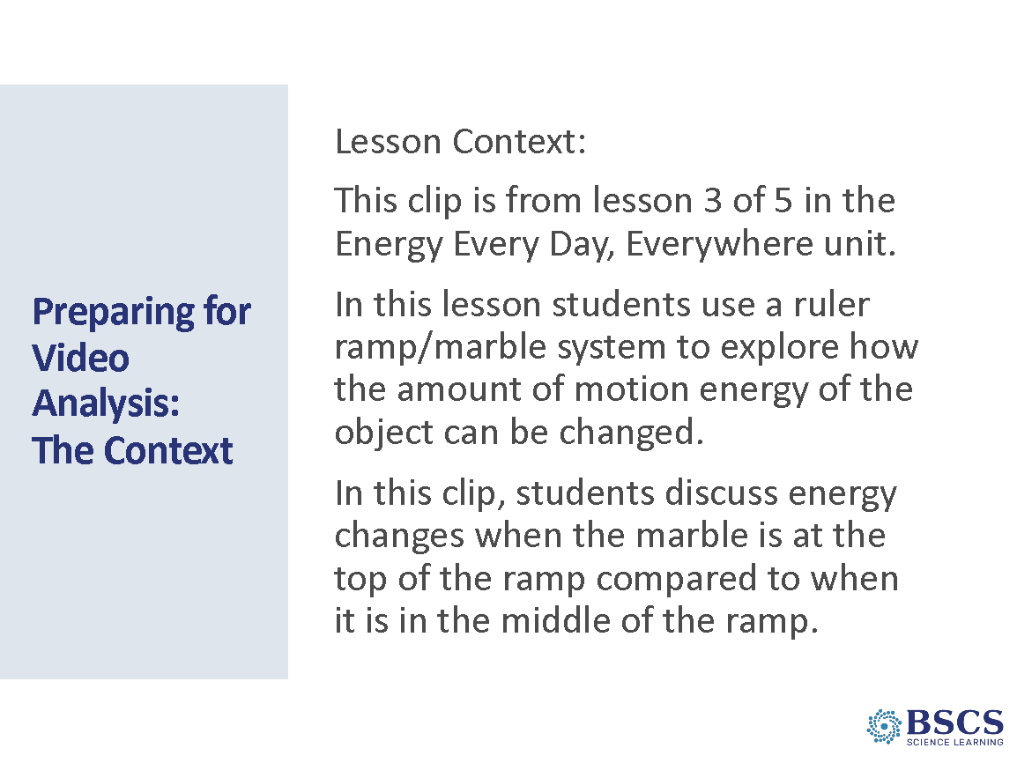 | - Prep for Video Analysis: Context (5 min)  - Direct participants to the transcript (Norris (A) SSUP_ET_KY GR4_SG3_L3_Norris_C1) in binder p. __.  - Share the context of the video: In this clip, the class discusses changes in the energy of a marble in different positions on a ruler ramp.
 |  | 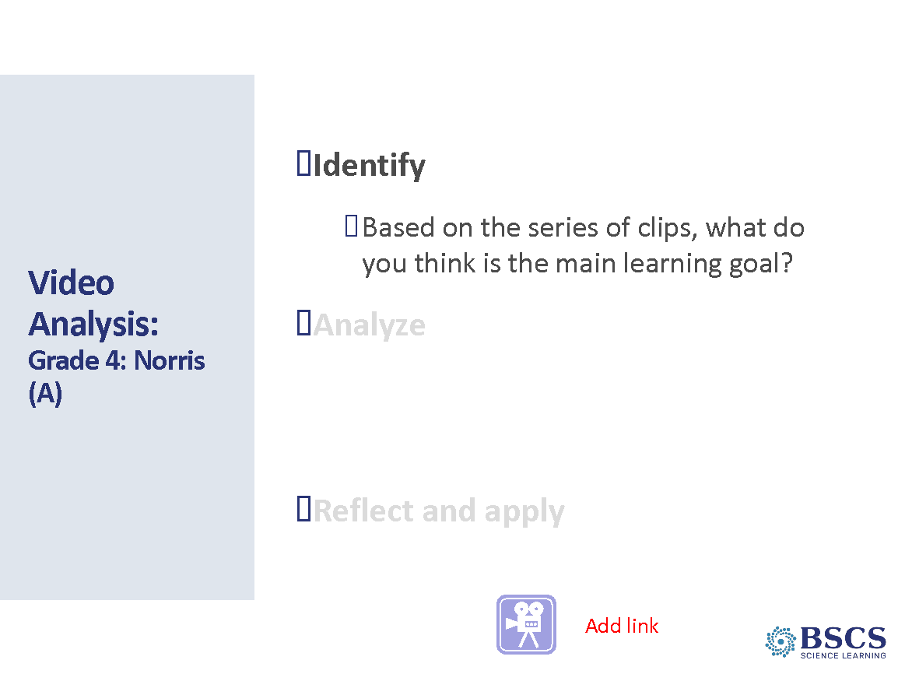 | - Lesson Analysis: Identify MLG (15 min)  - Watch the video clip to determine the learning goal that you think the teacher is working from/toward. Be prepared to share your ideas.  - Choose one of the best learning goals.  - Record the identified learning goal at the top of the analysis guide (HO p. __)
 |  | 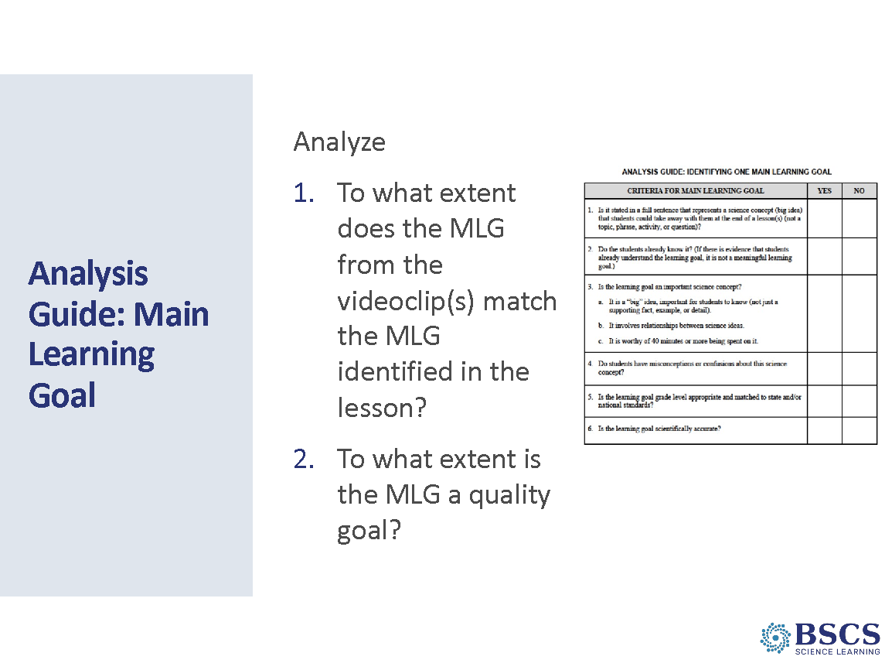 | - Analysis Using Analysis Guide (20 min)  - Use the analysis guide to help determine the quality of the learning goal.  - Share the MLG for L3: Position (potential) energy can be transformed to motion (kinetic) energy. The more position(potential) energy an object has, the more energy can be transformed to motion energy. As position (potential) energy is transformed to motion (kinetic) energy, the faster the object will move.  - Key ideas to highlight  - MLGs matter. Review the SCSL strategies in the Conceptual Framework to note the focus on MLG.  - While the teacher notes position energy and motion energy and compares the amount of position energy when the marble is at different points on the ramp, there is no focus on the transformation of position (potential) energy to motion (kinetic) energy. There is no connection made between the amount of positional (potential) energy and the amount of motion (kinetic) energy.  PDL Note: This is an opportune time to have a brief content deepening discussion. The teacher introduces the term ”stored energy” in place of positional energy, which supports a common student idea that energy is a “thing” that can exist in a place. Refer to the Teacher Content Background and Common Student Ideas documents to support you in leading this discussion.
 |  | 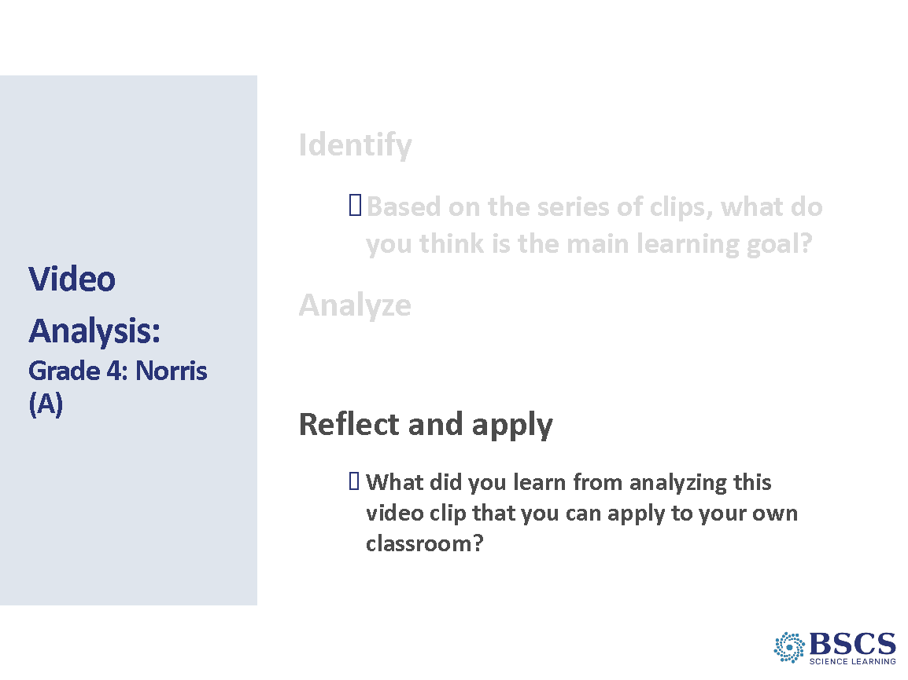 | - Reflect and Apply (10 min)  - Provide time for reflection and invite several participants to share their ideas.
 |  | 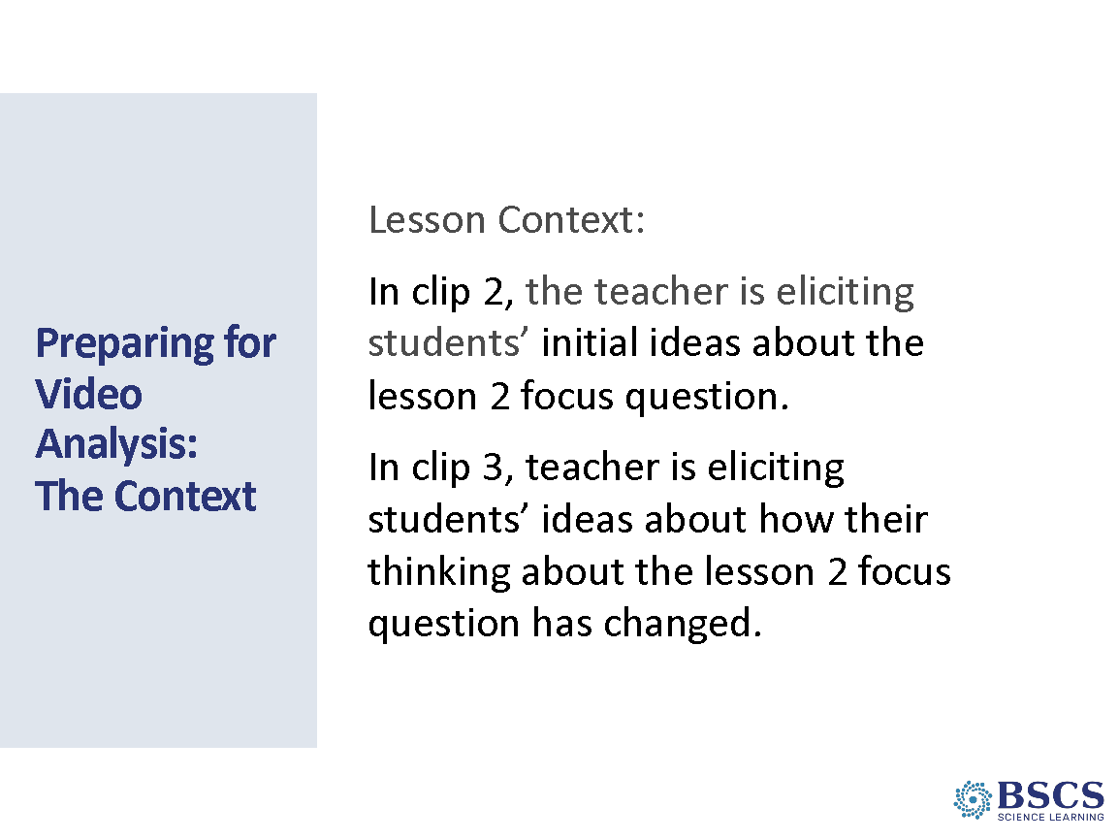 | - Context (0 min)  - Direct participants to the transcripts (Parco (B, I/9) SSUP_ET_L2_Parco_C2 Transcript) (Parco (B, I/9) SSUP_ET_L2_Parco_C3 Transcript) in binder p. __ and p. __.  - Share the context of the video. In clip 2, the teacher is eliciting students’ initial ideas about the lesson 2 focus question. In clip 3, teacher is eliciting students’ ideas about how their thinking about the lesson 2 focus question has changed.
 |  | 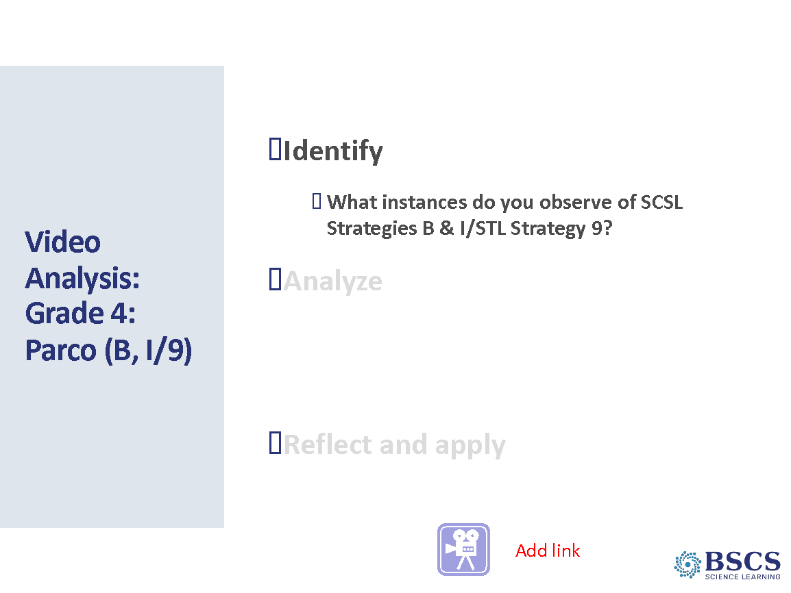 | - Video Analysis: Identify (15 min)  - Watch the video and note evidence of the selected strategies  PDL Note: Clear examples of strategies SCSL B/I-STL 9  Clip 2:  0:00:05 to 0:00:47- (SCSL B) Teacher sets the purpose of the lesson with the focus question and connects to questions on the DQB  0:02:22- (SCSL B) Teacher redirects student thinking back to the focus question  0:03:07- (SCSL B) Teacher uses sentence frames to support all students in sharing their initial ideas about the lesson focus question.  Clip 3:  0:00:09 to 0:01:17- (SCSL B and I) Teacher invites students to revise their ideas about the lesson focus question and summarizes key ideas figured out from the lesson activities.  0:01:39 to 2:08- (STL 9 and SCSL I) A student includes key science ideas as he shares how his ideas have changed and the teacher emphasizes important terms from his summary for the class.  0:02:25 to 0:03:04- (SCSL I) Teacher asks P and C questions to help a student connect his ideas with the key science ideas being summarized.  0:04:16 to 0:04:42- (STL 9 and SCSL I) Student summarizes key science ideas and the teacher emphasizes how the class’s ideas have changed to include those science ideas.  Key ideas that were learned during the unit are visible on the Science Ideas We’ve Figured Out chart on the chart stand.
 |  | 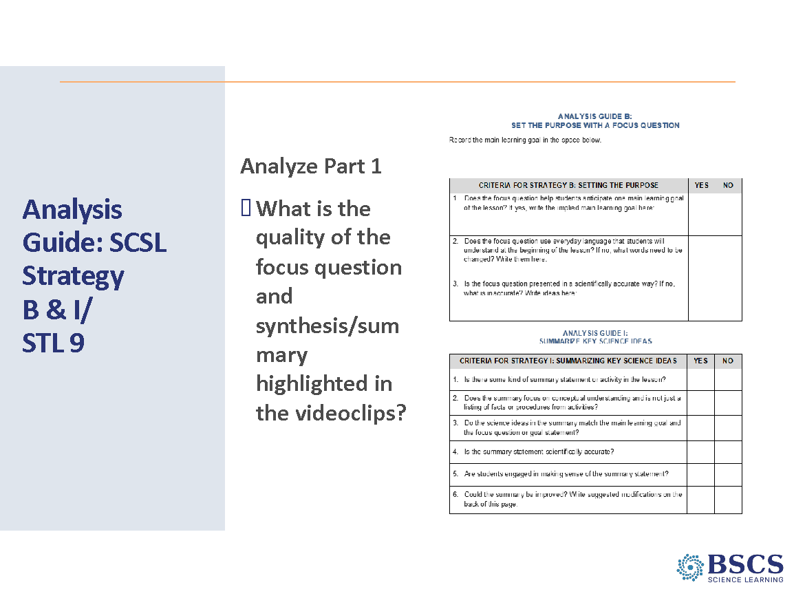 | - Analysis Guide: B, I/9 (5 min)  PDL Note: As with other analysis guides, this strategy includes questions to guide analysis  - Provide instructions for the task including the FQ and the use of Synthesize/Summarize.  - Ask participants to consider the quality of each.  Transition: Note that we’ll consider what summarizing and synthesizing looks like in the classroom and analyze how the use of these strategies influence student thinking.
 |  | 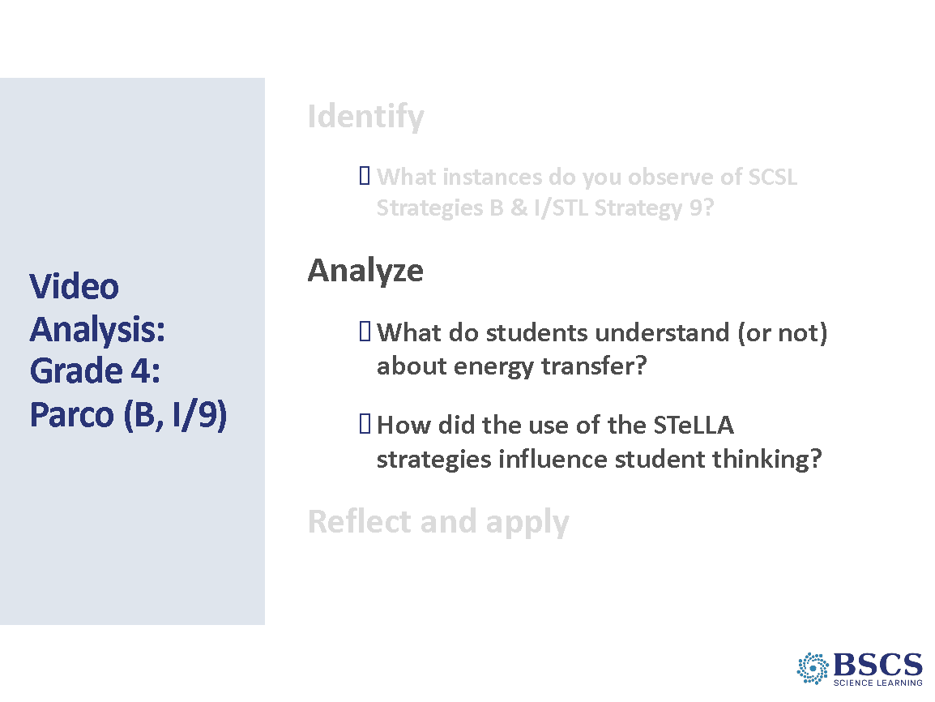 | - Video Analysis: (15 min)  - Provide a focus for the analysis and time to go back to the transcript.  - Remind participants to make a claim and support it with evidence. They should be ready to discuss why these ideas are important to teaching and learning.
 |  | 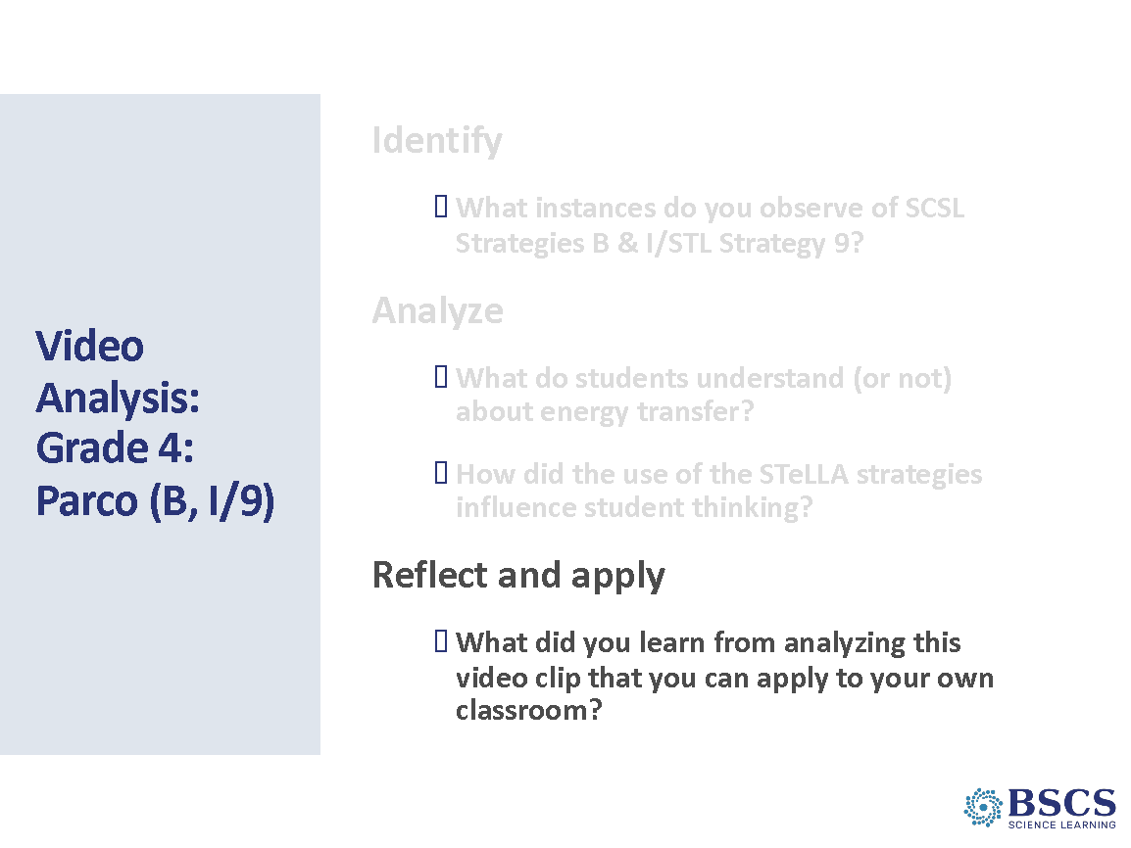 | - Video Analysis: Reflect and Apply (10 min)  - Offer a few minutes for teachers to record some of their ideas and then invite them to share something they wrote.
1:40 – 4:00  140 min with -10 min break  Slides 28-45  Study Group Teams | Content Deepening  Purpose: The purpose of this session is to model effective STeLLA-based science teaching and learning through a common experience that is grounded in a 3D, phenomena/problem driven unit and designed for adult learners.  Content: STeLLA model lessons/units attend to the characteristics of effective science teaching and learning (e.g., 3D, phenomenon/problem-driven, student-centered, make student thinking visible and support sense-making, coherent, and access/engage prior knowledge and develop metacognitive abilities).  The content deepening experience will include explicit modeling and use of STeLLA strategies.  Energy is all around us and can be detected using our senses. We can feel heat, see light, hear sound, and see movement. This is evidence that energy is present and changing. Energy changes in a system can be represented with a system diagram that shows the components of the system, observable changes, where energy changes are occurring, where the energy comes from, and where the energy goes.  Describing systems in terms of their components and interactions helps us make generalizable statements how energy is transformed and transferred between objects and systems.  Constructing a scientific explanation involves identifying and using relevant evidence to support the explanation. The explanation describes how energy changes result in observable changes in a system.  What participants do  Participants will use toys to investigate evidence of energy changes including heat, sound, light, and motion. They will create a system diagram for one toy that shows energy changes in the system that includes observable changes, changes in energy, where the energy comes from, and where the energy goes.  Resources  - Journals  - STeLLA Conceptual Framework Poster  - Norms poster  - CSW poster  - tape or glue stick  - 10 sticky notes  - fine tipped markers  - chart paper and markers  - plastic bag containing:  - wind-up toy  - hand-crank flashlight  - noise maker  - rubber ball  - electrical device to feel heat  - Driving Question Board  - Notice/Wonder chart  - Science Ideas We’ve Figured Out chart | 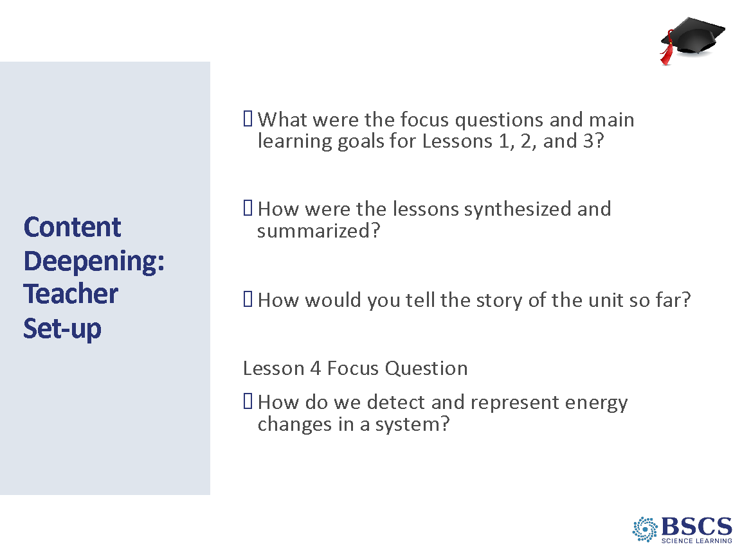 | - Content Deepening: Teacher Set-up (30 min)  - Build from the sessions up to this point and connect to content deepening experiences.  - Provide instructions for the task by revealing the first two questions and providing time for discussions in groups of 3-4.  - The focus questions and synthesize/summarize tasks are in their science notebooks.  - Participants will use their notes to draft potential main learning goals. Remind them to use their summary documents, Z-folds, charts, and analysis guide to help them.  - Whip around and have each group share their ideas either 1 strategy at a time or across all 3 strategies.  - Introduce the FQ for lesson 4 and transition from teacher set up to the science learner experience.  PDL Note: The entire content deepening experience should include attentions to strategies A, B, I/9.  Transition: Let’s investigate ways evidence of energy changes in a system and see if we can answer the question, “How do we detect and represent energy changes in a system?”
 |  | 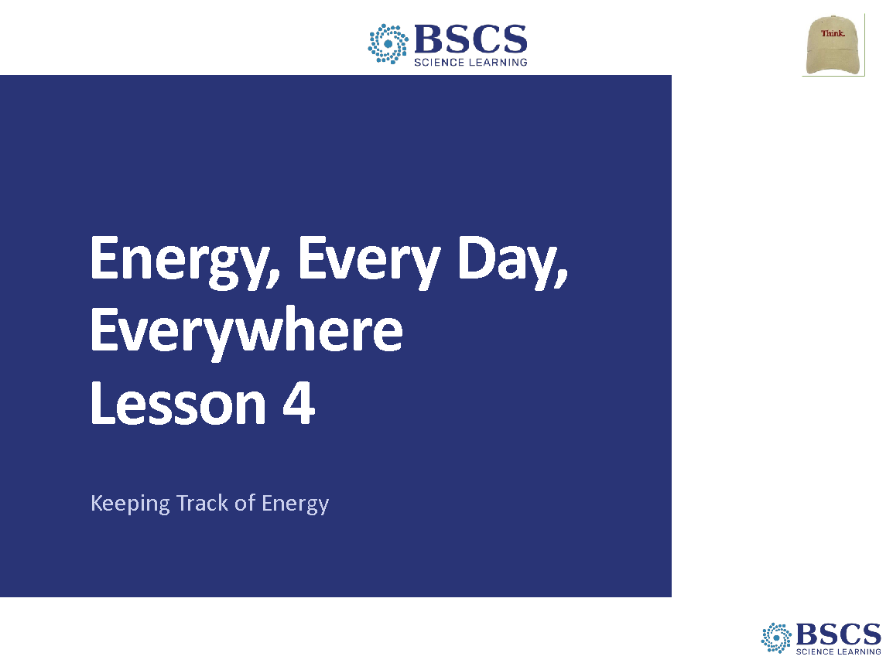 | - Energy, Every Day, Everywhere (0 min)  - Welcome learners to Lesson 4 of the unit.
 |  | 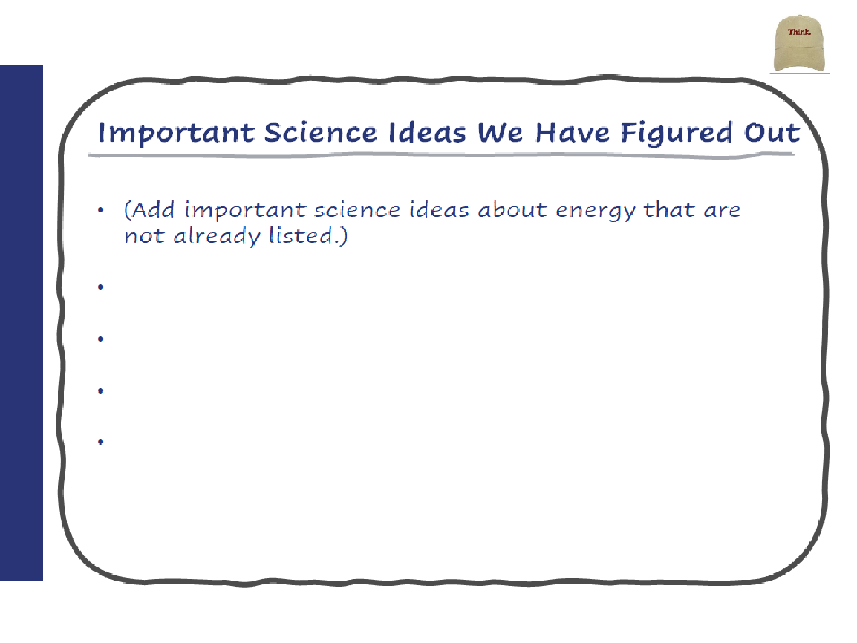 | - Important Science Ideas We Have Figured Out (5 min)  - Invite participants to revisit the Unit Central Question on the Driving Question Board and the Focus Question from Lesson 3. Provide a few moments for participants to think individually about the science ideas we figured out in the last lesson.  - Mark rows 6 and 7 of the CSW poster and invite participants to use these sentence stems as they share science ideas to add to the Important Science Ideas We Have Figured Out chart.  PDL Note: Ideas to add to the chart include:  - The faster an object moves, the more energy it has.  - As an object goes down an incline, it goes faster and faster as position energy is converted to motion energy.  - The higher the incline, the faster the object goes when it moves down the incline.  - An object that is released from a higher position goes faster and farther than an object that is released from a lower position.  - Objects that are not moving can have position energy.  - Position energy can be transformed into motion energy.
 |  | 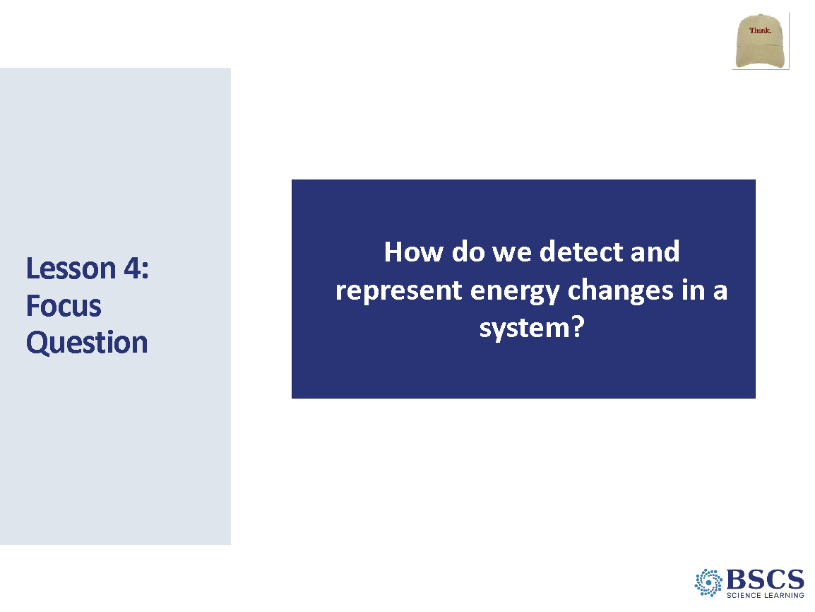 | - Focus Question (5 min)  - Draw participant attention to the Driving Question Board and Notice and Wonder Chart. Highlight questions about sound, heat, and/or light energy. Share the Lesson Focus Question and invite participants to write the focus question in their science notebooks and draw a box around it. Below the box, they should write the sentence starter: “I know that the energy of an object or system has changed…”  - Have participants write their best ideas about the focus question and leave plenty of room after to add to and revise their thinking throughout the lesson.  - Invite several participants to share their ideas with the class.  PDL Note: Highlight the lesson focus question throughout the content deepening session.
 |  | 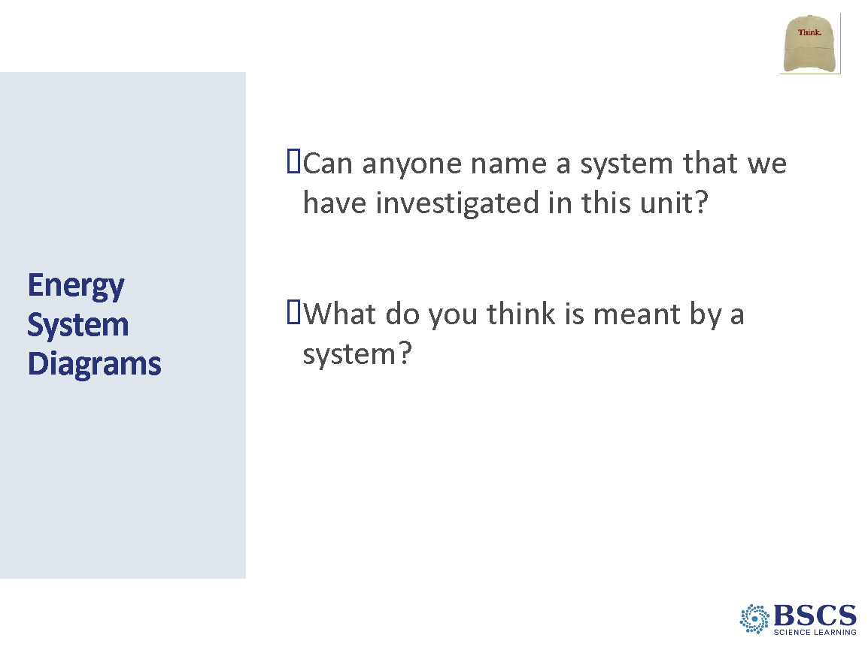 | - Energy System Diagrams (Slides 34-35: 5 min)  - Invite participants to discuss the prompts with an elbow partner.  - Have several groups share their ideas about what is meant by a system. Highlight ideas that a system is made of components (or parts) that interact. A system has boundaries and there may be inputs to and outputs from the system.  - Ask other groups to name a system that we have investigated so far in this unit. Groups may share the car launcher system (Lesson 1), the ruler/marble system (Lesson 2), and the ramp/marble system (Lesson 3).  Transition: We will focus on the ramp/marble system that we used in the last lesson. There were many observable changes in the system that were evidence of energy changes in the system. One way to represent the observable changes, energy changes, where the energy comes from, and where the energy goes is with a system diagram.
 |  | 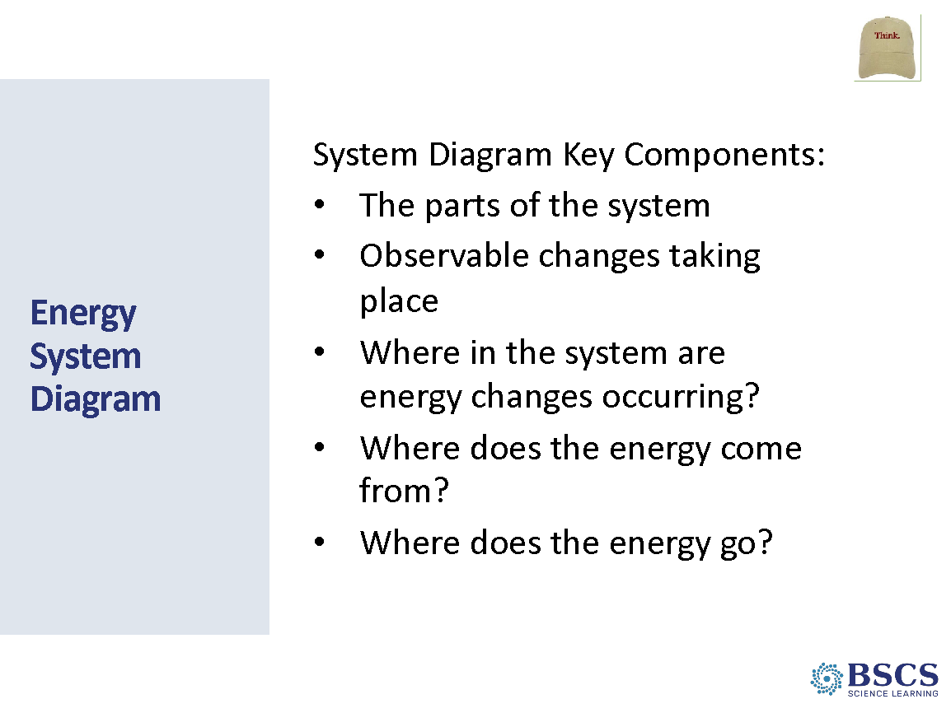 | - Energy System Diagram  - Share that a good system diagram includes the key components listed on the slide. Post the physical System Diagram Components chart listing the key components and note that we will refer to this list as we develop our own system diagrams.  Transition: Let’s construct a system diagram for the ramp/marble system from our last lesson together.  PDL Note: To change the dynamics in the room, you may choose to have participants stand around a blank chart paper as you model making a system diagram for the ramp/marble system.
 |  | 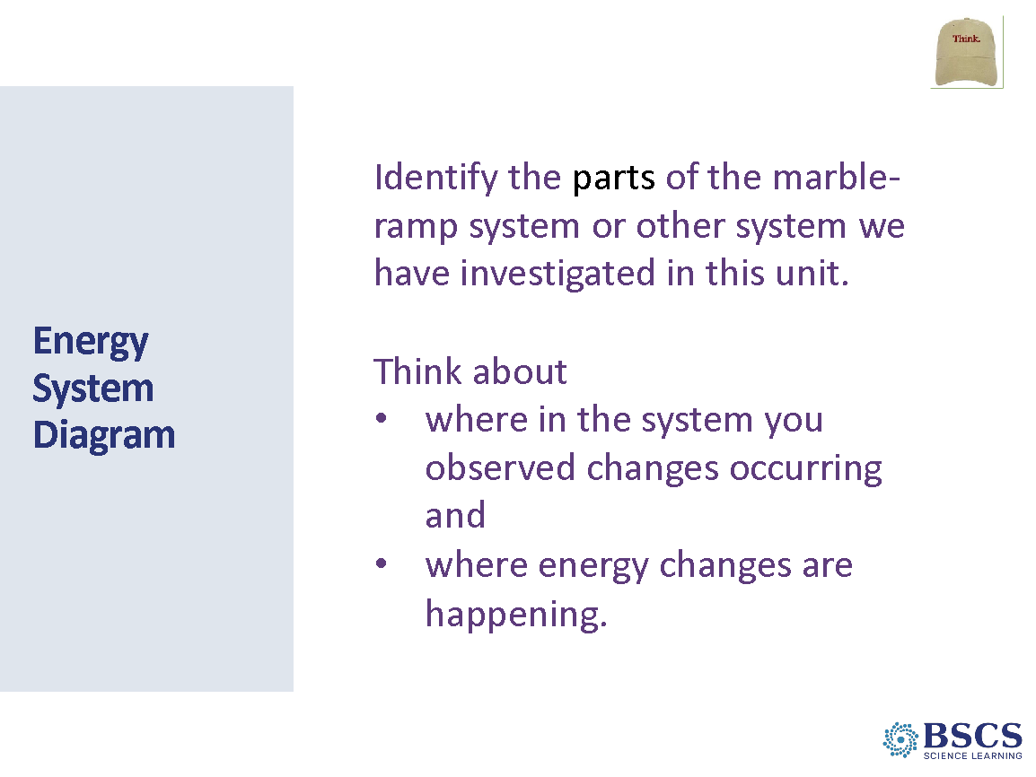 | - Energy System Diagram (5 min)  - Invite participants to first identify the components of the ramp/marble system. As participants name the parts of the ramp/marble system draw and label the components on the chart paper. As you draw the components, emphasize that symbols and shapes work well to represent the parts of the system and there are many ways that one could represent the parts of the system.  - Note that we have included the first key feature of a system diagram: the parts of the system. Invite participants share the observable changes they saw as the marble rolled down the ramp. As participants share, add their ideas to the chart in a different color.  - Invite participants to share where energy changes are occurring in the system, where the energy comes from and where the energy goes. Add these ideas to the system diagram.  PDL Note: Refer to the Figures in the Lesson 4 Teacher Guide for sample diagrams for each step. Your system diagram may look different, but should include all the components shown, representations of energy changes, and energy bars labeled with the type of energy.  - Invite participants to turn to an elbow partner and consider if the system diagram contains all the key features from the chart and discuss what feedback they might provide to improve the diagram.  - Draw participant attention to the Focus Question. Ask participants to think about how we have represented evidence of energy changes with our system diagram.
 |  | 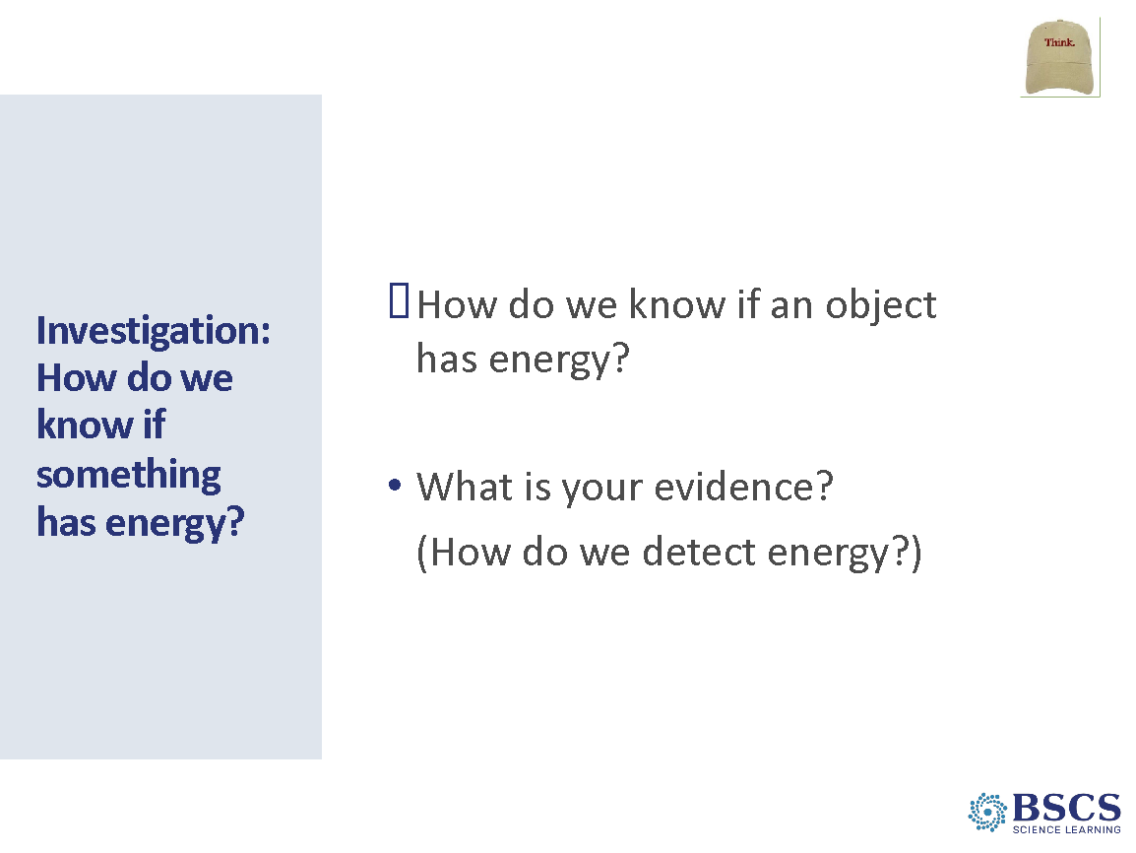 | - Investigation: How do we know if something has energy? (Slides 37-38: 5 min)  - Note that in the ramp/marble system we detected energy changes as we saw the marble and Styrofoam block move. Wonder aloud if there are other ways we could detect changes in energy in system. Invite participants to share their ideas with the whole group.
 |  | 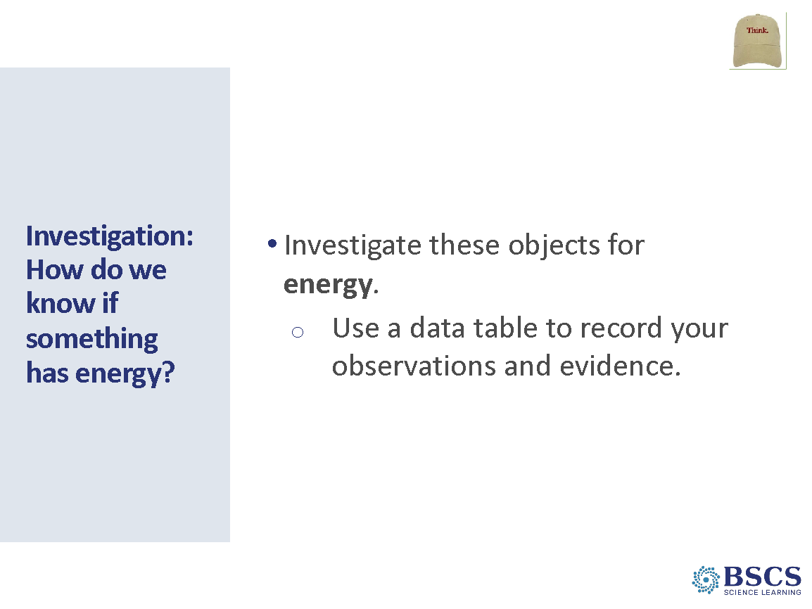 | - Investigation: How do we know if something has energy?  - Hold up a bag of toys and share that we will examine these objects for evidence of energy changes. Note that we may have to do something to some of the objects to look for energy changes.  - Share that we’ll record the observed changes to the objects and the evidence of energy in a data table.
 |  | 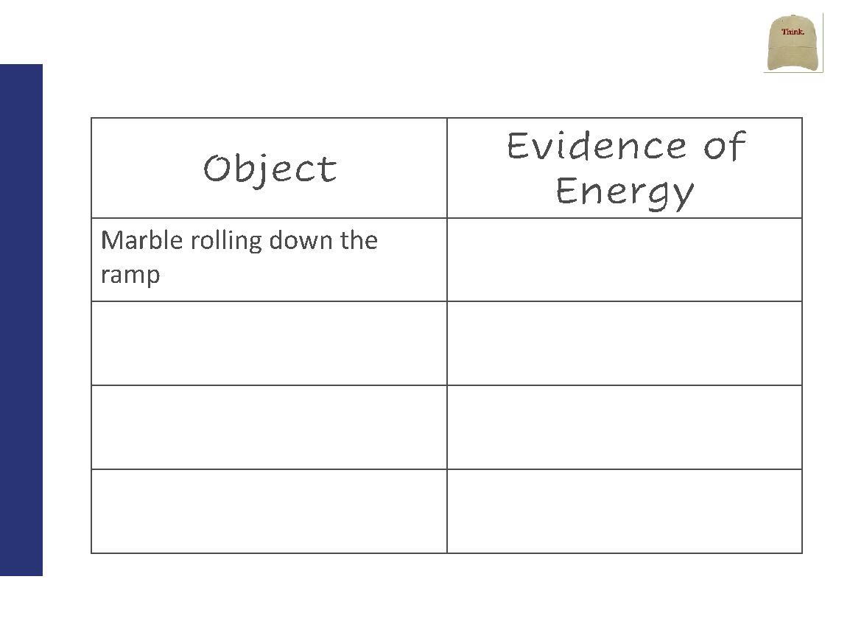 | - Object / Evidence of Energy (10 min)  - Invite participants to draw the data table on the slide in their science notebooks, leaving extra room at the bottom of the table to add extra rows.  - Advance the slide to model how you might fill in a row of the table if you were observing the ramp/marble system.  - Distribute a bag of toys to each group. Invite groups to come up to the projector to feel the heat coming from the device (they may also observe light coming from the projector).
 |  | 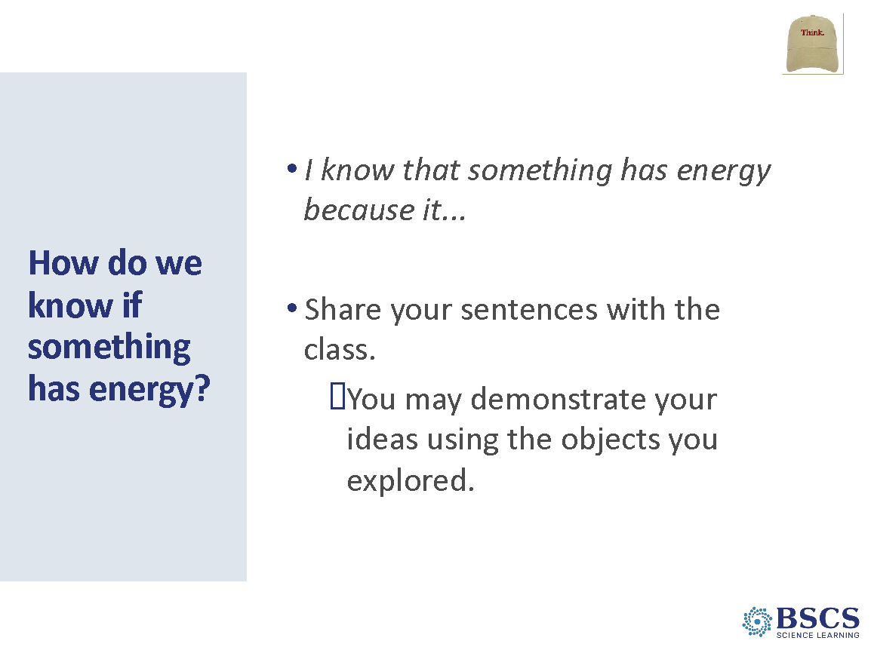 | - How do we know if something has energy? (5 min)  - Draw participants together and invite each group to use one of the objects to share the observable changes and evidence of energy changes. As groups share, have other groups use thumbs up/thumbs down to show agreement/disagreement with the presenting group’s statements.
 |  | 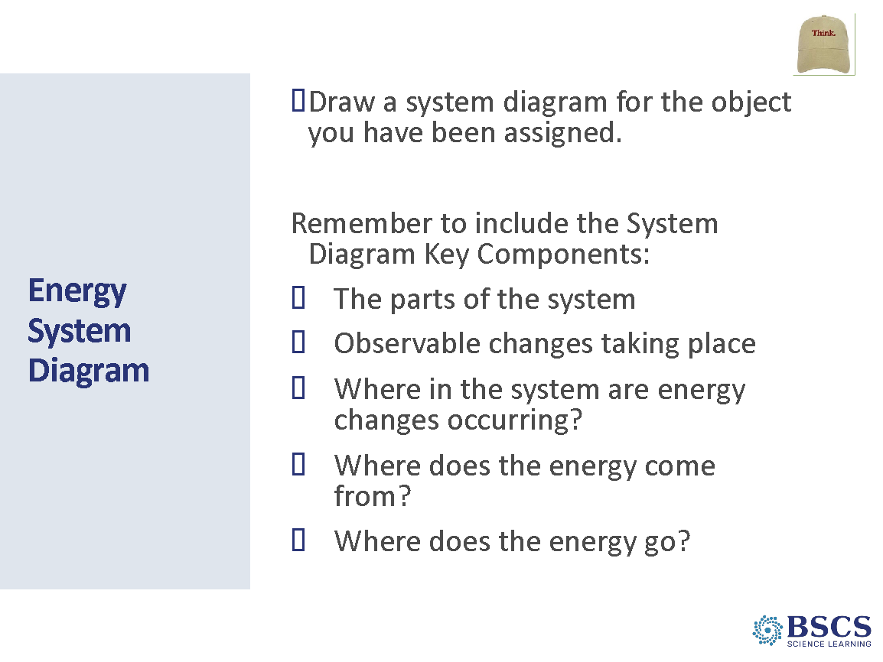 | - Energy System Diagram (10 min)  - Assign each group one object from the bag. Provide groups with chart paper, markers, tape, and the handout with the image of their assigned object.  - Invite groups to make a system diagram for their assigned object, making sure to include the key features of a system diagram.  - As groups finish their system diagram, they should post them in a place where other groups can observe the charts.
 |  | 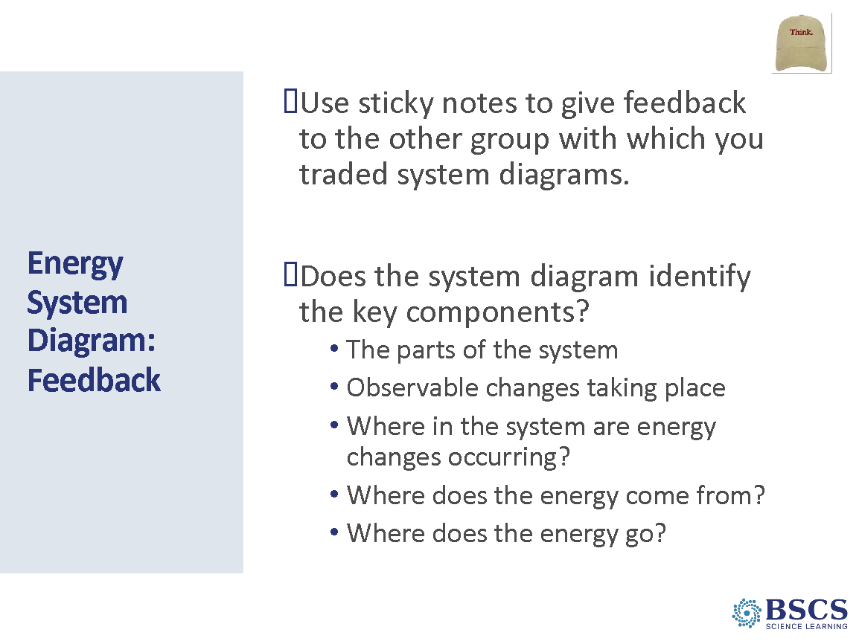 | - Energy System Diagram: Feedback (5 min)  - Invite groups to provide feedback on sticky notes to other groups. Remind participants to use the System Diagram Key Components chart as a guide for providing feedback. Note that they should provide one piece of feedback per sticky note.  PDL Note: You may choose to share an example and non-example of good feedback such as  - I wonder if you included all the observable changes. (example)  - Your labels and descriptions are written neatly (non-example)  PDL Note: Pair groups who developed a system diagram for the same toy together if possible.
 |  | 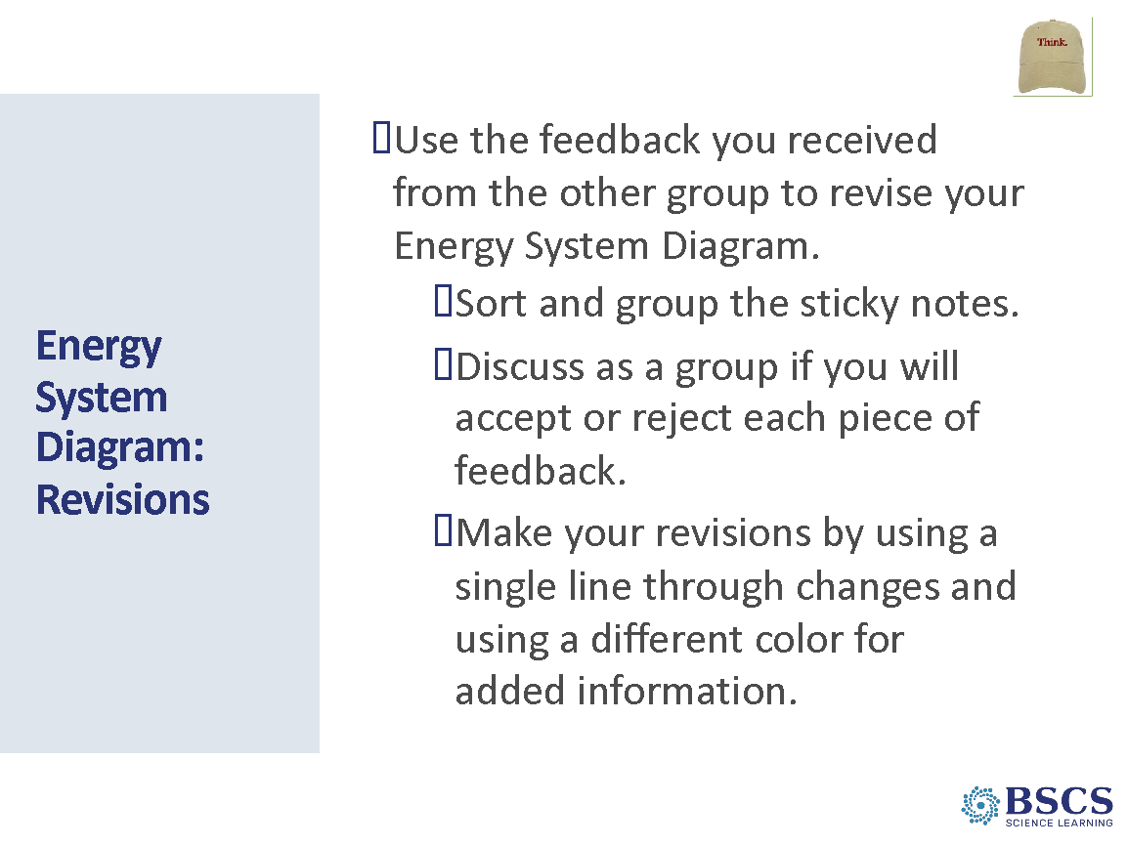 | - Energy System Diagram: Revisions (5 min)  - Invite groups to review the sticky note feedback they received by sorting and grouping the feedback. Groups should then discuss if they will accept or reject the feedback.  - Encourage groups to make revisions by drawing a single line through text they do not want to keep and using a different color for added text.  Transition: Now that we’ve revised our Energy System Diagrams, let’s take stock of what we’ve learned so far and the key science ideas we’ve figured out.
 |  | 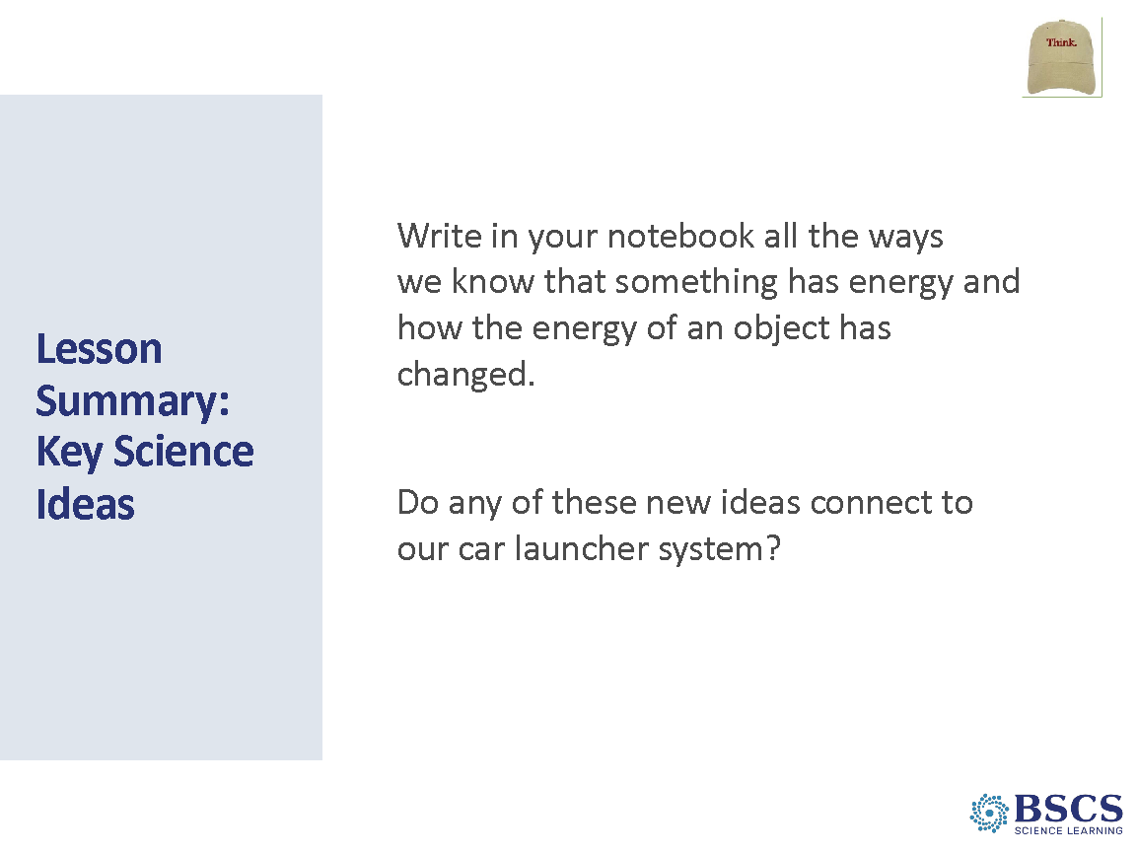 | - Lesson Summary: Key Science Ideas (5 min)  - As we finish our revisions to our systems diagrams, I’ll invite you to reflect on our lesson Focus Question: “How do we detect and represent energy changes in a system?” Let’s take a few minutes to revise our initial answer to the focus question.  - Invite participants to gather around the Key Science Ideas chart. Have participants share key science ideas about ways to detect energy that should be added to the chart. As participants share their ideas, use thumbs up/thumbs down to determine whole-group consensus on ideas.  PDL Note: Add new ideas in a different color marker.  Transition: In our next lesson we will apply these ideas to the car launcher system as well as a second, new system.
 |  | 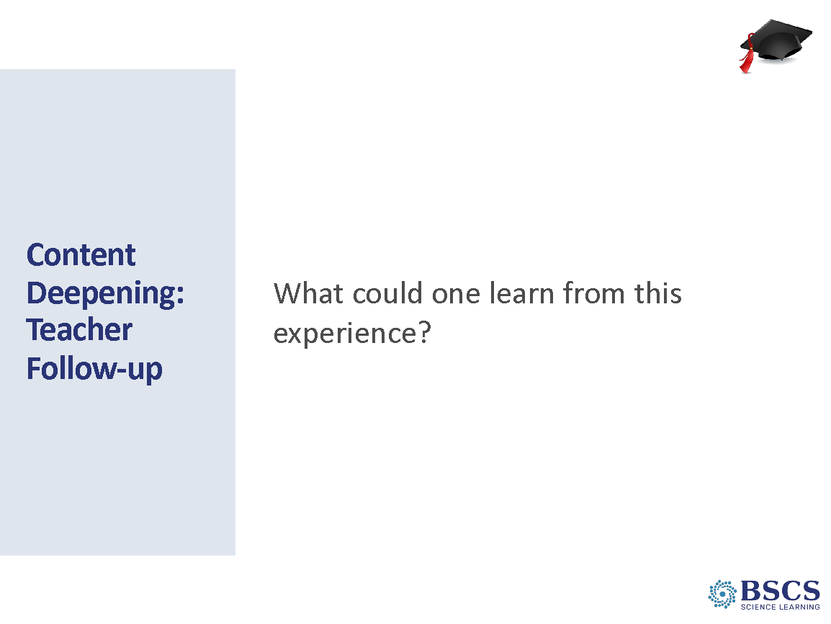 | - CD: Teacher Follow up (15 min)  Provide instructions for the task.  Invite participants to share their ideas and populate the wall charts.  If they haven’t already figured out the headers, then add them. For example: You may have noticed that I’ve been sorting your ideas onto the 4 pieces of chart paper. If you were going to place headers at the top of each chart, what would they be? Talk to someone near you?  After a few minutes, ask if anyone would be willing to put an idea on the table and see what others think. Record their ideas at the top of each chart more or less as stated. Share the categories by which you were sorting: DCIs, SEPs, CCCs, and Other (pedagogy).
 |  | 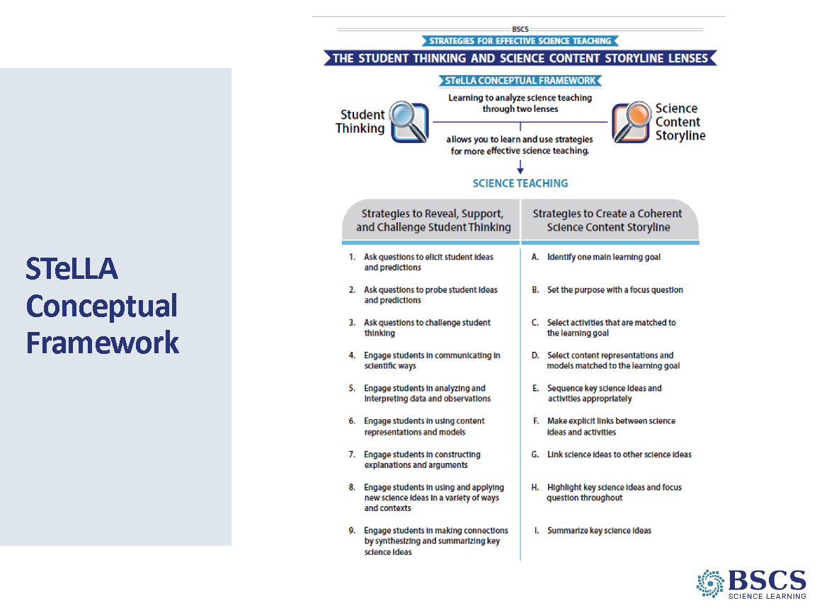 | - STeLLA Strategies Booklet (0 min)  PDL Note: Notice that this slide and the next few are considered part of the Teacher Follow-up.  - Remind participants that we have been considering the role of STeLLA Strategies A, B, I, and 9 today.
 |  | 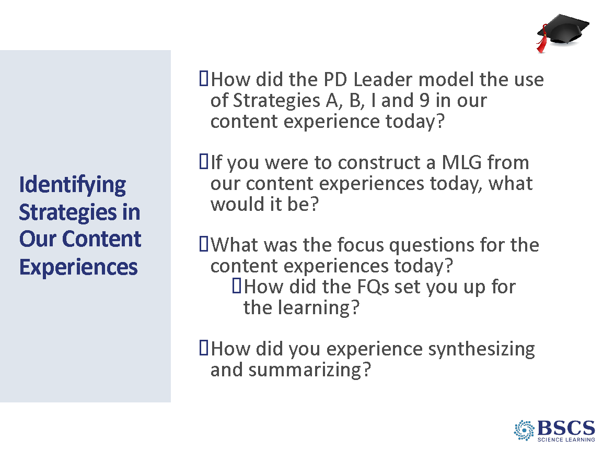 | - Identifying Strategies (15 min)  - Emphasize the importance of making links between what we do and what we learn.  - Provide instructions for this task.
4:00 – 4:30  30 min  Slides 46-51 | Closing  Purpose: The purpose of the closing is to continue to build community, reflect on the day, and set the stage for tomorrow’s learning.  Content: Focus Questions  - Why is one main learning goal (SCSL Strategy A) essential for coherence of the Science Content Storyline?  - How does the use of a focus question (SCSL Strategy B) contribute to the coherence of the Science Content Storyline?  - How does synthesizing and summarizing key science ideas (SCSL I/STL 9) contribute to the coherence of the science content storyline?  - How can we begin and end a lesson using STeLLA Strategies?  - How do we detect and represent energy changes in a system?  What participants do  Participants reflect on learning from day 3.  Resources  - BSCS Journal  - PD Binder  - Daily Reflection (if applicable)  - STeLLA Strategies Booklet  - SCSL Z-fold | 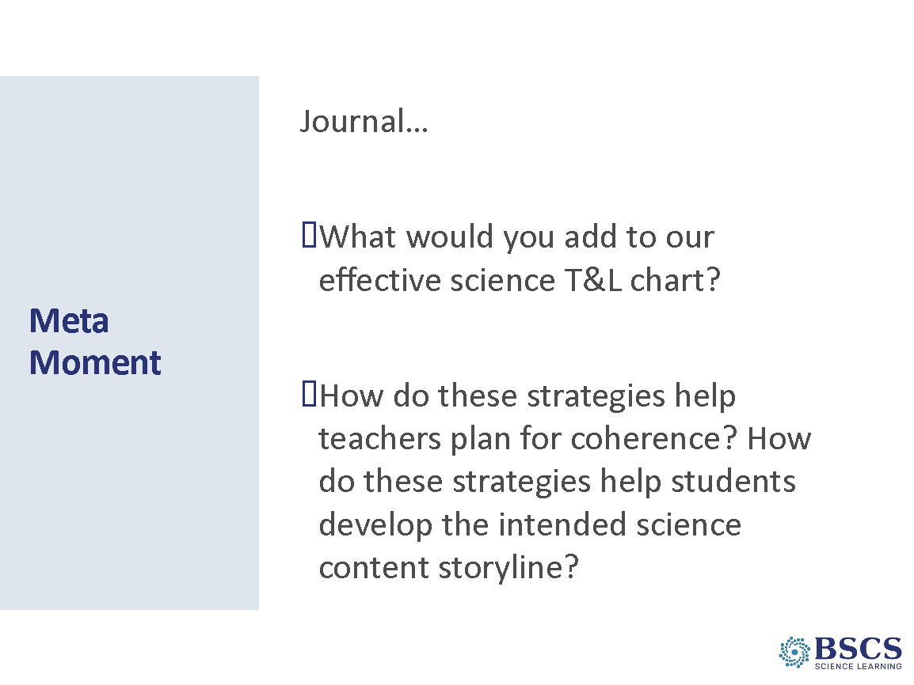 | - Meta Moment (5 min)  - Provide instructions for the task.
 |  | 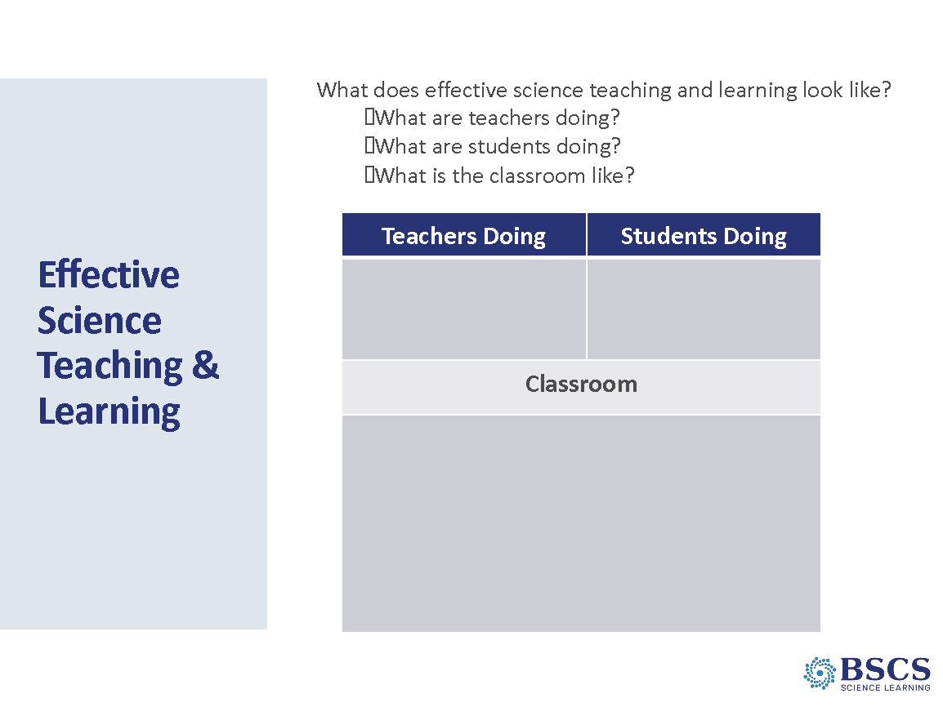 | - Revisit Effective Science T&L (15 min)  - Invite participants to revise their effective science T&L charts based on their experiences/learning so far. Remind them to use a different color marker.
- Day 3 Focus Questions (5 min)
  - Highlight the FQs.
 |  | 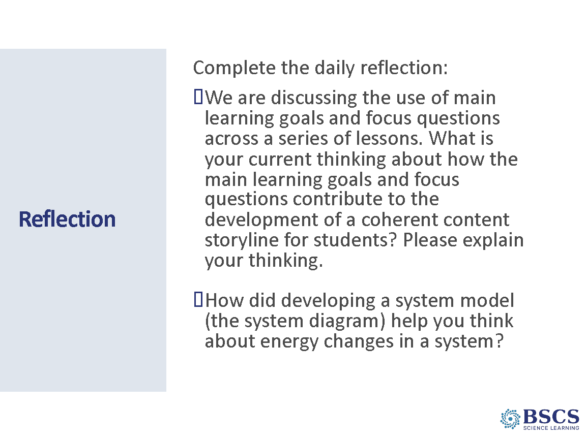 | - Reflection (5 min)  - Direct participants to the daily reflections sheet (PD Binder p.__). Completed sheets can be left in the center of each table.  - Remind Participants about the parking lot should they need to post a question or need.  Transition: In our content deepening today, we focused on developing a content representation or conceptual model to communicate our ideas about energy. Tonight’s homework and tomorrow’s session will help us think more deeply about the role of content representations and models in both making student thinking visible and helping students construct a coherent science content storyline.
 |  | 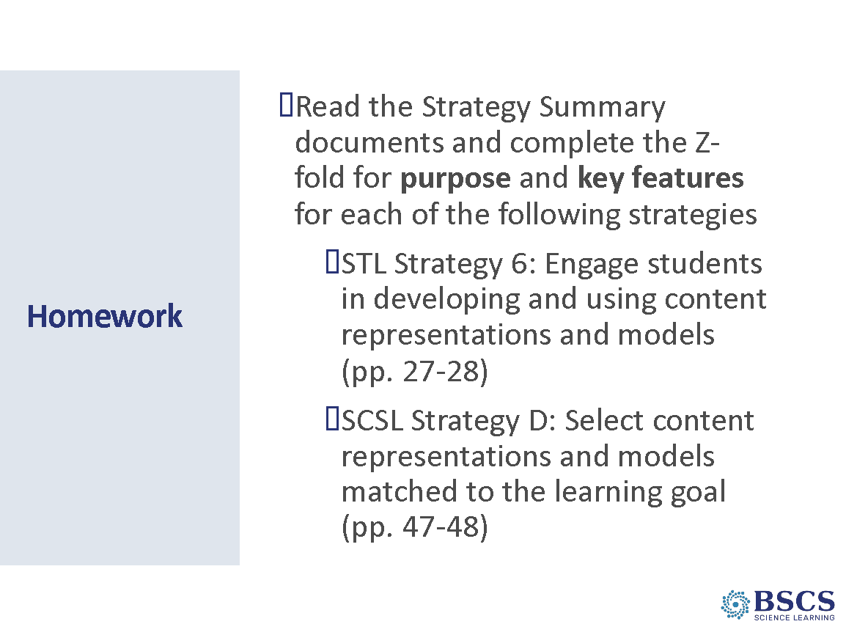 | - Homework (5 min)  - Provide instructions for completing the homework assignment.
 |  |  | - BSCS (0 min)

