SSUP: Summer Institute - PD Leader Guide Day 4
Grade Level | 4 | Day | 4 | STeLLA Strategies Focus | SCSL D/STL 6, STL 1-2-3-4 | Subject Matter Focus | Energy Transfer
Teacher Learning Goals | - Energy flows as it is transferred and changed in various ways in between objects and in and out of systems.  - Energy is dissipated in all macroscopic processes. All objects in motion eventually come to rest because there were other collisions that occurred that were not observable which we call friction. These collisions transfer energy to the object’s environment which is transformed to heat. This makes it difficult to fully account for all energy changes in a system.  - In order to develop meaningful understandings of science, students need multiple opportunities to develop content representations or models to help them explain phenomena or solve problems. Lesson analysis reveals the extent to which students are deepening their understandings of science ideas and use of practices.  - Teachers’ intentional use of elicit, probe, and challenge questions helps students engage with content representations and models as they make their thinking visible and develop the intended science content storyline built on increasingly accurate science ideas and practices.  - The intentional use of Student Thinking Lens Strategies supports the development of a classroom culture focused on student thinking. Lesson analysis makes the culture visible to teachers.
Focus Questions | - Where does the energy come from and where does it go when changes happen in a system?  - How can developing and using content representation and models selected for their match to the main learning goal help students explain phenomena or solve problems?  - How does the intentional use of Student Thinking Lens Strategies support a classroom culture of making thinking visible?
Ideal Teacher Response | Where does the energy come from and where does it go when changes happen in a system?  One way an object might get energy to move is when another object collides with it and energy gets transferred from one object to another. Another way an object could get energy to move is if it is higher up—like on the top of a hill—then it has position energy. Once it starts moving—like rolling down the hill—then the position energy changes into motion energy. Energy can also change from one way we detect it (like movement) into other ways we detect it (like sound or light). Energy changes into other forms of energy that are difficult to detect; sometimes it turns into light, heat, or sound energy that spreads out all around us. Energy enters and leaves a system from the surroundings.  How can developing and using content representation and models selected for their match to the main learning goal help students explain phenomena or solve problems?  Developing and using models and content representations help students make their thinking visible and represent how their thinking changes over time as they explain phenomena or solve problems. Lesson analysis can make students’ progress visible.  How does the intentional use of Student Thinking Lens Strategies support a classroom culture of making thinking visible?  Teachers support students in making their thinking visible and reconsidering their ideas through the intentional use of elicit, probe, and challenge questions linked with developing and using content representations and models. Engaging students in communicating in scientific ways as they develop and use models supports a classroom culture of making thinking visible. This type of engagement supports students as they make their thinking visible and develop the intended science content storyline built on increasingly accurate science ideas and practices.  STeLLA Lesson plans are designed based on the STeLLA approach and structured to make explicit the integration of STL and SCSL strategies and support teachers in enacting the strategies. Three dimensional, phenomena/problem-driven learning is highlighted throughout the lessons.

Preparation | Materials | Videos and Transcripts
Planning/Preparation Tasks:  - Study PDLG, PPTs, video clips, and handouts. Make changes to PPTs, if needed.  - Link clips  - Content Deepening Prep (if any)  Daily Set Up Tasks:  - Check that video clips are correctly linked to PPT  - Set up PowerPoint and speakers  - Check video & sound  - Arrange furniture, food (include social distancing protocols in set up)  - Arrange posters/charts  Day 4 Set Up Task:  Arrange teacher materials on tables:  - Tabletop name cards  - Table boxes (small red, green, and yellow dots)  Daily Follow-up Tasks:  - Archive final PPT  - Collect and turn in daily feedback  - Disinfect common materials, tables and common areas per protocol | Posters/Charts:  - STeLLA Conceptual Framework poster  - Day 4 Agenda chart  - Program Goals chart  - Norms poster  - Day 4 Focus Questions chart  - Effective Science Teaching chart  - Parking Lot chart  - Blank Purpose/Key Features Charts for Strategies D & 6 chart  Handouts in SSUP PD binder front pocket:  - Z-fold chart: Student Thinking Lens Strategies  - Z-fold chart: Science Content Storyline Lens Strategies  Handouts in SSUP PD binder, Tab 4:  - Strategy D Analysis Guide X 3  - ET_gr4_L2HO2.1_Investigating Energy Changes in Collisions  - ET_Gr4_L3HO3.1_Predicting Changes in Energy  - 5_L4HO4.2_System Diagram Hand Crank Flashlight  - Classroom Transcript: SSUP_ET_L4_Parco_C1  - Lesson Analysis Protocol: SSUP_ET_L4_Parco_Clip 1 Example  - Lesson Analysis Protocol: SSUP_ET_L4_Parco_Clip 1 Blank  - Classroom Transcript: SSUP_ET_TN GR4_L3_McDaniel_C1  - Lesson Analysis Protocol: SSUP_ET_TN GR4_L3_McDaniel_C1 Blank  - Day 4 Daily Reflection  - Unit Review Protocol  - Science Content Handouts for Lesson 5  - L5HO5.1_System Diagram_Car Launcher_Final  - L5HO5.2_BigCrash_Final  - L5HO5.3_MumfordandLeroysCollision_final  Supplies:  - Content Deepening Supplies  - Colored pencils  - Chart paper, markers, tape  - Driving Question Board from Lesson 1  Resources:  - STeLLA strategies booklet  - BSCS Journal  - Content Deepening Notebook  - Classroom Curriculum Binder | - SSUP_ET_L4_Parco_C1  - SSUP_ET_TN GR4_L3_McDaniel_C1

DAY 4 SESSION OUTLINE: 8:30 a.m. – 4:30 p.m.
Time | Purpose | Content | Activities
8:30 – 8:40  10 min  Slides 1-6  Study Group Teams | Purpose: The purpose of the opening is to continue to build community and set the stage for today’s learning | Content: Share focus questions for the day:  - How can developing and using content representation and models selected for their match to the main learning goal help students explain phenomena or solve problems?  - How does the intentional use of Student Thinking Lens Strategies support a classroom culture of making thinking visible?  - Where does the energy come from and where does it go when changes happen in a system? | Opening  - Reflections  - Norms, Goals, & Agenda  - Focus Questions
8:40 – 12:00  200 min including 10 min break  Slides 7-19  Study Group Teams | Purpose: The purpose of this session is to develop a shared understanding of STeLLA STL Strategy 6: Engage students in developing and using content representations and models, and SCSL Strategy D: Select content representations and models matched to the learning goal. | Content: Developing and using models and content representations help students make their thinking visible and represent how their thinking changes over time as they explain phenomena or solve problems. Lesson analysis can make students’ progress visible.  Teachers support students in making their thinking visible and reconsidering their ideas through the intentional use of elicit, probe, and challenge questions linked with developing and using content representations and models. Engaging students in communicating in scientific ways as they develop and use models supports a classroom culture of making thinking visible. This type of engagement supports students as they make their thinking visible and develop the intended science content storyline built on increasingly accurate science ideas and practices. | Lesson Analysis: STL 6/SCSL D  - Set up: Charting  - Analysis Guides  - Video Analysis C1  - Video Analysis C2  - Follow-up
12:00-12:30 | Lunch
12:30 – 3:15  165 min including break  Slides  20-39  Study Group Teams | Purpose: The purpose of this session is to model effective STeLLA-based science teaching and learning through a common experience that is grounded in a 3D, phenomena/program driven unit and designed for adult learners. | Content: STeLLA model lessons/units attend to the characteristics of effective science teaching and learning (e.g., 3D, phenomena/problem-driven, student-centered, make student thinking visible and support sense-making, coherent, and access/engage PK and develop metacognitive abilities).  The content deepening experience will include explicit modeling and use of STeLLA strategies.  Energy flows as it is transferred and changed in various ways between objects and in and out of systems. | Content Deepening ET L5  - Common Experience  - Teacher Follow-up
3:15-4:20  65 min  Slides 40-42  Study Group Teams | Purpose: The purpose of this session is to develop a shared understanding of the structure and content of the lesson planning documents and prepare to teach the lessons in the fall. | Content: STeLLA Lesson plans are designed based on the STeLLA approach and structured to make explicit the integration of STL and SCSL strategies and support teachers in enacting the strategies. Three dimensional, phenomena/problem-driven learning is highlighted throughout the lessons. | Lesson Analysis: Introduce Lesson Plans  - Set-up  - Study the Lesson Plans  - Follow-up
4:20 – 4:30  10 min  Slides 43-45  Study Group Teams | Purpose: The purpose of this session is to reflect on the day’s experiences and learning and prepare for Day 5. | Content: Focus Questions  - How can developing and using content representation and models selected for their match to the main learning goal help students explain phenomena or solve problems?  - How does the intentional use of Student Thinking Lens Strategies support a classroom culture of making thinking visible?  - Where does the energy come from and where does it go when changes happen in a system? | Closing  - Revisit Effective T & L charts  - Revisit Focus Questions  - Day 4 Reflections  - Homework: Study Lessons

DAY 4
Time and Focus | Purpose and Content &  What Participants Do | Slides | Process
8:00 – 8:30 | Coffee & Conversation |  | Need several hands on deck to help participants complete paperwork, registration, and logistics.
8:30 - 8:40  10 min  Slides 1-6  Study Group Teams | Opening  Purpose: The purpose of the opening is to continue to build community and set the stage for today’s learning  Content  Focus Questions  - How can developing and using content representation and models selected for their match to the main learning goal help students explain phenomena or solve problems?  - How does the intentional use of Student Thinking Lens Strategies support a classroom culture of making thinking visible?  - Where does the energy come from and where does it go when changes happen in a system?  What participant do  Participants reconnect to their learning and experiences from Day 3 and use the STeLLA Norms, Goals/Agenda and Day 4 Focus Questions to prepare for learning.  Resources  - Name Tags  - BSCS Journal  - Norms poster  - PD Binder  - STeLLA Conceptual Framework poster  - Charts  - Day 4 Agenda chart  - Focus Questions  - Parking Lot  - Effective Science T&L  - Blank Purpose/Key Features  - Program Goals chart | 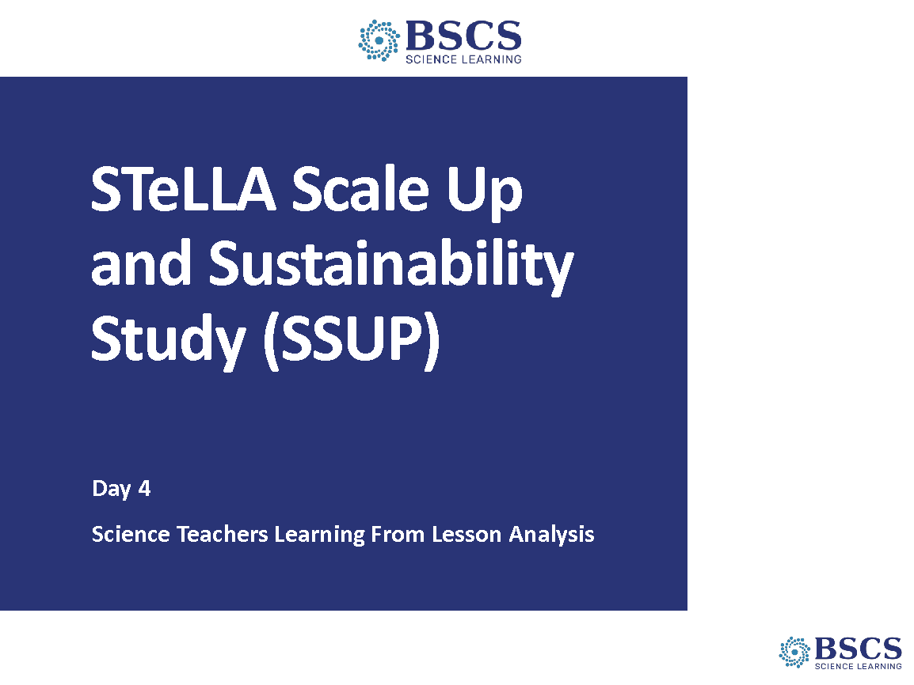 | - SSUP Program Day 4 (Slides 1-6: 10 min)  Greet participants as they enter the room. Help them pick up their materials and find their spots.
 |  | 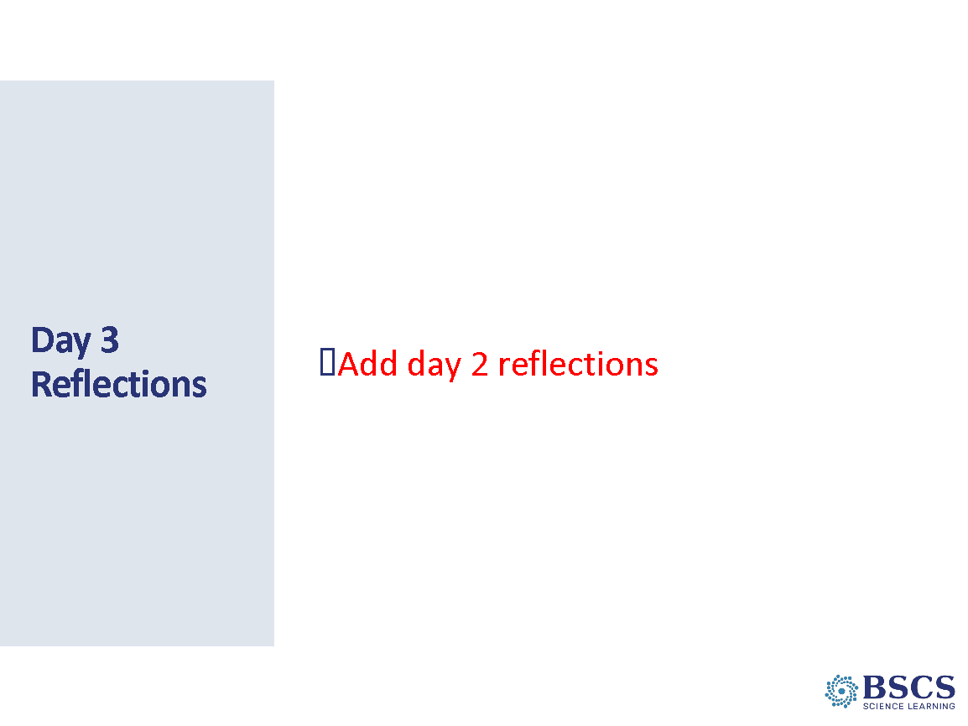 | - Reflections  - Share patterns in reflection from Day 3. Link to program goals and agenda for the day as appropriate.  - Direct participants to the daily reflections sheet (PD Binder p.__). Explain that we will be collecting these reflections again at the end of the day. Invite participants to add thoughts and ideas to their reflection sheet throughout the day.  - Check the parking lot and address issues as needed.  Transition: To continue our reflections, let’s consider the STeLLA norms.
 |  | 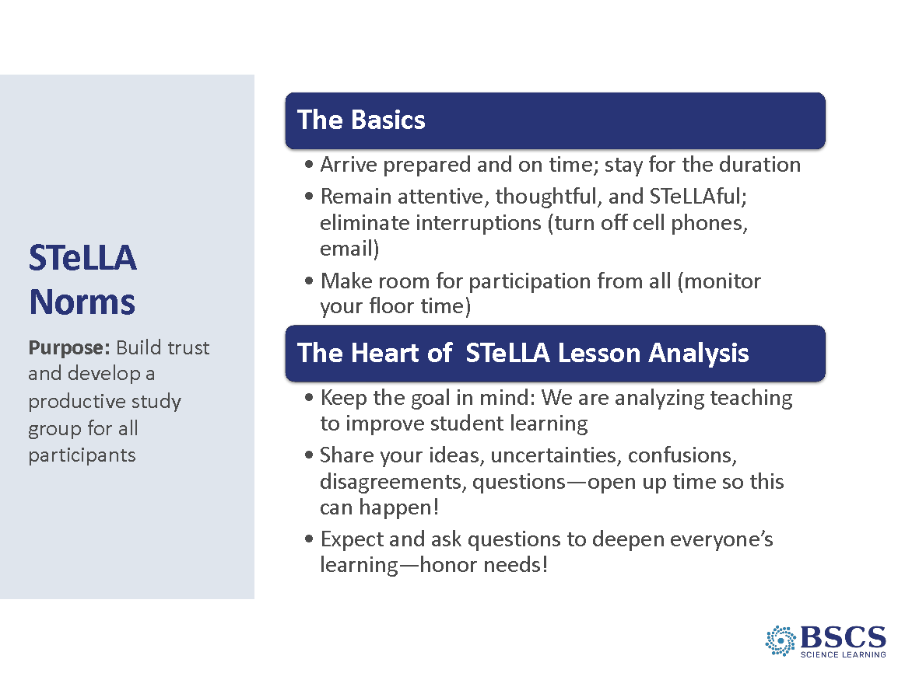 | - STeLLA Norms  - Revisit the norms. Ask participants to identify one norm they are doing particularly well with as a team and one they could work on as a team.
 |  | 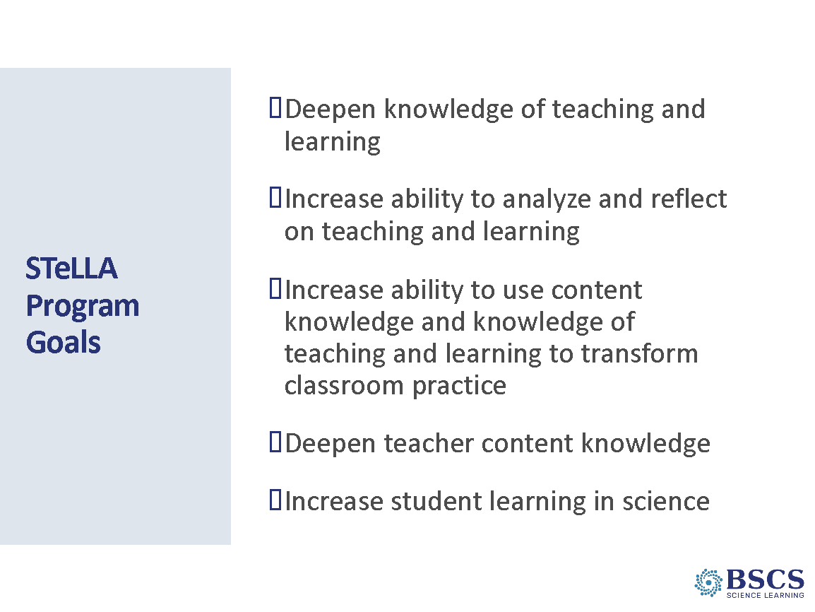 | - Program Goals  - Revisit program goals. Ask participants to identify one goal we are doing particularly well with and one we could work on as a team.
 |  | 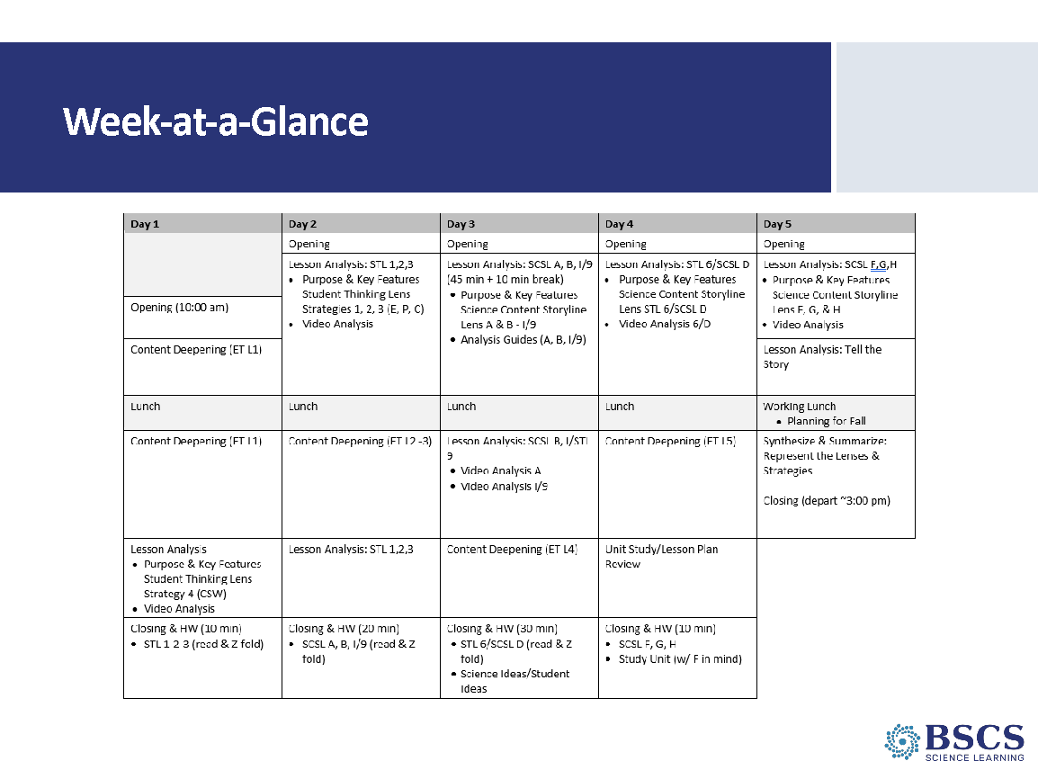 | - Week-at-a-Glance  - Refer to daily agenda. Make links to goals and/or focus questions for the day.
 |  | 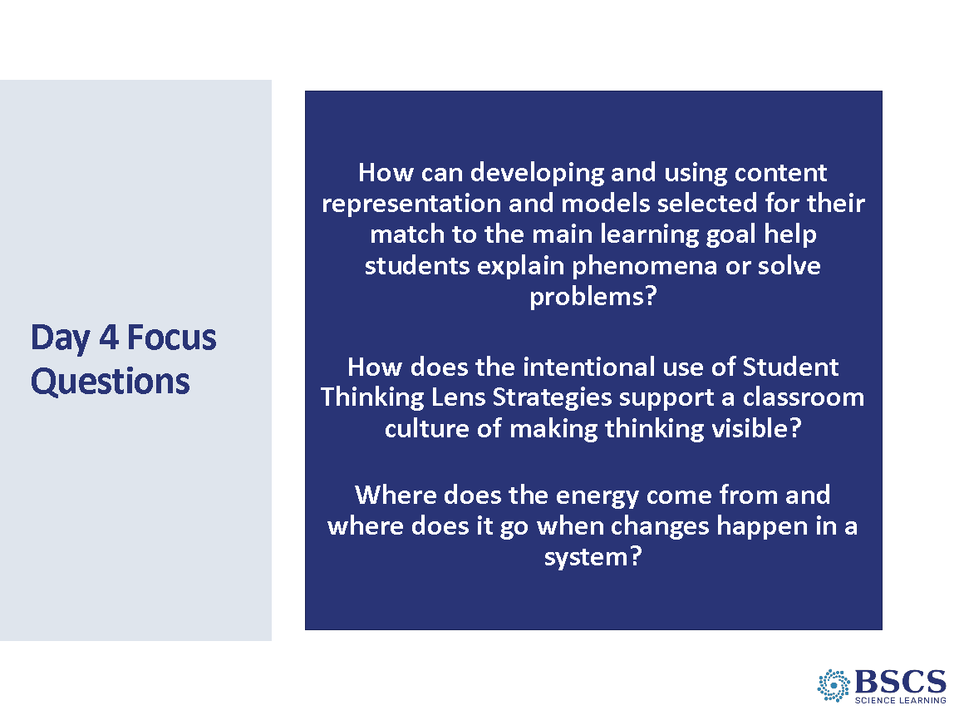 | - Focus Questions  - Share focus questions for the day. Mark that this is an important day. We will be using all the strategies we’ve studied to make student thinking visible and support laser-like focus on the science content storyline.
8:40 – 12:00  200 min including 10 min break  Slides 7-19  Study Group Teams | Lesson Analysis  Purpose: The purpose of this session is to develop a shared understanding of STeLLA Strategies 6: Engage students in developing and using content representations and models, and D: Select content representations and models matched to the learning goal.  Content: Developing and using models and content representations help students make their thinking visible and represent how their thinking changes over time as they explain phenomena or solve problems.  Teachers support students in making their thinking visible and reconsidering their ideas through the intentional use of elicit, probe, and challenge questions linked with developing and using content representations and models.  The Lesson Analysis Protocol (LAP) increases the rigor of video analysis and prepares study groups for peer video analysis as they implement the model lesson in the fall.  STeLLA SCSL Strategy D targets the selection of content representations and models matched to the main learning goal.  STeLLA STL Strategy 6 emphasizes the importance of engaging students in developing and using content representations and model matched to the learning goal. Students are not simply looking at a model, but rather using the model to deepen their understanding of relationships among components in a system and how and why something works the way it does. This strategy is particularly important because it’s use in the classroom correlates to increased student learning.  What participants do  Participants chart the purpose and key features of STL Strategy 6 and Science Content Storyline Strategy D.  Participants are introduced to the Strategy D Analysis Guide and use it to analyze a content representation or model used in their Content Deepening experience, then use it to analyze at least one other content representation or model.  They use what they learn to analyze classroom video using the newly introduced Lesson Analysis Protocol. In addition to analyzing classroom video for Strategies D and 6, they will revisit the three questioning strategies (STL Strategies 1, 2, and 3) and consider how they help teachers engage students in developing and using content representations and models.  Resources  - Blank Purpose/Key Features charts for STeLLA Strategies D and 6  - Purpose/Key Features charts for STeLLA Strategies 1, 2, and 3  - Marble/ramp system  - ET_gr4_L2HO2.1_Investigating Energy Changes in Collisions  - ET_Gr4_L3HO3.1_Predicting Changes in Energy  - 5_L4HO4.2_System Diagram Hand Crank Flashlight  - Learning from Lesson Analysis (p. 3 in STeLLA Strategies Booklet)  - Classroom Transcript: SSUP_ET_L4_Parco_C1  - Classroom Transcript: SSUP_ET_L4_Parco_C2  - LAP – completed example  - LAP - blank  - Classroom Video:  - SSUP_ET_L4_Parco_C1  - SSUP_ET_L4_Parco_C2 | 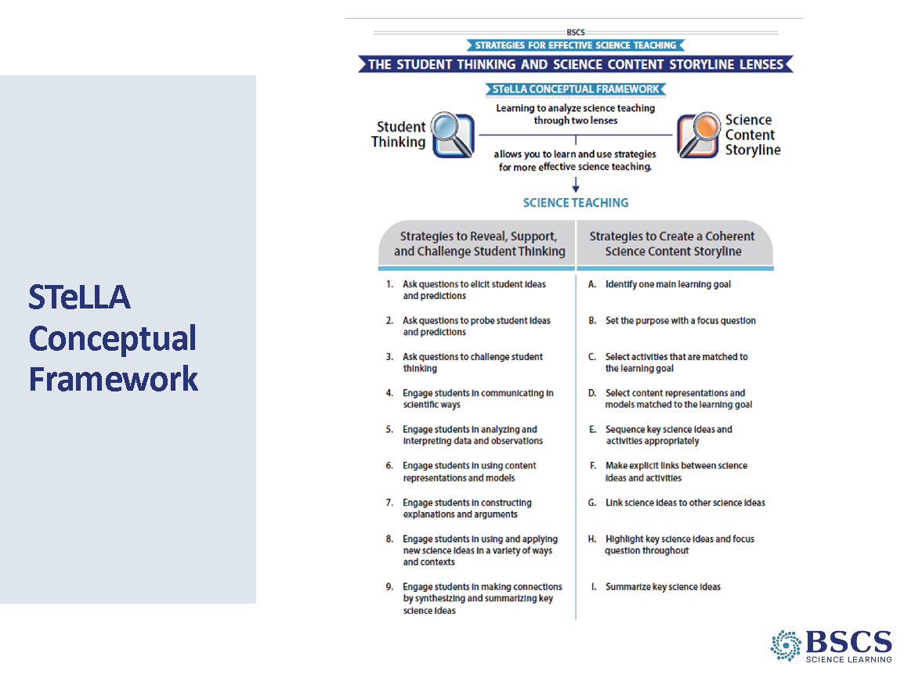 | - STeLLA Conceptual Framework (5 min)  - Orient participants to the STeLLA Conceptual Framework and the strategy focus for the day.
 |  | 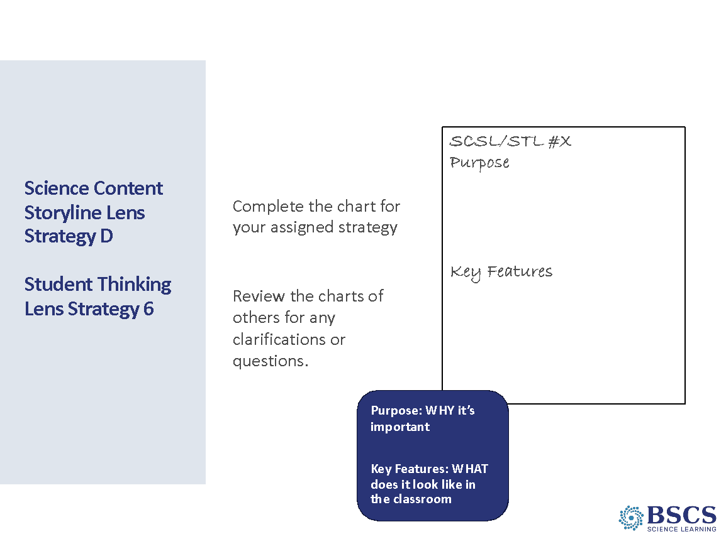 | - STeLLA SCSL Strat D/STL Strat 6 (20 min)  Divide the study group into 2 groups and assign one strategy (D/6) to each group. Remind participants:  Purpose: why the strategy is important  Key features: characteristics that distinguish the strategy from others  - Remind participants that our goal is shared understanding, so…if it is not in the summary doc, it doesn’t go on the chart.  - After charts are completed, invite participants to review the chart for their assigned strategy developed by the other part of the team. They should use sticky notes to ask clarifying questions and pose wonderings about ideas that might be missing or where ideas came from in the strategy doc. Revise charts as needed.  - Provide time for participants to revise their Z-fold summary charts as needed.  PDL Note: Mark that content representations tend to be static and show a science idea while models are dynamic and show the thinking behind the relationships between system components. Models are used to explain and predict and are intended to be revised. Offer time at the end of the day or start of tomorrow to talk more about the differences.  Transition: As with the other Science Content Storyline Strategies we’ve studied thus far, this strategy has an analysis guide to ensure the content representations and models we select are aligned with the main learning goal.
 |  | 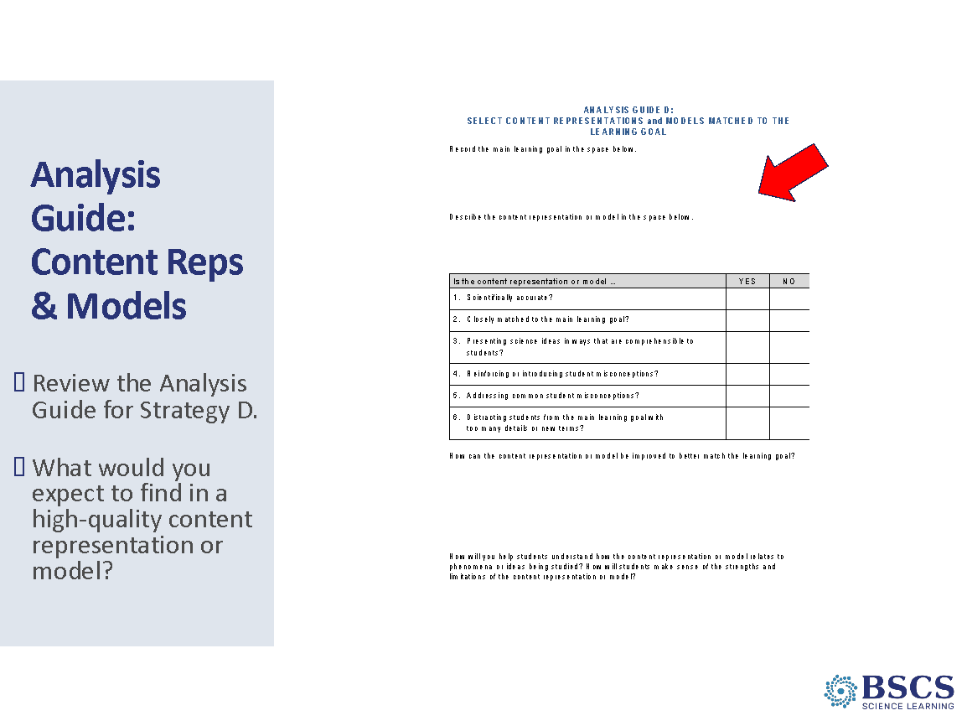 | - Analysis Guide: Content Reps & Models (5 min)  PDL Note: This is an animated slide.  - Provide a few minutes for participants to review the analysis guide (PD Binder p.__). Note the importance of the main learning goal and opportunity to capture ideas to strengthen the model or content representation.  Transition: We’ll use this analysis guide to evaluate one of the content representations/models we used in our content deepening experience.
 |  | 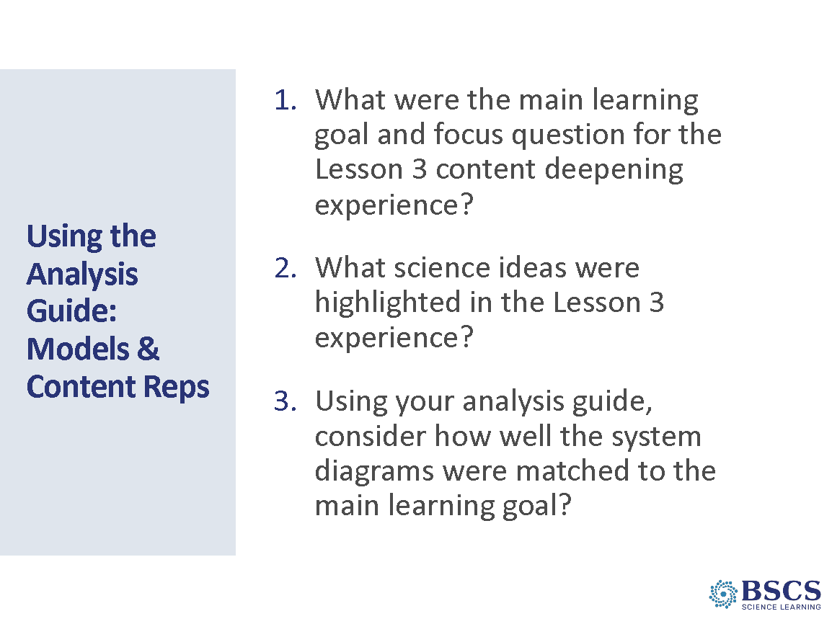 | - Using the Analysis Guide (20 min)  - Refer to the examples (PD Binder p. __).  - Provide instructions for the task.  PDL Note: Use the physical model of the marble ramp system.  - Lesson 3 Focus Question: How can we change the amount of motion energy of an object? Lesson 3 Main Learning Goal: Position energy (potential energy) can be transformed to motion energy (kinetic energy). The more position energy an object has, the more energy can be transformed to motion energy. As position energy is transformed to motion energy, the faster the object will move.  - L3 Science Ideas: The faster an object moves, the more motion energy it has. As an object goes down an incline, it goes faster and faster as position energy (potential energy) is converted to motion energy (kinetic energy). The higher the incline, the faster the object goes when it moves down the incline. Objects that are not moving can have position energy. Position energy can be transformed into energy of motion. If the moving object has a collision with another object, energy can be transferred from one object to another, and the motion of each object will change. The more motion energy an object has, the more energy will be transferred in the collision.  - Complete the Analysis Guide as an example.
 |  | 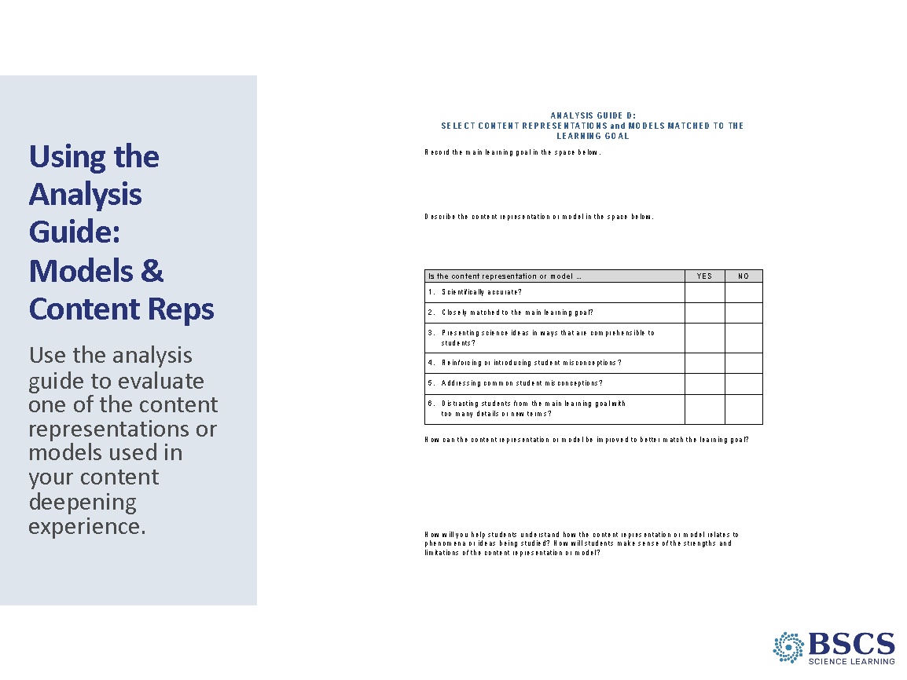 | - Using the Analysis Guide (25 min)  - Refer to sample models/content representations in PD binder (p. __). Assign one example to a small group of participants.  PDL Note: Jigsaw the following content representations: 1) L2 HO2.1: Investigating Energy Changes in Collisions, 2) L3 HO3.1: Predicting Changes in Energy, and 3) L4 HO4.2: System Diagram Hand Crank Flashlight.  - Provide instructions for the task including how to add the Main Learning Goal from the Day 3 card sort and which lesson the content representation or model each team will evaluate comes from.  - Invite participants to share the MLG for their assigned content representation or model and provide a summary of their analysis.  PDL Note: This experience should leverage the analysis of models that participants completed, and the lessons learned should help prepare participants for planning and teaching the lessons.
 |  | 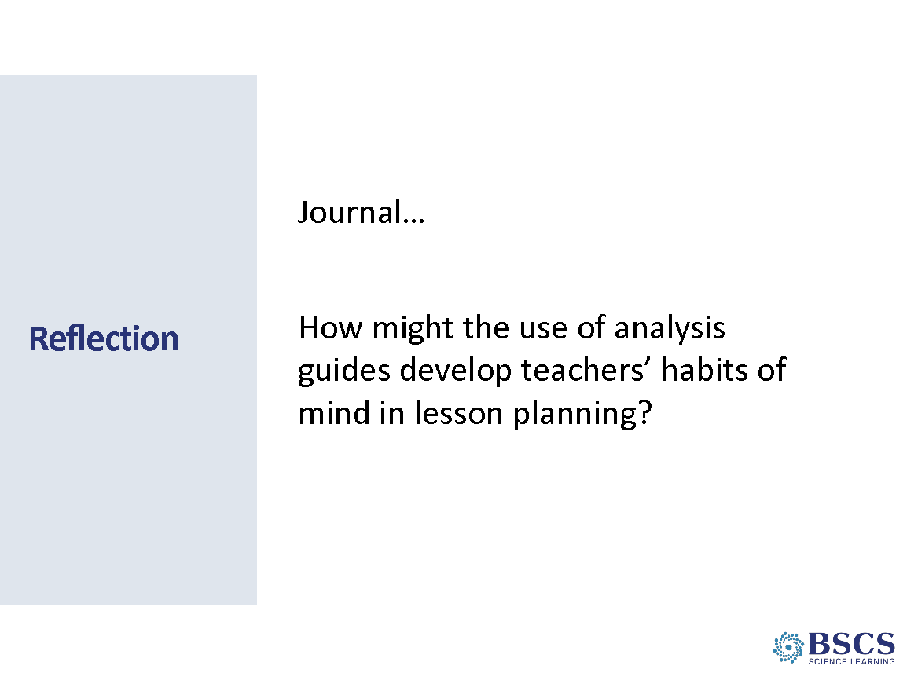 | - Reflection (5 min)  - Provide instructions for the task.  Transition: We experienced using content models and representations in our content deepening session and then analyzed them using our shared understanding of Strategies D and 6. We’ll continue to deepen our understanding of these strategies through video analysis of classroom practice.
 |  | 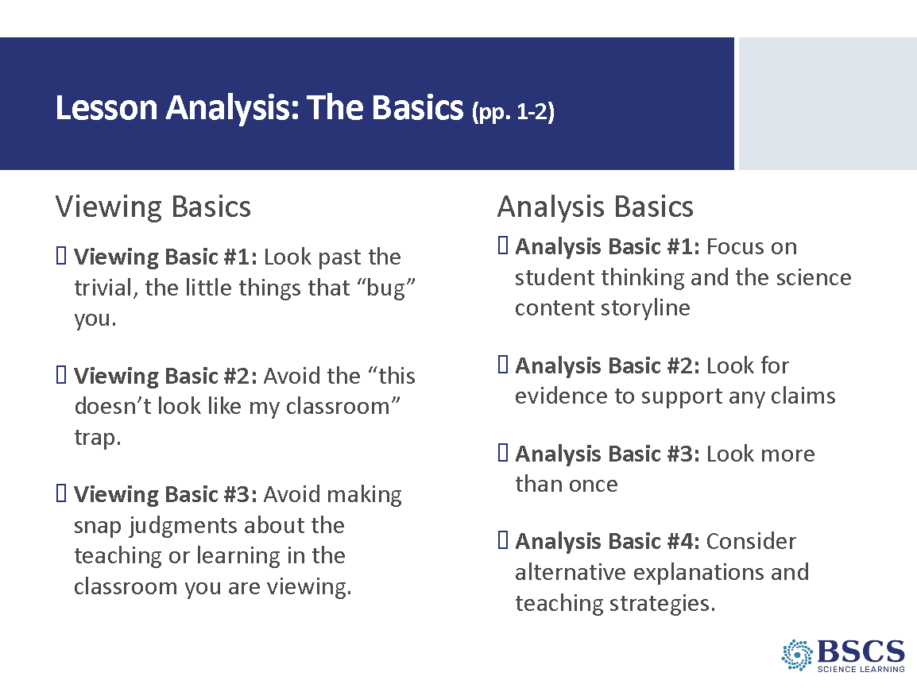 | - Viewing & Analysis Basics (5 min)  - Review the Viewing and Analysis Basics as needed. Refer to handout in STeLLA Strategies Booklet pp. 1-2.
 |  | 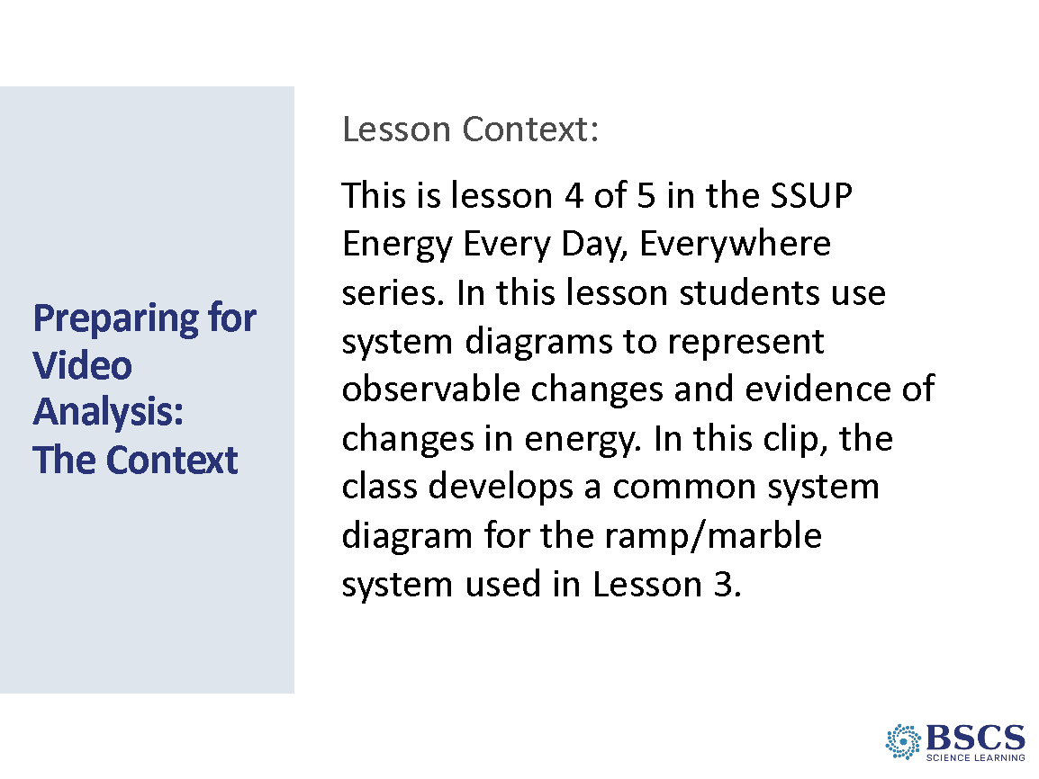 | - Prep for Video Analysis: Context (5 min)  - Refer participants to the SSUP_ET_L4_Parco_C1 transcript in binder (p. __).  - Provide the context for the video. Make a link to the focus question for the day, a program goal, or the kinds of thinking promoted by STeLLA-style video analysis.
 |  | 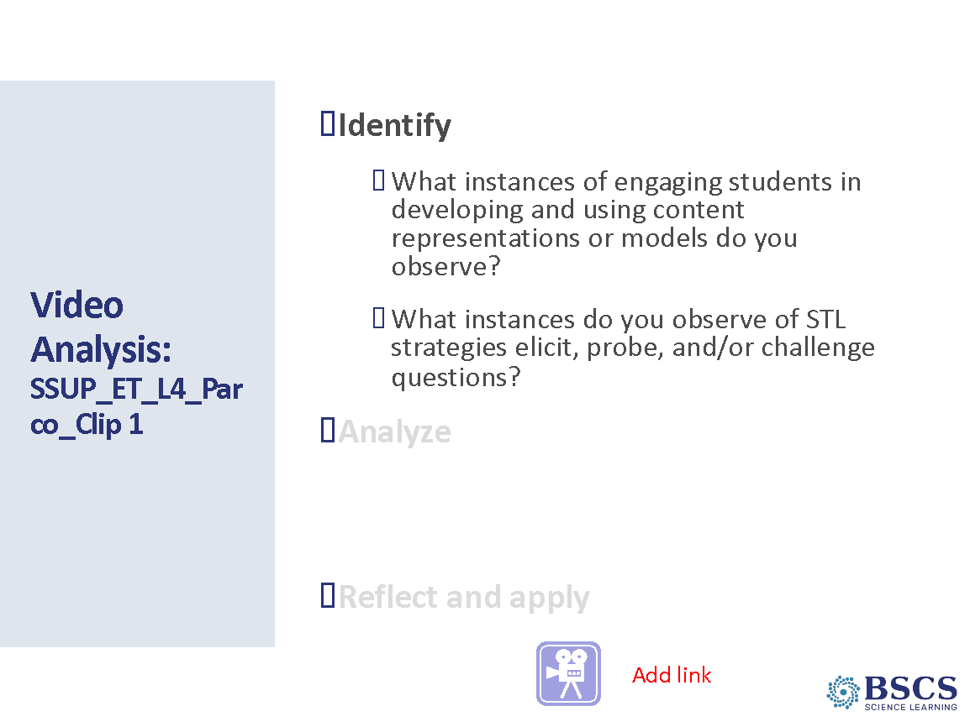 | - Video Analysis (20 min)  - Note that as participants watch the video, they should look for evidence of STL strategies 1, 2, 3, and 6.  - Share the video: SSUP_ET_L4_Parco_Clip 1.  - Point participants to the Strategy Booklet, Z-fold and charts as sources to help them justify their identification of a particular strategy.  PDL Note: Clear examples of STL 6:  01:32- “The model has to be at – in the middle of the roll.”  01:49 – 02:04- The teacher and student negotiate how to represent motion energy in the system diagram.  02:07 – 02:54- Students and teachers negotiate how to represent position energy in the system diagram.  PDL Note: Interesting student thinking revealed:  04:20 – 05:24- Students have different ideas about how to represent the transfer of energy when the marble hits the Styrofoam block.  05:42 – 6:44- Students are discussing how to represent the transfer of energy from the marble to the Styrofoam block.  Transition: Before we move to the Analyze phase, we’ll introduce and use a new tool, the Lesson Analysis Protocol (LAP). The LAP structures the three phases of video analysis we’ve been using: Identify, Analyze, and Reflect and Apply, and provides a scaffold to deepen our analysis as you’ll see in the example.
 |  | 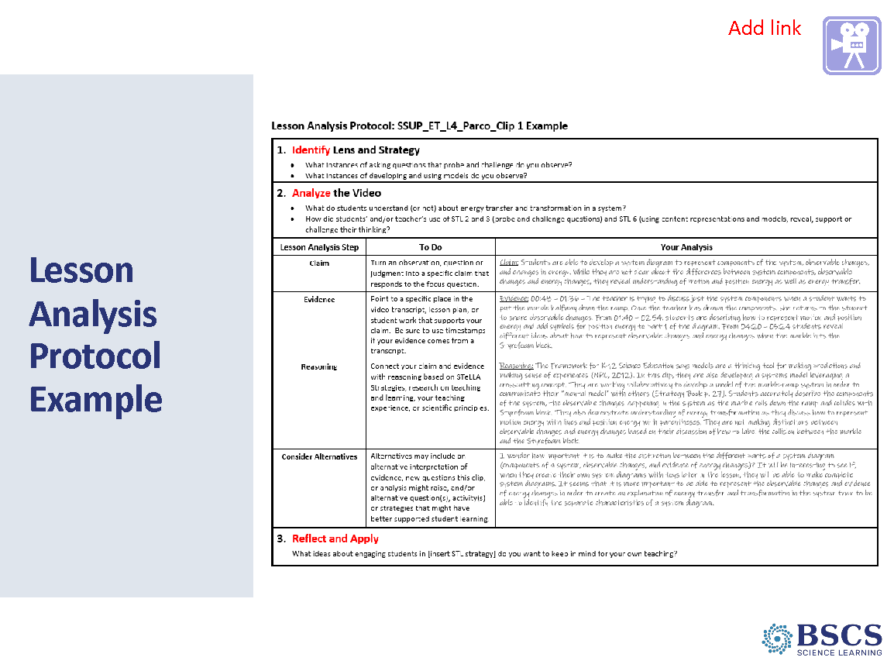 | - Lesson Analysis Protocol - Example (10 min)  PDL Note: The example analysis is based on a relatively obvious claim from the previous example.  - Refer participants to the Lesson Analysis Protocol example in the PD binder (p.__).  - Note the purpose of the Lesson Analysis Protocol (LAP). The LAP helps us focus on the three phases of video analysis. It guides us through the analysis process to focus on the claim, evidence and reasoning, and specific alternatives in each clip. It helps us to be thorough in our analysis and sets the stage for the analysis of one another’s classrooms this coming fall.  - Offer time for participants to review the protocol and the example.  - Ask participants to consider the kind of thinking they need to do in order to analyze classroom video in this way. Listen for connections to the Learning from Lesson Analysis Process.  - Highlight examples of reasoning and alternatives and discuss the roles of these components of the Analyze phase.  PDL Note: An important purpose of the scaffolding the LAP is to create a safe and respectful culture to make our teaching practice visible. Foreground that participants will be making their practice visible in the fall study groups when they watch and analyze their own video teaching the lessons they have been experiencing in content deepening sessions.
 |  | 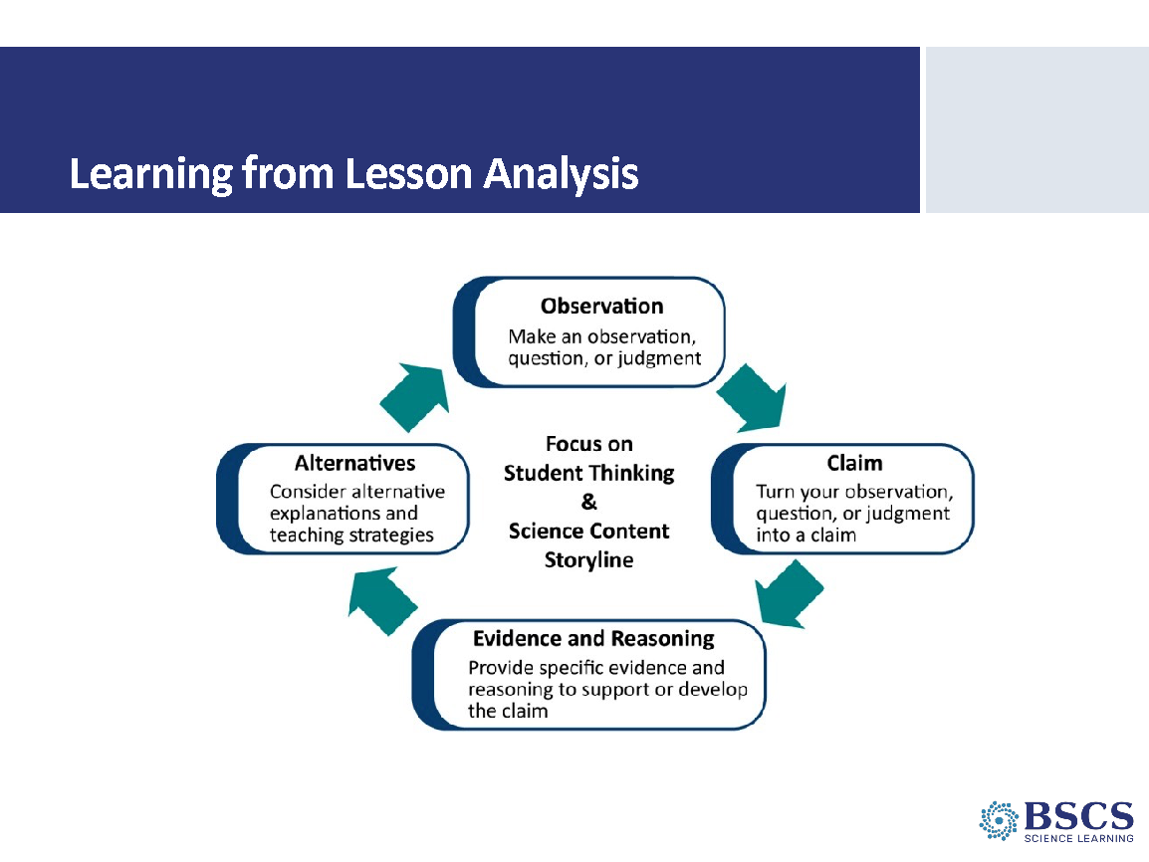 | - Learning from Lesson Analysis (5 min)  PDL Note: Cut for time  - Refer participants to p. 3 in their STeLLA Strategies Booklet.  - Share this representation of the process for turning an observation into a claim supported by evidence and reasoning along with alternatives.  - Ask participants to link the ideas they just shared during their review of the example LAP to this process.
 |  | 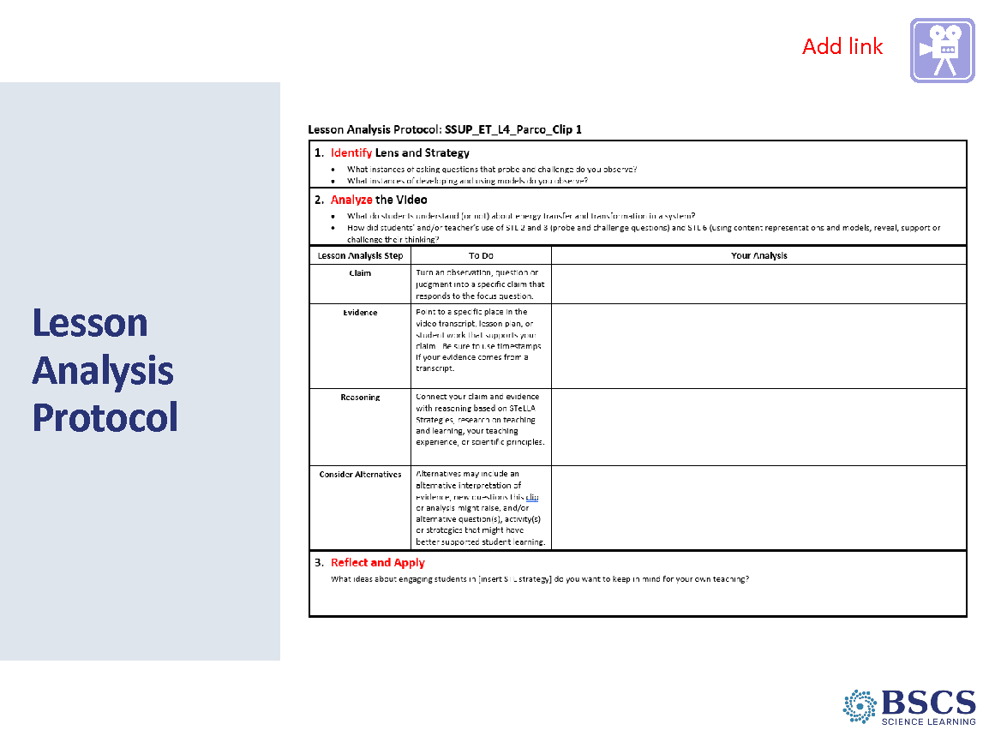 | - Lesson Analysis Protocol (35 min)  - Refer participants to blank LAP in PD Binder p.__.  - Provide time for participants to choose one of the Analysis questions and complete the LAP. They may choose to work independently or with a partner.  - Once everyone has had a chance to develop their claim, evidence, and reasoning as well as consider alternatives, use a round robin strategy to hear from every person or partner team.  - Conclude the process with the Reflect and Apply Phase.
 |  | 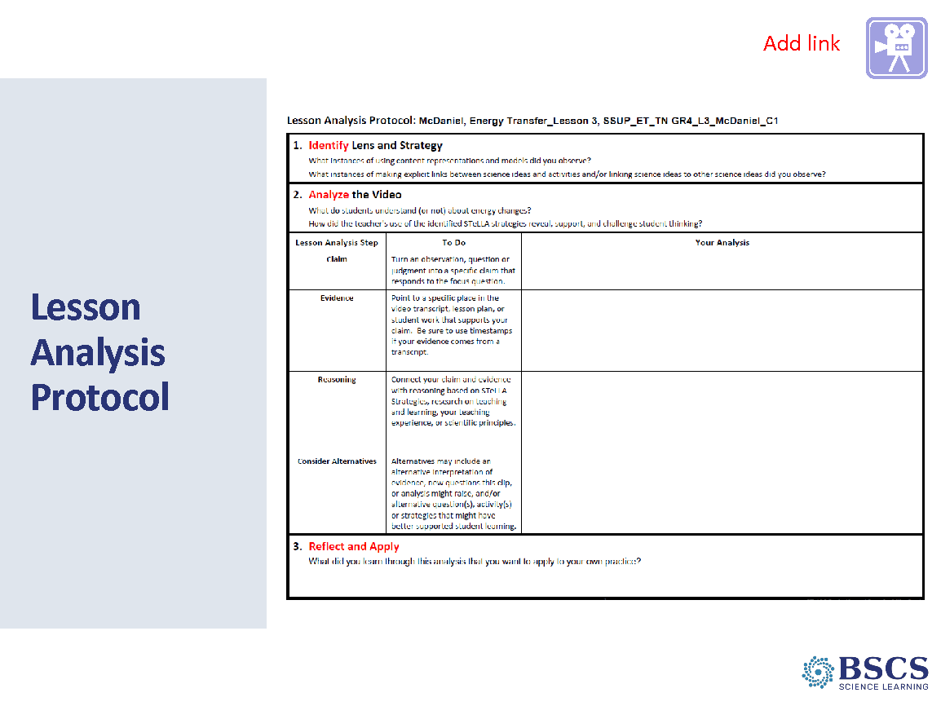 | - Lesson Analysis Protocol (30 min)  PDL Note: As participants become familiar with the lesson analysis process, less support for orienting to the context of the lesson and the lesson analysis protocol will be needed. This fading scaffold is modeled in this lesson analysis.  - Direct participants to the SSUP_ET_TN GR4_L3_McDaniel_C1 classroom transcript on p__ of their binder and the SSUP_ET_TN GR4_L3_McDaniel_C1 on p__ of their binder.  - Invite participants to read the context of the clip at the top of the transcript and the identify and analyze questions on their LAP.  - Show the video clip: SSUP_ET_TN GR4_L3_McDaniel_C1 and invite participants to identify instances of asking probe and challenge questions and instances of developing and using models.  PDL Note: Clear examples of STL 6 & SCSL D:  00:19 - S: “…like with so many lines.” The student is pointing to the representation of the ruler-marble-Styrofoam system  01:22 – T: “So tell me, why did you put three and three?”  01:46 – S: “… if there were six here and six here…”  02:56 – T: “But theses – these represent motion, correct?”  03:20 – SN: “I disagree with (inaudible) because when (inaudible) she only – she put three…”  03:48- S: “And where she should’ve put four because it has more energy.”  04:27 – S: “She should only put three here because she put four there and the- and the Styrofoam, and when it hits the Styrofoam block, it shouldn’t have as much energy.”  05:35 – SN: “I disagree because on number 3, she did make her lines bolder.”  PDL Note: Interesting student thinking:  01:22 – 02:33 – The student is using the model to explain how their thinking has changed as they explain the changes in energy as the marble hits the Styrofoam block.  03:20 – 05:22 – Students are negotiating their understanding of energy changes in the ramp-marble-Styrofoam system using their agreed-upon representations for the amount of energy of each component.  05:32 – 06:02 – A student offers an alternative idea about how the amount of energy is represented in the model and students consider this idea as a class.  - After participants have identified instances of the strategies, invite them to use the LAP to make a claim supported by evidence and reasoning in response to one of the analysis questions.  - Once everyone has had a chance to develop their claim, evidence, and reasoning as well as consider alternatives, use a round robin strategy to hear from every person or partner team.  Transition: Note that we’ll move into a content deepening session after lunch.
12:00 – 12:30 | Lunch
12:30 - 3:15  160 min plus break  Slides 20-39  Study Group Teams | Content Deepening  Purpose: The purpose of this session is to model effective STeLLA-based science teaching and learning through a common experience that is grounded in a 3D, phenomenon/problem driven unit and designed for adult learners.  Content: STeLLA model lessons/units attend to the characteristics of effective science teaching and learning (e.g., 3D, phenomenon/prob-driven, student-centered, make student thinking visible and support sense-making, coherent, and access/engage PK and develop metacognitive abilities).  The content deepening experience will include explicit modeling and use of STeLLA strategies.  Science content:  Energy transfers and changes occur in all interactions. Energy moves from object to object and from place to place and we detect it in different ways. Energy transfers away from the system through sound, light, or heat. A system diagram can track the energy transfers and transformations that occur in interactions.  Describing systems in terms of their components and interactions helps us track how energy can be transferred in various ways and between objects.  Evidence is used to construct an explanation of how energy transfers and transformations occur as energy is transferred in various ways and between objects.  What participants do  Participants will create a system diagram for the anchor phenomenon (car launcher system) that is used to explain the energy changes that occur in the system.  Participants will then apply the concepts from the car launcher system to a bike crash scenario. They will create a system diagram to explain the energy changes that occur in the bike crash and identify similarities and differences between the bike crash scenario and the car launcher system. After a recall of the key science ideas of lessons 1-5, participants will work with their groups to answer the unit central question.  Resources  HO 5.1 System Diagram Car Launcher  HO 3.2 Big Crash  HO 5.3 Mumford and Leroy’s Collision |  | - Day 4 Focus Questions (5 min)  - Briefly revisit focus questions for PD Day 4 and highlight the Focus Question for Lesson 5.  - Provide a few minutes for participants to consider the three relevant focus questions. Either invite them to capture a few ideas in their journals., turn to a partner, or whip around and share them publicly.  Transition: As is our pattern, we’ll begin our content deepening session with a teacher-focused set up.
 |  | 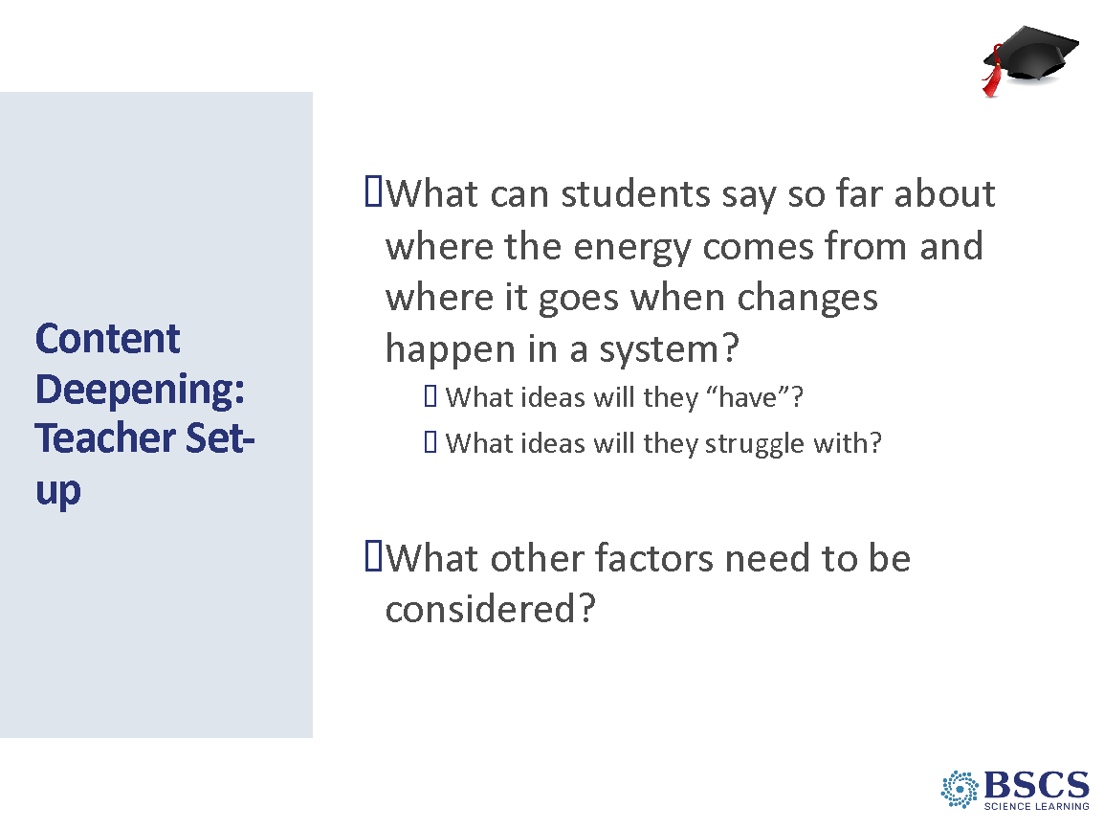 | - CD: Teacher Set up (10 min)  - Provide instructions for the task. Refer to charts around the room as needed.  PDL Note: It’s likely that participants will talk about the energy leaving the system as heat, light, sound. They may struggle with ideas of energy being added to the system as position energy.
 |  | 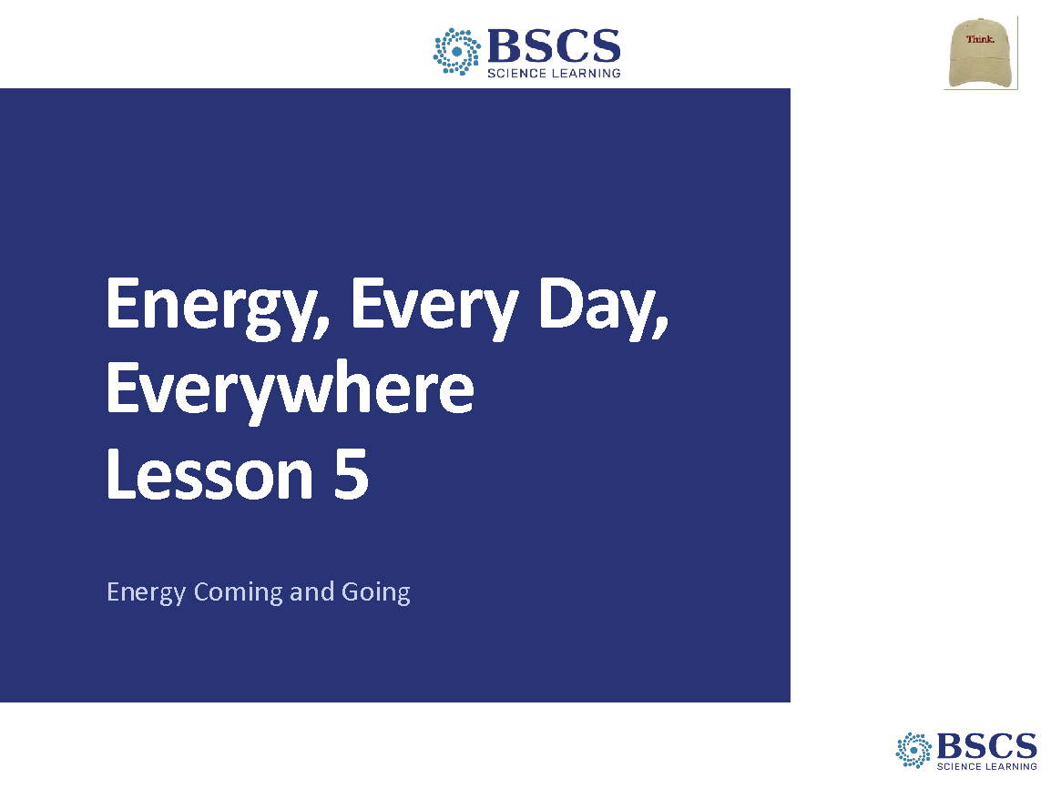 | - Content Deepening: Science Learner (15 min slide 22-24)  - Share that today’s content deepening session is based on Energy, Every Day, Everywhere Lesson 5: Energy Coming and Going
 |  | 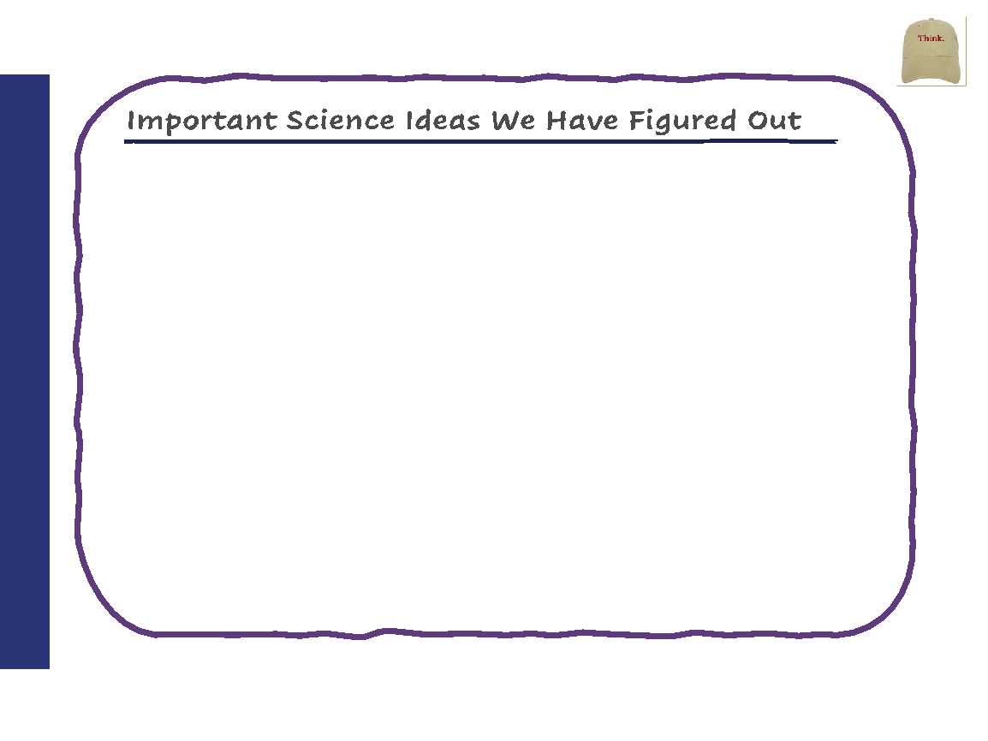 | - Ideas We’ve Figured Out  - Invite participants to refer to the Science Ideas We’ve Figured Out chart. Provide a few moments for silent think time. Mark rows 6 and 7 on the CSW poster and encourage participants to use sentence stems from these rows as they share their ideas with the group to ask clarifying questions, agree or disagree with others’ ideas, and to add on to someone else’s ideas. As participants share their ideas, listen for the distinction between what we did and what we figured out. Ask elicit and probe questions as needed to support participants to focus on what we figured out.
 |  | 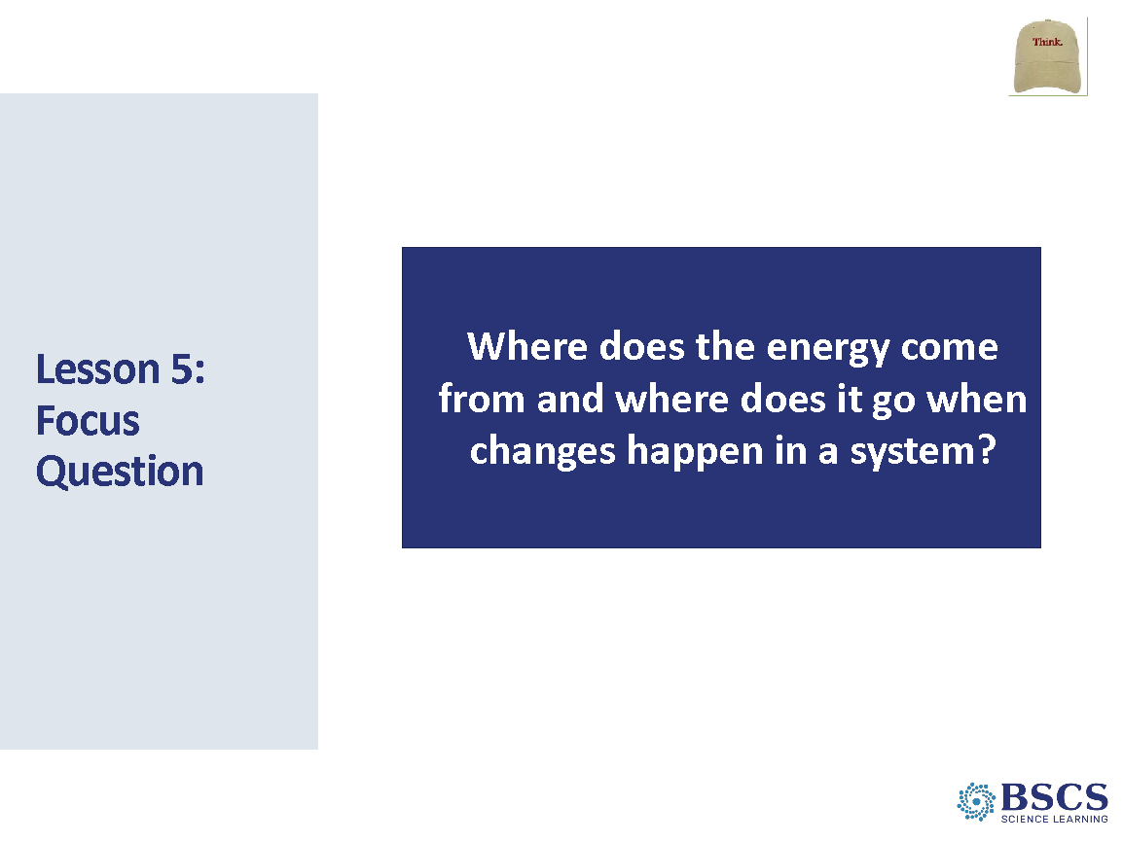 | - Lesson 5 Focus Question  - Share that today we will continue thinking about energy changes – transfer of energy and transformation of energy. Invite participants to look at our focus question and ask someone read the question to the group. “Where does the energy come from and where does it go when changes happen in a system?”  - Provide time for participants to set up their notebooks for a new lesson. Remind them that they should start on a new page and write the date and lesson title. Write this lesson’s focus question on the board and also have participants write it in their notebooks and draw a box around it. Refer to the focus question often throughout the lesson.  - Invite participants to start thinking about this question using this sentence starter:  - Observable changes could be...  - One way energy changes can happen in a system is...  - In this example, energy comes from... and goes to...  - This energy change occurs because...  - Invite participants to write these starters in their notebook and to leave plenty of room after it to add words to complete the sentence. Remind them that as they complete this, they should be sure to use our science words of motion energy, position energy, transfer of energy, or energy transformation when appropriate to their example.  - Ask participants to think about the answer now and to write their initial ideas. Tell them that they will do several activities to help them know what to write. They will have time to complete the sentence at the end of class. Allow time for participants to write and respond to the focus question. Ask elicit and probe questions to encourage participants to share their best idea about the focus question so far with the group.
 |  | 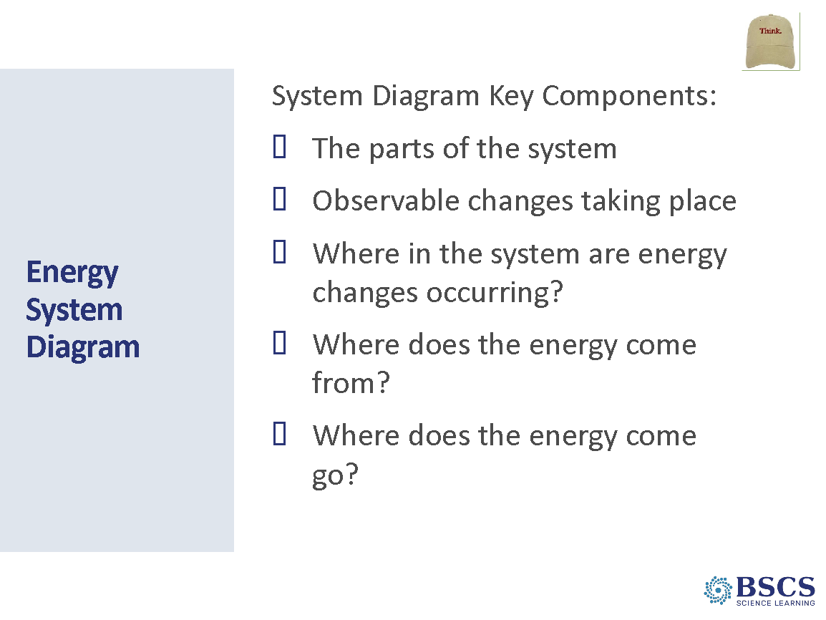 | - Energy System Diagram (5 min)  - Direct participant attention to the Ideas We’ve Figured Out chart and note that we’ve figured out a lot of ideas about energy and how it changes in a system.  - Share that we’ve also learned how to represent these changes with system diagrams and communicated our ideas like scientists. We can use everything we’ve figured out so far to explain how energy changes in the car launcher system. Making a system diagram might be a good way to begin thinking about the energy changes in the launcher system.  - Refer participants to the key components of a system diagram chart developed lesson 4.  - Remind participants that these are important ideas that we should make sure to include in our system diagrams. Ask someone to read aloud the ideas from the key components of a system diagram chart.
 |  | 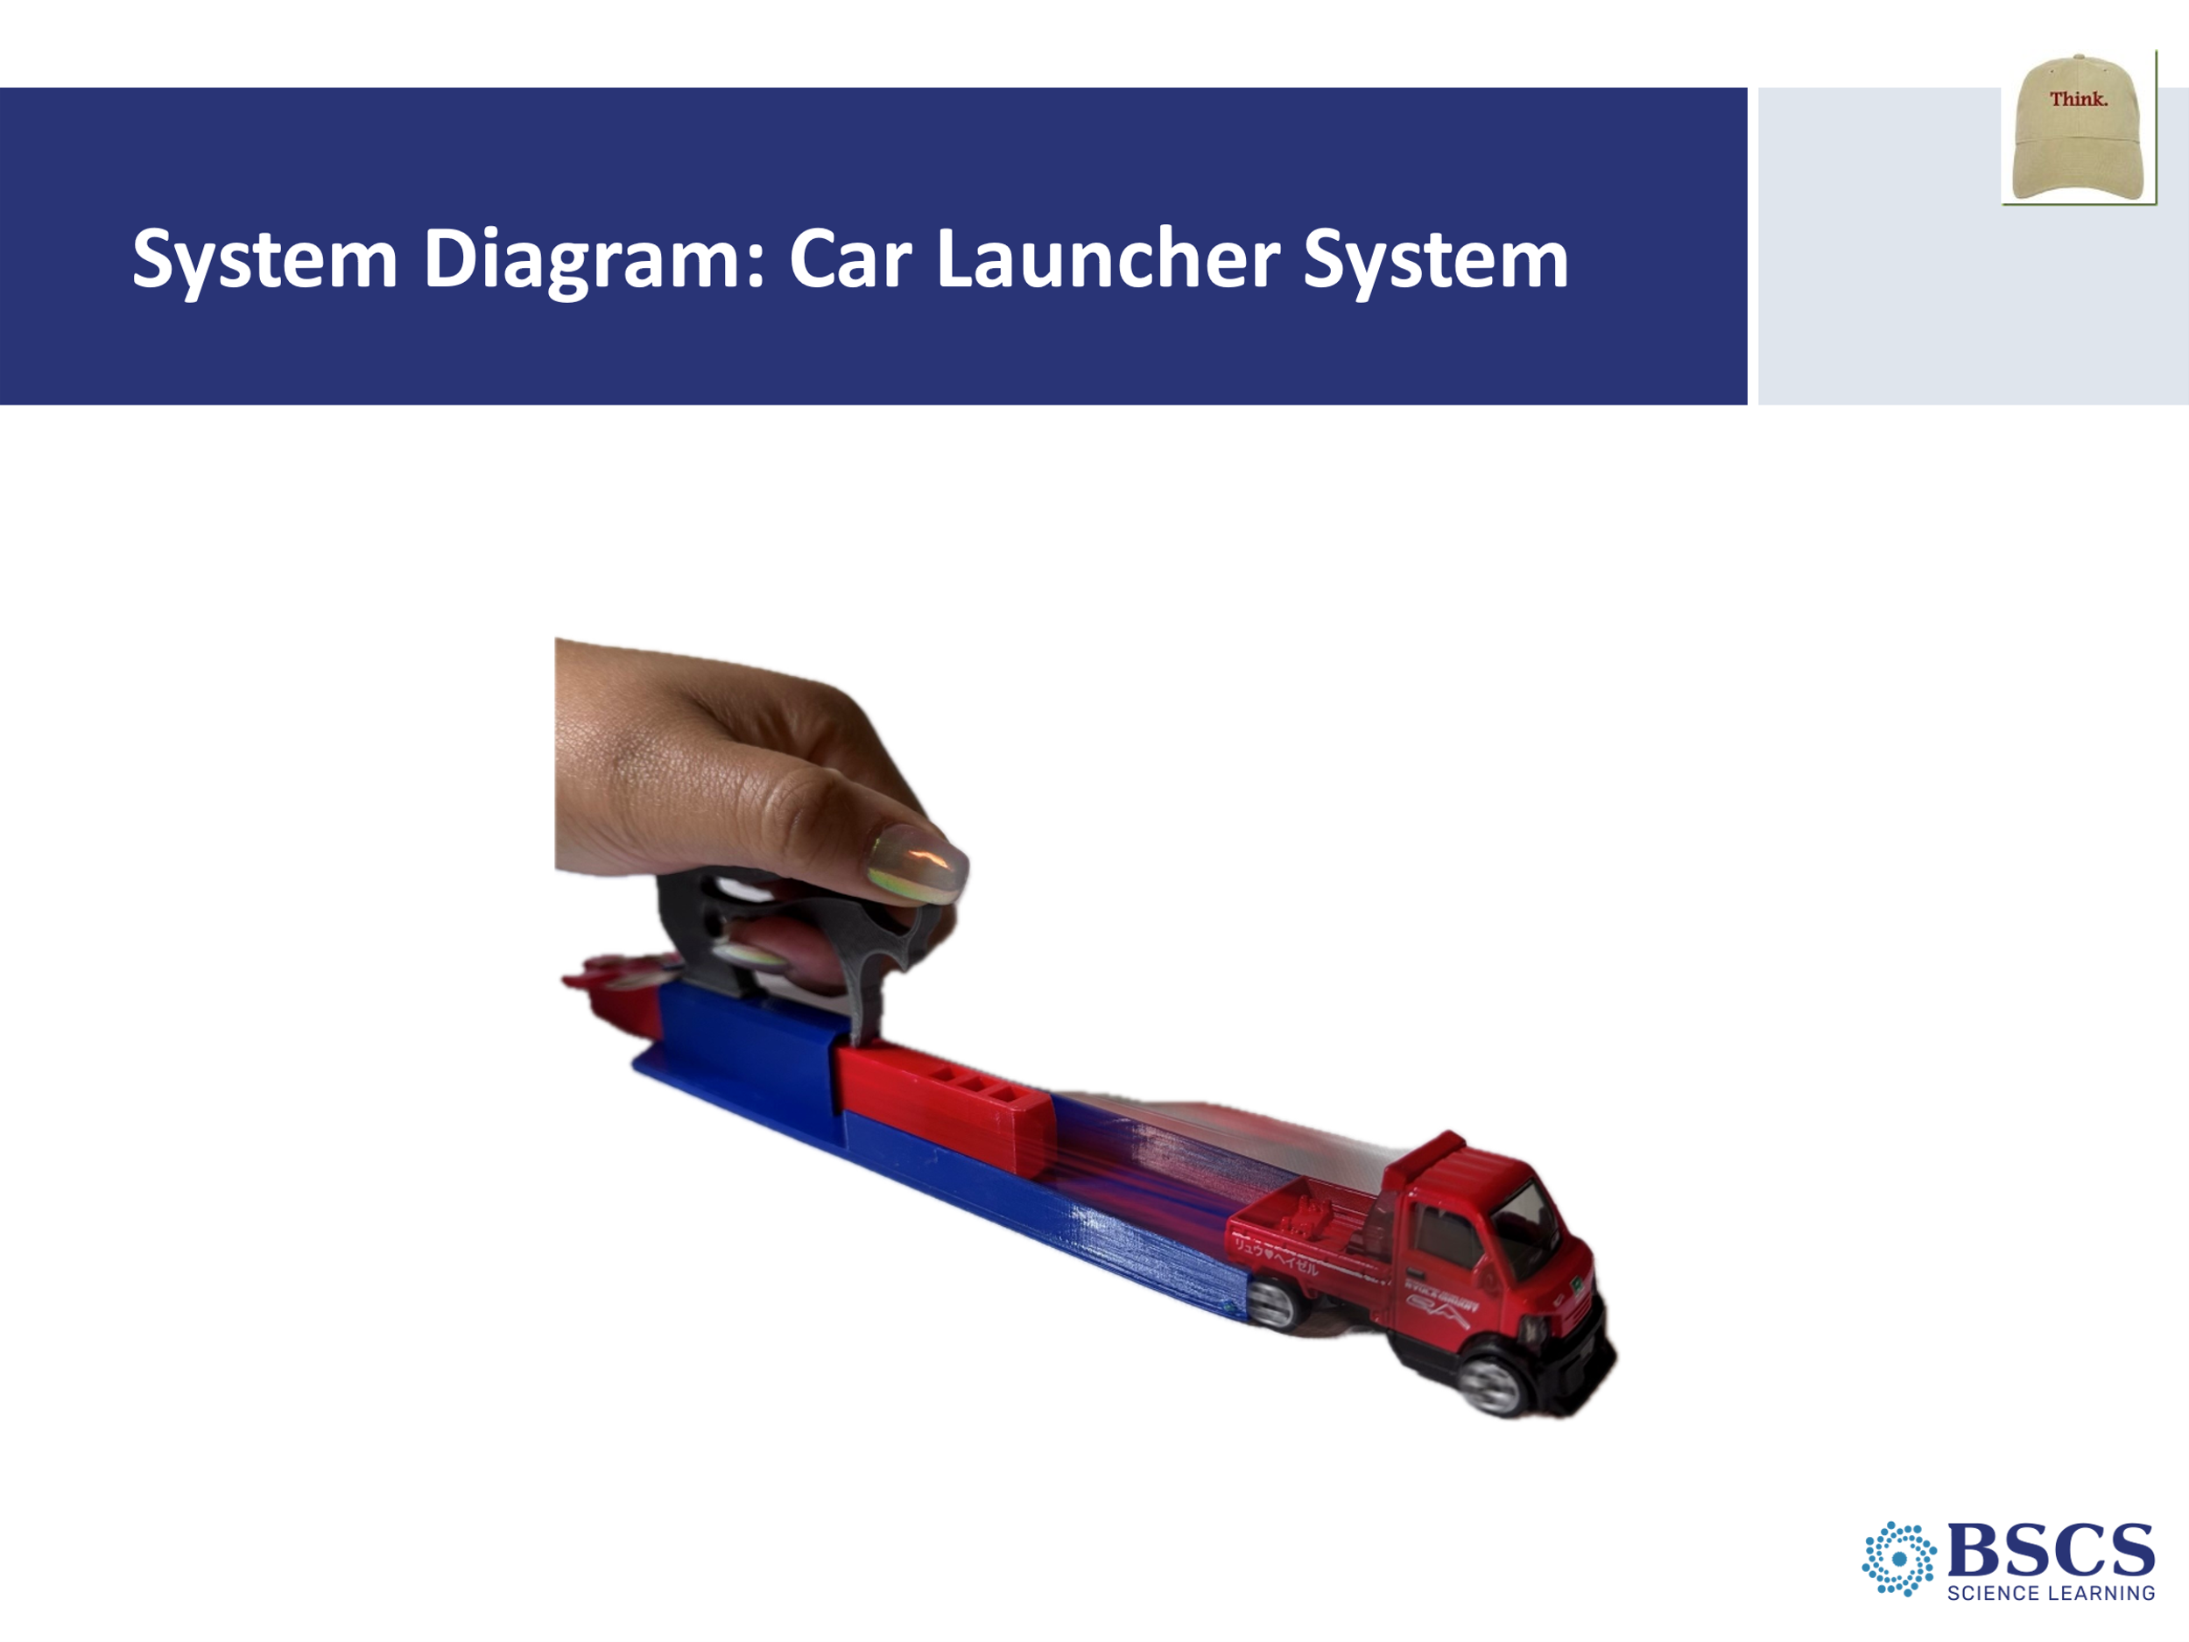 | - System Diagram: Car Launcher System (15 min)  - Share that we will draw a system diagram for the car launcher system. We will use all of the science ideas we have figured out in this unit to draw our diagrams. Your system diagram should explain all of the energy changes that occurred in the car launcher system. Remember to include the key components including evidence into your system diagram.  - Place participants in groups of 3 to draw a system diagram to explain the energy changes that occurred in the launcher system. Post system diagrams from Lesson 4 for participants to refer to as examples.  - Give each group a car launcher system to refer to as they make their diagram. Circulate while groups work asking the questions related to the aforementioned system diagram key components  - Give groups about 10 minutes to draw the system diagram for the car launcher system on chart paper. Provide a 5-minute warning as the end of the time approaches.  - Remind participants to consider the system diagram key components recorded on the chart during the last lesson as they develop their diagram. Also refer to the Ideas We’ve Figured Out chart to link science ideas and include other evidence of energy changes besides motion.
 |  | 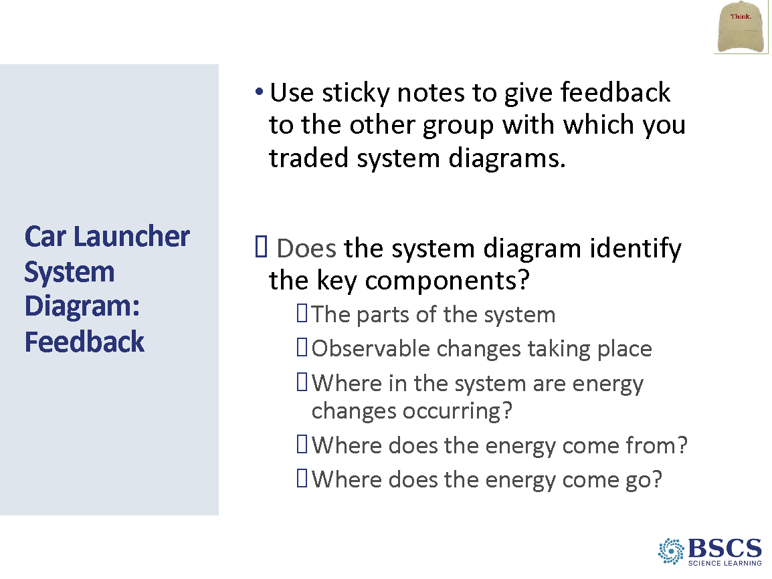 | - Car Launcher System Diagram: Feedback (25 min slide 27-28)  - Invite participants to do a gallery walk of the system diagram charts. Remind them to follow the protocol we used in the last lesson – one piece of feedback per sticky note. Focus the feedback on our key components list, as well as the Ideas We’ve Figured Out chart. They should not only give feedback, but they should also discuss ideas for revising their own group’s diagram based on observing others’ diagrams.  PDL Note: Groups of 2-4 can be used depending on the size of the whole group and the readiness of participants. If participants need additional content support, then smaller groups can be used.  - Have groups visit one to two posters (depending on the size of the group) to review and provide feedback. Give groups about 2 minutes for the first poster and increase the time to 3 minutes for the second poster to give time to read the feedback as well.
 |  | 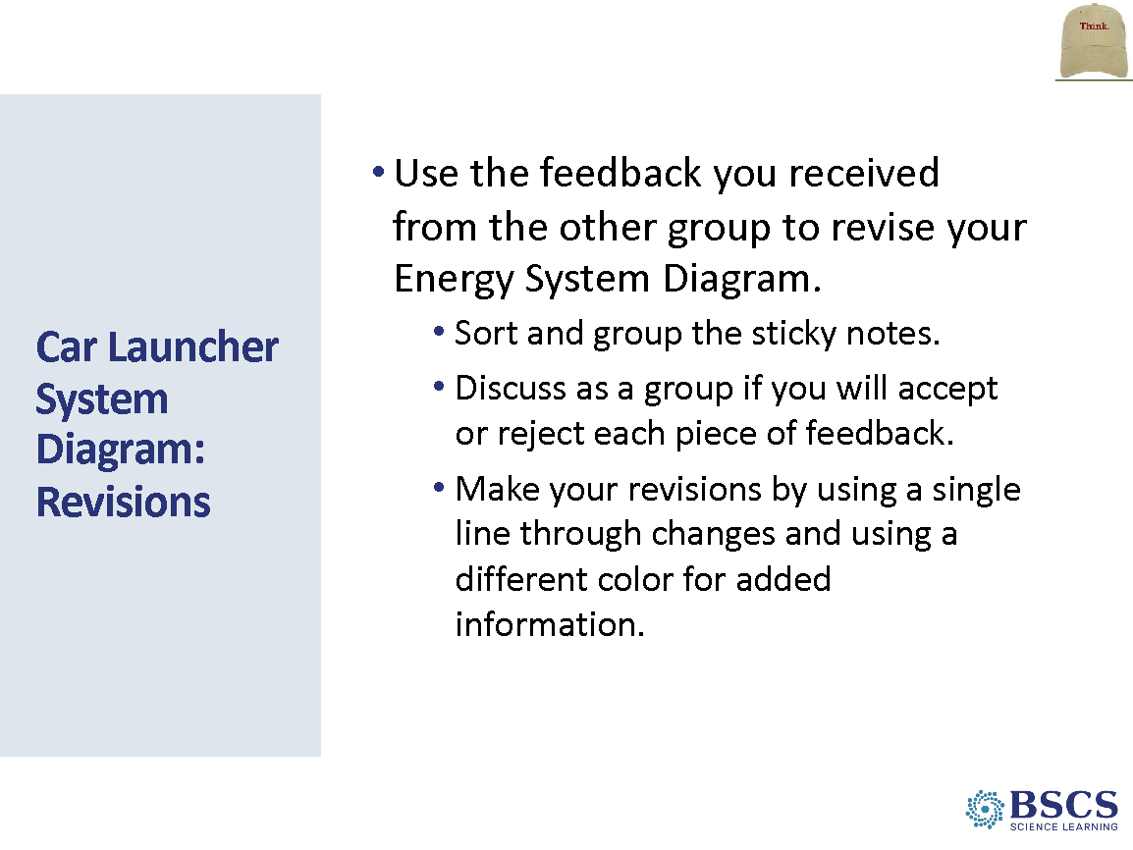 | - Car Launcher System Diagram: Revisions  - Once the gallery walk is complete, allow another 5 minutes for groups to revise their group’s system diagram based on peer feedback.  - Invite participants to use the feedback they received by sorting and grouping the sticky notes, accepting or rejecting feedback, and showing revisions by using a single line through changes and using a different color for added information. Remind them of the examples we discussed in the last lesson for useful feedback.  - Hang the diagrams nearby to refer to during the next activity.  Transition to Activity 2: Let’s take a look back at the Focus Question from Lesson 1 to reflect on how much we’ve learned about energy. Would anyone like to share an idea about energy that we learned in this unit?
 |  | 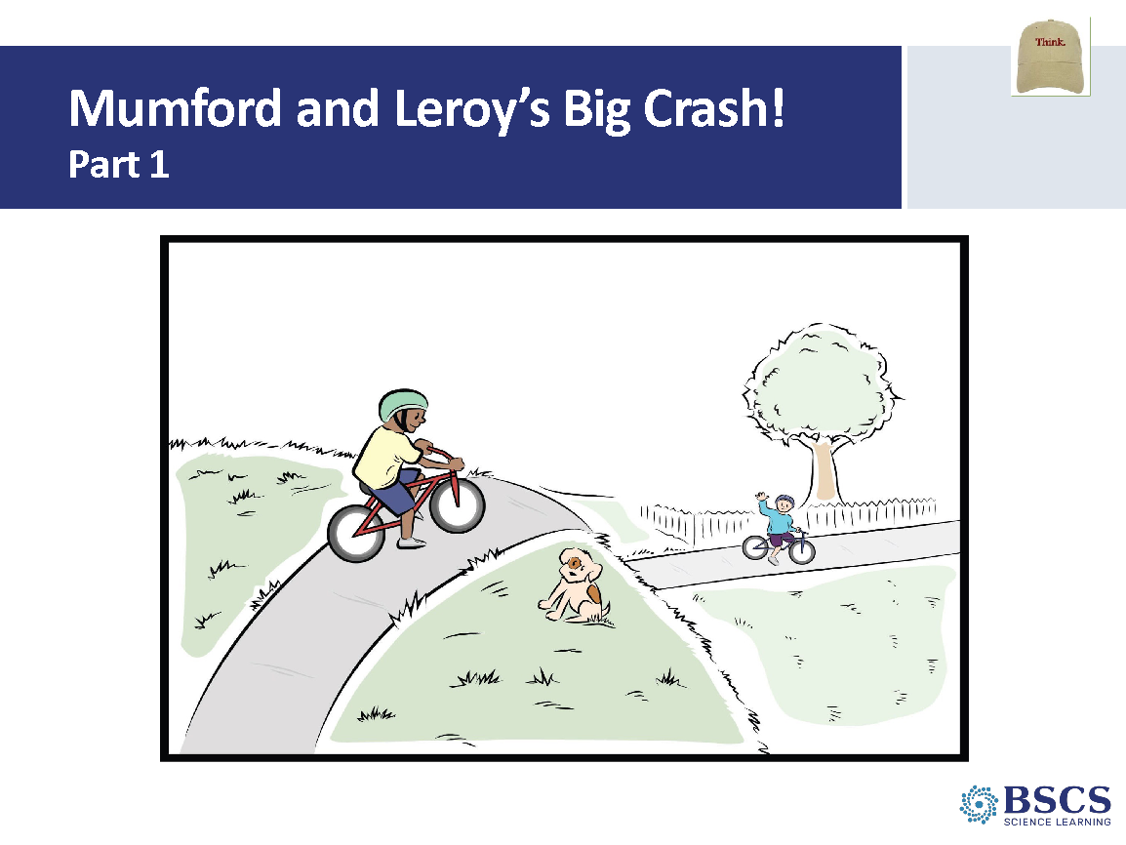 | - Mumford and Leroy’s Big Crash (Part 1) (10 min slides 29-31)  - Share that now that we have explained how energy changes occurred in the car launcher system, we can use these science ideas to explain a different phenomenon? Let’s read about two fourth grade students, Mumford and Leroy, and see if there are any energy changes that we can explain with our science ideas about energy.  PDL NOTE: Read the story aloud to the participants.
 |  | 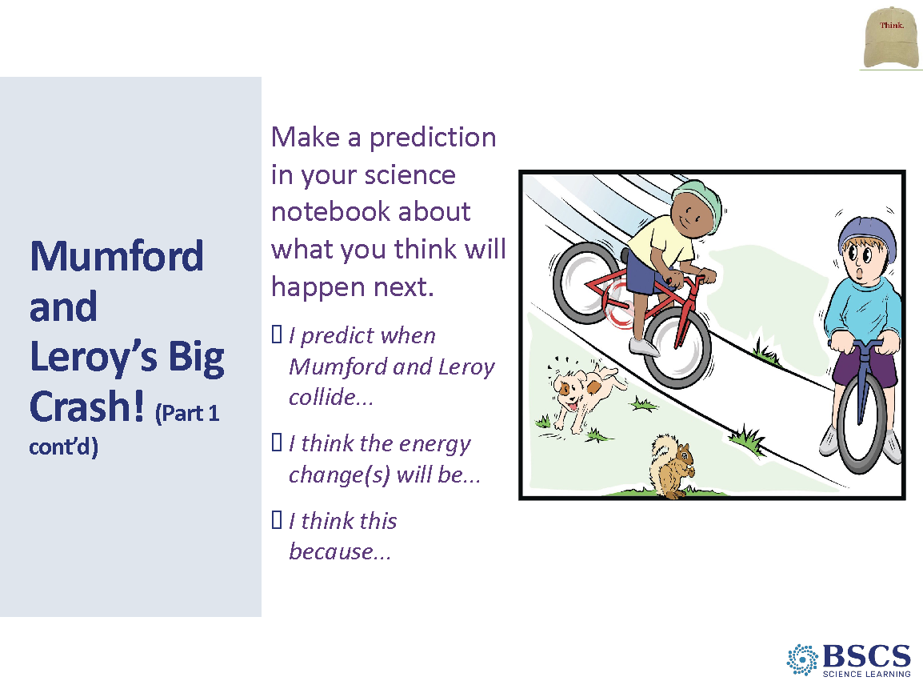 | - Mumford and Leroy’s Big Crash (Part 1 cont’d)  - Ask participants to make a prediction in their science notebook based on the following prompt: What do you think will happen when two objects (like Leroy and his bike and Mumford and his bike) collide?  - Invite participants to use these sentence stems:  - I predict when Mumford and Leroy collide...  - I think the energy change(s) will be...  - I think this because...  PDL NOTE: Provide a few moments of individual think time. Then, ask participants to share their ideas with an elbow partner. Give a few moments for partners to share.  - Invite participants to share their predictions with the class.  PDL NOTE: As participants share their predictions, ask them to use the sentence stems. Refer them to Rows 6, 7, and 9 of the CSW chart when responding to ideas that are shared. As participants share, ask probe and challenge. Engage as many participants as possible by asking if others agree or said it in another way.
 |  | 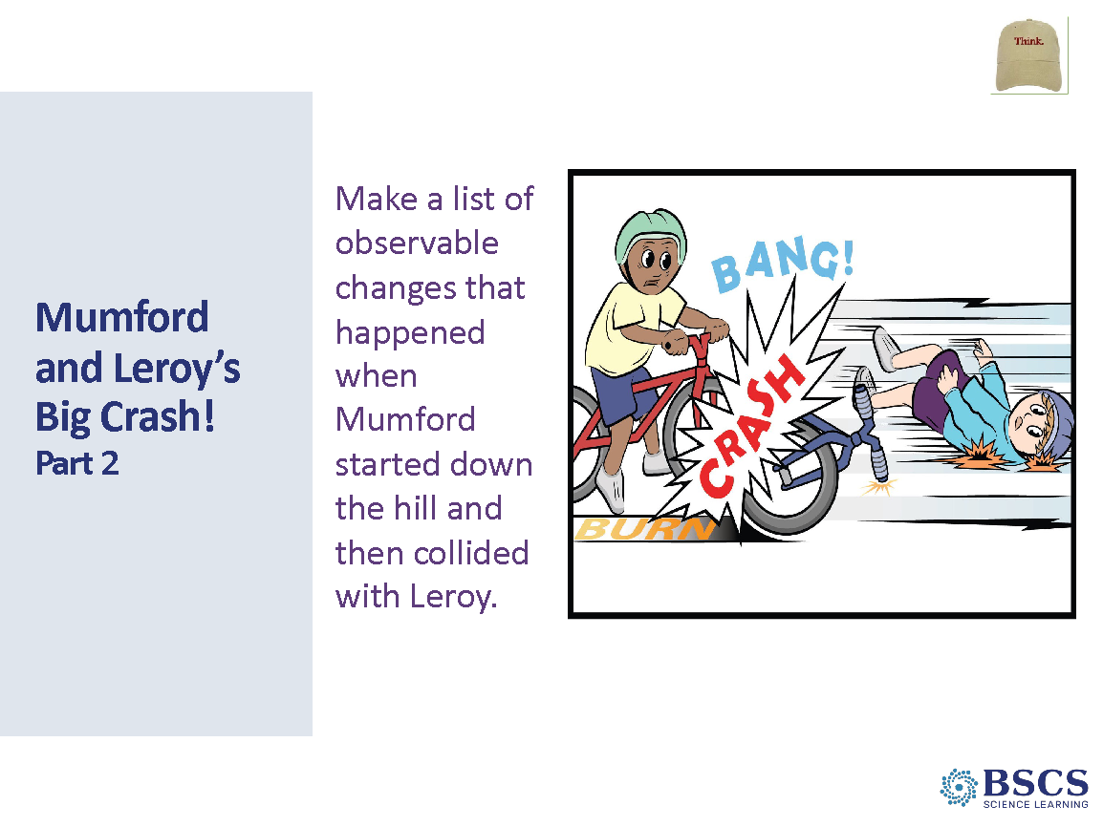 | - Mumford and Leroy’s Big Crash (Part 2)  - Invite participants to make a list in their notebooks of observable changes that occurred when Mumford started down the hill and collided with Leroy.
 |  | 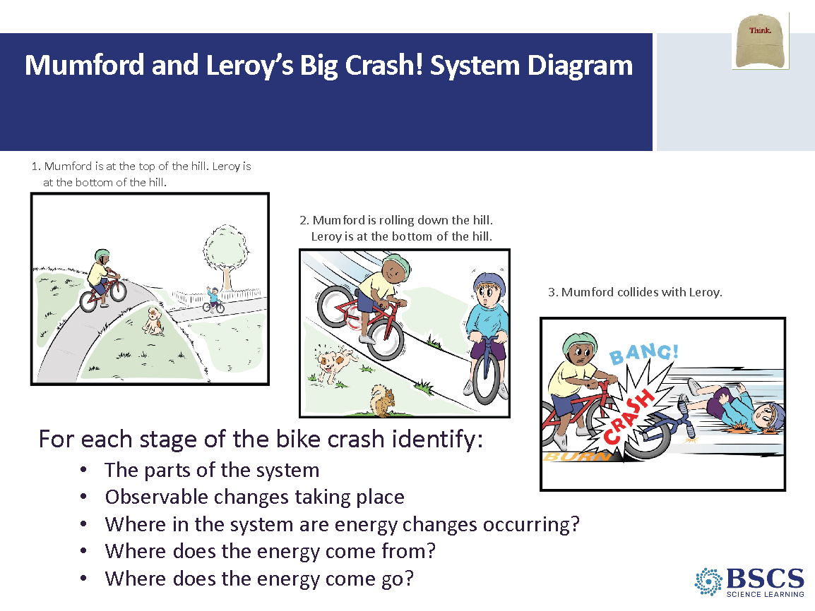 | - Mumford and Leroy’s Big Crash! System Diagram (15 min)  PDL NOTE: Create groups of 2 and distribute one copy HO5.2: Mumford and Leroy’s Collison to each group. Have participants tape the three pictures to a piece of chart paper. Point to the Key Components of a System Diagram chart and remind them to revisit the other diagrams if they need to.  - Invite participants to make a system diagram for the Mumford and Leroy story. Remind them to be sure to add additional information on the diagram to make it a system diagram that explains the energy changes during this bike collision. Give participants 15 minutes to do the following:  - Fill in the energy bars for before, during, and after the crash on the handout.  - Note observable changes such as movement, etc.  - Identify any energy changes that occur in the bike collision including heat, light, and sound if they are produced.  - Refer to the system diagram key components throughout the system drawing.  PDL NOTE: Circulate among groups as they work. Use elicit, probe, and challenge questions to guide participants through any difficulties they are having. Observe their diagrams and ask specific questions about their thinking when necessary.
 |  | 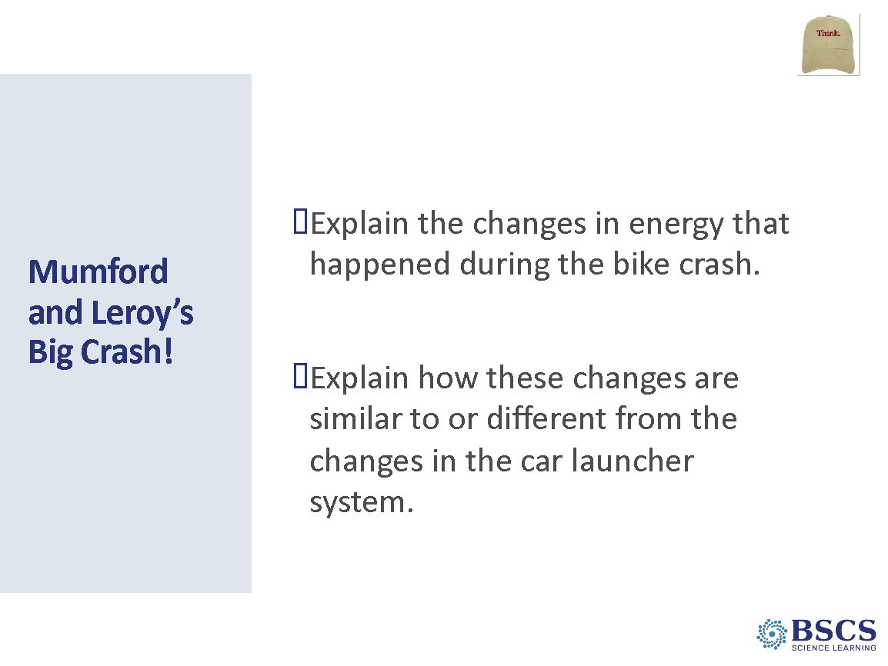 | - Mumford and Leroy’s Big Crash (10 min)  - Share that now that we have a system diagram of the bike crash, we will use it to construct an explanation in their notebooks. They will construct a scientific explanation for the changes in energy and how these changes are similar to or different from the changes in the car launcher system. They should use our CSW sentence starters if they need help sharing your ideas.  PDL NOTE: Place participants in groups of 2 and give them about 10 minutes to use the system diagram of the bike crash to construct a scientific explanation in their notebooks.  - After about 10 minutes, pair two groups and have them share their explanations with the group with which they were paired. Give groups about 5 minutes to share their explanations.  PDL NOTE: Rows 4 and 5 on the CSW poster can be helpful to participants sharing ideas and predictions. Rows 6, 7, 9, and 11 can be helpful for those responding to ideas that are shared. As participants are sharing their explanations, circulate and ask questions to probe and challenge their thinking. After they have constructed and shared their explanations, bring the whole group back together.  - Share that we are going to use what we did today to add to and revise the focus question for today’s lesson. Give time for participants to revise the focus question in their notebooks.
 |  | 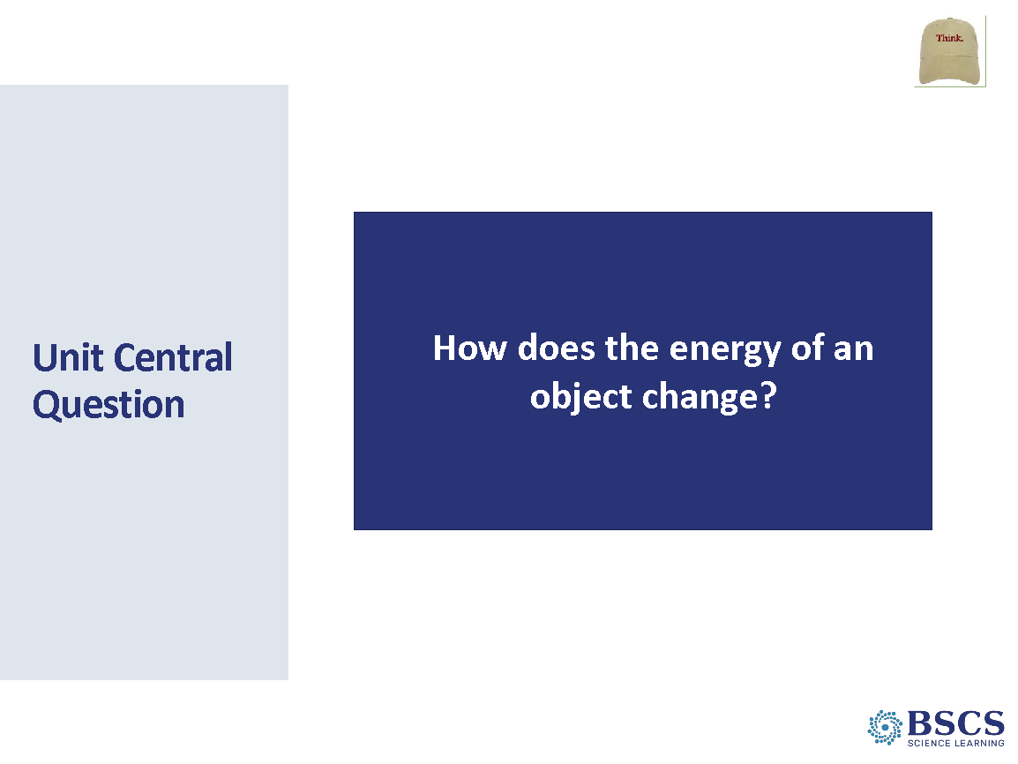 | - Unit Central Question (5 min)  PDL NOTE: Refer to the Driving Question Board and the Unit Central Question.  - Have participants identify the questions we have answered over the course of the unit by adding a heavy check mark on sticky notes we’ve answered. Celebrate all that we’ve figured out! Acknowledge there may still be questions we haven’t answered and perhaps some new questions that we thought of during the unit –explain that this happens to scientists when they investigate a phenomenon, too!
 |  | 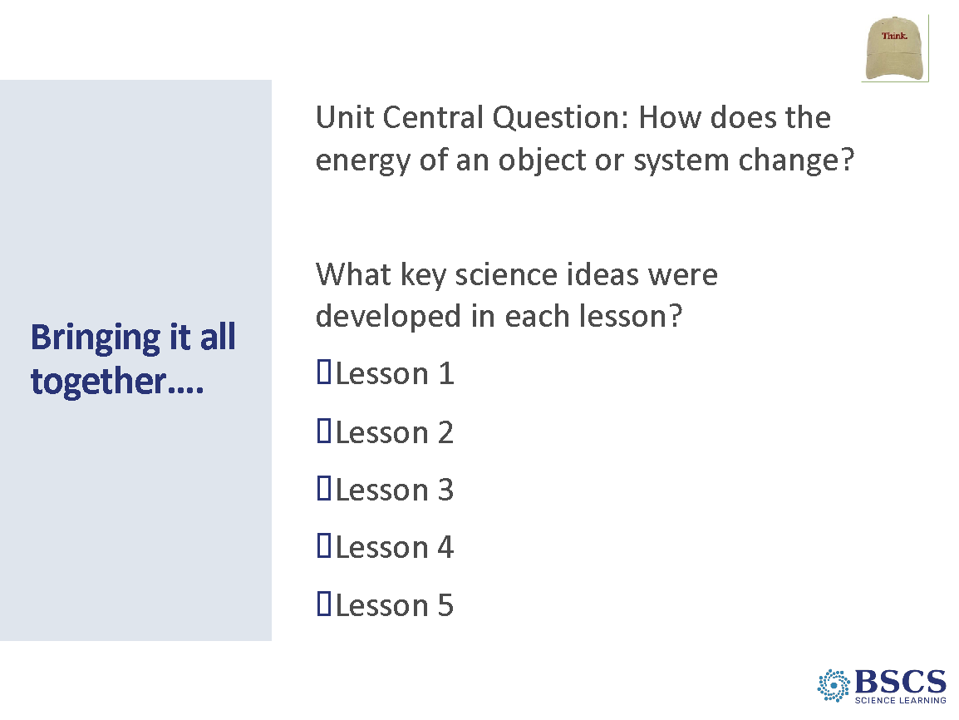 | - Bringing it all together (15 min slides 35-36)  - Ask participants to copy the Unit Central Question onto the current page in their science notebooks and think about the science ideas they learned from the lessons.  PDL Note: Participants may look in their notebook where they recorded “Key ideas we figured out” at the end of each content deepening session. Key Science Ideas from the lessons:  - Lesson 1: Observable changes in a rubber band car launcher system can provide evidence of energy changes (where energy comes from and where it goes) in the system. When the pulled-back rubber band is released, the launcher bar moves forward. Motion indicates an object has energy. As the moving launcher bar collides with the stationary car, the car begins moving and the launcher bar stops. Some of the motion energy of the launcher bar is transferred to the stationary car. This causes the car to begin moving as it gains energy and the launcher bar to stop moving as it has less energy after the collision. The farther the rubber band is stretched, the faster the launcher bar moves, and the faster and farther the car moves after the collision.  - Lesson 2: The faster an object moves, the more motion energy it has. When a moving object collides with a stationary object, the moving object slows down (its motion energy decreases) and the stationary object begins to move faster (its motion energy increases). Because the speed of the objects changes during a collision, this is evidence that the motion energy of the objects also change. Energy is transferred from a moving marble to a stationary marble during a collision. The faster an object is moving, the more energy it has, and the more energy can be transferred through collisions.  - Lesson 3: The faster an object moves, the more motion energy it has. As an object goes down an incline, it goes faster and faster as position energy (potential energy) is converted to motion energy (kinetic energy). The higher the incline, the faster the object goes when it moves down the incline. Objects that are not moving can have position energy. Position energy can be transformed into energy of motion. If the moving object has a collision with another object, energy can be transferred from one object to another, and the motion of each object will change. The more motion energy an object has, the more energy will be transferred in the collision.  - Lesson 4: Energy is all around us and can be detected using our senses. We can feel heat, see light, hear sound, and see movement. This is evidence that energy is present and changing. Energy changes in a system can be represented with a system diagram that shows the components of the system, the observable changes taking place, where in the system energy changes are occurring, where the energy comes from, and where the energy goes.  - Lesson 5: Energy transfers and changes occur in all interactions. Energy moves from object to object and from place to place and we detect it in different ways. Energy transfers away from the system through sound, light, or heat. A system diagram can track the energy transfers and transformations that occur in interactions.
 |  | 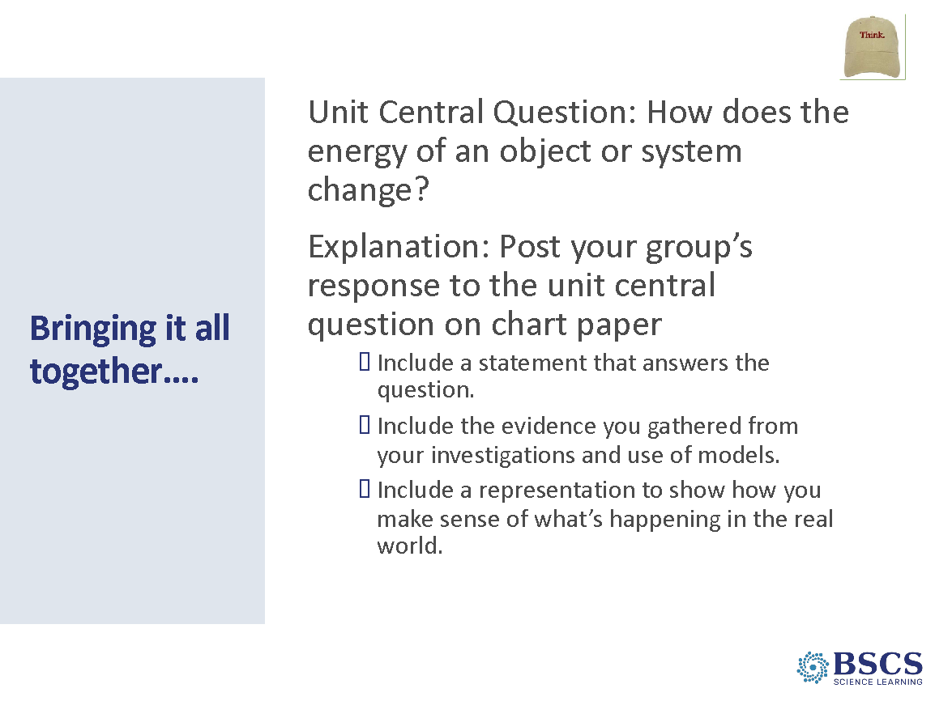 | - Bringing it all together…  - Invite participants to write their response to the question using the posted science ideas chart created by the class throughout the unit. In their response, they should also consider:  - How did CSW help us figure out important science ideas?  - How did using the analogy map help us compare different systems?  - How did the system diagrams and energy bars help us keep track and represent energy changes in the system?  PDL NOTE: Rows 4 and 5 on the CSW poster can be helpful to participants sharing ideas and predictions. Rows 6,7, and 9 can be helpful for those responding to ideas that are shared. Give participants 10 minutes to write their responses.  - Would anyone like to share their response to the Unit Central Question?  - As participants share, encourage other participants to use their CSW charts to add to, agree or disagree, and respond to ideas being shared. Help participants negotiate a response to the Unit Central Question that includes the ideas given as the Ideal Student Response to the Unit Central Question provided on the Unit Lesson Plan (see the main science ideas to the left).  - Invite participants to share their response to the Unit Central Question.  - As participants share, encourage other participants to use their CSW charts to add to, agree or disagree, and respond to ideas being shared. Help participants negotiate a response to the Unit Central Question that includes the ideas given as the Ideal Student Response to the Unit Central Question provided on the Unit Lesson Plan (see the main science ideas in the summary)
 |  | 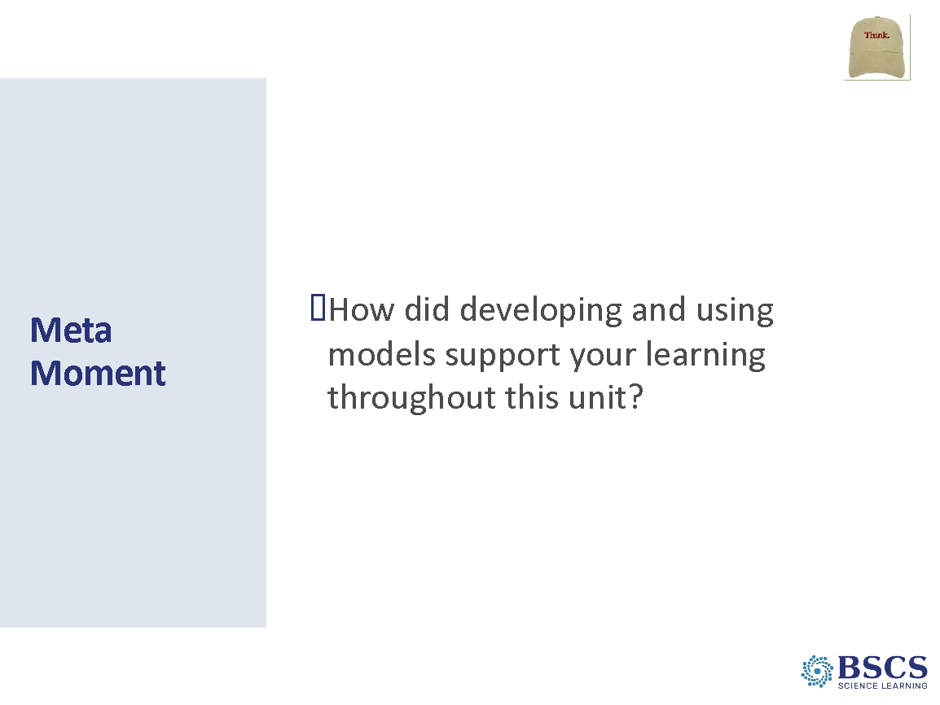 | - Meta Moment (5 min)  - Provide instructions for the task.
 |  | 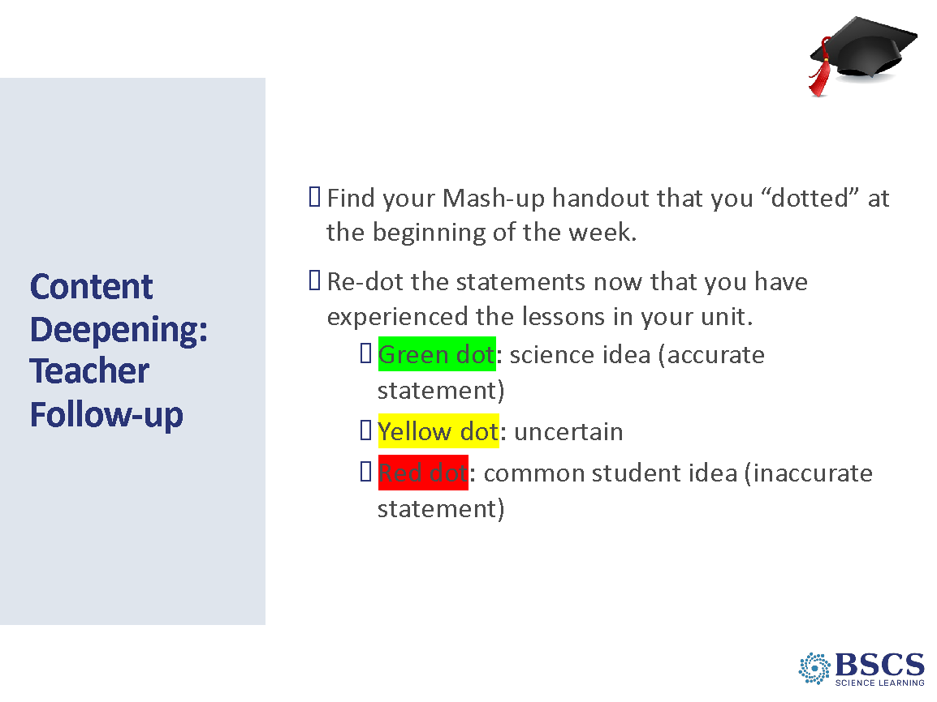 | - Content Deepening: Teacher Follow-up (20 min)  - Direct participants to p. __ in their binder and provide instructions for the task.  - Help participants make explicit links between ideas and lessons/activities.
 |  | 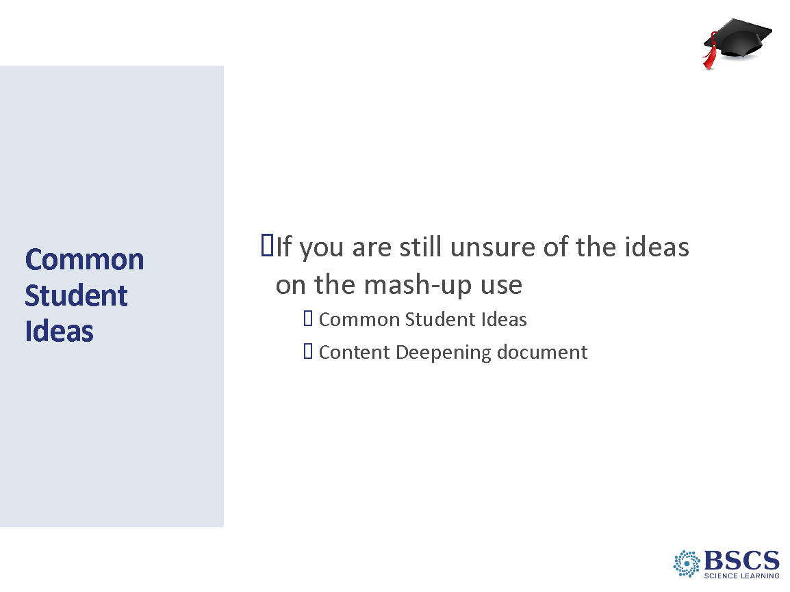 | - Common Student Ideas (5 min)  - Note that there are Common Student Ideas and Content Background documents in the ET Classroom Curriculum Binder, which they will get shortly.
3:15 – 4:20  65 min  Slides 40-42  Study Group Teams | Unit Review  Purpose: The purpose of this session is to develop a shared understanding of the structure and content of the lesson planning documents and prepare to teach the lessons in the fall.  Content: STeLLA lesson plans are structured to make explicit the integration of STL and SCSL strategies and support teachers in enacting the strategies. Three dimensional, phenomena/problem-driven learning is highlighted throughout the lessons.  What participants do  Participants receive and review the Classroom Curriculum Binder and instructions to prepare for telling the science story within an assigned lesson.  Resources  - Classroom Curriculum Binder |  | - Day 4 Focus Questions (5 min)  - Revisit the Day 4 focus questions.  Transition: Throughout our content deepening experiences, we’ve been “telling the story so far...” Part of the purpose for the storytelling was to set us up for the Review of the Unit you’ll all be teaching in the fall.
 |  | 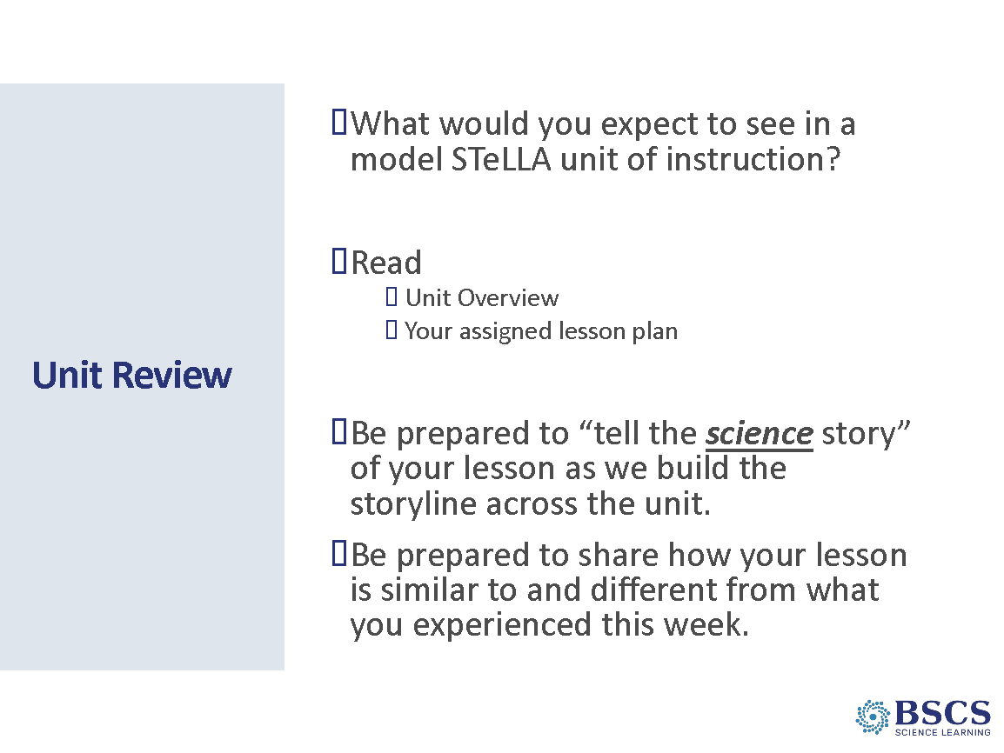 | - Unit Review (50 min)  - Remind participants of the opportunity to continue learning the STeLLA approach by enacting a unit of instruction with their students in the fall. They’ll be filmed on one of the lessons and we’ll have a chance to use the LAP to support their analysis of a clip or two from that lesson.  - Access their prior knowledge/experience with the first question on the slide. Gather a few ideas from the group.  - Distribute the Classroom Curriculum binder. Point participants to the Unit Overview and Front Matter (p. __).  - Provide a few minutes for participants to review the front matter and compare the information present and their ideas about what they expected to see. Point to the Content Deepening document.  - Invite all participants to turn to Lesson 1 (p. __) and review the first two pages of the document. Again, compare the information present and their ideas about what they expected to see.  - Divide the lessons across the study group team with the instruction that they should come prepared tomorrow to tell the science story in their assigned lesson (i.e., NOT activities story). This should be consistent with the way they’ve been telling the story all week. (Think about how PDLs/PTs; strengths are spread out across groups.)  - L1 = 2 ppl  - L2-3 = 2 ppl  - L4-5 = 3 ppl  - Possible follow-up questions  - What will be challenging?  - What do you want to think about when planning? Leading learning in the classroom?  - How are the STeLLA strategies represented in the lessons? How will that help you tell the story of your lesson(s)?  - Possible additional review instructions  - Add probe and challenge questions from your content deepening experiences or from the practice session on Day 2.  - Highlight places where you’d expect to see students struggle (pink) or make connections (green).  Transition: We’ll use our experiences today to add to our Effective Teaching and Learning charts.
 |  | 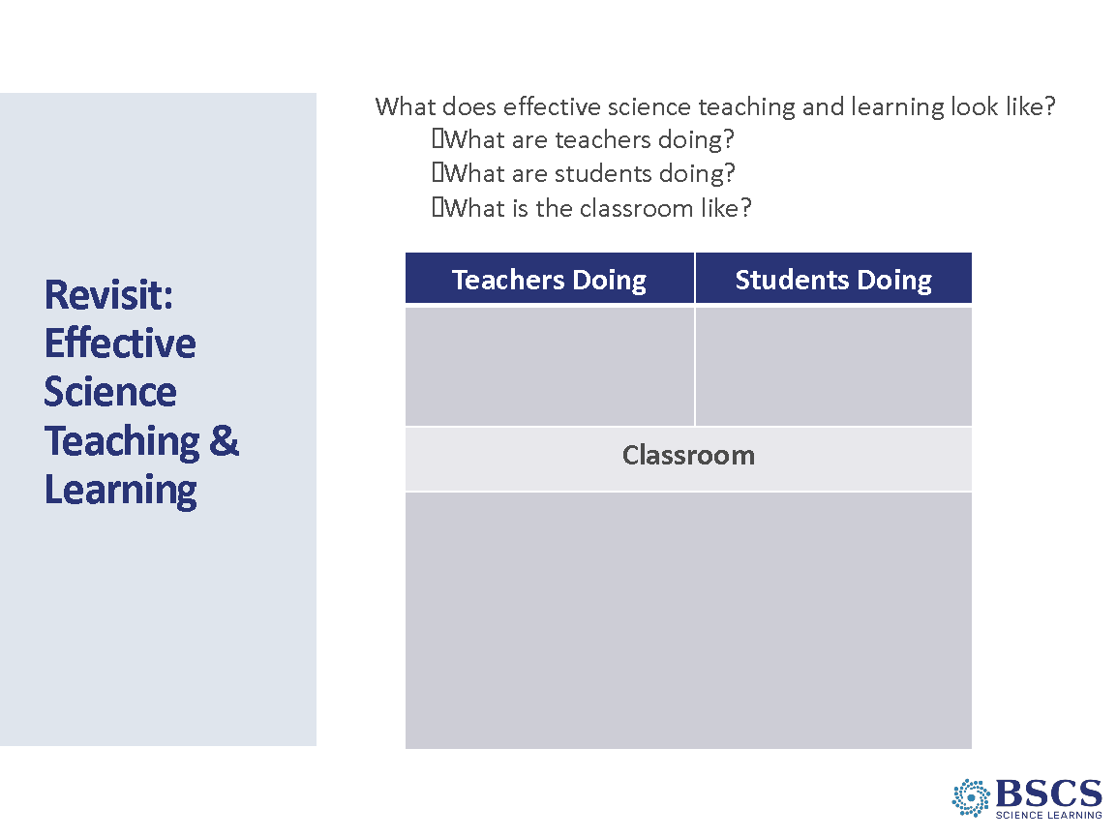 | - Revisit Effective Science T&L chart (10 min)  - Provide instructions to return to their effective science teaching and learning charts.  - Be sure to check the Parking Lot and respond as needed.  PDL Note: Key ideas to highlight:  It is important that content representations are matched to the MLG because, in addition to teachers using EPC to support students towards the main learning goal, the content representations we select can also move student thinking towards targeted science ideas (or not).  When students develop and use content representations and models, they are not only making their thinking visible, they are also building on their abilities to communicate in scientific ways. Communicating using content representations and models provides opportunities for all students to communicate their ideas in scientific ways.
4:20 - 4:30  10 min  Slides 43-45  Study Group Teams | Purpose: The purpose of this session is to reflect on the day’s experiences and learning and prepare for Day 5.  Content: Focus Questions  - Where does the energy come from and where does it go when changes happen in a system?  - How can developing and using content representation and models selected for their match to the main learning goal help students explain phenomena or solve problems?  - How does the intentional use of Student Thinking Lens Strategies support a classroom culture of making thinking visible?  What participants do  Participants revise their effective science teaching and learning and reflect on their learning from the day.  Resources  - Daily reflection sheet  Posters/Charts:  - Focus Questions | 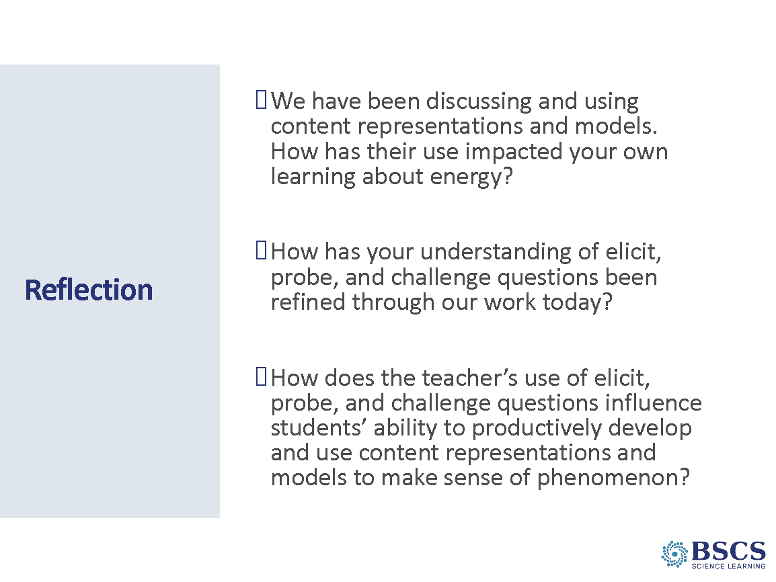 | - Reflection (5 min)  - Provide instructions for the Day 4 reflection.  - Remind participants to bring their personal and school calendars on Friday so we can do some scheduling for our study group meetings and lesson videotaping in the fall.  OR  - Daily reflection sheet
 |  | 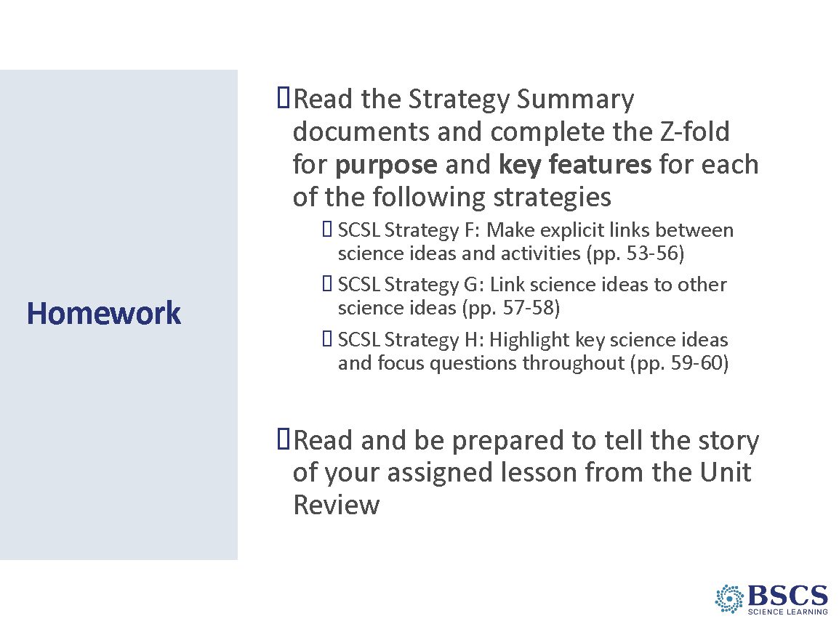 | - Homework (5 min)  - Provide instructions for the task.  - Remind participants to read their assigned lesson from the Unit Review and be prepared to tell the story of the lesson in addition to the homework listed here.
 |  |  | - BSCS (0 min)

