SSUP: Summer Institute - PD Leader Guide Day 5
Grade Level | 4 | Day | 5 | STeLLA Strategies Focus | SCSL F, G, H | Subject Matter Focus | Energy Every Day, Everywhere
Teacher Learning Goals | - The goals of the STeLLA PL program are to deepen knowledge of teaching and learning, increase ability to analyze and reflect on teaching and learning, increase ability to use content knowledge and knowledge of teaching and learning to transform classroom practice, deepen teacher content knowledge, and increase student learning in science.  - The coherence of a lessons is strengthened when teachers make explicit links between science ideas, other science ideas, and activities, and highlight the focus question throughout the lesson, or better yet, when teachers support students in making these connections.  - Coherent lessons attend to a structure that includes an activity set-up, activity, and activity follow-up.
Focus Questions | - How can we build coherence within and between lessons to help students craft a storyline of key science ideas?  - How can we be intentional about how we move student thinking forward?  - How could the strategies we’ve learned so far support your planning and enactment of lessons?
Ideal Teacher Response | How can we build coherence within and between lessons to help students craft a storyline of key science ideas?  Lessons with a strong science content storyline include a connected thread of content-related talk and activities leading from the focus question through a flow of events and science ideas to the summary of the lesson. For students to construct a coherent science content storyline, activities should have a purposeful set up, be designed to require links between the activity and science ideas, and a follow-up that focuses attention on how the activity contributed to the storyline.  How can we be intentional about how we move student thinking forward?  Science ideas should be explicitly linked to other science ideas, both within the lesson and between lessons so that students can construct a coherent science content storyline and develop an explanation of phenomena and/or design solutions to problems, Further, the key science ideas and focus question should be highlighted throughout the lesson. Teacher’s intentional use of elicit, probe, and challenge questions help students make links and progress toward a more accurate understanding of science.  How could the strategies we’ve learned so far support your planning and enactment of lessons?  Intentional use of the STeLLA Strategies in planning lessons, leading classroom learning, and reflecting on practice increase the likelihood that students will have multiple opportunities to learn in a classroom culture of student thinking.

Preparation | Materials | Videos and Transcripts
Planning/Preparation Tasks:  - Study PDLG, PPTs, video clips, and handouts. Make changes to PPTs, if needed.  - Link clips  Daily Set Up Tasks:  - Check that video clips are correctly linked to PPT  - Set up PowerPoint and speakers  - Check video & sound  - Arrange furniture, food (include social distancing protocols in set up)  - Arrange posters/charts  Day 5 Set Up Task:  Arrange teacher materials on tables:  - Tabletop name cards  - Table boxes  Daily Follow-up Tasks:  - Archive final PPT  - Collect and turn in daily feedback  - Disinfect common materials, tables and common areas per protocol | Posters/Charts:  - STeLLA Conceptual Framework poster  - Day 5 Agenda chart  - Program Goals chart  - Norms poster  - Day 5 Focus Questions chart  - Effective Science Teaching chart  - Parking Lot chart  - Blank Purpose/Key Features Charts for Strategies F, G, & H  Handouts in SSUP PD binder front pocket:  - Z-fold chart: Student Thinking Lens Strategies  - Z-fold chart: Science Content Storyline Lens Strategies  Handouts in SSUP PD binder, Tab 5:  - Grade 4 Classroom: SSUP_ET_TN GR4_SG3_L3_Greever_C1 Transcript  - Grade 4 Classroom: Parco (F, H) SSUP_ET_L5_Parco_C1 Transcript  - Lesson Analysis Protocol  - Day 5 Daily Reflection  Supplies:  - Synthesize/Summarize Model Development Supplies (if any)  Resources:  - STeLLA strategies booklet  - BSCS Journal  - Content Deepening Notebook  - Classroom Curriculum Binder | - Linking ideas to activities (F) Greever Video: Greever, Energy Transfer_Lesson 3, SSUP_ET_TN GR4_SG3_L3_Greever_C1  - Linking ideas to activities (F), Linking ideas to other ideas (G), highlighting (H) Parco Video: SSUP_ET_L5_Parco_C1

DAY 5 SESSION OUTLINE: 8:30 a.m. – 3:00 p.m.
Time | Purpose | Content | Activities
8:30 – 9:00  30 min  Slides 1-6  Study Group Teams | Purpose: The purpose of the opening is to continue to build community and set the stage for today’s learning | Content: Focus Questions  - How can we build coherence within and between lessons to help students craft a storyline of key science ideas?  - How can we be intentional about how we move student thinking forward?  How could the strategies we’ve learned so far support your planning and enactment of lessons? | Opening  - Norms  - Goals/Agenda  - FQs
9:00 – 10:15  75 min  Slides 7-11  Study Group Teams | Purpose: The purpose of this session are to 1) develop a shared understanding of STeLLA Strategies F, G, and H: Make explicit links between science ideas and activities, Link science ideas to other science ideas, and Highlight key science ideas and focus questions throughout and 2) develop a shared understanding of the LAP process. | Content: Lessons with a strong science content storyline include a connected thread of content-related talk and activities leading from the focus question through a flow of events and science ideas to the summary of the lesson. For students to construct a coherent science content storyline, activities should have a purposeful set up, be designed to require links between the activity and science ideas, and a follow-up that focuses attention on how the activity contributed to the storyline.  So students can construct a coherent science content storyline and develop an explanation of phenomena and/or design solutions to problems, science ideas should be explicitly linked to other science ideas, both within the lesson and between lessons. Further, the key science ideas and focus question should be highlighted throughout the lesson.  The LAP supports a deep dive into a teacher’s practice and student understanding through intentional inquiry into evidence provided in analysis of classroom video. | Lesson Analysis SCSL F, G, H  - Charting  - Lesson Analysis R1 F-H  - Lesson Analysis R2 G  - Meta Moment
10:15 – 10:25 | Break
10:25 – 11:25  60 min  Slides 12-13  Study Group Teams | Purpose: The purpose of this session is to develop a shared understanding of STeLLA Strategies are enacted and the science ideas developed throughout the lessons and prepare to teach the lessons in the fall. | Content: STeLLA lesson plans are structured to make explicit the integration of STL and SCSL strategies and support teachers in enacting the strategies. Three dimensional, phenomena/problem-driven learning is highlighted throughout the lessons. The ability to identify and articulate what students are learning, as opposed to what students are doing, is important to successfully enacting the STeLLA lessons. | Lesson Analysis  - Articulate coherence across lessons (scope and sequence)  - Tell the story across the unit
11:25 – 1:05  100 min including break  Slide 14  Study Group Teams | Purpose: The purpose of this work is to plan for ongoing program activities. |  | Working Lunch  Planning for fall  Check calendars to find a good group time for synchronous work  Identify who will be able to teach a lesson and sign up for filming (Round 1 and Round 2?)
1:05-2:15  70 min  Slide 15-16  Whole Group | Purpose: The purpose of this session is to engage participants in making connections among ideas, evidence, and experiences with which they have engaged over the week. Creating a visual representation of the week’s learning supports learners in pulling together, organizing, and finding relationships between important ideas. Presenting and explaining the representation publicly helps to further elaborate and make meaning of learning. | Content: The STL and SCSL work together to support effective teaching and improve student learning. The STeLLA approach promotes a culture of student-centered teaching and learning. | Synthesize & Summarize  Represent the 2 Lenses & Strategies  Present the 2 Lenses & Strategies
2:15 – 3:00  45 min  Slide 17-18  Whole Group | Purpose: Transformative professional learning experiences require sustained, collaborative work. It is important to reflect on and celebrate the work together and prepare for continued learning and reflection. Celebration of the work and learning of the week provides closure to the institute. | Content: A strong culture of ideas and trust contributes to the development of a community of teacher learners where we can learn while deprivatizing our practice. Analysis of practice based on a conceptual framework and done through video, student work, and common units of instruction provide a powerful focus for PLCs/study groups. | Closing  - Celebration and final reflection  - Distribute CSW posters and kit materials as appropriate.

DAY 5 Detail Agenda
Time and Focus | Purpose and Content &  What Participants Do | Slides | Process
8:00 – 8:30 | Coffee & Conversation |  | Need several hands on deck to help participants complete paperwork, registration, and logistics.
8:30 – 9:00  30 min  Slides 1-6  Study Group Teams | Opening  Purpose: The purpose of the opening is to continue to build community and set the stage for today’s learning  Content: Focus Questions  - How can we build coherence within and between lessons to help students craft a storyline of key science ideas?  - How can we be intentional about how we move student thinking forward?  - How could the strategies we’ve learned so far support your planning and enactment of lessons?  What participants do  Participants reconnect with one another and with the goals and content of the program.  Resources  - Name Tags  - BSCS Journal  - Norms poster  - PD Binder  - Classroom Curriculum Binder  - STeLLA Conceptual Framework poster  - Charts  - Program Goals chart  - Day 5 Agenda chart  - Day 5 Focus Question chart  - Parking Lot chart  - Effective Science T&L chart  - Blank Purpose/Key Features charts for F, G, and H | 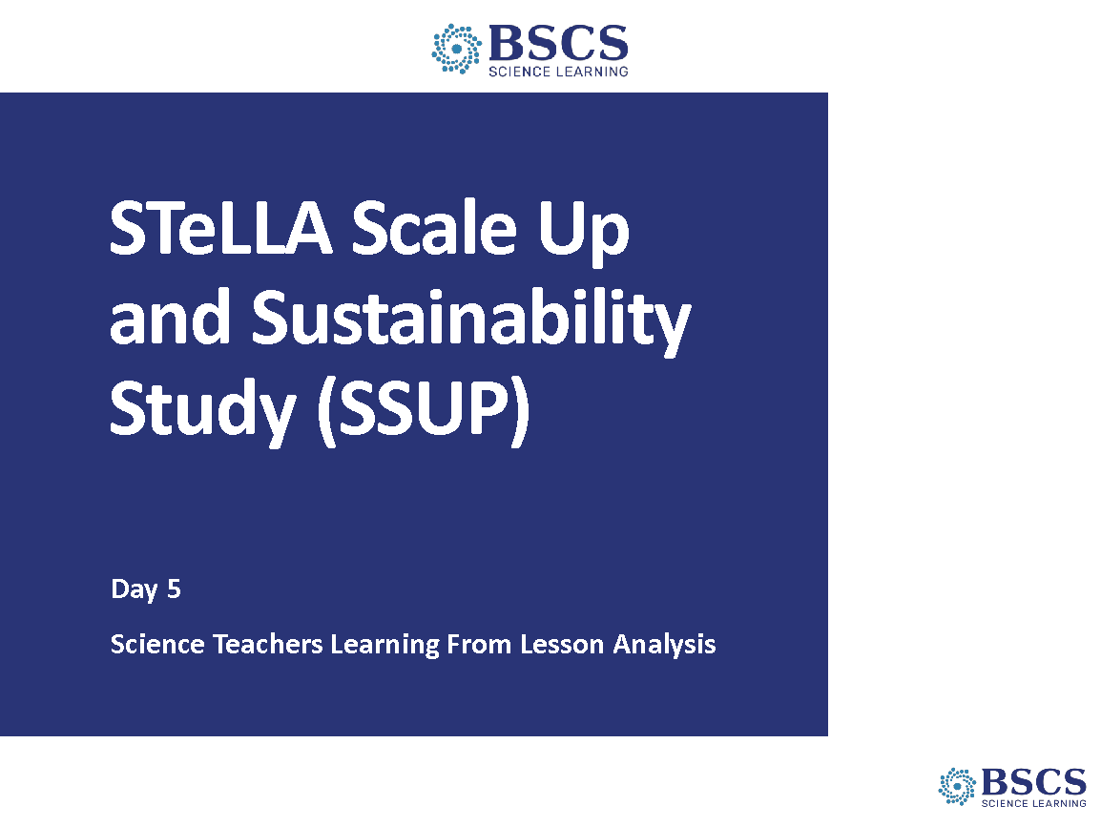 | - SSUP Program Day 5 (0 min)  - Greet participants as they enter the room. Help them pick up their materials and find their spots.
 |  | 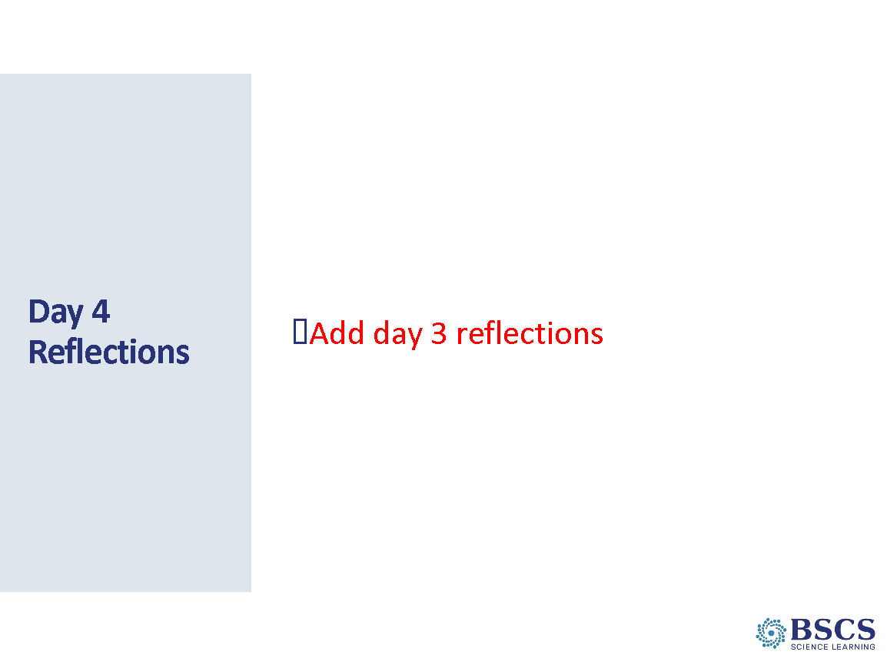 | - Reflections (5 min)  - Share patterns in reflection from Day 4. Link to program goals and agenda for the day as appropriate.  Transition: To continue our reflections, let’s consider the STeLLA norms.
 |  | 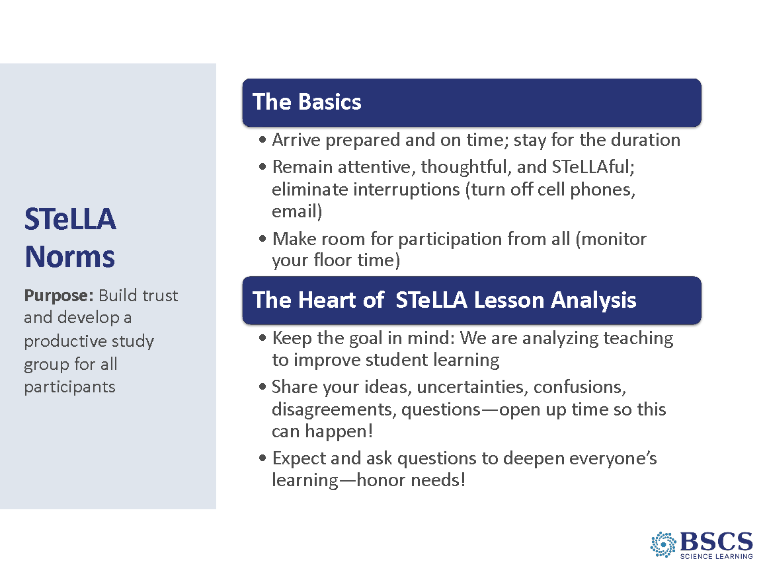 | - STeLLA Norms (10 min)  - Revisit the norms. Ask participants to identify one norm that will be important as they move into the fall study groups and will be analyzing one another’s classroom videos.
 |  | 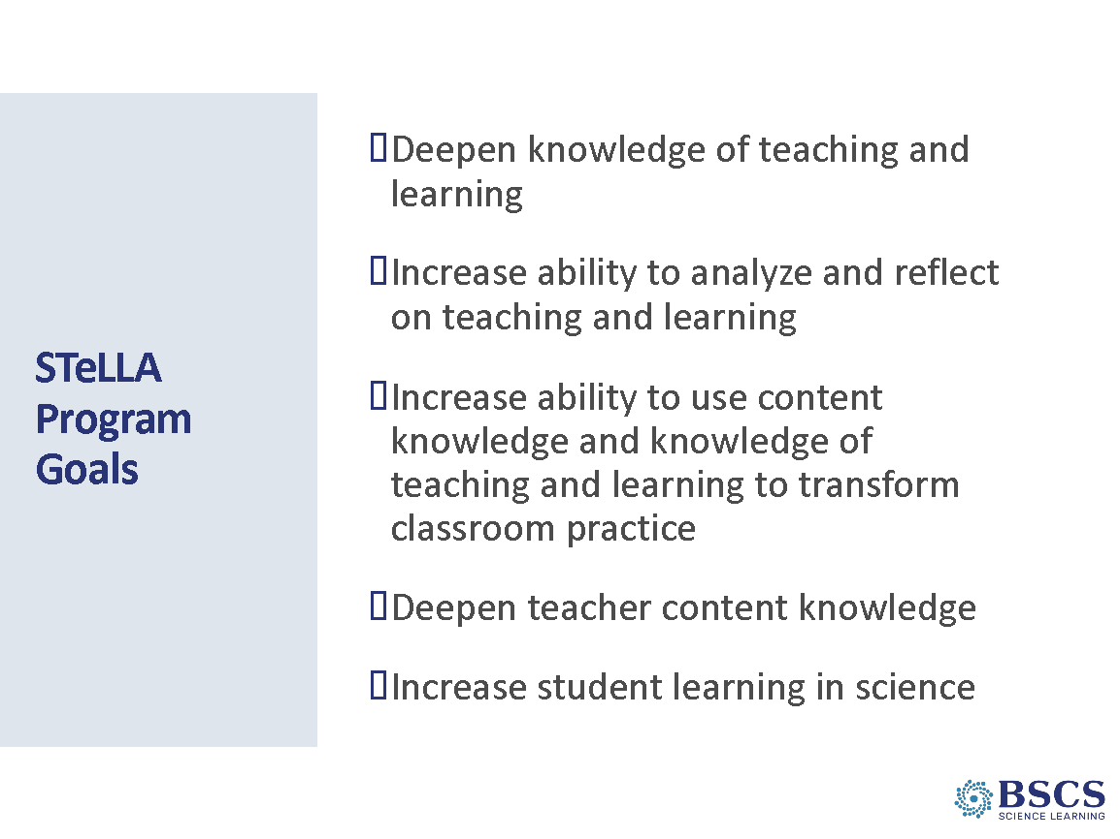 | - Program Goals (5 min)  - Revisit program goals. Ask participants to identify one goal we are doing particularly well with and one we could work on as a team.  - Invite participants to consider the progress we’ve made toward these goals this week? Possible questions.  - What contributed to progress on that goal?  - Where have we made less progress? What will it take to make progress?
 |  | 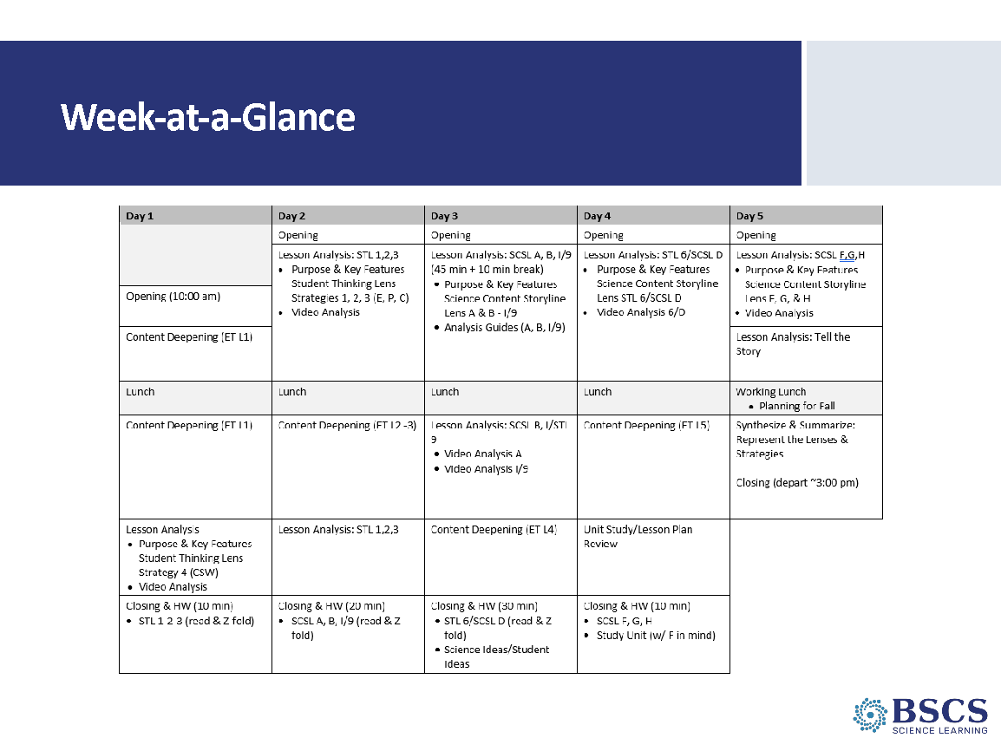 | - Week-at-a-Glance (5 min)  - Refer to the daily agenda chart.
 |  | 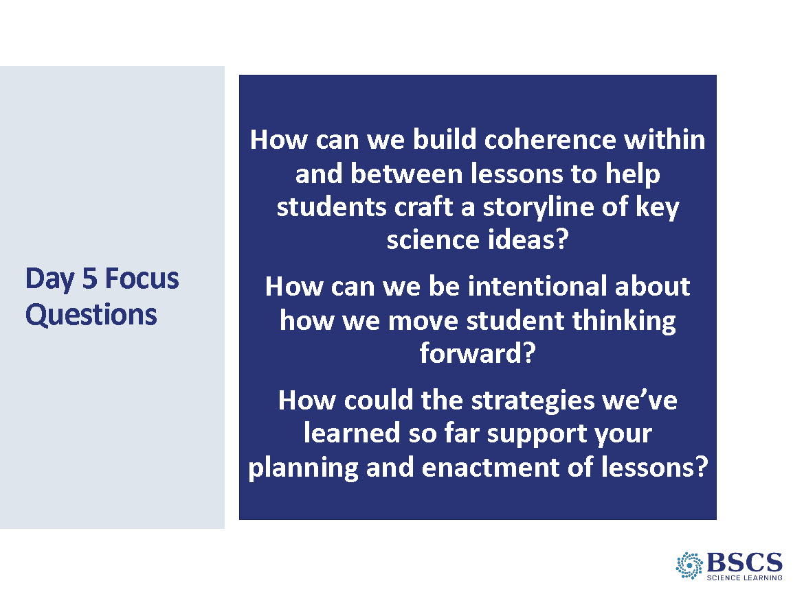 | - Day 5 Focus Questions (5 min)  - Share focus questions for the day.
9:00 - 10:15  75 min  Slides 7-11  Study Group Teams | Lesson Analysis: SCSL F, G, H  Purpose: The purposes of this session are to 1) develop a shared understanding of STeLLA Strategies F, G, and H: Make explicit links between science ideas and activities, Link science ideas to other science ideas, and Highlight key science ideas and focus question throughout; continue to refine understanding of STL Strategies 1, 2, and 3; and 3) continue to develop a shared understanding of the LAP process.  Content: Lessons with a strong science content storyline include a connected thread of content-related talk and activities leading from the focus question through a flow of events and science ideas to the summary of the lesson. For students to construct a coherent science content storyline, activities should have a purposeful set up, be designed to require links between the activity and science ideas, and a follow-up that focuses attention on how the activity contributed to the storyline.  So students can construct a coherent science content storyline and develop an explanation of phenomena and/or design solutions to problems, science ideas should be explicitly linked to other science ideas, both within the lesson and between lessons. Further, the key science ideas and focus question should be highlighted throughout the lesson.  The LAP supports a deep dive into a teacher’s practice and student understanding through intentional inquiry into evidence provided in analysis of classroom video.  What participants do  Participants chart the purpose and key features of STeLLA SCSL Strategies F, G, and H.  Participants analyze two video clips to deepen their understanding of STeLLA SCSL Strategies F, G, and H.  Resources  - Blank Purpose/Key Features charts for STeLLA Strategies F, G, and H  - Transcript: SSUP_ET_TN GR4_SG3_L3_Greever_C1  - LAP: SSUP_ET_TN GR4_SG3_L3_Greever_C1  - Transcript: Parco (F, H) SSUP_ET_L5_Parco_C1  - LAP: Parco (F, H) SSUP_ET_L5_Parco_C1  - Classroom video  - SSUP_ET_TN GR4_SG3_L3_Greever_C1  - SSUP_ET_L5_Parco_C1 | 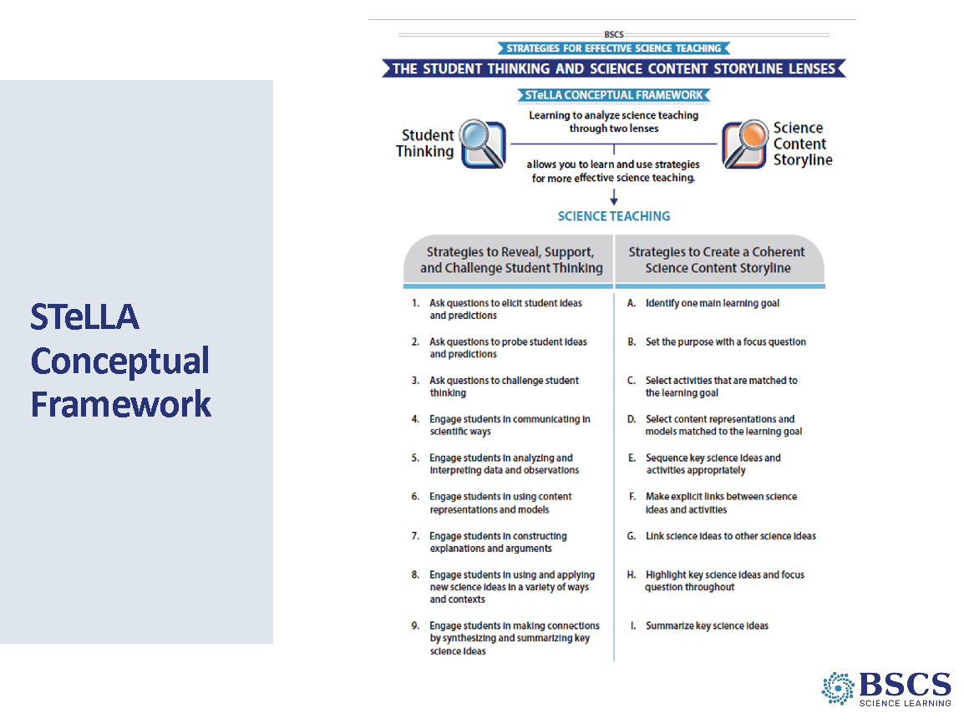 | - STeLLA Conceptual Framework (5 min)  - Orient participants to the Strategy focus for the day.
 |  | 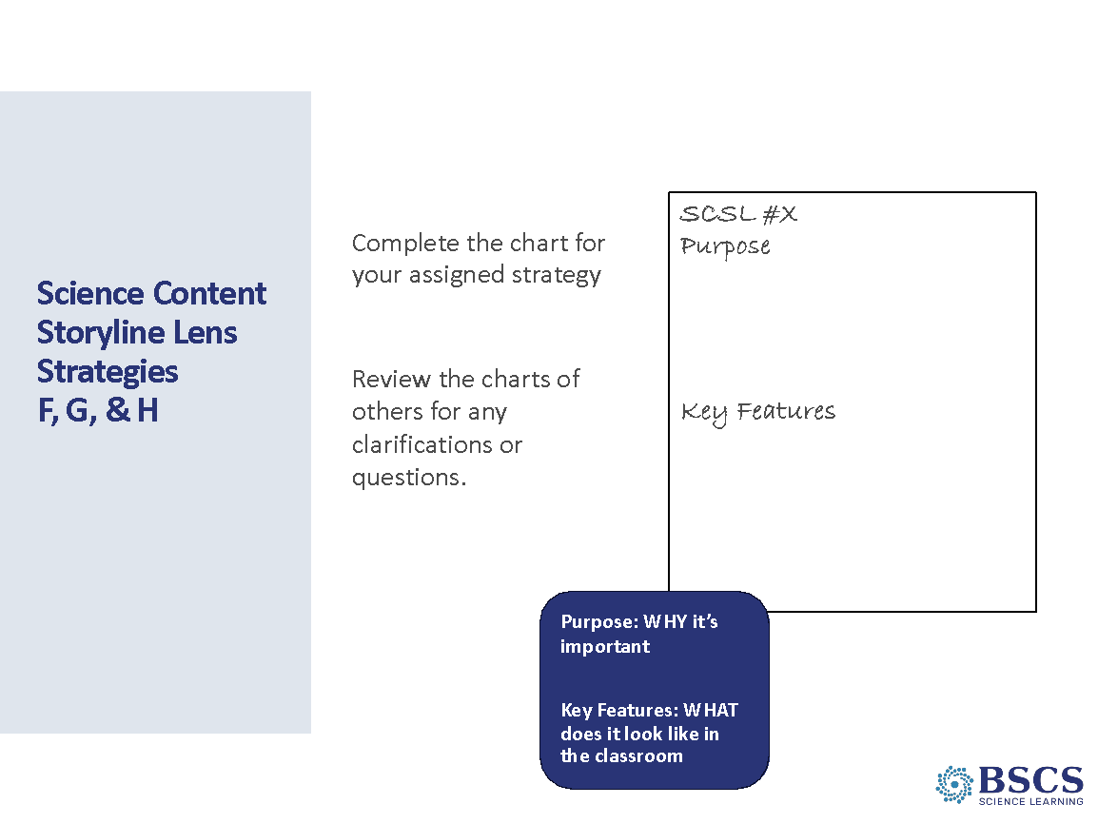 | - STeLLA SCSL Strategies F, G, & H (15 min)  - Provide jig-saw strategy instructions for participants to chart the purpose and key features of SCSL Strategies F, G, and H.  - Review charts and listen to conversations to ask probe or challenge questions and to identify ideas that should come before the whole group during the negotiation across the strategies.
 |  | 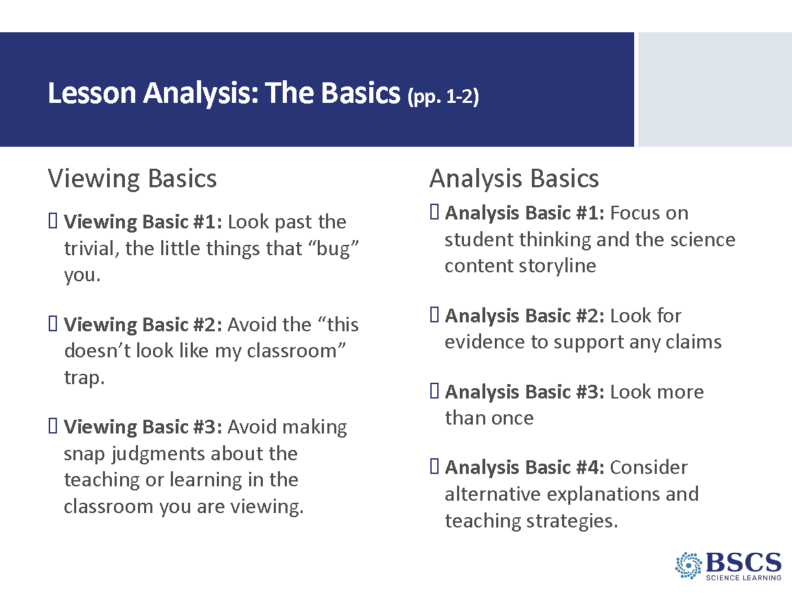 | - Viewing & Analysis Basics (5 min)  - Remind participants of the Viewing and Analysis Basics (STeLLA Strategies Booklet pp. 1-2). Ask them to comment on why these have been important during the week. If you have time, ask them how these basics will be important in the fall as they are analyzing their own video.
 |  | 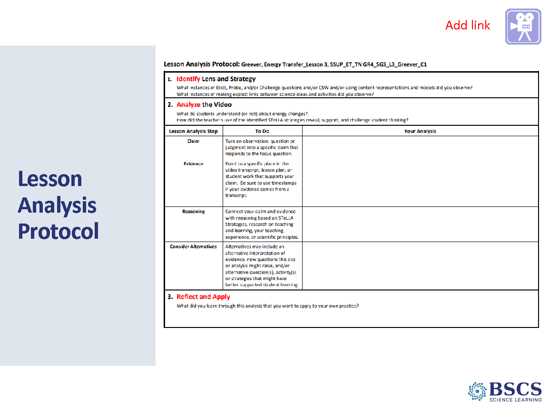 | - Lesson Analysis Protocol (25 min)  PDL Note: Add slides as needed for the analysis of additional clips.  - Refer participants to the transcript and LAP (PD Binder p. __). Provide the context for the videoclip: SSUP_ET_TN GR4_SG3_L3_Greever_C1.  - Remind participants of the focus on the Identify phase of the LAP. Participants should consider the presence of elicit, probe, and challenge questions in the Identify phase in addition to F, G, and H.  - Show the video.  - Ask for clear examples and remind participants to share their justification from the Strategies Booklet.  - Transition to the Analyze phase. Provide time for participants individually or with a partner to develop their claim, evidence, reasoning, and alternatives.  - Invite participants to share their analysis by noting the analysis question they chose.  - Conclude the LAP with the Reflect and Apply phase.
 |  | 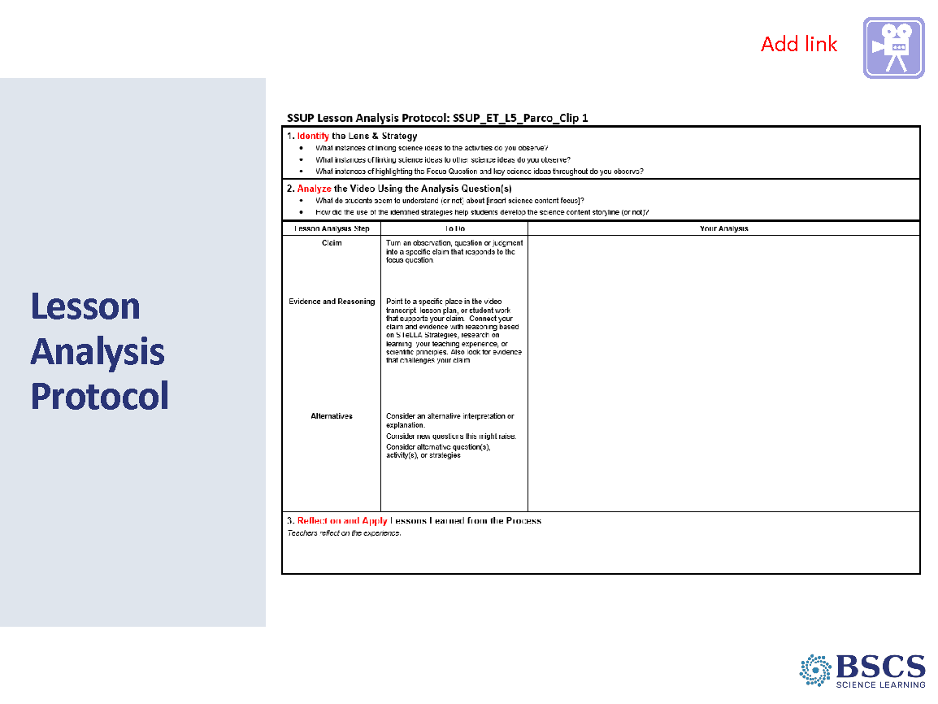 | - Lesson Analysis Protocol (25 min)  - Refer participants to the transcript and LAP (PD Binder p. __). Provide the context for the videoclip: SSUP_ET_L5_Parco_Clip 1.  - Remind participants of the focus on the Identify phase of the LAP. Participants should consider the presence of elicit, probe, and challenge questions in the Identify phase in addition to F, G, and H.  - Show the video.  - Ask for clear examples and remind participants to share their justification from the Strategies Booklet.  - Transition to the Analyze phase. Provide time for participants individually or with a partner to develop their claim, evidence, reasoning, and alternatives.  - Invite participants to share their analysis by noting the analysis question they chose.  - Conclude the LAP with the Reflect and Apply phase.
10:15 - 10:25 | Break
10:25 - 11:25  60 min  Slides 12-13  Study Group Teams | Lesson Analysis: Unit & Lesson Plans  Purpose: The purpose of this session is to develop a shared understanding of how the STeLLA strategies are enacted and the science ideas developed throughout the lessons and prepare to teach the lessons in the fall.  Content: STeLLA lesson plans are structured to make explicit the integration of STL and SCSL strategies and support teachers in enacting the strategies. Three dimensional, phenomena/problem-driven learning is highlighted throughout the lessons. The ability to identify and articulate what students are learning, as opposed to what students are doing, is important to successfully enacting the STeLLA lessons.  Process: Gather participants into a circle in order to retell the story of the unit.  What Participants Do: Participants will retell the story of the unit in their own words. They will take turns stating what was learned in the previous lesson, what is figured out in the current lesson and what will be the focus of the next lesson.  Resources  Additional participant resources in curriculum binder  - Content Deepening  - Scope and Sequence  - Standards Match  - Common Student Ideas | 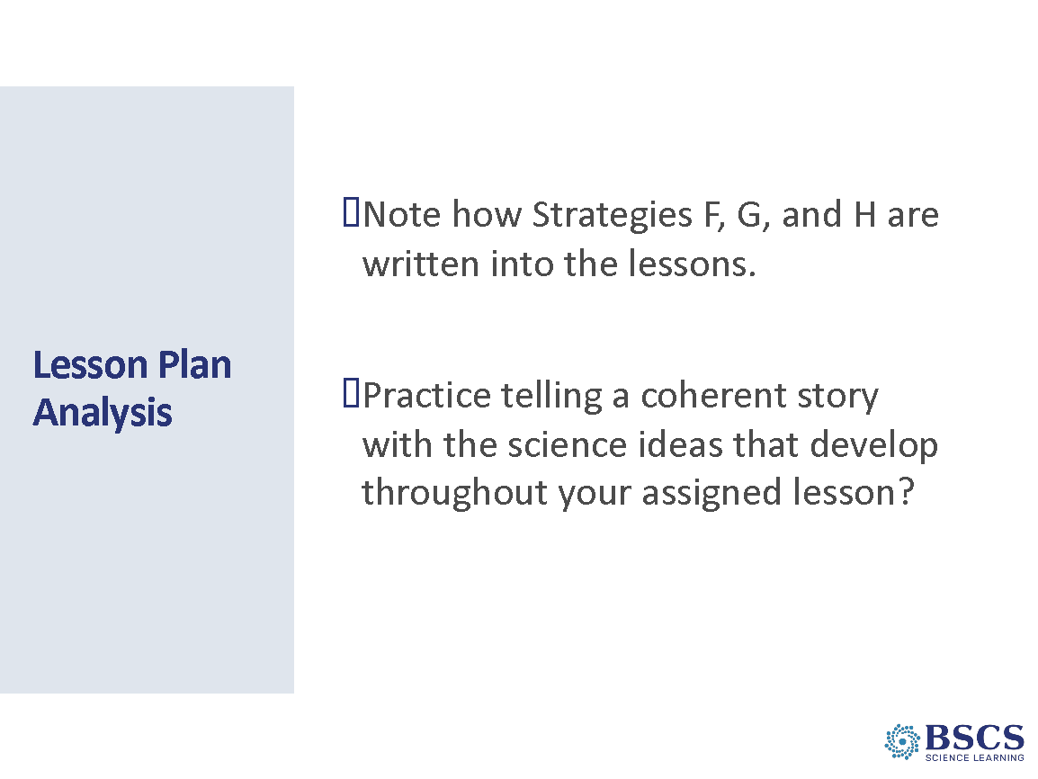 | - Lesson Plan Analysis (20 min)  - Provide instructions for the task. Advance the slide to show the sentence stems participants might use as they tell the story of their lesson. (5 min)  - Provide 15 minutes for participants to work together to prepare to tell the story of their lesson. As participants work, circulate among groups asking elicit and probe questions as needed.
 |  | 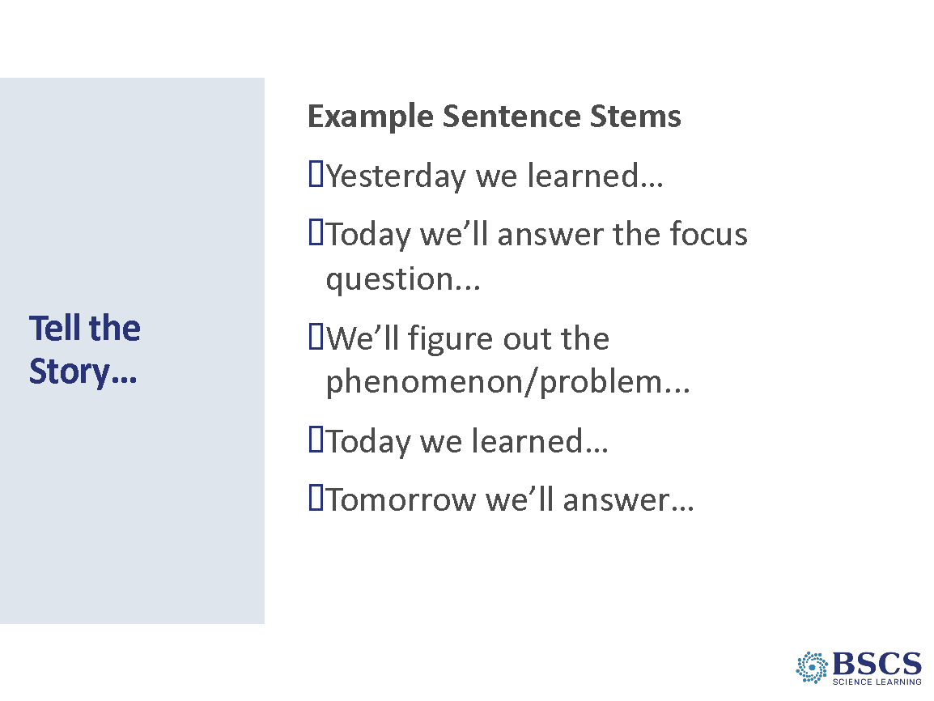 | - Tell the Story (40 min)  - Invite participants to stand in a circle and begin telling the story of the unit from lesson 1. Encourage them to check for additions or revisions between handing off to the next group. (20 min)  - Highlight that we will tell the story again with different lesson leads. Invite participants to regroup with their lesson team to make any adjustments to their story. (5 min)  - Tell the story of the unit again, beginning with lesson 1. (15 min)  Transition: As we move to lunch, consider how telling the story a second time supported (or not) your understanding of the storyline and how students will construct a coherent science content storyline when you teach the unit. During our working lunch, we’ll learn more specific details about teaching and videotaping the unit this fall.
11:25 - 1:05  100 min  Slide 13  Study Group Teams | Working Lunch  Purpose: The purpose of this work is to plan for ongoing program activities. | 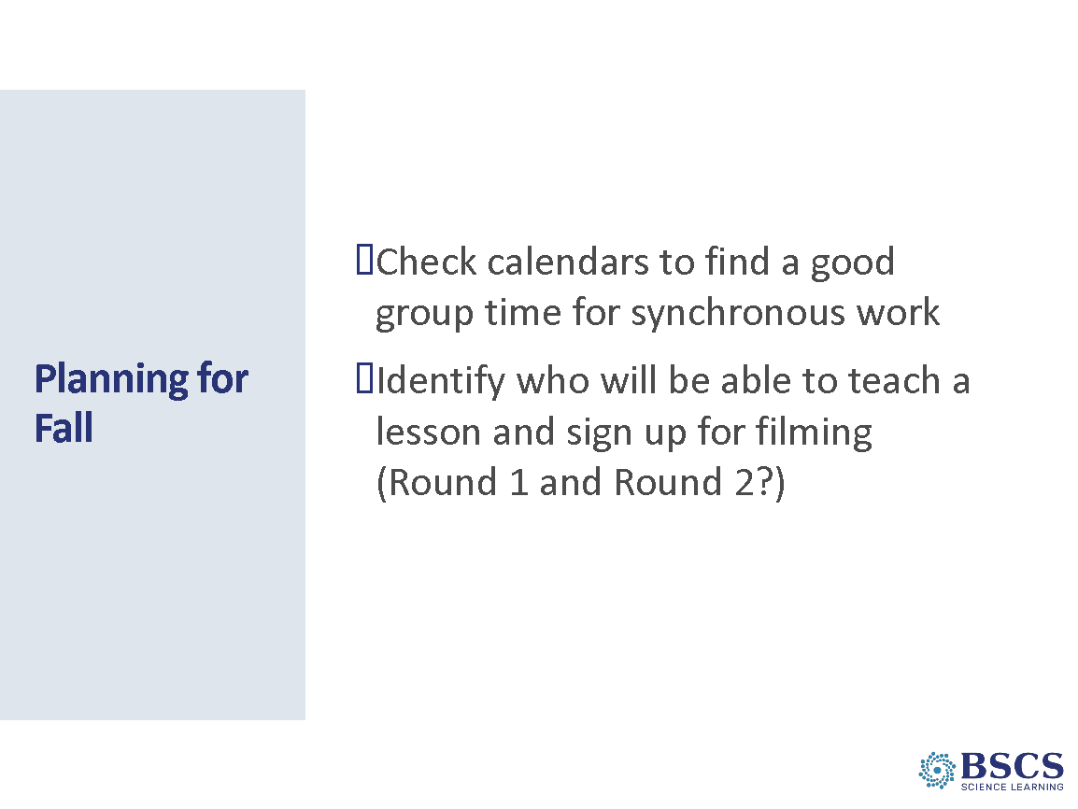 | - Planning for Fall (100 min)  - Provide instructions for fall planning.  - Ashley will provide logistics for scheduling videotaping, SWIVL, etc.  Transition: When we return from our working lunch we will gather as a whole group.
1:05 – 2:45  105 min  Slide 14-16  Whole Group | Closing  Purpose: Transformative professional learning experiences require sustained, collaborative work. It is important to reflect on and celebrate the work together and prepare for continued learning and reflection. Celebration of the work and learning of the week provides closure to the institute.  Content: A strong culture of ideas and trust contributes to the development of a community of teacher learners where we can learn while deprivatizing our practice. Analysis of practice based on a conceptual framework and done through video, student work, and common units of instruction provide a powerful focus for PLCs/study groups.  What participants do  Participants will use various materials to represent the relationship between the STeLLA Approach, Lenses and Strategies. Participants will also reflect on their learning and work for the week.  Resources  - BSCS Journal  - Miscellaneous materials  - Wrapped chocolate |  | - Day 5 Focus Questions (5 min)  - Remind participants of the focus questions for the day. Invite them to privately reflect on how their thinking has changed (or not) over the course of our work together.
 |  | 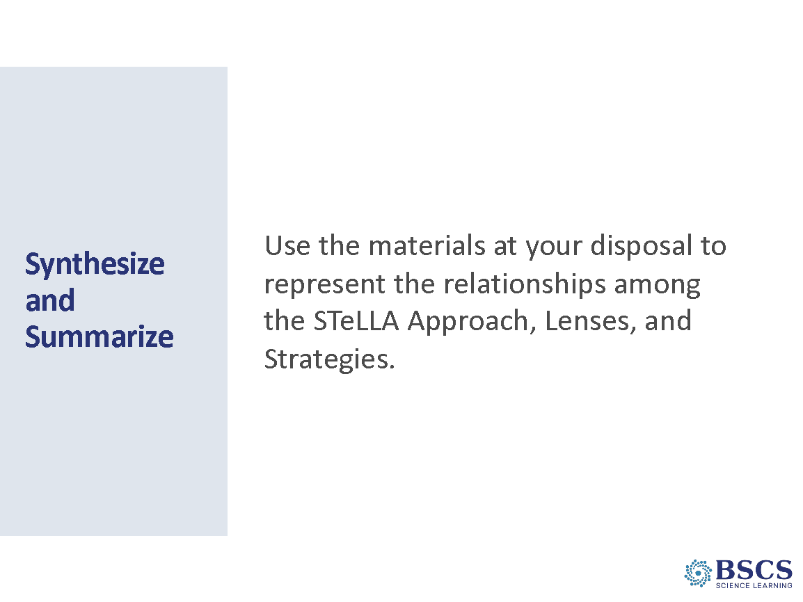 | - Synthesize & Summarize (55 min)  - Provide materials and instructions for the task. Form groups of 3-4 participants and offer up to 20 minutes of time.  - Offer more time as needed.  - Invite groups to share their representations.  - Provide a few minutes for a Meta Moment.  - What did you learn? How did this synthesize/summarize task contribute to your learning (or not)?  - Which representation spoke to you the most? How? Why?
 |  | 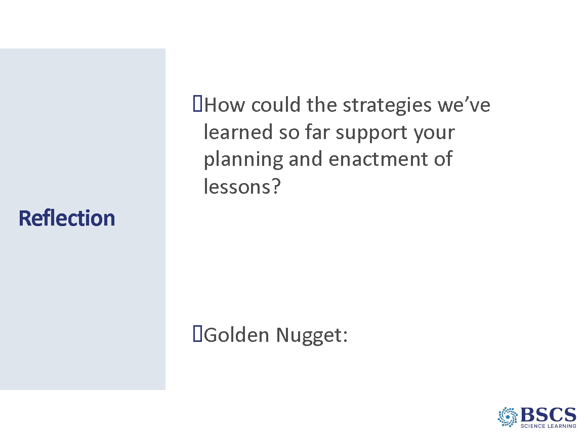 | - Reflection (45 min)  - Provide instructions for responding to the prompt or completing the Day 5 Reflection Sheet and sharing with others.  - Golden Nuggets will be the closing activity. Provide instructions and time for responding and sharing in the whole group.
 |  | 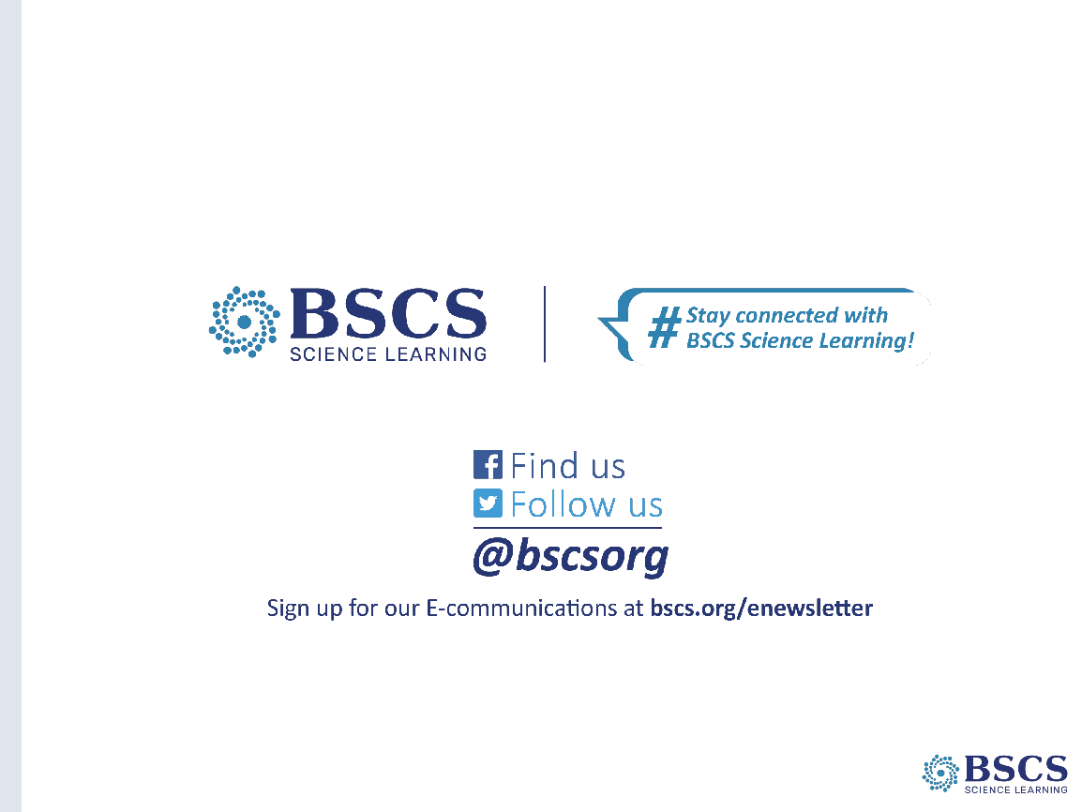 | - BSCS (0 min)

