SSUP: Cohort 2 Study Groups - PD Leader Guide
Grade Level | 4 | SG | #6 | STeLLA Strategies Focus | STL 1,2,3,4, 5, 6, SCSL F | Subject Matter Focus | Earth’s Changing Surface
Teacher Learning Goals | - The goals of the STeLLA PL program are to deepen knowledge of teaching and learning, increase ability to analyze and reflect on teaching and learning, increase ability to use content knowledge and knowledge of teaching and learning to transform classroom practice, deepen teacher content knowledge, and increase student learning in science.  - The understanding and application of research on teacher and student learning has shown that the STeLLA Student Thinking and Science Content Storyline Lenses are important to improve science teaching and students’ learning.  - We can detect energy when an object is moving. We can detect changes in energy when the motion of an object changes.  - Based on Communicating in Scientific Ways, teachers can distinguish observation and inference; data and evidence; claim, evidence, and reasoning; reasoning with data/evidence, ideas, and models; and eventually, explanation and argumentation.
Focus Questions | - Where and how do Strategies XXX influence teacher practice and student learning?  - To what extent have students taken on the STeLLA-related habits of mind?
Ideal Teacher Response | Where and how do Strategies XXX influence teacher practice and student learning?  Insert ideal response here.  To what extent have students taken on the STeLLA-related habits of mind?  Insert ideal response here.

Advance Preparation
Preparation | Materials | Videos and Transcripts
Planning/Preparation Tasks:  - Study PDLG, PPTs, video clips, and handouts. Make changes to PPTs, if needed.  - Link clips  Daily Set Up Tasks:  - Check that video clips are correctly linked to PPT  - Set up PowerPoint and speakers  - Check video & sound  Set Up Task:  - Email participants 1 week prior to the session asking them to do the following in preparation for the session  - Access the study group folder  - Print each Video Transcript and Lesson Analysis Protocol  - View each classroom video clip in the folder  - Complete the Identify phase ONLY of the Lesson Analysis Protocol (LAP) for each video by annotating the transcript(s) for use of E, P, C and Communicating in Scientific Ways.  Daily Follow-up Tasks:  - Archive final PPT  - Collect and turn in daily feedback | Posters/Charts:  Handouts in the Study Group Session Google Folder:  - Study Group Session Guide  - Transcript(s)  - XX  - Lesson Analysis Protocol(s)  - XX  Supplies:  Resources:  - STeLLA Strategies booklet  - BSCS Journal (norms pasted into the journal)  - Content Deepening Notebook  - PD Binder  - Lesson Binder | - Teacher Clip 1: XX  - Teacher Clip 2: XX

SG# SESSION OUTLINE: 2 hours
Time | Purpose | Content | Activities
5:00 – 5:10  10 min  Slides 1-7  Study Group Teams | Purpose: Continue to build community and set the stage for learning throughout the session and into the academic year. | Content: Share focus questions for the day:  - What can we learn from analysis of practice to intentionally use elicit, probe, and challenge questions and/or content representations to reveal and challenge student thinking about XX?  - How can students be empowered to reveal their thinking and to listen to and interact with each other during classroom conversations? | Opening (10 min)  - Welcome & introductions  - Goals, Agenda, and Norms  - Focus Questions
5:10 - 6:50  100 min  (95 min + 5 min break)  Slides 8-12  Study Group Teams | Purpose: The purpose of this session is to develop a shared understanding of STeLLA STL Strategy XX (Strategies will vary depending upon video clip selection and strategies focused on in past sessions.) | Content: Developing and using models and content representations help students make their thinking visible and represent how their thinking changes over time as they explain phenomena or solve problems. Lesson analysis can make students’ progress visible. Teachers support students in making their thinking visible and reconsidering their ideas through the intentional use of elicit, probe, and challenge questions linked with developing and using content representations and models. Engaging students in communicating in scientific ways as they develop and use models supports a classroom culture of making thinking visible. This type of engagement supports students as they make their thinking visible and develop the intended science content storyline built on increasingly accurate science ideas and practices. | Lesson Analysis: Lesson X (90 min)  - Video Analysis Set Up and Clip Context (5 min)  - Video Analysis C1 (45 min)  - Identify (10 min)  - Analyze (30 min)  - Reflect/Apply (5 min)  - Video Analysis C2 (45 min)  - Identify (10 min)  - Analyze (30 min)  - Reflect/Apply (5 min)
6:50 – 7:00  10 min  Slide 14-17  Study Group Teams | Purpose: Reflect on the session’s experiences and learning. | Content: Focus Questions:  - What can we learn from analysis of practice to intentionally use elicit, probe, and challenge questions, and analyzing and interpreting data, content representations and models, and making explicit links between science ideas and activities to reveal and challenge student thinking about (content area)?  - How can students be empowered to reveal their thinking and to listen to and interact with each other during classroom conversations? | Reflection and Closing (10 min)  - Revisit the Focus Questions  - Closing  - Next Steps/Announcements

SG# SESSION OUTLINE: 2 hours
Time and Focus | Purpose and Content &  What Participants Do | Slides | Process
5:00 – 5:10  10 min  Slides 1-7  Study Group Teams | Opening  Purpose: Continue to build community and set the stage for learning throughout the session and into the academic year  Content:  Focus Questions:  - What can we learn from analysis of practice to intentionally use elicit, probe, and challenge questions, and analyzing and interpreting data, content representations and models, and making explicit links between science ideas and activities to reveal and challenge student thinking about (content area)?  - How can students be empowered to reveal their thinking and to listen to and interact with each other during classroom conversations?  What participants do: Participants orient to the day’s activities and focus questions. They review the goals of the program.  Resources  - Journal  - PD Binder  - STeLLA Strategies Booklet  - STL z-fold | 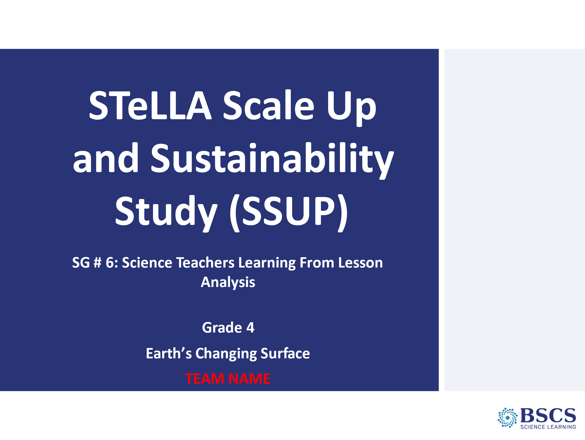 | - Welcome (10 min slides 1-7)  - Welcome participants to the session.
- Opening (0 min)
  - Invite participants to consider the prompt and invite them to share their ideas in the chat.
  - Note patterns in participant responses.

- Agenda
  - Share the agenda, noting that much of this study session will be devoted to lesson analysis. Link the agenda to the program goals.
- Program Goals (0 min)
- Remind participants of the STeLLA program goals.

- STeLLA Norms (0 min)
- Remind participants that to do this kind of work together, we need to develop a strong study group where everyone feels safe to share their ideas, questions, confusions, successes, and stumbles. Having a set of agreed upon norms will help us build this kind of community.

- Study Group # Focus Questions (0 min)
- Introduce the focus questions that will guide today’s work. Link back to the program goals and agenda for today.
- Remind participants that we will return to the focus questions at the end of the session.
**Adjust for content area and STL focus
- STeLLA Conceptual Framework (0 min)
- Invite participants to review the STeLLA Conceptual Framework.
- Note that today our analysis of practice will focus on STL Strategies XX

5:10 – 6:40  100 min  (95 min + 5 min break)  Slides 8-12  Study Group Teams | Lesson Analysis*Adjust for content focus and STL strategies  Purpose: The purpose of this session is to develop a shared understanding of STeLLA STL Strategy 6: Engage students in developing and using content representations and models, and SCSL Strategy D: Select content representations and models matched to the learning goal.  Content: Developing and using models and content representations help students make their thinking visible and represent how their thinking changes over time as they explain phenomena or solve problems. Lesson analysis can make students’ progress visible. Teachers support students in making their thinking visible and reconsidering their ideas through the intentional use of elicit, probe, and challenge questions linked with developing and using content representations and models. Engaging students in communicating in scientific ways as they develop and use models supports a classroom culture of making thinking visible. This type of engagement supports students as they make their thinking visible and develop the intended science content storyline built on increasingly accurate science ideas and practices  What participants do:  Participants apply what they’ve learned about the STeLLA strategies to the analysis of classroom video.  Resources  - STeLLA Strategies Booklet  - PD Binder  - STL Z-fold  - Transcript(s)  - LAP(s) |  | - Video Analysis: Purpose (slides 8-10: 5 min)  - Remind participants of the purposes of video analysis
- Lesson Analysis: The Basics (0 min)
- Remind participants that the viewing and analysis basics help to create a community where we all feel safe to share ideas, questions, confusions, successes, and stumbles.

- Preparing for Video Analysis: The Process (0 min)
- Remind participants of the video analysis process.

- Lesson Analysis Protocol (0 min)
- Remind participants that they have just completed the Identify section of the LAP.
- Provide time for participants to complete the Analyze sections of the LAP (claim, evidence, reasoning, and alternatives).
- Invite participants to share their claims, evidence, and reasoning with the whole group. Invite participants to add on to, or disagree with, the claims that others have shared. Invite participants to reflect on the analysis and journal what they want to take away from this analysis to apply in their own practice.
- Invite participants to share their reflections with the whole group.
- Invite the teacher whose video was analyzed to rejoin the group and share their response to the reflection question.

- Lesson Analysis Protocol (0 min)
  - Remind participants that they have just completed the Identify section of the LAP.
  - Provide time for participants to complete the Analyze sections of the LAP (claim, evidence, reasoning, and alternatives).
  - Invite participants to share their claims, evidence, and reasoning with the whole group. Invite participants to add on to, or disagree with, the claims that others have shared. Invite participants to reflect on the analysis and journal what they want to take away from this analysis to apply in their own practice.
  - Invite participants to share their reflections with the whole group.
  - Invite the teacher whose video was analyzed to rejoin the group and share their response to the reflection question.

6:50 – 7:00  10 mins  Slides 13-16  Study Group Teams | Closing: Focus Questions and Closing  Purpose: Reflect on the session’s experiences and learning.  Content:  Focus Questions:  - What can we learn from analysis of practice to intentionally use elicit, probe, and challenge questions, and analyzing and interpreting data, content representations and models, and making explicit links between science ideas and activities to reveal and challenge student thinking about (content area)?  - How can students be empowered to reveal their thinking and to listen to and interact with each other during classroom conversations?  What participants do:  Participants reflect on their learning experiences through the session.  Resources  - BSCS journal |  | - Focus Questions (slides 13-16: 10 min)  - Remind participants of the session’s focus questions. Invite them to consider how their thinking has changed as a result of the video analysis and investigation of the STL strategies.  - If time permits, invite several participants to share their ideas
- Closing (0 min)
- Invite participants to individually consider the prompts on the slide.
- Have participants share their responses in chat OR have a few participants share their responses verbally.
- Next Steps (0 min)
Share the asynchronous work in preparation for the next SG session.
 |  | 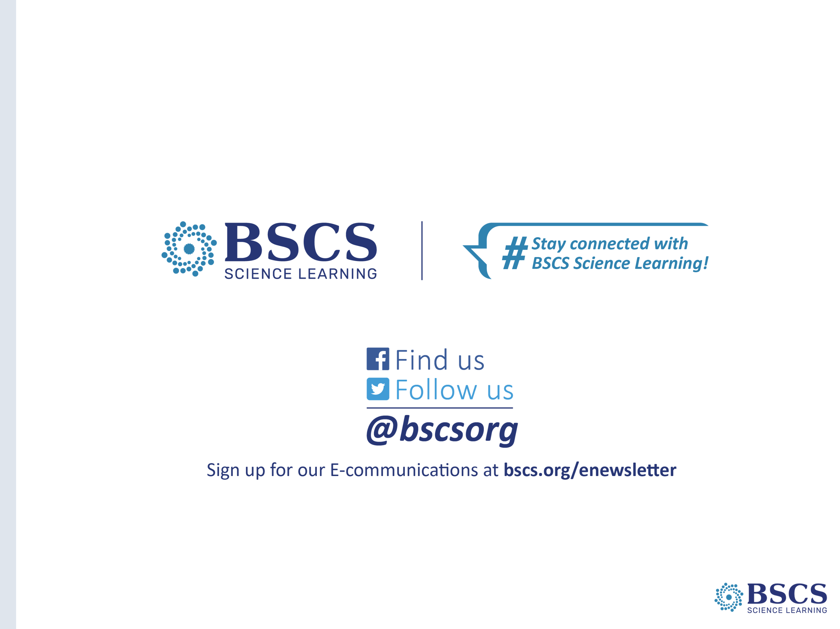 | - BSCS Info (0 min)

