SSUP: Summer Institute - PD Leader Guide Day 2
Grade Level | 4 | Day | 2 | STeLLA Strategies Focus | STL 1, 2, 3, 4 | Subject Matter Focus | Energy, Every Day, Everywhere
Teacher Learning Goals | - Motion energy can be transferred from object to object through collisions. The faster an object is moving, the more motion energy it has that can be transferred to another object in a collision.  - Position energy (potential energy) can be transformed to motion energy (kinetic energy). The more position energy an object has, the more energy can be transformed to motion energy. As position energy is transformed to motion energy, the faster the object will move.  - Student thinking can be made more visible in science classrooms when the teacher asks questions that elicit student ideas and predictions, probe student ideas and predictions, and challenge student thinking.  - Lesson analysis allows us to slow down teaching so we can clarify our understandings of the distinct purposes of elicit, probe, and challenge questions and how they can be used effectively in science lessons.
Focus Questions | - What happens to motion energy when objects collide?  - How can we change the amount of motion energy of an object?  - How can lesson analysis help us better understand how elicit, probe, and challenge questions reveal and challenge student thinking?  - How can we develop a classroom culture focused on student thinking?
Ideal Teacher Response | What happens to motion energy when objects collide?  The faster an object moves, the more motion energy it has. When a moving object collides with a stationary object, the moving object slows down (its motion energy decreases), and the stationary object begins to move faster (its motion energy increases). Because the speed of the objects changes during a collision, this is evidence that the motion energy of the objects also changes. Energy is transferred from a moving marble to a stationary marble during a collision. The faster an object is moving, the more energy it has, and the more energy can be transferred through collisions.  How can we change the amount of motion energy of an object?  As an object goes down an incline, it goes faster and faster as position energy (potential energy) is converted to motion energy (kinetic energy). The higher the incline, the faster the object goes when it moves down the incline. Objects that are not moving can have position energy. Position energy can be transformed into energy of motion. If the moving object has a collision with another object, energy can be transferred from one object to another, and the motion of each object will change. The more motion energy an object has, the more energy will be transferred in the collision.  How can lesson analysis help us better understand how elicit, probe, and challenge questions reveal and challenge student thinking?  Lesson analysis allows us to slow down teaching so we can clarify our understandings of the distinct purposes of elicit, probe, and challenge questions and how they can be used effectively in science lessons, in part to build toward more accurate understanding of the science and use of the practices and, in part to develop a classroom culture of student thinking.  How can we develop a classroom culture focused on student thinking?  The intentional use of elicit, probe, and challenge questions in ways consistent with the STeLLA strategies makes student thinking visible to both the teacher and students and provides opportunities for teachers to leverage students’ current understanding to figure out phenomena or solve problems and shift to more accurate understanding of the science and use of the practices. Teacher use of these questioning strategies provides a model for student interaction.  The intentional use of Student Thinking Lens Strategies 1, 2, 3, and 4 help to develop a classroom culture of student thinking in which student ideas—divergent and convergent, accurate and inaccurate—are valued by teachers and students as they figure out phenomena or solve problems and work together toward more accurate understanding of the science and use of the practices.

Preparation | Materials | Videos and Transcripts
Planning/Preparation Tasks:  - Study PDLG, PPTs, video clips, and handouts. Make changes to PPTs, if needed.  - Link clips  - Prep materials for ET Lesson 2: Patterns of Energy in Collisions (adult learning experience)  - Prep materials for ET Lesson 3: Predicting and Observing Changes in Energy (adult learning experience)  Daily Set Up Tasks:  - Check that video clips are correctly linked to PPT  - Set up PowerPoint and speakers  - Check video & sound  - Arrange furniture, food (include social distancing protocols in set up)  - Arrange posters/charts  Day 2 Set Up Task:  Arrange teacher materials on tables:  - Tabletop name cards  - Review reflection writing from Day 1 and create summary slide  - Table boxes (small red, green, yellow dots)  Daily Follow-up Tasks:  - Archive final PPT  - Collect and turn in daily feedback  - Disinfect common materials, tables and common areas per protocol | Posters/Charts:  - STeLLA Conceptual Framework poster  - Day 2 Agenda chart  - Program Goals chart  - Norms poster  - Focus Questions chart  - Parking Lot chart  - Effective Science T&L chart  - Purpose/Key Features (STL 1-2-3) chart  - Communicating in Scientific Ways poster  Handouts in SSUP PD binder front pocket:  - Z-fold chart: Student Thinking Lens Strategies  - Z-fold chart: Science Content Storyline Strategies  Handouts in SSUP PD binder, Tab 2  - Jody Bintz Pre-Interview S1 (E, P) SSUP_ET_Int_Bintz_C1.mp4 Transcript  - Grade 4 Classroom: Parco (E, P, C) SSUP_ET_KY GR4_SG1_L1_Osborne_C1  - Practice Probe/Challenge Protocol  - Day 2 Daily Reflection  - Cut Sheet: Science Content Handouts  - HO 2.1 Investigating Energy Changes in Collisions  - HO 2.2 Investigating Energy Changes Analogy Map  - HO 3.1 Predicting Changes in Energy  Supplies:  - Lesson 2: Patterns of Energy in Collisions (adult learning experience)  - 1 set/team: Colored pencils (one red, one blue), 2 marbles (one red, one blue), one 12” ruler with center groove  - Car launcher system, sticky note arrows, chart paper, markers, tape  - Lesson 3: Predicting and Observing Changes in Energy  - 1 set/team: Colored pencils (one red, one blue), 2 marbles (one red, one blue), one 12” ruler with center groove, 1 Styrofoam block with a notch cut out, wooden blocks to elevate one end of the ruler, plain white paper  - 1 set/pair: Energy Changes card set 1 & 2  - Car launcher system, sticky note arrows, tape  Resources:  - STeLLA Strategies booklet  - BSCS Journal/Science Notebook  - Elicit question cards | - Jody Bintz Pre-interview S1 (E, P) SSUP_ET_Int_Bintz_C1.mp4: Chandler is sharing her initial ideas about how a hand crank flashlight works.  - Grade 4 Classroom: Parco (E, P, C)  SSUP_ET_KY GR4_SG1_L1_Osborne_C1: Teacher elicits initial student ideas about what they know and wonder about energy.  Note: STL Strategies 1, 2, and 3 will be revisited on Days 4 and 5.

DAY 2 SESSION OUTLINE: 8:00 a.m. – 4:30 p.m.
Time | Purpose | Content | Activities
8:30 – 9:00  30 min  Slides 1-7  Study Group Teams | Purpose: The purpose of the opening is to continue to build community and set the stage for today’s learning, in part by customizing the norms. | Content: Focus Questions:  - What happens to motion energy when objects collide?  - How can we change the amount of motion energy of an object?  - How can lesson analysis help us better understand how elicit, probe, and challenge questions reveal and challenge student thinking?  - How can we develop a classroom culture focused on student thinking? | Opening  - Day 1 Reflections  - Goals/Agenda  - Focus Questions  - Norms (revise)
9:00 – 10:20  80 min  Slides 8-12  Study Group Teams | Purpose: The purpose of this session is to develop a shared understanding of STeLLA Strategies 1, 2, and 3: Elicit, Probe, and Challenge questions and how their use makes student thinking visible. | Content: The use of elicit, probe, and challenge questions helps teachers reveal student thinking and predictions and move student thinking forward. | Lesson Analysis: STLSs 1, 2, 3  - Set up: Charting
10:20 – 10:30 | Break
10:30 – 12:15  105 min  Slides 13-22  Study Group Teams | Purpose: The purpose of this session is to develop a shared understanding of STeLLA Strategies 1, 2, and 3: Elicit, Probe, and Challenge questions and how their use makes student thinking visible. | Content: The use of elicit, probe, and challenge questions helps teachers reveal student thinking and predictions and move student thinking forward. | Lesson Analysis: STLSs 1, 2, 3  - Video Analysis C1 (Bintz/Chandler pre-interview)  - Video Analysis C2 (Osbourne L1)  - Follow-up
12:15 – 12:45 | Lunch
12:45 – 3:20  145 min plus 10 min break  Slides 23-51  Study Group Teams | Purpose: The purpose of this session is to model effective STeLLA-based science teaching and learning through a common experience that is grounded in a 3D, phenomena/problem driven unit and designed for adult learners. | Content: STeLLA model lessons/units attend to the characteristics of effective science teaching and learning (e.g., 3D, phenomenon/problem-driven, student-centered, make student thinking visible and support sense-making, coherent, and access/engage PK and develop metacognitive abilities).  The content deepening experience will include explicit modeling and use of elicit, probe, and challenge questions.  Lesson 2: Motion energy can be transferred from object to object through collisions. The faster an object is moving, the more motion energy it has that can be transferred to another object in a collision.  Lesson 3: Position energy (potential energy) can be transformed to motion energy (kinetic energy). The more position energy an object has, the more energy can be transformed to motion energy. As position energy is transformed to motion energy, the object will move faster. | Content Deepening: Lessons 2 and 3  - Teacher Set-up  - Common Experience  - Teacher Follow-up
3:20 – 4:10  50 min  Slides 52-56  Study Group Teams | Purpose: The purpose of this session is to continue to develop a common understanding of probe and challenge questions, to support teachers as they develop the ability to effectively ask probe and challenge questions, and to emphasize the importance of planning. | Content: Probe questions are used to gain additional information about a student’s current thinking and build on the ideas they have made visible. They help guide a teacher’s instruction and are a powerful resource for student learning. Challenge questions help students think more deeply about science ideas and prompt students to link ideas and/or reconsider their ideas. Challenge questions (and probe questions for that matter) avoid leading students to the right answer. Teachers need deep content knowledge to ask productive elicit, probe, and challenge questions. | Practice Probe & Challenge  - Set-up  - Probe X 2 Rounds + follow-up  - Challenge X 2 Rounds + follow-up
4:10 – 4:30  20 min  Slides 57-62  Study Group Teams | Purpose: The purpose of the closing is to continue to build community, reflect on the day, and set the stage for tomorrow’s learning. | Content: Focus Questions  - What happens to motion energy when objects collide?  - How can we change the amount of motion energy of an object?  - How can lesson analysis help us better understand how elicit, probe, and challenge questions reveal and challenge student thinking?  - How can students be empowered to reveal their thinking and to listen, probe, and challenge each other during classroom conversations? | Closing  - Revisit FQs  - Day 2 Reflection  - Homework: Read and Z-fold SCSL A, B, I/9  Read Science Ideas/Student Ideas

DAY 2
Time | Purpose and Content & What Participants Do | Slides | Process
8:00 – 8:30 | Coffee & Conversation |  | Need several hands-on deck to help participants complete registration, paperwork, and other logistics.
8:30 – 9:00  30 min  Slides 1-7  Study Group Teams | Opening  Purpose: The purpose of the opening is to continue to build community and set the stage for today’s learning, in part by customizing the norms.  Content:  Focus Questions:  - What happens to motion energy when objects collide?  - How can we change the amount of motion energy of an object?  - How can lesson analysis help us better understand how elicit, probe, and challenge questions reveal and challenge student thinking?  - How can we develop a classroom culture focused on student thinking?  What Participants Do:  Participants make connections among the day 1 reflections, program goals, and agenda. The team revises the norms to strengthen the community.  Resources  - Journals  - Norms poster  - CSW poster  - PD Binder  - STeLLA Conceptual Framework poster  - Charts  - Day 2 Agenda  - Day 2 Focus Questions  - Parking Lot  - Effective Science T&L  - STL 1-2-3 Purpose/Key Features  - Program Goals chart | 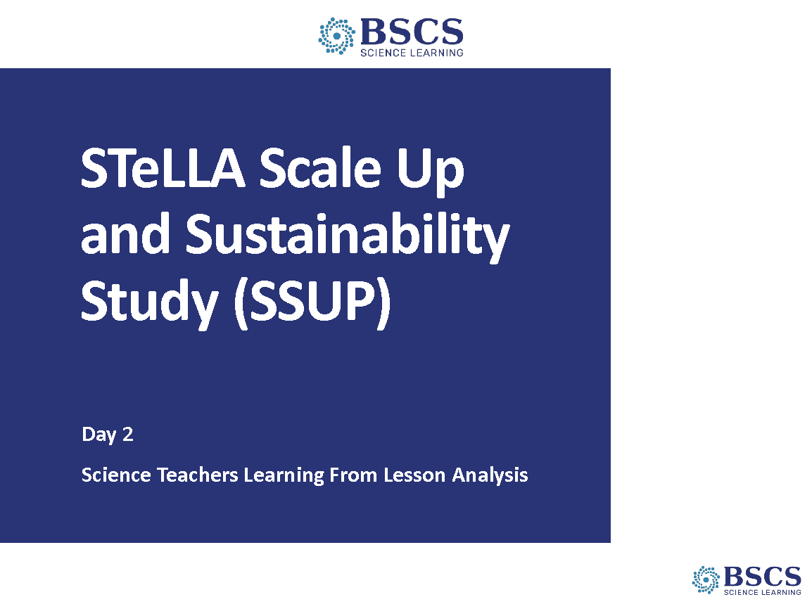 | - SSUP Program Day 1 (0 min)  - Greet participants as they enter the room.
 |  | 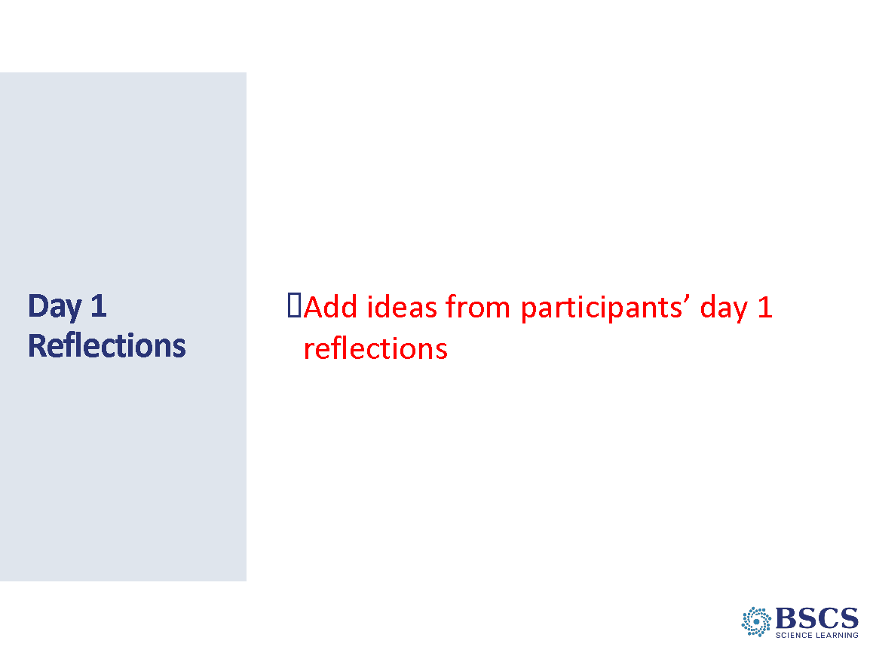 | - Day 1 Reflections (5 min)  - Share patterns in the Day 1 reflections. Link to goals and agenda for today as possible.  - Check parking lot and respond as appropriate.  - Direct participants to the Day 2 reflections sheet (PD Binder p.__). Explain that we will be collecting these reflections at the end of the day. Invite participants to add thoughts and ideas to their reflection sheet throughout the day.
 |  | 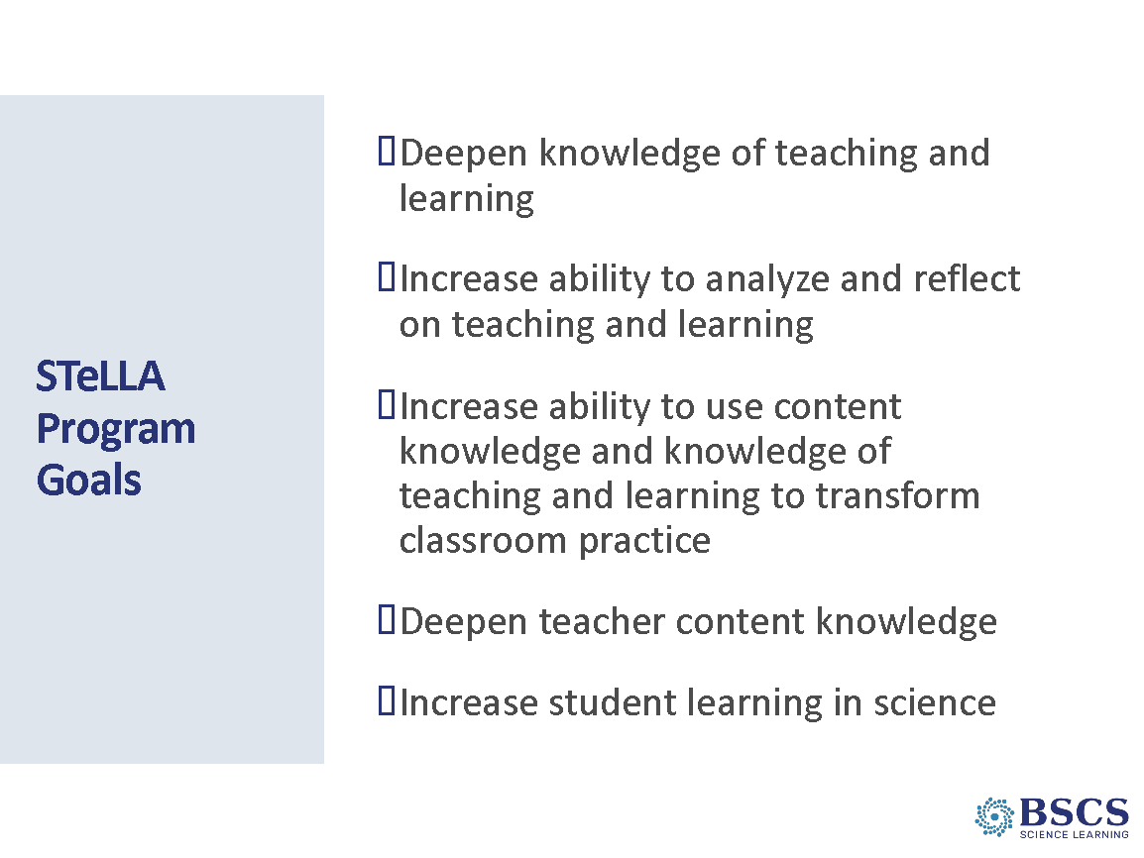 | - STeLLA Goals (5 min)  - Briefly highlight the program goals.
 |  | 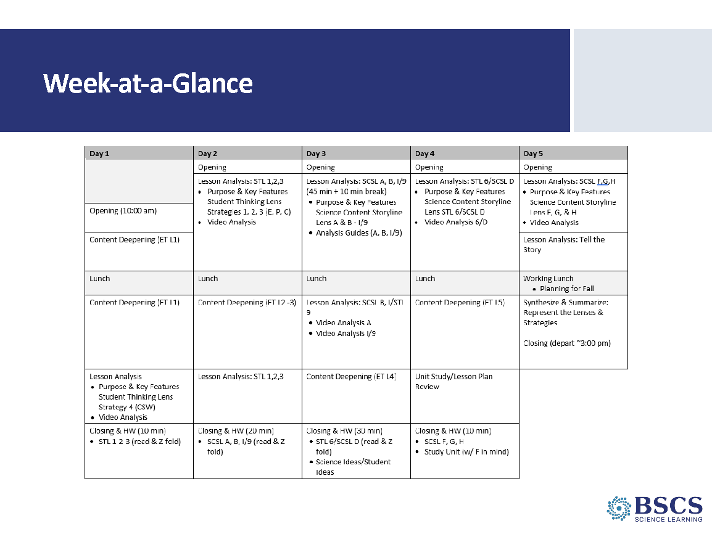 | - Week-at-a-Glance (0 min)  - Point to the Day 2 agenda chart and link the agenda to the program goals.
 |  | 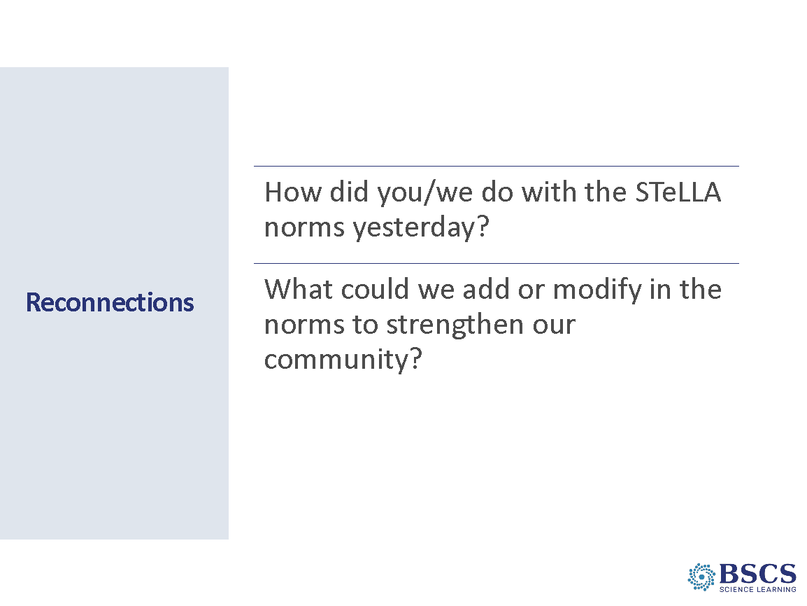 | - Reconnections (5 min)  - Set up the opening by reminding team members of the importance of norms to support collaborative learning.  - Invite team members to reflect on their attendance to the norms as an individual and as a team.  - Note that we will be working together throughout the summer institute and academic year. This work will include analysis of other teachers’ classroom videos. In the fall, and again in the spring, we will analyze classroom video from each other’s classrooms. For this work to be meaningful, we need to push and challenge each other, but we need to do this with a common understanding of our goals and purposes, so we’ll customize these norms for our work together.  - Provide a few moments for individual think time.
 |  | 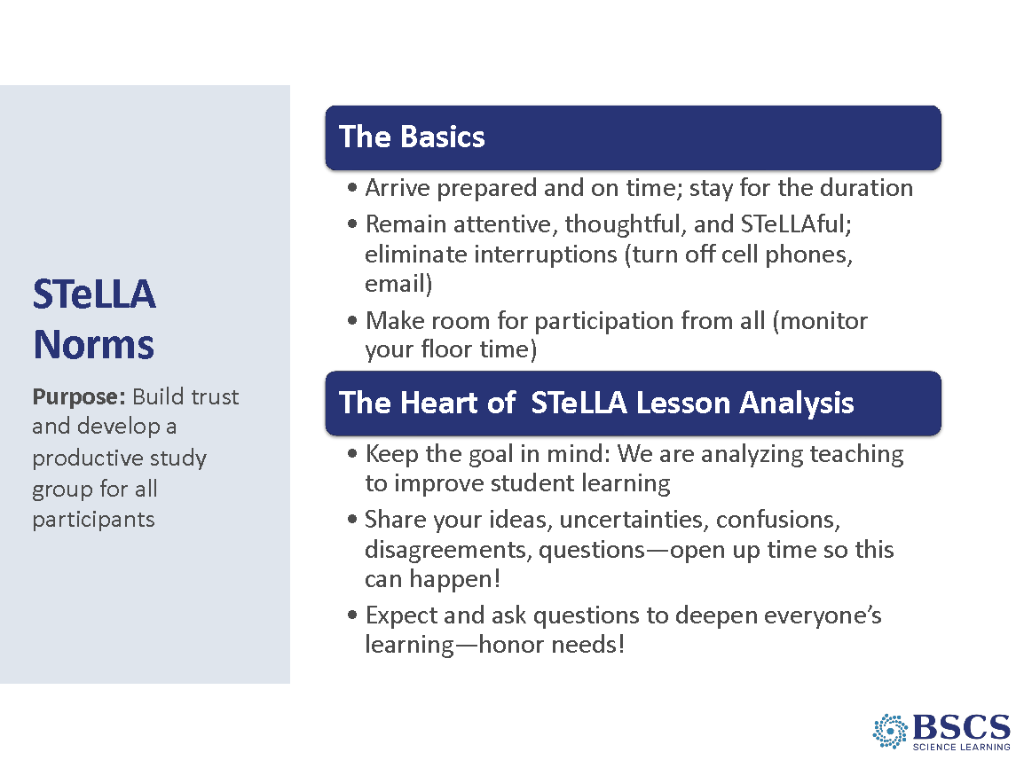 | - STeLLA Norms (15 min)  PDL Note: The revision of norms may take longer than 15 min.  - Ask study group members if there are there any of these norms that they would want to clarify or revise.  - Invite participants to suggest modifications to norms. Change the slide as needed.  PDL Note: Copy and paste a revised slide into the SSUP PPT decks for summer institute days 3-5 and use during academic year study group sessions.
 |  | 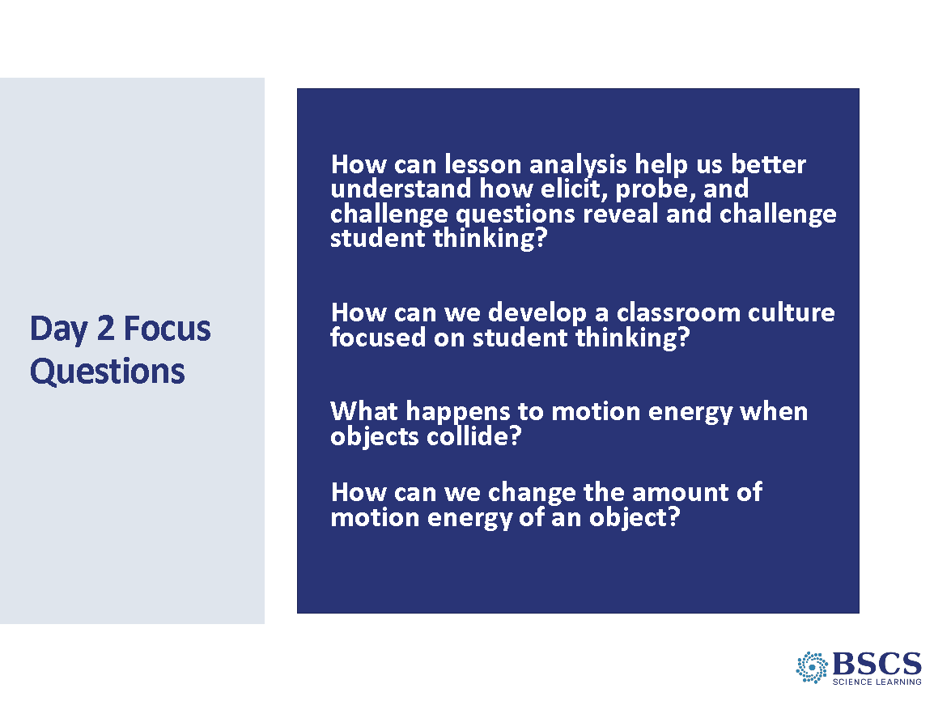 | - Focus Questions (0 min)  - Share the focus questions for Day 2. Link back to the program goals and the agenda for today.  Transition: We will dig into our first two focus questions through lesson analysis for elicit, probe and challenge questions.
9:00 – 10:20  80 min  Slides 8-12  Study Group Teams | Lesson Analysis: STL Strategies 1, 2, 3  Purpose: The purpose of this session is to develop a shared understanding of STeLLA Strategies 1, 2, and 3: Elicit, Probe, and Challenge questions and how their use makes student thinking visible.  Content: The use of elicit, probe, and challenge questions helps teachers reveal student thinking and predictions and move student thinking forward. Along with CSW, the use of EPC also supports developing a classroom culture of student thinking.  Key ideas for each strategy are listed below.  What participants do:  Participants begin to negotiate a shared understanding of elicit, probe, and challenge questions by sharing and charting their ideas based on a study of the STeLLA Strategies Booklet.  Resources:  - STeLLA Strategies Booklet  - STL Z-fold  - STeLLA Conceptual Framework poster  - Norms poster  - Charts  - STL 1-2-3 purpose/key feature charts  Key Ideas  Elicit questions are used to uncover students’ prior knowledge and experiences related to the content of the upcoming unit, lesson, or activity. Student responses help guide a teacher’s instruction. Student ideas and predictions are made visible to the individual student, other students, and the teacher.  - Purpose:  - Make student thinking visible  - Focus on some aspect of the main learning goal  - Key Features  - Asked of a group of students with responses from multiple students.  - Uses everyday language OR language within students’ experiences.  - Asked early in a unit, lesson, and activity, but can be asked at any time in a lesson or unit to uncover the thinking of multiple students.  Probe questions are used to gain additional information about a student’s current thinking and build on the ideas they have made visible. Student responses help guide a teacher’s instruction. Student ideas and predictions are made visible to the individual student, other students, and the teacher.  - Purpose  - Clarify a student’s CURRENT thinking.  - Key Features:  - Focuses on the thinking of one student but can be turned to others.  - Can be a paraphrase (ala Norms of Collaboration) (revoicing could be considered in this category)  - Does NOT introduce new language or ideas.  - PRODUCTIVE probe questions have some connection to the MLG; however, there are times when students (particularly those with different ways of knowing) put ideas on the table that seem unrelated but are not. See Ch. 3 in Helping Students Make Sense of the World (Schwarz).  Challenge questions help students think more deeply about science ideas and prompt students to link ideas and/or reconsider their ideas. Challenge questions (and probe Qs for that matter) avoid leading students to the right answer. Student thinking made visible to the individual student, other students, and the teacher.  - Purpose  - Help students reconsider their ideas; make connections, and develop more scientifically accurate ideas or explanations  - Deepen their understanding  - Prompt students to use academic language  - Key Features  - Open-ended; no one right answer  - NOT leading questions: questions seeking one right answer (i.e., guess what’s in my head)  Other ideas to emphasize when appropriate  - IRE pattern (Initiate-Response-Evaluate)  - Leading questions can be used to highlight reasoning (e.g., a series of if, then statements) if/when followed by the student’s summary and/or what made sense/what didn’t and a meta moment about what the process did for their thinking. | 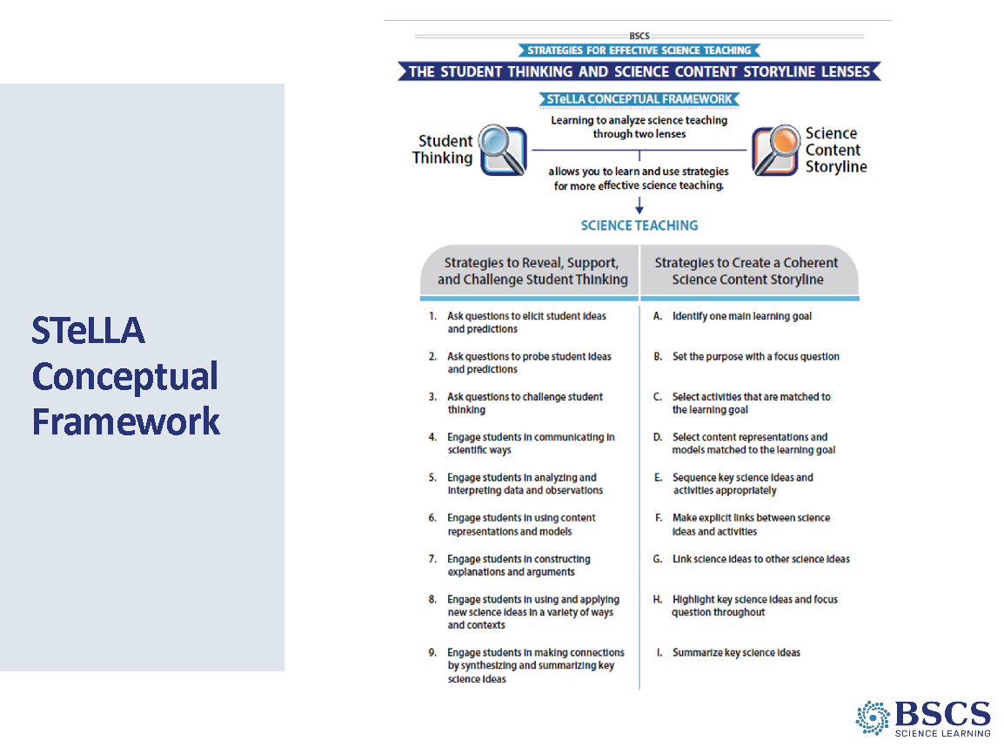 | - Conceptual Framework (10 min)  Point to the strategies highlighted on the slide to focus on the Student Thinking Lens questioning strategies, elicit, probe, and challenge questions. Note that one goal for today is to develop a deeper shared understanding of each of these strategies, in part because we’ll use them to analyze video much as we did for CSW yesterday and in part because using them makes a difference in student learning.  Invite participants to pull out their completed Z-fold and their STeLLA Strategies Booklet. Provide instructions for participants to share their ideas with a partner.  Remind participants to clarify one another’s’ thinking and to ask where they found that idea in the strategy booklet.  Transition: To help us refine our understanding of each of these important strategies, we’ll make our thinking public.
 |  | 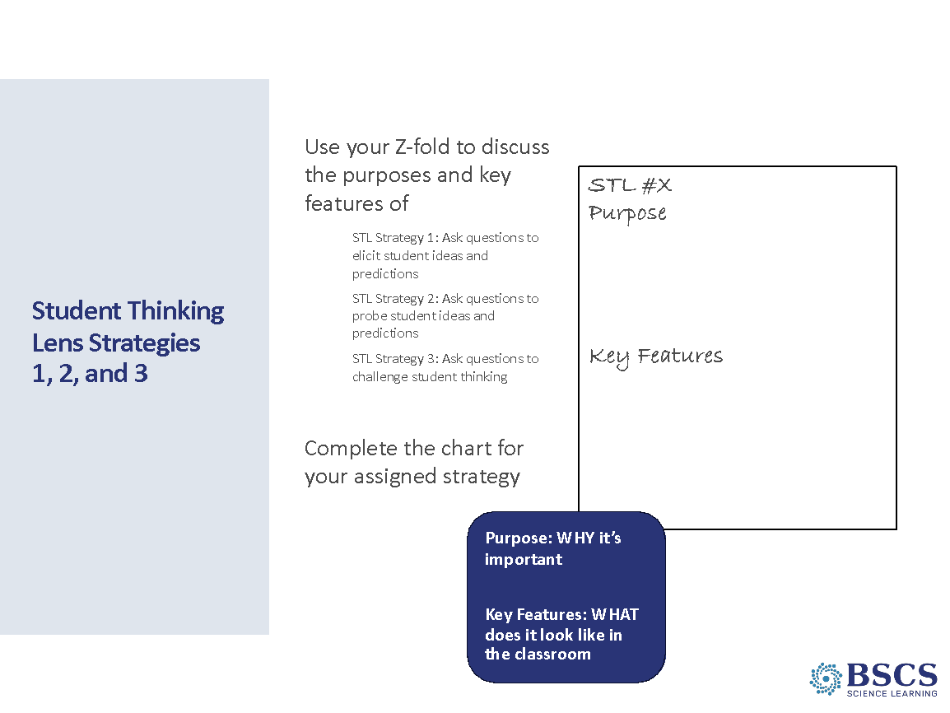 | - STL Strategies 1, 2, & 3 (30 min)  PDL Note: The slide provides an example of the charts that study group members will create.  Divide study group members into 3 groups and assign one strategy to each group. Remind participants:  Purpose: why the strategy is important  Key features: characteristics that distinguish the strategy from others  Focus on the text; if the idea is not in the strategy document, it doesn’t go on the chart.  - Remind participants that our goal is shared understanding, so…if it is not in the summary doc, it doesn’t go on the chart.  - After charts are completed, invite participants to review other charts. They should plan to ask clarifying questions and pose wonderings about ideas that might be missing or where ideas came from in the strategy doc.  - Use the clarifications and wonderings to revise charts as needed.  PDL Note: As teams are working, move around to each group and ask questions such as:  - What do you mean by…?  - Where did you see that in the text?  Pay attention to ideas on the charts that need to be probed and challenged during the whole group conversation. Some of these ideas will be made visible to everyone by the prompts on the next two slides.
 |  | 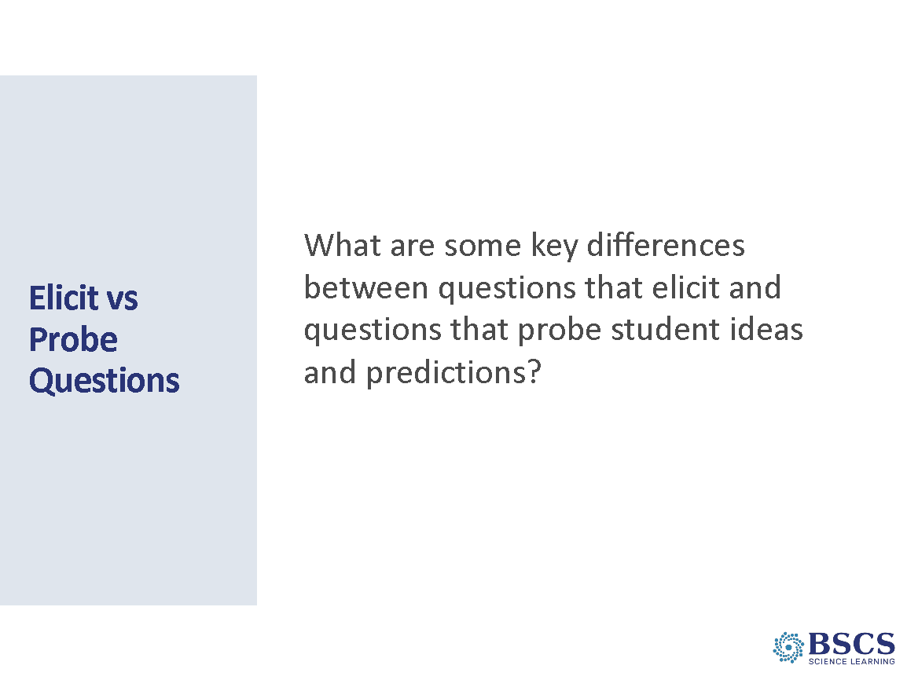 | - Elicit vs Probe Questions (20 min)  - Turn and talk to elbow partner about this question, share out.  - Revise the elicit and probe charts during the debrief.  Key Ideas  - Elicit questions are addressed to whole class, probe questions are addressed to individual students.  - Elicit questions are used before students have studied a concept or as an intro into new ideas; probe questions can be asked at any time.  - Elicit questions start a discussion; probe questions follow up on something a student has already said.
 |  | 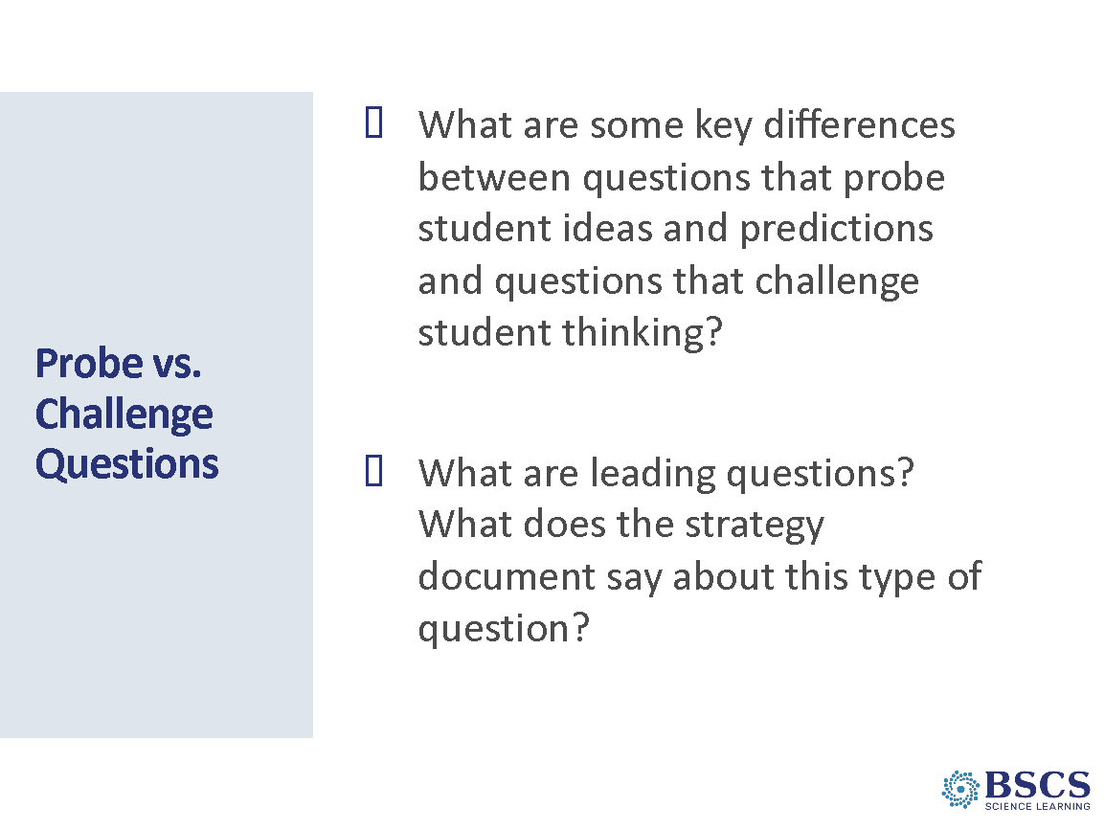 | - Probe vs. Challenge Questions (15 min)  - Turn and talk to an elbow partner about this question, share out.  - Revise charts during the debrief.  Key Ideas  - Probe questions build on CURRENT thinking. Challenge questions deepen understanding.  - Probe questions often precede challenge questions.
 |  | 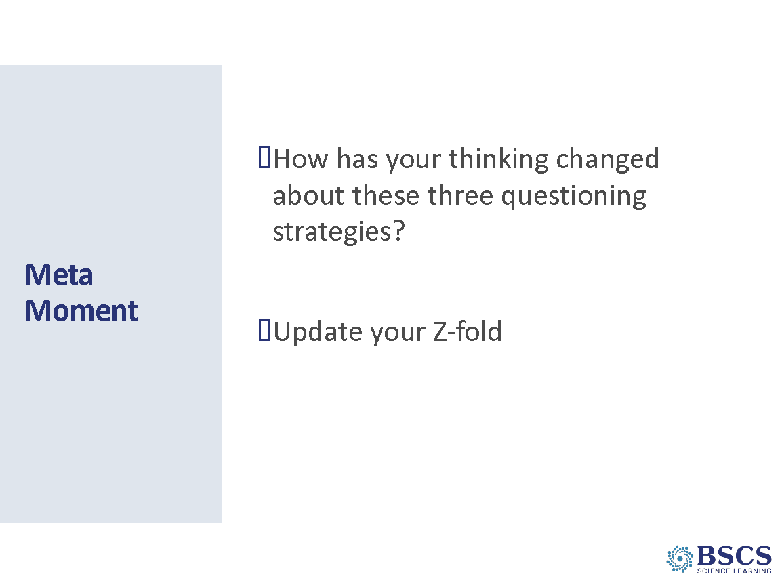 | - Meta Moment (5 min)  - Provide a few moments for individual reflection.  - Whip around and gather thoughts from a few teachers to share ideas that have been clarified or changed through the process.  - Advance slide and invite teachers to return to their Z-fold charts and update information based on the public charts and debrief of the strategies. This will serve as the Meta Moment.  Transition: Synthesize and summarize key ideas a few key ideas.  When we come back from break, we’ll apply what we learned about EPC questions in video analysis of classroom practice.
10:20 – 10:30 | Break
10:30 – 12:15  105 min  Slides 13-22  Study Group Teams | Lesson Analysis: STL Strategies 1, 2, 3  Purpose: The purpose of this session is to continue to develop a shared understanding of STeLLA Strategies 1, 2, and 3: Elicit, Probe, and Challenge questions.  Content: The use of elicit, probe, and challenge questions helps teachers reveal student thinking and predictions and move student thinking forward. Their use makes student thinking visible and contributes to the development of a classroom culture of student thinking.  Key ideas for each video are listed below.  What participants do  Participants analyze two videoclips (student interview and classroom) related to the content in Lesson 1 of the Energy, Every Day, Everywhere unit.  Resources  - PD Binder  - Bintz/Chandler Interview Transcript p. __  - Parco L1 Transcript p. __  - Video Clips  - Jody Bintz Pre-interview S1 (E, P) SSUP_ET_Int_Bintz_C1.mp4: Chandler is sharing her initial ideas about how a hand crank flashlight works.  - Grade 4 Classroom: Parco (E, P, C, and CSW)  SSUP_ET_L1_Parco_C1: Teacher elicits student ideas about their noticings of energy changes in a toy car launcher system.  - STeLLA Strategies Booklet  - STL Z-fold  - STeLLA Conceptual Framework poster  - Norms poster  - Charts  - STL 1-2-3 purpose/key feature charts | 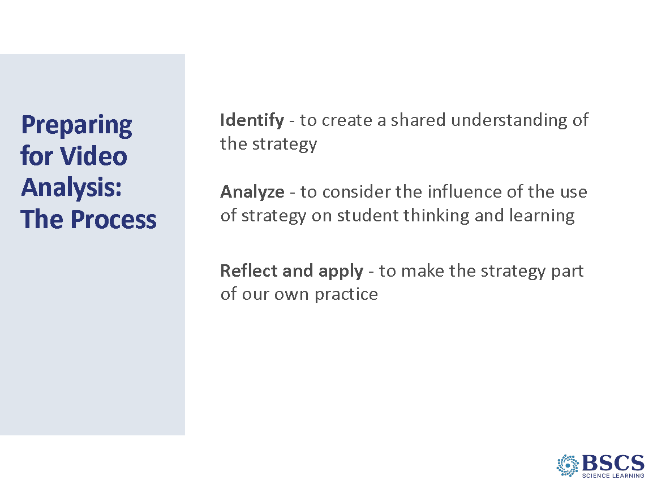 | - Prep for Video Analysis (5 min)  - Share that, again, we’ll be explicit about our video analysis structure. Framing our analysis in this way (i.e., identify, analyze, reflect, and apply) will help us to focus more holistically on BOTH the teaching and the impact of particular STeLLA strategies on student thinking and learning, and the storyline the students are constructing (i.e., the two lenses).  - Note that over the next couple of hours, we’ll analyze two video clips. The first will be of a student interview and the second of a classroom. Revisit other key ideas about video analysis as needed (refer to Day 1 PDLG).  PDL Note: Remind participants of the viewing and analysis basics introduced on Day 1.
 |  | 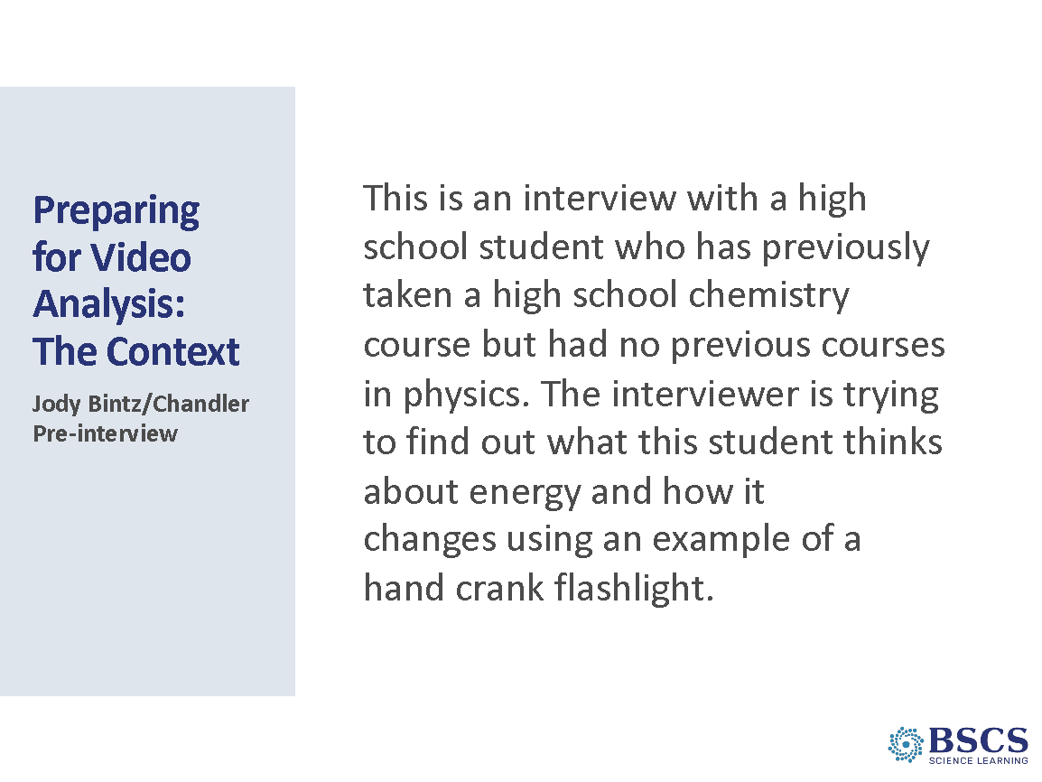 | - Prep for Video Analysis: Context (5 min)  - Direct participants to the transcript in binder p.__.  - Share the context of the video.
 |  | 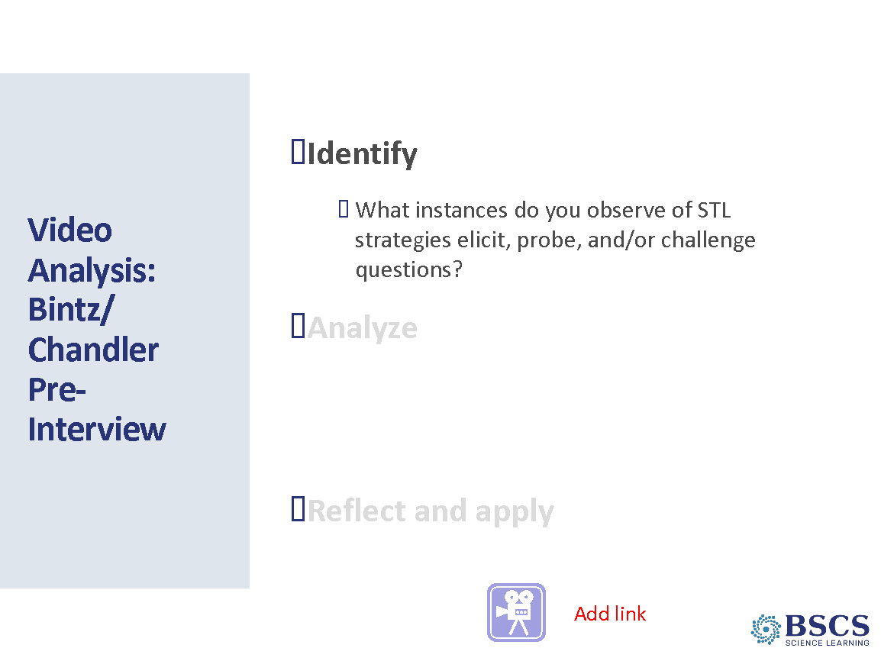 | - Video Analysis (20 min)  - Provide an overview of the sequence of events  - Watch the video  - Time to study and mark up the transcript  - Whole group discussion focused initially on clear examples.  - Individually: Give time for individual team members to review the transcript and mark questions using E, P, C, LQ (leading question) notations. Remind participants that not everything a teacher says is an EPC question.  - Whole group: Discuss what they found. Encourage teachers to point to the timestamp from the transcript and justify their identification using the large charts, Z-Fold Chart, or the STeLLA strategy booklet. Teachers should work to differentiate elicit and probe questions from each other and from other types of teacher questions or statements. BEGIN BY asking for a CLEAR example of each type of question so you can make progress. After discussing clear examples, take some time to work through a more challenging example or two. Make sure to keep in mind that it’s about the justification…not the “right” answer.  PDL Note: The interview shows some clear examples of elicit and probing questions. Participants may suggest that there are no elicit questions since they are not directed at multiple students.  Examples of elicit questions  00:33- (elicit) “… what do you notice about it?”  Examples of probe questions  00:59- (probe) “So what role do you think the crank plays in the flashlight?”  01:30- (probe) “Changing how?”  02:19- (probe) “So you said, um, energy when you turn it is … taken to light the light?”  03:49- (probe) “And what is this whole thing that you drew?”  Other time stamps that may come up in discussion:  03:55- “Can you talk a little bit about … a little bit more about what role you think that electrons might play” (probe or challenge depending on interpretation) The point is not to arrive at consensus, but to use evidence from the strategy booklet and reasoning to gain a deeper understanding of the strategies.  - Provide a few minutes for teachers to discuss any interesting student thinking they noticed and to reflect on the process. [PDL Note: Cut this if time is short, especially if the clip doesn’t include particularly compelling student thinking.]
 |  | 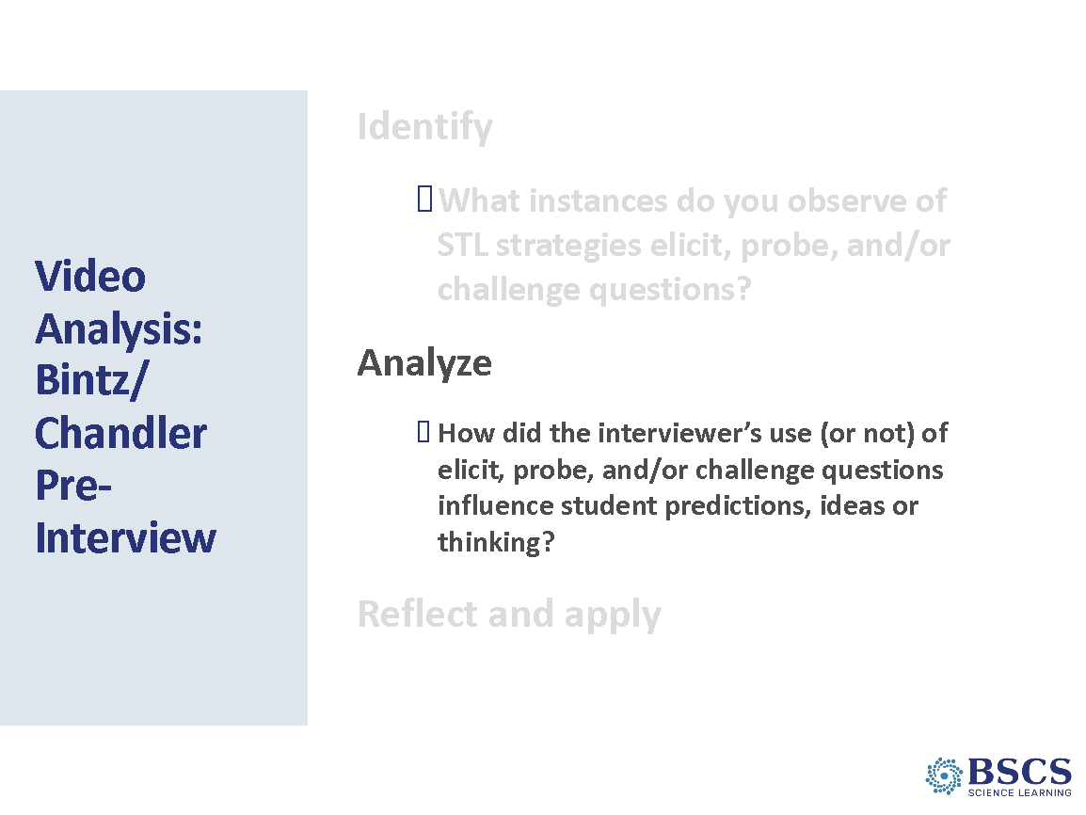 | - Video Analysis (15 min)  - Provide instructions for the Analyze phase of video analysis.  - Note that they may want to focus on interesting student thinking identified in the previous phase.  - Key Ideas to Highlight:  - Chandler thinks the energy she puts into the hand crank flashlight is converted to light but is not sure how it is converted.  - The interviewer probes with questions and challenges Chandler to explain her thinking by using the hand crank flashlight and a drawing.  - Chandler has difficulty explaining the role of the motor in production of light, and cannot connect the role of the motor and electrons in the conversion of energy in the system.  PDL Note: Cut this piece if you are short on time and especially if the video clip doesn’t include particularly compelling student thinking.
 |  | 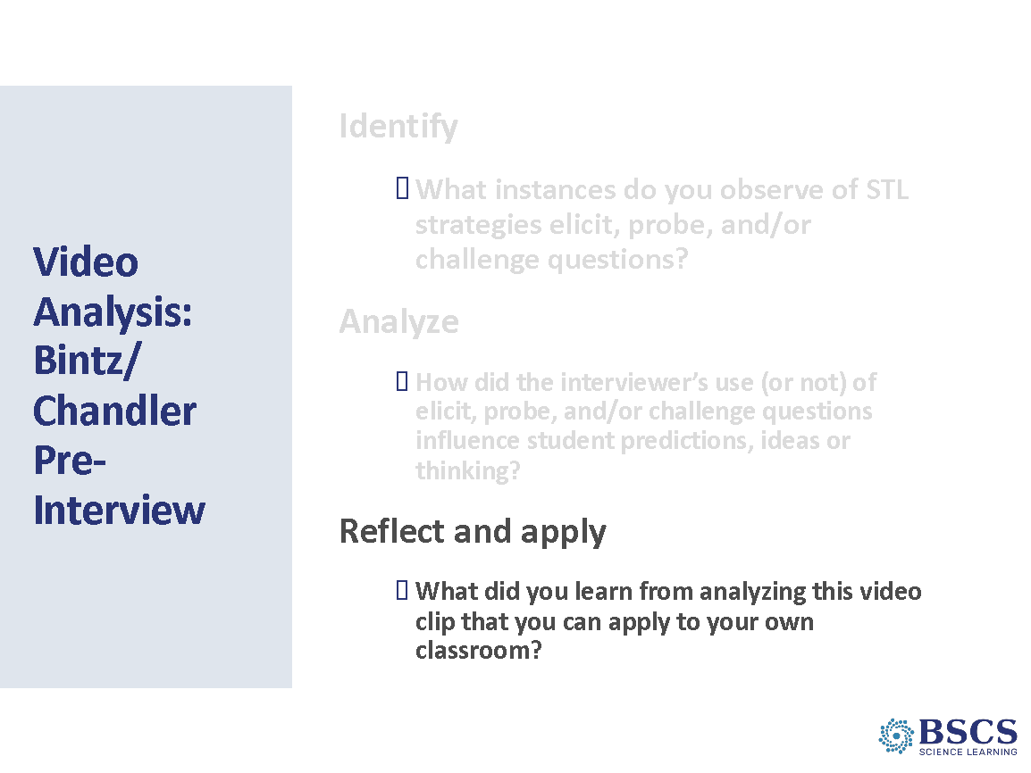 | - Video Analysis (5 min)  - Provide instructions for the Reflect and Apply phase of video analysis.  - Key Ideas to highlight: Elicit, probe and challenge questions can help reveal student ideas, whether accurate or inaccurate, and develop a classroom where all ideas are valued as students figure out/explain given phenomena.  Transition: Now that we’ve had a chance to consider interview video, let’s take a look at the use of these strategies in the classroom setting.
 |  | 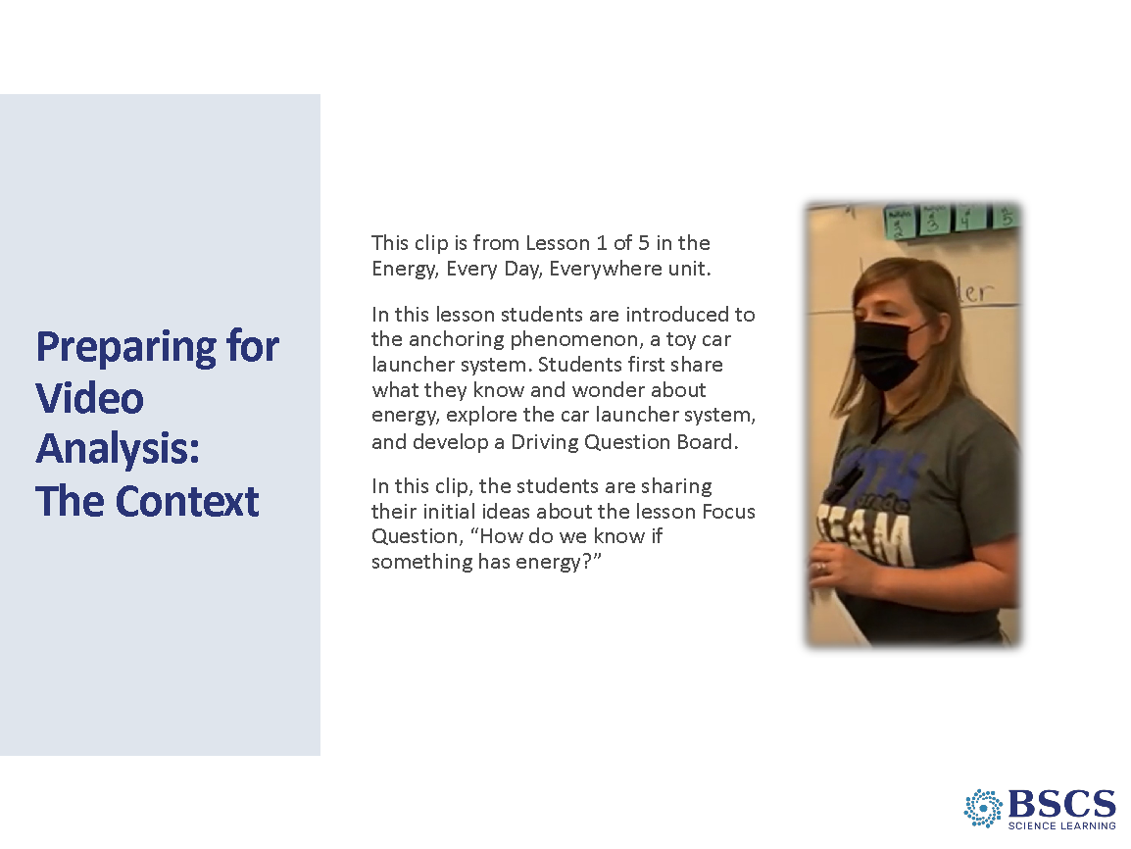 | - Prep for Video analysis: Context (5 min)  - Direct participants to the transcript in binder p.__.  - Share the context of the video: This is lesson 1 of 5 in the SSUP Energy Every Day, Everywhere series. In this lesson, students explore the anchor phenomenon and develop a Driving Question Board that will set the mission for the unit's learning. In this clip, students are sharing their initial ideas about the lesson Focus Question, “How do we know if something has energy?”
 |  | 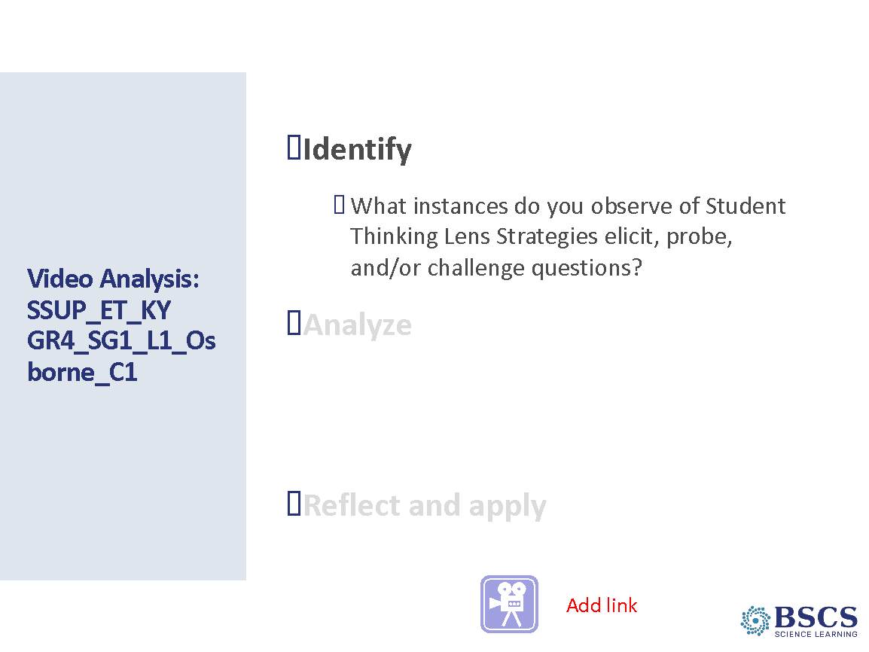 | - Video analysis: (15 min)  - Provide an overview of the sequence of events  - Watch the video  - Time to study and mark up the transcript  - Whole group discussion focused initially on clear examples  - Show the video.  - Individually: Give time for individual team members to review the transcript and mark questions using E, P, C, LQ notations. Remind participants that not everything a teacher says is an EPC question.  - Whole group: Discuss what they found. Encourage teachers to use point to the timestamp from the transcript and justify their identification using the large charts, Z-Fold Chart, or the STeLLA strategy booklet. Teachers should work to differentiate elicit and probe questions from each other and from other types of teacher questions or statements. BEGIN BY asking for a CLEAR example of each type of question so you can make progress. After discussing clear examples, take some time to work through a more challenging example or two. Make sure to keep in mind that it’s about the justification…not the “right” answer.  PDL Note: Clear examples of elicit/probe/challenge questions  0:00:03- (elicit) “Let’s start with some things you think you know about energy.”  0:00:50- (probe) “It turns stuff on, okay.”  0:01:06- (probe) “So you’re talking about computers and lights and electricity?”  0:01:31- (probe) “What do you mean by strong?”  0:02:00- (elicit) “What else?”  0:02:07- (probe) “What do you mean?  0:03:05- (probe) “Is that what you mean?”  0:03:23- (probe) “..what else do you mean?”  0:04:10- (elicit) “How do we get energy?”  - Provide a few minutes for teachers to discuss any interesting student thinking they noticed and to reflect on the process. [PDL Note: Cut this if time is short, especially if the clip doesn’t include particularly compelling student thinking.]
 |  | 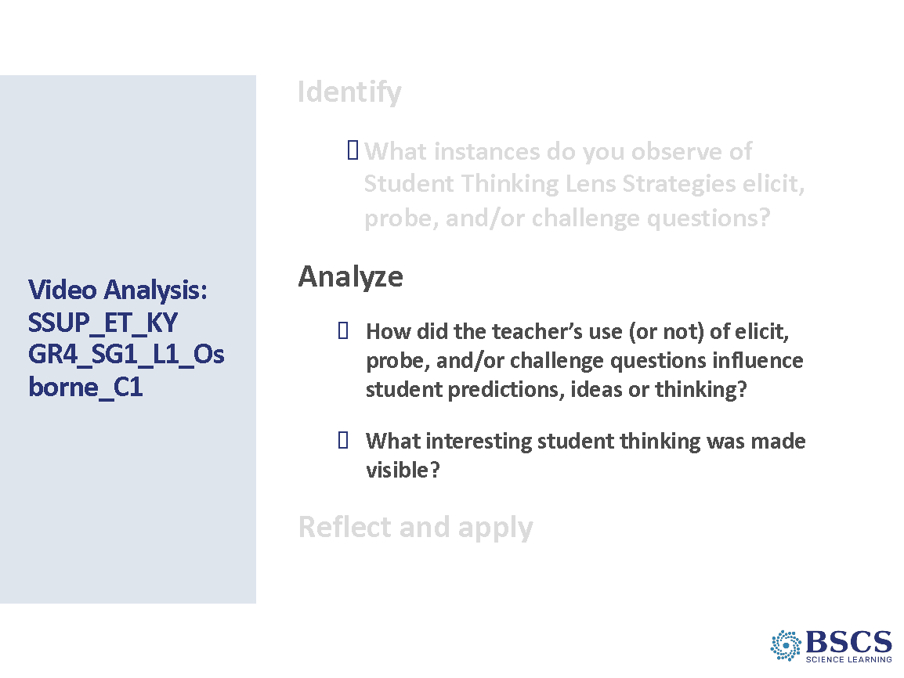 | - Video analysis: (15 min)  - Provide instructions for the Analyze phase.  - Note that participants may want to focus on interesting student thinking identified in the previous phase.  - Key Ideas to Highlight:  - The teacher begins with an elicit statement (rather than a question). However, there may have been a similar elicit question posed to the class prior to the start of the clip.  - The teacher regularly probes student ideas by asking, “What do you mean?”.  - Between time stamps 0:02:46 – 0:03:35 a student offers an idea about energy and a guitar. The teacher’s first interpretations were different than what the student was actually thinking, and through the use of probe questions, the student had the opportunity to clarify their thinking to the class.
 |  | 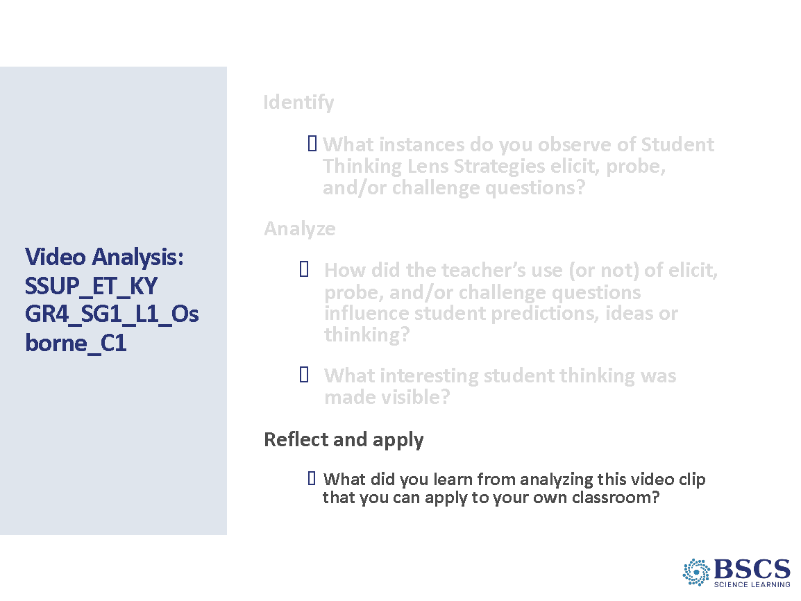 | - Video Analysis (15 min)  - Provide instructions for the Reflect and Apply phase of video analysis.  - Key Ideas to Highlight: When used effectively, we can use elicit, probe and challenge questions to build toward more accurate understanding of the science.
 |  | 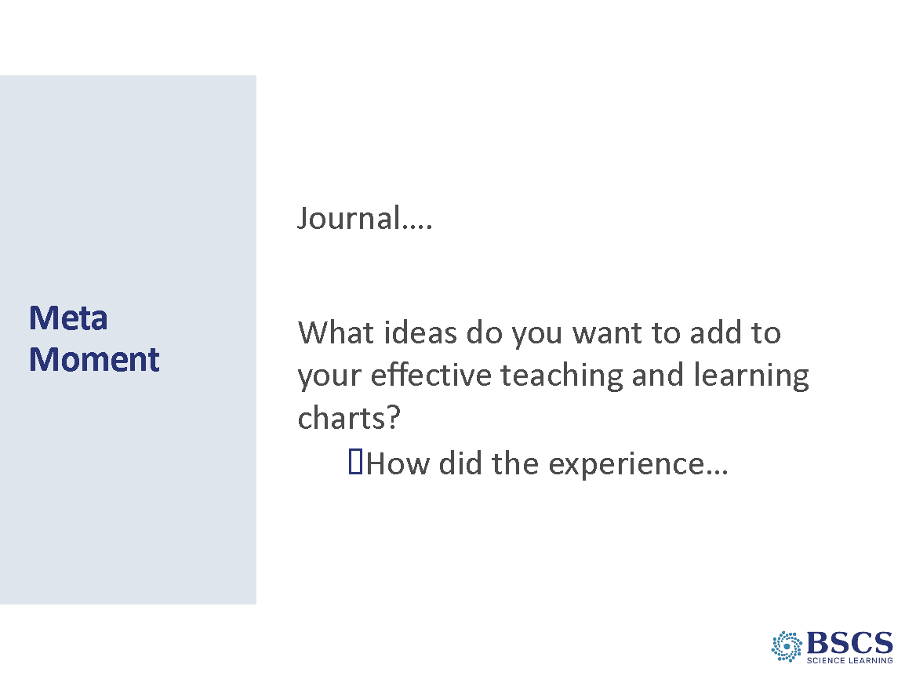 | - Meta Moment (5 min)  - Provide a few moments for participants to respond to the question in their journal.  Transition: We’ve had an opportunity to think about the STeLLA questioning strategies and how they develop a classroom culture focused on student thinking. After lunch, we’ll build on our common Anchor lesson experience from yesterday by digging into our last two focus questions using the next lessons in the STeLLA unit you will teach this fall.
12:15 – 12:45 | Lunch
12:45 – 3:20  145 min plus 10 min break  Slides 23-51  Study Group Teams | Content Deepening  Purpose: The purpose of this session is to model effective STeLLA-based science teaching and learning through a common experience that is grounded in a 3D, phenomena/problem driven unit and designed for adult learners.  Content: STeLLA model lessons/units attend to the characteristics of effective science teaching and learning (e.g., 3D, phen/prob-driven, student-centered, make student thinking visible and support sense-making, coherent, and access/engage PK and develop metacognitive abilities).  The content deepening experience will include explicit modeling and use of elicit, probe, and challenge questions.  Lesson 2: When a moving object collides with a stationary object, the moving object slows down (its motion energy decreases) and the stationary object begins to move faster (its motion energy increases). Because the speed of the objects changes during a collision, this is evidence that the motion energy of the objects also changes. Energy is transferred from a moving marble to a stationary marble during a collision. The faster an object is moving, the more energy it has, and the more energy can be transferred through collisions.  Energy can be transferred from one object to another through collisions (CCC5).  The pattern of energy bars shows the more energy the first marble/launcher bar has, the more energy will be transferred to the second marble/car from the first marble/launcher bar through the collision (CCC1).  Scientists ask questions that can be investigated (What happens to the stationary second marble when the first marble has more energy of motion?) and predict reasonable outcomes based on patterns such as cause and effect relationships (If the first marble has more energy of motion, the second marble should have more energy after the collision) (SEP 1).  Lesson 3: As an object goes down an incline, it goes faster and faster as position energy (potential energy) is converted to motion energy (kinetic energy). The higher the incline, the faster the object goes when it moves down the incline. Objects that are not moving can have position energy. Position energy can be transformed into energy of motion. If the moving object has a collision with another object, energy can be transferred from one object to another and the motion of each object will change. The more motion energy an object has, the more energy will be transferred in the collision.  Patterns can be used as evidence to support explanations (CCC 1): An object that is released from a higher position goes faster (and farther) than an object that is released from a lower position.  Scientists construct explanations of observed relationships (SEP 6): A stretched rubber band has energy of position. When the stretched rubber band is released, position energy (potential energy) decreases as it is transformed to motion energy (kinetic energy). As a result of this transformation, motion energy increases.  What participants do:  Participants review and share their learnings from L1/Day 1 to transition to Day 2 content, which includes the next two lessons from the Energy, Every Day, Everywhere Unit.  Engaging in learning experiences from lesson 2, participants explore what happens to energy when objects collide using a ruler/marble system, energy bars and representations. After naming the idea of energy transfer, participants create and add to a “Science Ideas We’ve Figured Out Chart”. Participants then complete an analogy map comparing the ruler/marble system and the car launcher system before revising their answer to the lesson 2 focus question.  After a short break, participants continue in the learner lens and record their ideas about the lesson 3 focus question: How can we change the motion energy of an object? Participants make predictions, investigate a marble ramp system, and name the ideas of position energy and energy transformation before adding to the “Science Ideas We’ve Figured Out Chart”. Participants then complete two card sorts: the first to link observed changes in the marble/ruler system with science ideas about energy changes; and the second to link observe changes in the car launcher system to the same science ideas. Participants then revise their answer to the lesson 3 focus question, revisit the Driving Question Board, and link to the next lesson.  Resources  - BSCS Journal  - Science Notebook  - STeLLA PD Binder  - STeLLA Strategies Booklet  Posters  - STeLLA Conceptual Framework poster  - CSW poster  Charts  - Parking lot chart  - Day 2, 3 Focus Questions  - Notice/Wonder Chart  - Driving Question Board  - Key Science Ideas chart  Handouts  - HO 2.1 Investigating Energy Changes in Collisions  - HO 2.2 Investigating Energy Changes Analogy Map  - HO 3.1 Predicting Changes in Energy  Materials  - Energy Change Card Sets  - Ruler marble system  - Toy car launcher system | 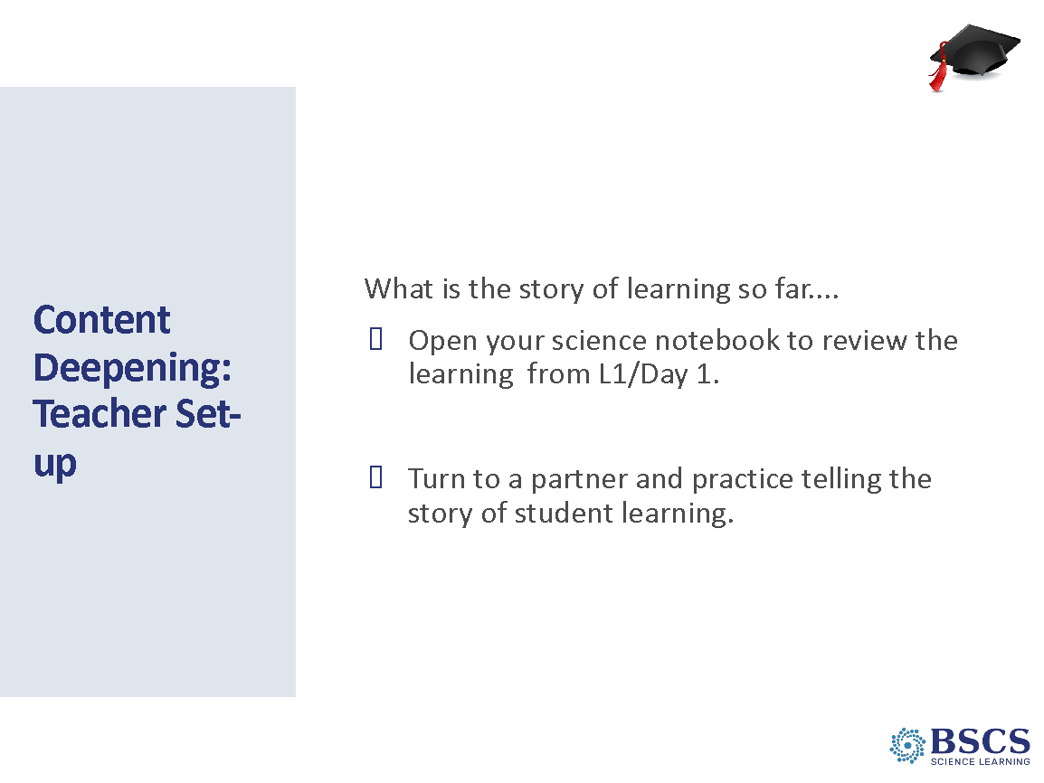 | - Content Deepening (5 min)  PDL Note: The Teacher Set-up for Lesson 2 should build on the content deepening session from Day 1 and include “the story so far...” Plan to model telling the story so far. This will help teachers develop the science content storyline over the unit and help prepare them for the unit review scheduled for Day 5.  In addition, the Teacher Set-up should prepare them to think about the ideas being developed in the lesson and the teacher main learning goal.  - Invite participants to return to the science notebook to review the learning (and activities) from L1/Day 1.  - Then have them turn to a partner and practice telling the story of student learning (not the activities) in L1.  - Call on someone to model OR PDL model telling the story so far. Your example should focus on student thinking not doing activities and figuring out, not learning about!  - How was that story similar to or different from yours?  - What made it similar or different.  PDL Note: Remind participants that the science learner experiences model the STeLLA-based strategies but are designed to engage them as adult learners. This is the time to take their teacher hat off.  PDL Note: Refer to the Day 1 PDL notes about supporting participants in taking on a learner hat.
 |  | 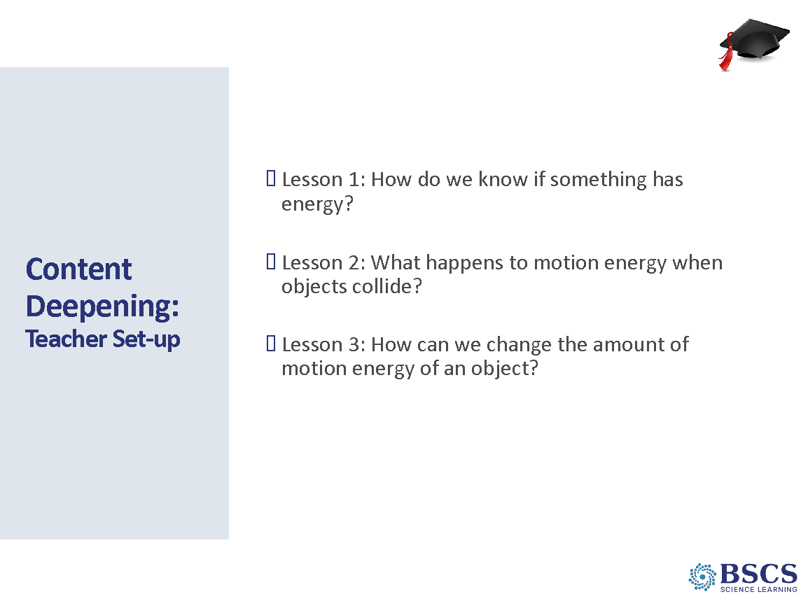 | - CD: Teacher Set-up (5 min)  - Introduce the lesson focus questions for the content deepening session today.  - Distribute the staged investigation materials on each table.
 |  | 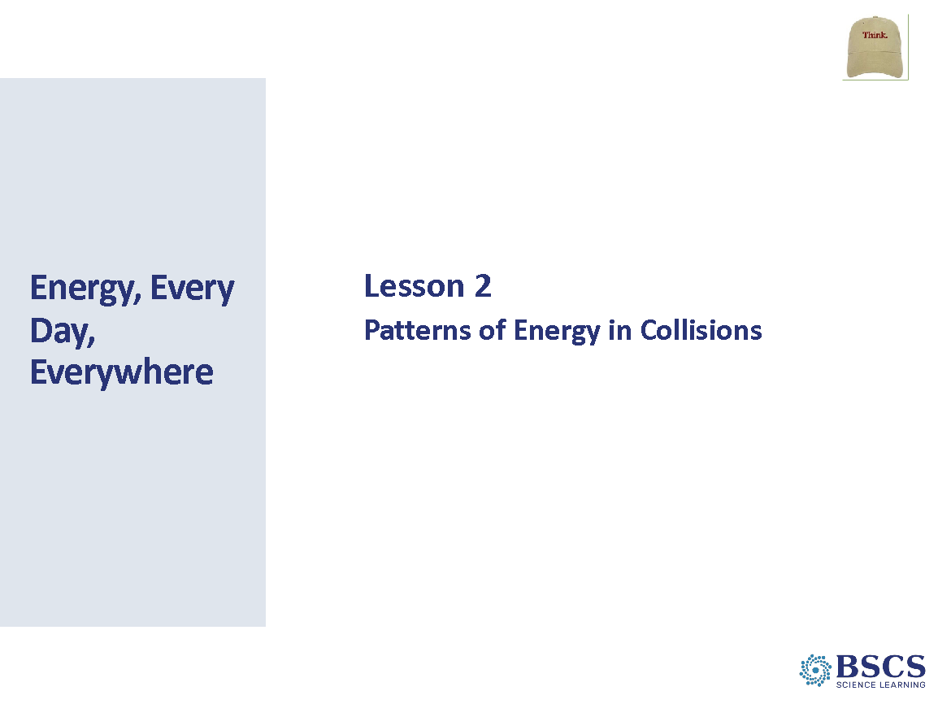 | - Energy Transfer Lesson2 Title Slide (5 min for slides 25-27)  - Share that today we will be starting with the second lesson in the Energy Unit.
 |  | 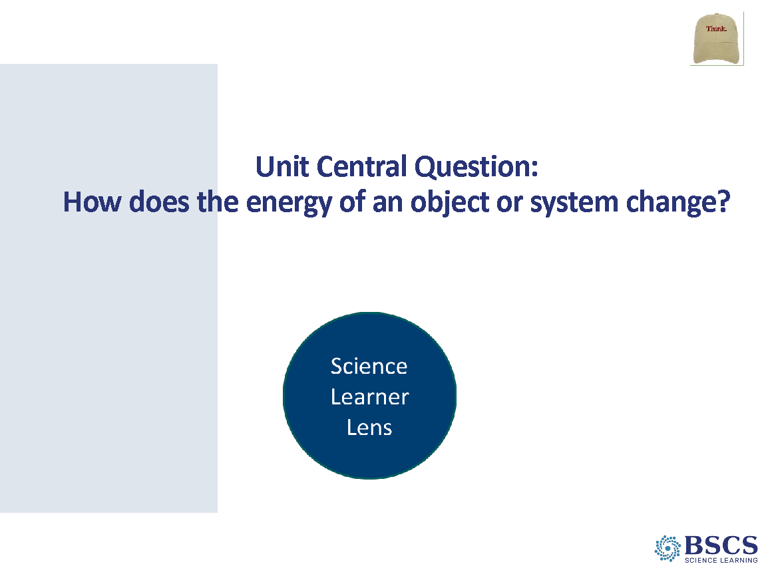 | - Unit Central Q.  - Let’s revisit our Unit Central question to remind ourselves what we learned about energy as we explored the car launcher system yesterday. What do you remember? What are the ideas that we talked about?  PDL Note: Ask elicit and probe questions as needed to have participants focus on what we figured out, not what we did.
 |  | 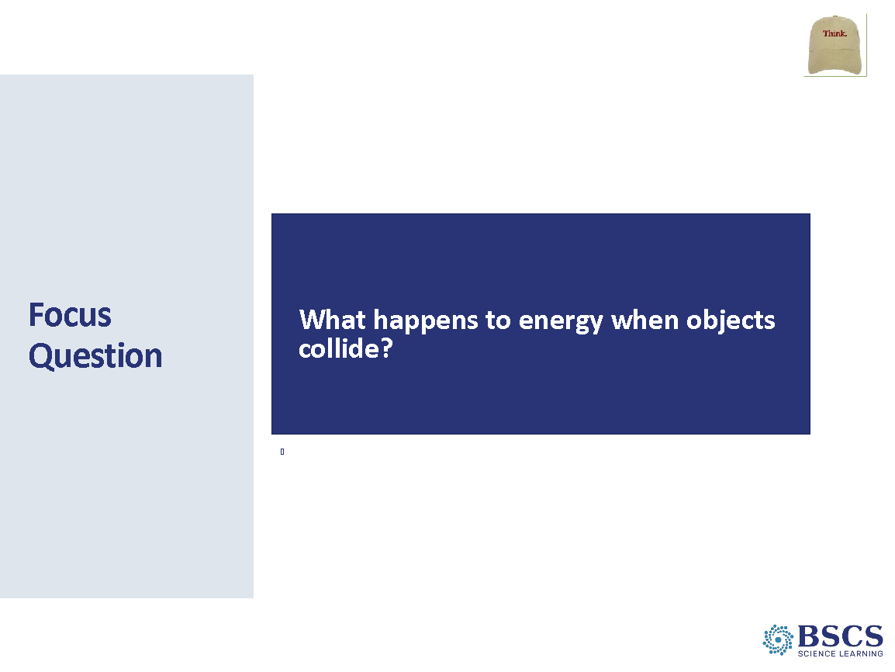 | - Focus Question  - At the end of yesterday’s lesson, we thought that our questions on the Driving Question Board about collisions would be a good place to start our investigations today. Our focus question for today (lesson 2) is, What happens to energy when objects collide?  - We know from our lesson yesterday (if mentioned on the Know/Wonder chart) that there are other kinds of energy, but we will focus on motion energy as we study collisions.  PDL Note: Refer to the focus question often throughout the lesson and use/emphasize the term motion energy when possible. This will help establish the foundational knowledge necessary to understand and differentiate between transfer and transformation of energy in general.  - Have participants write the focus question in their science notebook and under the focus question, record their initial thinking: When objects collide, …. Participants should leave space below to revise their ideas later.
 |  | 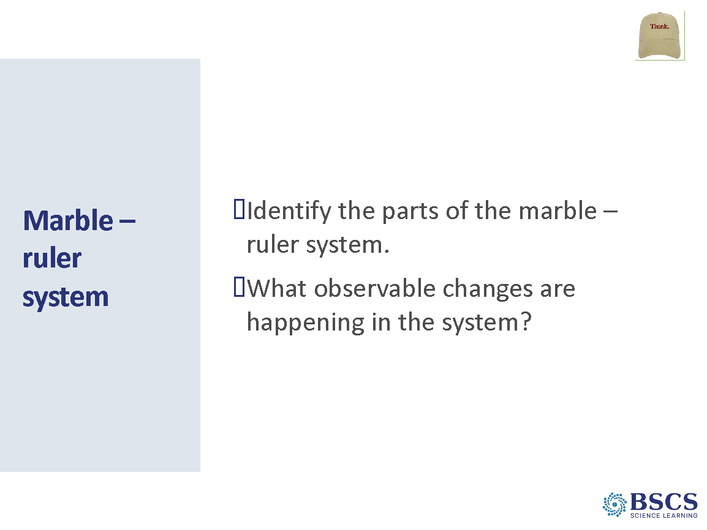 | - Marble – ruler system (5 min)  - Share that yesterday we used the car launcher system, today we will use a marble-ruler system, which is a simpler system, to help us investigate what happens to motion energy when objects collide.  - Invite participants to gather around the marble-ruler demonstration, have the group name the parts of the system and ask, “Does our system have any motion energy at this point? What is your evidence?“  - Give the red marble a push so that it rolls toward and collides with the blue marble. The blue marble should start moving and the red marble should stop. Repeat the demonstration several times, asking participants use CSW sentence stems to identify observable changes in the system. Have participants focus on observations about motion energy during a collision.  PDL Note: Support participants to reach consensus that the initially the system has no observable motion energy. The moving finger adds energy to the system when it hits the red marble causing it to move. The blue marble has ‘no motion’ and the red marble has ‘more motion’. After the collision, the blue marble has ‘more motion’ and the red marble has ‘no motion’ or ‘less motion’.  - Introduce the term – transfer – to use when talking about energy going from one object to another. We will continue to use the words moving or motion as evidence of motion energy being present in an object. Invite participants to use the term transfer by saying, here is a challenge to help you begin to use this term: How did the motion energy transfer into our system and throughout it during the collision? What was your evidence?  - Have the participants record their ideas in their science notebook, offering these stems:  - Motion energy transferred into our system to the red marble... My evidence is...  - Motion energy transferred during the collision from... to... My evidence is...
 |  | 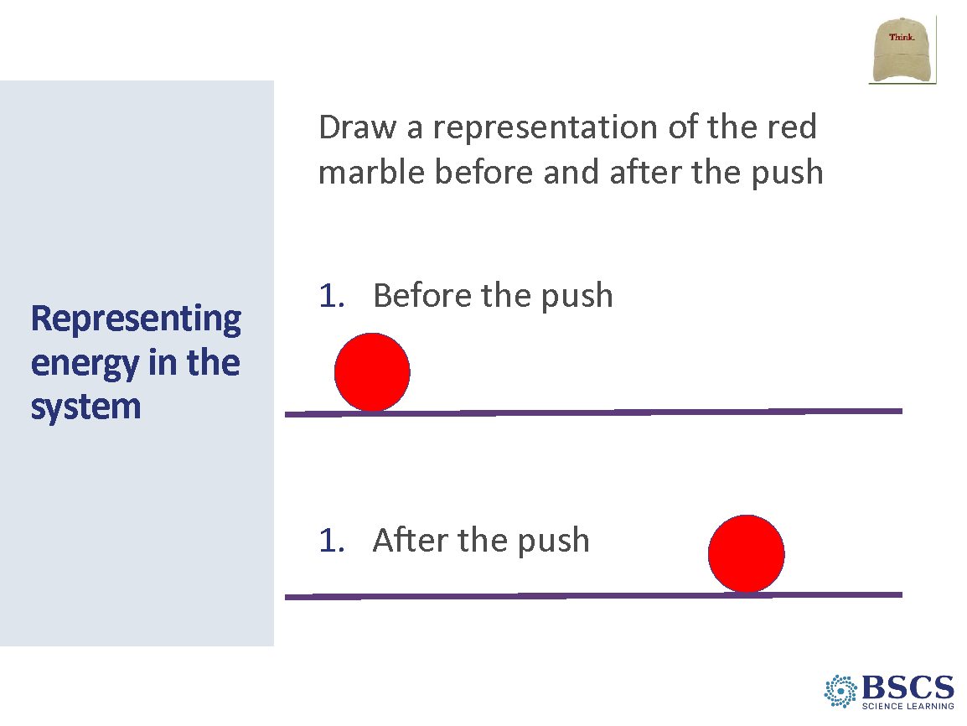 | - Representing energy in the system (5 min for slides 29-30)  - Invite participants to consider another way to represent the amount of motion energy objects have before and after a collision. Under your sentence frames, draw and label a representation of only the red marble before and after it is pushed.  - Invite a few participants to share their representations to show that there are many ways to represent the amount of motion energy and object has.
 |  | 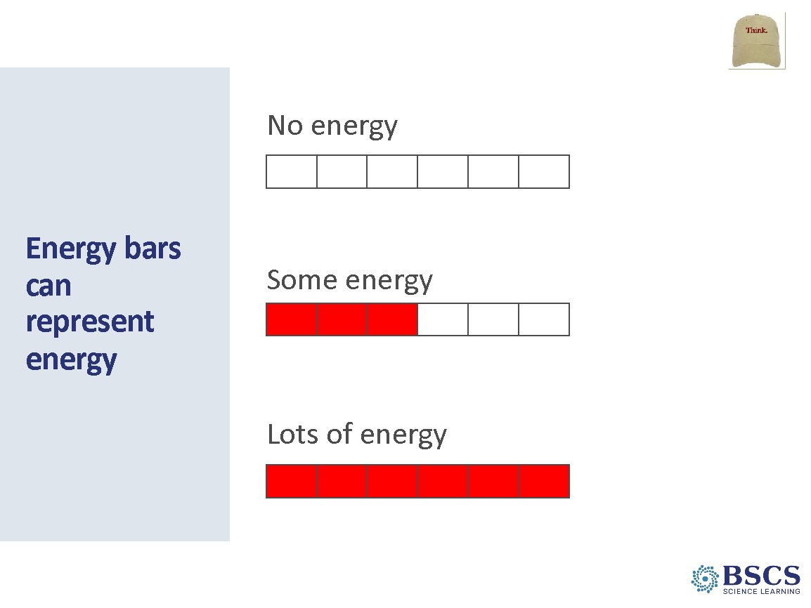 | - Energy bars can represent energy  - Share that we can use energy bars as a common representation that will be used to communicate the amount of motion energy an object has.  - Draw a stationary marble before a push on the board and add an energy bar below. Then draw a marble after the push and add an energy bar below. Color in the bars based on participants ideas about the amount of motion energy of the marble before and after the push.
 |  | 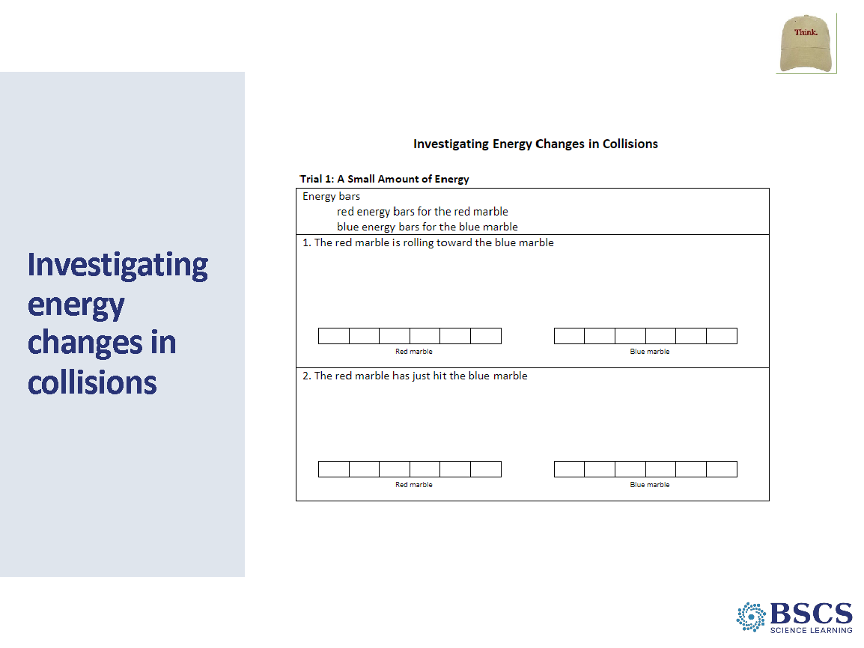 | - Investigating energy changes in collisions (10 min)  - Share that we will continue to use energy bar diagrams to clarify our thinking while investigating motion energy during a collision.  - Distribute HO 2.1: Investigating Energy Changes in Collisions to each participant. Invite participants to read the heading of each trial on the handout. Ask, what do you notice?  - The trials go from small to medium to large amounts of motion energy.  - Establish the procedure by sharing that the blue marble should be stationary in the center of the ruler and the red marble should be at one end of the ruler. For each trial, give the red marble a different size push – small, medium, large - as indicated on the handout.  - Mark for participants that after each trial, as a group, they will discuss and come to consensus about (1) the changes in motion energy of each marble and (2) the amount of motion energy to represent on the energy bars with the appropriate color.  PDL Note: As groups work together to complete the trials and representations, circulate among groups asking elicit, probe, and challenge questions to make thinking visible and move thinking forward.  - Have each group share their data with another group to look for patterns. Encourage use of the Communicating in Scientific Ways poster stems in row 3.  PDL Note: Emphasize that groups do not need to have consensus about the number of energy bars for each trial. However, groups should come to consensus about the pattern of change in motion and motion energy that occurred. Encourage qualitative terms such as “no motion”, “some motion”, “more motion”, and “no motion energy”, “some motion energy”, “more motion energy” to describe what happens before and after the collision.  - Have groups share out: What patterns in motion energy did you observe from your energy bar data representations?  - Possible responses:  - In all three trials, before the collision, the red marble had motion energy as it was rolling toward the blue marble. The blue marble didn’t have motion energy because it wasn’t moving.  - Just after the collision, the red marble slowed down or stopped, and the blue marble started to move. The motion energy of the red marble decreased while the motion energy of the blue marble increased.  - The more motion energy the red marble had before the collision, the more motion energy the blue marble had after the collision.
 |  | 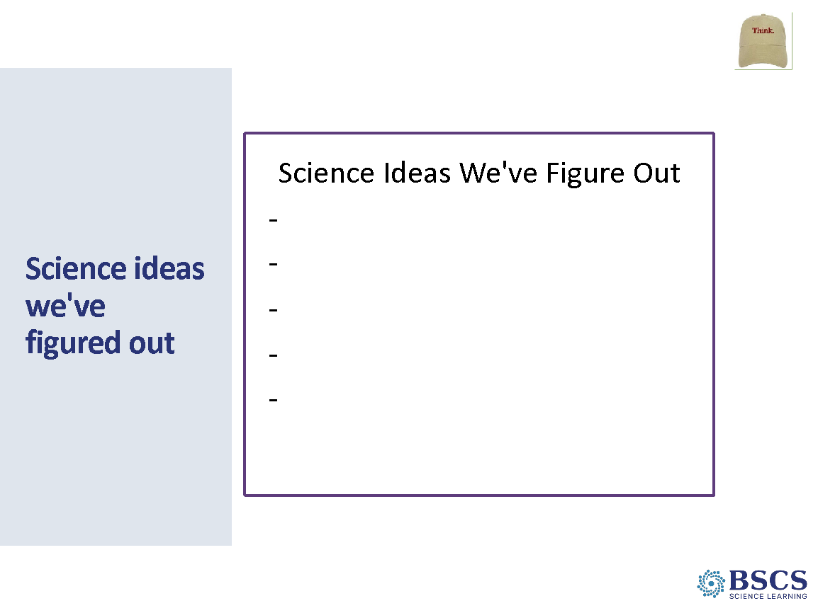 | - Science Ideas we‘ve figured out (0 min)  - Share that we have figured out an important science idea: energy can be transferred from one object to another in a collision. Record this idea on the chart and ask if there are other important ideas we should add at this time.  - Possible answers include:  - Energy is present when an object is moving; the faster an object is moving, the more energy it has. The energy is in the form of motion energy.  - We can show the amount of energy an object has using energy bars.  - When a moving object collides with a stationary object, the moving object slows down or stops, and the stationary object begins to move.  - Energy can be transferred from one object to another through collisions.  - The more energy a moving object has, the more energy it can transfer to another object through a collision.
 |  | 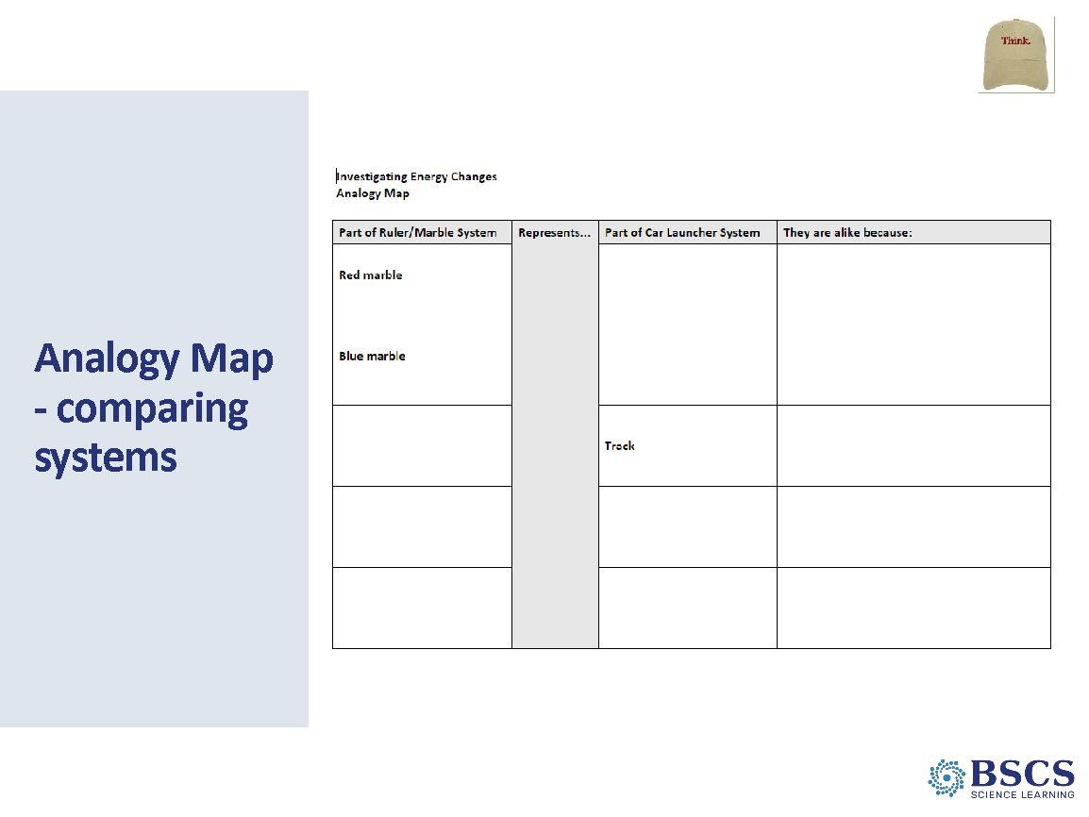 | - Analogy Map – comparing systems (10 min for slides 32-33)  - Direct HO 2.2: Investigating Energy Changes Analogy Map to participants. Share that we can use an analogy map to help us compare how the two systems are similar and highlight the columns on the map.  - Model the process by completing the first column as a whole group and then invite pairs to complete the next two rows.  - Have pairs share their ideas with another pair using CSW poster rows 6 and 7.  - Use analogy map to consider: How was energy transferred from one object to another in the system? What is your evidence? After individual think time, invite a few participants to share out using sentence stems from the CSW poster. Possible responses:  - In the car launcher system, there was a collision between the launcher and the car.  - Before the collision, the launcher had energy of motion after the rubber band was released. The car did not have energy of motion.  - After the collision, the launcher stopped moving; it no longer had energy of motion. The car started moving; it had energy of motion.  - The launcher transferred its energy to the car through the collision.  - Meta moment: Invite participants to share how the analogy map helped them think about how the two systems were similar and how energy was transferred from one object to another in the collision in the car launcher system.
- Focus Question (5 min)
  - In science notebook, review initial response to focus question and add or revise it in a different color. Draw a single line through any ideas you want to change so you can see how your ideas have changed and grown during today’s lesson.
  - Invite participants to share out using row 11 of the CSW poster.
PDL Note: Listen for participants use of the term transfer.
 |  | 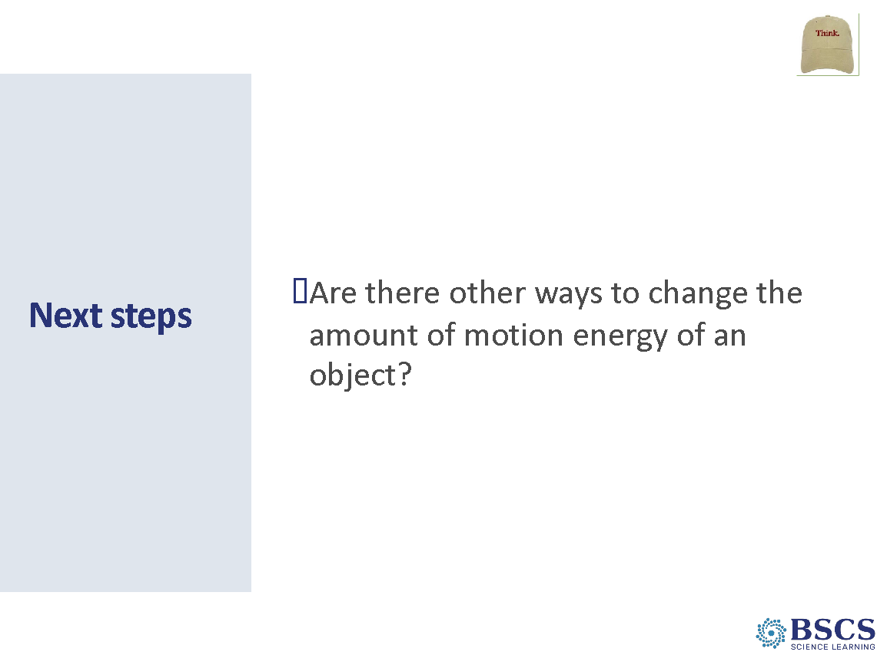 | - Next Steps (5 min)  - Share that we have used two different systems so far. Ask: In each one, how did the amount of motion energy an object change?  - Share that you wonder if there are other ways to change the amount of motion energy an object has. Point to clusters of questions on the Driving Question Board that focus on amount of energy or changes to the amount on energy.  - Share that tomorrow in our next lesson, we will investigate ways to change the amount of energy of an object.
 |  | 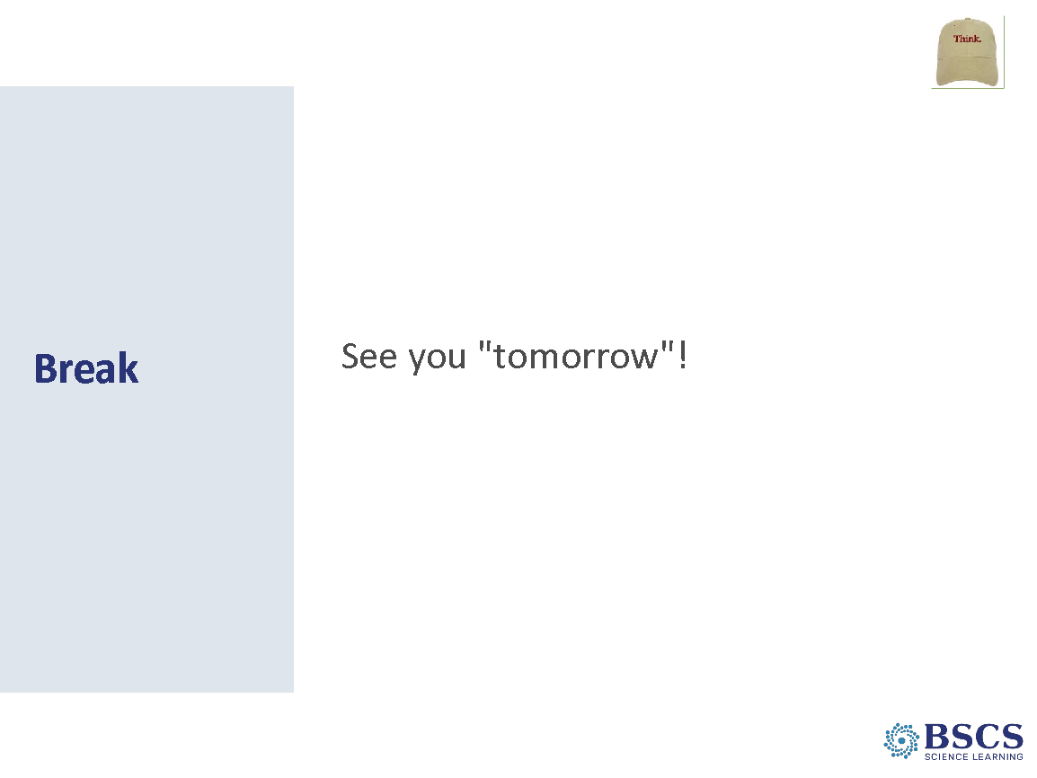 | - Break (10 min)  - That was the end of lesson 2, we will see you “tomorrow”, which is actually a 10 min break, to continue on to Lesson 3. When we return, we will continue in Learner Lens.
 |  | 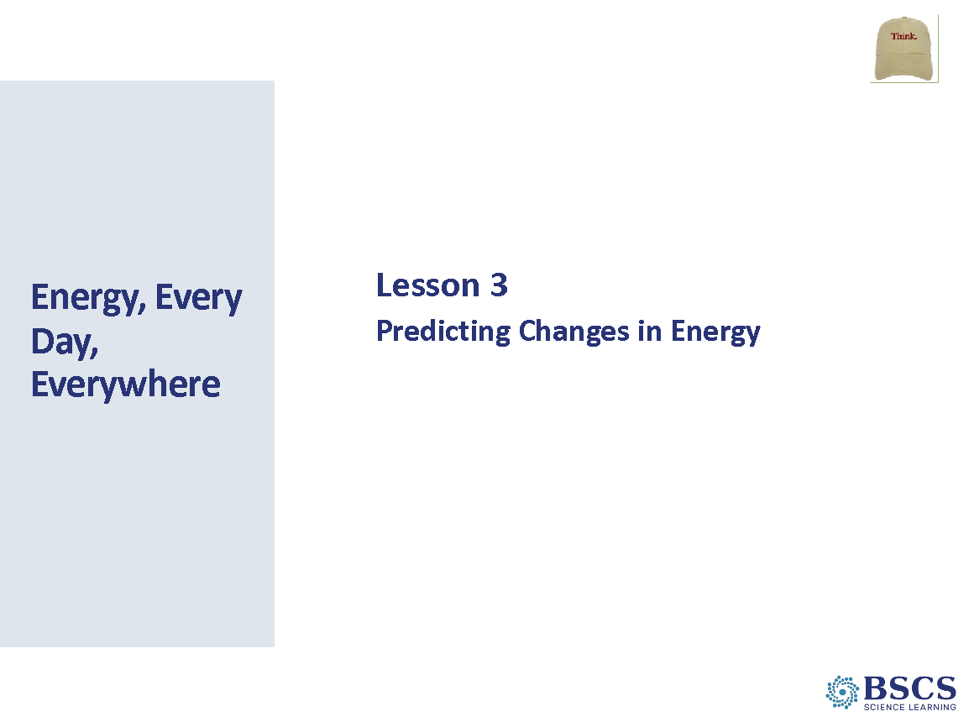 | - Energy Transfer Lesson 3 Title Slide (5 min for slides 37-39)  - Welcome the group back from break. Share that we will now continue on to Lesson 3 of the Energy Unit.
 |  | 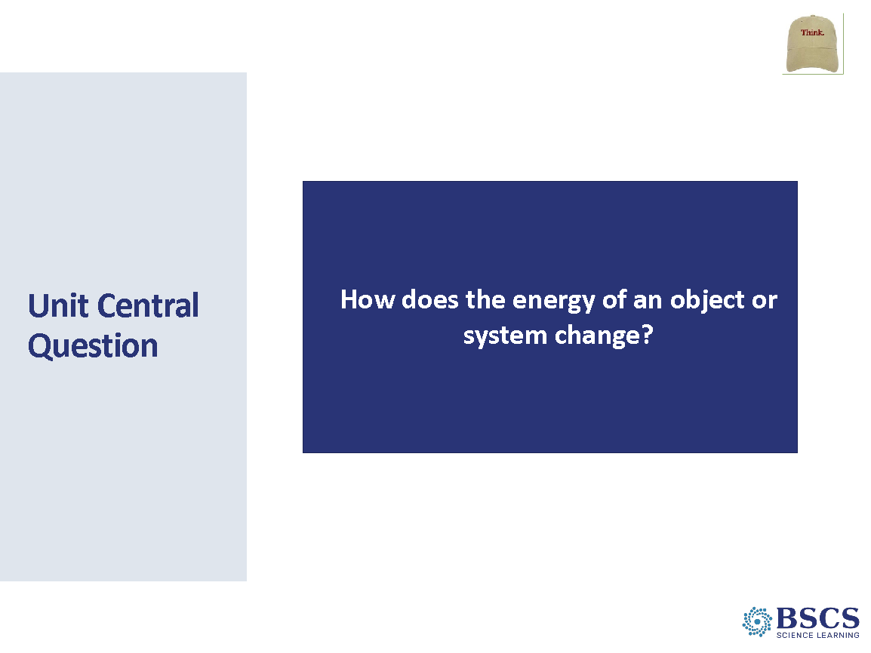 | - Unit Central Question  - As we explored the Unit Central Question yesterday, we figured out many ideas about how the energy of an object can change. [Point to the “Science Ideas We’ve Figured Out Chart”.]
 |  | 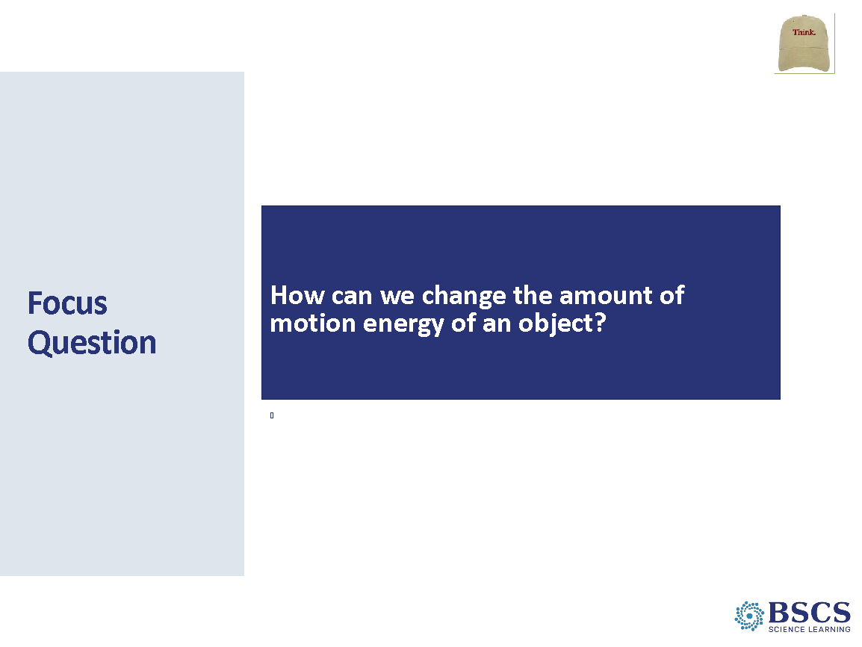 | - Focus Question  - At the end of our lesson yesterday, we wondered if there are other ways to change the amount of motion energy an object has.  - Introduce the focus question for today by writing the question on the board. Invite participants to write it in their notebooks, place a box around it, and write their current thinking under the focus question.
 |  | 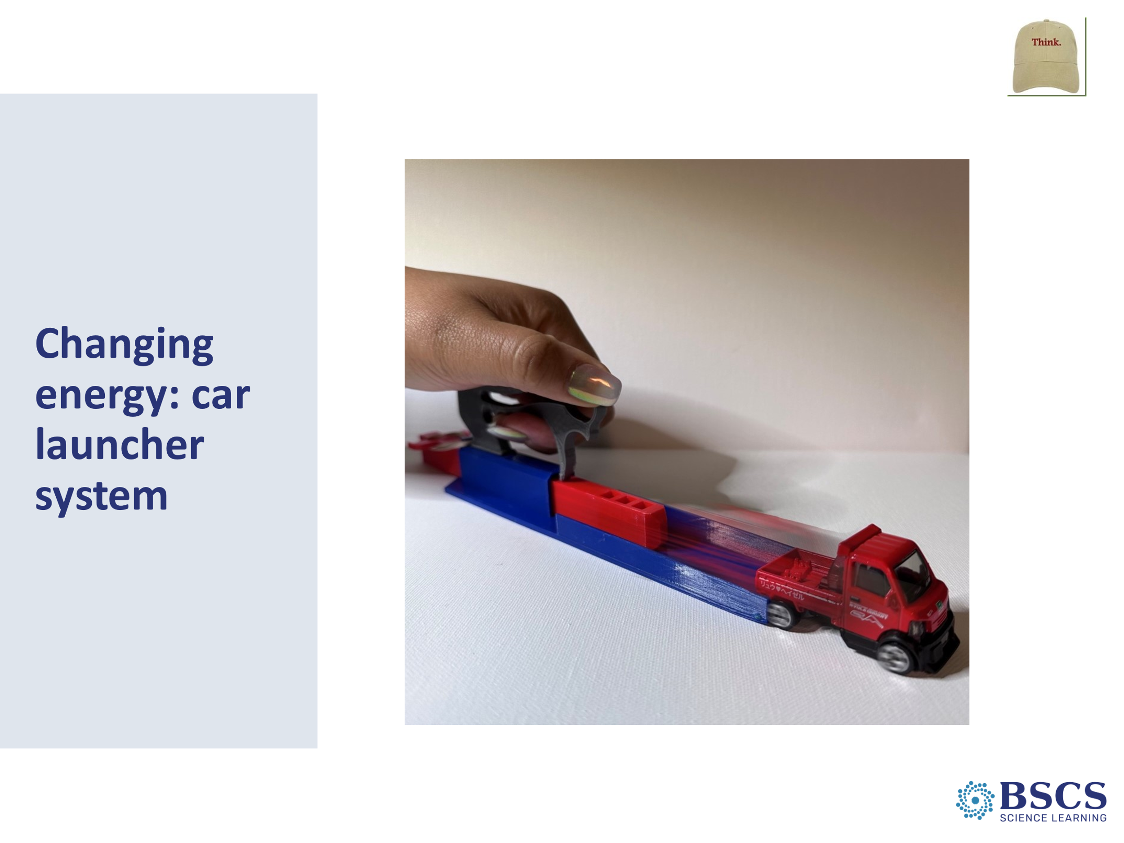 | - Changing energy: car launcher system (5 min)  - Share that we will revisit thinking about motion energy changes in car launcher system by asking: How did we change the amount of motion energy in the car launcher system?  - Possible responses:  - Stretching the rubber band farther caused the launcher to move faster before the collision and the car to move faster after the collision.  - Faster motion is evidence that the motion energy in the system increased.  - We can change the motion energy in the car launcher system by changing how far the rubber band is stretched.  PDL Note: Add these ideas to the Science Ideas We’ve Figured Out chart if not already listed.  - Invite participants to think about the second system we’ve used by asking, How did we change the amount of energy in the marble/ruler system?  - Possible responses:  - The harder/bigger the push, the more energy the red marble had.  - Faster motion of the red marble is evidence that it had more motion energy.  PDL Note: Make sure to draw a distinction between observed changes in the system (e.g., changes in motion) and changes in motion energy. Observable changes in the system provide evidence for where in the system motion energy changes are occurring.
 |  | 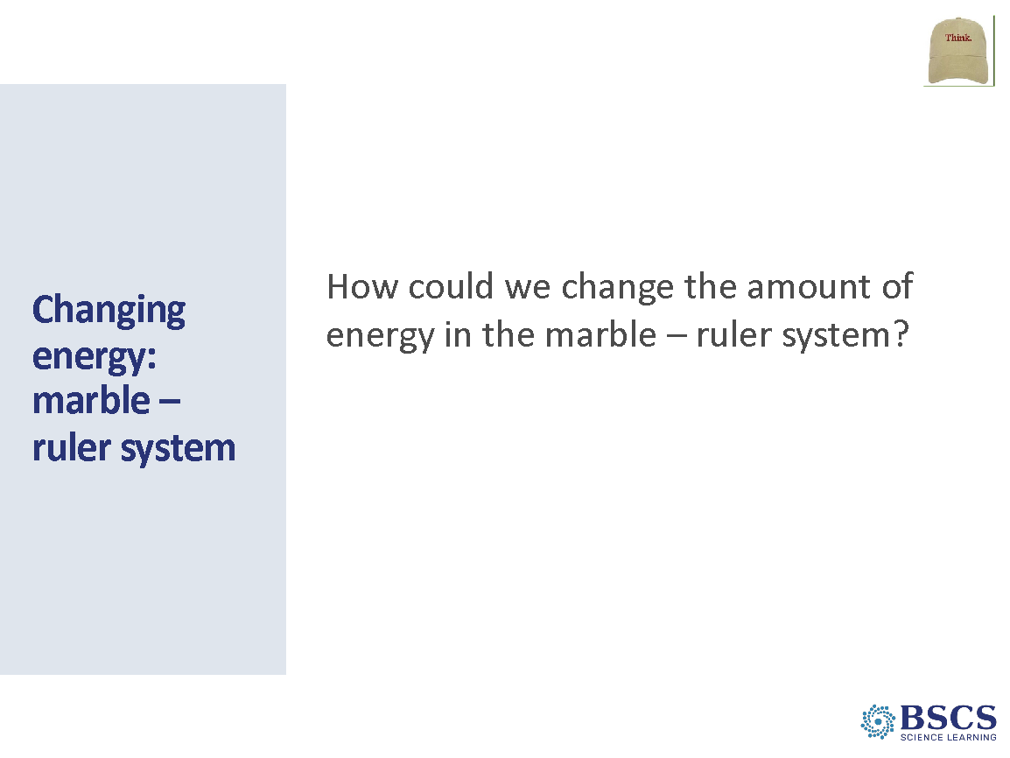 | - Changing energy: marble – ruler system (5 min for slides 41-42)  - Invite participants to think of other ways we could change the amount of energy in the marble/ruler system.  - Listen to participant ideas, making note of anyone who suggests increasing the height of the red marble.  Transition: ____ shared that increasing the height of the red marble by making a ramp could change the amount of energy in the system. Let’s investigate that wondering now.
 |  | 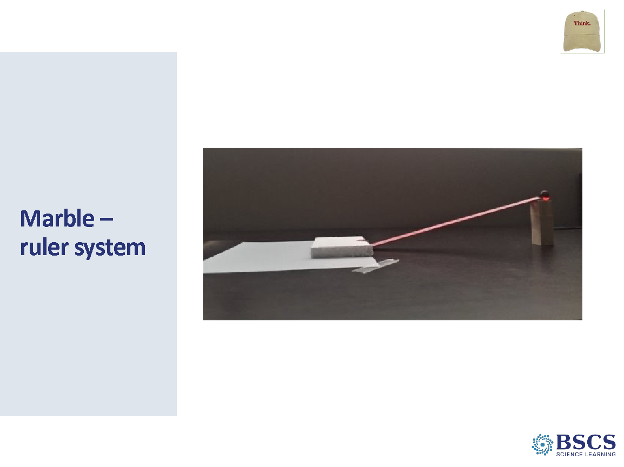 | - Marble – ruler system  - Direct participants’ attention to the marble-ruler-Styrofoam system and note the replacement of the blue marble with a Styrofoam block to better observe evidence of changes.  PDL Note: Demonstrate elevating one end of the ruler to make a ramp. Explain that one wooden block will be used for the low ramp and 3 wooden blocks for the high ramp.  - Place the Styrofoam block on the edge of a piece of white paper taped down to the desk surface. Point out that the Styrofoam block should be at the end of the ruler. Show how a mark should be made on the paper at one end of the Styrofoam block (Figure 3.2).  - Place the marble at the top of the ramp, emphasizing that, in each trial, the marble should start from the same place on the ruler, and that it is important to not push the marble, but rather to just release it. Demonstrate this from the low ramp so students can observe how the marble will collide with the Styrofoam block causing them to move together until they come to rest.  - Note that if the marble does NOT collide with the Styrofoam in the groove or the marble bounces back from the Styrofoam before it stops, then the trial must be repeated.  - Once the marble/Styrofoam come to a stop, mark on the paper at the same end of the Styrofoam. Demonstrate how to measure the distance the Styrofoam block moved using a second ruler.
 |  | 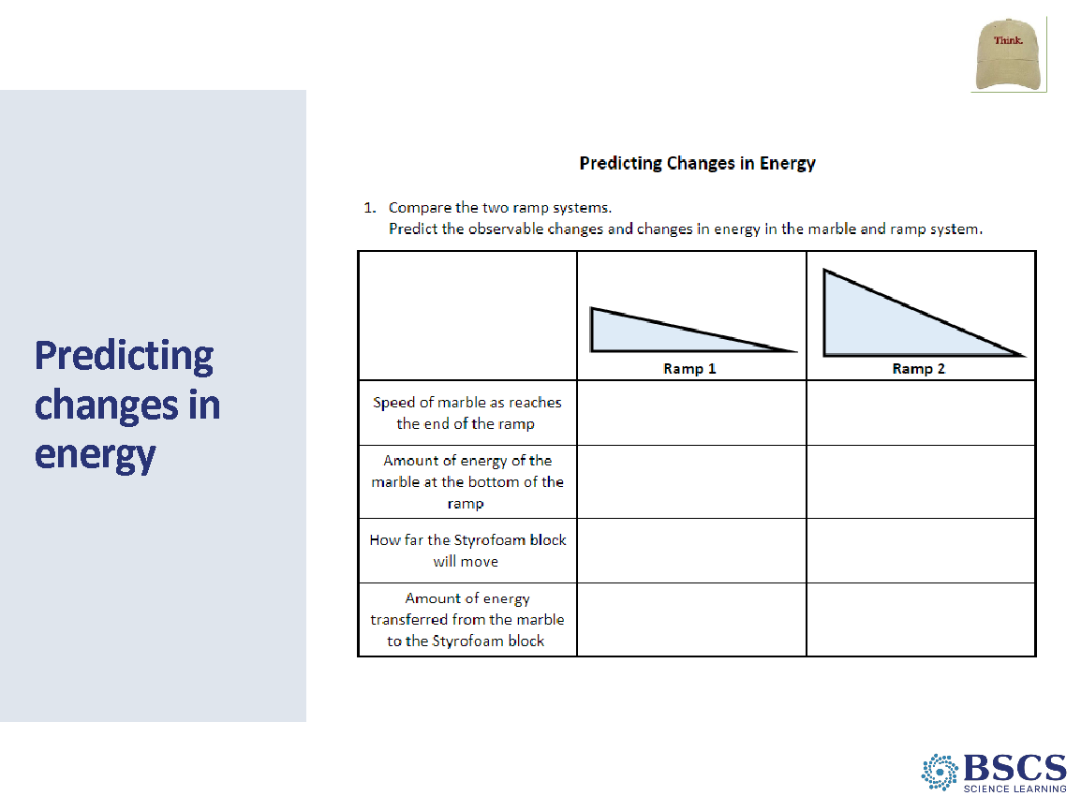 | - Predicting changes in energy (5 min)  - Direct participants to HO 3.1: Predicting Changes in Energy (PD Binder p. __) and invite them to examine the organization of the handout and the data they will be collecting with an elbow partner.  - Highlight that they will use terms that show a comparison of the two systems (e.g., faster, or slower, more energy or less energy, farther or less far.)  - Have participants complete Step 1 by making predictions with an elbow partner.  PDL Note: Participants will not share out predictions at this time but will revisit them later to see if they are supported by the data.  PDL Note: While participants discuss comparisons between systems, listen to language being used as there may be opportunities to address teacher learning goals (TLGs) 2b and 3c by the end of the lesson. If teacher learning goals are part of discussions in the “Learner Lens”, make sure to differentiate between student learning goals and teacher learning goals during the Teacher debrief.  TLG-2b: Qualitative comparisons of the amount of energy an object has can be made when a single object is moving at different speeds. Qualitative comparisons of the amounts of energy between two objects can be made when the objects have the same mass. If objects have different masses, but are moving at the same speed, the object with the larger mass will have more energy of motion.  TLG-3c: Qualitative comparisons of the amount of energy an object has can be made when a single object is at a different position relative to the earth. Qualitative comparisons of the amounts of energy between two objects can be made when the objects have the same mass. If objects have different masses but are at the same height within the system, the object with the larger mass will have more stored energy.
 |  | 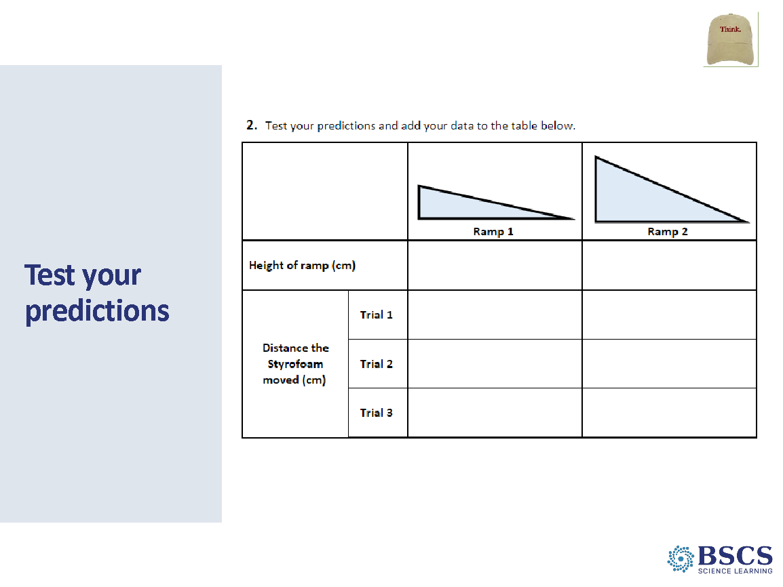 | - Test your predictions (10 min)  - Invite participants to set up their investigation and begin testing their predictions, recording their data in Step 2 of the handout. Ask participants to pause after they complete Step 2.  - After groups collect their data, share that, for Step 3, they are invited to use rows 2 & 3 of the CSW poster (place a sticky note arrow on these rows) as they work with their group to identify patterns and compare their data to their predictions.  PDL Note: As groups work together, circulate among groups asking elicit, probe, and challenge questions to make thinking visible and move their thinking forward.  Transition: Now that we have completed Step 3, we will dig more deeply into energy changes that occur in the marble/ramp/Styrofoam system by looking at Ramp 2, the higher ramp.
 |  | 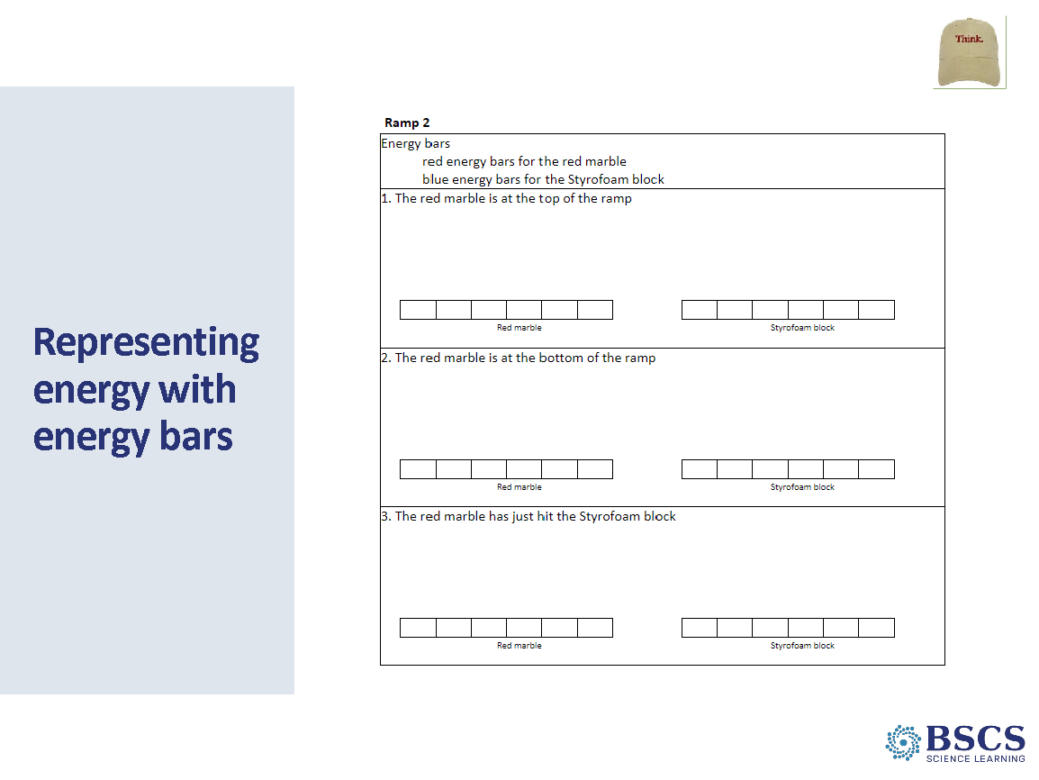 | - Representing energy with energy bars (15 min)  - Invite participants to gather around the marble/ramp 2/Styrofoam system. Roll the marble roll down the ramp and catch it at the bottom before it collides with the Styrofoam block. Invite participants to consider the red marble’s energy at the position where you caught it - at the bottom of the ramp just before collision.  - Invite participants to consider the energy of the red marble at different positions in the Ramp 2 system, asking elicit, probe and challenge questions to make thinking visible and move their thinking forward. If learners note that here is no motion energy at the top of the ramp but there is a lot of motion energy at the bottom of the ramp, ask Where did the energy come from?  - Invite participants to make comparisons between the marble ruler system in lesson 2 and today and compare Ramp 1 and Ramp 2 in the investigation today. Name that the marble has position energy (stored energy) at the top of the raised side of the ruler. Have participants consider position energy and motion energy at different point on the ramp.  PDL Note: Avoid using the word “ground” because whether you are at the top of the hill or the bottom, you are still on the “ground”. Instead use phrase like, “object is at a place higher than this place” or “at position A, the object is higher than at position B”. Depending on participants’ discussion, there may be an opportunity to address Teacher Learning Goal 3a: The system of interest must be defined to determine the lowest point of the system at which potential energy is zero. An object may be able to move to a lower position, but if this position is outside of the system of interest, it is not considered.  If teacher learning goals are part of discussions in the “Learner Lens”, make sure to differentiate between student learning goals and teacher learning goals during the Teacher debrief.  - To transition to Step 4, note that we were representing motion energy with lines (adding more lines to represent faster speed and more motion energy). How can we represent position energy?  - Invite a few ideas and note that it is important to decide on and use the same symbols. Suggest that can:  - parentheses for position like this ( ) and add more to show more position energy.  - label “M” and “P” for motion energy and position energy in the energy bars.  - Quick check: If the marble is at the top of the ramp, we would label the energy bar with...If the marble is at the bottom...If the marble is at the middle of the ramp...  PDL Note: Do not spend much time on symbol discussion. The purpose is to allow some input. Based on the group’s ideas, you may suggest two different symbols than above. However, note that the two symbols described above are used in the Answer Key.  - Circulate as groups are making their representations. Ask elicit, probe, and challenge questions to reveal and move thinking forward.  PDL Note: Groups may have colored in different numbers of energy bars than other groups. However, the number of energy bars colored at the top and bottom of the ramp should be the same. Highlight that the total number of energy bars for the marble at the top of the ramp is the same as for the marble at the bottom of the ramp. The amount of energy of the marble did not change from the top of the ramp to the bottom. No energy was added to the system; it was transformed from stored energy to motion energy. Participant discussion may present an opportunity to consider Teacher Learning Goal 3b: As potential energy is converted to kinetic energy, some potential energy may also be converted to light, sound, and/or heat. This is also a focus of Day 3 Content Deepening.  - After all groups finish their representations, ask if participants see any patterns when comparing changes in energy in the three positions.  - Note where the word “changing” or “changed” is used and introduce the terms, transformed (converted) and energy transformation.  PDL Note: Participants may attempt to explain stored or potential energy as a force. This may be an opportunity to address Teacher Learning Goal 1b: Energy is a property of matter that often involves motion. Ideas related to the forces that affect the motion of objects are often confused with ideas related to energy. However, a force is a push or a pull that starts, stops, or changes motion and the amount of energy the object has. The force is not the energy. Energy is often transferred through forces.  If teacher learning goals are part of discussions in the “Learner Lens”, make sure to differentiate between student learning goals and teacher learning goals during the Teacher debrief.
 |  | 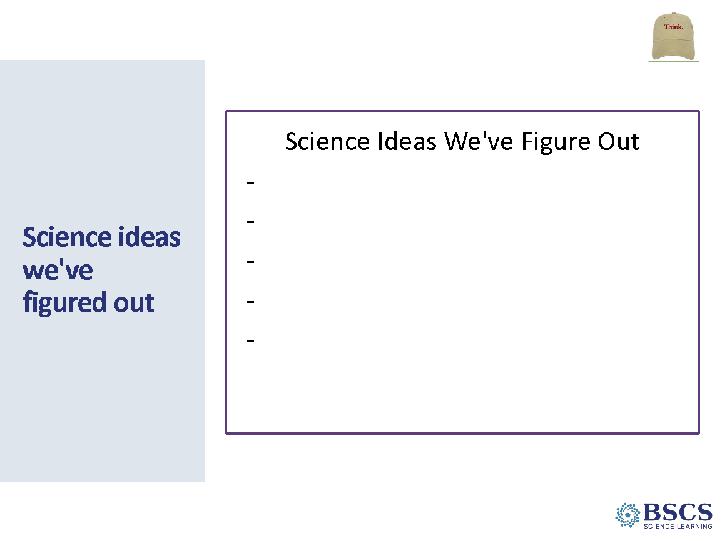 | - Science Ideas we’ve figured out (5 min)  - Invite participants to contribute science ideas from the activity that can be added to the chart. Use a different color marker to add ideas that the group agrees upon.  - Use probe and challenge questions to differentiate between energy transfer and energy transformation.  - Possible ideas:  - In addition to energy of motion, objects can have stored energy.  - Stored energy can be transformed into energy of motion.  - The more stored energy an object has, the more energy can be transformed into energy of motion.  - As an object’s position energy decreases, its motion energy increases.  Transition: We can use these ideas along with our observations of changes to develop a scientific explanation of how energy changes in the marble/ruler system.
 |  | 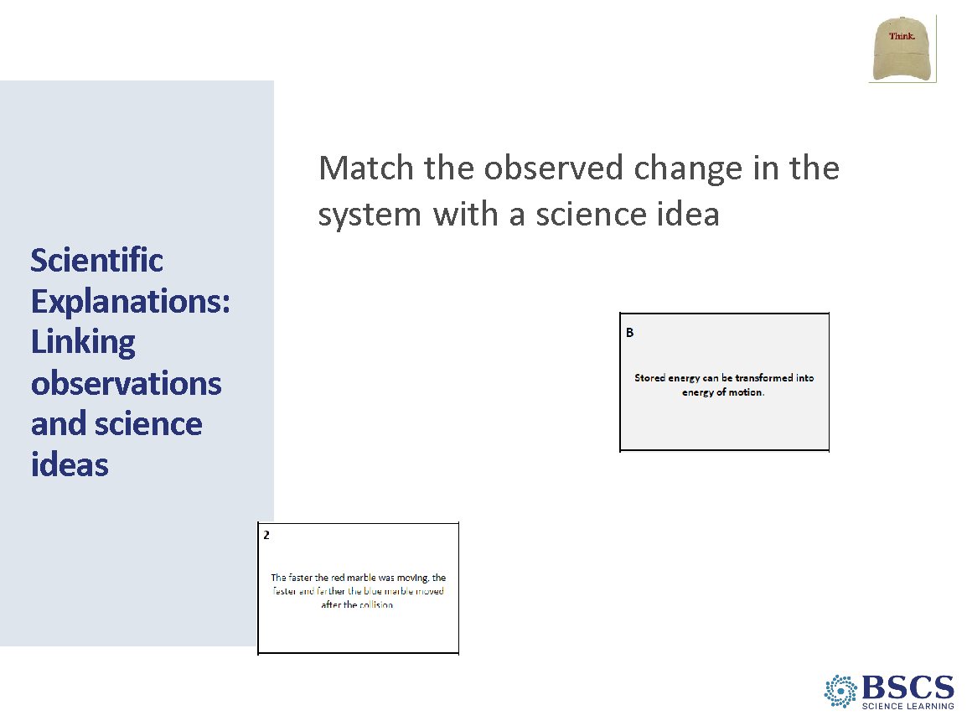 | - Scientific Explanations: Linking observations and science ideas (20 min)  - Share that a scientific explanation consists of a claim supported by evidence and science ideas. Explain that they will work in pairs to match observed changes in the marble/ruler system with science ideas about energy changes.  - Distribute an Energy Changes card set to each pair. Note that science ideas are listed on the gray cards and that changes we observed in the marble/ruler system (evidence) are listed on the white cards. As they match observed changes with science ideas, pairs should discuss how the observed change is evidence for the change in energy on the paired card. As pairs work, circulate among groups asking elicit, probe, and challenge questions to make student thinking visible and move their thinking forward.  - After pairs have time to match their cards, invite pairs to share out a card pairing and explain why they paired them. As the group discusses ideas, encourage use of CSW Row 4: Think of an idea that explains your data and observations; Row 7: Agree or disagree with others’ ideas; add onto someone else’s ideas, and Row 9: Consider if new ideas make sense.  - Share that now that we’ve linked science ideas to explain changes in the marble/ruler system, that they will receive a new set of cards that have observed changes in the car launcher system, which they will place on the other side of the science idea (gray) cards.  - Invite pairs to share their new matches and explain their thinking.  - Once the matches have been shared, invite participants to compare the two sets of observed changes and their matched science ideas.  - Possible ideas include:  - Like the marble at the top of the ramp, the rubber band has stored energy when it is pulled back or stretched.  - Stored energy in the rubber band can be transformed into energy of motion when the rubber band is released.  - Stretching the rubber band further increases the difference between its stretches and unstretched position, giving it more stored energy. The more stored energy the rubber band has, the more energy can be transformed into energy of motion.  Transition: We’ve linked science ideas with evidence, an important part of constructing a scientific explanation. Now that we’ve linked science ideas to what we observed in today’s investigations, let’s revisit our initial ideas about today’s focus question.
 |  | 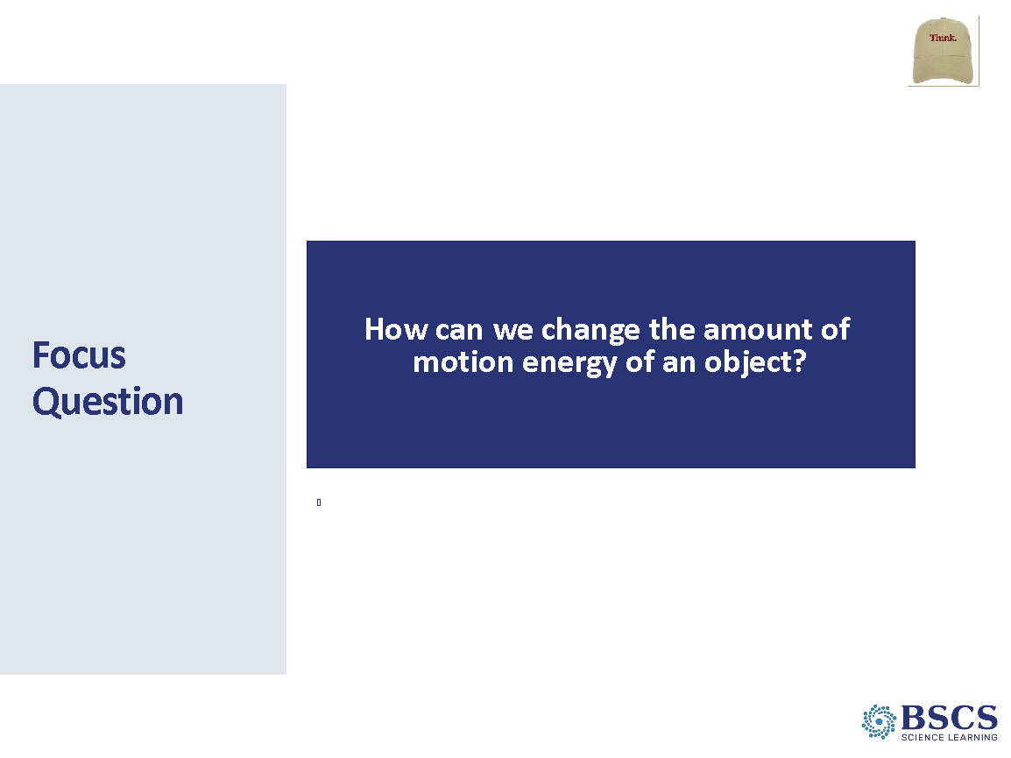 | - Focus Question (5 min)  - Invite participants to add to or revise their initial response to lesson focus question in their science notebooks. Participants should draw a single line through any ideas they want to change so they can see how their ideas have changed and grown during the lesson.  - Highlight row 11 of the CSW poster with a sticky note arrow. Invite a few participants to share their revisions to the lesson focus question using sentence stems from this row.
 |  | 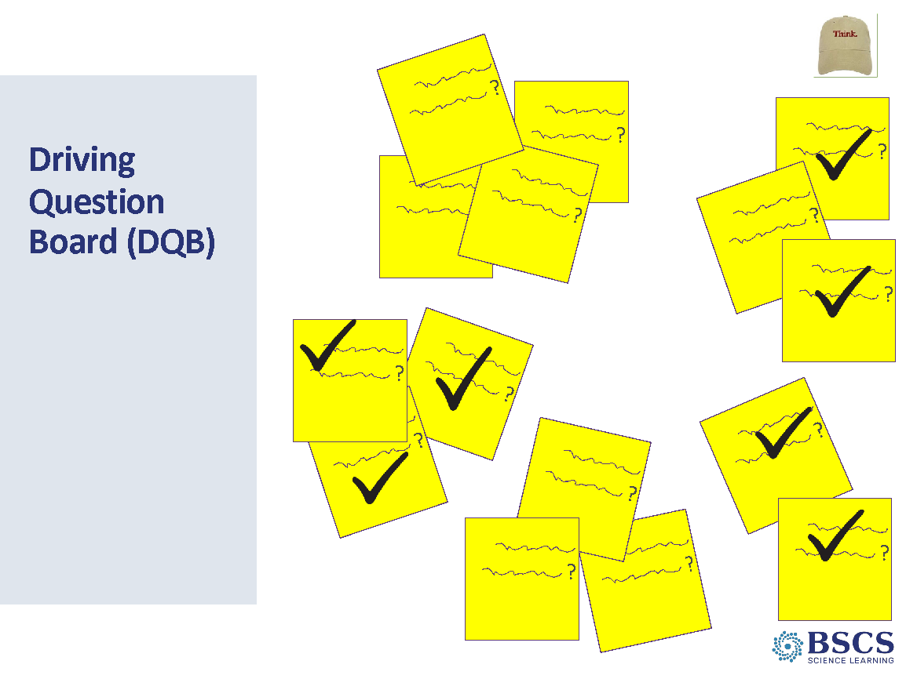 | - Driving Question Board (5 mins for slides 49-50)  - Revisit Driving Question Board to identify what questions we have answered in the last two lessons.  - Invite participants to identify questions what they think we have answered. Add a dark check mark on questions the group feels like they have answered.  - Invite participants to consider questions that they still need to figure out or add to the DQB in order to answer the Unit Central Question.
 |  | 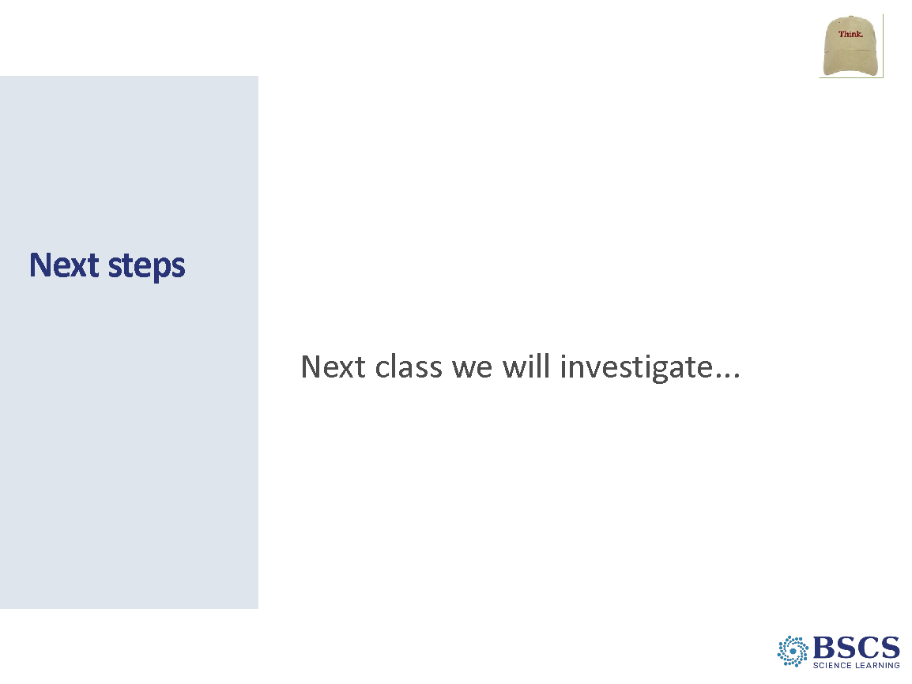 | - Next Steps (0 min)  - Share that we still have questions about other kinds of energy such as light, sound, and heat. Tomorrow we will look for evidence of other kinds of energy.
 |  | 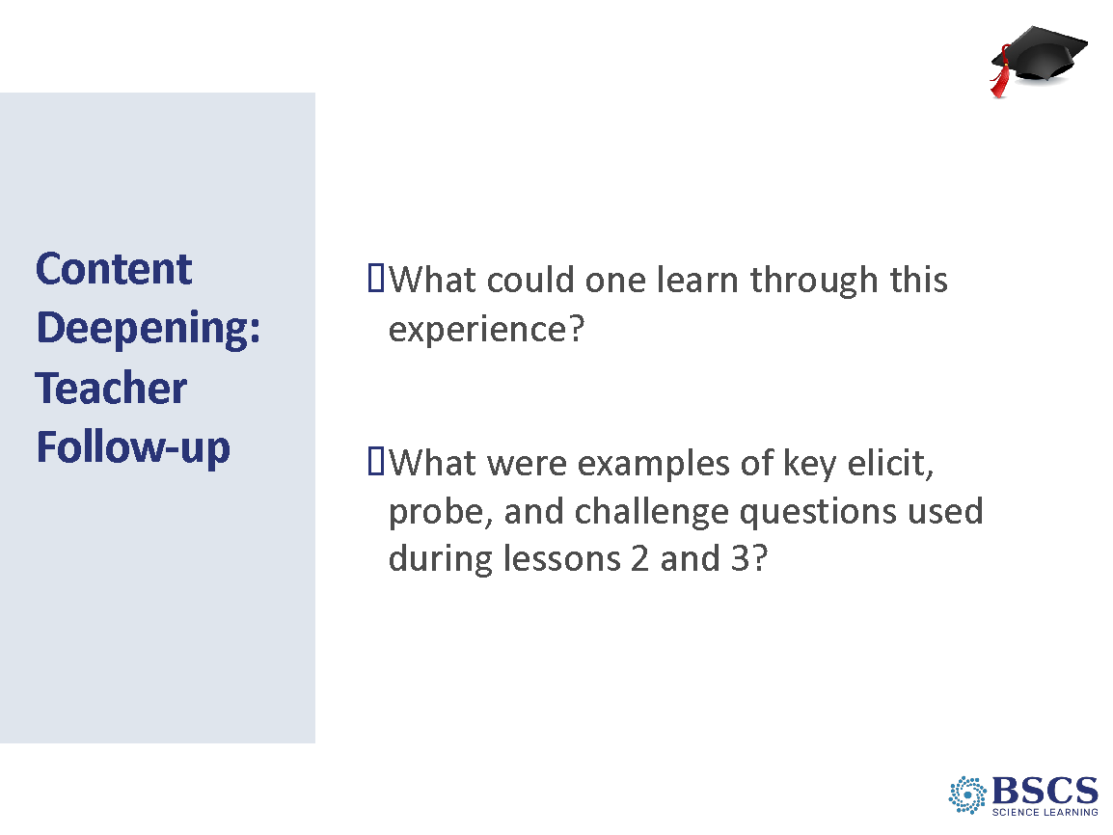 | - CD: Teacher Follow-up (10 min)  PDL Note: This Teacher Follow-up should continue teacher learning from the content deepening experience. This part of the session should engage teachers as learners and support them in explaining and reflecting on their experience. The teacher follow-up should include attention to the STeLLA strategies studied so far and how the STeLLA strategies may have supported that learning. Given that teacher’s homework, charting, and video analysis included STL Strategies 1, 2, and 3, you could expect them to make their current thinking visible. Take note of naïve conceptions and stay focused on the bigger picture of making thinking visible.  - What can we add to our “learning” charts?  - Probe ideas about EPC questions that teachers suggest for chart 4 (Misc.). Examples could include:  - How did that question influence your thinking? Learning?  - Why was that important?  - What did you notice about the sequence of questions?  Transition: Now that we’ve experienced several lessons and thought about how the STeLLA lessons incorporate strategies to make student thinking visible, we’ll continue to deepen our understanding of and ability to use these strategies with some focused practice.
3:20 - 4:10  50 min  Slides 52-56  Study Group Teams | Practice Probe and Challenge  Purpose: The purpose of this session is to continue to develop a common understanding of elicit, probe, and challenge questions, to support teachers as they develop the ability to effectively ask probe and challenge questions, and to emphasize the importance of planning.  Content: Probe questions are used to gain additional information about a student’s current thinking and build on the ideas they have made visible. They help guide a teacher’s instruction and are a powerful resource for student learning. Challenge questions help students think more deeply about science ideas and prompt students to link ideas and/or reconsider their ideas. Challenge questions (and probe Qs for that matter) avoid leading students to the right answer. Teachers need deep content knowledge to ask productive elicit, probe, and challenge questions.  What participants do  Participants practice planning for and using probe questions and then repeating the process to practice challenge questions.  Resources  - Practice Probe/Challenge Protocol  - Card set of elicit questions (1 set/2 participants) | 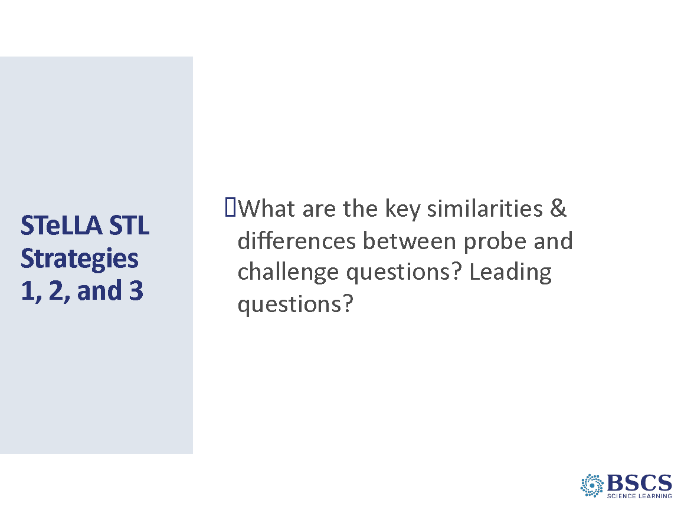 | - STeLLA Strategies 1,2, and 3 (10 min)  - Point to the strategies highlighted on the slide – we will again focus on the Student Thinking Lens questioning strategies – elicit, probe, and challenge.  - Note that we’ll dive more deeply into these strategies in two practice rounds. It’s one thing to study these strategies, analyze their use by others in video or content deepening and it’s another to use them ourselves.  - Invite participants to pull out their completed Z-fold and Strategies Booklet
 |  | 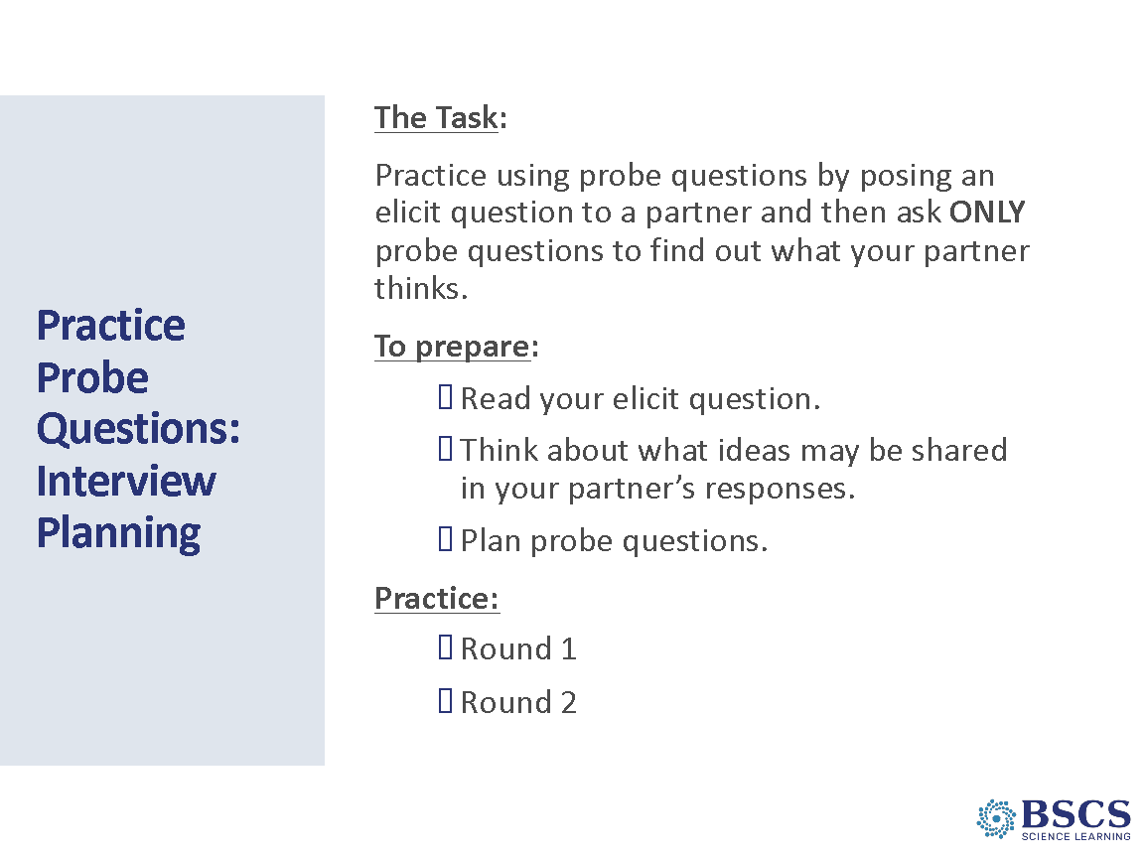 | - Practice Probe (10 min)  - Direct participants to the Practice Probe/Challenge Protocol (PD Binder p. __) and describe the task – we will practice probe questions by interviewing each other. The challenge is to pose an elicit question to a colleague and then follow up by ONLY asking probe questions.  - Pass out a different elicit question to each participant.  - Prepare to interview each other. Make sure that participants switch roles halfway through the time.
 |  | 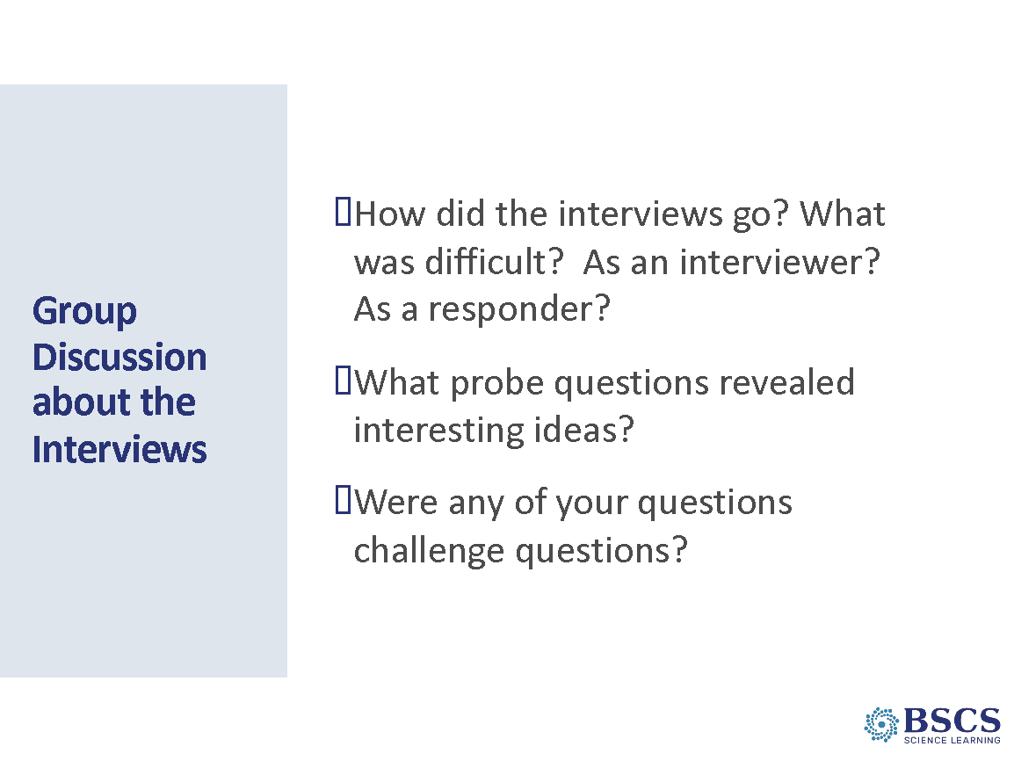 | - Group Discussion/Interview (5 min)  - Discuss the questions on the slide.  - If time, ask: How might doing more of this type of practice (with a partner or small group) help your teaching?
 |  | 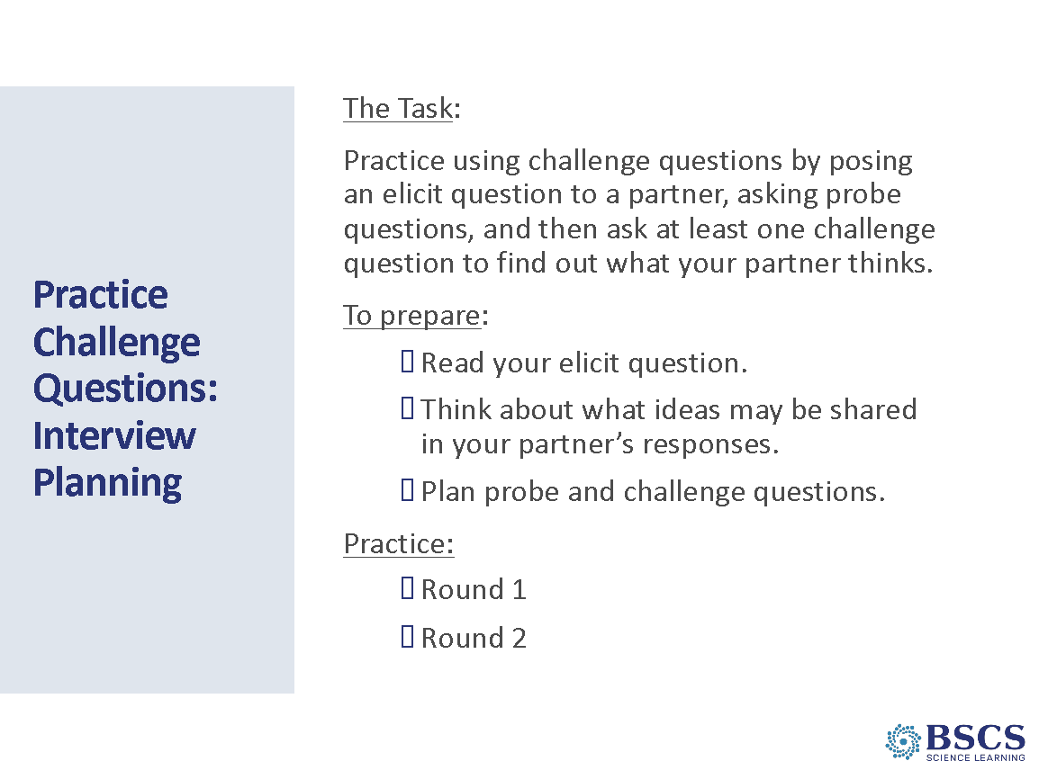 | - Practice Challenge (10 min)  PDL Note: Skip this practice session if time is short.  - Describe the task – we will practice challenge questions by interviewing each other. The challenge is to pose an elicit question to a colleague and then follow up by asking probe questions and at least one challenge question.  - Pass out a different elicit question to each participant.  - Prepare to interview each other. Make sure that participants switch roles halfway through the time.
 |  | 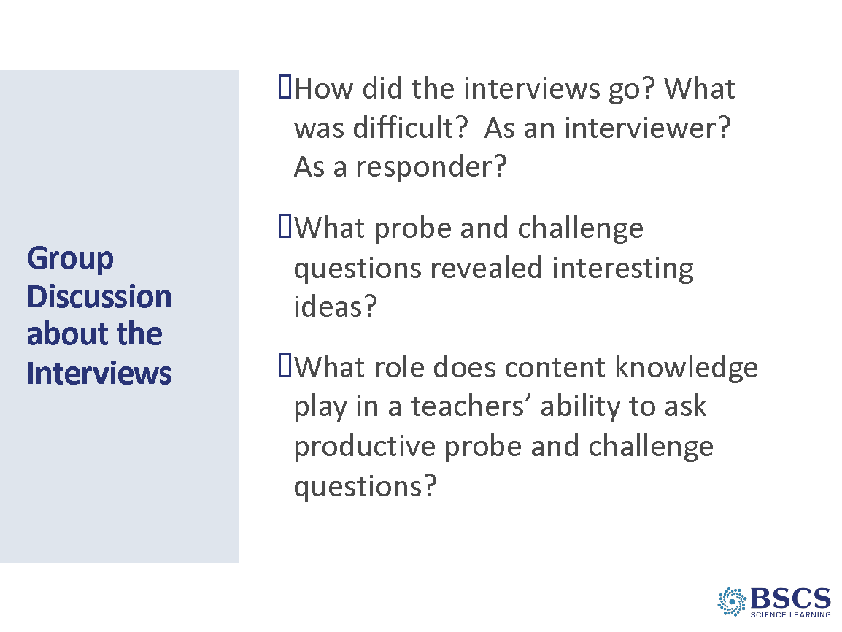 | - Group Discussion/Interviews (15 min)  - Discuss the questions on the slide.  - If time permits, ask participants how doing more of this type of practice (with a partner or small group) helps your teaching practice.
4:10 - 4:30  20 min  Slides 57-62  Study Group Teams | Closing and Reflection  Purpose: The purpose of this session is to reflect on the day’s experiences and learning and prepare for Day 3.  Content:  Focus Questions:  - How can lesson analysis help us better understand how elicit, probe, and challenge questions reveal and challenge student thinking?  - How can we develop a classroom culture focused on student thinking?  - What happens to motion energy when objects collide?  - How can we change the amount of motion energy of an object?  What participants do  Participants reflect on learning from both days 1 and 2.  Resources  - BSCS Journal  - PD Binder  - Day 2 Daily Reflection  - STeLLA Strategies Booklet  - SCSL Z-fold  - Charts  - Effective Science T&L |  | - Focus Questions (0 min)  - Highlight the day 2 focus questions.
 |  | 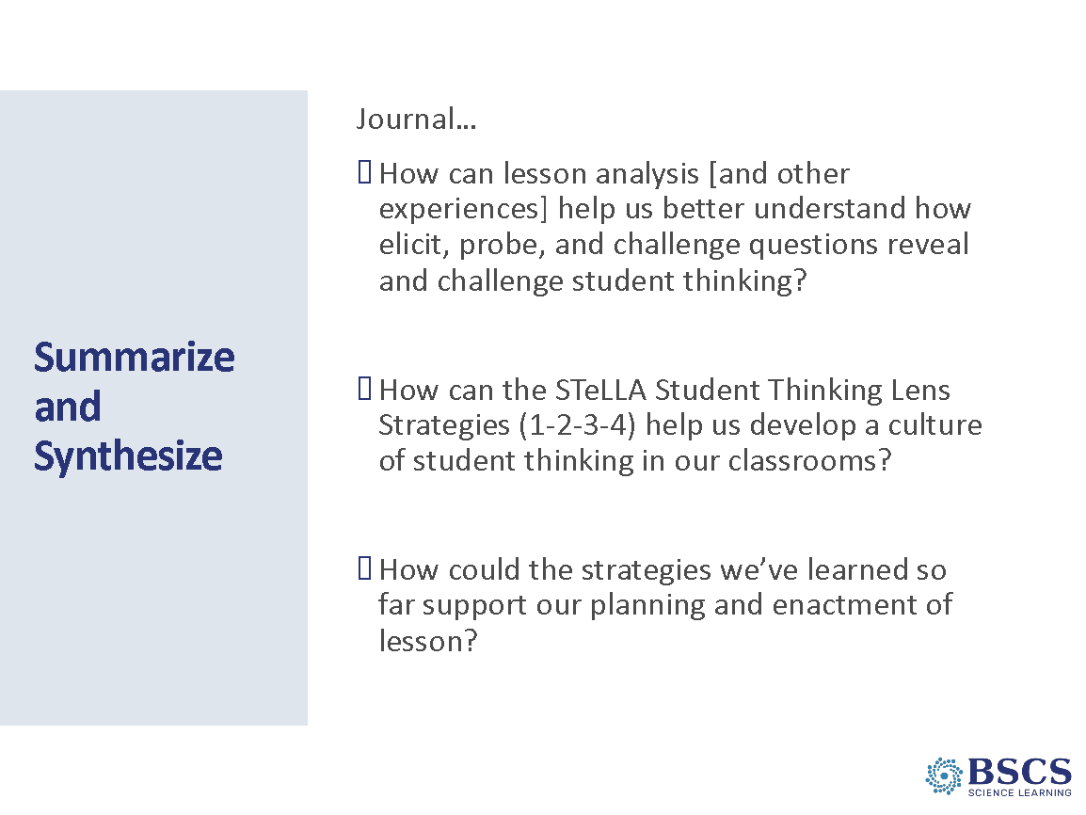 | - Summarize and Synthesize (5 min)  - Provide instructions for the task.  - Note that they should be prepared so share some of the ideas they’ve written down.  PDL Note: Check the Parking Lot for questions and comments. Respond as needed.
 |  | 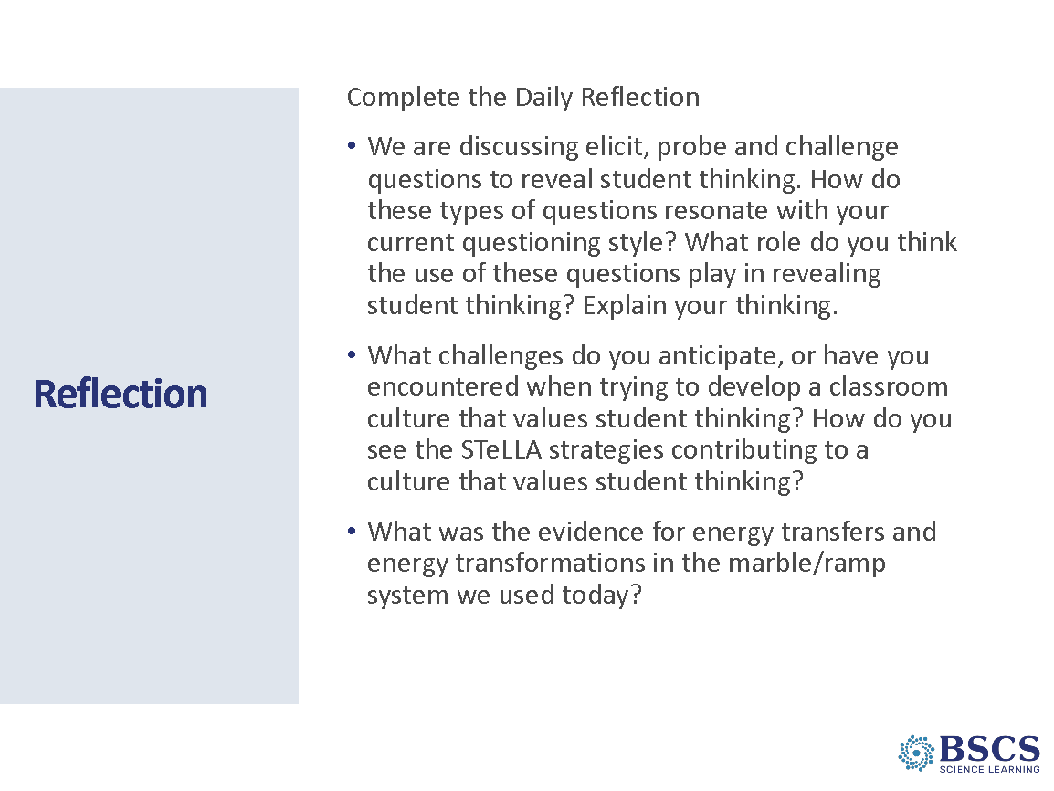 | - Reflection (10 min)  - Direct participants to the daily reflections sheet (PD Binder p.__). Completed sheets can be left in the center of each table.  - Remind participants that the parking lot is available for any concerns or questions.
 |  | 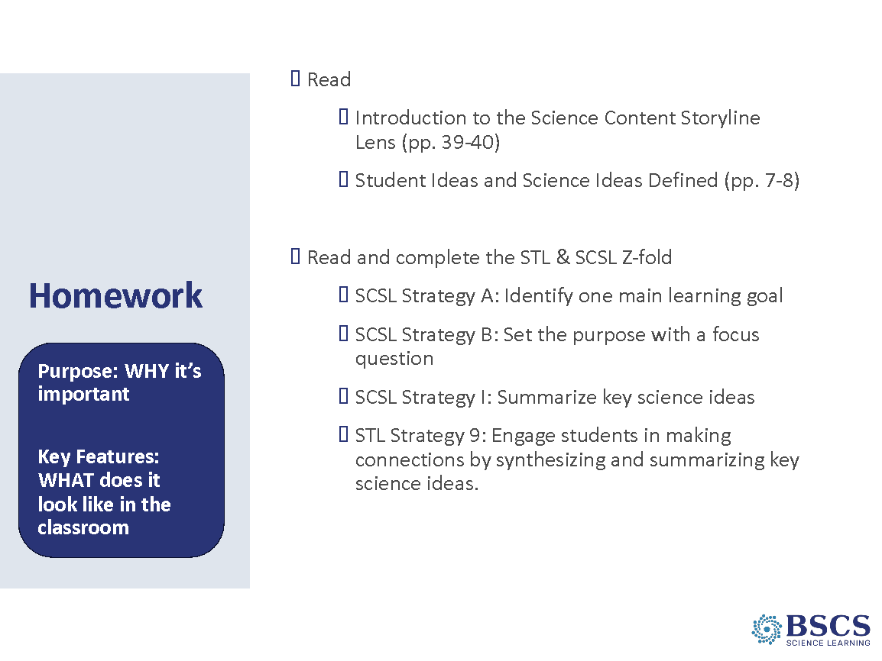 | - Homework (5 min)  - Refer to STeLLA Strategies Booklet and STL/SCSL Z-folds.  - Provide instructions for homework.  - Remind participants that we’ll begin in the whole group for Day 3. They will need their Z-folds, STeLLA Strategies Booklet, the Walk-about-Review HO (p.__) from their PD binder, a writing utensil, and a few 3X3 sticky notes.  PDL Note: Use participant ideas from the Synthesize and Summarize journal entry to emphasize the role of EPC, classroom culture, and planning/enacting lessons to begin the transition.  Transition: Today we deepened our understanding of how communicating in scientific ways can bring student ideas to the table and how teacher elicit, probe, and challenge questions can reveal and move student thinking forward. Tomorrow we will think about how one main learning goal and setting the purpose with a focus question can support our EPC decision making, and how summarizing key science ideas gives students a chance to consider how their thinking has changed.
 |  |  | - BSCS (0 min)

