SSUP: Making the Case Virtual Session
Program Goals
- Deepen knowledge of teaching and learning
- Increase ability to analyze and reflect on teaching and learning
- Increase ability to use content knowledge and knowledge of teaching and learning to transform classroom practice
- Deepen teacher content knowledge
- Increase student learning in science
Session Learning Goals
- The understanding and application of research on teacher and student learning has shown that the STeLLA Student Thinking and Science Content Storyline Lenses are important to improve science teaching and students’ learning.
Session Focus Question
- What are the STeLLA Lenses and Strategies, and why do we think they will make a difference in your science teaching? Increase student learning in science
Ideal Teacher Response
- The two STeLLA Lenses are the Student Thinking Lens and the Science Content Storyline lens. The lenses and associated strategies are based on meta-analyses of research from TIMSS and How People Learn/How Students Learn Science in the Classroom.
Session Preparation
Well Before
- Make a copy of the template PDLG and PPT in your folder.
- Become familiar with slides and PDLG, think through the goals/purpose for each section, consider possible participant responses (What do you expect to hear? Hope to hear? What ideas might you want to probe if they surface?)
- Look through slides and pace out timing
- Specify Zoom roles with co-leader (who is running slides, who is leading which parts, who is “tech support” for which parts)
- Reach out to BSCS Leaders for support and questions!

Before
- Check links to TIMSS video, videos for Japanese and US classrooms, Minds of our Own (no need to make individual copies): https://drive.google.com/drive/folders/1NQ8gZlzVp3KCU8rBUs3NL2wOQ7VDugcZ
- In your group’s subfolder, make copies of the Google Form for your study group. Make sure you check permissions for participant access and customize each copy as needed. https://docs.google.com/forms/d/13dIgL7oc6vULep0WOV0ft5c0VxWlRugvWruvZRw-TB8/edit
- You will need the link for your group’s Effective Science Teaching and Learning Google Doc to share with the group on slide 18

Right Before
- Double check links and permissions
- Make both PDLs co-hosts

SESSION OUTLINE: 180 min
Time | Purpose and Content | Activities
Preparation | Materials Needed (Mailed ahead of time)  STeLLA Strategies Booklet  BSCS Journal  STeLLA Norms  TIMSS_Ed_Leadership  Transcript_US_TIMSS  Transcript_Japan_TIMSS  ResearchSummary Principles_HSL_HPL_HPLII_012522
25 min  Slides 1-5 | Opening  Purpose: Continue building community and connect back to Program Goals and Norms.  Content: Today’s session will make the case for the STeLLA Science Content Storyline and Student Thinking Lenses. | Opening  - Welcome  - Program Goals  - Agenda  - STeLLA Norms
65 min  Slides 6 - 12 | Purpose: Gain insights into some of the research and literature that underpins the STeLLA Conceptual Framework and for them to be able to make the case for the STeLLA Conceptual Framework, specifically the Science Content Storyline Lens.  Content: The TIMSS Video Study provides an example of research that underpins the STeLLA Conceptual Framework, specifically the Science Content Storyline Lens and Strategies. The TIMSS Study showed the importance of connecting lesson activities to science ideas to form a coherent science content storyline in science lessons. | The Case for The Science Content Storyline  - Set-up SCSL  - TIMSS Video Study (Article & Videoclips)  - Follow-up
80 min  Slides 13 - 18 | Purpose: Gain insights into some of the research and literature that underpins the STeLLA PD program design and for them to be able to make the case for the STeLLA Conceptual Framework, specifically the Student Thinking Lens.  Content: HPL/HSL summary chart describes the findings from the meta-analysis of research on learning and includes the importance of accessing prior knowledge and experiences, developing a conceptual framework, and developing metacognitive abilities | The Case for The Student Thinking Lens  - Set-up  - Minds of our Own/HPL/HSL Summary  - Follow-up
10 min  Slides 19 - 22 | Purpose: Reflect on learning and prepare for Summer Institute.  Content: Focus Question:  What are the STeLLA Lenses and Strategies, and why do we think they will make a difference in your science teaching and students’ learning? | Closing  - Revisit Focus Questions  - Reflections  - Homework:  - Read STL overview and Z-fold STL 1, 2, and 3

Virtual Session 2: Making the Case
Slides & Tech Notes | Process
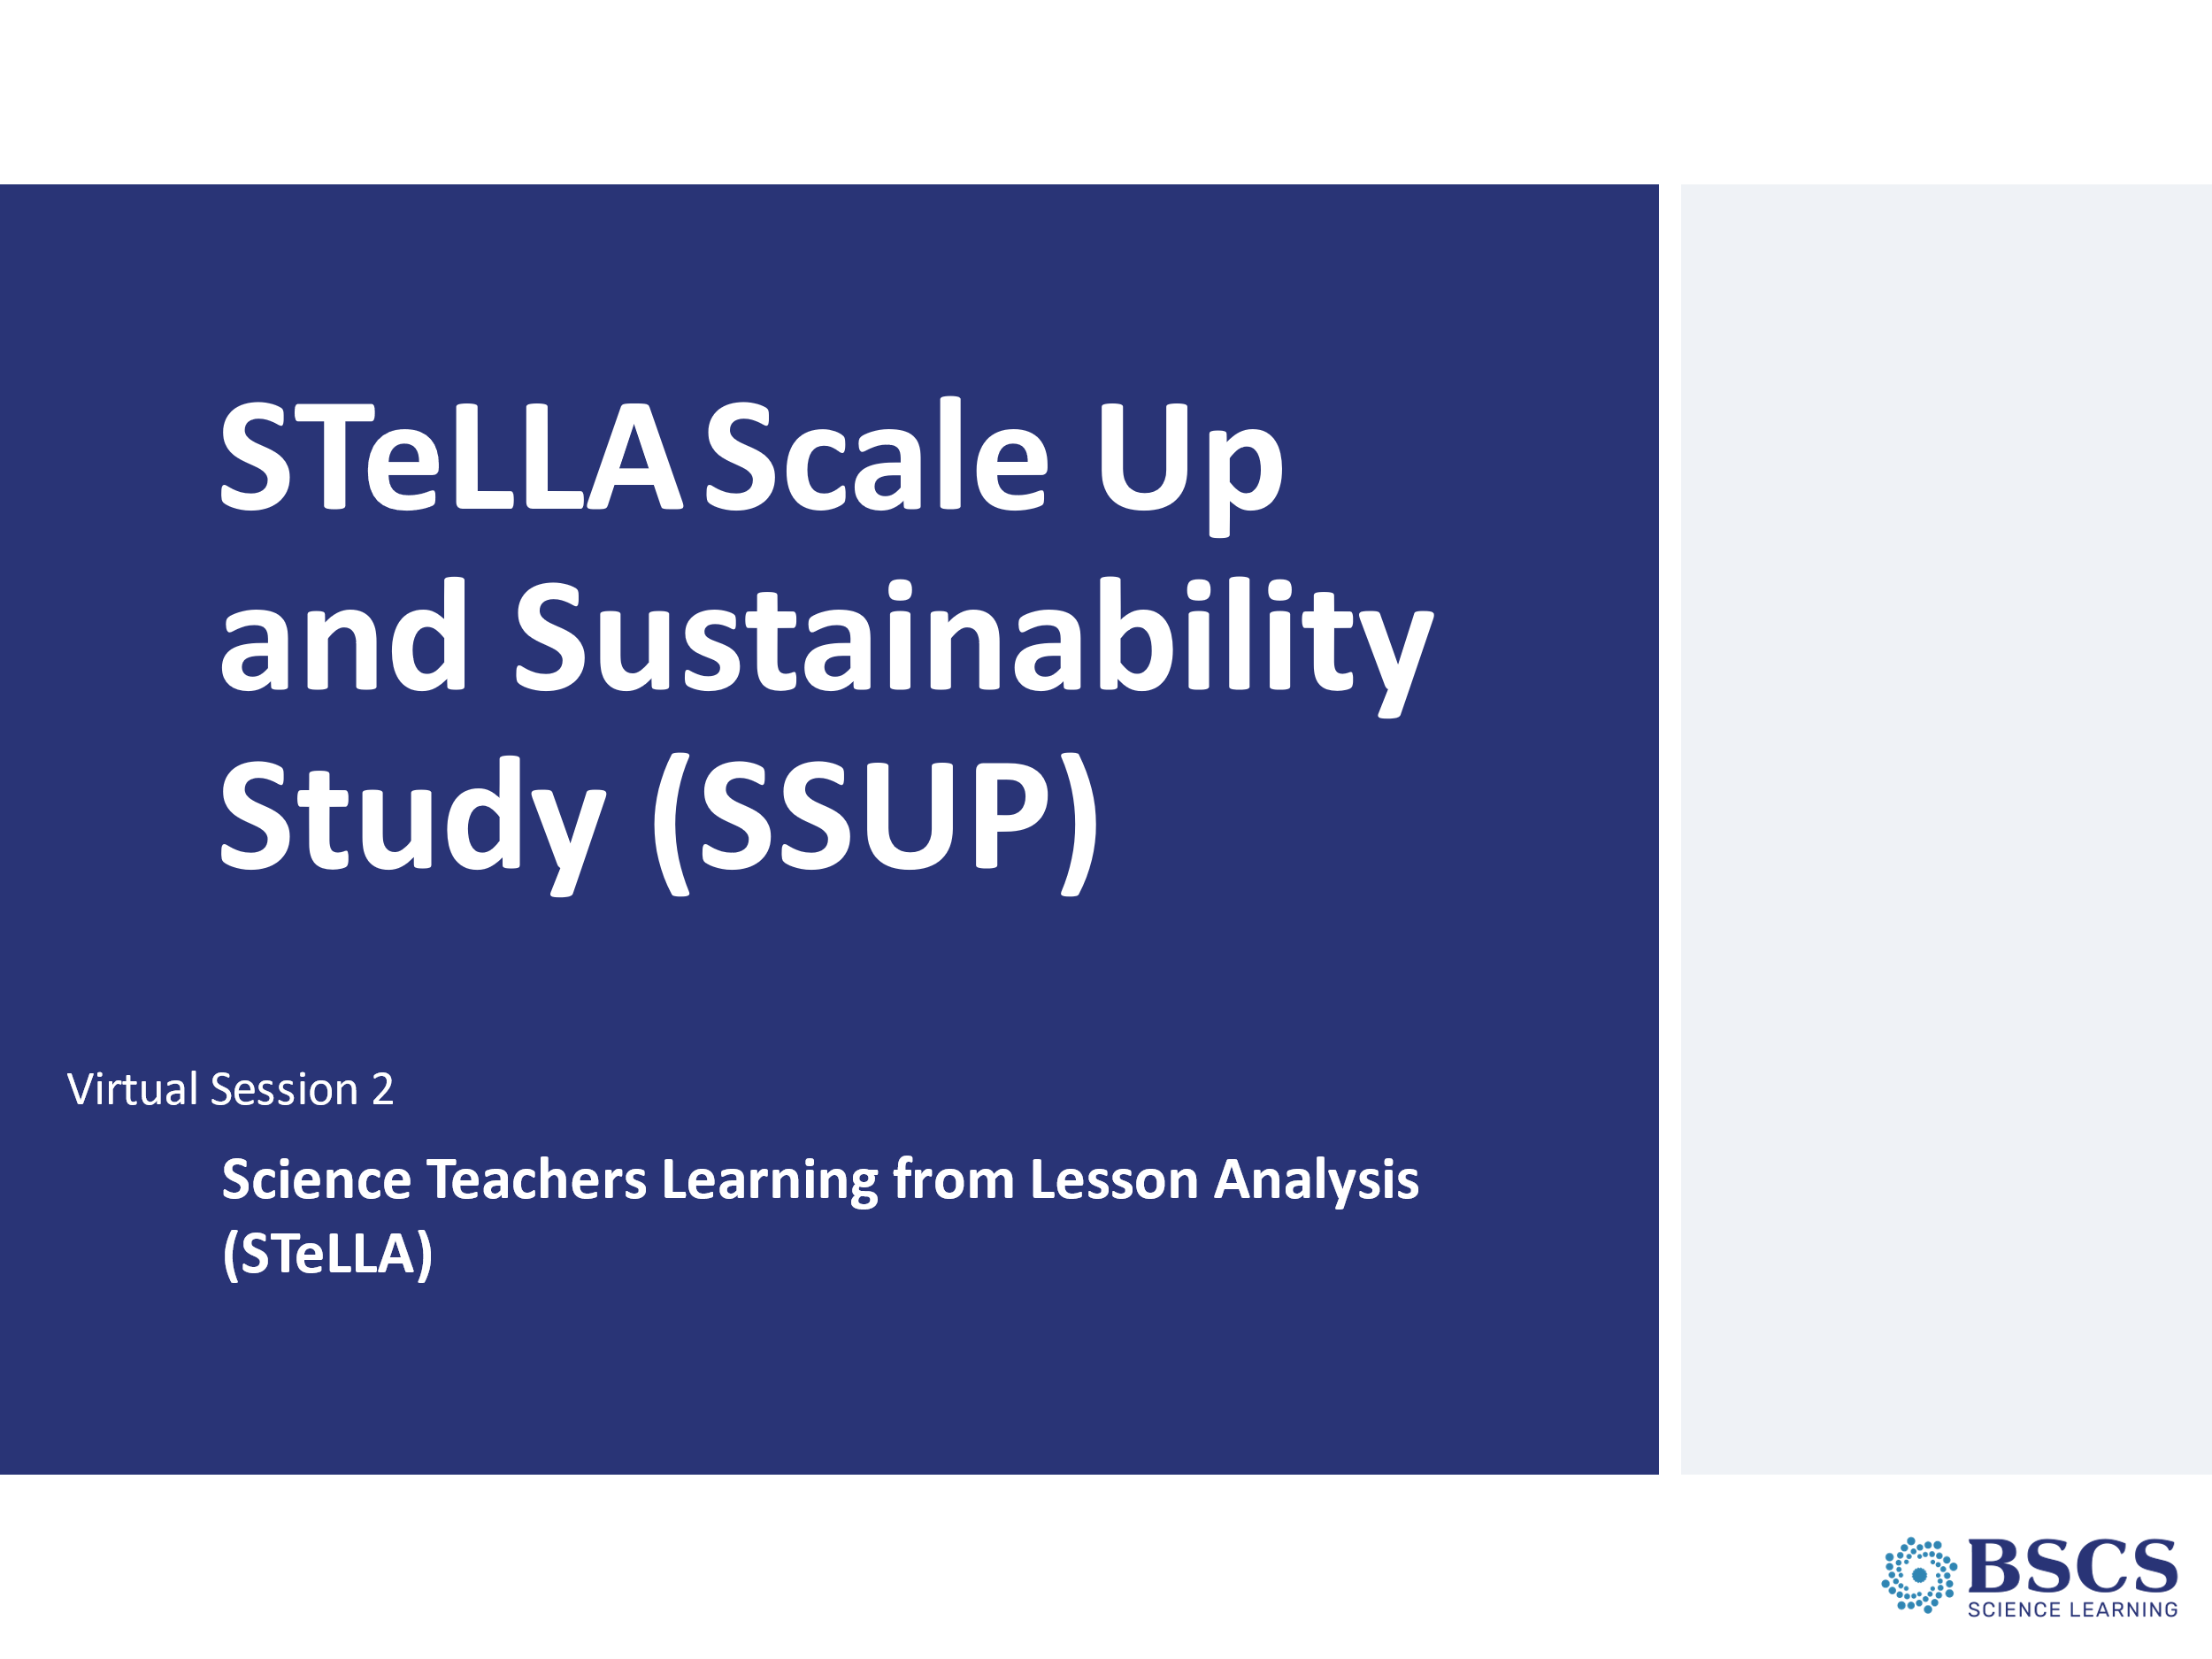 | - Making the Case (0 min)  - Greet participants as they enter the room. Help them pick up their materials and find their small group.
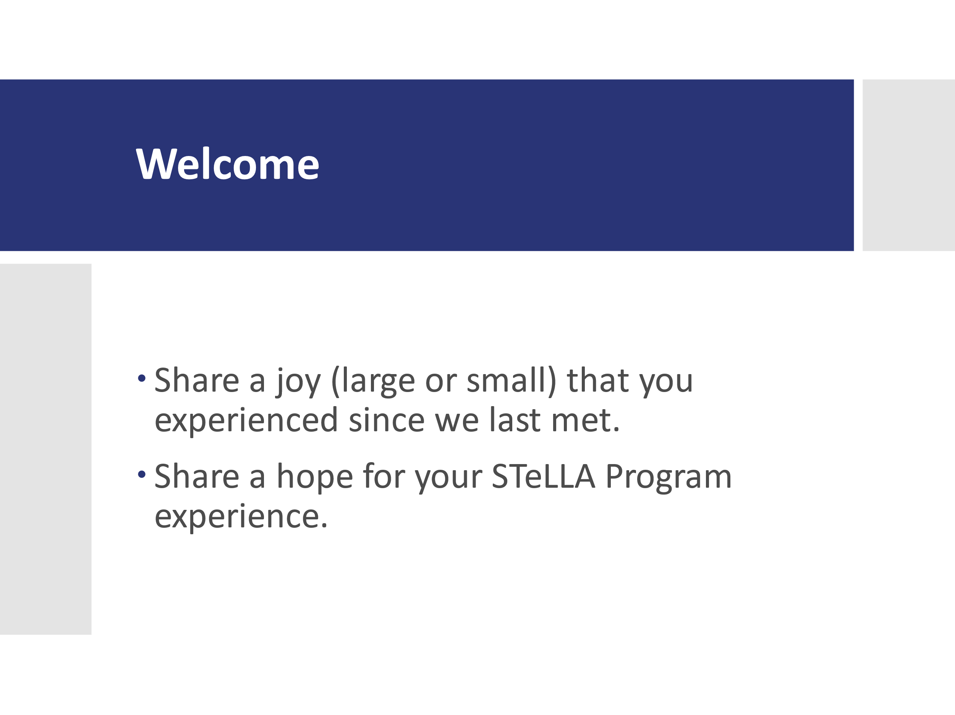 | - Welcome (10 min)  - Welcome the team and frame this second virtual session as part of continuing to get to know one another and building community.  - Invite participants to share a joy since the last virtual session and a hope for the work to come.
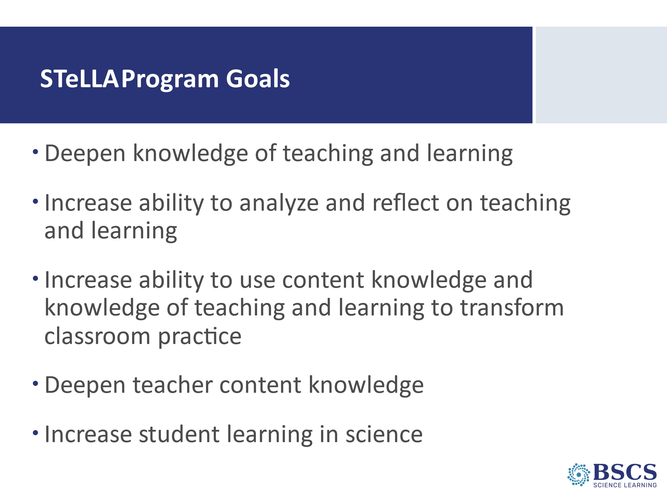 | - Program Goals (5 min)  - Briefly share the program goals (p. __).  - Forecast that we will work toward these goals together today and throughout the academic year. Note that today’s session will help us think together about why we think this program will “work”.  - Ask participants to consider how these goals resonate with their hopes. Invite participants to record some ideas in their notebook.
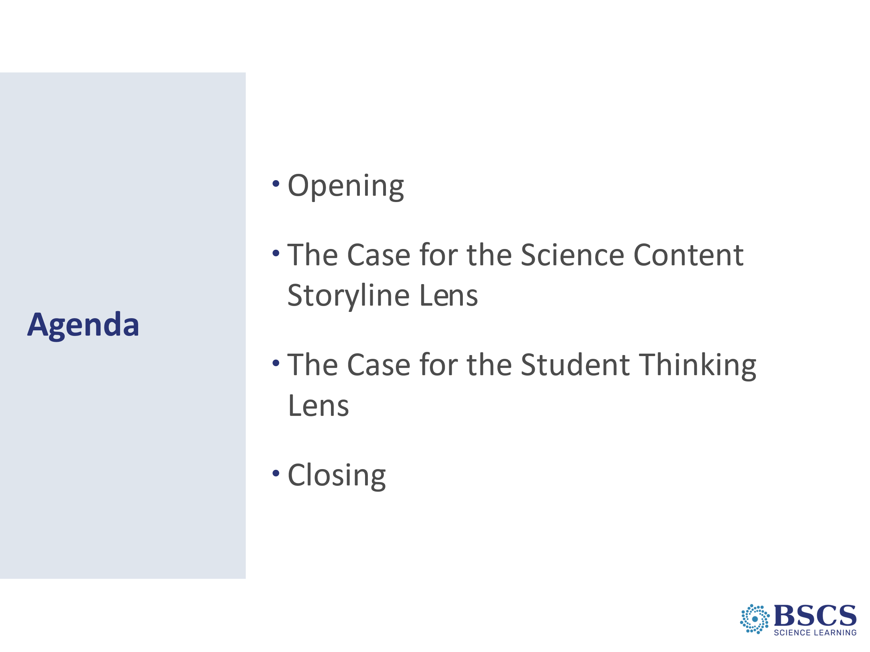 | - Agenda (5 min)  - Share the agenda and note that there will be homework.  - Link back to our previous session for the Project Kickoff. We discussed that the STeLLA Conceptual Framework is split into two lenses. Hold up or cite the front of the strategy booklet. Mark that the work of this session is to gain a shared understanding of the research that led to the creation of each of these lenses.  - Remind participants how we will work.  - Parking lot  - Breaks/take care of your own needs
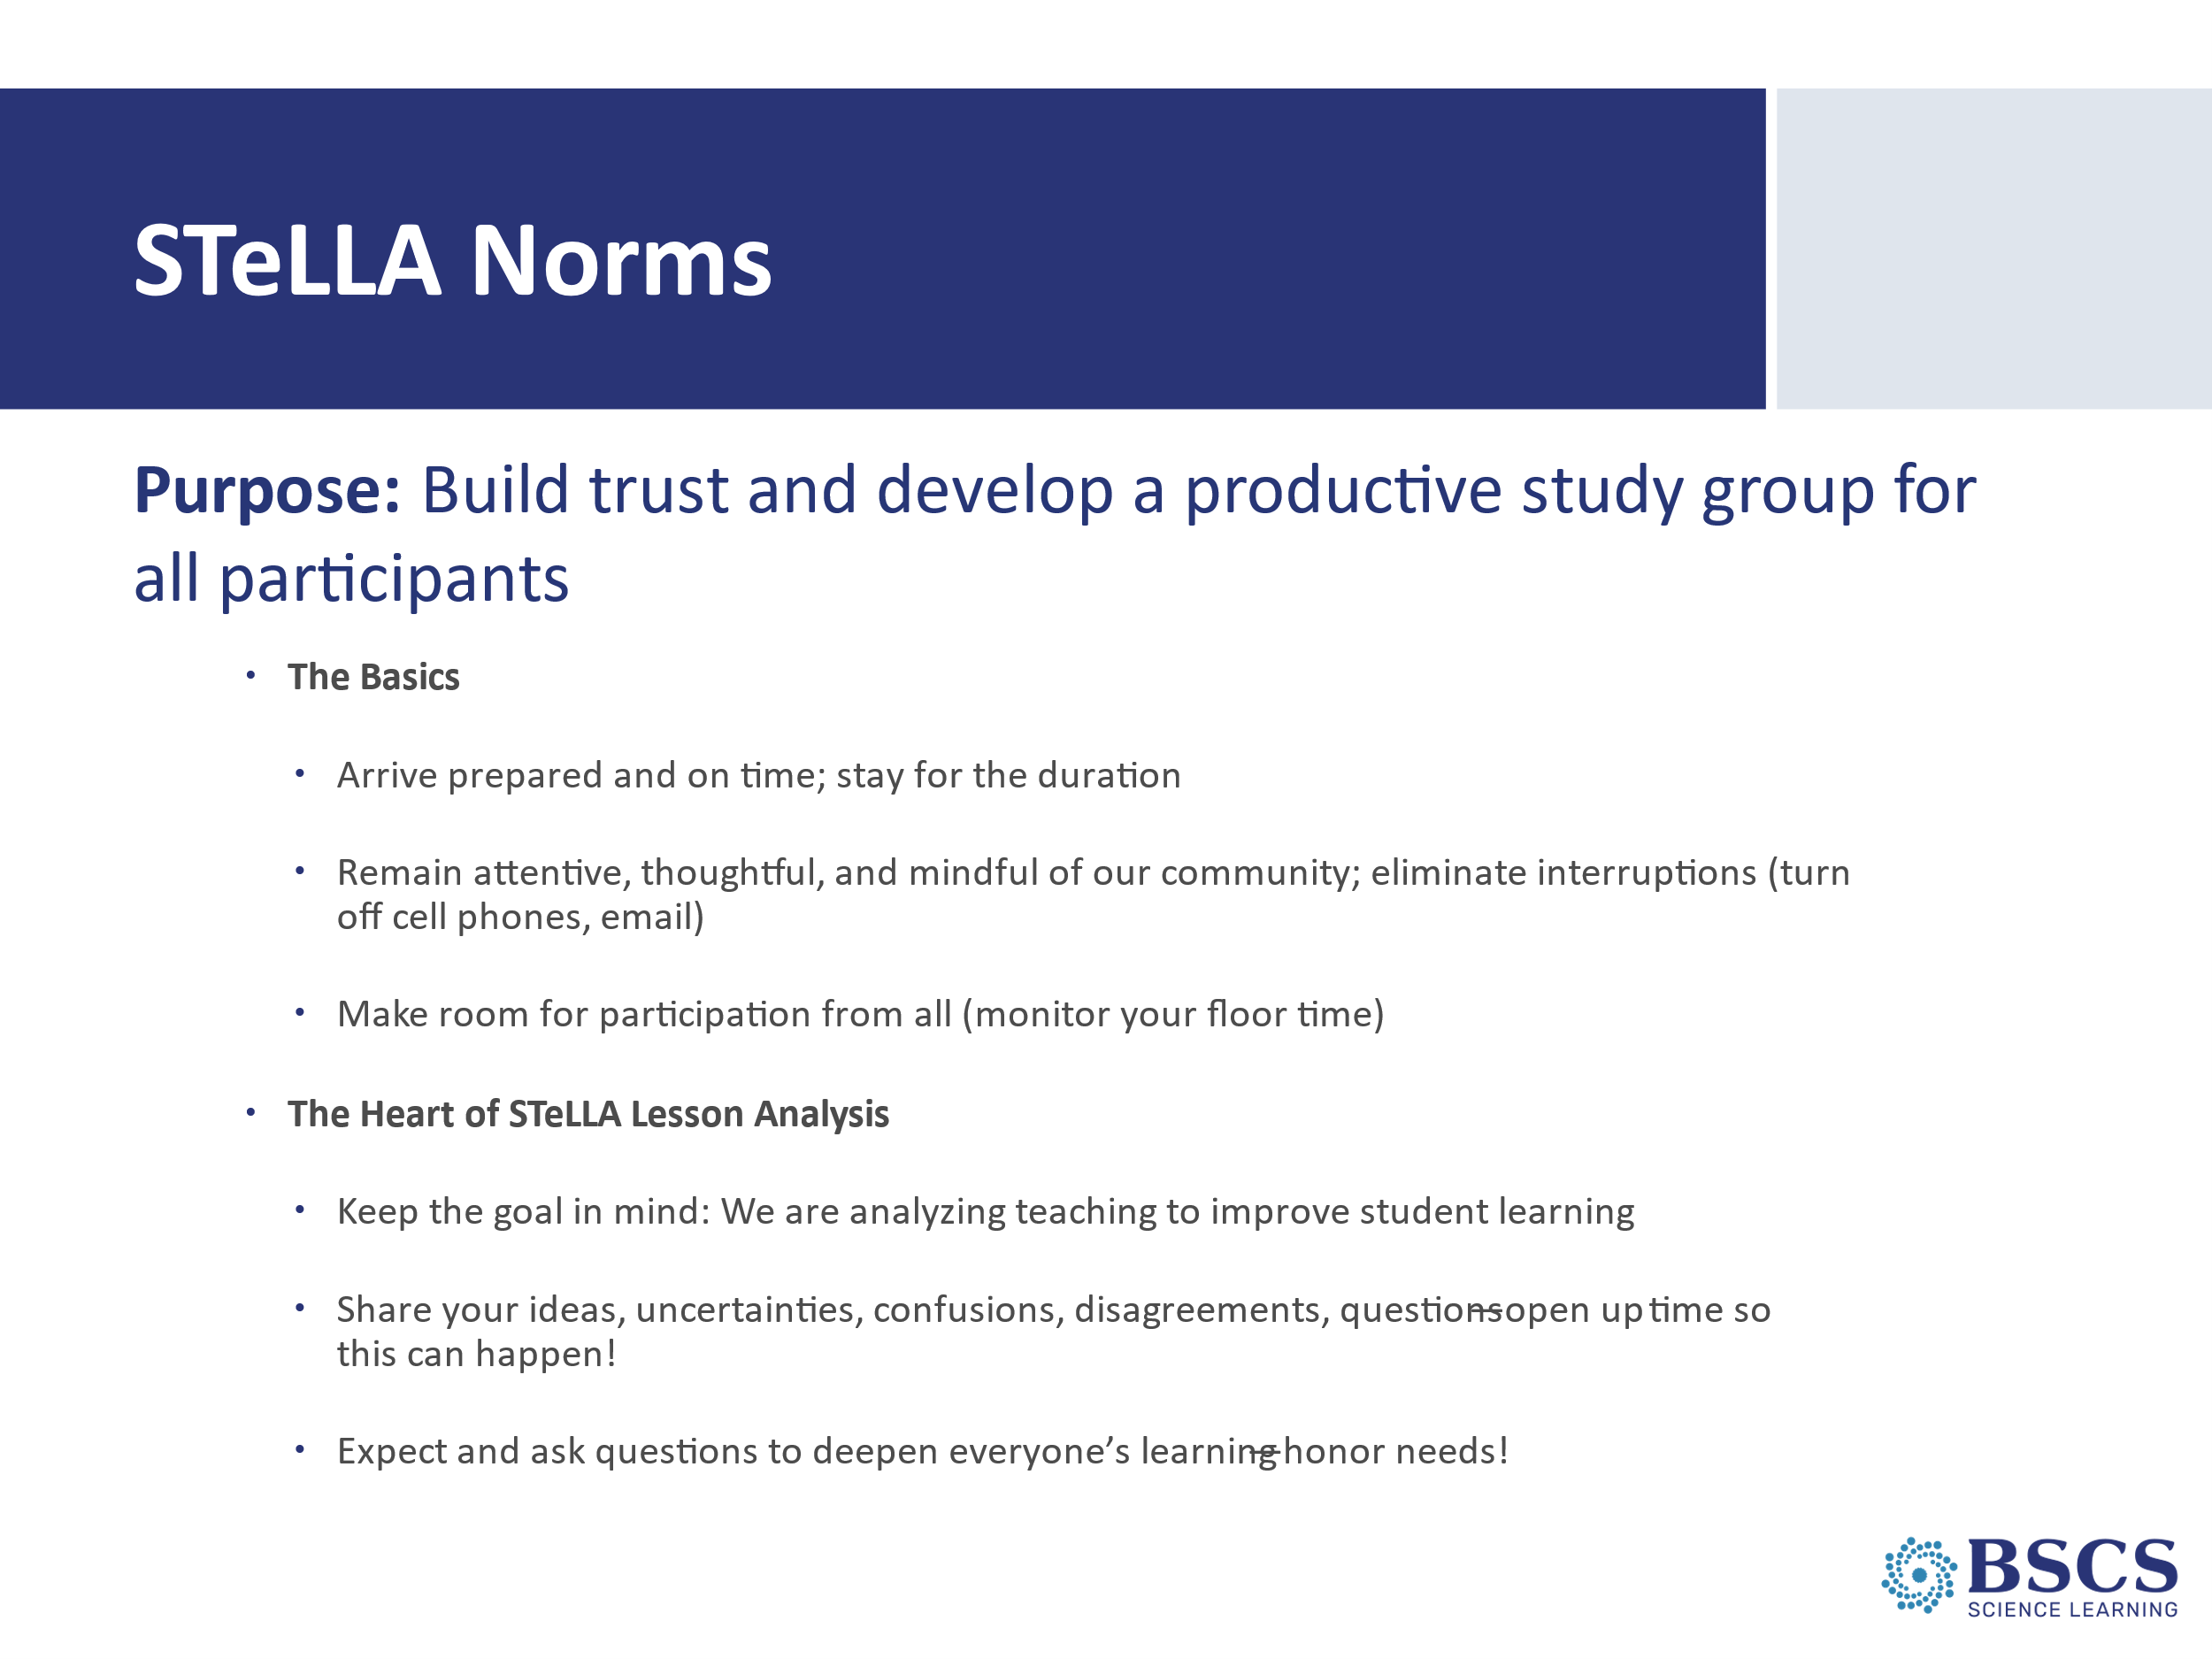 | - Norms (5 min)  - Refer participants to p.__ in the PD binder.  - Remind the group that they annotated these STeLLA Norms at the last session. Ask that in their second read of the STeLLA Norms, they consider what is standing out to them today and to share a few words in the chat.  - Highlight the purpose of norms in collaboration (i.e., learning together) and link to their ideas as possible. Note that we’ve found these particular norms to be especially helpful in the work of a STeLLA Study group.  - Ask for any clarifying questions and then to note which norms they think are really important to promote collaboration.  - Share that we’ll revisit the norms periodically and take some time at Summer Institute to customize them for our work together.
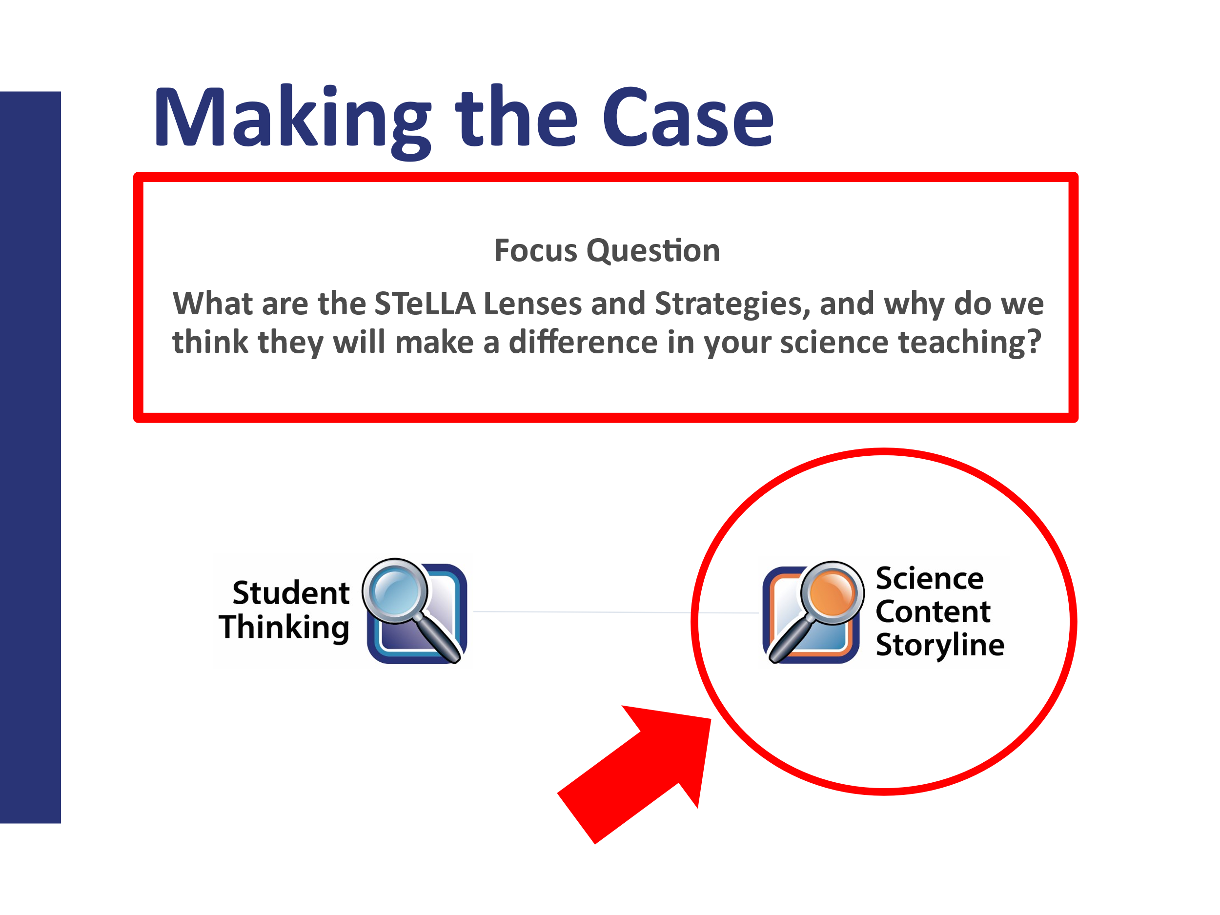 | - Making the Case (0 min)  PDL Note: This slide is animated.  - Review the focus question and note that we’ll begin by studying selected parts of the research and literature that underpins a foundational component of the STeLLA PL program—the STeLLA Conceptual Framework (point to the cover page of the strategy booklet).  - Share that we will first consider the research for the Science Content Storyline Lens.
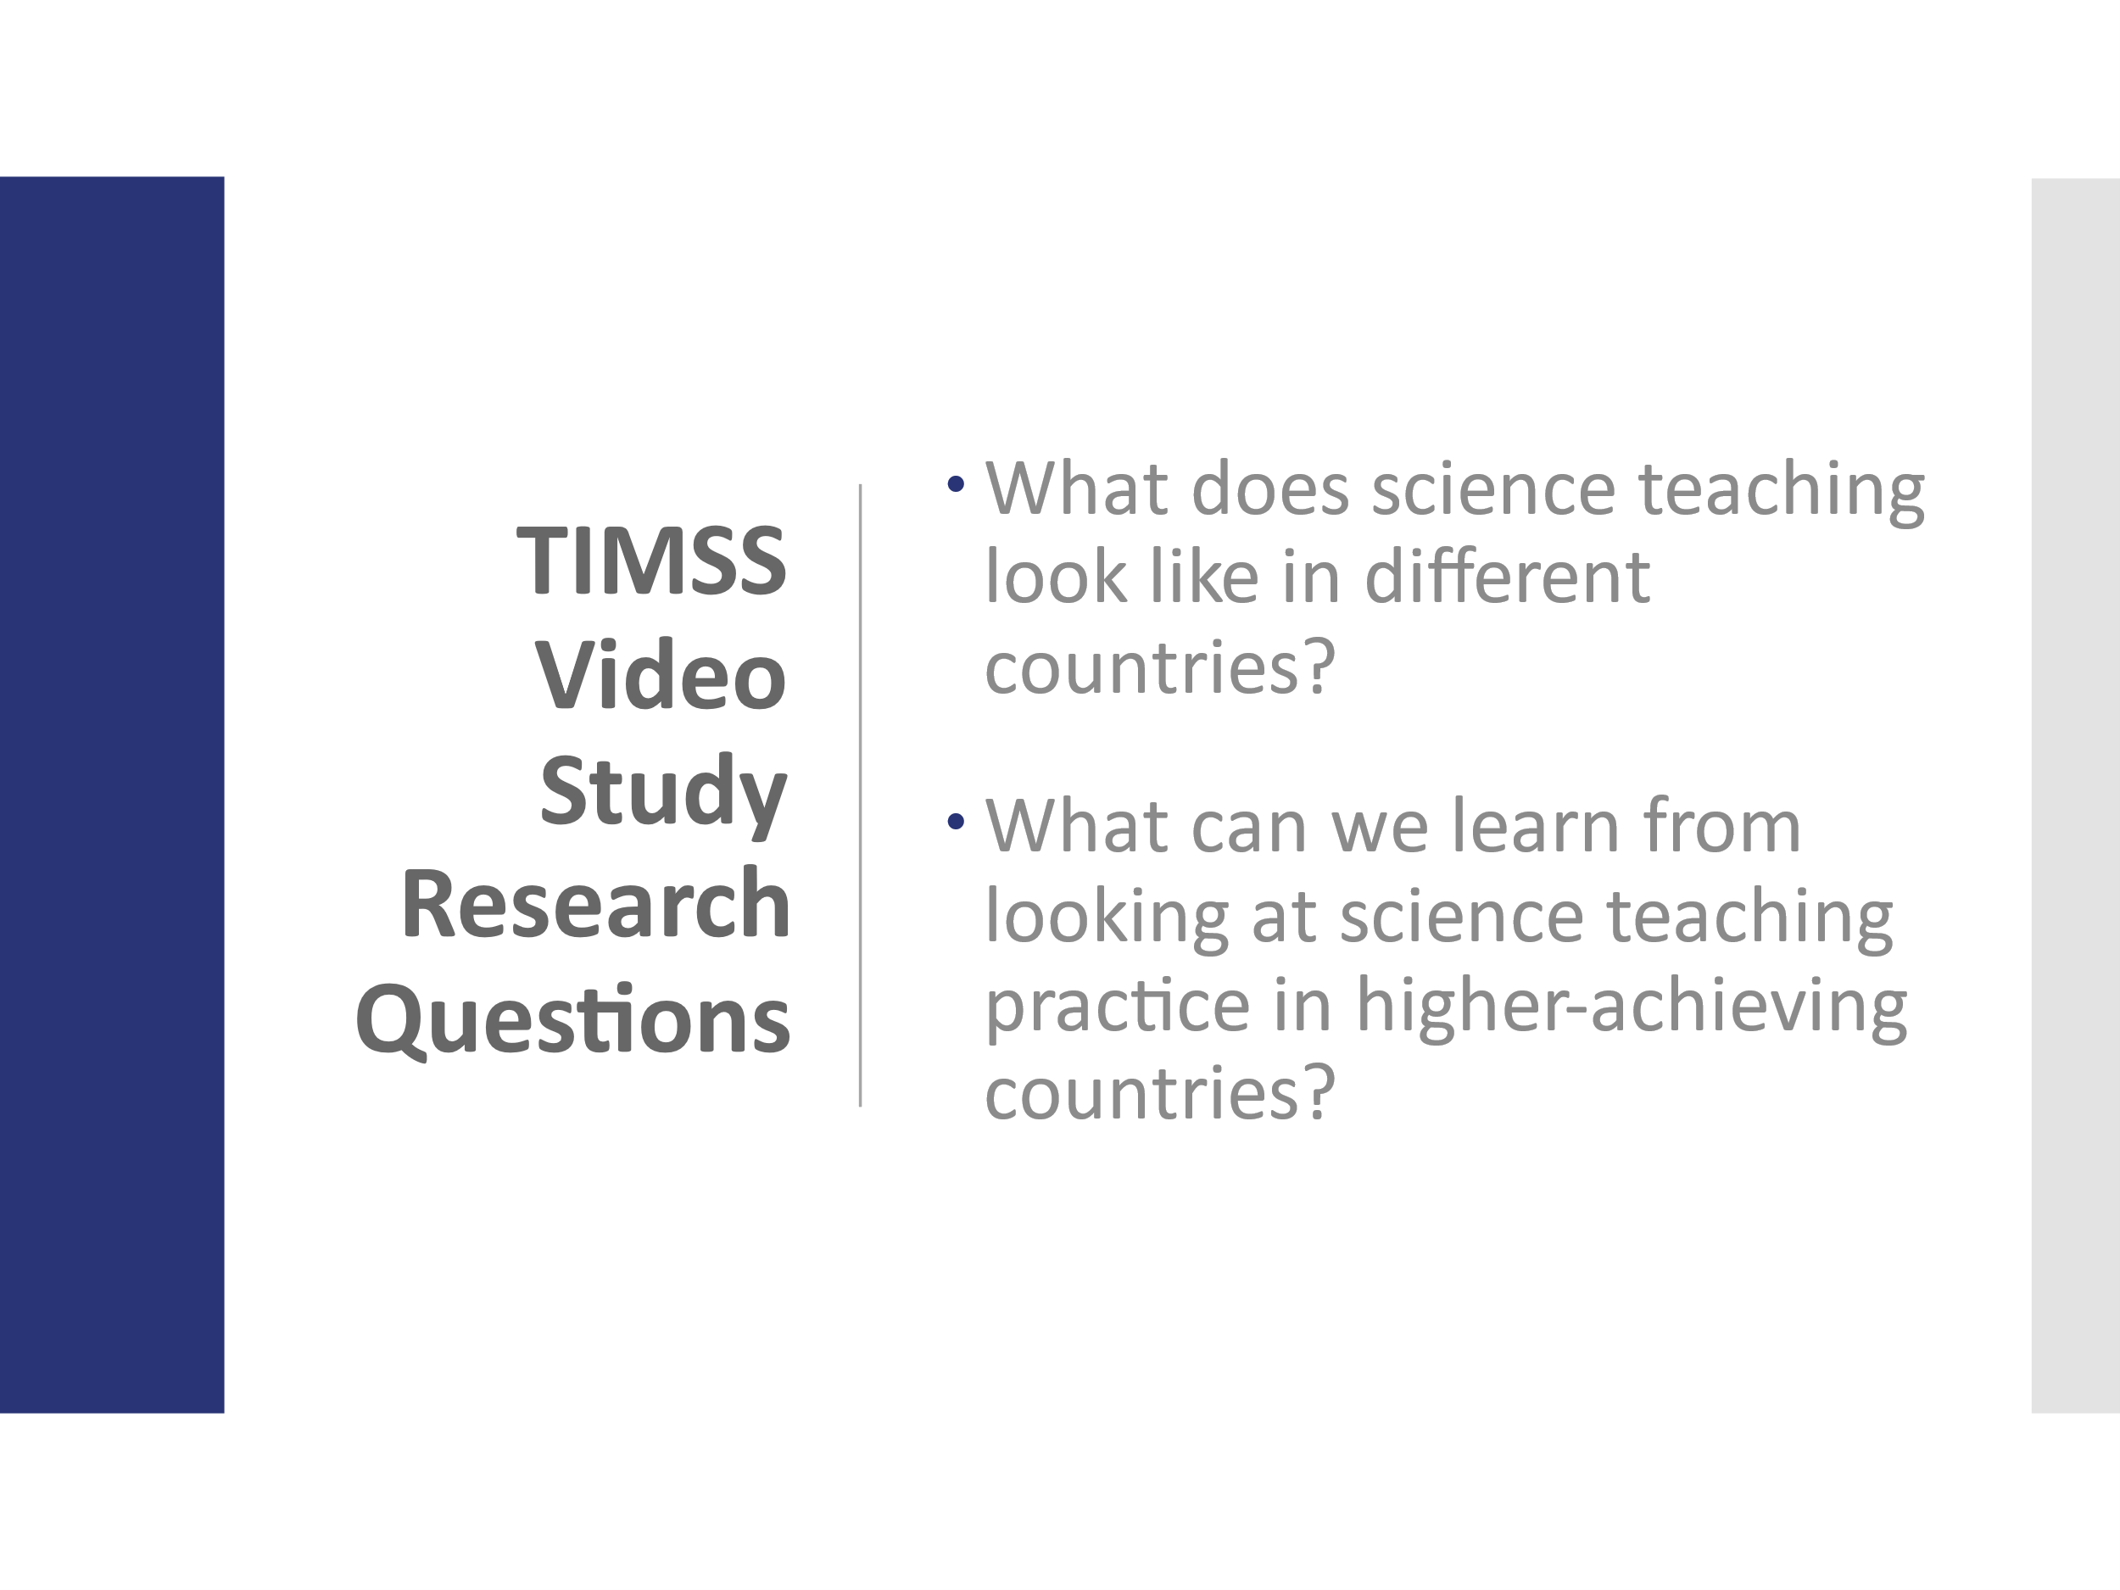 | - TIMSS Video Study (5 min)  - Share the two research questions that guided the study. Emphasize these questions as REAL wonderings.  - Refer to article assigned for homework from Education Leadership: What Science Teaching Looks Like (PD Binder p.__). Encourage participants to jot the two questions on the slide at the top of their article.  Background Info:  - TIMSS stands for Trends in Mathematics and Science Study.  - TIMSS is known for its achievement studies, comparing student performance in math and science internationally.  PDL Note: Teachers can get hung up on the differences in educational systems and sometimes make excuses for the differences. Emphasizing the wonderings and research questions can help avoid that pitfall.
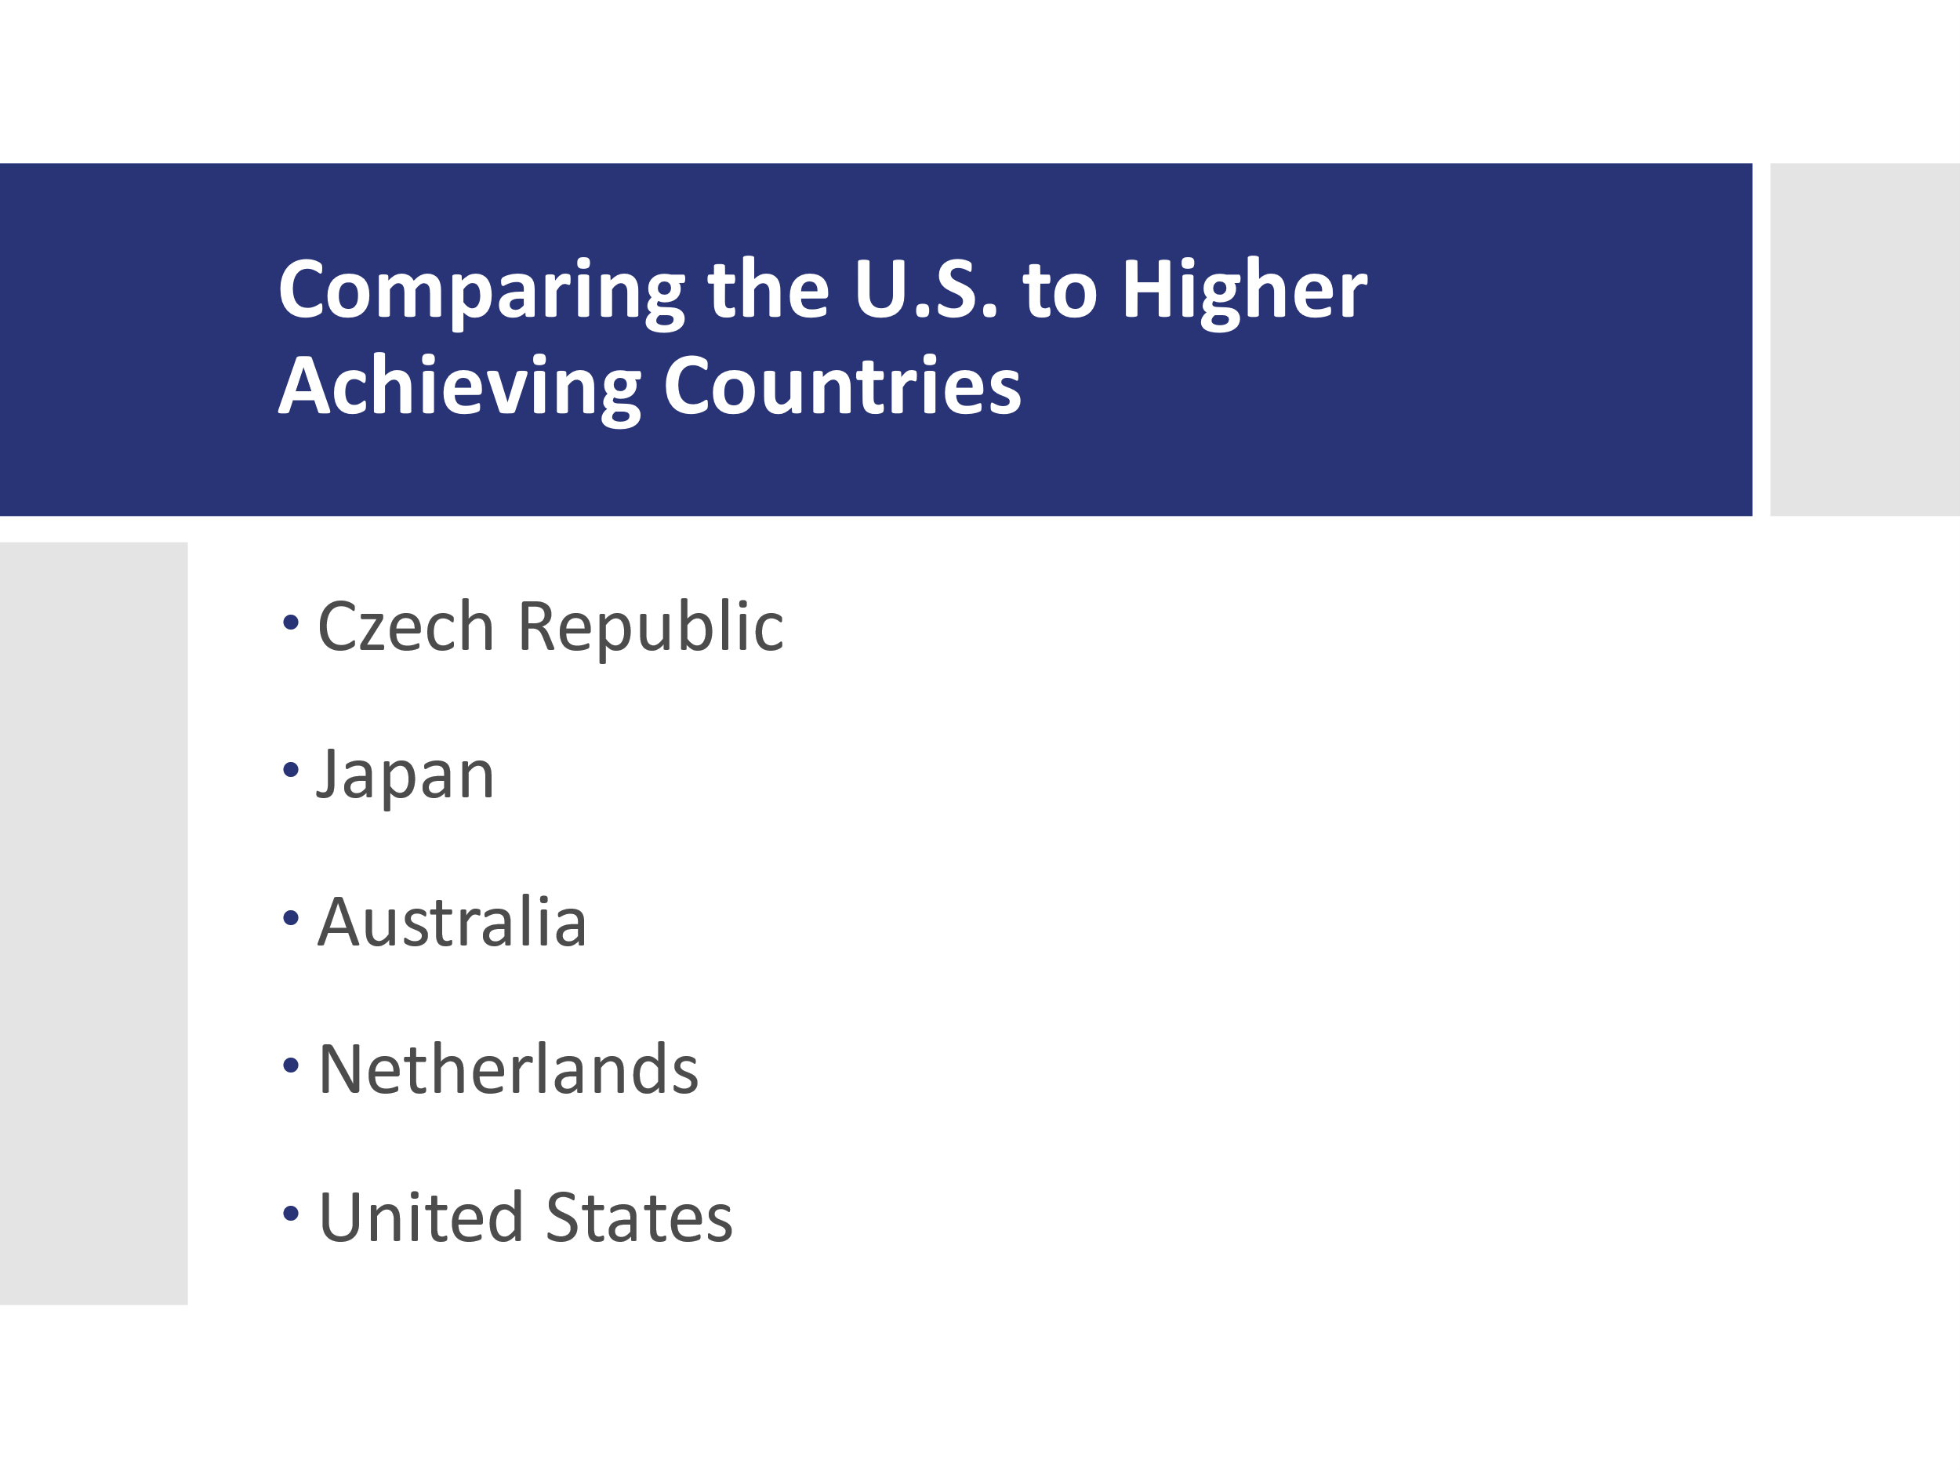 | - Comparing U.S. to Other Countries (5 min)  - Share that Australia, the Czech Republic, and Japan are higher achieving countries in science compared to the U.S.  - Note that 100 8th grade lessons were randomly videotaped in each country. The goal was to describe typical science teaching in each country.  - Note that the study also included the Netherlands, but that the context in the Netherlands is different enough that we won’t focus on their results at this time.
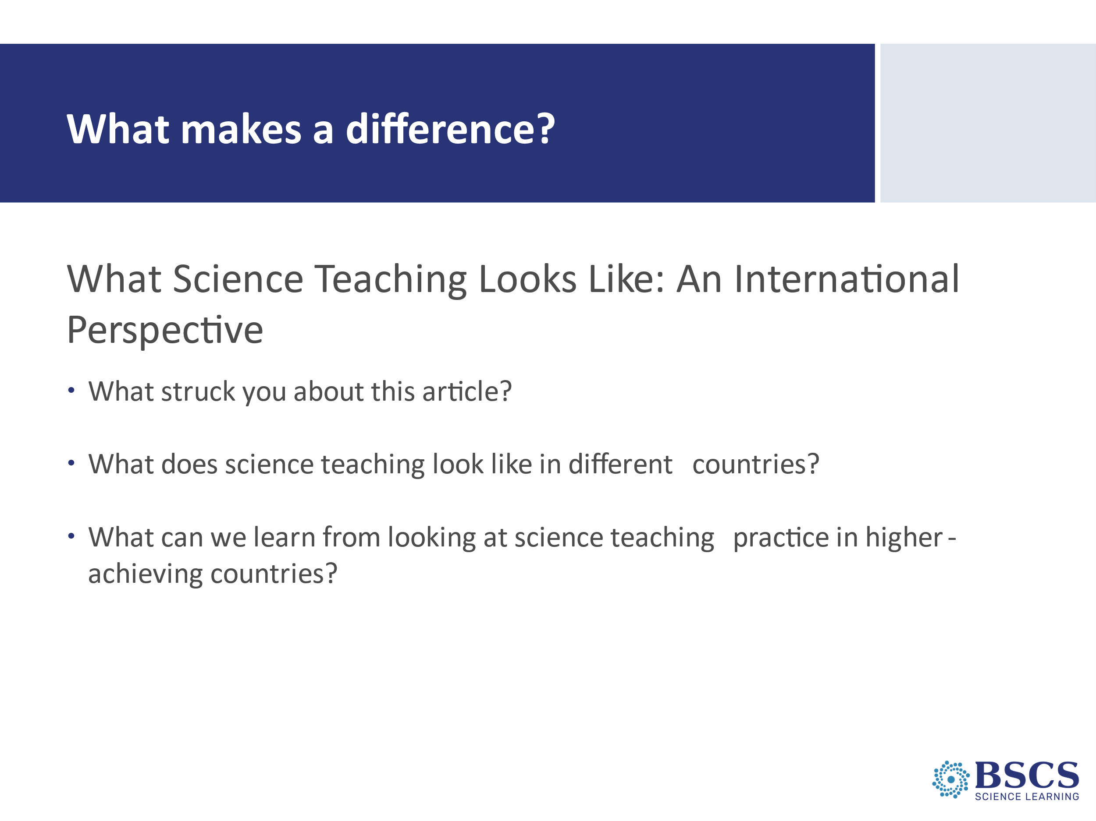  Breakout rooms: randomly assigned to include 3-4 participants in each. | - What makes a difference (15 min)  - Note that participants already read the article for homework.  - Let participants they’ll go into breakout rooms of 3-4 participants.  - In breakout rooms, they’ll have 10 minutes to discuss each of the three questions on the slide. Ask someone in each room to volunteer to be timekeeper so that your group has enough time to discuss all three. Ask participants to be sure to ground their responses in the article.  - Bring everyone back to the whole group for a whole group discussion.  - Ideas to highlight in discussion:  - Each higher-achieving country engaged students with core science concepts and ideas (more consistently than US). For example, both Japan and Australia classrooms introduced a few science concepts and explored them in depth while multiple discrete facts and definitions were the focus in US classrooms.  - All the higher-achieving countries linked ideas and activities (more consistently than US). For example, even though in Australia high-interest activities were noted, they were directly aligned to the science concepts and learning goals.  - In U.S. lessons, the focus was on doing activities with less attention to content and even less attention to linking activities and science ideas. Activities rarely supported content idea development in ways that were coherent or challenging for students in the US.  - In the U.S. over a quarter of the lessons had “no science content” whereas in the other countries the majority of the randomly selected lessons (e.g., typical lessons) had content with strong conceptual links. In higher achieving countries, students had to use evidence to develop explanations and use models to explain real-world phenomena. In the US, real-life connections were used to generate interest, but were not connected to science content.  - In this research, a lesson with at least one complete sentence statement of a science idea was scored as “learning content.”
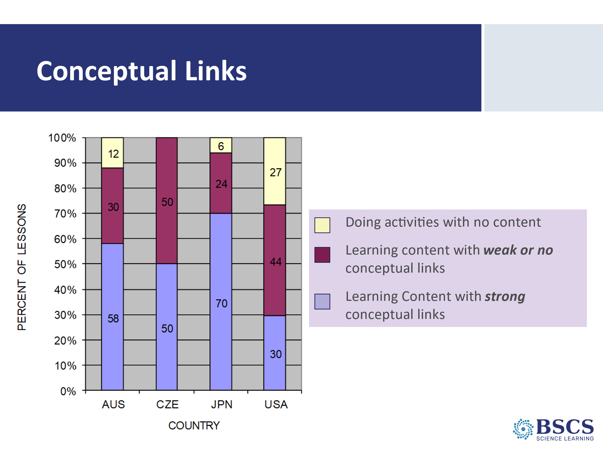 | - Conceptual Links (0 min)  - Use this slide if/when questions arise about the findings and in conjunction with discussion of what it means for a lesson to have no conceptual links.  - Begin by asking teachers what they notice about the graph.  - Note that, in the U.S., only 27% of lessons included learning content with strong conceptual links. Often lessons contained no science content at all. Lessons with “no content” had ONLY topic level mentions of science concepts. For example, in one lesson the teacher started the lesson by telling students to get out their rockets and get to work. They had directions that told them how to build the rockets. In the teacher’s interactions with the students, his focus was only on how to build the rockets. At the end of the lesson, he told students to clean up and then dismissed them.  - Mark the difference between procedures and science ideas.
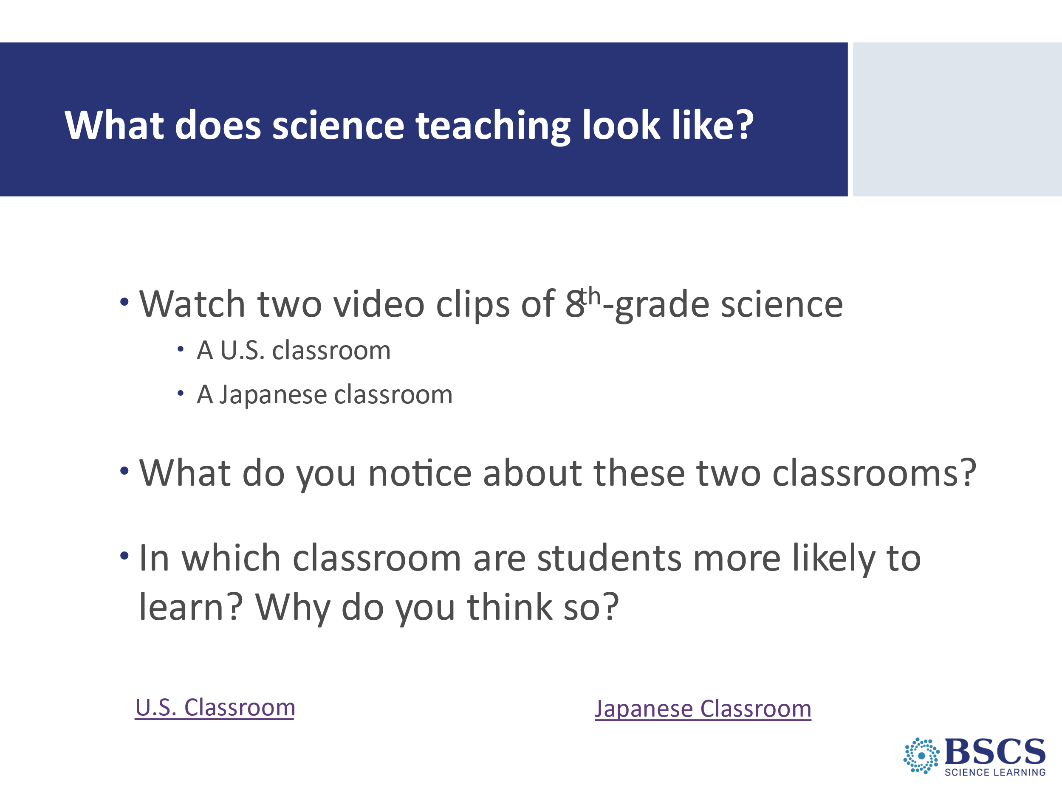 | - What does science teaching look like? (20 min)  - Remind participants that one of the research questions from the TIMSS video study was, What does science teaching look like in high-achieving countries?  - Forecast that they’ll see two videos. We’ll watch the video from the US classroom first, provide a few minutes for them to capture their ideas and then watch the video from the Japanese classroom. Note that both are 8th grade classrooms studying physical science subject matter—the US classroom is related to physics and the Japanese classroom related to chemistry. Both are mid-way through a sequence of lessons, and we see less than a 5 min clip of each.  - Point them to the transcript for the US Classroom in their binders (PD Binder p.__). Remind them that to pay attention to the science content and storyline.  - Show the video clip and provide a few minutes for individuals to capture some notes and any science ideas in the lesson.  - Point them to the transcript of the Japanese classroom (PD Binder p.__). Remind them that this class is also mid-way through a sequence of lessons.  - Emphasize that participants should focus on differences in instruction rather than differences in context. Show the video clip and provide a few minutes for individuals to capture some notes.  - Use the first question (What do you notice?) to begin a whole group discussion. Use probe and challenge questions as appropriate. Follow-up as appropriate with the second question.  US Classroom  Key ideas to emphasize and link back to results include:  - Teacher focuses on the activity and the procedure needed to complete the activity.  - No real focus on important science ideas by either the student or the teacher.  - Only topic level mention of science ideas (“pulleys,” “effort distance,” “resistance force”).  Japanese Classroom  Key ideas to emphasize and link back to results include:  - The content ideas are made clear to students (focus question, pairs talk) before doing any activity.  - Students are asked to talk about science ideas, not just procedures.  - Lesson purpose is made clear to students.  PDL Note: Teachers may be critical of both classrooms because student thinking is not made visible. This is true – but bring their focus back to the science content and its storyline. They should see a clear distinction between the science content storyline in the Japanese and US lessons. Students in the Japanese lesson are more likely to learn because science ideas are made visible, and students are engaged in thinking about science content ideas, not just science activities. You may want to note that these classroom videos weren’t chosen as extreme examples to highlight the differences between US and high achieving classrooms in other countries; each were pretty typical of the videos collected in their country.  Transition: Reflection is an important of the learning process for both us and our students. Let’s take a moment to reflect on what we’ve just experienced with the reading and videos from the TIMSS study.
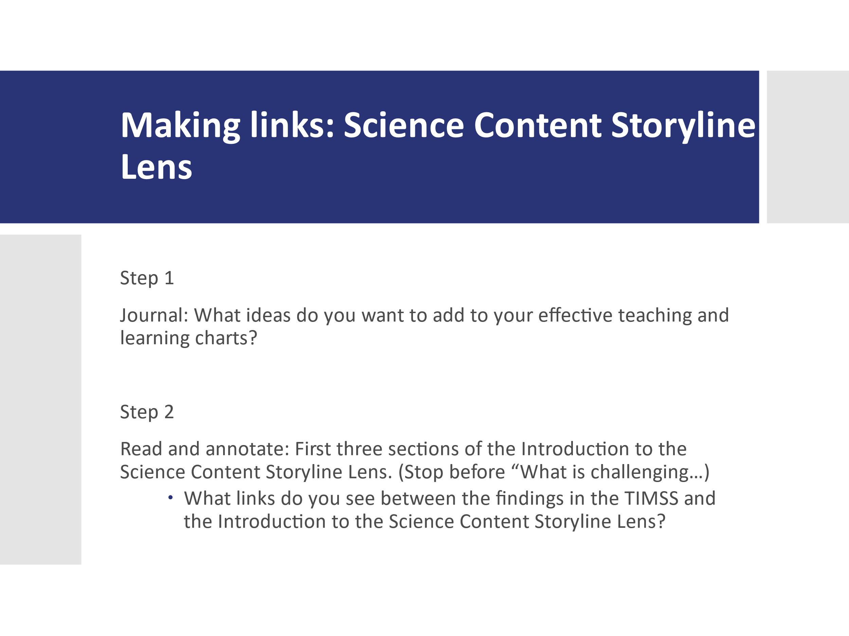 | - Making Links (10 min)  PDL Note: This slide is animated.  - Reveal Step 1 and invite participants to respond individually to the prompts on the slide in their journals. Mark that we will revise our charts later today.  - Reveal Step 2, remind participants of the FQ today, and invite them to annotate the text. Invite participants to consider links between the findings of the TIMSS study and the Introduction to the Science Content Storyline Lens.  - Ask a couple participants to share one link they noted  Transition: The TIMSS Video Study had great influence on the development of the STeLLA Conceptual Framework, particularly the Science Content Storyline and Strategies. The original goal for the STeLLA program was to only have ONE lens, but the research was clear, the Conceptual Framework required two lenses. Now we’ll take a look at some of the research behind the Student Thinking Lens and Strategies.
 | BREAK (If running behind, just give participants a 2-3 minute stretch break)
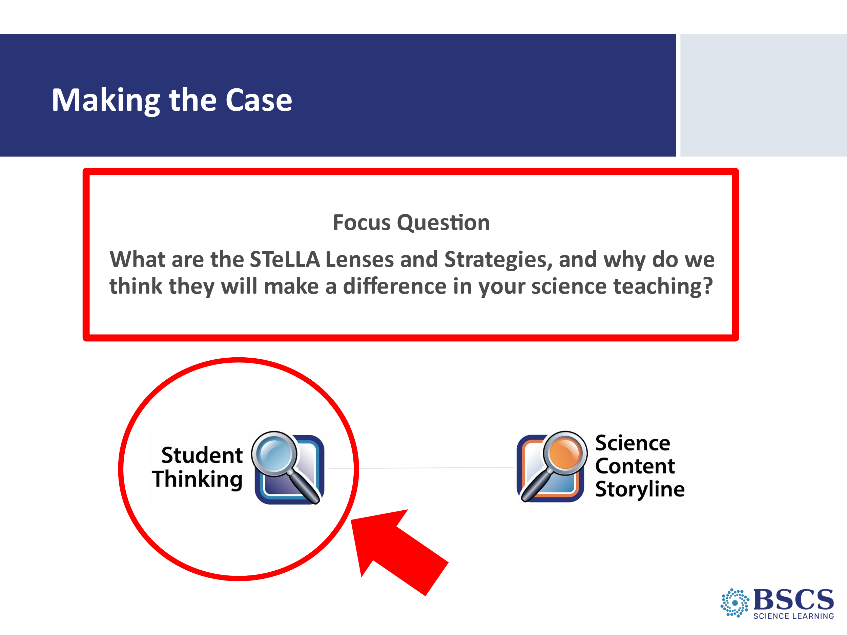 | - Making the Case (0 min)  - Revisit the focus question and mark that we’ll now shift our focus to the research that underpins the Student Thinking Lens of the STeLLA conceptual framework.
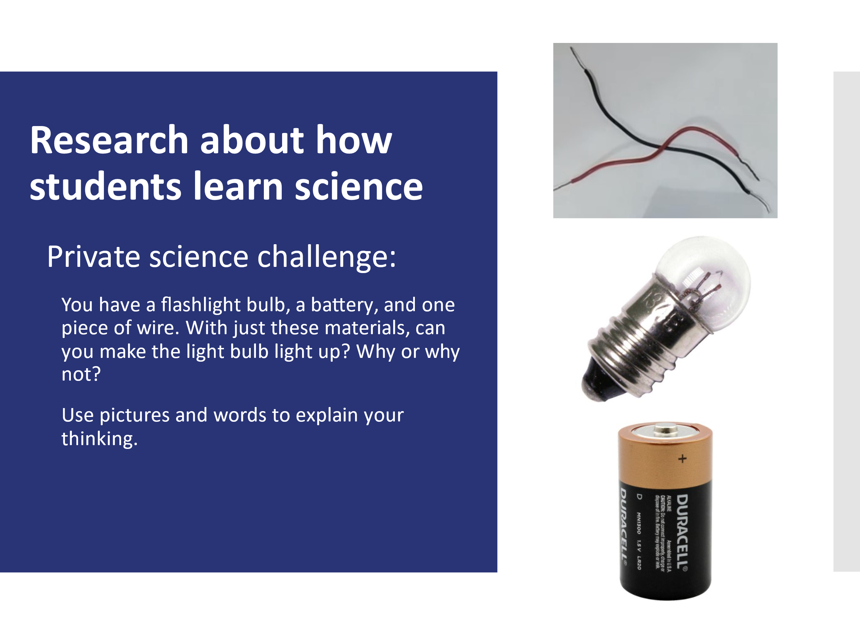 | - Research about how students learn science (5 min)  - Note that when we consider student thinking, it helps to have some ideas about the science content they are thinking about.  - Provide instructions for the task. Invite participants to record their ideas in the BSCS Journal.
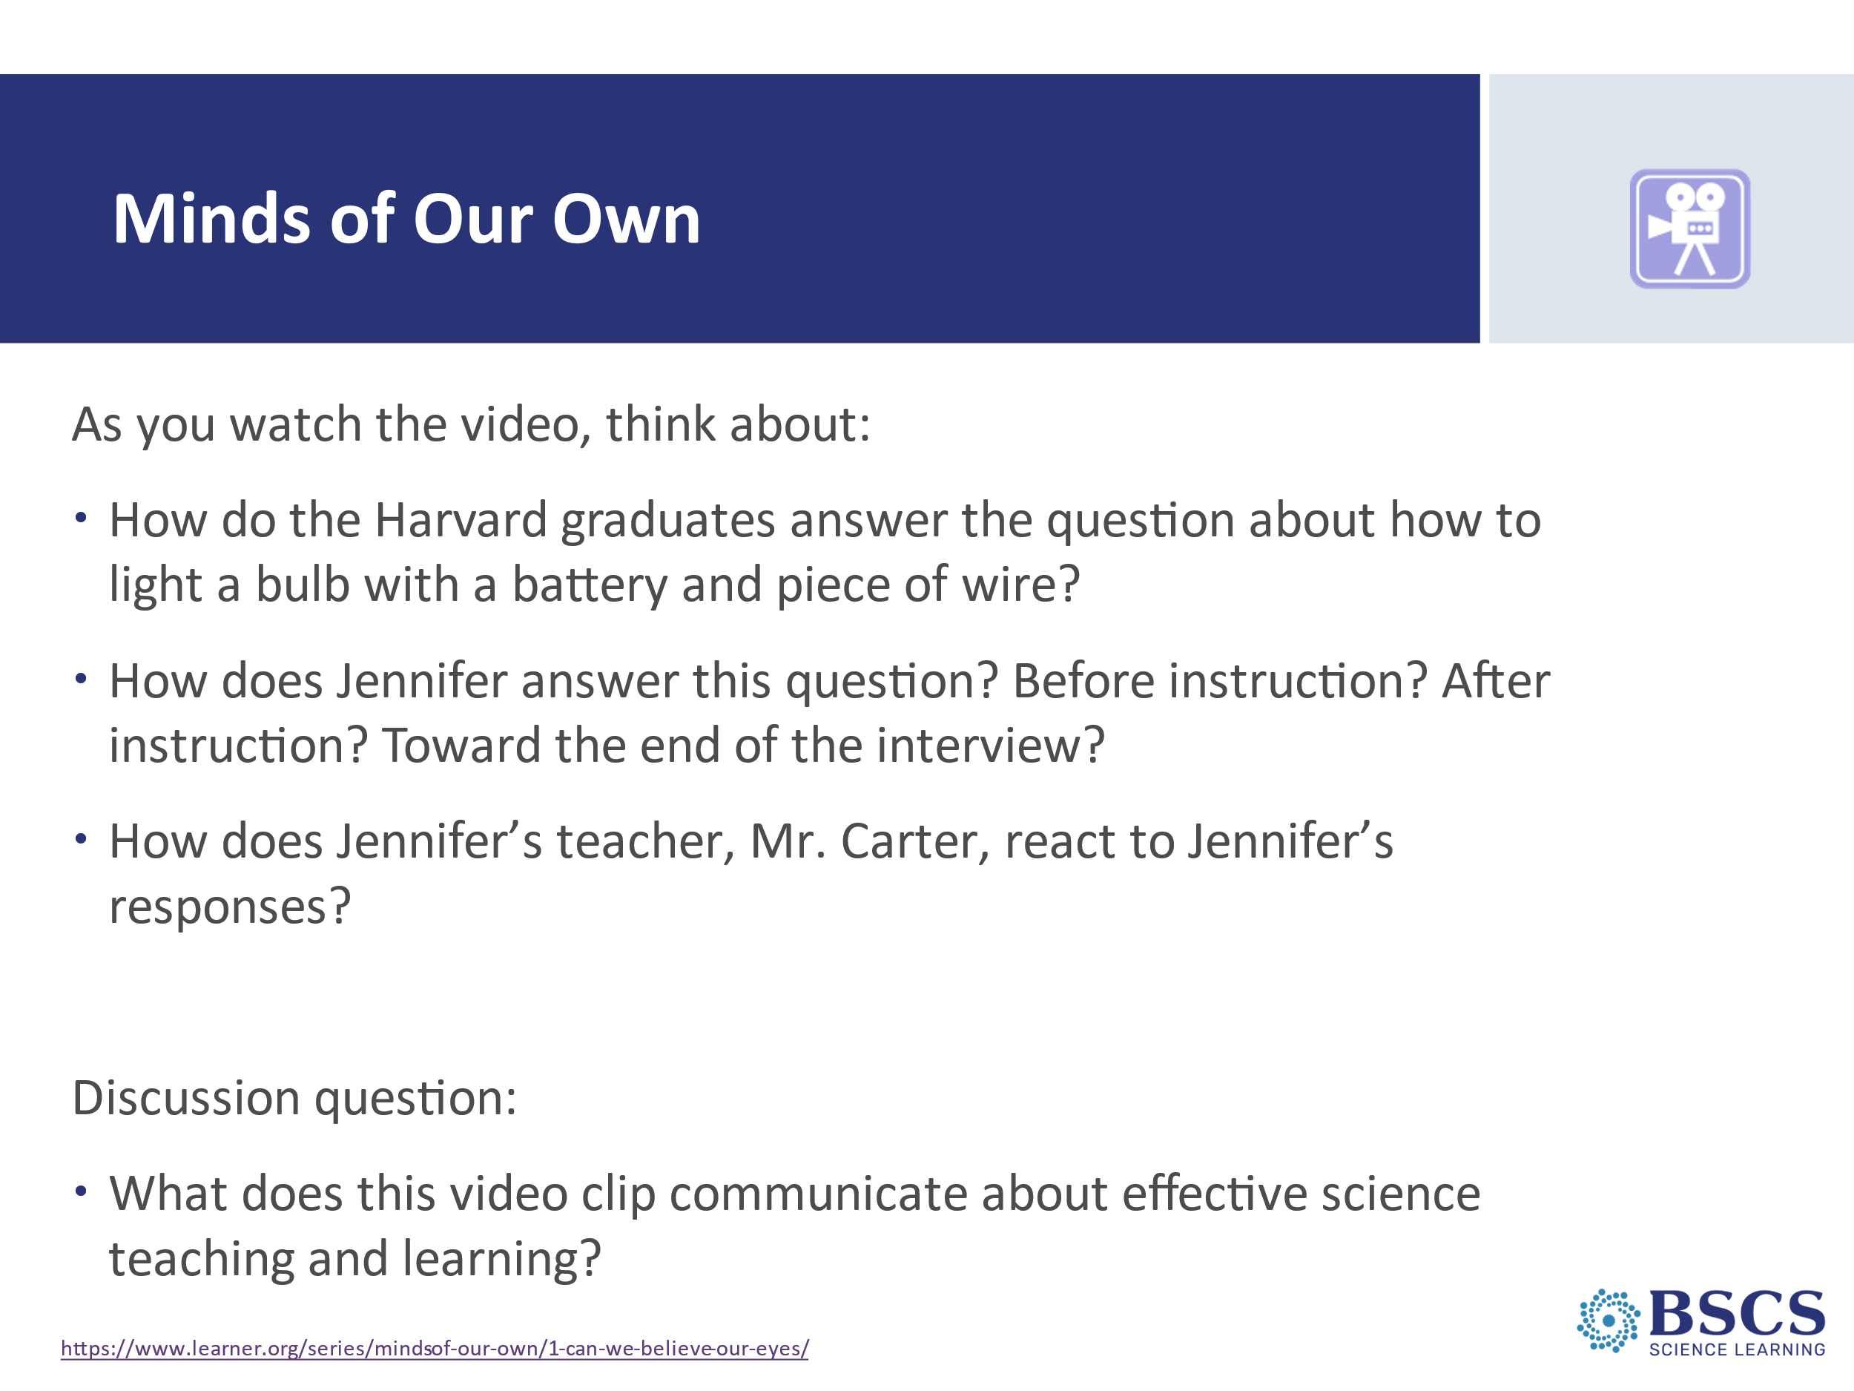  Share in chat before sending to breakout rooms:  Discuss: What does this video clip communicate about effective science teaching and learning?  Breakout rooms:  - 2-3 people  - Total time: 5 minutes  - Broadcast time left at 2 minutes | - Minds of Our Own (30 min)  PDL Note: This slide is animated.  - Set up the video. Refer to questions on the slide. Ask how many are familiar with the Private Universe and Minds of Our Own video series. If appropriate, note that you learn something new every time you watch and discuss video clips from the series.  - Use DVD or access video at: https://www.learner.org/series/minds-of-our-own/1-can-we-believe-our-eyes/ Clip 1: 1:23-3:53; Clip 2: 19:35-25:48; Clip 3: 46:26-50:16.  PDL Note: The video clips total ~13 minutes.  - Reveal the discussion prompt and explain that they will have a chance to share their observations in a breakout room. As you place the question in the chat and create breakout rooms (2-3 people), invite participants to jot down a few ideas before sharing in their small group. Send participants to breakout rooms to discuss.  - After time to discuss in breakout rooms, bring participants back to the main room to share highlights from their small group discussion. Use elicit, probe, and challenge questions to reveal and support teacher thinking about student thinking.  Ideas to highlight:  - Knowing what students already know is the most important thing…or at least one of the important things!  - Common science ideas are persistent. Why should I give up my idea?  - Hands on experiences don’t necessarily provide opportunities for sense-making.  - We don’t learn from experience; we learn from reflecting on the experience. We learn to learn by being metacognitive.  - The interviewer was prepared to challenge Jennifer’s preconceptions about the need for a ceramic socket for the bulb to light.  - The interviewer asked thoughtful questions grounded in an understanding how light bulbs and electrical circuits work.  - The interviewer invited Jennifer to represent her ideas on paper.  - The person who learned the most may have been Mr. Carter, Jennifer’s teacher.  - Jennifer heard the “right ideas” but didn’t have a chance to “figure out” …figuring out is a fundamental shift with the NGSS and is inherent in student learning through the STeLLA approach.  Transition: (if there’s time) We’ll continue our conversation about by digging into a summary of key research focused on how student learn science.
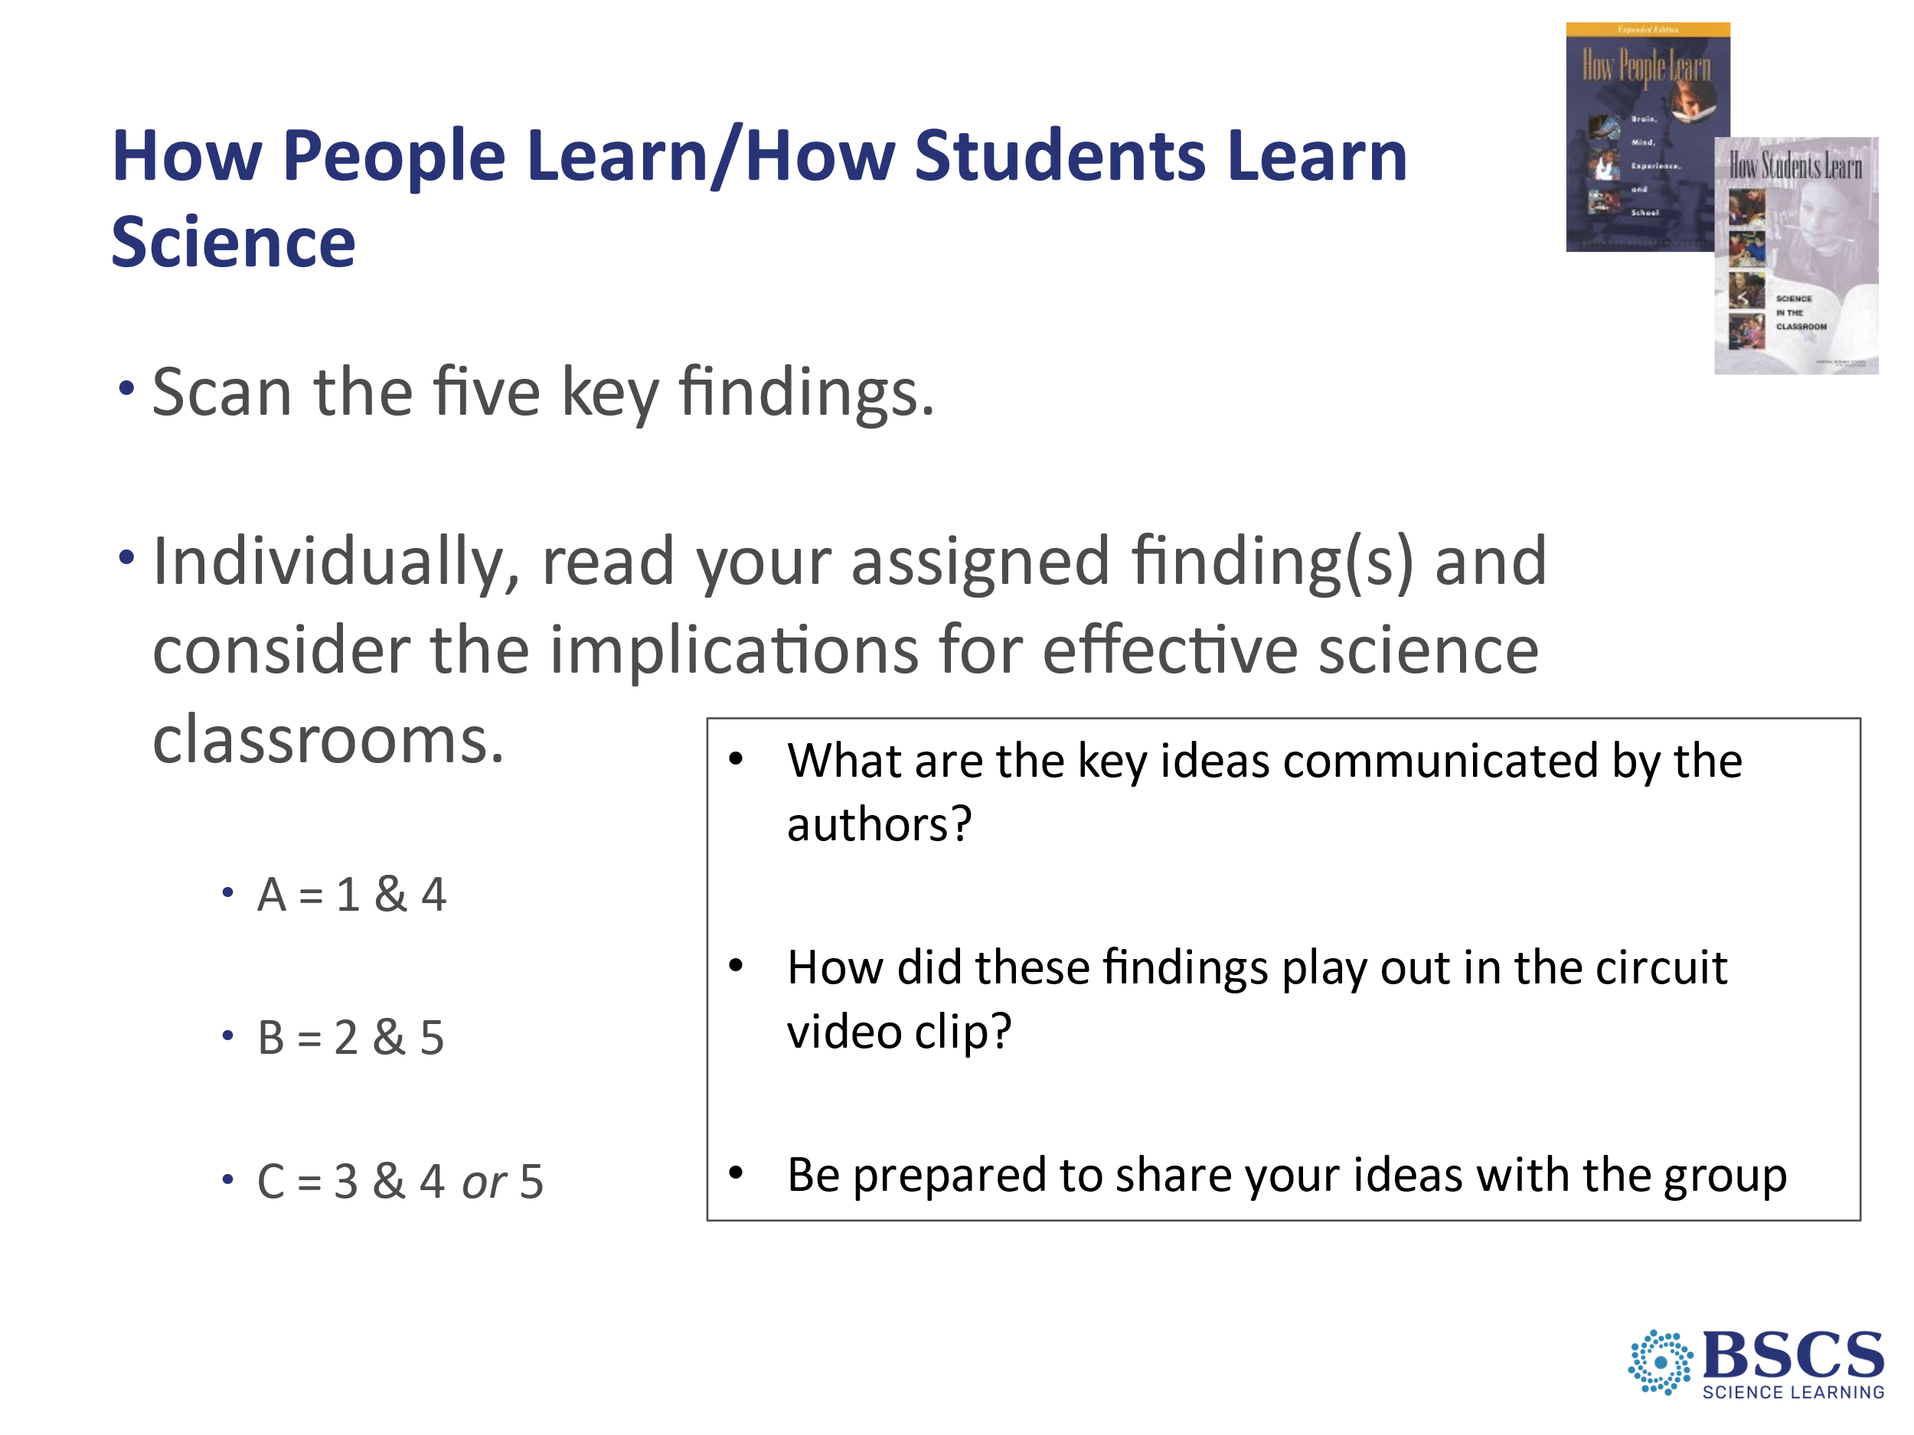 | - Research about how students learn science (25 min)  PDL Note: This slide can be cut if you are short on time. Share the reading (note location in PD Binder; p.__) with participants and invite them to read the findings on their own.  - Provide instructions for the jig-saw of the findings from HPL/HSL Science in the Classroom.  - Set up the task and refer participants to page _ in their PD binder. Link to the STeLLA program goal, particularly:  - Deepen knowledge of teaching and learning  - Increase student learning in science  - Provide instructions for the jig-saw of the findings from HPL/HSL Science in the Classroom.  PDL Note: The STeLLA Framework addresses the need uncovered in this and other studies on how people learn, and more specifically, how students learn science. Key ideas from the reading:  - If students’ initial knowledge is not engaged, they may fail to grasp the new concepts and information that are taught, they may distort the new information to make it fit with their prior experience  - This idea of learning with understanding has two parts: (1) factual knowledge MUST be placed in a conceptual framework (a “big idea” or a set of “big ideas”) organized in ways that enable them to use and apply that knowledge to make predictions, solve problems, explain new situations, and so forth. , and (2) concepts are given meaning by multiple representations that are rich in science ideas and details.  - To help students monitor their developing understandings, engage them in reflecting on their learning, their changing ideas, and their remaining questions and wonderings.  - Students’ experiences and cultural influences shape their understanding of their world and how they learn. Culture shapes every learning environment and the experience of each learner within that environment.  - To learn, students must find the experiences relevant and valuable. Motivation to learn is fostered when students feel like they belong and the learning environment promotes their safety, agency, and purpose.  Transition: Throughout the STeLLA program we will make use of Meta Moments and journal prompts as part of our learning experiences to attend to finding 3, and the importance of developing metacognitive abilities.
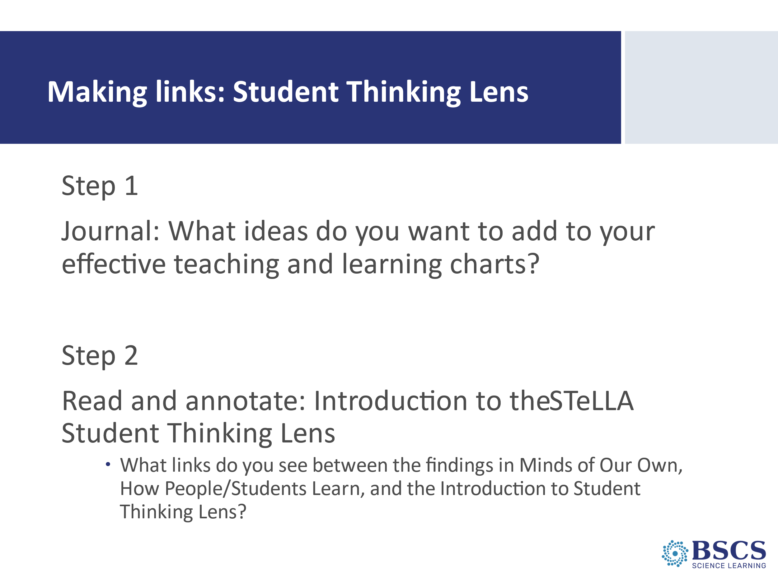 | - Making Links: Student Thinking Lens (10 min)  PDL Note: This slide is animated.  - Reveal Step 1 and invite participants to respond individually to the prompts on the slide in their journals. Mark that we will revise our charts soon.  - Reveal Step 2, remind participants of the FQ today, and invite them to annotate the text.
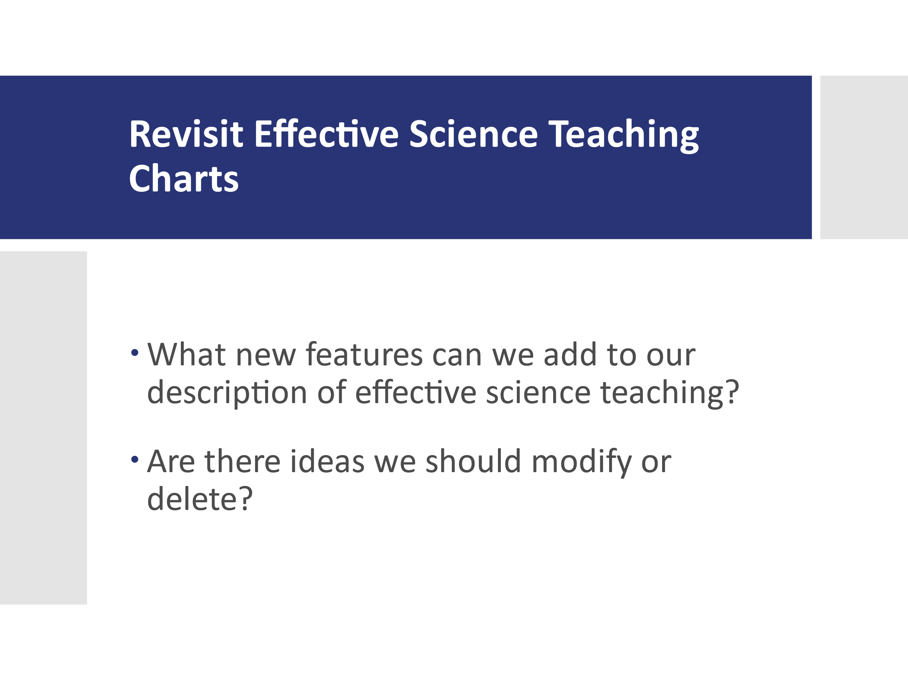  Tech Directions: Share link to your group’s effective science teaching and learning Google Doc. | - Revisit Effective Science Teaching Charts (10 min)  - Set up the task. Link to program goals.  - Encourage them to use a different color font to show how their ideas change over time.  - Encourage participants to keep an open mind to changing their ideas and we want to provide opportunities for them to reflect on any changes and the reasons for those changes.  - Invite participants to share their revisions with the whole group. Highlight ideas that connect to TIMSS and How People Learn.  - Share the link to your group’s EST&L Google Doc.  Transition: Over the course of the STeLLA program and starting with our Summer Institute next (week/month), we’ll see how these two lenses affect science teaching and learning through video analysis and the analysis of lesson plans.
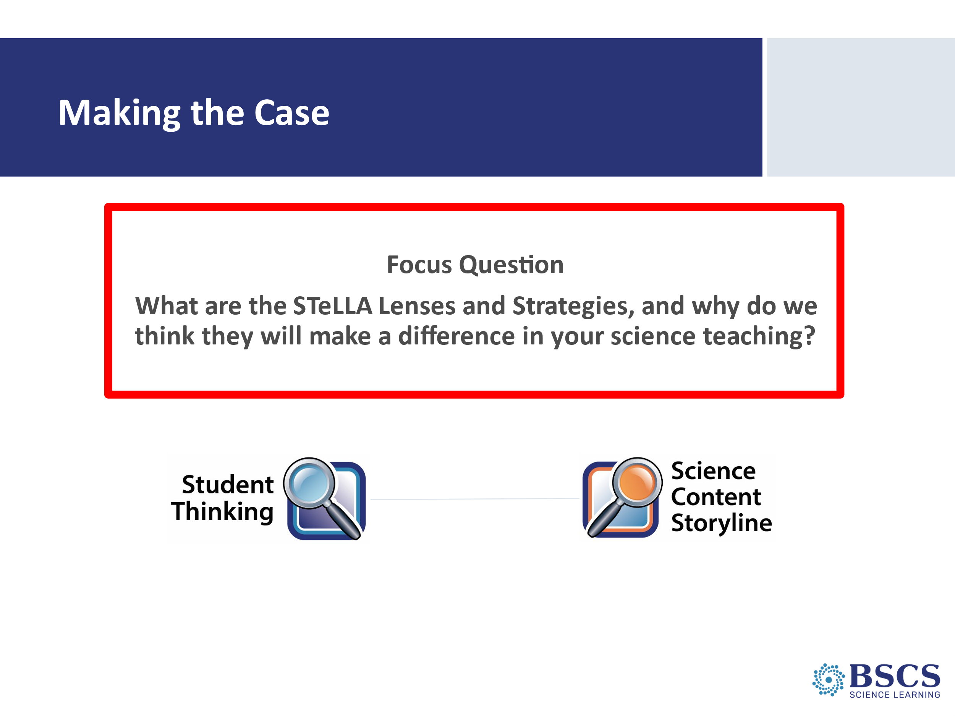 | - Focus Question (0 min)  - Remind participants of our focus question for today. Invite participants to consider how their ideas about these questions have grown and changed throughout the day.
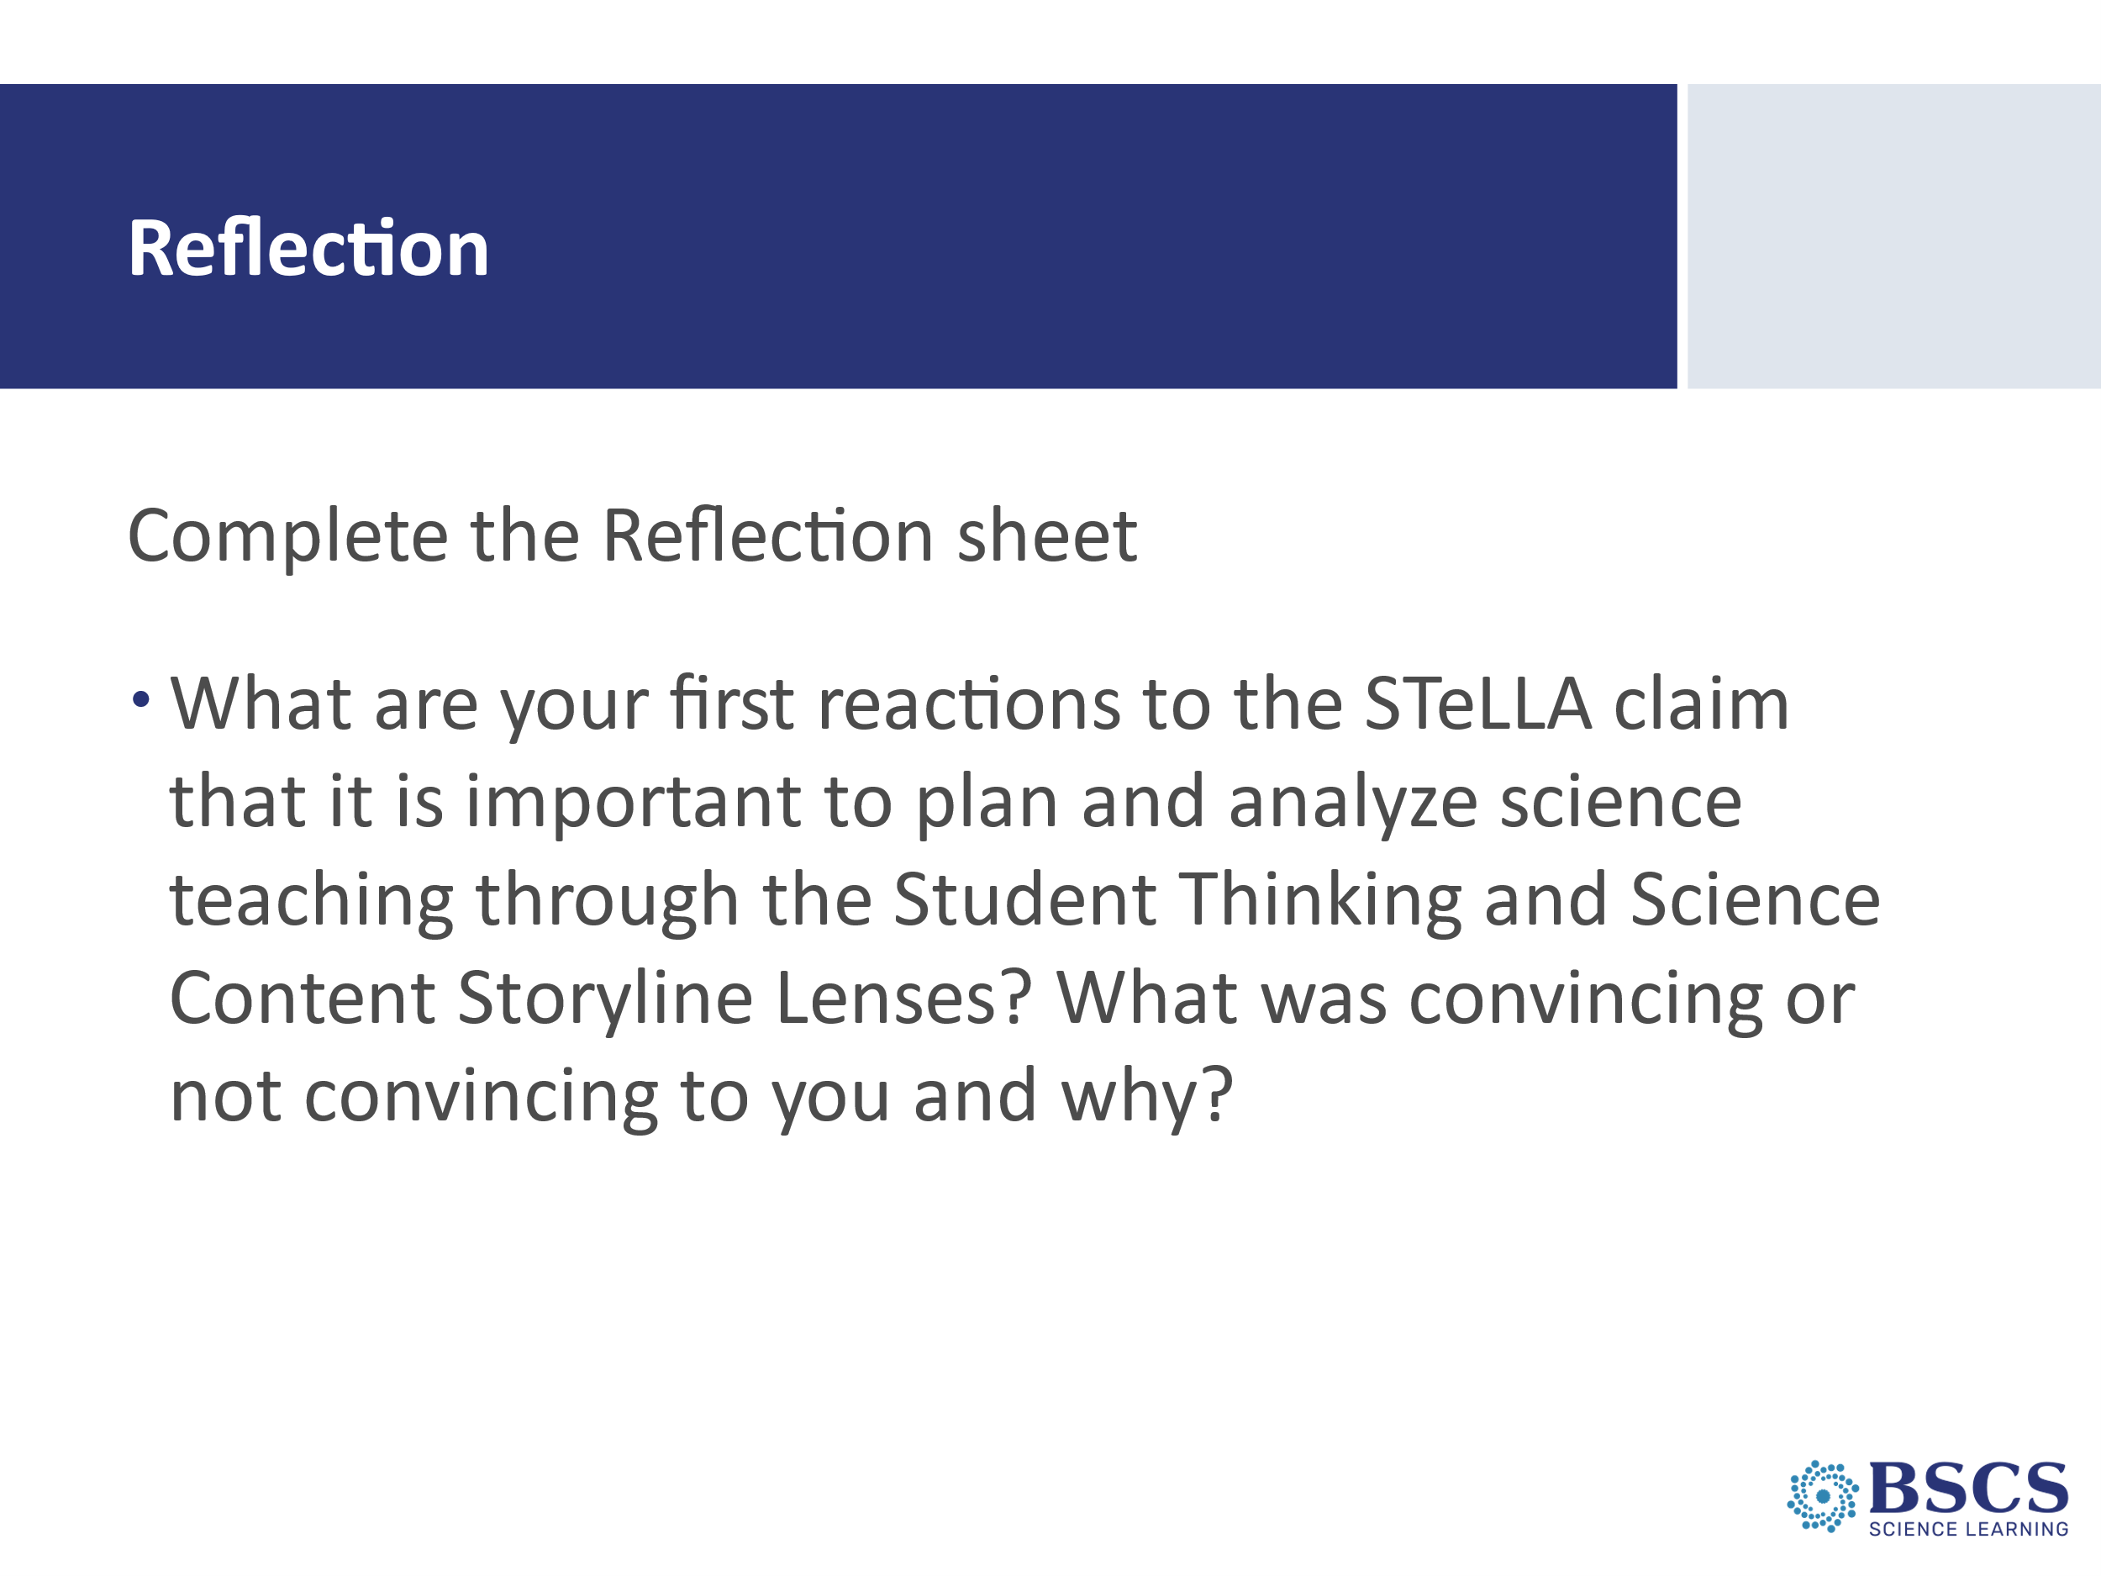  Tech Directions: Make a copy of this Google Form in your group’s sub-folder. Insert the topic of your content area. Double check sharing settings so participants can view but not edit the form.  Template link: https://docs.google.com/forms/d/13dIgL7oc6vULep0WOV0ft5c0VxWlRugvWruvZRw-TB8/edit | - Reflection (5 min)  - Direct participants to the reflections Google Form.  - Remind participants that the parking lot on the Jamboard is also available for any concerns or questions.
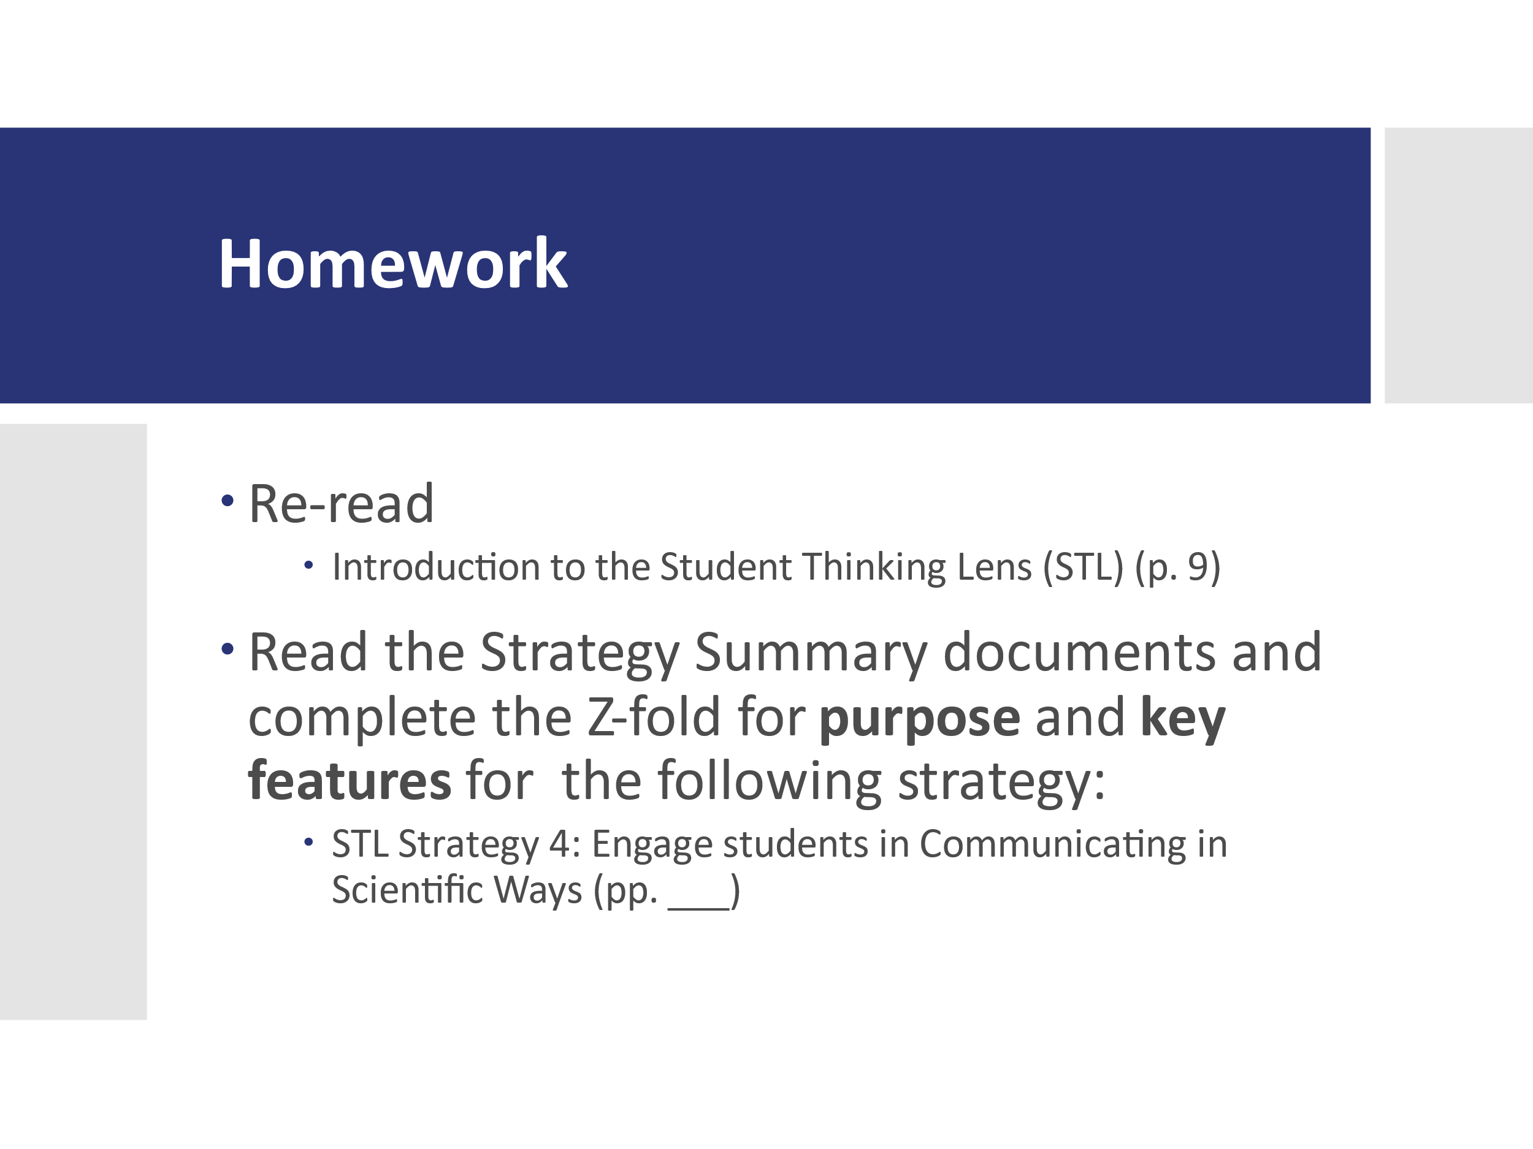 | - Homework (5 min)  - Provide instructions for the homework and ask for any clarifying questions about the homework.  - Remind participants that our goal is to develop a shared understanding of these important strategies so that we can enact them in our classrooms to improve student learning.
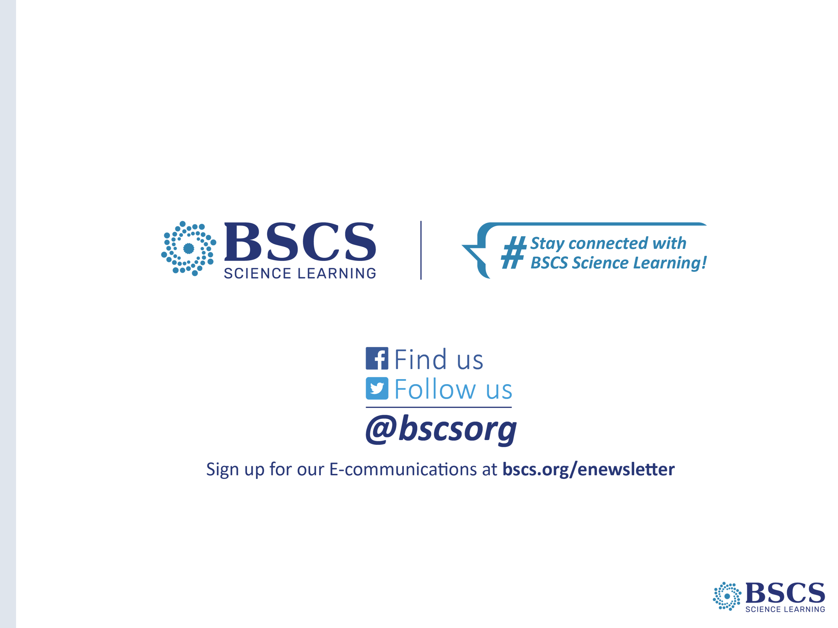 | - BSCS (0 min)  - Thank participants for a great virtual session!

